INCIDENT HIGHLIGHTS
DATE:
September 11, 2018
TIME:
8:56 a.m.
VICTIM:
59-year old male foreman
INDUSTRY/NAICS CODE:
Landscaping services / 561730
EMPLOYER:
Municipal public works / forestry division
SAFETY & TRAINING:
Some safety training, no comprehensive program
SCENE:
Side of the road in a residential area
LOCATION:
Massachusetts
EVENT TYPE:
Fall

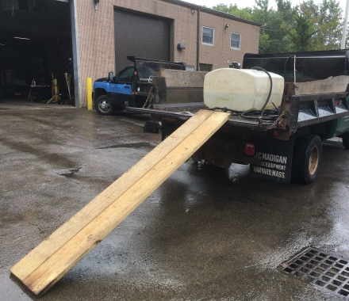

REPORT#: 18MA050 REPORT DATE: August 12, 2019
Municipal Public Works Foreman Dies After Falling From a Dump Truck – Massachusetts

SUMMARY
On September 11, 2018, a 59-year-old municipal foreman died after falling from the bed of a dump truck. At the time of the incident, the foreman and a co-worker were using wood planks as a ramp to unload a sod cutter that was located on the truck’s bed. When the foreman fell, his head struck the ground. READ THE FULL REPORT> (p.3)

CONTRIBUTING FACTORS
Key contributing factors identified in this investigation include:
- Not using appropriate ramps or transport vehicle for the task;
- Not performing a job safety analysis prior to beginning work; and
- No health and safety program. LEARN MORE> (p.6)

RECOMMENDATIONS
Massachusetts FACE Program concluded that, to help prevent similar occurrences, employers should:
- Ensure the appropriate equipment is available and used for each assigned task.
- Ensure that a job safety analysis is performed prior to the start of each project.
- Develop and implement a comprehensive safety and health program that addresses hazard recognition and avoidance of unsafe conditions.
In addition, employers should:
- Work towards creating a positive safety culture and safety climate in the workplace.
- Ensure that all workers assigned to tasks where they will spend time along roadways wear high visibility, reflective clothing. LEARN MORE> (p.6)
Fatality Assessment and Control Evaluation (FACE) Program

The Massachusetts Department of Public Health, in cooperation with the National Institute for Occupational Safety and Health (NIOSH), conducts investigations on the causes of work-related fatalities. The goal of this program, known as Massachusetts Fatality Assessment and Control Evaluation (Massachusetts FACE) is to prevent future fatal workplace injuries. Massachusetts FACE aims to achieve this goal by identifying and studying the risk factors that contribute to workplace fatalities, by recommending intervention strategies, and by disseminating prevention information to employers and employees.

NIOSH funded state-based FACE Programs currently include: California, Kentucky, Massachusetts, Michigan, New York, Oregon, and Washington.
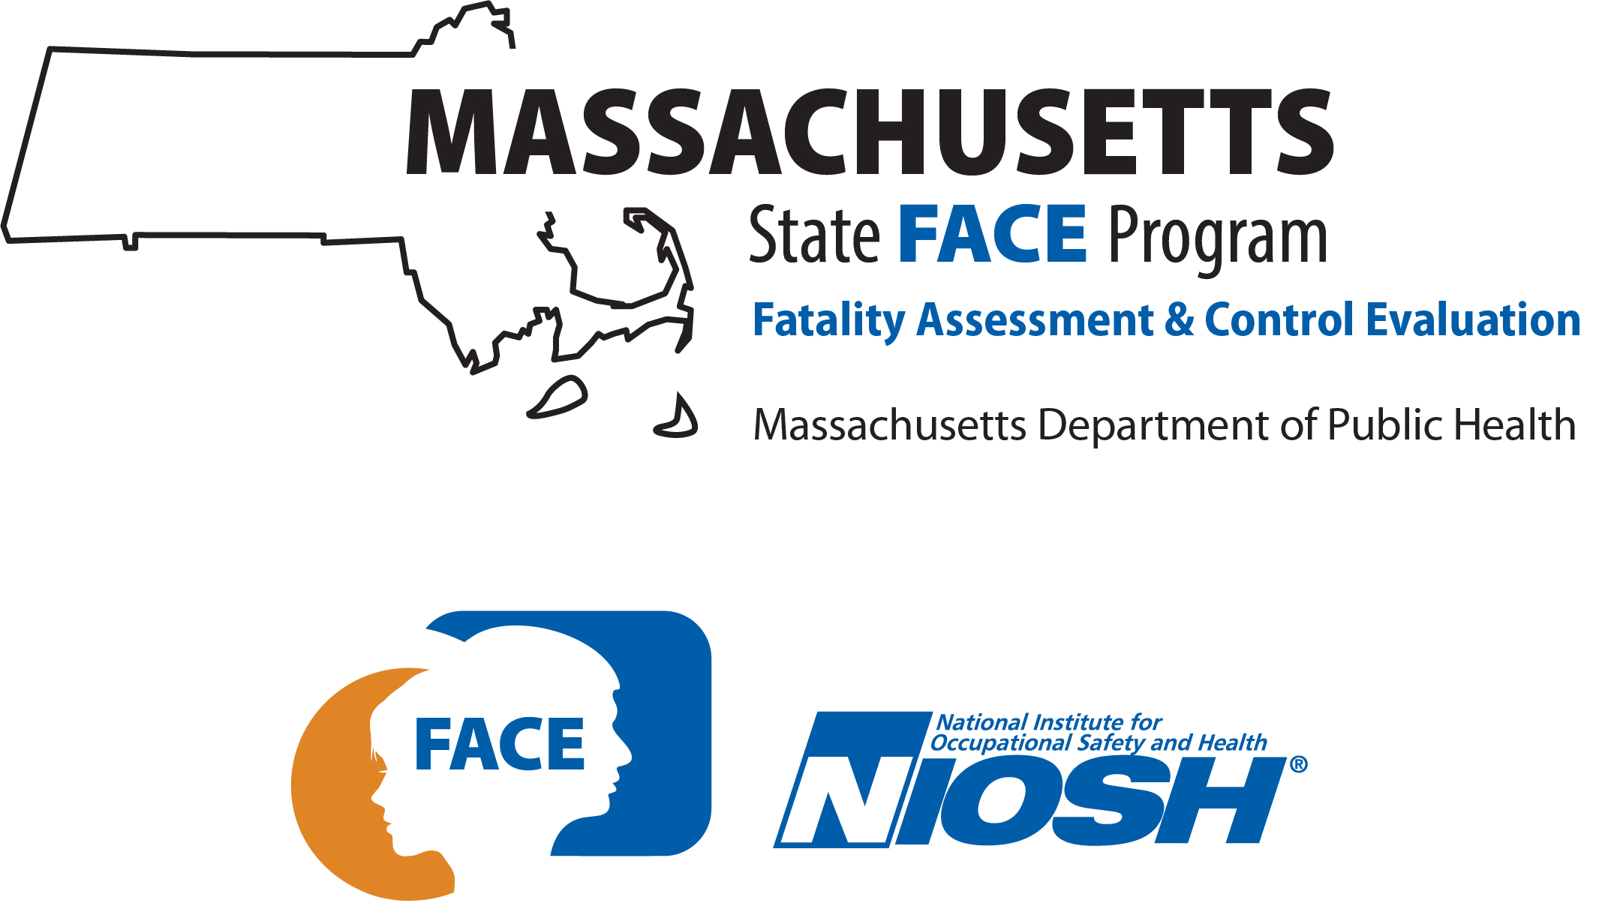

SUMMARY
On September 11, 2018, a 59-year-old male municipal foreman died after falling from a dump truck bed. At the time of the incident, the foreman and a co-worker were unloading a sod cutter that was located on the truck’s bed. Wood planks were being used as a ramp to help with this task. The victim climbed the wood planks and as he was stepping onto the dump truck’s bed, one of the wood planks slipped out and fell to the ground. The victim also fell, striking his head on the ground. The co-worker, who witnessed the incident, placed a call for emergency medical services (EMS) and assisted the victim. EMS arrived quickly and the victim was transported to the hospital.

INTRODUCTION
On September 17, 2018, the Massachusetts FACE Program was notified by the Massachusetts Department of Labor Standards (DLS) about the death of a worker after falling from a truck. On September 25, 2018, representatives from the Massachusetts FACE Program and DLS traveled to the municipal department of public works offices and met with multiple municipal representatives to discuss the incident. The incident location, police report, death certificate, and other information were reviewed.

EMPLOYER
The employer was a local municipal department of public works (DPW) for a Massachusetts city with a population of more than 27,000 residents. The city was first incorporated as a town in the mid 1800’s. The DPW is organized into eleven divisions. The victim worked for the Forestry and Parks Division. The Forestry and Parks Division had about twelve employees, with the majority of these positions being laborers. Employees typically worked eight hours per day with shifts routinely starting at 7:00 a.m. and ending at 3:30 p.m., Monday through Friday. Most of the town’s non-management public works employees had union representation, as did the victim.

WRITTEN SAFETY PROGRAMS and TRAINING
At the time of the incident, the municipal public works department did not have a comprehensive safety and health program. Some training was provided to employees on topics that included proper lifting, chainsaw safety, cardiopulmonary resuscitation, and driving safety. The city also provided employees with personal protective equipment (PPE) and a yearly allowance for additional PPE. The provided PPE included hearing and eye protection and high visibility safety apparel, winter jackets, and gloves.

WORKER INFORMATION
The victim was a 59-year-old white, non-Hispanic male municipal foreman for a local city public works department. At the time of the incident, he had worked at the city’s DPW for approximately fourteen years. He had first been hired as a heavy motor equipment operator and worked his way up to the division foreman positon. The victim held two Massachusetts Department of Public Safety and Inspections issued licenses. One was a hoisting engineer license and the other was a license to operate front end loaders and backhoes.

WEATHER
The weather at the time of the incident was approximately 74 degrees Fahrenheit, 79% humidity, 3 miles per hour (mph) average, east southeasterly wind speed, and mostly cloudy.¹ Rain precipitation had started the day before and continued into the early morning hours on the day of the incident, but had stopped hours before the incident. At the time of the incident, the wood planks were damp from the previous precipitation. Therefore, the weather on the day of the incident is believed to have been a factor in this incident.

EQUIPMENT
At the time of the incident, a sod cutter was in the process of being off loaded from the dump truck (Figure 1). The sod cutter was a rental for the day from a large home improvement store. Sod cutters cut sections of grass at the root level. The overall dimensions of the sod cutter were 24 inches wide, 34 inches high, and 54 inches long. The unit weighed 340 pounds. The sod cutter had two six inch wide drive axle wheels in the front and a third free wheel in the rear of the machine. The sod cutter was a self-propelled, walk behind machine with a gasoline powered engine. It was reported that renting equipment was not a routine occurrence.
The truck involved in the incident was a 2012, six-wheel, one ton, heavy duty truck that the city had purchased when the truck was new. The truck had a dump style bed (Figure 2). The city owned three of the same truck and the victim routinely used these trucks. When the truck’s tailgate is open, in the down (horizontal) positon, the height from the ground to the tailgate is 45 inches.

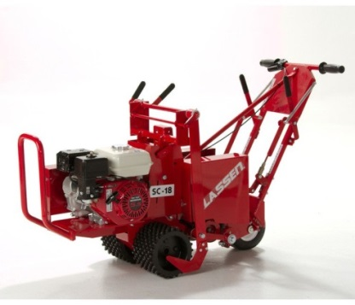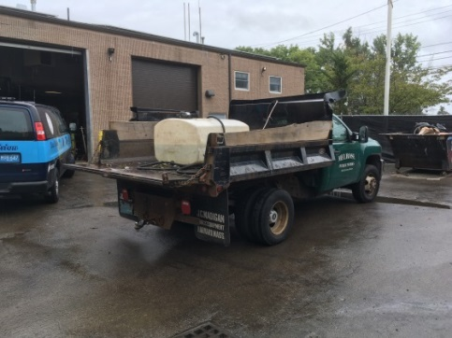
Figure 1 - Similar sod cutter to the one involved Figure 2 - Dump truck involved in the incident with tailgate down
in the incident

INCIDENT SCENE
The incident occurred in an area of the city that was primarily residential. At the time of the incident, the truck was parked at the edge of a roadway in front of a large city-owned historic house (Figure 3). The roadway runs generally east and west in this area (Figure 4). The road is comprised of asphalt and on either side of the roadway are granite curbing, narrow strips of grass, cement sidewalks, and then a chain link fence on the side of the roadway where the incident occurred. There are no painted marking on the roadway and parking is permitted on this roadway. This city owned property is enclosed by a chain-link fence. There are two walkway entrances and a driveway that leads to this building.
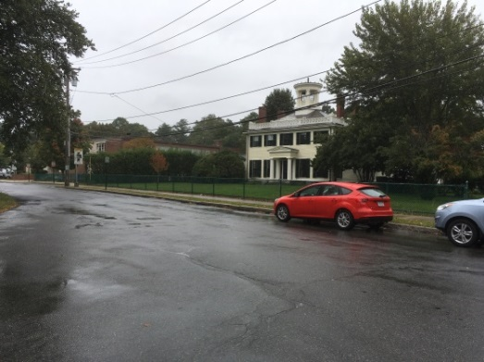
Figure 3 - Incident location Figure 4 - Aerial view of incident location

INVESTIGATION
At the time of the incident, the city was in the beginning stages of creating a rose garden in the front yard of the historic house. The victim routinely took on “special projects” such as this project of creating a rose garden. The rose garden was to be 60’ long, 5’ wide, and to contain 11 rose bushes. The victim and a co-worker, a skilled laborer who had been employed by the city for about five years, were assigned to this task.
The victim started his shift the morning of the incident at the DPW office and garage location. He met with his boss and made sure his crews of workers were set for their day’s tasks. Then the victim and the co-worker grabbed two pressure treated 2” x 10” x 8’ long wood planks and placed them in the dump truck’s bed. They drove the truck to a local home improvement store to rent a sod cutter. To load the sod cutter into the dump truck bed, the truck’s tailgate was lowered and the two wood planks were position to be used as a ramp. One end of each plank was resting against the edge of the tailgate and the other ends were on the ground. The wood planks were positioned together (Figure 5). The victim and the co-worker then loaded the sod cutter into the bed of the dump truck. The sod cutter was self-propelled and while the co-worker footed the ends of the wood planks that were on the ground, the victim walked with the sod cutter up the wood planks and into the dump truck bed. Reportedly, the DPW had one pair of engineered/manufactured metal ramps that were in the garage the morning of the incident. The dimensions of these metal ramps were 7’ 8” long x 1’ wide.
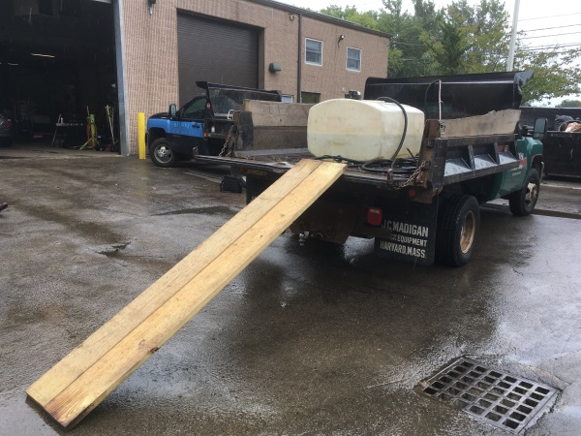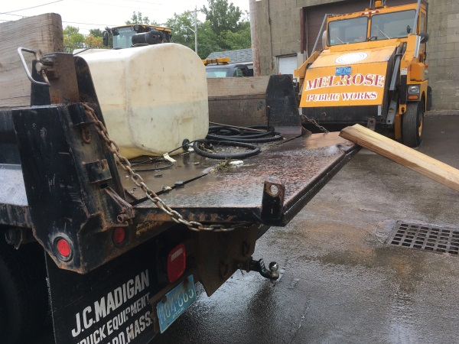
Figure 5 – Dump truck with wood planks set up as a ramp Figure 6 – Close up view of tailgate and the edge of the wood planks
They drove to the city owned historic house where the rose garden was being installed and parked the dump truck on the edge of the roadway in front of the house, parallel to the sidewalk. They marked out the location of the rose garden with spikes and string. Then they went to the truck and lowered the tailgate to unload the sod cutter. When fully lowered, the tailgate was 45” from the ground and was not completely parallel with the ground. The chains that were attached to the tailgate and the right rear corner of the truck were adjusted so that the tailgate was not quite horizontal and remained slanted towards the bed of the truck (Figure 6). At the very end of the tailgate there was a sizeable dent and along the edge the tailgate there was a narrow lip. The wood planks were again set up, as previously described, so the workers could offload the sod cutter.
At this point, the wood planks were still damp from the rain earlier in the morning. The victim, who was wearing boots, then walked up the wood planks and as he started to step onto the tailgate, the co-worker realized that one of the planks might have been shifting. The co-worker attempted to foot the plank but before he could get to it, the plank slipped off the tailgate and fell to the ground. The victim then fell backwards off the tailgate. He landed on the asphalt, striking his head.
The co-worker immediately placed a call for emergency medical services (EMS) and stayed with the victim. Within minutes of the placed call, the police and EMS arrived. The victim was transported to a local hospital where he died two days later.

CAUSE OF DEATH
The medical examiner listed the cause of death as complications of blunt head trauma.

CONTRIBUTING FACTORS
Occupational injuries and fatalities are often the result of one or more contributing factors or key events in a larger sequence of events that ultimately result in the injury or fatality. The Massachusetts FACE Program identified the following contributing factors in this incident:
- Not using appropriate ramps or transport vehicle for the task;
- Not performing a job safety analysis prior to beginning work; and
- No health and safety program.

RECOMMENDATIONS/DISCUSSION
Recommendation #1: Employers should ensure the appropriate equipment is available and used for each assigned task.
Discussion: The task that was involved in this incident was to create a rose garden using a rented sod cutter. Before leaving the garage, it was reported that the victim grabbed the wood planks from the DPW shop and then he and the co-worker drove to the home improvement store location to rent the sod cutter. The truck they took was the heavy duty dump truck that they routinely used. Reportedly the one pair of engineered ramps was available in the DPW shop, but this could not be confirmed.
It is the employer’s responsibility to ensure that the appropriate equipment, tools, and PPE needed to complete a task are readily available and used when completing the task. In this case, the employer should have had more than one pair of engineered ramps readily available and should have ensured work crews knew the location of the ramps. This could also include wood planks that have been fitted with manufactured wood ramp metal ends that, once bolted to the wood planks, provide a more stable slip-resistant end. If wood planks are going to be used, they should also have a nonslip walking surface.
In this case, the employer should have requested that one of the four low load trailers that the DPW owned was used to transport the sod cutter. One of these low load trailers had a floor height eight inches above the ground level as compared to the dump truck that had a bed and tailgate height 45 inches above the ground level. In addition, this trailer had a ramp the width of the trailer incorporated into the design that would have made loading the sod cutter onto the trailer much easier.
Recommendation #2: Employers should ensure that a job safety analysis is performed prior to the start of each project.
Discussion: A job safety analysis (JSA) is a technique to systematically evaluate job tasks to ensure they are performed safely. It involves identifying potential hazards and hazardous situations that could occur when performing tasks by focusing on the relationship between the worker, the task, the tools, and the work environment.² JSA should be routinely performed to identify uncontrolled and potential hazards. The JSA should begin by breaking down the tasks to be performed into steps, including the selection and operation of any equipment and the use of tools to complete the task. Each step should be evaluated to identify the hazards or potential hazards and the best equipment and tools to be used to safely complete the task. Once hazards are identified, employers should take steps to eliminate or control these hazards, such as selecting different equipment and tools or the proper PPE. It is important to have employees participate in the JSA.
In this case, a JSA could have identified the potential hazards and unsafe conditions involved with using the wood planks as ramps, especially with the damp conditions. The JSA could have prompted the selection the engineered ramps if they were available. Furthermore, the JSA might have prompted the selection of one of the low load trailers with the built in ramp rather than attempting to get the 300 pound piece of equipment up almost four feet to the dump truck bed. In addition, because the workers were going to spend some of their time along the edge of a roadway, the JSA might have initiated the wearing of high visibility clothing/vests (see recommendation # 5).
Recommendation #3: Employers should develop and implement a comprehensive safety and health program that addresses hazard recognition and avoidance of unsafe conditions.
Discussion: Having a municipality-wide safety and health program is an important part of keeping employees safe. A safety and health program should include the systematic identification, evaluation, and prevention and control of both general workplace hazards and the hazards of specific jobs and tasks. The core elements of an effective safety and health program are management leadership, worker participation, hazard identification and assessment, hazard prevention and control, education and training, and program evaluation and improvement.³ The program should outline safe work practices workers are expected to adhere to, specific safety protection for all tasks workers perform, how workers can identify and avoid hazards, and who workers should contact when safety and health issues or questions arise. The program should also include an explanation of the workers’ rights to protection in the workplace.
When developing a safety and health program, employers should start by performing a hazard analysis of all routine tasks performed by employees for potential hazards and incorporate information about any identified hazards and their controls into the program.² When determining potential hazards associated with equipment, information in the manufacturer operator’s manual and on the equipment’s warning labels should be reviewed and incorporated into the safety and health program procedures.
Employers should also use their employees’ expertise throughout the program development process by seeking employee input. Once the program is developed, employers should continue to seek employees’ input during the routine updating of the program. The program should be updated when safety concerns arise and when new equipment, tasks or chemicals are introduced into the workplace. In addition, for situations where work sites change with each job, the safety and health program should also require that a job safety analysis be performed for each job site before work begins to ensure that the required tools and PPE needed to complete the tasks are available.
Employers should ensure that they have fully and effectively implemented their safety and health program by routinely performing assessments of tasks and immediately addressing any observed unsafe conditions. As part of the program’s implementation, training should be provided to all employees on the program’s topics and procedures, and should also include hazard recognition and the avoidance of unsafe conditions. All training provided to employees should be documented. In this case, the safety and health program should include a section on proper mower and other equipment selection, use of the equipment, and training.
The Massachusetts Department of Labor Standards (DLS) offers free consultation services to help small employers improve their safety and health programs, identify hazards, and train employees. DLS can be contacted at 978-242-1351. More information about DLS can be found on their website at www.mass.gov/dos/consult.
The Massachusetts Department of Industrial Accidents (DIA) has grants available for providing workplace health and safety training to employers and employees. Any company covered by the Massachusetts Workers’ Compensation Insurance Law is eligible to apply for these grants. More information about these DIA grants can be found on their website at www.mass.gov/dia/safety.
Recommendation #4: Employers should work towards creating a positive safety culture and safety climate in the workplace.
Discussion: Many workplaces have room to improve their safety climate and culture. Safety culture is a measure of how a company values safety. Safety climate is a measure of how workers feel about the company’s safety program based on what they see and hear from supervisors and upper management on a daily basis. In short, safety climate is workers’ perception of how much the company values safety in relation to other competing priorities.⁴ A positive and strong safety climate and safety culture can help prevent work-related injuries.
Employees know how management thinks about safety and how safety is handled on a daily basis. Workplaces with a less than desirable safety climate and safety culture can work towards enhancing them by building trust between workers and management. Once workers see that management values safety, dramatic improvements in safety climate are often the result. Here are some opportunities for management and supervisors to build trust at your workplace.⁶
- Respond to safety problems quickly and fairly. Don’t ignore them until someone gets hurt.
- Encourage and reward workers for reporting unsafe conditions. Don’t discipline workers for halting work to report a safety problem.
- Don’t let external pressures be an excuse to cut corners. Let external pressure lead to a reevaluation and planning so the job can be done both safely and productively.
- Supervisors should be good listeners who act on worker concerns. Supervisors should not solely focus on getting the job done faster at the expense of the worker.
The CPWR (Center for Construction Research and Training) developed a Safety Climate Assessment Tool for Small Contractors (S-CATSC).⁵ This tool was designed to help small construction company employers and their employees assess and improve their jobsite safety climate, but can also be a useful resource for public works departments. The S-CATSC uses the following eight leading indicators to assess a company’s safety climate:
- Demonstrates management commitment to safety
- Promotes and incorporates safety as a value
- Ensures accountability at all levels
- Supports effective supervisory leadership
- Empowers and involves employees
- Communicates effectively
- Provides training at all levels
- Encourages client involvement
The S-CATSC includes ideas for improving leading indicators to strengthen workplace safety climate starting on page seven of the tool (www.cpwr.com/sites/default/files/publications/SCAT-SC.pdf). CPWR also has provided a page of resources to help implement the ideas (www.cpwr.com/safety-culture/strengthening-jobsite-safety-climate).

Recommendation #5: Employers should ensure that all workers assigned to tasks where they will spend time along roadways wear high visibility reflective clothing.
Discussion: All workers who will spend time on and along roadways while completing tasks, including those who will spend a limited amount of time along a roadway, face many hazards. One of these hazards is routinely being in close proximity to moving motor vehicle traffic. In this case, the truck that the victim and the co-worker were using was parked along the side of a roadway. While they were unloading the sod cutter from the dump truck, they were exposed to passing vehicles.
Although not a contributing factor in this incident, to help ensure that workers, in close proximity to moving vehicles, are as visible as possible to vehicle operators, employers should make sure they wear high-visibility safety apparel. The American National Standards Institute’s (ANSI) standard for High–Visibility Safety Apparel (ANSI/ISEA 107-2015) is published by the International Safety Equipment Association (ISEA).⁶ This standard recommends three classes of garments based on the workers’ activities while working in or near moving vehicles. These classes are:
- Class 3 garments, which provide the highest level of visibility for workers who face serious hazards with high task loads that require attention away from their work where traffic exceeds 50 miles per hour (mph).
- Class 2 garments, which are intended for use where greater visibility is necessary during inclement weather conditions and when activities occur near roadways where traffic speeds exceed 25 mph.
- Class 1 garments (not for use along highways and streets), which are intended for use in activities that permit the wearer's full and undivided attention to approaching traffic. There should be ample separation of the worker from traffic, which should be traveling no faster than 25 miles per hour.
Employers should ensure that all workers have access to the required PPE, such as high visibility clothing.⁷ Employers should provide workers with training on why the PPE is needed, when the PPE is needed, how to properly use the PPE, the limitations of the PPE and how to care for and maintain the PPE. In addition, employers should replace high-visibility safety apparel when it becomes faded, torn, dirty, soiled, worn, or defaced, or if it is not visible at 1,000 feet day or night. The typical useful service life of high-visibility safety apparel depends on the type of work an individual performs while wearing the apparel.

ADDITIONAL RESOURCES
Work Safe BC. Enhancing health & safety culture & performance. www.worksafebc.com/en/health-safety/create-manage/enhancing-culture-performance

DISCLAIMER
Mention of any company or product does not constitute endorsement by the National Institute for Occupational Safety and Health (NIOSH). In addition, citations to websites external to NIOSH do not constitute NIOSH endorsement of the sponsoring organizations or their programs or products. Furthermore, NIOSH is not responsible for the content of these websites. All web addresses referenced in this document were accessible as of the publication date.

REFERENCES
1. Weather Underground. Weather History. Massachusetts: TWC Product and Technology LLC.
https://www.wunderground.com/history/daily/us/ma/boston/KBOS/date/2018-9-11

2. OSHA. Job Hazard Analysis. Publication Number: 3071.
www.osha.gov/Publications/osha3071.pdf. Date accessed: April 10, 2018.

3. OSHA. Recommended Practices for Safety and Health Programs. OSHA 3885. 2016. www.osha.gov/shpguidelines/. Date accessed: April 10, 2018.

4. Laborers’ Health and Safety Fund of North America. Lifelines. Assessing and Improving Safety Climate on Your Jobsite. January, 2017; Vol 13, Num 8. www.lhsfna.org/index.cfm/lifelines/january-2017/assessing-and-improving-safety-climate-on-your-jobsite/

5. CPWR. Strengthening Jobsite Safety Climate by Using and Improving Leading Indicators. www.cpwr.com/safety-culture/strengthening-jobsite-safety-climate

6. ANSI/ISEA [2015]. American National Standard for high-visibility safety apparel. New York, NY: American National Standards Institute, ANSI/ISEA 107 -2015.

7. OSHA. Code of Federal Regulations. 29 CFR 1910.132. General requirements. Washington, D.C.: U.S. Printing Office, Office of the Federal Register. www.osha.gov/laws-regs/regulations/standardnumber/1910/1910.132

