Mass in Motion Municipal Wellness and Leadership Program

Mass in Motion is a statewide obesity prevention initiative to help people eat better and move more in the places where they live, learn, work and play.

Obesity and being overweight has become an epidemic in Massachusetts, causing an increase in obesity-related chronic diseases and increasing health care costs in the Commonwealth.
- Two out of three Massachusetts adults, and one in four children, are either overweight or obese.
- Almost half of Massachusetts adults do not get the recommended amount of physical activity, and more than 75% do not eat enough fruits and vegetables.
- Obesity-related diseases account for 7.6% of all health care costs in Massachusetts, a full $3.5 billion in excess health care expenditures each year.

To address this significant public health problem, the Massachusetts Department of Public Health launched Mass in Motion in January 2009. This multi-faceted initiative includes a workplace wellness program, a communications campaign, school nutrition regulations, and the release of Executive Order 509. It also included the creation of a community-based initiative providing grants to cities and towns to help them build policies, systems and environments that promote wellness and healthy living.
Today, DPH funds 33 local Mass in Motion programs covering 52 communities across the Commonwealth. These programs provide municipal leadership in creating opportunities within their cities and towns that make active living easier and healthy foods more accessible and affordable.

Mass in Motion communities:

- Increase access to fresh foods by helping schools, neighborhood stores, restaurants, farmers markets, and food pantries offer healthy, affordable choices..

- Increase safe opportunities for physical activity through new and enhanced open spaces, parks, playgrounds, other recreational facilities, and joint use agreements.

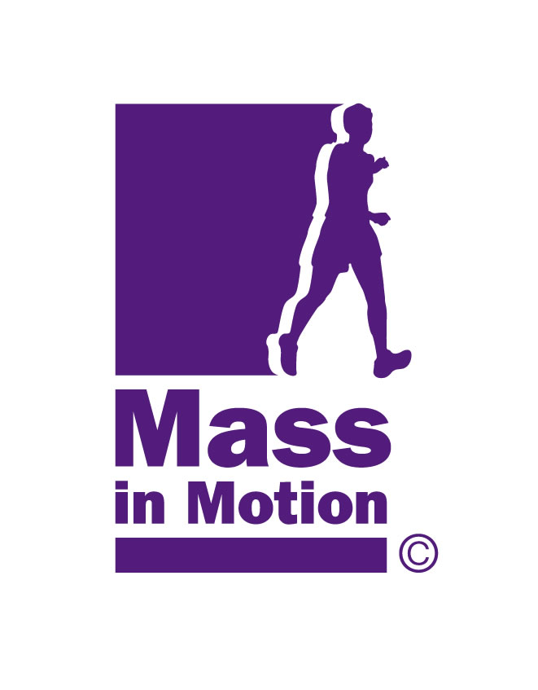
- Design neighborhoods that promote and support walking, biking, and healthy living through sidewalk improvements, bike lanes, mixed use development, establishing healthy design standards and Complete Streets policies and shared use paths.

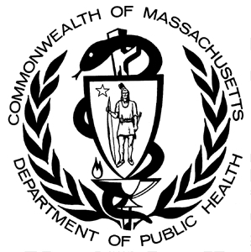
Together, we’re making the healthy choice the easy choice.

Eat Better. Move More. Live Well.

