Water Damage Investigation

Murkland Elementary School
350 Adams Street
Lowell, Massachusetts

Prepared by:
Massachusetts Department of Public Health
Bureau of Environmental Health
Indoor Air Quality Program
August 2018

Background
Building: | Murkland Elementary School (MES)
Address: | 350 Adams Street, Lowell
Assessment Requested by: | Rick Underwood, Director of Operations,  Lowell Public Schools
Reason for Request: | Water damage/mold concerns on items in particular classrooms (107, 108 and 202); several other classrooms were also observed for comparison.
Date of Assessment: | August 22, 2018
Massachusetts Department of Public Health/Bureau of Environmental Health (MDPH/BEH) Staff Conducting Assessment: | Cory Holmes, Environmental Analyst/Inspector, IAQ Program
Date of Building Construction: | 1913, renovations/addition 2001-2003
Building Description: | The MES is a two-story brick structure built in 1913. Extensive renovations and an addition were made from 2001 to 2003.
Windows: | Openable

Methods
BEH/IAQ staff conducted a visual assessment of suspect classroom items for water damage and possible mold colonization. Please refer to the IAQ Manual and appendices for methods, sampling procedures, and interpretation of results (MDPH, 2015).

Results and Discussion
A heating, ventilating, and air conditioning (HVAC) system has several functions. First it provides heating and, if equipped, cooling. Second, it is a source of fresh air. Finally, an HVAC system will dilute and remove normally occurring indoor environmental pollutants by not only introducing fresh air, but also filtering the airstream and ejecting stale air to the outdoors via exhaust ventilation. The act of cooling/providing air conditioning is two-fold; the system chills the air via cooling coils while also typically removing moisture from the air.
Moisture removal is important since the sensation of heat conditions increases as relative humidity (RH) increases (the relationship between temperature and RH is called the heat index). As indoor temperatures rise, the addition of more RH will make occupants feel hotter. If moisture is removed, the comfort of the individuals is improved.
While temperature is mainly a comfort issue, RH in excess of 70 percent for extended periods of time can provide an environment for mold and fungal growth (ASHRAE, 1989).Visual inspection of classrooms indicates that elevated indoor RH levels experienced over the summer have resulted in the fabric of seat cushions and some area rugs becoming moistened, which has led to mold growth. In addition, condensation moistening dust/debris collected on the surface of metal air diffusers in particular classrooms (203-209) and surrounding surfaces such as ceiling tiles, can become a source of mold growth.

- Classroom 107: Several office chairs (4 total) with had visible mold growth on their fabric/cushions (Picture 1) and on an area rug (Picture 2). These items were discarded at the time of assessment.
- Classroom 108: Upholstered office chairs (2 total; Picture 3) and one leather chair had visible mold growth on their cushions/surface (Picture 4). The upholstered chairs were discarded; the leather chair had a non-porous surface that was cleaned with disinfectant wipes.
- Classroom 202: No visible mold was observed on porous surfaces. Occupants had concerns relative to dust/debris in the grill of the classroom univent. This surface is non-porous and was recommended to be cleaned. A water-damaged book cover was observed in a cardboard box but it was not colonized with mold (Picture 5).
- Classrooms 203-209: Dust/debris accumulation on vents can provide a medium for mold growth if wet repeatedly (Pictures 6 through 8). Many of the vents were rusted/corroded, a sign of chronic moisture exposure. Visible staining was also observed on surrounding ceiling tiles (Pictures 6 through 8). At the time of assessment it was recommended that soiled ceiling tiles be replaced and the vents be removed, thoroughly cleaned and refinished/repainted or replaced. Please note, due to chronic moisture exposure/corrosion, they will show signs of staining even after cleaning. It was reported at the time of assessment that replacement ceiling tiles had been ordered.

Symptoms commonly associated with molds include allergic reactions and respiratory irritation. Some people with chronic respiratory conditions, such as asthma, are more likely to experience health symptoms. Controlling moisture is the key to preventing mold growth and potential health symptoms.

Other Conditions
Other conditions that can affect IAQ were observed during the assessment. Some areas have area rugs. The Institute of Inspection, Cleaning, and Restoration Certification (IICRC) recommends that carpeting be cleaned annually (or semi-annually in soiled high traffic areas) (IICRC, 2012). Regular cleaning with a high efficiency particulate air (HEPA) filtered vacuum in combination with an annual cleaning will help to reduce accumulation and potential aerosolization of materials from carpeting.
Finally, a damaged wall with exposed fiberglass insulation was observed in classroom 108 (Picture 8). Fiberglass can be a source of eye, skin and respiratory irritation if disturbed.

Conclusions and Recommendations
In view of the findings at the time of the visit, the following recommendations are made:
- Remove and clean supply vents in classrooms 203-209 (and other areas with same issues). If they cannot be adequately cleaned, resurface/paint or replace.
- Change all water-damaged/soiled ceiling tiles.
- Discard any porous items found to be colonized with mold (e.g., seat cushions, cardboard, area rugs).
- Consider using dehumidifiers in areas prone to excessive moisture/condensation.
- Ensure that procedures are in place and encourage occupants to report HVAC/maintenance issues so that they can be logged and repaired promptly.
- Conduct thorough cleaning of univent grill in classroom 202 and other areas as needed.
- Clean supply/return and exhaust vents periodically of accumulated dust/debris.
- Clean carpeting and area rugs annually or semi-annually in soiled high traffic areas as per the recommendations of the Institute of Inspection, Cleaning and Restoration Certification (IICRC, 2012).
- For more information about mold/remediation consult Mold Remediation in Schools and Commercial Buildings” published by the US Environmental Protection Agency (US EPA, 2008).
- Make repairs to wall in classroom 108; as a temporary measure seal with plastic and duct tape to prevent exposure to fiberglass insulation.
- Refer to resource manual and other related indoor air quality documents located on the MDPH’s website for further building-wide evaluations and advice on maintaining public buildings. These documents are available at http://mass.gov/dph/iaq.

REFERENCES
ASHRAE. 1989. Ventilation for Acceptable Indoor Air Quality. American Society of Heating, Refrigeration and Air Conditioning Engineers. ANSI/ASHRAE 62-1989.
IICRC. 2005. Carpet Cleaning FAQ 4 Institute of Inspection, Cleaning and Restoration Certification. Institute of Inspection Cleaning and Restoration, Vancouver, WA.
MDPH. 2015. Massachusetts Department of Public Health. Indoor Air Quality Manual: Chapters I-III. Available at: http://www.mass.gov/eohhs/gov/departments/dph/programs/environmental-health/exposure-topics/iaq/iaq-manual/.
US EPA. 2008. Mold Remediation in Schools and Commercial Buildings. US Environmental Protection Agency, Office of Air and Radiation, Indoor Environments Division, Washington, D.C. EPA 402-K-01-001. http://www.epa.gov/mold/mold-remediation-schools-and-commercial-buildings-guide.

Picture 1
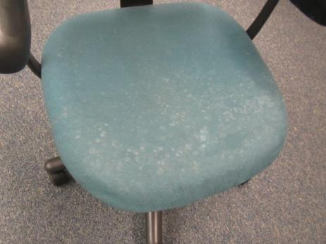
Visible mold growth (light splotches) on fabric seat cushion in classroom 107
Picture 2
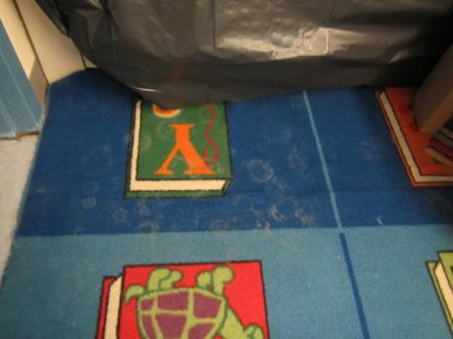
Likely mold growth (light splotches) on area carpet in classroom 107
Picture 3
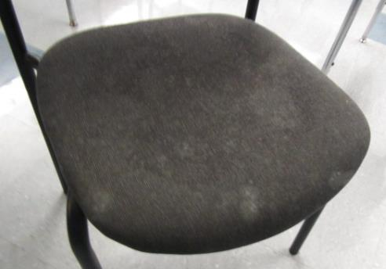
Visible mold growth (light splotches) on fabric seat cushion in classroom 108
Picture 4
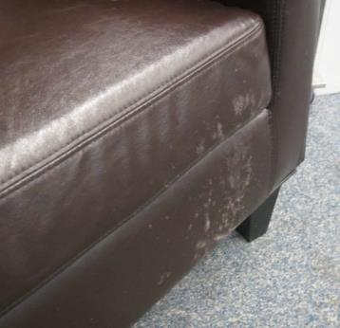
Visible mold growth (light splotches) on leather/vinyl chair in classroom 108
Picture 5
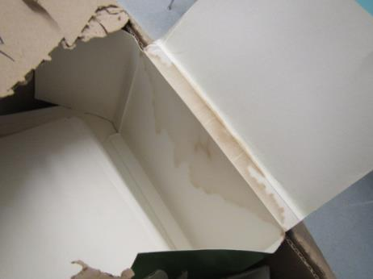
Water-damaged book cover in classroom 202
Picture 6
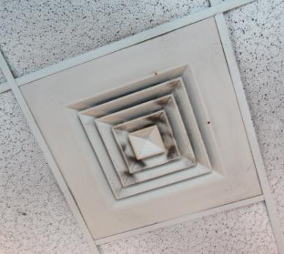
Dust/debris accumulation on supply diffuser
Picture 7
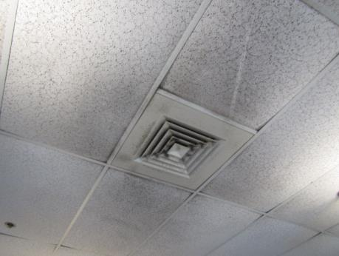
Dust/debris accumulation on supply diffuser and surrounding ceiling tiles
Picture 8
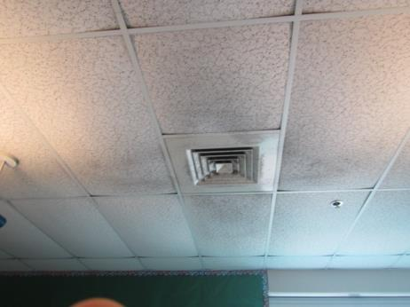
Dust/debris accumulation on supply diffuser and surrounding ceiling tiles
Picture 7
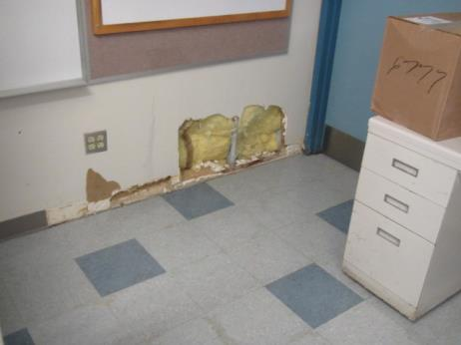
Damaged wall/exposed fiberglass insulation in classroom 108

