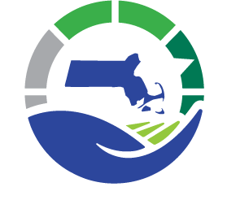
Municipal Vulnerability Preparedness Program Yearly Progress Report
Massachusetts Executive Office of Energy & Environmental Affairs

Date: Click here to enter text.
Municipality: Click here to enter text.
Local MVP Contact Name: Click here to enter text.

- Please list your municipalities’ top priority actions, in order of priority, identified through the MVP planning process.

- Has your Core Team reconvened since your Listening Session? If so, describe the process and any revisions or updates your team made to the original MVP Report. Please list your MVP Core Team members and note any new members.

- Discuss any other work related to the MVP process or climate change resiliency in the municipality. In what ways has your municipality used the outcomes of your workshop in other planning efforts (e.g., updating existing local plans)?

- Please list any grants that your municipality has applied for, or received, to implement actions from your MVP report. Please note grant awards or applications that advanced priority actions.

- Please list any other steps that your municipality has taken towards implementing your priority actions.

- Please list any potential next steps to advance priority actions during the next year.

- Please note any difficulties or challenges the community has identified through the MVP planning process or while seeking to implement priority actions and any steps the community has identified to address these challenges.

- Please identify any data needs or information gaps that the state could help fill.

