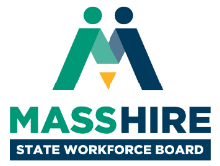

MassHire State Workforce Board Meeting
Thursday, December 8, 2022
9:30 a.m. to 11:30 a.m.

Virtual Meeting
Register for access info

Agenda

- Welcome & Introductions, Meeting Minutes (10 min)
  - Joanne Pokaski, Chair, MassHire State Workforce Board
  - Cheryl Scott, Executive Director, MassHire State Workforce Board

- Workforce Development Update (20 min)
  - Rosalin Acosta, Secretary, Executive Office of Labor & Workforce Development

- MassHire Diversity, Equity and Inclusion Project Update (20 min)
  - Joanne Kamens, Senior Consultant, The Impact Seat

- Looking Back and Looking Forward (60 min)
  - Rosalin Acosta, Secretary, Executive Office of Labor & Workforce Development
  - Board Member Round-Robin & Discussion

- Open Meeting, Wrap Up & Adjourn (10 min)

