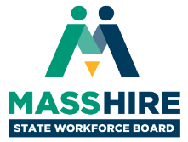

**MassHire State Workforce Board Meeting**  
Thursday, December 9, 2021  
9:30 a.m. to 11:30 a.m.

*Virtual Meeting*

**Agenda**

* **Welcome & Introductions, Meeting Minutes (10 min)**
  + *Joanne Pokaski, Chair, MassHire State Workforce Board*
  + *Cheryl Scott, Executive Director, MassHire State Workforce Board*
* **Workforce Development Update (40 min)**
  + *Rosalin Acosta, Secretary, Executive Office of Labor & Workforce Development*
* **Dispatches from the Field: MassHire Update (40 min)** 
  + *Shannon Norton, Executive Director, MassHire Lowell Career Center*
  + *David Cruise, President & CEO, MassHire Hampden County Workforce Board*
* **Workforce System Modernization Committee Update & Discussion (20 min)**
  + *Rainer Gawlick, Chair, Workforce System Modernization Committee*
* **Open Meeting, Wrap Up & Adjourn (10 min)**