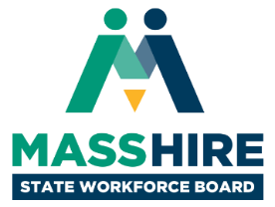

**MassHire State Workforce Board Meeting**  
Tuesday, June 18, 2019  
9:30 a.m. to 10:45 a.m.

Verizon Technology Center

60 Sylvan Road

Waltham, MA 02451

**Meeting Agenda**

* **Welcome & Introductions (15 min)**
  + *Donna Cupelo, Chair, MassHire State Workforce Board*
  + *Cheryl Scott, Executive Director, MassHire State Workforce Board*
* **Board Updates & Meeting Minutes (10 min)**
  + *Donna Cupelo, Chair, MassHire State Workforce Board*
  + *Cheryl Scott, Executive Director, MassHire State Workforce Board*
* **Workforce Development Update & Discussion (50 min)**
  + *Rosalin Acosta, Secretary, Executive Office of Labor & Workforce Development*
  + *Rick Jeffers, Director, Department of Unemployment Assistance*

*The MassHire Awards Ceremony will begin promptly at 11:00 a.m.*