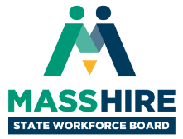

**MassHire State Workforce Board Meeting**  
Thursday, June 10, 2021  
9:30 a.m. to 11:30 am

Virtual Meeting

*(WebEx)*

**Agenda***(draft)*

* **Welcome & Introductions, Meeting Minutes (20 min)**
  + *Joanne Pokaski, Chair, MassHire State Workforce Board*
  + *Cheryl Scott, Executive Director, MassHire State Workforce Board*
* **Workforce Development Update (45 min)**
  + *Rosalin Acosta, Secretary, Executive Office of Labor & Workforce Development*
  + *Christine Abrams, President & CEO, Commonwealth Corporation*
* **Apprenticeship Update & Discussion (45 min)** 
  + *Patrick Mitchell, Director of Apprenticeship, Executive Office of Labor and Workforce Development*
* **Open Meeting, Wrap Up & Adjourn (10 min)**