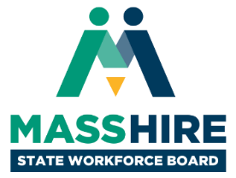

**Massachusetts State Workforce Board Meeting**  
Tuesday, March 19, 2018  
9:30 a.m. to 12:00 noon

Fidelity Investments

245 Summer Street

Boston, MA 02210

**Agenda**

1. **Welcome & Introductions (30 min)**
   * *Donna Cupelo, Chair, MassHire State Workforce Board*
   * *Pamela Everhart, SVP, Head of Regional Public Affairs and Community Relations, Fidelity Investments*
   * *Cheryl Scott, Executive Director, MassHire State Workforce Board*
2. **Review and Approval of Meeting Minutes (5 min)**
   * *Donna Cupelo, Chair, MassHire State Workforce Board*
3. **Workforce Development Update (40 min)**
   * *Rosalin Acosta, Secretary, Executive Office of Labor & Workforce Development*
4. **WIOA State Plan Update and Proposed Organizing Framework (30 min)**
   * *Jennifer James, Undersecretary for Workforce Development, Executive Office of Labor & Workforce Development*
5. **Massachusetts Apprenticeship Expansion (45 min)**
   * *Bill McKinney, Director, Department of Labor Standards*
   * *Marina Zhavoronkova, Assistant Secretary for Program and Performance Management, Executive Office of Labor and Workforce Development*
   * *Brian Norris, Director, Northeast Advanced Manufacturing Consortium*
   * *Mary Sarris, Executive Director, MassHire North Shore Workforce Board*
   * *Lauren Jones, Director, Apprenti Massachusetts*
   * *Liz Skidmore, Business Representative/Organizer, New England Regional Council of Carpenters*