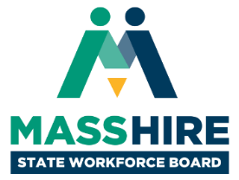

**MassHire State Workforce Board Meeting**

Monday, September 10, 2018  
9:30 a.m. to 12:00 noon

Brockton Area Workforce Investment Board

34 School Street

Brockton, MA 02301

**Agenda**

1. **Welcome & Introductions (25 min)**
   * *Donna Cupelo, Chair, MassHire State Workforce Board*
   * *Sheila Sullivan-Jardim, Executive Director, Brockton Area Workforce Investment Board*
   * *Cheryl Scott, Executive Director, MassHire State Workforce Board*
2. **Workforce Development Update (25 min)**
   * *Rosalin Acosta, Secretary, Executive Office of Labor & Workforce Development*
3. **Review and Approval of Meeting Minutes (5 min)**
   * *Donna Cupelo, Chair, MassHire State Workforce Board*
4. **MassHire Update & Implementation Incentive Funding Recognition (20 min)**
   * *Marina Zhavoronkova, Assistant Secretary for Program & Performance Management, Executive Office of Labor and Workforce Development*
   * *Juliette Mayers, Member, WIOA Oversight Committee*
5. **MassHire: Living the Brand (25 min)**
   * *Jason Hunter, Assistant Director, Brockton Area Workforce Investment Board*
6. **Labor Market and Workforce Information Dashboard (10 min)**
   * *Joanne Pokaski, Co-Chair, Labor Market and Workforce Information Committee*
7. **MassHire State Workforce Board Committees Discussion (40 min)**
   * *Donna Cupelo, Chair, MassHire State Workforce Board*
   * *Rosalin Acosta, Secretary, Executive Office of Labor & Workforce Development*
   * *Cheryl Scott, Executive Director, MassHire State Workforce Board*