 

**How to Print Your Performance Review**

The following steps guide an employee through the process of printing their personal performance review.

**STEP 1.** Sign in to your **MyPath** account at [**www.mass.csod.com**](http://www.mass.csod.com/) (Login is your employee ID).

**STEP 2.** On the homepage, click the **Performance Reviews** button located above the My Performance Action   
 Items widget.

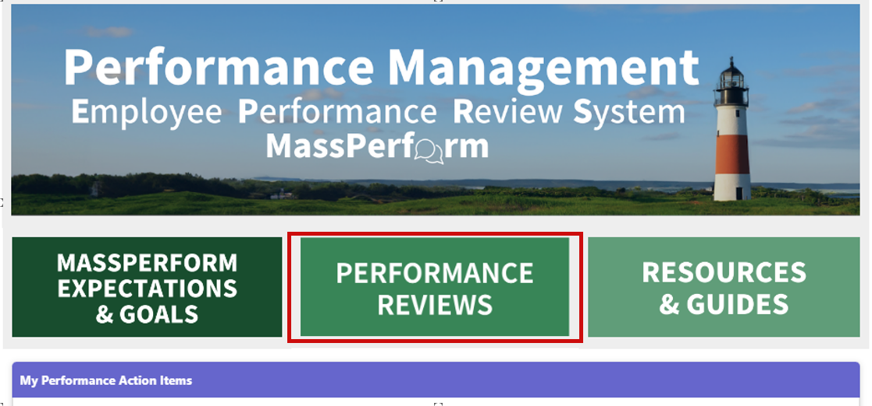

**STEP 3.** From the **Performance Review Summary** page, select the **My Personal Reviews** tab and click the   
 relevant fiscal year’s **FYXX MassPerform** link for which you wish to print.

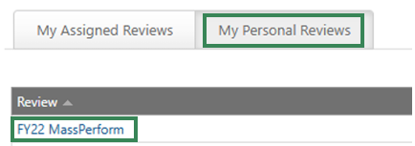

**STEP 4.** Depending on when during the fiscal year you are trying to print, this will either create a PDF document   
 that will save to your downloads folder, *or* it will automatically bring you to the **Overview** page within   
 the active task.

**STEP 5.** *If a PDF was automatically generated for you, no further action is required.* To locate the PDF, access   
 your file folder and select the downloads folder. However, if you are brought into the active task (i.e.,   
 Wrap Up is not complete), please select the **Next** button on the **Overview** page to proceed.

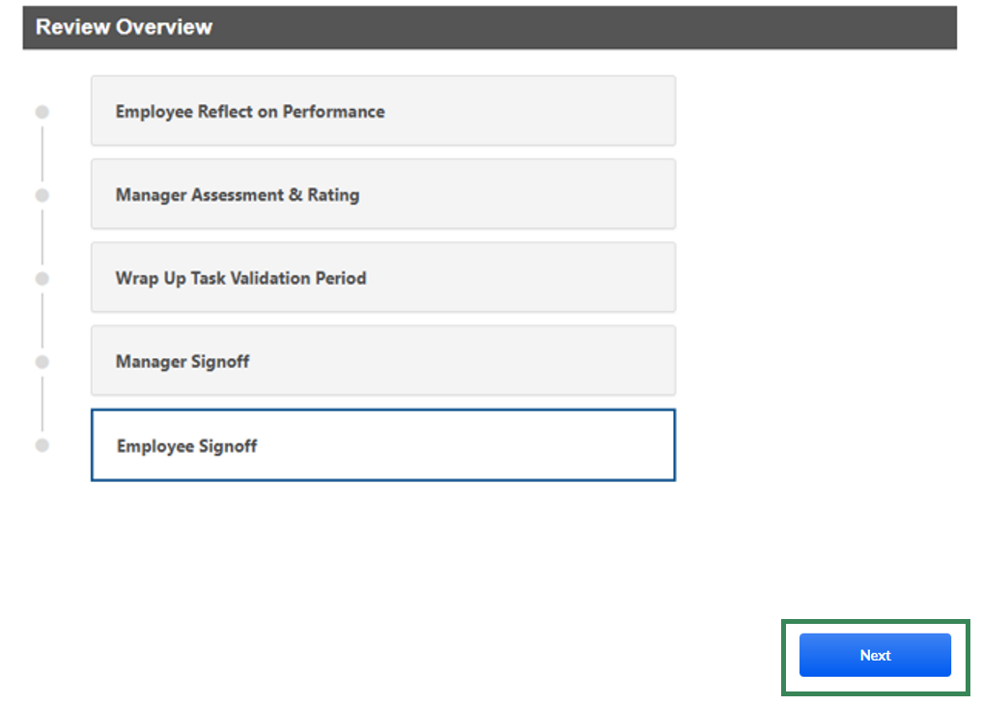

**STEP 6.** While in the task, click the **Options** button in the top right corner of the screen.

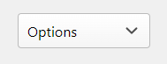

**STEP 7.** Click the **Print Review** button from the expanded drop-down menu. This will create a PDF document   
 that will automatically save to your downloads folder.

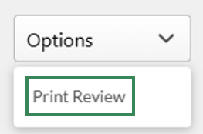

**STEP 8. Reminder:** If you are brought into the open task, this means you have not completed Wrap Up. Take   
 this time to ensure you complete any outstanding action items, when applicable.