MyServices
MyServices is a web portal designed for all applicants and members. With this portal, you can
- review your contact information
- review eligibility status for MassHealth and the Health Connector
- review MassHealth enrollment information
- check the status of Requests for Information (RFIs) you have sent to MassHealth
- get alerts about important events and actions you need to take
- review eligibility notices sent by MassHealth
How it Works
There are different ways to log in to MyServices (myservices.mass.gov).
Existing Members
If you already have an MA Login you use to log in to www.MAhealthconnector.org (see image below) or an account with login.mass.gov, we recommend using that account information to sign in to MyServices.
MA Login
As an account holder, you will be redirected to the “Sign In With Your MA Login” screen to enter your MA Login username and password. Once you’re logged in, you will be redirected to the MyServices dashboard.
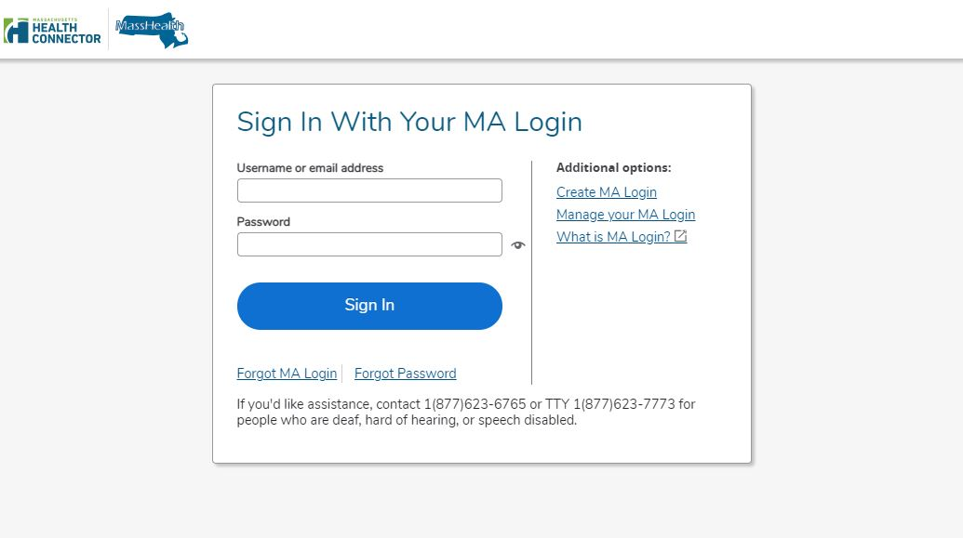

Login.mass.gov
As an account holder, you will be prompted to enter your email address and password. Once you’re logged in, you will be redirected to the MyServices dashboard.
New Members
You can sign up for MyServices by clicking “Create an Account” on the login screen. You will be redirected to the login.mass.gov login screen and required to enter a valid email address. To verify your email, we will send you a verification code. You’ll enter that code on the login.mass.gov login screen to begin creating your profile using your first name, last name, and valid email address.
You can create a new profile whether or not you already have a MAhealthconnector or DTAConnect account. If you sign up for services from MassHealth or DTA later, you can link those accounts to MyServices by entering your complete social security number or MassHealth ID in MyServices.
MyServices Dashboard
At the MyServices dashboard, you can find important information and next steps related to your benefits. If you are a member, you can get more information about your account using the dashboard tabs:
- My Info
  - Here you can review your contact information such as your full name, date of birth, home and mailing addresses, primary phone numbers, email address, and preferred language.
- My Benefits
  - This tab gives you information about what program(s) you are eligible for, the status of your MassHealth health plan enrollment, and details of your plan type.
- My Documents
  - Did you recently send a document to MassHealth? Find out here whether we received it, when we received it, or whether we are still reviewing it.
- My Notices
  - Here you can find all the eligibility notices MassHealth has sent you.
Get Help
If you need help understanding your health benefits, you can call MassHealth Customer Service.
MassHealth Customer Service Center
(800) 841-2900, TDD/TTY:711
Monday through Friday, 8:00 a.m. through 5:00 p.m.
Self-service is available 24 hours a day, seven days a week.
To learn more about MyServices or to create an account,
scan this QR code with your smartphone.
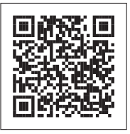

Frequently Asked Questions (FAQs)
See below for FAQs related to MyServices.

Who can use MyServices?
Anyone who has an MAhealthconnector or DTAConnect account can use MyServices to review current MassHealth or some Health Connector information. The information could include MassHealth and Health Connector documents and eligibility information, as well as MassHealth enrollment status and notices. This person could be
an account holder: a person who has created an online account and may have applied for benefits for themselves or another person
a head of household: the person signing the application for benefits. Usually the account holder and the head of the household are the same person.
a household member: a person who is on the application but is not an account holder or the head of the household.

I am over 65. Can I use MyServices?
Yes. You can sign up for MyServices by clicking “Create an Account” on the login screen. Once you enter your information, you will be redirected to the MyServices dashboard.

I am a Certified Assister, Navigator, or authorized representative, or I am named on someone else’s Permission to Share Information form. Can I use MyServices?
Certified Assisters, Navigators, authorized representatives, and people named on Permission to Share Information forms can’t currently access MyServices without the member or applicant present.

I have my health insurance through the Health Connector. Can I review my information in MyServices?
You won’t be able to review all of your Health Connector information in MyServices. When you log in to MyServices using your MA Login, you will be able to review your Health Connector plan type. To review all other Health Connector information, visit mahealthconnector.org.

I have an MA Login account. Why do I need to access MyServices?
MyServices is designed for applicants and members to easily review all their MassHealth information, and some Health Connector information, in one place rather than having to log in to two sites.
When you log in to MyServices with your MA Login account information, MyServices will connect to your MAhealthconnector account. You’ll be able to report changes and update your MAhealthconnector account without having to log in again.

I don’t have an MA Login or login.mass.gov login. Will I be able to review my information from these accounts after I sign up for benefits?
You can create a new profile whether or not you already have an MAhealthconnector or DTAConnect account. If you sign up for services from MassHealth or DTA later, you can link those accounts to MyServices by entering your complete social security number or MassHealth ID in MyServices.

What can I review in MyServices?
If you’re the head of the household, you can review eligibility information and MassHealth enrollment information for all the members of your household. The “My Documents” tab shows information on documents you have submitted, and the “My Notices” tab shows notices that have been sent to you.
If you are not the head of the household, you can review your own information provided on your application. You can’t review the information of anyone else in the household.

Can I update my information when I am in MyServices?
You won’t be able to make changes directly in MyServices. To learn how to report changes, visit our webpage “Report changes to MassHealth” at https://www.mass.gov/how-to/report-changes-to-masshealth.
If you have an MAhealthconnector account, you can go to the “My Info” or “My Benefits” tab in MyServices and choose “To update your application information, click here.” You will be redirected to your MAhealthconnector dashboard, where you can update your application information.

How do I add or remove a person in my MyServices account?
MyServices uses the information you provided on your application. If you need to add or remove someone in your account, you can let us know. To learn how, visit our webpage “Report changes to MassHealth” at https://www.mass.gov/how-to/report-changes-to-masshealth.

What’s the best way to get to the site?
The following browsers are supported by MyServices.
Supported browsers: Microsoft Edge, Google Chrome, Firefox, Safari
You can also download the MyServices mobile app for Android or iOS:
Operating systems: Android: minimum version 6.0
iOS: minimum version 11.0
If you are having technical problems with MyServices in your web browser, try clearing your browser’s memory, also known as the cache. To learn how to clear your cache, go to https://www.mass.gov/guides/clear-your-browser-cache.

What languages is the MyServices Portal available in?
MyServices is available in the following six languages: English, Spanish, Brazilian Portuguese, Traditional Chinese, Vietnamese, and Haitian Creole.
MCP-0823

