
Commonwealth of Massachusetts
Executive Office of Health and Human Services
www.mass.gov/masshealth

Don’t miss important information from MassHealth!
MyServices is an easy-to-use web tool and mobile app for all MassHealth members.
Available in six languages: Brazilian Portuguese, English, Haitian Creole, Simplified Chinese, Spanish, and Vietnamese.
With MyServices, you can:
- review your contact information, such as your name, address, and phone number;
- find out what benefits from MassHealth or the Massachusetts Health Connector you may qualify for;
- review your MassHealth enrollment information, such as the name of your plan and the date your plan started;
- check the status of Requests for Information (RFIs), including whether any response you submitted has been processed;
- view and print a copy of your MassHealth ID card;
- get alerts about important events and actions you need to take; and
- review certain MassHealth notices and voter registration information online.

How it Works
There are different ways to log in to MyServices (myservices.mass.gov).

Existing Members
If you already have an MA Login you use to log in to www.MAhealthconnector.org or an account with MyMassGov, we recommend using that account information to sign in to MyServices.

MA Login
As an account holder, you will be redirected to the “Sign In With Your MA Login” screen to enter your MA Login username and password. Once you’re logged in, you will be redirected to the MyServices dashboard.
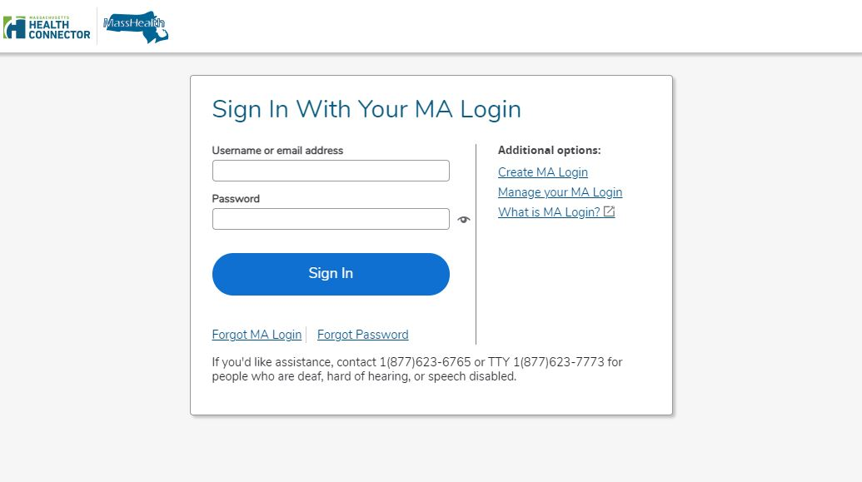

MyMassGov
If you already have an account, enter your email address and password. Select “Login.” Once you’re logged in, you will be redirected to the MyServices dashboard.

New Members
You can sign up for MyServices.
- Go to MyServices (MyServices.mass.gov). Click “Sign up.” When you click “Sign up,” you will be sent to the MyMassGov login screen.
- Click “Create an Account.”
- Type in your email address. To make sure you typed in the correct email address, we will send a code to your email account.
- Enter or copy the code in the “Verification code” box.
- Click “VERIFY.”
- Enter your first name and last name. Click “CONTINUE.”
- Create a password that meets the requirements.
- Confirm your password by re-entering it.
- Click “CREATE ACCOUNT.”
You can create a new profile in MyServices whether or not you already have a MAhealthconnector or DTAConnect account. If you later sign up for services from MassHealth or DTA, you can link those accounts to MyServices by entering your complete social security number or MassHealth ID in MyServices.

MyServices Dashboard
On the MyServices dashboard, you can find important information and next steps related to your benefits. If you are a member, you can get more information about your account using the dashboard tabs.

My Info
Review your contact information, such as your full name, date of birth, home and mailing addresses, primary phone numbers, email address, and preferred language.

My Benefits
Review the program(s) you are eligible for and the status of your MassHealth health plan enrollment.

My Documents
Did you recently send a document to MassHealth? Find out if we received it, when we received it, or if we’re still reviewing it.

My Notices
Review certain MassHealth notices and voter registration information online.

Get Help
If you need help understanding your health benefits, you can call MassHealth Customer Service.

MassHealth Customer Service Center
(800) 841-2900, TDD/TTY:711
Monday through Friday, 8:00 a.m. through 5:00 p.m.
Self-service is available 24 hours a day, seven days a week.
To learn more about MyServices or to create an account,
scan this QR code with your smartphone.
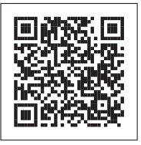
MCP-0924

Frequently Asked Questions (FAQs)
See below for FAQs related to MyServices.

Who can use MyServices?
Anyone who has an MAhealthconnector or DTAConnect account can use MyServices to review current MassHealth or some Health Connector information. The information could include MassHealth and Health Connector documents and eligibility information, as well as MassHealth enrollment status and notices. This person could be
an account holder: a person who has created an online account and may have applied for benefits for themselves or another person.
a head of household: the person signing the application for benefits. The account holder and the head of the household are usually the same person.
a household member: a person who is on the application but is not an account holder or the head of the household.

I am over 65. Can I use MyServices?
Yes. You can sign up for MyServices by clicking “Create an Account” on the MyMassGov login screen. Once you enter your information, you will be redirected to the MyServices dashboard.

I am a Certified Assister, Navigator, or authorized representative, or I am named on someone else’s Permission to Share Information (PSI) form. Can I use MyServices?
Certified Assisters, Navigators, authorized representatives, and people named on PSI forms can’t currently access MyServices without the member or applicant present.

I get my health insurance through the Health Connector. Can I review my information in MyServices?
You won’t be able to review all of your Health Connector information in MyServices. When you log in to MyServices using your MA Login, you will be able to review your Health Connector eligibility. To review all other Health Connector information, visit mahealthconnector.org.

I have an MA Login account. Why do I need to access MyServices?
MyServices is designed for applicants and members to easily review all their MassHealth information, and some Health Connector information, in one place rather than having to log in to two sites.
When you log in to MyServices with your MA Login account information, MyServices will connect to your MAhealthconnector account. You’ll be able to report changes and update your MAhealthconnector account without having to log in again.

I don’t have an MA Login or MyMassGov login. Will I be able to review my information from these accounts after I sign up for benefits?
You can create a new profile whether or not you already have an MAhealthconnector or DTAConnect account. If you later sign up for services from MassHealth or DTA, you can link those accounts to MyServices by entering your complete social security number or MassHealth ID in MyServices.

Can I update my information when I am in MyServices?
You won’t be able to make changes directly in MyServices. To learn how to report changes, visit www.mass.gov/how-to/report-changes-to-masshealth.
If you have an MAhealthconnector account, you can go to the “My Info” or “My Benefits” tab in MyServices and choose “To update your application information, click here.” You will be redirected to your MAhealthconnector dashboard, where you can update your application information.

How do I add or remove a person in my MyServices account?
MyServices uses the information you provided on your application. If you need to add or remove someone on your account, let us know by visiting www.mass.gov/how-to/report-changes-to-masshealth.

What’s the best way to get to the site?
The following browsers are supported by MyServices.
Supported browsers: Microsoft Edge, Google Chrome, Firefox, Safari
You can also download the MyServices mobile app for Android or iOS:
Operating systems: Android: minimum version 6.0
iOS: minimum version 11.0
If you are having technical problems with MyServices in your web browser, try clearing your browser’s history, also known as the cache. To learn how to clear your cache, go to www.mass.gov/guides/clear-your-browser-cache.

What languages is the MyServices Portal available in?
MyServices is available in the following six languages: English, Brazilian Portuguese, Haitian Creole, Simplified Chinese, Spanish, and Vietnamese.
MCP-0924

