
THE COMMONWEALTH OF MASSACHUSETTS
EXECUTIVE OFFICE FOR ADMINISTRATION AND FINANCE
HUMAN RESOURCES DIVISION
ONE ASHBURTON PLACE, BOSTON, MA 02108
LESLIE A. KIRWAN
Secretary

PAUL DIETL
Chief Human Resources Officer

DEVAL L. PATRICK
Governor

TIMOTHY P. MURRAY
Lieutenant Governor

MEMORANDUM

TO: Departmental Human Resources, Labor Relations Directors, Payroll and Budget Staff, with Employees in Bargaining Unit 6
FROM: Mark E. D’Angelo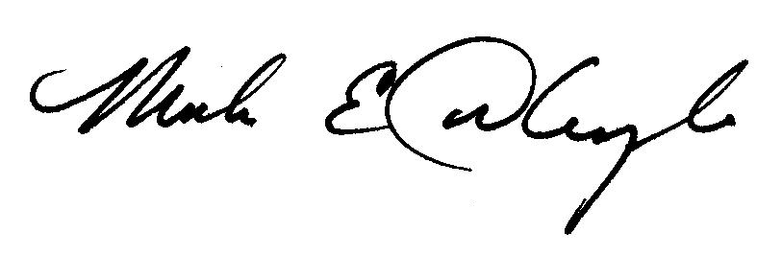
Director, Office of Employee Relations

DATE: May 16, 2008

RE: Massachusetts Bar Fees Reimbursement Payment for Bargaining Unit 6 Counsels
_____________________________________________________________________________

This memorandum authorizes annual reimbursement payments of up to $155.00 to incumbents of Counsel I, Counsel II, Tax Counsel and Tax Counsel-DOR, Bargaining Unit 6 position titles, for Massachusetts Bar memberships, commencing fiscal year 2008.

An appropriation for this payment was made by the Legislature on October 19, 2007, to cover the incremental cost items (Chapter 140 of the Acts of 2007). For FY08, payments will be funded from the reserve itself. A reserve request for FY09 costs is pending in the FY09 budget. Assuming it is funded, the Administration and Finance Budget Unit plans to transfer an equivalent amount of funding to affected departments in FY09.

In accordance with Section 46 of Chapter 30 of the Massachusetts General Laws, these payments will not apply to employees in confidential positions, or to intermittent and short-term employees in the affected titles. Employees who are appointed to nine-hundred sixty (960) hour positions, (retirees occupying so-called PR position types), will also be ineligible for this reimbursement payment. In addition, reimbursements will not be made to employees whose agencies currently absorb the full cost of such Bar fees; however, reimbursement will be made to employees whose agencies defray a portion of the fees, up to the maximum reimbursement amount. In all cases, employees may not receive payment for more than the actual amount of the fee paid by the employee, up to the maximum reimbursement amount of $155.00. Similarly, and where applicable, this reimbursement is not meant to replace the coverage of such fees by agencies.

Employees seeking reimbursement should submit the form in Attachment A to their Human Resources/Payroll director or his/her designee, not later than June 6, 2008. Agency HR/payroll staff will need to compile and forward to HRD (Jeanine.Hopkins@Massmail.state.ma.us or Alex.F.Dion@Massmail.state.ma.us) an Excel spreadsheet containing all affected employees’ names, employee id, record number and amount to be reimbursed, not later than June 10, 2008, for automated processing of the payments in HRCMS. Reimbursement payments will be issued to the affected Unit 6 members with the pay advice issued June 27, 2008.

Questions about this payment should be directed to Matthew Hale, Assistant Director, Employee Relations, at (617) 878-9795. Please address questions on Administration and Finance practice to Jennifer Hewitt at 617-727-2081 x 35423

HRCMS INSTRUCTIONS
PPED June 21, 2008
Effective for the pay period ending 6/21/08 eligible employees in Counsel I, Counsel II, Tax Counsel and Tax Counsel-DOR, position titles will receive up to a $155.00 reimbursement payment for Massachusetts Bar membership purposes.
- On June 11, 2008, after 3:00 pm, a predictive reimbursement report (HMCMP06B) will be available in document direct.
- On June 13, 2008, after 6:00 pm, a row will be inserted into additional pay with an effective date of June 8, 2008 to pay the bar membership fee using the BX6 earnings code.
- The comment “Bar Membership Fee” will be added in additional pay.
- On June 13, 2008, after 6:00 pm, an updated reimbursement report (HMCMP06) will be available in document direct.

Employees will receive the reimbursement in their pay advice, Friday, June 27, 2008.

INSTRUCTIONS FROM ADMINISTRATION AND FINANCE

Chapter 140 of the Acts of 2007 included an appropriation (1599-4231) to fund incremental costs of the Commonwealth/NAGE-SEIU, Units 1, 3 & 6 collective bargaining agreements which cannot be absorbed within departments’ existing funds.

The FY08 costs of the bar fee reimbursements will be routed through an LCM Rule to the ANF reserve. In FY09, departments should request the value of the new reimbursements via their ANF spending plans. Please address questions on Administration and Finance practice to Jennifer Hewitt at 617-727-2081, x35423.

INSTRUCTIONS FROM THE OFFICE OF THE COMPTROLLER

The Comptroller’s Office will ensure all BX6 payments will be funded directly from the Reserve Account utilizing LCM automated Distribution. Departments do not have to submit Rule requests to direct the costs.

Questions regarding these instructions can be sent to the MMARS Helpline at 617-973-2468

Attachment A

NAGE Unit 6
Counsel Position Titles
Mass Bar Reimbursement Form

Please attach a copy of your Massachusetts Bar card

Employee Name:
 |  |  | Last |  |  |  |  |  | First |  |  |  | MI
Name of Dept./Agency: |  |  |  |  |  |  |  |  | Work Location:
 |  |  |  |  |  |  |  |  | Work Email (if any):
NAGE Job Title: |  |  |  |  |  |  |  |  | Work Email (if any):
NOTE: Reimbursements will be made for Bar memberships paid during Fiscal Year 2008
 |  |  |  |  | Cost of Membership Fees Paid: |  |  |  | Amount Reimbursed by Agency (if any) |  |  |  | Date Paid
 |  |  |  | $
 |  |  | Total : | $
Please submit to your agency's designated Human Resources/Payroll Staff |  |  |  |  |  |  |  |  | Signature:
not later than June 6, 2008. |  |  |  |  |  |  |  |  |  |  | Required
 |  |  |  |  |  |  |  |  | Emp. ID #:
 |  |  |  |  |  |  |  |  |  |  | Required
 |  |  |  |  |  |  |  |  | Date:
 |  |  |  |  |  |  |  |  |  |  | Required

Attachment B

To: Employees in NAGE/SEIU, Unit 6

From: Agency Head Name

Date: June 27, 2008

Re: Massachusetts Bar Reimbursement Payment

I am pleased to inform you that the pay advice you receive today contains a reimbursement payment of up to $155.00 for your Massachusetts Bar fees. This benefit is being provided pursuant to the most recent collective bargaining agreement between the Commonwealth and NAGE, Unit 6, regarding the parties classification pool.

If you have any questions regarding this payment, please contact your payroll office.

Thank you for the services that you and your colleagues provide to the Commonwealth

