INDOOR AIR QUALITY ASSESSMENT

Nantucket High School
10 Surfside Road
Nantucket, Massachusetts

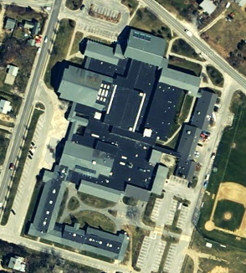

Prepared by:
Massachusetts Department of Public Health
Bureau of Environmental Health
Indoor Air Quality Program
December 2007

Background/Introduction
At the request of a parent and the Nantucket Board of Health, the Massachusetts Department of Public Health (MDPH), Bureau of Environmental Health (BEH) provided assistance and consultation regarding indoor air quality concerns at Nantucket High School (NHS), 10 Surfside Road, Nantucket, Massachusetts. Complaints of headache, fatigue, pool odors and potential irritants prompted the request. On October 17, 2007, a visit to conduct an assessment was made to the NHS by Cory Holmes and Sharon Lee, Environmental Analysts in BEH’s Indoor Air Quality (IAQ) Program.
The school was built in the late 1980s and has reportedly undergone improvements to the building envelope and roof replacement over the last several years to prevent water penetration. At the time of the assessment, new mechanical ventilation had been installed in the pool/natatorium, and plans were underway to replace all 46 rooftop exhaust vents over the course of the next school year.

Methods
Air tests for carbon monoxide, carbon dioxide, temperature and relative humidity were conducted with the TSI, Q-Trak, IAQ Monitor, Model 8551. Air tests for airborne particulate matter with a diameter less than 2.5 micrometers were taken with the TSI, DUSTTRAK™ Aerosol Monitor Model 8520. Screening for total volatile organic compounds (TVOCs) was conducted using a Thermo Environmental Instruments Inc., Model 580 Series Photo Ionization Detector (PID). BEH staff also performed visual inspection of building materials for water damage and/or microbial growth.

Results
The school houses approximately 450 high school students from grades 9 to 12 and approximately 100 staff members. Tests were taken during normal operations at the school and results appear in Table 1.

Discussion
Ventilation
It can be seen from Table 1 that carbon dioxide levels were above 800 parts per million (ppm) in of eight of sixty-six areas surveyed, indicating adequate ventilation in the large majority of areas surveyed during the assessment. Several classrooms had windows open or were empty or sparsely populated. Open windows and low populations in classrooms can greatly reduce carbon dioxide levels.
Fresh air in exterior classrooms is supplied by unit ventilator (univent) systems (Picture 1). A univent draws air from outdoors through a fresh air intake located on the exterior wall of the building (Picture 2) and returns air through an air intake located at the base of the unit (Figure 1). Fresh and return air are mixed, filtered, heated and provided to classrooms through an air diffuser located in the top of the unit. Univents were operating in all but a few areas surveyed at the time of the assessment (Table 1); this was reported to Mr. Jack McFarland, Facilities Director. Mr. McFarland directed NHS maintenance staff to reactivate the univents during the assessment. The univent in room 008 was inoperable and reportedly on a repair list.
Exhaust ventilation in exterior classrooms is provided by wall- or ceiling-mounted vents ducted to rooftop motors (Pictures 3 and 4). Exhaust vents were operating in each of the areas surveyed during the assessment. As previously mentioned, complete replacement of all rooftop exhaust motors is scheduled over the next school year. Several of the new rooftop exhaust units had already been installed at the time of the MDPH assessment.
In some cases, the location of exhaust vents can limit exhaust efficiency. In several classrooms, exhaust vents are located above hallway doors (Picture 1). When classroom doors are open, exhaust vents will tend to draw air from both the hallway and the classroom, reducing the effectiveness of the exhaust vent to remove common environmental pollutants.
Mechanical ventilation in interior classrooms and common areas (e.g., gym, auditorium) is provided by rooftop air-handling units (AHUs) (Picture 5). Fresh air is continuously distributed via ceiling-mounted air diffusers (Picture 6) and ducted back to AHUs via ceiling or wall-mounted return vents.
To maximize air exchange, the MDPH recommends that both supply and exhaust ventilation operate continuously during periods of school occupancy. In order to have proper ventilation with a mechanical supply and exhaust system, the systems must be balanced to provide an adequate amount of fresh air to the interior of a room while removing stale air from the room. It is recommended that HVAC systems be re-balanced every five years to ensure adequate air systems function (SMACNA, 1994). Portions of the HVAC system were reportedly balanced in 2004. The mechanical ventilation systems at NHS should be rebalanced upon completion of the exhaust replacement project.
The Massachusetts Building Code requires a minimum ventilation rate of 15 cubic feet per minute (cfm) per occupant of fresh outside air or have openable windows in each room (SBBRS, 1997; BOCA, 1993). The ventilation must be on at all times that the room is occupied. Providing adequate fresh air ventilation with open windows and maintaining the temperature in the comfort range during the cold weather season is impractical. Mechanical ventilation is usually required to provide adequate fresh air ventilation.
Carbon dioxide is not a problem in and of itself. It is used as an indicator of the adequacy of the fresh air ventilation. As carbon dioxide levels rise, it indicates that the ventilating system is malfunctioning or the design occupancy of the room is being exceeded. When this happens, a buildup of common indoor air pollutants can occur, leading to discomfort or health complaints. The Occupational Safety and Health Administration (OSHA) standard for carbon dioxide is 5,000 parts per million parts of air (ppm). Workers may be exposed to this level for 40 hours/week, based on a time-weighted average (OSHA, 1997).
The MDPH uses a guideline of 800 ppm for publicly occupied buildings. A guideline of 600 ppm or less is preferred in schools due to the fact that the majority of occupants are young and considered to be a more sensitive population in the evaluation of environmental health status. Inadequate ventilation and/or elevated temperatures are major causes of complaints such as respiratory, eye, nose and throat irritation, lethargy and headaches. For more information concerning carbon dioxide, consult Appendix A.
Temperature measurements ranged from 70º F to 80º F, which were within the MDPH recommended comfort range in the majority of areas surveyed. The MDPH recommends that indoor air temperatures be maintained in a range of 70º F to 78º F in order to provide for the comfort of building occupants. Chronic heat complaints were expressed in interior classrooms on the lower level, particularly in rooms 001-003. Thermal comfort is difficult to maintain Room 001 because it was designed as a general non-air conditioned classroom that now serves as a computer room housing 20+ computers, printers and other associated heat-generating equipment. In many cases concerning indoor air quality, fluctuations of temperature in occupied spaces are typically experienced, even in a building with an adequate fresh air supply.
The relative humidity measured in the building ranged from 38 to 52 percent, which was within or slightly below the MDPH recommended comfort range. Relative humidity in the pool area was 61 percent. The MDPH recommends a comfort range of 40 to 60 percent for indoor air relative humidity. Relative humidity levels in the building would be expected to drop during the winter months due to heating. The sensation of dryness and irritation is common in a low relative humidity environment. Low relative humidity is a very common problem during the heating season in the northeast part of the United States.

Microbial/Moisture Concerns
What appeared to be visible mold growth was observed on surfaces in a few areas, these included:
- a damaged seat cushion in the handicapped shower of the boys locker room (Picture 7);
- metal ceiling tracks of classroom 201 and the drama/chorus room (Pictures 8 and 9);
- the gasket of the mini-refrigerator in room 109 (Picture 10); and
- a ceiling tile in room 100 (Picture 11).

Several potential sources of water damage and mold growth were observed in other areas of the building. A number of areas had water-damaged ceiling tiles (Table 1) which can indicate leaks from either the roof or plumbing system (Picture 12/Table 1). Water-damaged ceiling tiles can provide a source of mold and should be replaced after a water leak is discovered and repaired.
The US Environmental Protection Agency (US EPA) and the American Conference of Governmental Industrial Hygienists (ACGIH) recommend that porous materials be dried with fans and heating within 24 to 48 hours of becoming wet (US EPA, 2001; ACGIH, 1989). If not dried within this time frame, mold growth may occur. Once mold has colonized porous materials, they are difficult to clean and should be removed/discarded.
Several classrooms had a number of plants. Moistened plant soil and drip pans can be a source of mold growth. Plants should be equipped with drip pans; the lack of drip pans can lead to water pooling and mold growth on windowsills. Plants are also a source of pollen. Plants should be located away from the air stream of ventilation sources to prevent the aerosolization of mold, pollen or particulate matter throughout the classroom (Picture 1).
Open seams between sink countertops and walls were observed in several rooms (Picture 13/Table 1). If not watertight, water can penetrate through the seam, causing water damage. Improper drainage or sink overflow can lead to water penetration into the countertop, cabinet interior and areas behind cabinets. Water penetration and chronic exposure of porous and wood-based materials can cause these materials to swell and show signs of water damage. Countertop wood was damaged/splayed in rooms 005 and 008 (Picture 14).

Other IAQ Evaluations
Indoor air quality can be negatively influenced by the presence of respiratory irritants, such as products of combustion. The process of combustion produces a number of pollutants. Common combustion emissions include carbon monoxide, carbon dioxide, water vapor and smoke (fine airborne particle material). Of these materials, exposure to carbon monoxide and particulate matter with a diameter of 2.5 micrometers (μm) or less (PM2.5) can produce immediate, acute health effects upon exposure. To determine whether combustion products were present in the school environment, BEH staff obtained measurements for carbon monoxide and PM2.5.
Carbon monoxide is a by-product of incomplete combustion of organic matter (e.g., gasoline, wood and tobacco). Exposure to carbon monoxide can produce immediate and acute health affects. Several air quality standards have been established to address carbon monoxide and prevent symptoms from exposure to these substances. The MDPH established a corrective action level concerning carbon monoxide in ice skating rinks that use fossil-fueled ice resurfacing equipment. If an operator of an indoor ice rink measures a carbon monoxide level over 30 ppm, taken 20 minutes after resurfacing within a rink, that operator must take actions to reduce carbon monoxide levels (MDPH, 1997).
The American Society of Heating Refrigeration and Air-Conditioning Engineers (ASHRAE) has adopted the National Ambient Air Quality Standards (NAAQS) as one set of criteria for assessing indoor air quality and monitoring of fresh air introduced by HVAC systems (ASHRAE, 1989). The NAAQS are standards established by the US EPA to protect the public health from six criteria pollutants, including carbon monoxide and particulate matter (US EPA, 2006). As recommended by ASHRAE, pollutant levels of fresh air introduced to a building should not exceed the NAAQS levels (ASHRAE, 1989). The NAAQS were adopted by reference in the Building Officials & Code Administrators (BOCA) National Mechanical Code of 1993 (BOCA, 1993), which is now an HVAC standard included in the Massachusetts State Building Code (SBBRS, 1997). According to the NAAQS, carbon monoxide levels in outdoor air should not exceed 9 ppm in an eight-hour average (US EPA, 2006).
Carbon monoxide should not be present in a typical, indoor environment. If it is present, indoor carbon monoxide levels should be less than or equal to outdoor levels. On the day of assessment, outdoor carbon monoxide concentrations were non-detect (ND) (Table 1). Carbon monoxide levels measured in the school were also ND.
The US EPA has established NAAQS limits for exposure to particulate matter. Particulate matter is airborne solids that can be irritating to the eyes, nose and throat. The NAAQS originally established exposure limits to particulate matter with a diameter of 10 μm or less (PM10). According to the NAAQS, PM10 levels should not exceed 150 microgram per cubic meter (μg/m³) in a 24-hour average (US EPA, 2006). These standards were adopted by both ASHRAE and BOCA. Since the issuance of the ASHRAE standard and BOCA Code, US EPA established a more protective standard for fine airborne particles. This more stringent PM2.5 standard requires outdoor air particle levels be maintained below 35 μg/m³ over a 24-hour average (US EPA, 2006). Although both the ASHRAE standard and BOCA Code adopted the PM10 standard for evaluating air quality, MDPH uses the more protective PM2.5 standard for evaluating airborne particulate matter concentrations in the indoor environment.
Outdoor PM2.5 concentrations were measured at 12 μg/m³ (Table 1). PM2.5 levels measured in the school were between 5 to 22 μg/m³ (Table 1), which were below the NAAQS PM2.5 level of 35 μg/m³. Frequently, indoor air levels of particulates (including PM2.5) can be at higher levels than those measured outdoors. A number of mechanical devices and/or activities that occur in schools can generate particulate during normal operations. Sources of indoor airborne particulates may include but are not limited to particles generated during the operation of fan belts in the HVAC system, cooking in the cafeteria stoves and microwave ovens; use of photocopiers, fax machines and computer printing devices; operation of an ordinary vacuum cleaner and heavy foot traffic indoors.
Indoor air quality can also be negatively influenced by the presence of materials containing volatile organic compounds (VOCs). VOCs are carbon-containing substances that have the ability to evaporate at room temperature. Frequently, exposure to low levels of total VOCs (TVOCs) may produce eye, nose, throat and/or respiratory irritation in some sensitive individuals. For example, chemicals evaporating from a paint can stored at room temperature would most likely contain VOCs. In an effort to determine whether VOCs were present in the building, air monitoring for TVOCs was conducted. An outdoor air sample was taken for comparison. Outdoor TVOC concentrations were ND (Table 1). Indoor TVOC concentrations were also (Table 1).
Please note, TVOC air measurements are only reflective of the indoor air concentrations present at the time of sampling. Indoor air concentrations can be greatly impacted by the use of TVOC containing products. In an effort to identify materials that can potentially increase indoor TVOC concentrations, BEH staff examined classrooms for products containing these respiratory irritants. Several classrooms contained dry erase boards and dry erase board markers. Materials such as dry erase markers and dry erase board cleaners may contain VOCs, such as methyl isobutyl ketone, n-butyl acetate and butyl-cellusolve (Sanford, 1999), which can be irritating to the eyes, nose and throat.
Several other conditions that can affect indoor air quality were noted during the assessment. Pool odors (i.e., chlorine) were detected in the main hallway near the administrative offices. BEH staff observed that hallway doors leading to the pool hallway were propped open (Picture 15). In addition, spaces were observed beneath doors to the pool (Pictures 16 and 17). Although the pool is equipped with its own dedicated local exhaust system, these spaces can serve as potential pathways for pool odors to migrate into adjacent areas. Chlorine/pool odors can provide a source of eye and respiratory irritation. Similarly, doors to the industrial arts wing were found open and spaces were observed below doors to the auto and wood shops (Pictures 18 and 19), which can provide pathways for odors and particulates into adjacent areas.
In a few classrooms, items were observed on windowsills, tabletops, counters, bookcases and desks. The large number of items stored in classrooms provides a source for dusts to accumulate. These items (e.g., papers, folders, boxes) make it difficult for custodial staff to clean. Items should be relocated and/or be cleaned periodically to avoid excessive dust build up. In addition, these materials can accumulate on flat surfaces (e.g., desktops, shelving and carpets) in occupied areas and subsequently be re-aerosolized causing further irritation.
A number of univent air diffusers, supply vents, personal fans and exhaust/return vents (particularly in the wood shop) were observed to have accumulated dust/debris (Pictures 6, 20 to 23). If exhaust vents are not functioning, backdrafting can occur, which can re-aerosolize accumulated dust particles. Re-activated univents and fans can also aerosolize dust accumulated on vents/fan blades. Accumulated chalk dust and dry erase particulate were also noted in some classrooms. These materials can become aerosolized, irritating eyes and the respiratory system.
Upholstered furniture (e.g., couches) was observed in a few areas. These upholstered items are covered with fabric that comes in contact with human skin, which can leave oils, perspiration, hair and skin cells. Dust mites feed upon human skin cells and excrete waste products that contain allergens. Furthermore, increased relative humidity levels above 60 percent can also perpetuate dust mite proliferation (US EPA, 1992). In order to remove dust mites and other pollutants, frequent vacuuming of upholstered furniture is recommended (Berry, 1994). It is also recommended that upholstered furniture present in schools be professionally cleaned on an annual basis or every six months if dusty conditions exist (IICRC, 2000).
Finally, the boy’s locker room had a damaged florescent light cover. Light fixtures should have intact access covers with bulbs fully secured in their sockets. Breakage of glass can cause injuries and may release mercury and/or other hazardous compounds.

Conclusions/Recommendations
In view of the findings at the time of the visit, the following recommendations are made:
- Operate both supply and exhaust ventilation continuously during periods of school occupancy, independent of classroom thermostat control to maximize air exchange.
- Continue with plans to replace rooftop exhaust vents.
- Consult the school’s heating, ventilation and air conditioning (HVAC) engineer concerning an increase in the introduction of outside air in areas where carbon dioxide levels are above 800 ppm.
- Consider the feasibility of providing air conditioning to areas with chronic heat complaints.
- Consider having the ventilation system balanced by an HVAC engineer every five years (SMACNA, 1994).
- Close classroom doors to maximize air exchange.
- For buildings in New England, periods of low relative humidity during the winter are often unavoidable. Therefore, scrupulous cleaning practices should be adopted to minimize common indoor air contaminants whose irritant effects can be enhanced when the relative humidity is low. To control for dusts, a high efficiency particulate arrestance (HEPA) filter equipped vacuum cleaner in conjunction with wet wiping of all surfaces is recommended. Avoid the use of feather dusters. Drinking water during the day can help ease some symptoms associated with a dry environment (throat and sinus irritations).
- Clean mold growth on the surface of metal ceiling panels with an antimicrobial or mild detergent and/or using a HEPA vacuum with a brush attachment. Examine areas above/around these tiles for microbial growth.
- Replace moldy/damaged seat cushion in boy’s locker room.
- Ensure roof/plumbing leaks are repaired and replace water-damaged ceiling tiles. Examine the area above and around these areas for mold growth. Disinfect areas of water leaks with an appropriate antimicrobial.
- Clean and disinfect refrigerator gasket in room 109.
- Move plants away from univents in classrooms. Avoid over-watering and examine drip pans periodically for mold growth. Disinfect with an appropriate antimicrobial where necessary.
- Seal areas around sinks to prevent water damage to the interior of cabinets and adjacent wallboard. Inspect wallboard for water damage and mold growth, repair/replace as necessary. Disinfect areas with an appropriate antimicrobial, as needed.
- Relocate or consider reducing the amount of materials stored in classrooms to allow for more thorough cleaning of classrooms. Clean items regularly with a wet cloth or sponge to prevent excessive dust build-up.
- Ensure doors to shop and pool areas fit completely flush with their threshold, replace/repair if necessary. Seal doors with foam tape and/or weather-stripping. Ensure tightness of doors by monitoring for light penetration and drafts beneath door and around doorframes.
- Ensure doors between the industrial arts wing and main hallway remain closed.
- Ensure fire doors connecting the pool wing to the main hallway remained closed.
- Clean personal fans, univent air diffusers, return vents and exhaust vents periodically of accumulated dust. Particular attention should be paid in the shop and art areas due to dust generating activities (e.g., wood working, clay).
- Clean upholstered furniture on the schedule recommended in this report. If not possible/practical consider removal.
- Clean chalk and dry erase board trays to prevent accumulation of materials.
- Repair fluorescent light cover in boy’s locker room (and any other areas) to prevent breakage.
- Consider adopting the US EPA (2000) document, “Tools for Schools”, as an instrument for maintaining a good indoor air quality environment in the building. This document is available at: http://www.epa.gov/iaq/schools/index.html.
- Refer to resource manual and other related indoor air quality documents located on the MDPH’s website for further building-wide evaluations and advice on maintaining public buildings. These documents are available at: http://www.state.ma.us/dph/MDPH/iaq/iaqhome.htm.

References
ACGIH. 1989. Guidelines for the Assessment of Bioaerosols in the Indoor Environment. American Conference of Governmental Industrial Hygienists, Cincinnati, OH.
ASHRAE. 1989. Ventilation for Acceptable Indoor Air Quality. American Society of Heating, Refrigeration and Air Conditioning Engineers. ANSI/ASHRAE 62-1989
Berry, M.A. 1994. Protecting the Built Environment: Cleaning for Health, Michael A. Berry, Chapel Hill, NC.
BOCA. 1993. The BOCA National Mechanical Code/1993. 8th ed. Building Officials & Code Administrators International, Inc., Country Club Hills, IL.
IICRC. 2000. IICRC S001 Reference Guideline for Professional On-Location Cleaning of Textile Floor Covering Materials Institute of Inspection, Cleaning and Restoration Certification. Institute of Inspection Cleaning and Restoration, Vancouver, WA.
MDPH. 1997. Requirements to Maintain Air Quality in Indoor Skating Rinks (State Sanitary Code, Chapter XI). 105 CMR 675.000. Massachusetts Department of Public Health, Boston, MA.
OSHA. 1997. Limits for Air Contaminants. Occupational Safety and Health Administration. Code of Federal Regulations. 29 C.F.R 1910.1000 Table Z-1-A.
Sanford. 1999. Material Safety Data Sheet (MSDS No: 198-17). Expo® Dry Erase Markers Bullet, Chisel, and Ultra Fine Tip. Sanford Corporation. Bellwood, IL.
SBBRS. 1997. Mechanical Ventilation. State Board of Building Regulations and Standards. Code of Massachusetts Regulations. 780 CMR 1209.0
SMACNA. 1994. HVAC Systems Commissioning Manual. 1st ed. Sheet Metal and Air Conditioning Contractors’ National Association, Inc., Chantilly, VA.
US EPA. 1992. Indoor Biological Pollutants. US Environmental Protection Agency, Environmental Criteria and Assessment Office, Office of Health and Environmental Assessment, research Triangle Park, NC. EPA 600/8-91/202 January 1992.
US EPA. 2000. Tools for Schools. Office of Air and Radiation, Office of Radiation and Indoor Air, Indoor Environments Division (6609J). EPA 402-K-95-001, Second Edition. http://www.epa.gov/iaq/schools/tools4s2.html
US EPA. 2001. “Mold Remediation in Schools and Commercial Buildings”. Office of Air and Radiation, Indoor Environments Division, Washington, DC. EPA 402-K-01-001. March 2001. Available at: http://www.epa.gov/iaq/molds/mold_remediation.html
US EPA. 2006. National Ambient Air Quality Standards (NAAQS). US Environmental Protection Agency, Office of Air Quality Planning and Standards, Washington, DC. http://www.epa.gov/air/criteria.html.

Picture 1

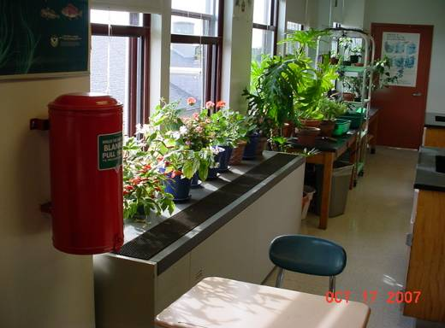

Classroom Univent, Note Plants near Air Diffuser

Picture 2

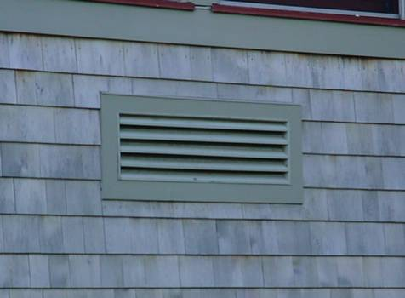

Univent Fresh Air Intake Vent

Picture 3
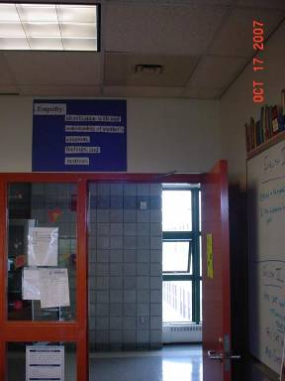

Classroom Exhaust Vent, Note Location over Open Hallway Door

Picture 4

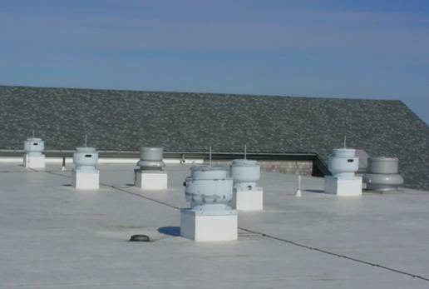

Rooftop Exhaust Motors
Picture 5

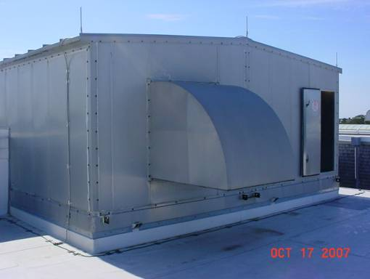

Rooftop Air Handling Unit

Picture 6

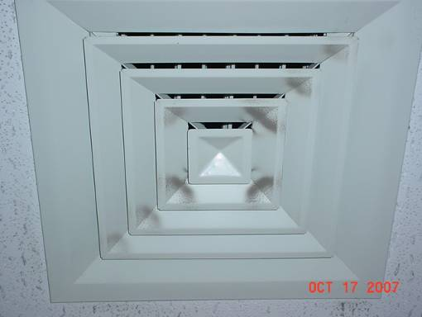

Ceiling-Mounted Air Diffuser, Note Dust/Debris Accumulation
Picture 7

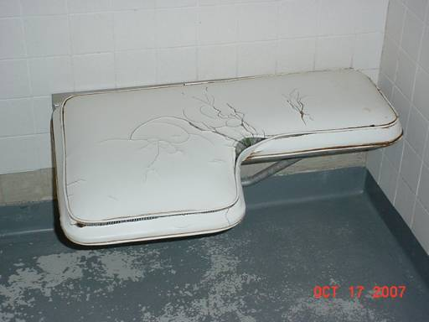

Damaged/Moldy Seat Cushion in Boy’s Locker Room

Picture 8

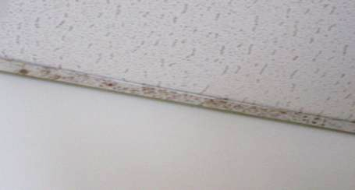

Dark Staining/Possible Mold Growth on Ceiling Tile Tracks
Picture 9

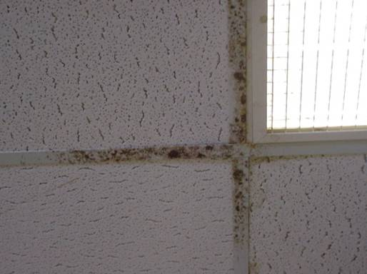

Dark Staining/Possible Mold Growth on Ceiling Tile Tracks

Picture 10

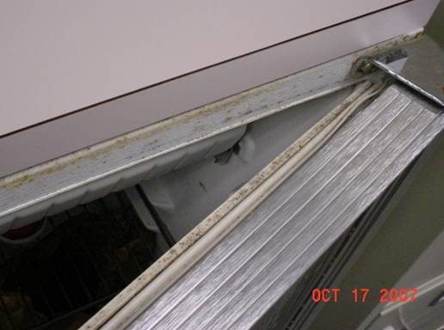

Mold Growth along Gasket of Mini-Refrigerator in Room 109
Picture 11

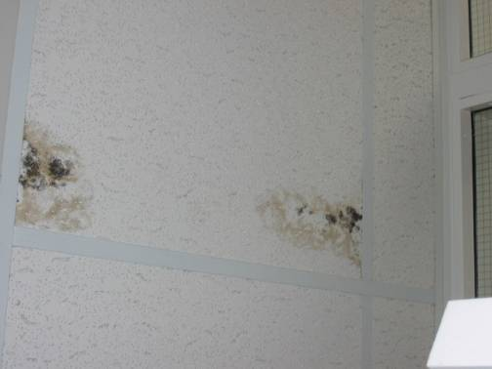

Mold Growth on Ceiling Tile in Room 100

Picture 12

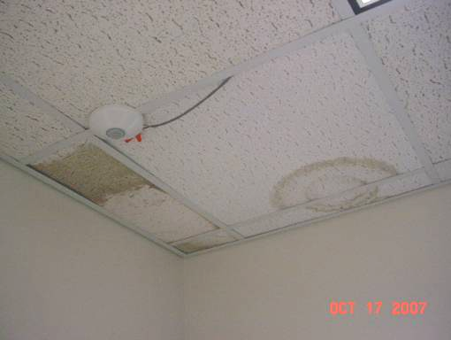

Water Damaged Ceiling Tiles in Classroom

Picture 13

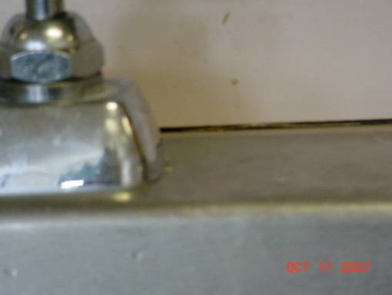

Open Seam between Sink Countertop and Backsplash

Picture 14

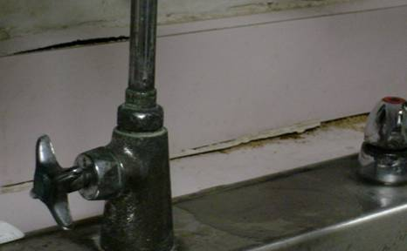

Splayed/Damaged Countertop/Backsplash in Art Room 008
Picture 15

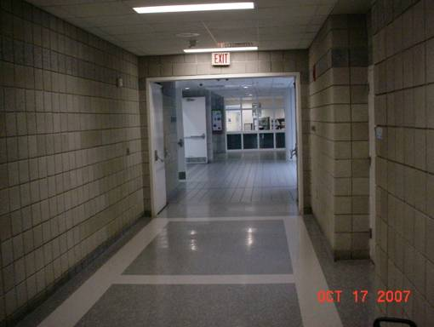

Hallway Doors to Pool Propped Open

Picture 16

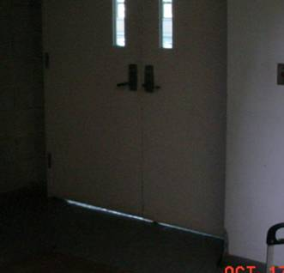

Space under Pool Door (as Indicated by Light Penetrating)
Picture 17

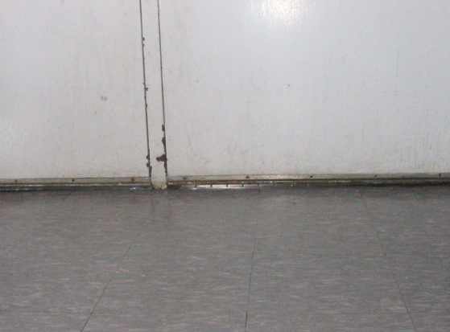

Space under Pool Door

Picture 18

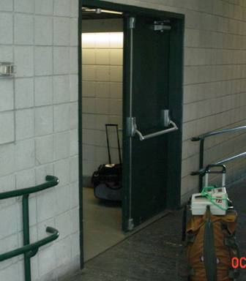

Door to Industrial Arts Wing Pegged Open
Picture 19

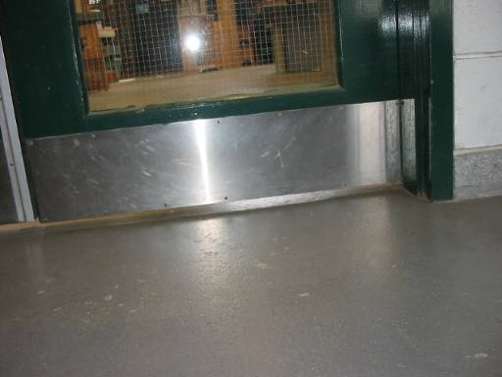

Space under Shop Door

Picture 20

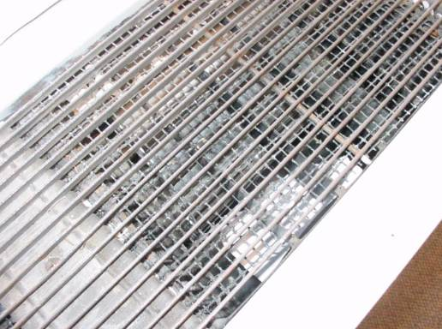

Dust/Debris in Univent Air Diffuser
Picture 21

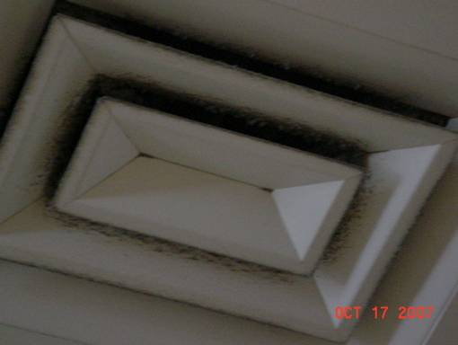

Dust/Debris Build-up on Supply Diffuser

Picture 22

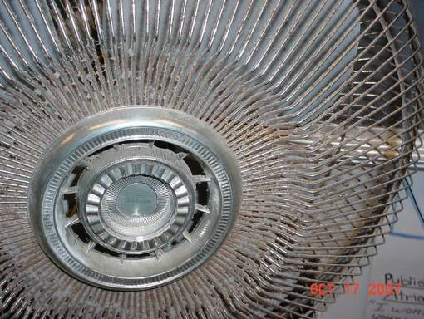

Dust/Debris Build-up on Personal Fan
Picture 23

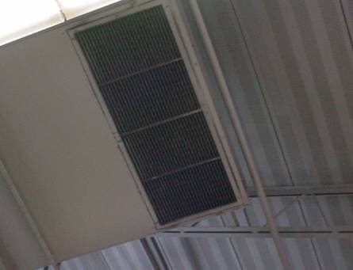

Heavy Dust/Debris Build-Up on Exhaust Vent in Wood Shop
Location/ Room | Carbon  Dioxide  (ppm) | Carbon Monoxide  (ppm) | Temp  (°F) | Relative  Humidity  (%) | TVOCs  (ppm) | PM2.5  (µg/m3) | Occupants in Room | Windows  Openable | Ventilation |  | Remarks
 |  |  |  |  |  |  |  |  | Supply | Exhaust | Remarks
background | 412 | ND | 71 | 41 | ND | 12
217 | 740 | ND | 73 | 52 | ND | 10 | 1 | Y | Y | Y | Window open, 21 occupants gone 4 mins, DEM, 4 WD-CT, DO, DEM particulate
213 | 620 | ND | 75 | 47 | ND | 11 | 1 | Y | Y | Y | Window open, 14 occupants gone 6 mins, CD, DO
206 | 620 | ND | 76 | 46 | ND | 10 | 17 | Y | Y | Y | Plants, UV-off (reactivated by NHS staff), DO
204 | 539 | ND | 78 | 43 | ND | 7 | 4 | Y | Y | Y | Window open, plants on UV-debris in air diffuser, DO
201 | 608 | ND | 76 | 40 | ND | 9 | 8 | Y | Y | Y | Window open, DO, 5 WD-CT, dusty ex vent, black material on CT tracks (mold/rust?)
Gym | 420 | ND | 74 | 41 | ND | 6 | 0 | N | Y | Y
Boys Locker Room | 420 | ND | 75 | 42 | ND | 6 | 0 | N | Y | Y | Dusty ex vent, broken florescent light cover, moldy/damaged shower seat
Chorus/Drama | 459 | ND | 72 | 41 | ND | 5 | 1 | Y | Y | Y | 5 WD-CT, black material on CT tracks (mold/rust?)
Auditorium | 474 | ND | 71 | 44 | ND | 6 | 0 | N | Y | Y
Library | 762 | ND | 71 | 41 | ND | 6 | 35-40 | N | Y | Y | Dusty vents, 5+ WD-CT
LMC 3 | 726 | ND | 70 | 41 | ND | 7 | 0 | N | Y | Y | 4 WD-CT, DO, dusty vents
LMC 4 | 694 | ND | 71 | 40 | ND | 7 | 1 | N | Y | Y | DO, PC, dusty vents
120 Culinary | 508 | ND | 74 | 42 | ND | 9 | 10 | Y | Y | Y | DO, spaces sink/countertop, 10+ WD-CT, floor drains
109 | 783 | ND | 76 | 44 | ND | 9 | 2 | Y | Y | Y | Window open, mold growth gasket of refrigerator, upholstered furniture-cover
Director of Special Services | 576 | ND | 74 | 41 | ND | 6 | 2 | Y | Y | Y | Window AC, dusty vents/fan
104-A | 571 | ND | 77 | 42 | ND | 7 | 1 | Y | Y | Y | Window open, 15 occupants gone 20 mins, plant on UV
104-B | 407 | ND | 76 | 38 | ND | 8 | 1 | Y | Y | Y | Window open, paper in UV-noise, 12 occupants gone 20 mins
Auto Shop | 418 | ND | 72 | 41 | ND | 8 | 20 | N | Y | Y | Local exhaust, dirty vents , spaces under doors
Wood Shop | 413 | ND | 71 | 42 | ND | 7 | 1 | N | Y | Y | Local exhaust, spaces under doors
001 Computer Room | 526 | ND | 80 | 41 | ND | 6 | 2 | N | Y | Y | Chronic heat complaints, No AC
004 | 795 | ND | 76 | 44 | ND | 10 | 18 | Y | Y | Y | Window open, fan on, AP
006 | 597 | ND | 75 | 43 | ND | 8 | 1 | Y | Y | Y | PF-dusty
003 | 822 | ND | 76 | 42 | ND | 5 | 26 | N | Y | Y | Dusty vents, DO, chronic heat complaints
005 | 509 | ND | 74 | 39 | ND | 6 | 1 | N | Y | Y | Local exhaust, WD countertop-wood splayed
008 | 612 | ND | 74 | 43 | ND | 9 | 2 | Y | Y | Y | UV-off (motor not functioning-on repair list), clay dust, WD countertop-wood splayed, vented kiln
Art | 755 | ND | 74 | 45 | ND | 8 | 23 | Y | Y | Y | Rubber cement (flammable) in storage cabinet, 1 WD-CT near window, PF accumulated items
007 | 468 | ND | 71 | 42 | ND | 10 | 0 | Y | Y | Y | PF
020 LGI | 410 | ND | 72 | 43 | ND | 5 | 0 | N | Y | Y | 3 WD-CT, storage of boxes (paper), stuffed toys
Adjustment Councilor | 778 | ND | 75 | 43 | ND | 11 | 4 | N | Y | Y | DO
158 Band Room | 458 | ND | 71 | 44 | ND | 10 | 15 | Y | Y | Y | DO, slight rusting on acoustic panels
158-A Office | 503 | ND | 71 | 45 | ND | 11 | 2 | N | Y | Y | 3 WD-CT, DO
Main Office | 481 | ND | 72 | 42 | ND | 11 | 5 | Y | Y | Y | 9 WD-CT, DO
129 | 450 | ND | 71 | 42 | ND | 11 | 0 | N | Y | Y | DO
127 | 450 | ND | 71 | 42 | ND | 11 | 0 | N | Y | Y | DO, DEM
125 | 392 | ND | 71 | 41 | ND | 10 | 0 | N | Y | Y | PC, 6 WD-CT, breach sink/countertop, DO
Conference Room | 436 | ND | 71 | 40 | ND | 11 | 0 | N | Y | Y | DEM
100 | 487 | ND | 74 | 41 | ND | 9 | 0 | N | Y | Y | WD/mold growth on CT near door
Guidance 101 | 584 | ND | 74 | 43 | ND | 10 | 2 | N | Y | Y | 2 MT, DO
101-C | 511 | ND | 74 | 44 | ND | 9 | 0 | N | Y | Y
101-B | 464 | ND | 73 | 44 | ND | 9 | 0 | N | Y | Y | DO
217 Office | 933 | ND | 76 | 48 | ND | 10 | 1 | Y | N | N | Window open, PF, DEM, plants
215 | 876 | ND | 75 | 46 | ND | 10 | 4 | Y | Y | Y | CD, DEM, PF, window open
207 | 758 | ND | 75 | 43 | ND | 14 | 11 | Y | Y | Y | Window open, plants, DO, DEM
205 | 715 | ND | 76 | 45 | ND | 15 | 15 | Y | Y | Y | PF, DO, DEM
203 | 1023 | ND | 76 | 45 | ND | 14 | 12 | Y | Y | Y | Window open (1/6), plants on UV, DEM, PF
Girls Locker Room | 468 | ND | 75 | 43 | ND | 9 | 0 | N | Y | Y | DO, dusty vents
Pool | 602 | ND | 79 | 61 | ND | 9 | 30 | N | Y | Y | Spaces under door
165 | 402 | ND | 74 | 44 | ND | 10 | 0 | N | Y | Y | DEM, CD, MT
PE Office | 548 | ND | 74 | 44 | ND | 10 | 1 | N | Y | Y | MT, accumulated items
Athletic Dir Office | 446 | ND | 75 | 44 | ND | 9 | 1 | N | Y | N | PF
150-B | 504 | ND | 73 | 43 | ND | 9 | 0 | N | Y | Y
101-A | 486 | ND | 74 | 45 | ND | 10 | 0 | N | Y | Y
Psychologist Office | 508 | ND | 74 | 44 | ND | 10 | 1 | N | Y | Y | 3 WD WD-CT, 1 AT
107 | 560 | ND | 76 | 42 | ND | 13 | 7 | N | Y | Y | Dusty vents, PF, CD, AT, DEM, DO
103 | 559 | ND | 77 | 40 | ND | 11 | 10 | N | Y | Y | PF, 1 MT, DEM, AP-HEPA, DO, breach-sink/countertop
102 | 598 | ND | 76 | 40 | ND | 13 | 2 | Y | Y | Y | PF, DEM, 3 WD-CT
105 | 815 | ND | 77 | 43 | ND | 11 | 20 | N | Y | Y | PF, DEM, MT, DO
202 | 686 | ND | 78 | 41 | ND | 11 | 25 | Y | Y | Y | Windows open, flow hood-storage, 3 WD-CT, MT, DEM, heating issues reported, DO
211 | 638 | ND | 78 | 41 | ND | 11 | 19 | Y | Y | Y | Dusty vents, windows open, DEM, DO
209 | 533 | ND | 74 | 40 | ND | 10 | 2 | Y | Y |  | DO
013 | 606 | ND | 73 | 41 | ND | 13 | 2 | Y | Y | Y | PF, DEM, DO, 4 WD-CT
011 | 654 | ND | 73 | 43 | ND | 12 | 7 | Y | Y | Y | DEM-odors, DO, CD
009 | 909 | ND | 73 | 45 | ND | 11 | 7 | Y | Y | Y | AD, DEM, PF, 2 AT
Nurse Office | 594 | ND | 75 | 42 | ND | 16 | 2 | Y | Y | N | DO, no restrooms in space, breach-sink/countertop
Nurse Main | 853 | ND | 75 | 42 | ND | 14 | 2 | N | Y | Y | Supply ventilation-weak, heat complaints
29 | 852 | ND | 75 | 43 | ND | 22 | 0 | N | Y | N | Supply ventilation-weak

