NARRAGANSETT/MT. HOPE BAY WATERSHED
61/53-AC-1

1999 WATER QUALITY ASSESSMENT REPORT

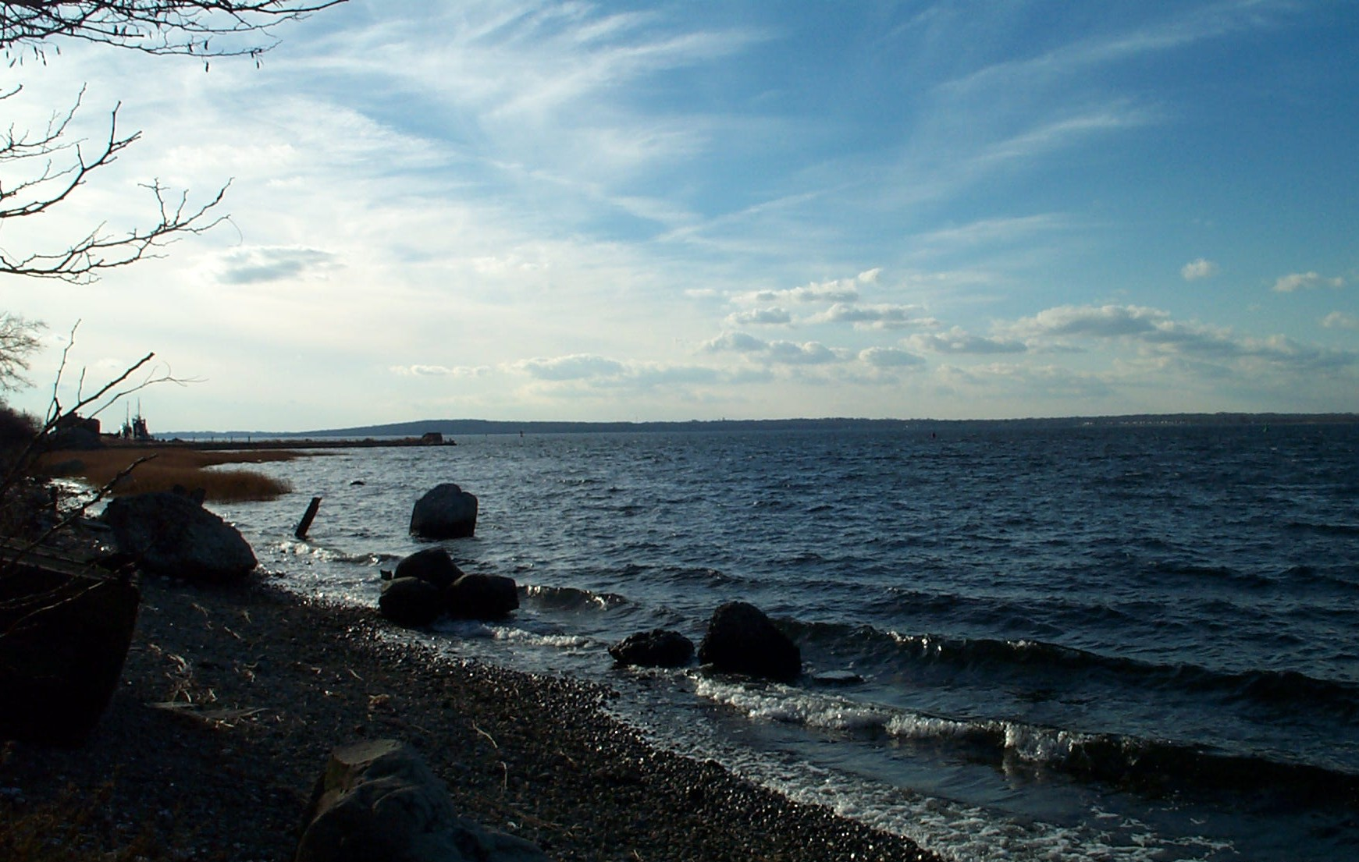
Mt. Hope Bay
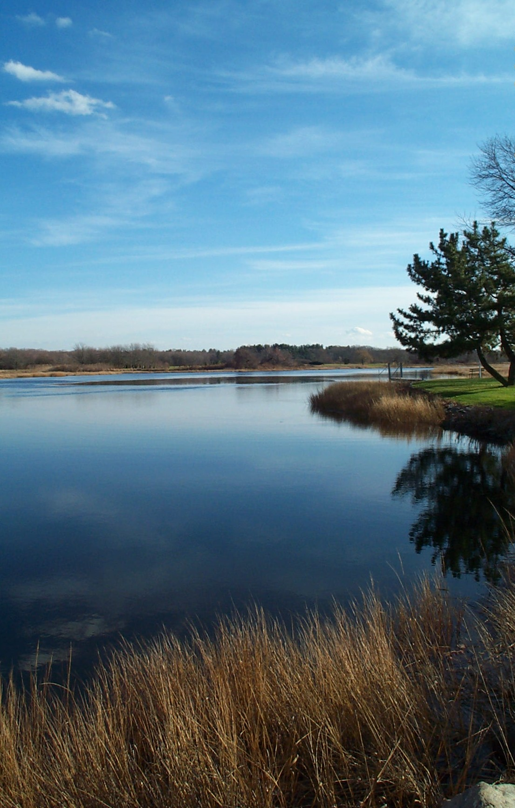
Palmer River

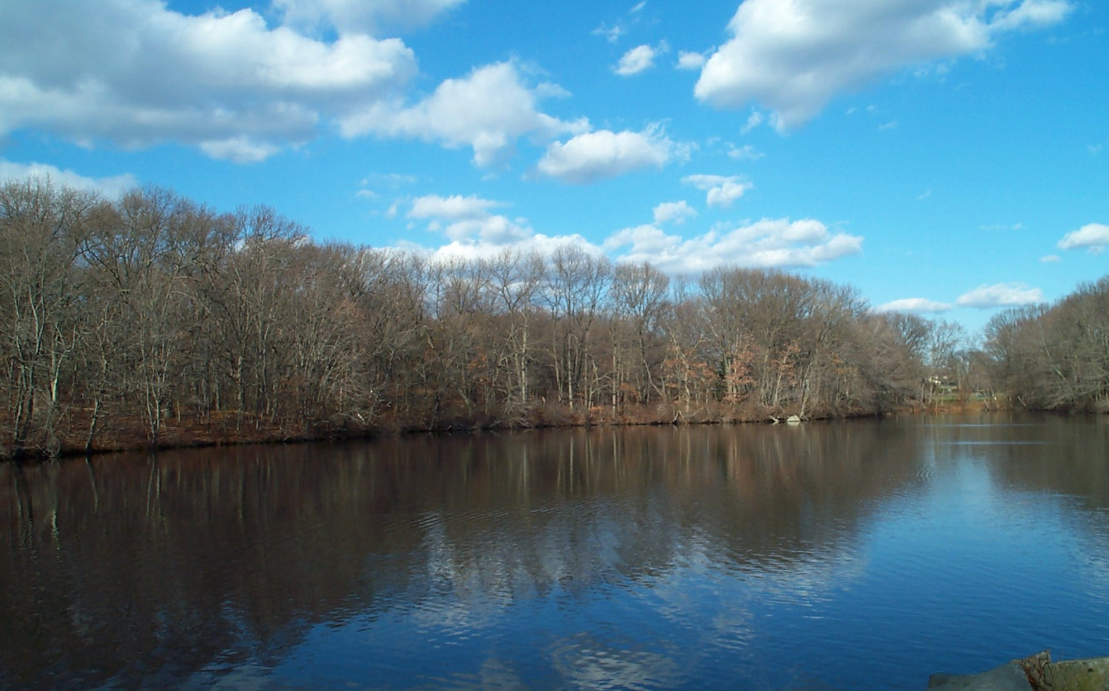
Burrs Pond

COMMONWEALTH OF MASSACHUSETTS
EXECUTIVE OFFICE OF ENVIRONMENTAL AFFAIRS
BOB DURAND, SECRETARY
MASSACHUSETTS DEPARTMENT OF ENVIRONMENTAL PROTECTION
LAUREN A. LISS, COMMISSIONER
BUREAU OF RESOURCE PROTECTION
Cynthia Giles, ASSISTANT COMMISSIONER
DIVISION OF WATERSHED MANAGEMENT
GLENN HAAS, DIRECTOR

NOTICE OF AVAILABILITY

LIMITED COPIES OF THIS REPORT ARE AVAILABLE AT NO COST BY WRITTEN REQUEST TO:

MASSACHUSETTS DEPARTMENT OF ENVIRONMENTAL PROTECTION
DIVISION OF WATERSHED MANAGEMENT
627 MAIN STREET
WORCESTER, MA 01608

This report is also available from DEP’s home page on the World Wide Web at:

http://www.state.ma.us/dep/brp/wm/wmpubs.htm

Furthermore, at the time of first printing, eight copies of each report published by this office are submitted to the State Library at the State House in Boston; these copies are subsequently distributed as follows:

- On shelf; retained at the State Library (two copies);
- Microfilmed retained at the State Library;
- Delivered to the Boston Public Library at Copley Square;
- Delivered to the Worcester Public Library;
- Delivered to the Springfield Public Library;
- Delivered to the University Library at UMass, Amherst;
- Delivered to the Library of Congress in Washington, D.C.

Moreover, this wide circulation is augmented by inter-library loans from the above-listed libraries. For example a resident in Winchendon can apply at their local library for loan of any DEP/DWM report from the Worcester Public Library.

A complete list of reports published since 1963 is updated annually and printed in July. This report, entitled, “Publications of the Massachusetts Division of Watershed Management – Watershed Planning Program, 1963-(current year)”, is also available by writing to the DWM in Worcester.

DISCLAIMER

References to trade names, commercial products, manufacturers, or distributors in this report constituted neither endorsement nor recommendations by the Division of Watershed Management for use.

NARRAGANSETT/MT. HOPE BAY WATERSHED

1999 WATER QUALITY ASSESSMENT REPORT

Prepared by:

Mollie J. Weinstein, Peter Mitchell, and Katie O’Brien

Department of Environmental Protection
Division of Watershed Management

Report Number:

53/61-AC-1

DWM Control Number:

53.0

Massachusetts Department of Environmental Protection
Division of Watershed Management
Worcester, Massachusetts

January 2002

ACKNOWLEDGEMENTS

Coordination of local, state and federal agencies and private organizations is fundamental to the success of the Massachusetts Watershed Initiative. We would like to thank Andrea Langhauser, Executive Office of Environmental Affairs (EOEA) team leader and members of the Narragansett/Mt. Hope Bay Watershed Team for their efforts to facilitate that process.

Data and information used in this report were provided in part by the following agencies and organizations:

State
- Department of Environmental Protection (MA DEP):
- Bureau of Strategic Policy and Technology’s Wall Experiment Station
- Bureau of Resource Protection
- Bureau of Waste Prevention
- Bureau of Waste Site Cleanup
- Massachusetts Department of Public Health (MDPH)
- Department of Fisheries, Wildlife, and Environmental Law Enforcement (DFWELE)
- Division of Fisheries and Wildlife
- Riverways Program
- Division of Marine Fisheries (DMF)
- Department of Environmental Management (MA DEM)
- Massachusetts Office of Coastal Zone Management (CZM)
- Rhode Island Department of Environmental Management (RIDEM)

Federal
- Environmental Protection Agency (EPA)
- United States Geological Survey (USGS)
- Water Resources Division

Regional
- River Aware II
- South Watuppa Assessment Network (SWAN)
- Massachusetts Community Water Watch – Cook Pond

Much appreciation is also extended to several MA DEP employees for their contributions: Joan Beskenis, Tom Dallaire, Ken Dominick, Laurie Kennedy, Bob Maietta, Juliet Mathers, Rick McVoy, Ph.D., and Arthur Screpetis.

It is impossible to thank everyone who contributed to the assessment report process: field, laboratory, data management, writing, editing, and graphics, as well as meetings, phone calls, and many e-mails. All of these contributions are very much appreciated.

Cover photo credit: Mt. Hope Bay, Palmer River, Burrs Pond - Stella Kiras, DEP DWM

TABLE OF CONTENTS

Acknowledgements iv
Table of Contents v
List of Tables and Figures vi
List of Acronyms vii
List of Units viii
Executive Summary xix
Introduction 1
Assessment Methodology 1
Narragansett/Mt. Hope Bay Descriptions and Classifications 112
Summary of Existing Conditions and Perceived Problems 15
Sources of Information 17
Objectives 21
Report Format 22
Narragansett Bay Watershed – River Segment Assessments 24
Runnins River (Segment MA53-01) 25
Palmer River (Segment MA53-04) 30
Palmer River (Segment MA53-05) 34
Palmer River (Segment MA53-03) 39
Warren River Pond (Segment MA53-06) 43
Mt. Hope Bay Watershed – River Segment Assessments 44
Lee River (Segment MA61-01) 45
Lee River (Segment MA61-02) 47
Cole River (Segment MA61-03) 50
Cole River (Segment MA61-04) 53
Quequechan River (Segment MA61-05) 56
Mt. Hope Bay (Segment MA61-06) 58
Mt. Hope Bay (Segment MA61-07) 63
Narragansett and Mt. Hope Bay – Lake Segment Assessments 65
Trophic Status Evaluation 65
Burrs Pond (Segment MA53001) 67
Cook Pond (Segment MA61001) 69
Lewin Brook Pond (Segment MA61011) 71
South Watuppa Pond (Segment MA61006) 73
Literature Cited 75

TABLE OF CONTENTS (Continued)

List of Appendices 79
Appendix A – Data Validation Report for 1999 DEP/DWM Narragansett/Mt. Hope Bay Watershed Monitoring Data A1
A.1 Field and Laboratorty QA/QA Objectives, Criteria and Prochedures A1
A.2 Data Validation A6
A.3 1999 Analytical Methods and MDLs A16
A.4 Conclusions A18
Appendix B - 1999 DEP DWM Narragansett/Mt. Hope Bay Watershed Survey Report B1
Materials and Methods B1
Survey Conditions B2
Stream Water Quality Monitoring B3
Periphyton B6
Fish Toxics B6
Results B7
Survey Conditions B7
Stream Water Quality Monitoring B8
Macroinvertebrates B13
Periphyton B13
Fish Toxics B14
1999 Fish Toxics B14
1994 Fish Toxics B14
Appendix C 1999 Narragansett/Mt. Hope Bay Watershed Biomonitoring Rsults C1
Table of Contents C1
Introduction C2
Methods C2
Results and Discussion C2
Summary and Conclusions C7
Literature Cited C8
Appendix D - Public Water Supply Information D1
Appendix E - DEP Grant and Loan Programs E1
Appendix F - DMF Shellfish Data: F1

LIST OF TABLES AND FIGURES

Table 1. Summary of Massachusetts Surface Water Quality Standards. 3
Table 2. 1998 303(d) List of Impaired Waters in the Narragansett/Mt. Hope Bay Watershed. 15
Table 3. Narragansett / Mt. Hope Bay Watershed Lakes. 61
List of Appendices Tables 79

Figure 1. Aquatic Life Use Assessment Summary xxi
Figure 2. Primary Contact Recreational Use Assessment Summary xxv
Figure 3. Secondary Contact Recreational Use Assessment Summary xxvii
Figure 4. Aesthetics Use Assessment Summary xxix
Figure 5. Five-year Cycle of the Watershed Approach 1
Figure 6. Narragansett/Mt. Hope Bay Watershed Location 12
Figure 7. Location of Massachusetts Portions of Narragansett Bay and Mt. Hope Bay Watersheds 12
Figure 8. Assessed River and Estuarine Segments in Narragansett Bay 24
Figure 9. Assessed River and Estuarine Segments in Mt. Hope Bay. 44
Figure 10. Location of Assessed Lakes in the Narragansett/ Mt. Hope Bay Watershed. 66
List of Appendices Figures 79

LIST OF ACRONYMS

7Q10 | Seven day, ten year low flow
ACEC | Area of Critical Environmental Concern
ACOP | Administrative Consent Order with Penalty
BCWA | Bristol County (RI) Water Authority
BMP | Best Management Practice
BPJ | Best professional judgment
BRP | Bureau of Resource Protection
CLF | Conservation Law Foundation
CMR | Code of Massachusetts Regulations
CNOEC | Chronic no observed effect concentration
CSO | Combined Sewer Overflow
CTD | Conductivity Temperature Depth
CWA | Clean Water Act
CZM | Massachusetts Coastal Zone Management
DDT | Dichlorodiphenyltrichloroethane
DFWELE | Department of Fisheries, Wildlife, and Environmental Law Enforcement
DMF | Division of Marine Fisheries
DMR | Discharge Monitoring Report
DO | Dissolved oxygen
DWM | Division of Watershed Management
DWP | Drinking Water Program
EOEA | Executive Office of Environmental Affairs
EPA | United States Environmental Protection Agency
EPT | Ephemeroptera, Plecoptera, Trichoptera
ESS | Environmental Science Services, Inc
FWA | Florescent Whitening Agent
GIS (MassGIS) | Geographic Information System
Hg | Mercury
IBT | Interbrain Transfer Act
IWW | Industrial waste water
LC₅₀ | Lethal concentration to 50% of the test organisms
L-EL | Lowest effect level
MA DEM | Massachusetts Department of Environmental Management
MA DEP | Massachusetts Department of Environmental Protection
MDPH | Massachusetts Department of Public Health
MDL | Minimum detection level
MEPA | Massachusetts Environmental Policy Act
MOA | Memorandum of Agreement
MPN | Most probable number
MWI | Massachusetts Watershed initiative
NAS | National Academy of Scientists
NAE | National Academy of Engineers
NCCW | Non-Contact Cooling Water
NH₃-N | Ammonia-nitrogen
NOAA | National Oceanographic and Atmospheric Administration
NPDES | National Pollutant Discharge Elimination System
NPS | Non-Point Source
NTNC | Non-Transient Non-Community
ORW | Outstanding Resource Waters
PALIS | Pond and Lake Information System
PCB | Polychlorinated Biphenyls
PWS | Public water supply
QA/QC | Quality assurance/ quality control
QAPP | Quality assurance project plan

LIST OF ACRONYMS (Continued)

RBP | Rapid bioassessment protocol
RIDEM | Rhode Island Department of Environmental Management
SARIS | Stream and River Inventory System
SDWA | Safe Drinking Water Act
S-EL | Severe Effect Level
SOP | Standard operating procedure
SWAN | South Watuppa Assessment Network
SWQS | Surface Water Quality Standards
TMDL | Total maximum daily load
TNC | Transient Non-Community
TOC | Total organic carbon
TOXTD | MA DEP DWM Toxicity Testing Database
TRC | Total Residual Chlorine
TSS | Total Suspended Solids
USGen | U.S. Generating Company
USGS | United States Geological Survey
WBID | Waterbody Identification
WBS | Waterbody System
WMA | Water Management Act
WWTP | Waste Water Treatment Plant

list of units

cfs | cubic feet per second
cfu | colony forming unit
gpd | gallons per day
MGD | million gallons per day
μg/kg | microgram per kilogram
mg/L | milligram per liter
mL | milliliter
ng | nanogram
NTU | nephelometric turbidity units
ppb | parts per billion
ppm | parts per million
SU | standard units
TEQ/kg | toxic equivalents per kilogram
µm | micro-moles

Executive Summary

NARRAGANSETT/Mt Hope Bay WATERSHED

WATER QUALITY ASSESSMENT REPORT

The Massachusetts Surface Water Quality Standards (SWQS) designate the most sensitive uses for which surface waters in the Commonwealth shall be protected. The assessment of current water quality conditions is a key step in the successful implementation of the Watershed Approach. This critical phase provides an assessment of whether or not the designated uses are being met (support, partial support, non-support) or are not assessed, as well as basic information needed to focus resource protection and remediation activities later in the watershed management planning process. All or portions of the Runnins, Palmer, and Cole rivers, and Mount Hope Bay in Massachusetts are on the 1998 303(d) list of impaired waters. Additionally, the Lee River is identified on the 1998 303(d) list as “needing confirmation”, that is more data is needed to determine if a TMDL is warranted.

This assessment report presents a summary of current water quality data/information used to assess the status of the designated uses as defined in the Massachusetts surface water quality standards. Each use, within a given segment, is individually assessed as 1) support, 2) partial support, or 3) non-support. When too little current data/information exist or no reliable data are available the use is not assessed. However, if there is some indication of water quality impairment, which is not “naturally occurring”, the use is identified with an “Alert Status”. It is important to note that not all waters are assessed. Many small and/or unnamed rivers and ponds are currently unassessed; the status of their designated uses has never been reported to EPA in the Commonwealth’s 305(b) Report nor is information on these waters maintained in the Waterbody System (WBS) database.

There are a total of five freshwater rivers, streams, brooks and/or creeks (the term “rivers” will hereafter be used to include all) assessed in this report. These include the Runnins River, Palmer River, Lee River, Cole River and Quequechan River. The rivers assessed within this report represent approximately 19% of the 27 named streams and 58% of the estimated 22.4 river miles in the Narragansett/Mt. Hope Bay Watershed.

Five estuarine areas, Mt. Hope Bay, Warren River Pond, and the tidally influenced portions of the Palmer, Cole, and Lee rivers are discussed in this report. These estuarine waters total 5.9 square miles Four lakes, ponds and/or impoundments (the term “lakes” will hereafter be used to include all) -- Burrs, Cook, Lewin Brook, and South Watuppa ponds are also included in this assessment report. These lake assessments represent approximately 14%, of the 28 lakes and 35% of the 4,164 lake acres in the Narragansett/Mt. Hope Bay Watershed.

The status of the designated uses for these waterbodies is summarized in segment format, including five freshwater river segments (totaling 13.3 river miles), seven estuarine segments (5.21 square miles), and four lakes (totaling 1453 acres). The designated uses where applicable are: Aquatic Life, Drinking Water, Fish Consumption, Shellfishing, Primary Contact Recreation, Secondary Contact Recreation and Aesthetics.

AQUATIC LIFE USE – Rivers, Estuaries/Coastal Embayments, and Lakes

The Aquatic Life Use is supported when suitable habitat (including water quality) is available for sustaining a native, naturally diverse community of aquatic flora and fauna. Impairment of the Aquatic Life Use (non-support or partial support) may result from anthropogenic stressors that include point and/or nonpoint source(s) of pollution and hydrologic modification.

The status of the Aquatic Life Use in the Narragansett/Mt. Hope Bay Watershed can be summarized as follows:
Rivers | Estuaries | Lakes
4.6 miles NON-SUPPORT  8.7 miles NOT ASSESSED | 4.0 square miles NON-SUPPORT  1.21 square miles NOT ASSESSED | 1453 acres NOT ASSESSED

Where assessed, the river and estuaries in the in the Narragansett/Mt. Hope Bay Watershed do not support the Aquatic Life Use, as illustrated in Figure 1. The entire length of the Runnins River in Massachusetts, due to unknown causes (nutrients suspected), is assessed as non-support. Less than one mile of the Quequechan River is impaired (non-support) by habitat alteration from river channelization. Although currently not assessed, the Palmer River (from its headwaters to its estuary) is identified with an “Alert Status” due to low flows.

The entire 4.0 square miles of Mt Hope Bay estuary are assessed as non-support for the Aquatic Life Use. Causes of impairment include organic enrichment/low dissolved oxygen, effluent toxicity and thermal modifications. The source of impairment is an industrial point source (Brayton Point Station) discharging heated effluent to Mt. Hope Bay.

No lakes in the Narragansett/Mt. Hope Bay Watershed are currently assessed for the Aquatic Life Use.

DRINKING WATER USE – Rivers, Estuaries/Coastal Embayments, and Lakes

The term Drinking Water Use is used to indicate sources of public drinking water. While Drinking Water Use is not assessed in this report, information on drinking water source protection and finish water quality is available at http://www.state.ma.us/dep/brp/dws/dwshome.htm and from the Narragansett/Mt Hope Bay Watershed’s public water suppliers. These waters are subject to stringent regulation in accordance with the Massachusetts Drinking Water Regulations. MA DEP’s Drinking Water Program (DWP) has primacy for implementing the provisions of the federal Safe Drinking Water Act. DWP has also initiated work on its Source Water Assessment Program, which requires that the Commonwealth delineate protection areas for all public ground and surface water sources, inventory land uses in these areas that may present potential threats to drinking water quality, determine the susceptibility of water supplies to contamination from these sources, and publicize the results. Except for suppliers with surface water sources for which a waiver from filtration has been granted (these systems also monitor surface water quality), public water suppliers monitor their finished water (tap water) for major categories of contaminants (e.g., bacteria, volatile and synthetic organic compounds, inorganic compounds) and report their data to DWP.
Narragansett/Mt. Hope Bay Watershed
Aquatic Life Use Assessment Summary
Rivers, Estuaries/Coastal Embayments and Lakes
Figure 1. Aquatic Life Use Assessment Summary – Rivers, Estuaries/Coastal Embayments, and lakes

Intentionally left blank
FISH CONSUMPTION USE – Rivers, Estuaries/ Coastal Embayments, and Lakes

The Fish Consumption Use is supported when there are no pollutants present that result in unacceptable concentrations in edible portions of marketable fish or for the recreational use of fish, other aquatic life or wildlife for human consumption. The assessment of this use is made using the most recent list of Fish Consumption Advisories issued by the Massachusetts Executive Office of Health and Human Services, Department of Public Health (MDPH), Bureau of Environmental Health Assessment (MDPH 2001a). The MDPH list identifies waterbodies where elevated levels of a specified contaminant in edible portions of freshwater species pose a health risk for human consumption. Hence, the Fish Consumption Use is assessed as non-support in these waters.
NOTE: In addition to site specific advisories, in July 2001, MDPH issued new consumer advisories on fish consumption and mercury contamination. The MDPH “is advising pregnant women, women of childbearing age who may become pregnant, nursing mothers and children under 12 years of age to refrain from eating the following marine fish; shark, swordfish, king mackerel, tuna steak and tilefish. In addition, MDPH is expanding its previously issued statewide fish consumption advisory which cautioned pregnant women to avoid eating fish from all freshwater bodies due to concerns about mercury contamination, to now include women of childbearing age who may become pregnant, nursing mothers and children under 12 years of age (MDPH 2001b).”

Additionally, MDPH “is recommending that pregnant women, women of childbearing age who may become pregnant, nursing mothers and children under 12 years of age limit their consumption of fish not covered by existing advisories to no more than 12 ounces (or about 2 meals) of cooked or uncooked fish per week. This recommendation includes canned tuna, the consumption of which should be limited to 2 cans per week. Very small children, including toddlers, should eat less. Consumers may wish to choose to eat light tuna rather than white or chunk white tuna, the latter of which may have higher levels of mercury (MDPH 2001b).” MDPH’s statewide advisory does not include fish stocked by the state Division of Fisheries and Wildlife or farm-raised fish sold commercially.

The status of the Fish Consumption Use in the Narragansett/Mt Hope Bay Watershed is as follows:
Rivers | Estuaries | Lakes
0.14 miles NON-SUPPORT  13.16 miles NOT ASSESSED | 5.21 square miles NOT ASSESSED | 16 acres NON-SUPPORT  1437 NOT ASSESSED

MDPH issued a fish consumption advisory for Burrs Pond in Seekonk because of elevated mercury concentrations in fishes (MDPH 2001a). This pond is a five-acre impoundment of the Runnins River. The Fish Consumption Use is, therefore, assessed as non-support for the 0.14 miles of the Runnins River that flows through this impoundment.

A fish consumption advisory was issued by MDPH for Lewin Brook Pond, an 11-acre impoundment, due to elevated mercury levels in edible fish tissues. Therefore, the Fish Consumption Use for this waterbody is assessed as non-support. No other river miles were assessed for the Fish Consumption Use in the Narragansett/Mt Hope Bay Watershed. Additionally, no estuarine segments are assessed for this use. Both Burrs and Lewin Brook ponds are assessed as non-support due to the fish consumption advisories.

Shellfishing Use – Rivers, Estuaries, Coastal Embayments

The Shellfishing Use is supported when shellfish harvested from approved Open Shellfish Areas (Class SA) are suitable for consumption without depuration and shellfish harvested from approved Restricted Shellfish Areas (Class SB) are suitable for consumption with depuration. The Division of Marine Fisheries (DMF) classifies shellfishing areas in the Narragansett/Mt Hope Bay Watershed. The Shellfishing Use for this report was assessed using the DMF shellfishing closure list dated October 2000 (DFWELE 2000). The status of the 11,138 acres of shellfishing beds in the watershed (including areas that extend into open-water not specifically included in this assessment report) is as follows:
DMF Classification Type | MA DEP Use Support Status | DMF Area (acres) | % of total DMF acreage
Approved | Support | 7106.453 | 64%
Conditionally Approved | Partial support | 3494.853 | 31%
Prohibited | Non-support | 536.662 | 5%

Individual DMF management area classifications are provided in Appendix E of this assessment report. It should be noted that their areas are defined in acres of shellfishing habitat.
PRIMARY CONTACT RECREATIONAL USE – Rivers, Estuaries/Coastal Embayments, and Lakes
MDPH issued site-specific advisories for three ponds in the Parker River Watershed due to elevated levels of mercury. These ponds, and the reach of the Parker River that flows through Rock and Pentucket ponds, are assessed as non-support with sources of contamination unknown.

The Primary Contact Recreational Use is supported when conditions are suitable (fecal coliform bacteria densities, pH, temperature, turbidity and aesthetics meet the Surface Water Quality Standards) for any recreational or other water related activity during which there is prolonged and intimate contact with the water with a significant risk of ingestion. Activities include, but are not limited to, wading, swimming, diving, surfing and water skiing. For lakes, macrophyte cover and/or transparency (secchi disk depth) data are also evaluated to assess the status of the recreational uses.

The status of the Primary Contact Recreational Use in the Narragansett/Mt Hope Bay Watershed is as follows:
Rivers | Estuaries | Lakes
1.3 miles SUPPORT  2.4 miles NON-SUPPORT  9.6 miles NOT ASSESSED | 5.0 square miles SUPPORT  0.15 square miles NON-SUPPORT  0.06 miles NOT ASSESSED | 1453 acres NOT ASSESSED

The majority (72%) of the rivers in the Narragansett/Mt. Hope Bay watershed are not assessed for the Primary Contact Recreational Use. Only 10% of the total river miles assessed meet the Primary Contact Recreational Use (Figure 2). The Runnins River is the only freshwater river assessed for this use. The upper 0.4 miles (above Grist Mill and Burrs ponds) and the lower 2.0 miles (downstream from the confluence with Cemetery Stream) are assessed as non-support due to elevated levels of fecal coliform bacteria. The source of the bacterial contamination, although unknown, is suspected to be failing septic systems. The middle reach of the Runnins River (1.3 river miles) supports the Primary Contact Recreational Use.

Ninety-six percent of the assessed estuarine area in this watershed (the Lee and Cole rivers and Mt. Hope Bay) support the Primary Contact Recreational Use. The entire estuarine length of the Palmer River does not support this use due to elevated levels of fecal coliform bacteria. Causes of impairment are not known, however, agriculture/livestock are suspected. The only estuarine waterbody not assessed for the Primary Contact Recreational Use is Warren River Pond (0.06 square miles).

No lakes in the Narragansett/Mt Hope Bay Watershed have recently been surveyed for variables used to assess the status of the recreational uses (i.e., bacteria data, macrophyte cover, transparency). Therefore, no lakes in the Narragansett/Mt. Hope Bay Watershed are currently assessed for the Primary Contact Recreational Use.

Narragansett/Mt. Hope Bay Watershed
Primary Contact Recreational Use Assessment Summary - Rivers, Estuaries/Coastal Embayments and Lakes

Figure 2. Primary Contact Recreational Use Assessment Summary - Rivers, Estuaries/Coastal
Embayments and Lakes

Secondary Contact RECREATIONAL Use – Rivers, Estuaries/Coastal Embayments, and Lakes

The Secondary Contact Recreational Use is supported when conditions are suitable for any recreational or other water use during which contact with the water is either incidental or accidental. These include, but are not limited to, fishing, boating and limited contact incident to shoreline activities. For lakes, macrophyte cover and/or transparency (secchi disk depth) data are evaluated to assess the status of the recreational uses.

The status of the Secondary Contact Recreational Use in the Narragansett/Mt Hope Bay Watershed is as follows:
Rivers | Estuaries | Lakes
2.7 miles SUPPORT  2.4 miles NON-SUPPORT  8.2 miles NOT ASSESSED | 5.08 square miles SUPPORT  0.07 square miles NON-SUPPORT  0.06 miles NOT ASSESSED | 1453 acres NOT ASSESSED

The majority (62%) of the rivers in the Narragansett/Mt. Hope Bay watershed are not assessed for the Secondary Contact Recreational Use. Twenty percent of the total river miles assessed, including the entire length of the Cole River and the middle 1.3 river miles of the Runnins River, support the Secondary Contact Recreational Use Figure 3). The upper 0.4 miles (above Grist Mill and Burrs ponds) and the lower 2.0 miles (downstream from the confluence with Cemetery Stream) of the Runnins River are assessed as non-support due to elevated levels of fecal coliform bacteria. The source of the bacterial contamination, although unknown, is suspected to be failing septic systems.

Ninety-seven percent of the assessed estuarine areas in this watershed (the Palmer River from the Shad Factory Pond Dam to the Route 6 Bridge in Rehoboth, the entire Lee River, Cole River and Mt. Hope Bay) support the Secondary Contact Recreational Use. The Palmer River, however, from the Route 6 Bridge in Rehoboth to its confluence with Mt. Hope Bay, does not support the Secondary Contact Recreational Use due to elevated levels of fecal coliform bacteria. Sources of impairment are not known. The only estuarine waterbody not assessed for the Secondary Contact Recreational Use is Warren River Pond (0.06 square miles).

No lakes in the Narragansett/Mt Hope Bay Watershed have recently been surveyed for variables used to assess the status of the recreational uses (i.e., bacteria data, macrophyte cover, transparency). Therefore, no lakes in the Narragansett/Mt. Hope Bay Watershed are currently assessed for the Secondary Contact Recreational Use.

Narragansett/Mt. Hope Bay Watershed
Secondary Contact Recreational Use Assessment Summary - Rivers, Estuaries/Coastal Embayments and Lakes
Figure 3. Secondary Contact Recreational Use Assessment Summary - Rivers, Estuaries/Coastal
Embayments and Lakes.

Aesthetics Use – Rivers, Estuaries/Coastal Embayments, Lakes

The Aesthetics Use is supported when surface waters are free from pollutants in concentrations or combinations that settle to form objectionable deposits; float as debris, scum or other matter to form nuisances; produce objectionable odor, color, taste or turbidity; or produce undesirable or nuisance species of aquatic life.

The status of the Aesthetics Use in the Narragansett/Mt. Hope Bay Watershed is as follows:
Rivers | Estuaries | Lakes
5.3 miles SUPPORT  3.7 miles PARTIAL SUPPORT  4.3 miles NOT ASSESSED | 1.6 square miles SUPPORT  1.0 square miles PARTIAL SUPPORT  2.61 square miles NOT ASSESSED | 154 acres NON-SUPPORT 1299 acres NOT ASSESSED

The Aesthetics Use of the Palmer River is assessed as support for its entire length in Massachusetts of 5.3 miles (Figure 4). The entire length of the Runnins River is assessed as partial support due to objectionable deposits (trash and debris) from urban runoff. Thirty-two percent of the river miles in this watershed are not assessed for the Aesthetics Use.

Where assessed, Mt. Hope Bay (1.6 square miles) supports the Aesthetics Use. The Lee River from the Route 6 Bridge in Swansea/Somerset to its mouth at Mt Hope Bay is assessed as partial support due to trash and debris from both unknown sources and urban runoff. The Cole River from the Route 6 Bridge in Swansea to the mouth at old railway grade in Swansea is assessed as partial support due to sewage odors and trash and debris. The cause of impairment, when known, is urban runoff. Approximately half the estuarine area (2.61 square miles) in the Narragansett/Mt. Hope Bay Watershed is not assessed for the Aesthetics Use.

The only lake in the Narragansett/Mt. Hope Bay Watershed assessed for the Aesthetics Use is Cook Pond. Due to trash and debris from unknown sources this pond is assessed as non-support (154 acres). Almost ninety percent of the lake acres in this watershed are not assessed for the Aesthetics Use.

Narragansett/Mt. Hope Bay Watershed
Aesthetics Use Assessment Summary - Rivers, Estuaries/Coastal Embayments and Lakes
Figure 4. Aesthetics Use Assessment Summary - Rivers, Estuaries/Coastal Embayments and Lakes

Recommendations – Rivers, Estuaries/Coastal Embayments, and Lakes

In addition to specific issues for the individual segments, the evaluation of current water quality conditions in the Narragansett/Mt Hope Bay Watershed has revealed the need for the following:

- Collect additional data to determine the frequency, duration, and spatial extent of low flow conditions in the Palmer River subwatershed and assess habitat quality as it is related to streamflow.

- Complete the Water Management Act (WMA) five-year reviews for permits in the Narragansett/Mt. Hope Bay Watershed and continue to evaluate compliance with WMA registration and/or permit limits. Work with water suppliers to optimize water withdrawal and reservoir management practices to maintain minimum streamflow.

- Work with local residents and watershed associations to remove trash/debris and prevent future dumping to the Narragansett/Mt. Hope Bay Watershed.

- Conduct a preliminary analysis to prioritize the need for collecting quality-assured data to fully assess all designated uses of segments in the Narragansett/Mt. Hope Bay Watershed. Follow the strategy presented in the USGS Statewide Water-Quality Network Report for examples of the monitoring necessary to completely assess all uses (USGS 2001).

- Inspections should be conducted of facilities with general storm water permits (i.e., Phase II) to determine if storm water protection plans have been developed and implemented.

- In cooperation with RIDEM (to the degree possible), identify and remediate sources of bacterial contamination to the Narragansett/Mt. Hope Bay Watershed.

- Conduct bacteriological monitoring (using the indicator organism specified in the Massachusetts Surface Water Quality Standards) to assess the status of the Primary and Secondary Contact Recreational uses in currently not assessed waters (i.e., freshwater rivers).

- Conduct in lake monitoring (e.g., fecal coliform bacteria, secchi disk depth) to assess the Primary and Secondary Contact Recreational uses and collect water chemistry data (e.g., dissolved oxygen and temperature profiles, total phosphorus, chlorophyll a) to assess the Aquatic Life Use. Conduct all monitoring under an approved quality assurance project plan (QAPP).

- As part of any lake water quality evaluation, include mapping of macrophyte cover in order to evaluate the status of the Aquatic Life, Recreational and Aesthetic uses.

