**Weymouth Endoscopy LLC**

Determination of Need Application:

New Expanded Ambulatory Surgery Center

(97 Libbey Industrial Parkway, Weymouth, Massachusetts)

May 5, 2024

# Who are we? History and Mission

* Founded in 2004, Greater Boston’s leading endoscopy center
* Owned and operated by 6 physicians
  + 4 of the physicians have 20+ years of practice experience on the South Shore
* Services provided: endoscopic services (colonoscopy, upper endoscopy, sigmoidoscopy, esophageal and colonic dilation) in its 3 procedure rooms.
* Highly trained support staff of nurses and endoscopic technicians
* All credentialed endoscopic physicians have privileges at South Shore Hospital:
  + 24 hour/day, 7 days/week coverage for emergency consultations for inpatients at the South Shore Hospital
  + Reserved block of time in one of the two endoscopy rooms at South Shore Hospital to accommodate overflow patients and for patients with a medical need for a hospital setting
* The Mission of Weymouth Endoscopy Center is to provide high quality of care to our patients in the most caring and cost-effective manner.

We will return the patient to their social environment within the shortest and safest time frame with the least psychological, emotional, or physical trauma possible.

Our Philosophy and Objectives

1. To render modern, excellent and safe care to patients requiring outpatient endoscopic procedures.
2. To provide skillful support to physicians.
3. To recruit and retain personnel with outstanding ability and positive, willing attitudes, organized into a competent and smoothly functioning team.
4. To provide experienced registered professional nurses for excellent quality patient care and the supervision, education, and evaluation of other professionals when appropriate.
5. To keep Weymouth Endoscopy Center well equipped and ready to meet/exceed the needs of patients and the attending staff physicians.
6. To accord caring, individual consideration and treatment to each patient.
7. Facilitate and provide educational programs for nurses and other personnel to assure Weymouth Endoscopy Center’s future capability to provide state of the art care.
8. To reduce health care costs without compromising the quality of care.
9. Weymouth Endoscopy Center will operate without limit to race, creed, sex, national origin, religion or disability.

# Purpose and Goals of this Presentation

* To discuss the future Plans of Weymouth Endoscopy
  + our lease is expiring
  + we are planning to move and expand to serve our existing and growing patient panel
  + our proposed new location will double our capacity to 6 procedure rooms (we are also in process of employing 2-3 new physicians)
* Weymouth Endoscopy must receive approval from the Department of Public Health through the Determination of Need review process
* Part of this process is to engage with our community in a meaningful discussion about the project and receive input and feedback

# Benefits of Performing More Procedures at ASC setting

Endoscopic procedures performed in ambulatory surgery centers are lower cost as compared to hospital-based procedures.



The quality of care, health outcomes and physician experience level in the outpatient surgical setting are equal to or better than hospital

Why is there a pressing need for the Proposed Project?

* + There is a 6-month scheduling delay at the ASC
    - South Shore Hospital also has greater need for their endoscopy rooms (WE still has some access at South Shore Hospital but our access is slightly reduced)
    - Urgent procedures are prioritized
  + Our volumes continue to increase as the need for colonoscopy and endoscopy is increasing. Colorectal Cancer (“CRC”) is the leading cause of death nationally1 and also in Massachusetts.2 Colonoscopy is the gold-standard for screening, diagnosing, and treating CRC.3 The recommended age for CRC screening has been lowered from age 50 to 45.4
  + Rates of esophageal cancer are increasing in younger people5 including in WE's patient population.
  + If detected early, CRC and esophageal cancer can be detected and treated more effectively, and the survival rate is high.6

Proposed New Site: 97 Libbey Park Drive, 3rd Floor

## What it has to offer

* 6 procedure rooms
* Spacious state-of-the-art facility , a medical building
* Clinically and operationally more efficient
* Timely access

## Accessibility

* Ample free parking
* Close to highway - 0.25 miles from Route 3
* Proximity to public transportation - 0.2 miles from MBTA bus stop

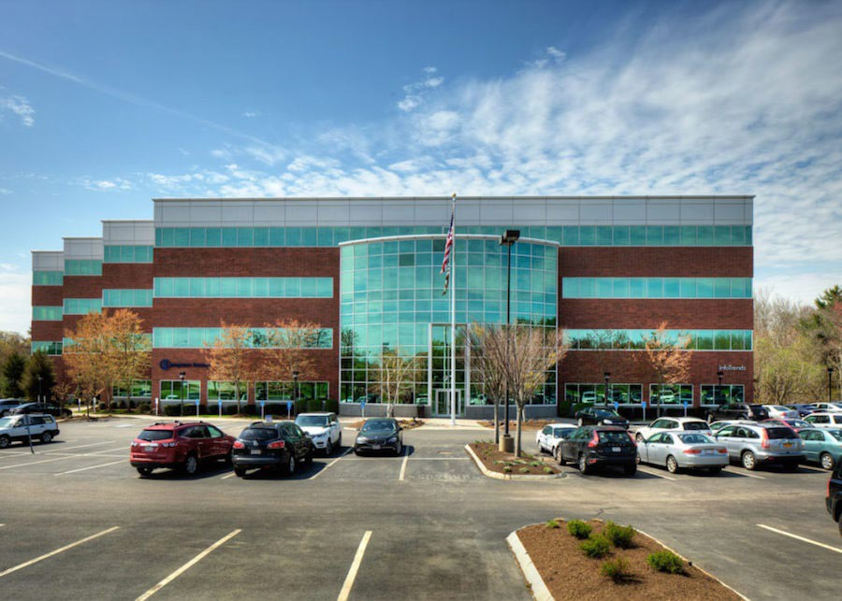

# Support for Local Community Providers

Local providers are supportive of this Proposed Project, including

1. South Shore Health
   * South Shore Hospital
   * South Shore Medical Center
2. Manet Community Health Center
3. Healthcare South P.C. and other area primary care practices

# Next Steps

* + Gather community input through this presentation
  + Keeping the public informed through news articles
  + Timeline of approval and construction
    - Official filing will occur on Spring 2024
    - The DON review process typically takes place over a 4-month period
    - If approved, we hope to move into the new center in January 2025

Questions or Feedback?

* We welcome and questions and feedback
* Contact: Mary Phillips

[Mary@WeymouthEndoscopy.com](mailto:Mary@WeymouthEndoscopy.com) 781-331-2922

Thank You!

# References

* + 1 - [Key Statistics for Colorectal Cancer](https://www.cancer.org/cancer/types/colon-rectal-%20cancer/about/key-%20statistics.html#:~:text=The%20American%20Cancer%20Society's%20estimates,men%20and%2018%2C890%20in%20women), AM. CANCER SOC. (last revised Jan. 29, 2024) ([https://www.cancer.org/cancer/types/colon-rectal-](https://www.cancer.org/cancer/types/colon-rectal-cancer/about/key-statistics.html#%3A%7E%3Atext%3DThe%20American%20Cancer%20Society%27s%20estimates%2Cmen%20and%2018%2C890%20in%20women) [cancer/about/key-](https://www.cancer.org/cancer/types/colon-rectal-cancer/about/key-statistics.html#%3A%7E%3Atext%3DThe%20American%20Cancer%20Society%27s%20estimates%2Cmen%20and%2018%2C890%20in%20women) [statistics.html#:~:text=The%20American%20Cancer%20Society's%20estimates,men%20and%2018%2C890%20in%20women](https://www.cancer.org/cancer/types/colon-rectal-cancer/about/key-statistics.html#%3A%7E%3Atext%3DThe%20American%20Cancer%20Society%27s%20estimates%2Cmen%20and%2018%2C890%20in%20women));
  + 2 - *See*, *Data Report November 2020 on Colorectal Cancer in Massachusetts*, MASS. DEPT. OF PUBLIC HEALTH (Nov. 2020) (available at: <https://www.mass.gov/doc/data-report-on-colorectal-cancer-in-massachusetts-november-2020/download>).
  + 3 - [Colorectal Cancer: What You Should Know About Screening](https://www.fda.gov/consumers/consumer-updates/colorectal-cancer-what-you-should-know-about-%20screening#:~:text=Your%20Colorectal%20Cancer%20Screening%20Choices&text=The%20gold%20standard%20for%20screening,no%20pr ecancerous%20changes%20are%20found), U.S. FOOD & DRUG ADMIN. (last revised Mar. 28, 2024), [https://www.fda.gov/consumers/consumer-updates/colorectal-cancer-what-you-should-know-about-](https://www.fda.gov/consumers/consumer-updates/colorectal-cancer-what-you-should-know-about-screening#%3A%7E%3Atext%3DYour%20Colorectal%20Cancer%20Screening%20Choices%26text%3DThe%20gold%20standard%20for%20screening%2Cno%20precancerous%20changes%20are%20found) [screening#:~:text=Your%20Colorectal%20Cancer%20Screening%20Choices&text=The%20gold%20standard%20for%20screening,no%20pr](https://www.fda.gov/consumers/consumer-updates/colorectal-cancer-what-you-should-know-about-screening#%3A%7E%3Atext%3DYour%20Colorectal%20Cancer%20Screening%20Choices%26text%3DThe%20gold%20standard%20for%20screening%2Cno%20precancerous%20changes%20are%20found) [ecancerous%20changes%20are%20found](https://www.fda.gov/consumers/consumer-updates/colorectal-cancer-what-you-should-know-about-screening#%3A%7E%3Atext%3DYour%20Colorectal%20Cancer%20Screening%20Choices%26text%3DThe%20gold%20standard%20for%20screening%2Cno%20precancerous%20changes%20are%20found).
  + 4 - *See*, Colorectal Cancer: Screening, U.S. PREVENTATIVE SERVICES TASK FORCE (May 18, 2021) (<https://www.uspreventiveservicestaskforce.org/uspstf/recommendation/colorectal-cancer-screening>).
  + 5 - [Key Statistics for Colorectal Cancer](https://www.cancer.org/cancer/types/colon-rectal-%20cancer/about/key-%20statistics.html#:~:text=The%20American%20Cancer%20Society's%20estimates,men%20and%2018%2C890%20in%20women), AM. CANCER SOC. (last revised Jan. 29, 2024) ([https://www.cancer.org/cancer/types/colon-rectal-](https://www.cancer.org/cancer/types/colon-rectal-cancer/about/key-statistics.html#%3A%7E%3Atext%3DThe%20American%20Cancer%20Society%27s%20estimates%2Cmen%20and%2018%2C890%20in%20women) [cancer/about/key-](https://www.cancer.org/cancer/types/colon-rectal-cancer/about/key-statistics.html#%3A%7E%3Atext%3DThe%20American%20Cancer%20Society%27s%20estimates%2Cmen%20and%2018%2C890%20in%20women) [statistics.html#:~:text=The%20American%20Cancer%20Society's%20estimates,men%20and%2018%2C890%20in%20women](https://www.cancer.org/cancer/types/colon-rectal-cancer/about/key-statistics.html#%3A%7E%3Atext%3DThe%20American%20Cancer%20Society%27s%20estimates%2Cmen%20and%2018%2C890%20in%20women)); [Incidence of Esophageal Adenocarcinoma is Increasing in Younger Adults](https://www.aacr.org/about-the-aacr/newsroom/news-releases/incidence-of-esophageal-adenocarcinoma-is-increasing-in-younger-%20adults/#:~:text=PHILADELPHIA%20%E2%80%93%20Esophageal%20adenocarcinoma%20is%20occurring,American%20Association%20 for%20Cancer%20Research), AM. ASS’N FOR CANCER RESEARCH (Dec. 16, 2020) (available at: https://[www.aacr.org/about-the-aacr/newsroom/news-releases/incidence-of-esophageal-adenocarcinoma-is-increasing-in-younger-](http://www.aacr.org/about-the-aacr/newsroom/news-releases/incidence-of-esophageal-adenocarcinoma-is-increasing-in-younger-) adults/#:~:text=PHILADELPHIA%20%E2%80%93%20Esophageal%20adenocarcinoma%20is%20occurring,American%20Association%20 for%20Cancer%20Research)
  + 6 - [Can Colorectal Polyps and Cancer Be Found Early](https://www.cancer.org/cancer/types/colon-rectal-cancer/detection-diagnosis-staging/detection.html)?, AM. CANCER SOC. (last revised Jan. 29, 2024) (<https://www.cancer.org/cancer/types/colon-rectal-cancer/detection-diagnosis-staging/detection.html>); [Survival Rates for Esophageal Cancer?,](https://www.cancer.org/cancer/types/esophagus-cancer/detection-diagnosis-%20staging/survival-rates.html) AM. CANCER SOC. (last revised Jan. 27, 2024) (https://[www.cancer.org/cancer/types/esophagus-cancer/detection-diagnosis-](http://www.cancer.org/cancer/types/esophagus-cancer/detection-diagnosis-) staging/survival-rates.html)