Contributors: Antonia Blinn, BS, CPHQ, LSSBB; Elizabeth Pinto, MPH; Pia Markkanen, ScD, MSc; Rachel Lee, BS; Emily Song, BS; and Hae-In Kim, MPH
Suggested Citation: Massachusetts Department of Public Health, Scan of Community Health Improvement & Community Health Implementation Plans from Across Massachusetts, 2019 – May 2023, August 2023. May 2024.
Executive Summary

Introduction: As part of the State Health Assessment (SHA) and State Health Improvement Planning (SHIP) processes, the Massachusetts Department of Public health (MDPH) collected and analyzed community health improvement and community health implementation plans from health systems, hospitals, organizations, and municipalities across the state. These community health improvement and implementation plans provide an opportunity to discover health and racial equity needs in the various populations serviced by the individual hospital systems Furthermore, they provide an opportunity to develop and implement strategies that bring improvements in systems and structures, including access to care specifically to historically marginalization populations. Utilizing qualitative and quantitative data, community health improvement and community health implementation plans were analyzed for the identification of priority health needs. The purpose of this analysis was to ensure that the SHA includes most of the key health issues identified in these documents.
Methods: Community health improvement and implementation plans completed between 2019-2023 were collected through the Massachusetts Attorney General’s Annual Community Benefits Reports search tool known Community Health Improvement Plans from previous year analysis, and Google searches. Exclusion criteria were established so that specialty hospitals and those health systems serving many out of state populations were excluded. The documents fitting the inclusion criteria were compiled into a data base for review and analysis. The final database includes the review of 52 documents.
Each document was read and coded using NVIVO, a qualitative data analysis software. The final merged analysis was completed using NVIVO version 14, released in 2023. For coding, a pre-determined coding system was applied (i.e., deductive coding). The highest levels of “parent” nodes, or key words and phrases, included the following: (i) Priority Needs Areas, (ii) Priority Populations, and (iii) Racial Equity. In total 52 different documents -- comprising in total about one thousand pages -- were coded using NVIVO Software. Coding reports were generated for high and medium levels of racial health equity content.
Results: The 52 analyzed documents cover most municipalities in Massachusetts. Table 1 lists the parent and their first-level child nodes and number of documents these nodes are coded.
Coded Key Words and Phrases Identified from the 52 Analyzed Documents: The appendix shows the three sets of key words or phrases and the number of documents where each key words were coded. These are considered nodes. Out of the Priority Needs areas the ten child nodes with the greatest number of documents coded were as follows (number of documents coded): mental health-behavioral health (52), alcohol and substance use (50), chronic disease (42), housing (40), poor nutrition (39), cancer (29), homelessness (26), poverty (25), youth development (24), and lack of physical activity (22). For the Priority Populations parent node, the top seven child nodes were: youth (38), elderly-aging population (34), individuals who do not speak English (31), individuals with mental illness (23), individuals experiencing homelessness (22), immigrants (18), and violence survivors (17). For the Racial Equity parent node, three categories were established to characterize the strength of racial equity in the documents. There were 29 documents categorized as low strength of racial equity, 18 categorized as medium strength of racial equity, and 13 categorized as high strength of racial equity.
Conclusions and Recommendations: MDPH aims to advance racial equity throughout the Commonwealth. Community Health Assessments (CHA), Community Health Improvement Plans, and Community Health Implementation Plans (CHIP) describe the status of health in their respective communities. As understanding of populations evolve, future CHAs and CHIPs have the opportunity to address inequities and racism more explicitly. The analysis identified the top priority needs areas that the State Health Assessment (SHA) should include (Appendix A). The analysis also revealed which priority populations communities and health systems are focused on and should be considered when putting the SHA together (Appendix B).
MDPH recommends the following ways to include racial equity in these types of future improvement and implementation plans:
- Provide specific interview guidance.
- Provide racial equity training.
- Recommend community-level interventions.
- Perform regular analysis of demographics and social determinants of health data.
- Share data on priority populations.

Suggestions for next analysis:
- Begin with a list of priority populations.
- Similar NVIVO versions.
- Consistent quality checks of the analysis.
- Establish a quick tips & tricks guide to NVIVO.
- Increase community engagement particularly with priority populations.
- Take goals and activities from the MDPH Strategic Plan to Advance Racial Equity.

The information gathered through this analysis will inform the 2024 Massachusetts SHA and SHIP.

Introduction
Achieving accreditation is an important goal for any state health department. The Public Health Accreditation Board (PHAB) is a voluntary public health accreditation organization whose goal is to advance public health performance by providing a national framework of standards for tribal, state, local, and territorial health departments. The Massachusetts Department of Public Health (MDPH) was granted accreditation by PHAB in November 2017. In December 2022, the MDPH applied for and was granted an extension for its application for reaccreditation. In December 2023, the MDPH applied for reaccreditation and has approximately six months to finalize the collection and uploading of necessary narratives, documentation, and examples.
Two requirements for reaccreditation are a regularly updated State Health Assessment (SHA) and State Health Improvement Plan (SHIP). A SHA is the result of a collaborative and systematic process involving the collection, analysis, and interpretation of a prioritized subset of available state level data. The goal of this process is to provide a current state of health context for health across populations in the state. Individuals, organizations, and coalitions can reference the SHA when applying for state, federal, or private funding. In addition, coalitions and MDPH staff can also reference the SHA when conducting state level improvement planning.
Similar to a SHA, a Community Health Assessment (CHA) describes the status of health in a particular community. Health Improvement Plans or Community Health Implementation Plans (CHIP) compliment the CHA. According to the Attorney General’s website, the Patient Protection and Affordable Care Act (the “ACA”) passed in 2010 included federal requirements for how nonprofit hospitals approach Community Benefits, including standards for Community Health Needs Assessments (CHNAs) and Implementation Strategies, as well as public reporting on Community Benefits programs. MDPH updated its Determination of Need (DoN) regulations in 2017 and included new guidelines on statewide health priorities and community engagement for the DoN Community Health Initiative program. In addition, other organizations and municipalities have taken the initiative to conduct community health implementation plans for their communities either for PHAB documentation requirements or to establish a collaborative plan of action with other agencies and community-based organizations and local health departments in their region.
The MDPH Performance Management and Quality Improvement (PMQI) team has been charged with leading the 2024 Massachusetts State Health Assessment process. As part of this process, the PMQI team conducted a scan of Community Health Improvement Plans and CHIPs (herein referred to as “Documents”) from healthcare and public health entities across the state of Massachusetts. Data were collected from these documents and analyzed to ensure that the SHA includes most of the prominent health issues identified for these communities.
Methods: Description of Coding Process with NVIVO software
NVIVO is a qualitative data analysis software that the team utilized to create nodes to code each document. A deductive coding approach was applied in which the team members decided the nodes for coding beforehand. In total, four team members performed coding with their own NVIVO software version. Each team member was assigned a set of documents to be coded. The members met via Zoom on either a weekly or bi-monthly basis to discuss their coding work. At the very end, all individual coding projects were merged into one “master” NVIVO project database. NVIVO version 14 (released in 2023) for Windows was used as the main project database; the final changes were applied on this master project database.
Documents completed between 2019-2023 were collected through the Massachusetts Attorney General’s Annual Community Benefits Reports search tool, and Google searches. Additional exclusion criteria were established so that specialty hospitals, and those health systems serving many out of state populations were excluded. The final database includes 52 documents.
Each document was read and coded using NVIVO (version 14, released in 2023). For coding, a pre-determined coding system was applied (i.e., deductive coding). The highest levels of “parent” nodes included the following: (i) Priority Needs Areas, (ii) Priority Populations, and (iii) Racial Equity. Each parent node comprised a set of lower level “child” nodes as described below.
Priority Needs Areas
For the parent node “Priority Needs Areas”, the following 25 child nodes were determined beforehand and applied during coding (listed according to the coding frequency in analyzed documents):
- Mental Health/Behavioral Health
- Alcohol and Substance Use
- Chronic Disease
- Housing
- Poor Nutrition
- Cancer
- Homelessness
- Poverty
- Youth Development
- Lack of Physical Activity
- Tobacco Use and Vaping
- Domestic and community violence
- Environmental Concerns
- Social Isolation
- Emergency Preparedness
- Stroke
- Infectious and Communicable Disease
- Public Safety
- Suicide
- Injuries
- Reproductive Health and Sexual Health
- Lack of Access
- Transportation
- Oral Health
- Problem Gambling
Priority Populations:
For the parent node “Priority Populations”, the following 16 child nodes were determined beforehand and applied during coding (listed according to the coding frequency):
- Youth
- Elderly/Aging Population
- Individuals who do not speak English
- Individuals without Access to Public Transport
- Individuals Experiencing Homelessness
- Individuals with Mental Illness
- Violence Survivors (e.g., intimate partner, gun violence, community)
- Immigrants
- People of Color
- Individuals with Disabilities
- Identify as LGBTQIA+
- Hispanic
- Asian
- Black
- Indigenous/Native American
- Middle Eastern

Racial Equity
For the parent node “Racial Equity”, three categories were established to characterize the strength of racial equity in documents: low, medium, and high. These categories are defined as follows:
Low:
- Demonstrates an awareness of racial health equity.
- Disparities – generally recognizes disparities as a problem, but not demonstrably core to mission.
- Data – acknowledges data gaps and alludes to collecting and reporting data by race/ethnicity.
- Determinants – alludes to social determinants of health and distribution by race/ethnicity in general.
Medium:
- Demonstrates substantive, if inconsistent, attention to racial health inequities and concrete strategies to ameliorate them.
- Disparities – acknowledges root causes of disparities.
- Data – shows good awareness of current states and future population health goals.
- Determinants – displays solid understanding of social determinants of health related to the Massachusetts Department of Public Health (MDPH) missions and services and proposes some strategies for mitigation.
High:
- Demonstrates deep understanding of racial equity disparities, their root causes, as well as the organization’s role in perpetuating them, and offers concrete strategies for dismantling them.
- Disparities – emphasizes the importance of power-sharing and healing disparities.
- Data – sets specific targets for racial and ethnic populations, more nuanced goals for data collection infrastructure related to racial disparities.
- Determinants – displays a keen and nuanced understanding of social determinants of health, including practices at MDPH.
In total, 52 different documents -- comprising in total about one thousand pages -- were coded using the NVIVO software. Coding reports were generated for high and medium levels of racial health equity content.

ResultsRacial Equity Coding
Thirteen (13) plans comprising 25% of the documents reviewed were coded as “high racial equity”. These plans included:
- Beth Israel Deaconess - Milton Implementation Strategy 2020-2022,
- Beth Israel Lahey Health Anna Jacques Hospital Implementation Strategy FY23-25,
- Greater Worcester Community Health Improvement Plan,
- Greater Lowell Community Health Improvement Plan, 2020 CHIP,
- Mass General Brigham Boston and North Suffolk Regional Community Health Improvement Plan 2023,
- Mass General Hospital, Center for Community Health Improvement, Community Health Implementation Plan 2019-2020,
- Mount Auburn Hospital Implementation Strategy 2021,
- Newton Wellesley Hospital 2021-22 Community Health Improvement Plan,
- St. Elizabeth Medical Center Implementation Strategy,
- Tufts Medical Center Implementation Strategy,
- University of Massachusetts (UMass) Memorial Health Alliance-Clinton Hospital Community Benefits Strategic Implementation Plan 2019-2020,
- UMass Memorial Medical Center (Worcester) Community Benefits Strategic Implementation Plan, and
- Winchester Hospital Implementation Strategy.
Eighteen (18) documents comprising 35% of the documents reviewed were coded as “medium” racial equity. These included:
- Baystate Noble Strategic Implementation Plan 2020-2022,
- Boston CHNA-CHIP Collaborative Community Health Improvement Plan 2022,
- Emerson Hospital 2022,
- Greater Lowell Community Health Improvement Plan, 2020 CHIP
- Holyoke Medical Center 2020-2023 Community Benefit Implementation Strategy,
- Lawrence General Hospital Community Health Implementation Strategy 2020,
- Mass General Brigham Boston and North Suffolk Regional Community Health Improvement Plan 2023,
- Martha’s Vineyard Hospital, FY19 Community Benefit Strategic Implementation Plan,
- Mass General Hospital, Center for Community Health Improvement, Community Health Implementation Plan 2019-2020,
- Milford Regional Medical Center, Community Health Needs Assessment 2021,
- Newton Wellesley Hospital 2021-22 Community Health Improvement Plan,
- South Shore Health, 2022-2024 Implementation Strategy,
- St Elizabeth Medical Center Implementation Strategy,
- Sturdy Memorial Hospital, Community Health Needs Assessment Implementation Plan, FY 2020-FY2022,
- Tufts Medical Center 2020-2022 Implementation Strategy,
- UMass Memorial Health Alliance-Clinton Hospital Community Benefits Strategic Implementation Plan 2019-2020,
- UMass Memorial Medical Center Implementation Strategy 2022, and
- Worcester Community Health Implementation Plan.
Additionally, racial equity strategies, activities, and programs were coded and found in 16 documents and through 58 references which constitutes 31% of the documents reviewed. The team did not conduct any further analysis on the racial equity and racism measures and goals that were coded in the analysis.
Word Queries
The project team ran several word queries with NVIVO software to identify which documents contained important terms or wording. Word frequency is a key concept in qualitative analysis especially when there are large collections of texts. It helps identify the most common and important words, as well as the patterns and relationships between them. These queried terms included such items as health equity, racial equity, and racism. Health equity was integrated into all documents reviewed.
Racism was mentioned in more than half of the analyzed documents or 30 documents with 118 references in 8% of documents reviewed. Structural racism was mentioned in seven documents with 16 references in 13% of documents reviewed and Institutional racism was found in three documents with 4 specific references.
The term “racial equity” was mentioned in the following ten documents:
- Mass General Brigham Boston and North Suffolk Regional Community Health Improvement Plan (CHIP),
- Baystate Noble Hospital Community Health Needs Assessment 2022,
- The Boston CHNA-CHIP Collaborative 2022,
- Cape Cod Healthcare: Cape Cod Hospital and Falmouth Hospital CHNA 2020 – 2022: Strategic Implementation Plan FY21,
- Nantucket Cottage Hospital 2021 Community Health Needs Assessment,
- Mount Auburn Hospital Implementation Strategy 2021,
- Mercy Medical Center Community Health Needs Assessment Implementation Strategy FY23-25,
- Newton-Wellsley Hospital 2022-2025 Strategic Implementation Plan,
- UMass Memorial Health Harrington Hospital, Community Benefits Strategic Implementation Plan 2022-2024, and
- Greater Worcester Community Health Improvement Plan 2012-2016.
The below Figure 1 shows the NVIVO generated word tree for racial equity in the 10 coded documents.
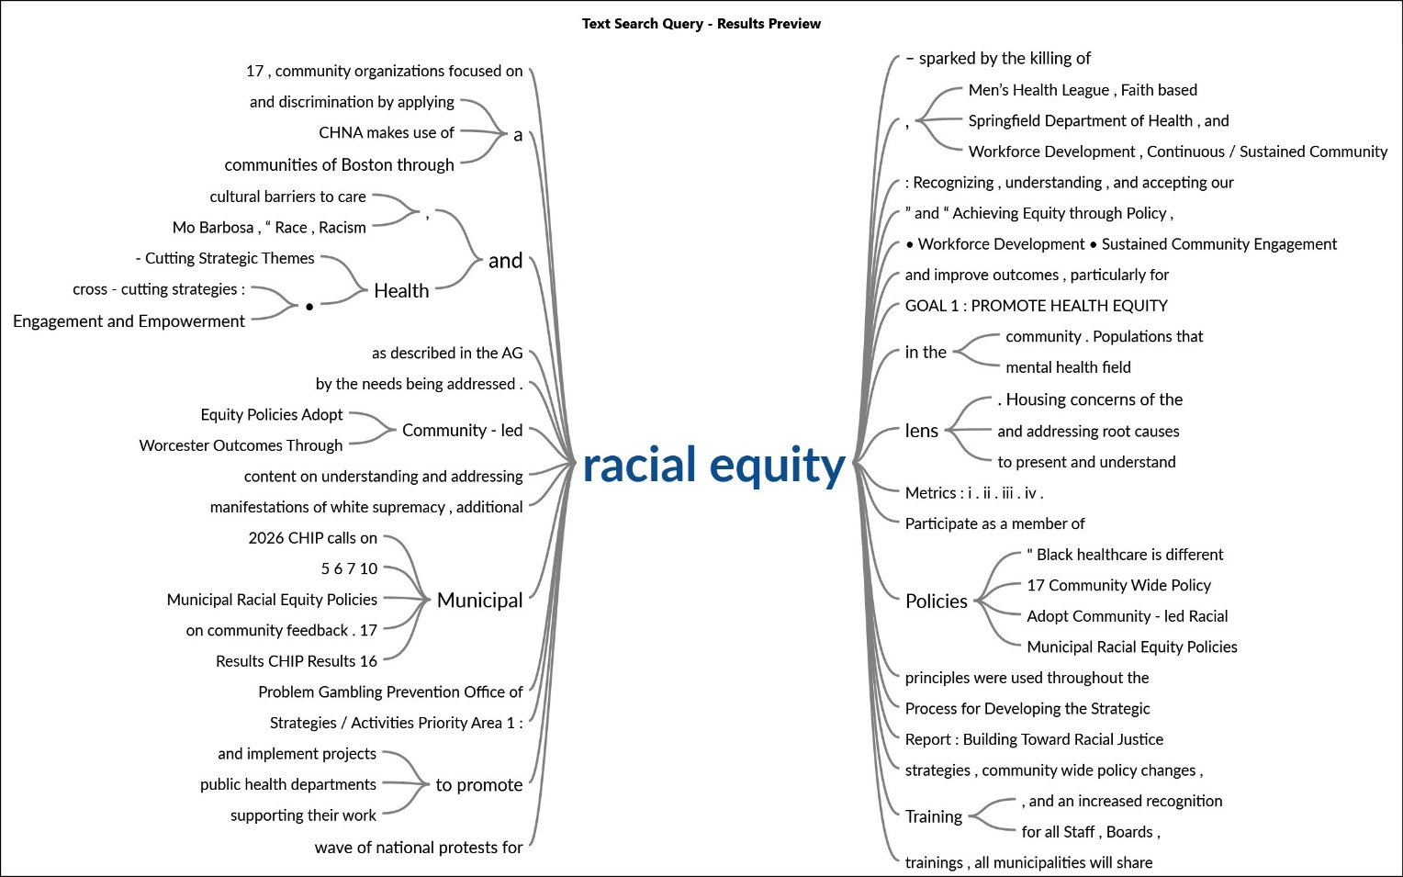
Figure 1: The word tree for “racial equity” generated by NVIVO Qualitative Data Analysis Software as a word query result.
Discussion

Out of the thirteen documents coded as ‘high racial equity’, there were 61 associated references. These references identify health equity as a priority goal and displayed an understanding of how social determinants of health -- like access to safe, affordable housing -- disproportionately impact health outcomes across different populations. Many name priority populations including Black, Indigenous, and People of Color, Immigrants and Dual Language learners, LBGTQ community members, youth and veteran populations. Some references highlight disparities among different populations, maternal-infant mortality rates among Black mothers and babies being a key example. Coded documents analyzed revealed that activities like providing multi-lingual, culturally relevant services, pushing for policy change and policy actions, and working with community partners are considered key strategies for achieving greater equity. Robust data collection and analysis were also referenced as essential for understanding baseline conditions as well as for tracking ongoing progress. Overall, these references demonstrate a commitment to addressing health disparities in the Commonwealth.
Of the eighteen documents coded as “medium racial equity”, there were 40 associated references comprising 35% of the documents reviewed. These associations identified barriers to healthcare and health equity as they relate to the social determinants of health with particular emphasis on disparities associated with gender, communities of color, youth and older adults, language, and economic stability. Workforce development for improved racial and cultural understanding and improved access to care was recognized as necessary for better population health through cultural humility and advocacy. Coded documents analyzed also identified focusing on priority populations- such as Black and Hispanic people with complex medical conditions- through community partners and organizations, focused health prevention strategies, promotion of wellness strategies, and healthcare accessibility, were found to be connected to improving health outcomes. Health literacy and education to improve health, injury prevention, systemic health disparities, and promote health equity were strategies recognized as instrumental in reducing racial and ethnic disparities. Mental health, substance use disorders, and COVID-19 were also identified as increasing cultural and racial equity disparities among youth, Latino males, and Black and Hispanic populations.
Limitations
There are many limitations to this analysis. The project team did not have full perspective of all CHIPs, it was limited to availability from the Attorney General’s website, Google searches, or individual knowledge of existence. Some documents were not current and some documents were brief in their length and expansiveness of an improvement or implementation plan. The documents within the same healthcare system utilized almost the same content. CHIPs often shared demographic information and were based on their service area which may not be as diverse in population by race/ethnicity, yet their discussions of inequities were limited in its depth and focus. The level of specificity was not consistent among all documents analyzed; some had more detail and some lacked detail. There was significant variability in the level of community engagement leading to the development of the CHIPs. For example, the level of community engagement, the level of specificity, and structure of the information presented in the CHIPs depended upon the vendor hired to conduct the CHIP. While communities have borders, the CHIPs often crossed multiple communities and often overlapped one another yet had different priority populations and different interventions. Finally, the document is counted in high, medium, or low racial equity based upon the highest level of coding in that document. The coding was specific to whether the document coded for each of these not for specific information in the document.

Conclusions and Recommendations
- The analysis identified the top priority needs areas that the Massachusetts State Health Assessment should include. These are listed in Appendix A.
- The analysis also revealed which priority populations communities and health systems are focused on and should be considered when putting the Massachusetts SHA together. These are listed in Appendix B.
- Given that only 25% of the coded documents included racial equity, MDPH has the opportunity to recommend the following ways to include racial equity in these types of future assessments:
  - Provide specific interview guidance. MDPH recommends specific questions to be used for key informant interviews and focus groups on structural racism explicitly.
  - Provide training. MDPH recommends guidance and training on understanding how to engage in conversation about social determinants of health.
  - Recommend community-level interventions. MDPH recommends additional discussion and analysis at the community level on identifying specifically where current programming is focused in addressing health issues. For example, there was little mention of upstream interventions, like policy interventions, yet there were many details about individual level programming changes.
  - Perform regular analysis. MDPH should conduct this type of analysis with each update to the SHA/SHIP.
  - Share data on priority populations. MDPH should consider sharing gaps of addressing priority populations or even providing a list of priority populations as identified by data provided by MDPH.
  - Take goals and activities from the MDPH Strategic Plan to Advance Racial Equity. Communities and health systems should review the MDPH Strategic Plan to Advance Racial Equity to identify other potential recommendations and next steps.
  - Provide links to recommendations on visuals such as from the Robert Wood Johnson Foundation

- Suggestions for next analysis:
  - Begin with a list of priority populations. Begin with a list of priority populations, it helps to identify gaps in focus of specific priority populations.
  - Similar NVIVO versions. All analysts should be provided access to the same version of NVIVO or even consider a shared project online.
  - Consistent quality checks of the analysis. To ensure consistency, have analyst team code, meet, and discuss the same documents.
  - Establish a quick tips & tricks guide to NVIVO –Include YouTube videos or a short instructional video/class to help with understanding of coding, uses, and limitations of NVIVO.
  - Community Engagement, particularly with Priority Populations. Include an analysis on types and specifics of community engagement.
  - Take goals and activities from the MDPH Strategic Plan to Advance Racial Equity. Communities and health systems should review the MA DPH Strategic Plan to Advance Racial Equity to identify other potential recommendations and next steps.
The information gathered through this analysis will inform the 2024 Massachusetts SHA and SHIP.

Acknowledgements
- UMass Lowell Department of Public Health provided the time of Dr. Markkanen for this Project.
- UMASS Lowell, Boston University School of Public Health, and Tufts University School of Medicine Graduate Programs – Master of Public Health provided the NVIVO licenses for staff and students engaged in the analysis.
Contributors
- Pia Markkanen, ScD, MSc – Visiting Faculty, O’Leary Library 540G, Department of Public Health, Zuckerberg College of Health Sciences, University of Massachusetts Lowell, 61 Wilder Street, Lowell, MA 01854.
- Elizabeth Pinto, MPH - Intern, Massachusetts Department of Public Health, 250 Washington Street, Boston, MA 02108.
- Hae In Kim, MPH - SHA/SHIP Program Manager, CDC Foundation, 600 Peachtree St NE #1000, Atlanta, GA 30308.
- Antonia Blinn, BS, CPHQ, LSSBB – Deputy Chief Operating Officer, Massachusetts Department of Public Health, 250 Washington Street, Boston, MA 02108.
- Emily Song - Intern, Massachusetts Department of Public Health, 250 Washington Street, Boston, MA 02118. Student, Tufts University School of Medicine Graduate Programs, Public Health.
- Rachel Lee – Intern, Massachusetts Department of Public Health, 250 Washington Street, Boston, MA 02118. Graduate student, Boston University School of Public Health.

APPENDIX A: Priority Needs Areas Identified in the Reports Analyzed
 | Number of Documents Coded
Mental Health-Behavioral Health | 50
Alcohol and Substance Use | 45
Chronic Disease | 42
Housing | 40
Poor Nutrition | 39
Cancer | 29
Homelessness | 26
Poverty | 25
Youth Development | 24
Lack of Physical Activity | 22
Tobacco Use and Vaping | 21
Domestic and Community Violence | 20
Environmental Concerns | 20
Social Isolation | 19
Emergency Preparedness | 15
Stroke | 13
Infectious and Communicable Disease | 12
Public Safety | 10
Suicide | 10
Injuries | 8
Reproductive Health and Sexual Health | 7
Lack of Access | 7
Transportation | 6
Oral Health | 5
Problem Gambling | 0

APPENDIX B: Priority Populations Identified in the Reports Analyzed
Key Words or Phrases | Number of Documents Coded
Youth | 38
Elderly-Aging population | 34
Individuals who do not speak English | 31
Individuals without access to public transport | 27
Individuals with mental illness | 23
Individuals experiencing homelessness | 22
Immigrants | 18
Survivors of violence | 17
People of Color | 15
Identify as LGBTQIA+ | 14
Individuals with disabilities | 14
Hispanic | 11
Asian | 8
Black | 8
Indigenous-Native American | 7
Middle Eastern | 0

APPENDIX C: Racial Equity Levels Identified in the reports analyzed
Key Words or Phrases | Number of Documents Coded
Low | 29
Medium | 18
Strategies, Activities, Programs | 16
Measures and Goals | 14
Social Determinates of Health (SDOH) | 14
High | 13

APPENDIX D: Racial Equity Specific Visuals
There were two documents that included borrowed from the Massachusetts Department of Public Health visuals as in Figure 2 below.
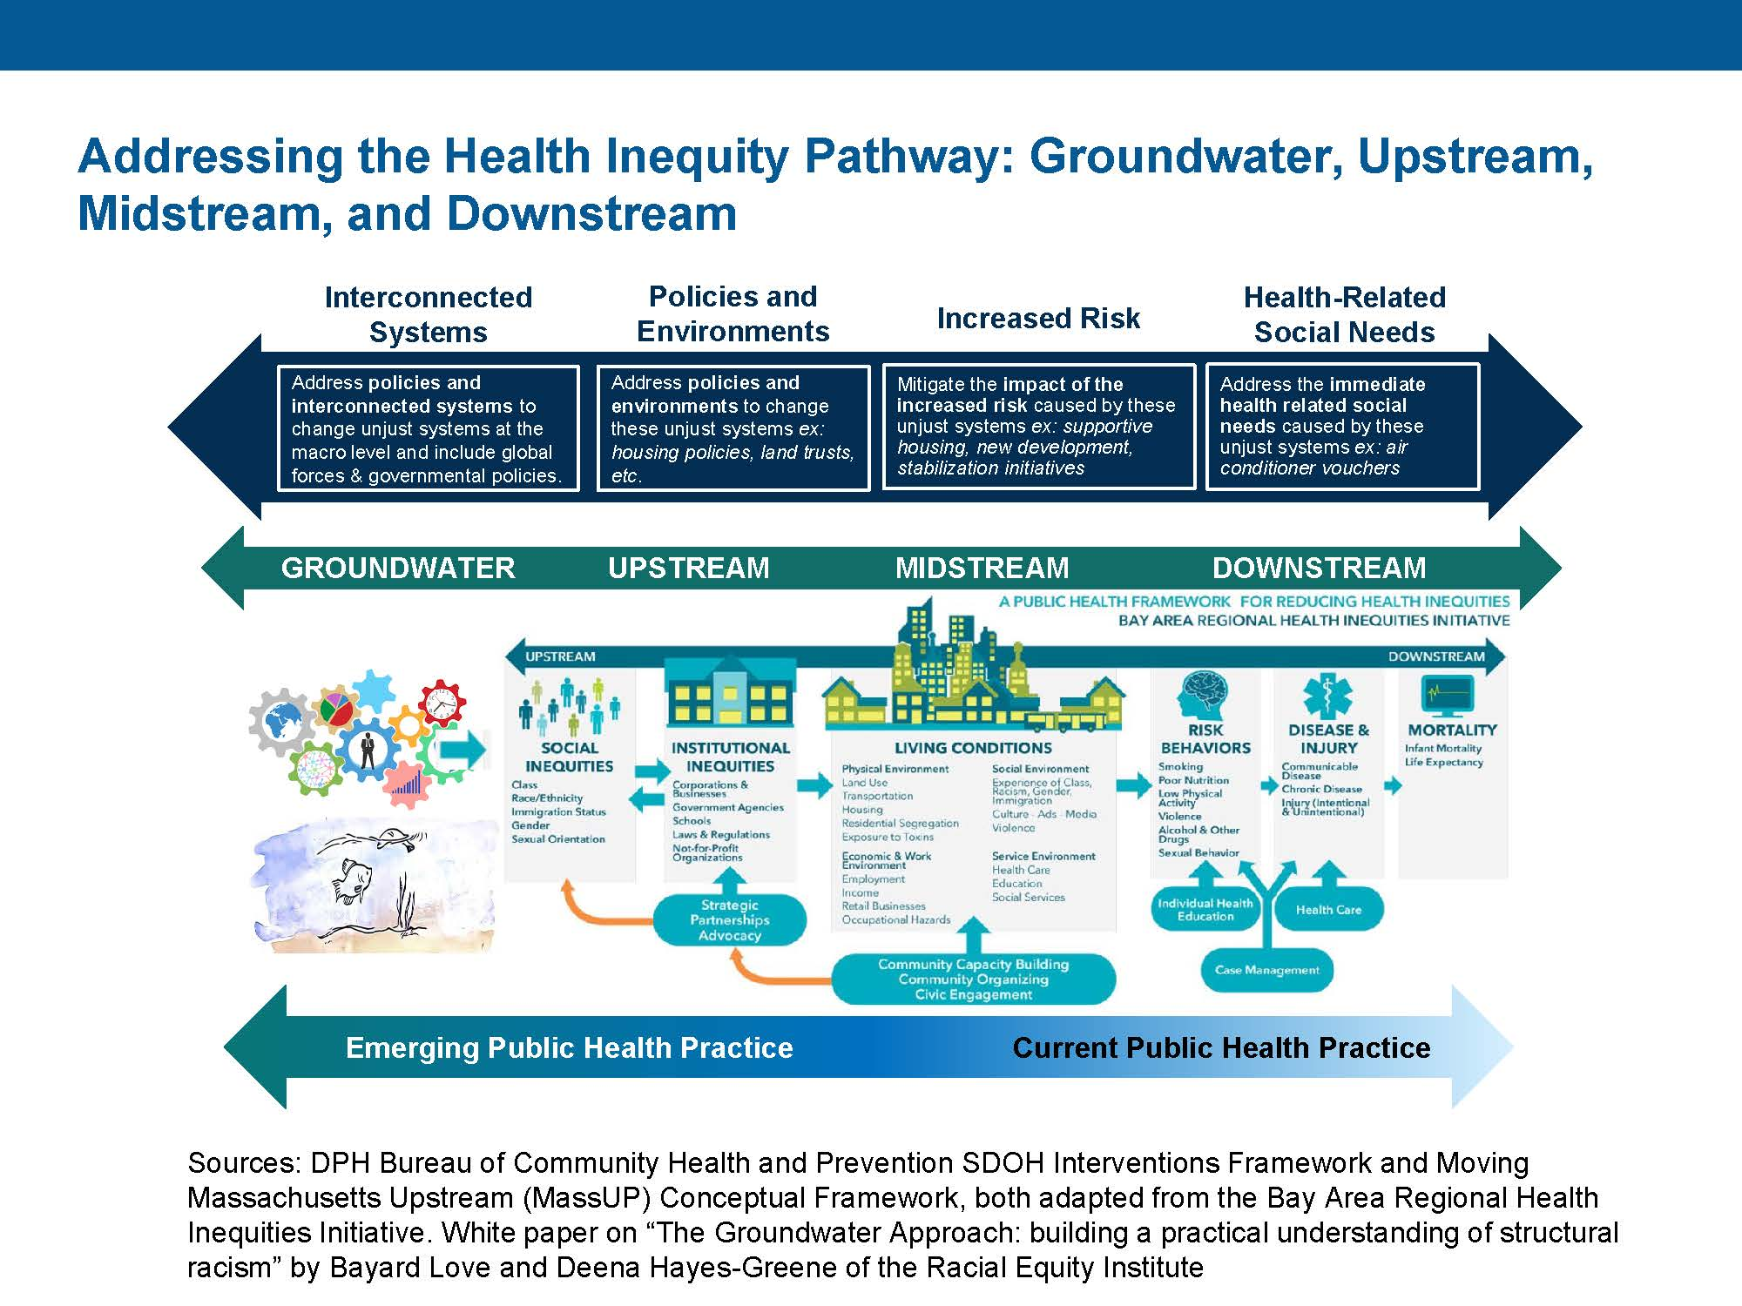
Figure 2. Massachusetts Department of Public Health Bureau of Community Health and Prevention SDOH Interventions Framework and Moving Massachusetts Upstream (MassUP) Conceptual Framework. Adapted from the Bay Area Regional Health Inequities Initiative (BARHII) Source: Athol Hospital and Heywood Hospital Community Health Improvement Plan 2022-2024.
This visual in Figure 3 is from UMass Memorial HealthAlliance-Clinton Hospital’s Community Benefits Strategic Implementation Plan. Their visual names racism and discrimination being addressed explicitly. 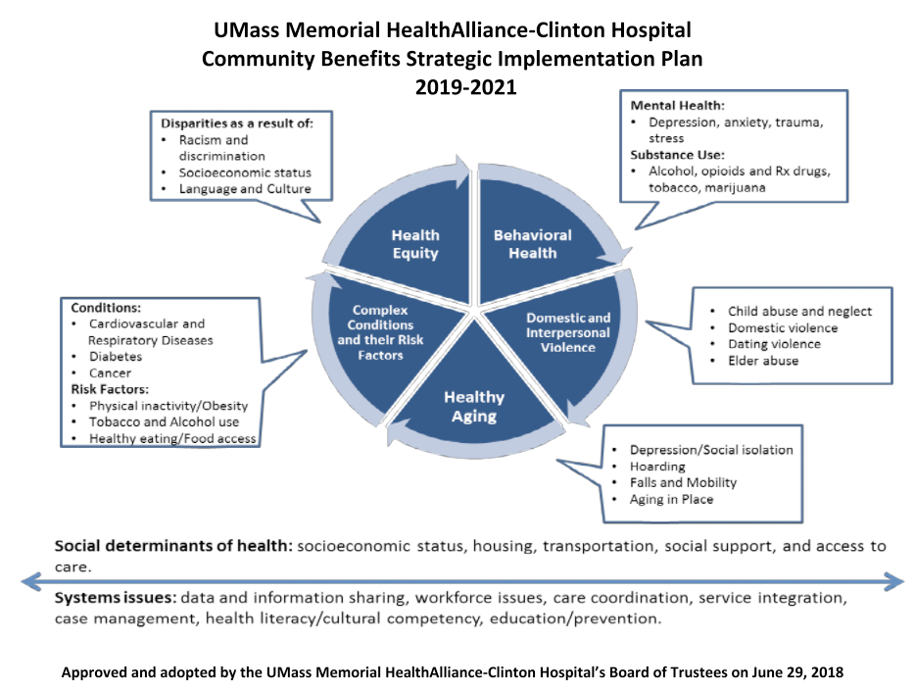
Figure 3. UMass Memorial HealthAlliance-Clinton Hospital Community Benefits Strategic Implementation Plan 2019-2021
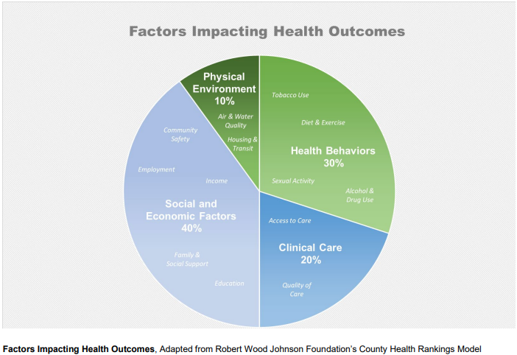
Figure 4. Factors Impacting Health Outcomes visual demonstrates how clinical care only contributes 20% to healthy outcomes for a population. The other 80% are factors related to social determinants of health. Source: Community Health Needs Assessment 2021 Berkshire Health Systems

APPENDIX E: List of All Documents Reviewed

Document Name
Anna Jacques Hospital FY23-FY25 Implementation Strategy
Athol Hospital and Heywood Hospital Community Health Improvement Plan 2022-2024
Baystate Franklin Medical Center Community Benefits Strategic Implementation Plan (SIP) 2020-2022
Baystate Medical Center Community Benefits Strategic Implementation Plan (SIP) 2020-2022
Baystate Noble Hospital 2022 Community Health Needs Assessment
Baystate Noble Hospital Community Benefits Strategic Implementation Plan (SIP) 2020-2022
Baystate Wing Hospital Community Benefits Strategic Implementation Plan (SIP) 2020-2022
Berkshire Health Systems Community Health Needs Assessment 2021
Beth Israel Deaconess - Milton Implementation Strategy 2020-2022 (Appendix D: Summary Implementation Strategy)
Beth Israel Deaconess - Needham FY23-FY25 Implementation Strategy
Beth Israel Deaconess - Plymouth FY23-FY25 Implementation Strategy
Beth Israel Deaconess Medical Center FY23-FY25 Implementation Strategy
Boston Children's Hospital Community Health Improvement Plan FY2022-2025
Boston CHNA-CHIP Collaborative 2022 Community Health Improvement Plan
Cape Cod Healthcare: Cape Cod Hospital and Falmouth Hospital CHNA 2020 – 2022: Strategic Implementation Plan FY21 – Year 2
Community Benefits Plan 2019-2021 Umass Memorial - Marlborough Hospital
Community Benefits Strategic Implementation Plan 2022-2024 for UMass Memorial Harrington Hospital an Affiliate of UMass Memorial Health
Community Benefits Strategic Implementation Plan 2022-2024 for UMass Memorial Medical Center an Affiliate of UMass Memorial Health
Cooley Dickinson Community Health Implementation Plan 2019-2022
Emerson Health 2022-2024 Strategic Implementation Plan
Greater Lowell Community Health Improvement Plan 2020 CHIP
Greater Worcester Community Health Improvement Plan 2021-2026
Holy Family Hospital Community Benefits Program Implementation Strategy 2021
Holyoke Medical Center 2020-2023 Community Benefit Implementation Strategy
Lahey Hospital and Medical Center FY23-FY25 Implementation Strategy
Lawrence General Hospital 2019 Implementation Strategy
Martha's Vineyard Hospital FY19 Community Benefit Strategic Implementation Plan
Mass General Brigham - Salem Hospital 2022 Community Improvement Plan (CHIP)
Mass General Brigham Boston and North Suffolk Regional Community Health Improvement Plan (CHIP) (?2023)
Massachusetts General Hospital 2019-2020 Community Health Implementation Plan
Melrose Wakefield Healthcare Community Health Implementation Plan 2020-2022
Mercy Medical Center Trinity Health Community Health Needs Assessment (CHNA) Implementation Strategy Fiscal Years FY23-25
Metrowest Community Health Improvement Plan 2021-2022
Milford Regional Medical Center - Community Health Needs Assessment Final Report - Community Health Implementation Plan 2021
Morton Hospital Community Benefits Plan 2021
Mount Auburn Hospital Implementation Strategy September 2021
Nantucket Cottage Hospital 2021 Community Health Needs Assessment
Nashoba Valley Medical Center 2022-2024 Community Health Implementation Plan (CHIP)
Newton -Wellesley Hospital 2021-22 Community Health Improvement Plan
Newton -Wellesley Hospital 2022-2025 Strategic Implementation Plan
Northeast Hospital Corporation Beverly Hospital and Addison Gilbert Hospital Implementation Strategy 2020-2022
Norwood Hospital Community Benefits Community Health Implementation Strategy 2022
Saint Anne's Hospital 2021 Community Benefits Implementation Strategy
Saint Vincent Hospital Implementation Strategies for 2022 goals
Signature Healthcare Implementation Strategy 2021/2022 (Brockton Hospital)
South Shore Health 2022-2024 Implementation Strategy
St. Elizabeth's Medical Center Community Benefits Implementation Strategy 2021
Sturdy Memorial Hospital Community Health Needs Assessment Implementation Plan FY 2020 - FY 2022
The Southcoast Health Community Benefits Implementation Strategy for FY2020-2022
Tufts Medical Center 2020-2022 Implementation Strategy
UMass Memorial HealthAlliance-Clinton Hospital Community Benefits Strategic Implementation Plan 2019-2021
Winchester Hospital Implementation Strategy 2020-2022

