National Career Clusters
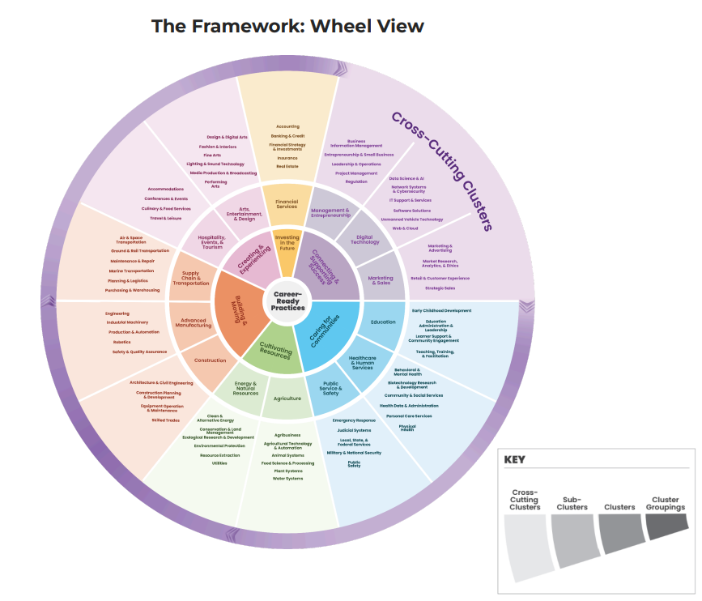

AGRICULTURE

Cluster Definition:
The Agriculture Career Cluster concentrates on scientific advancement of agriscience, cultivation, processing, and distribution of agricultural products, employing advanced technologies and sustainable practices to optimize global food systems.
This Cluster also supports other plant- and animal-based industries including regenerative agriculture, sustainable logging, and fisheries.
This Cluster has meaningful connections with the Energy and Natural Resources Cluster, highlighting a symbiotic relationship that emphasizes stewardship and resilient communities.

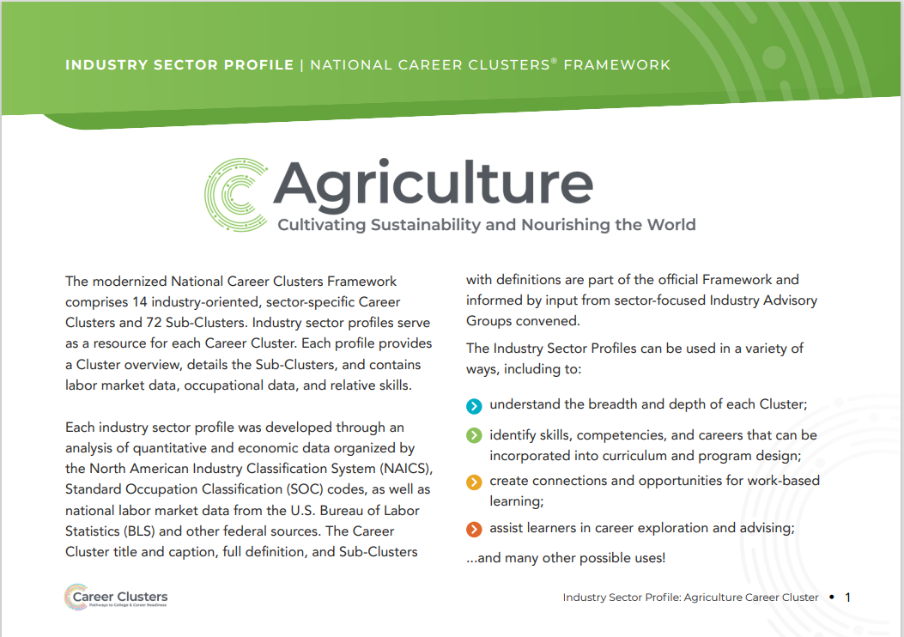
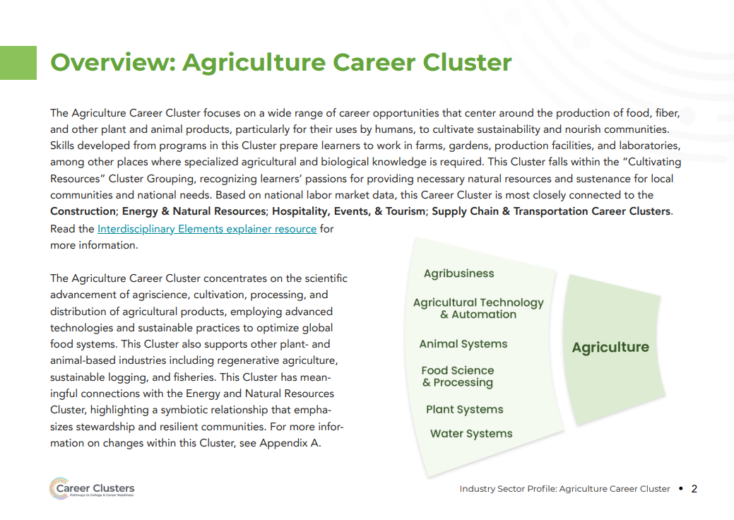
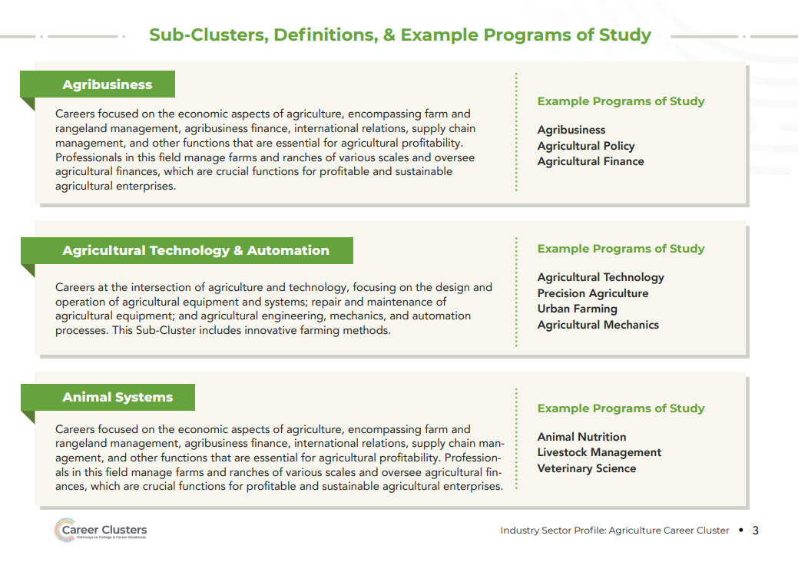
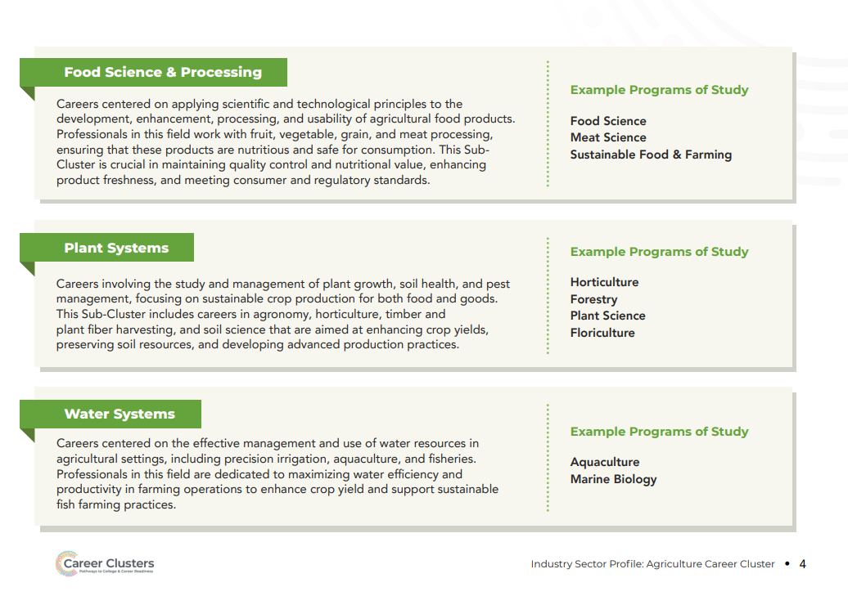
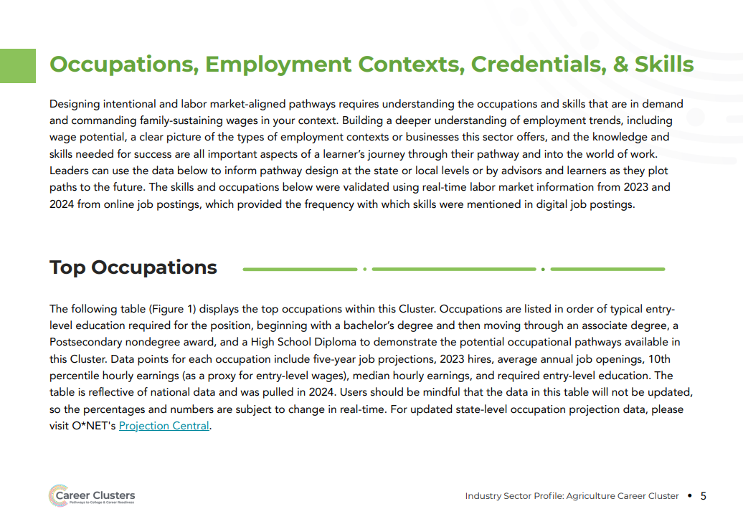
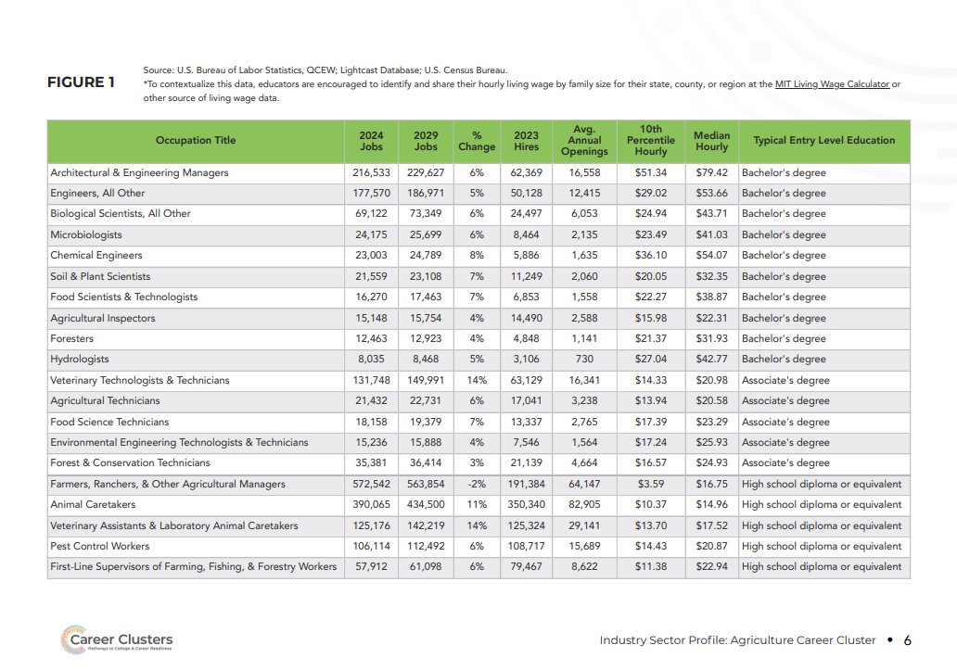
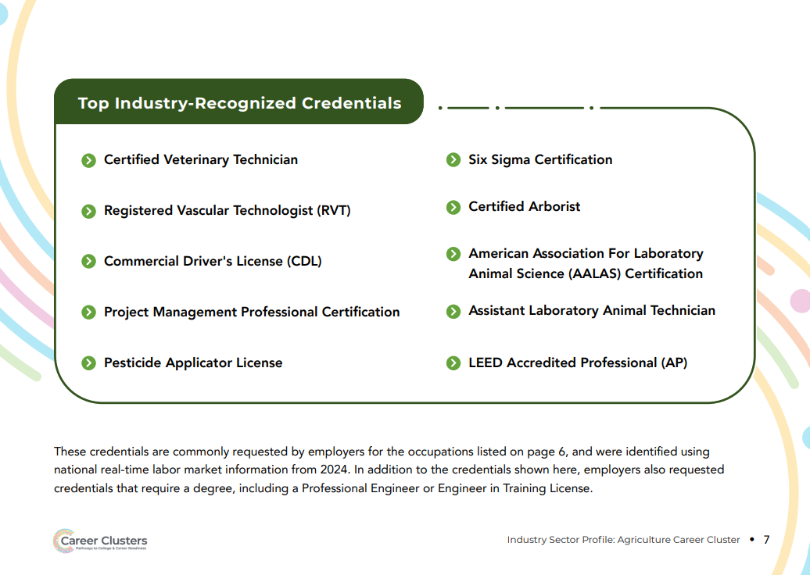
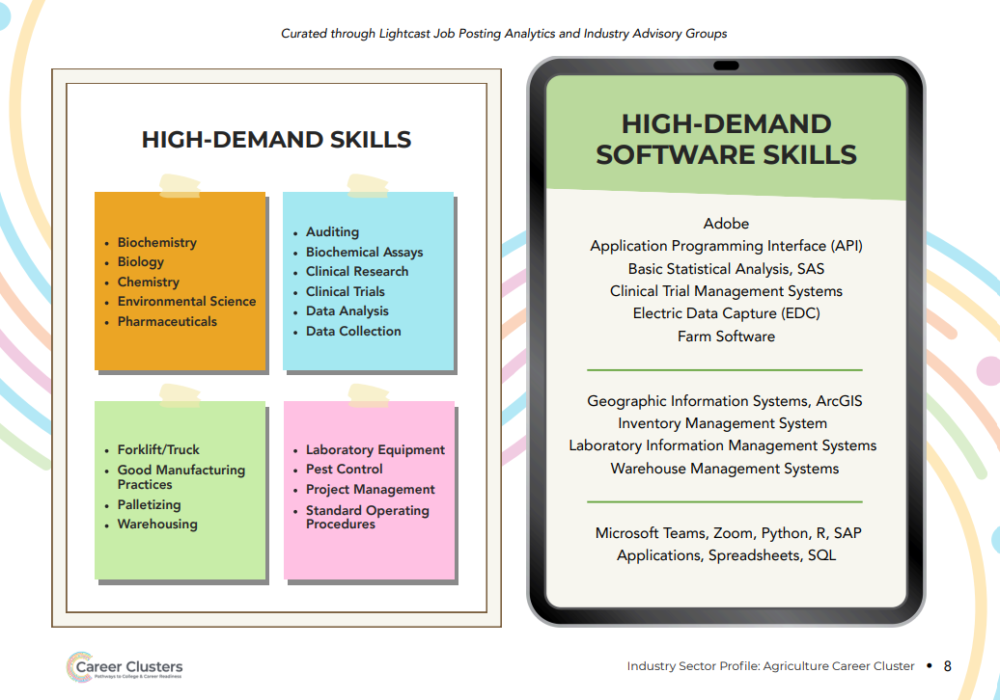
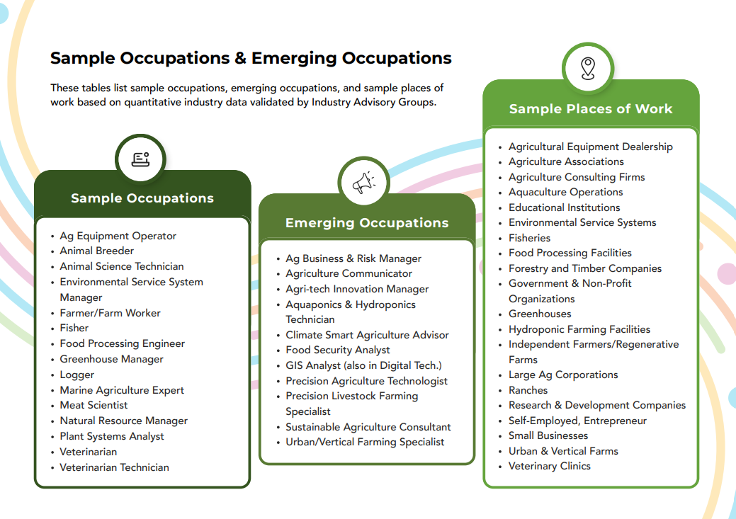
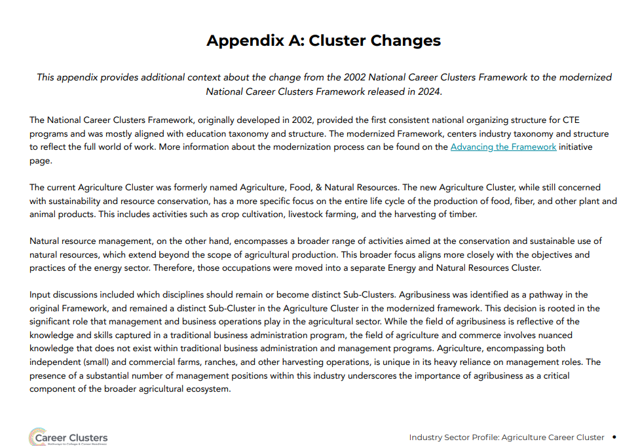
Advance Manufacturing

Cluster Definition:
The Advanced Manufacturing Career Cluster blends innovative technologies and practices to enhance design and production.
It covers areas such as engineering, research and development, automation and artificial intelligence, equipment maintenance, safety protocols, and quality control.
This Cluster aims to increase efficiency, reduce waste, ensure safety, and produce high-quality goods, driving the industry’s growth and adapting to modern demands

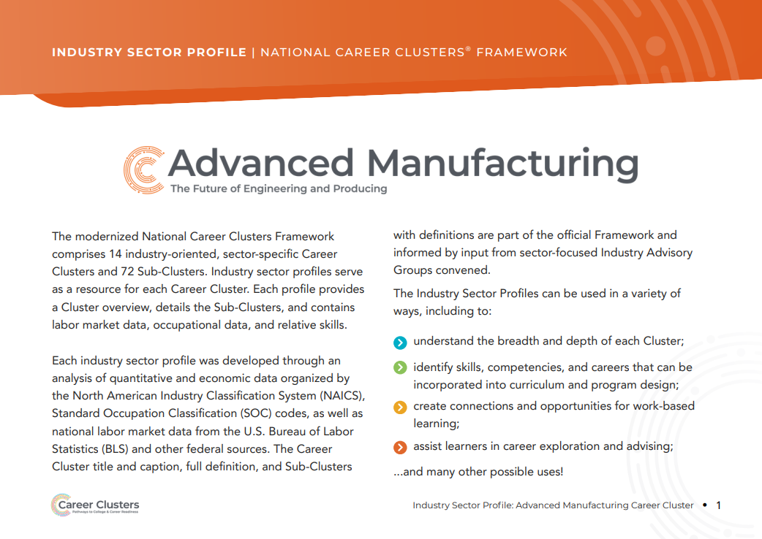
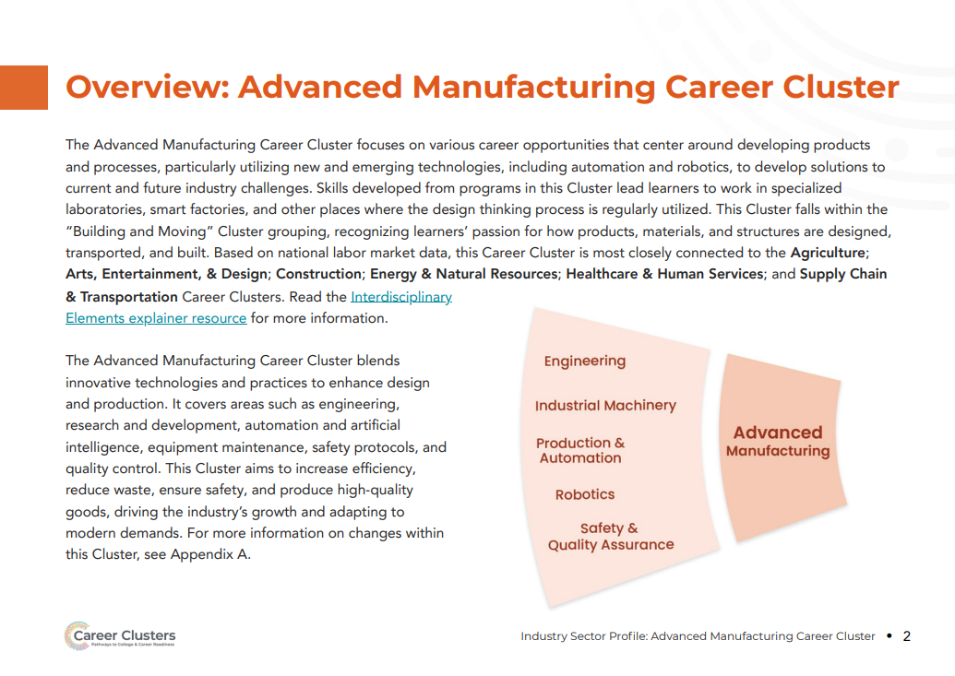
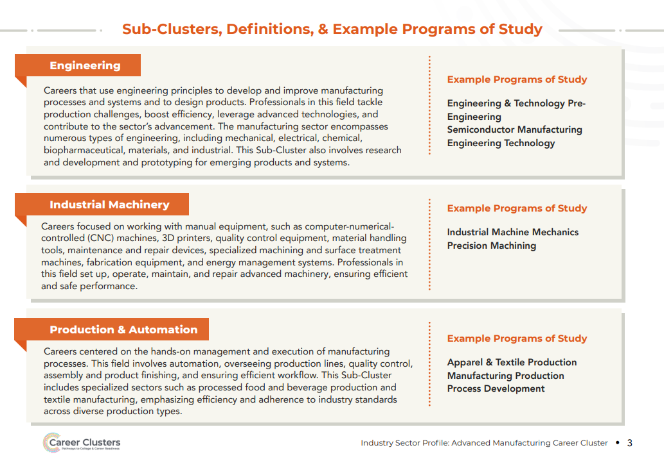
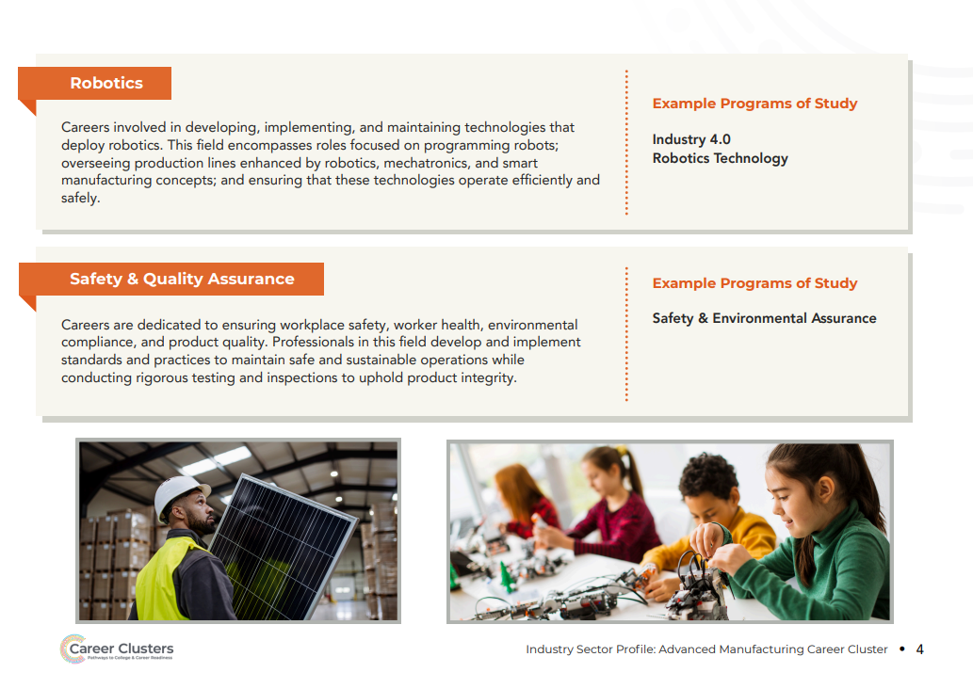
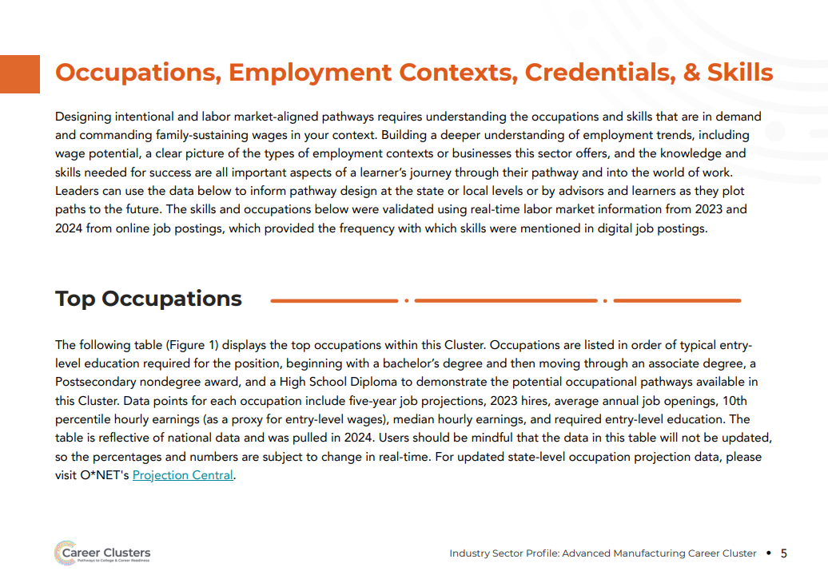
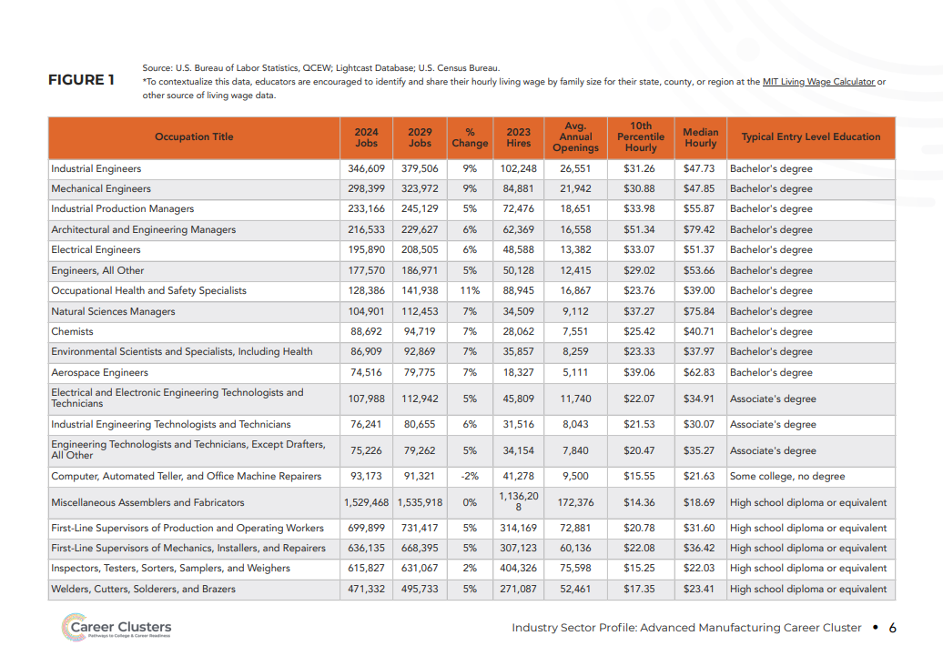
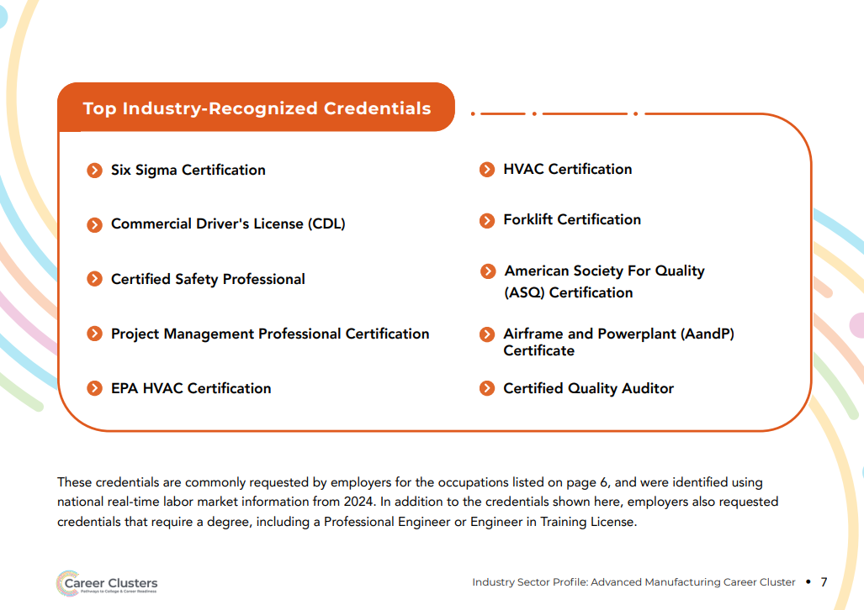
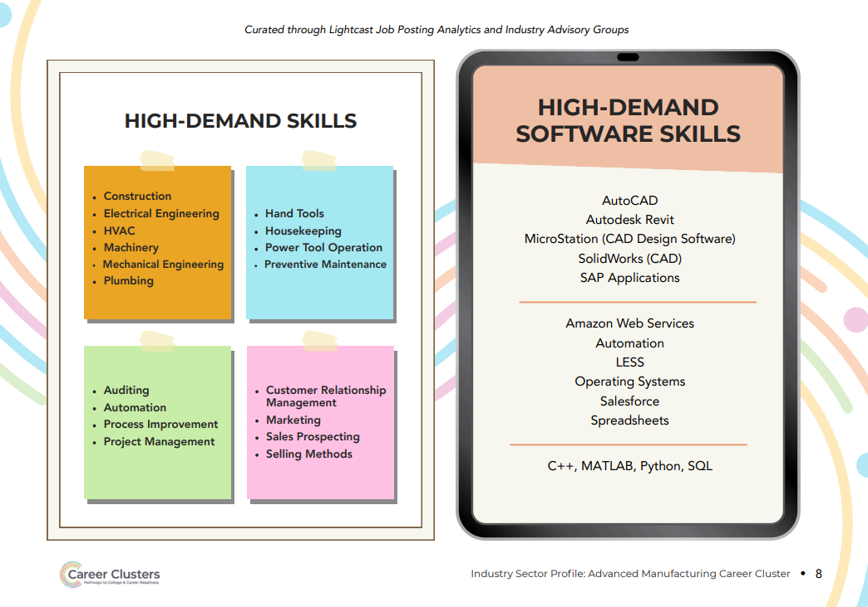
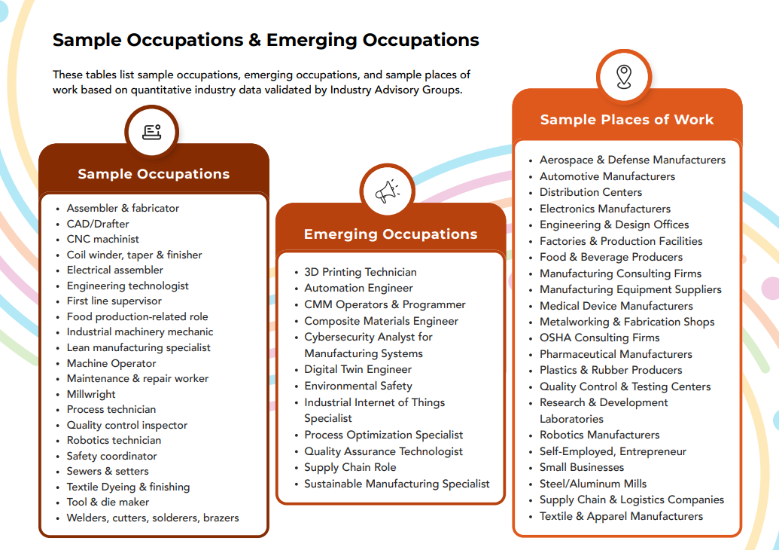
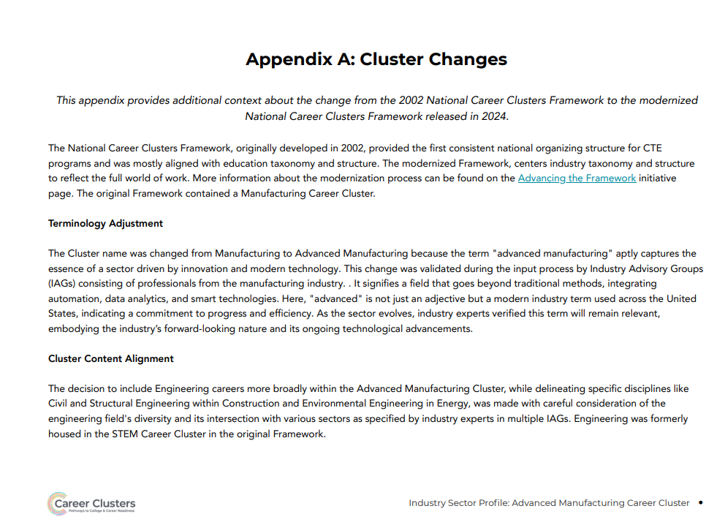

Arts Entertainment and Design

Cluster Definition:
The Arts, Entertainment, & Design Career Cluster combines creative roles in visual and performing arts, film, journalism, fashion, interior design, and creative technologies.
This Cluster focuses on creating, producing, and sharing artistic and design work across multiple platforms, aiming to entertain, inform, beautify, and inspire.

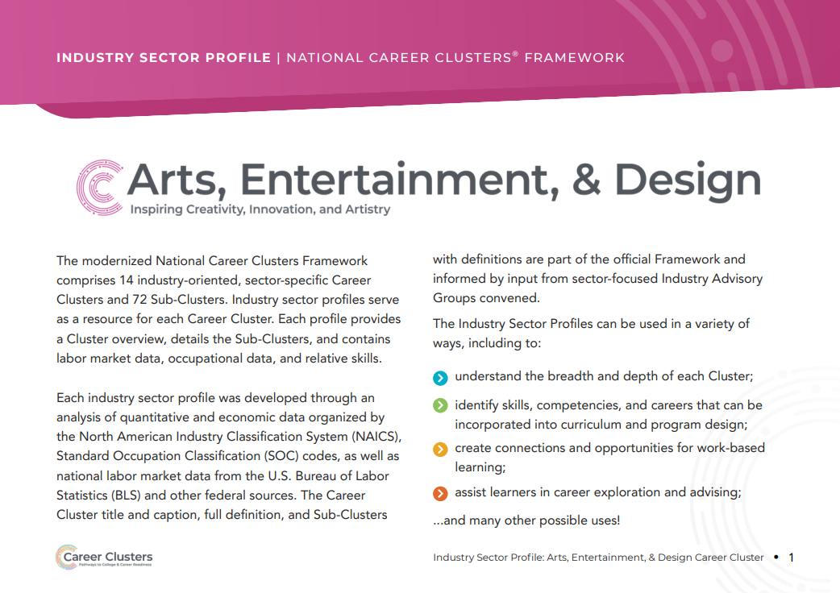
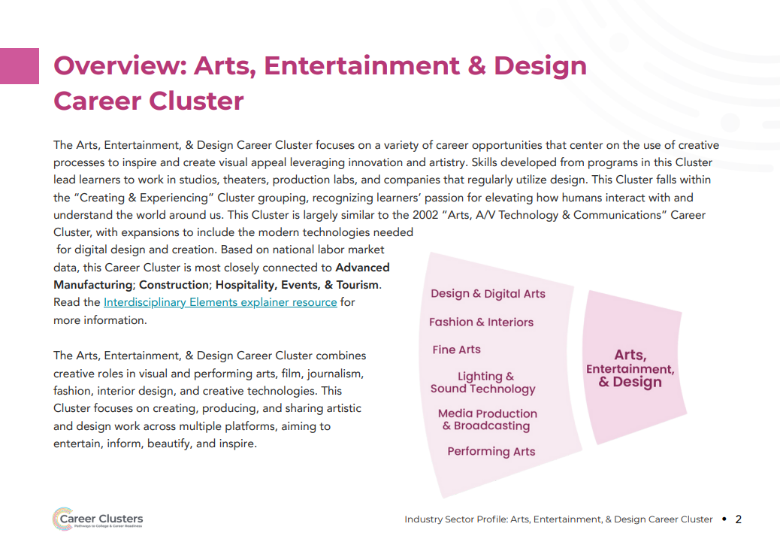
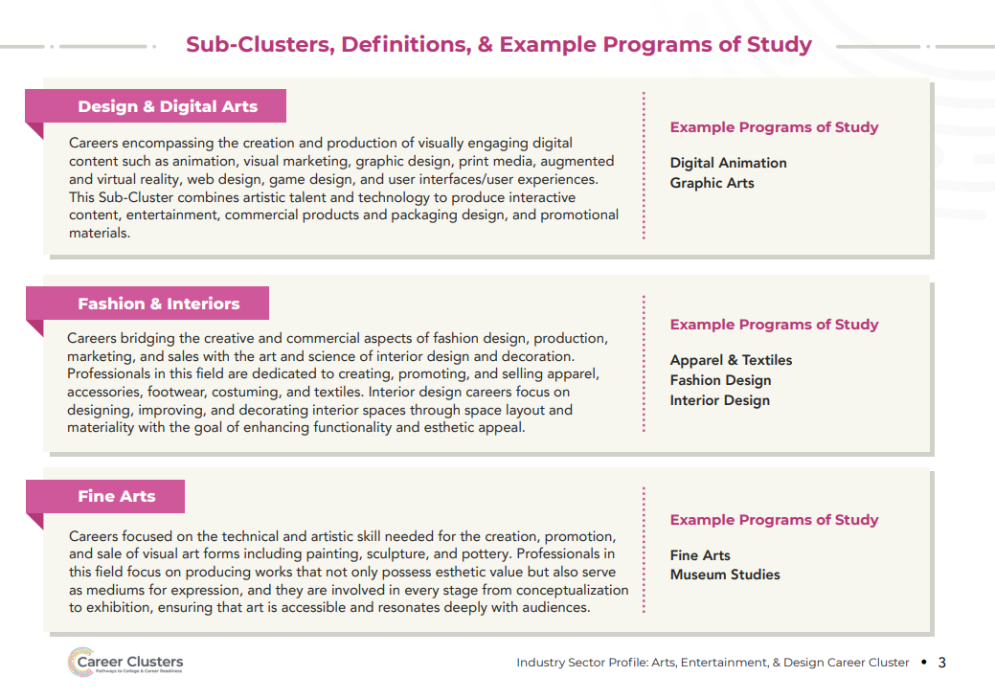
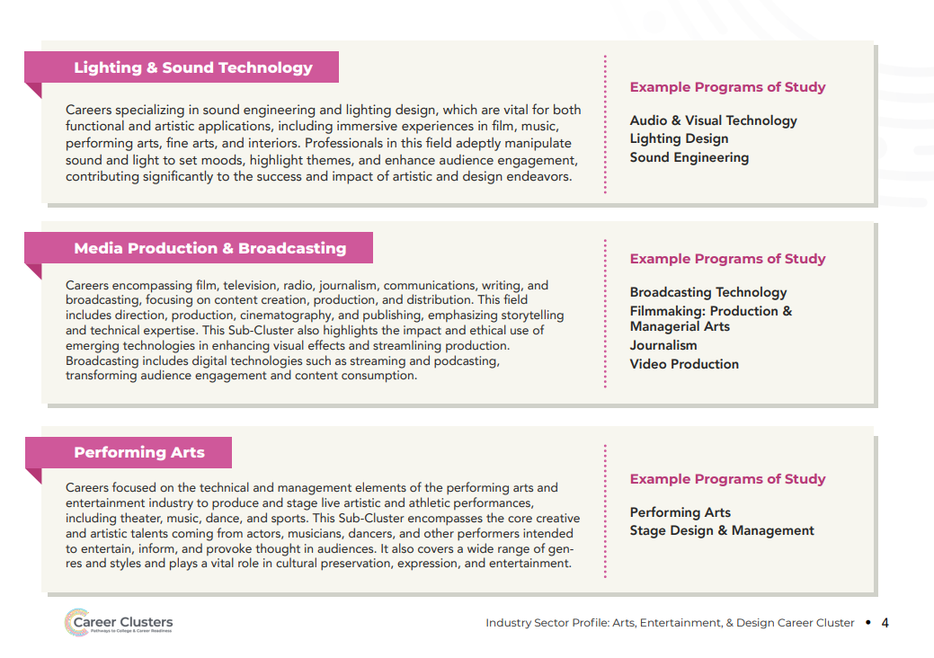
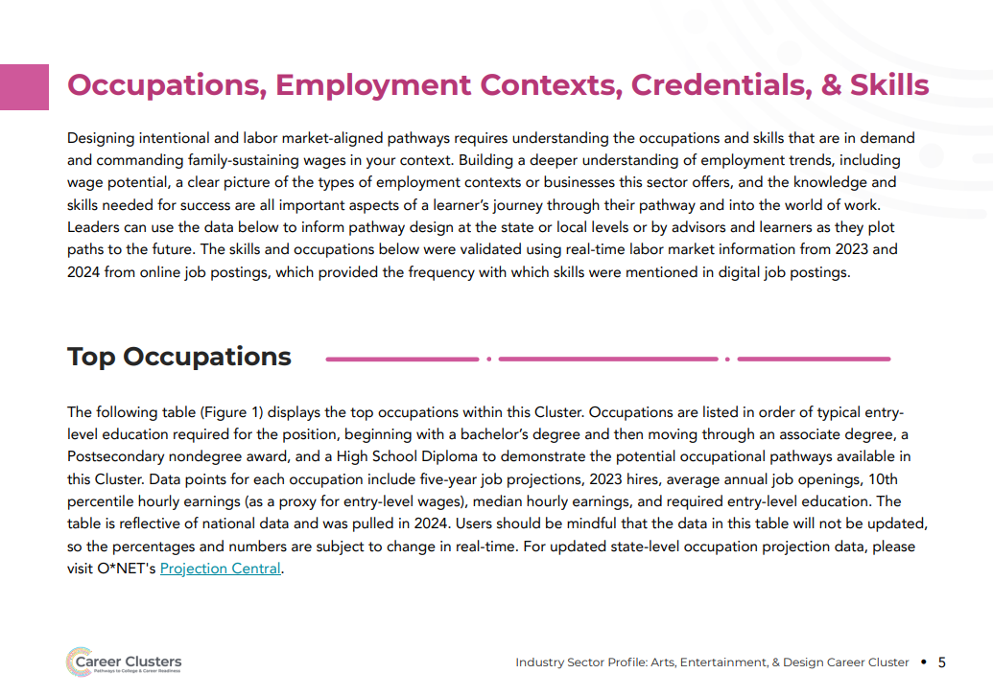

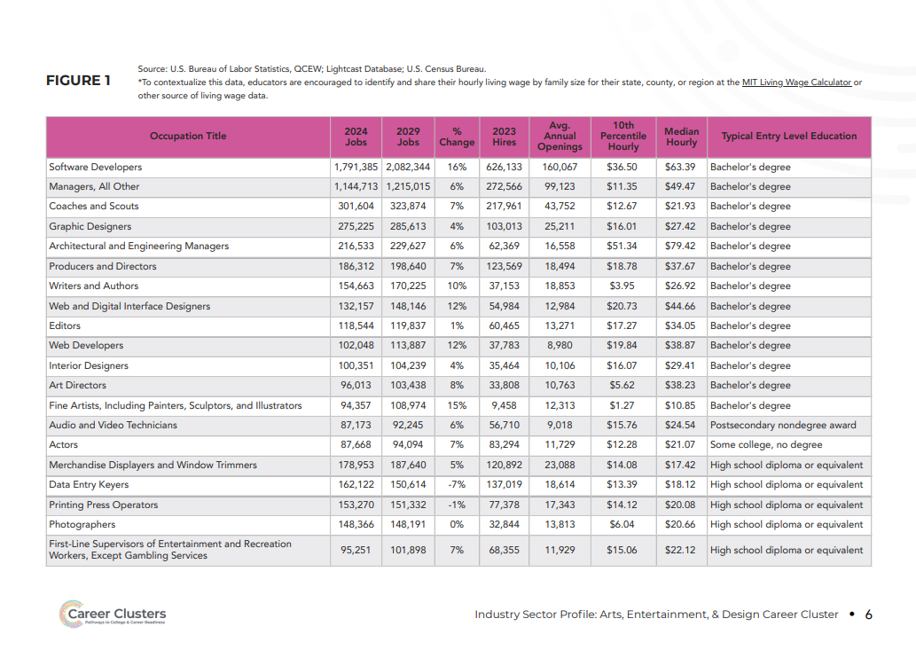
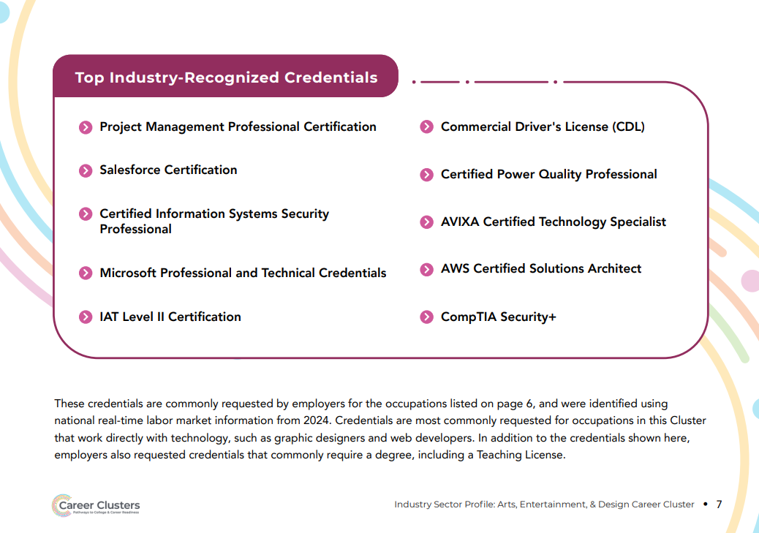
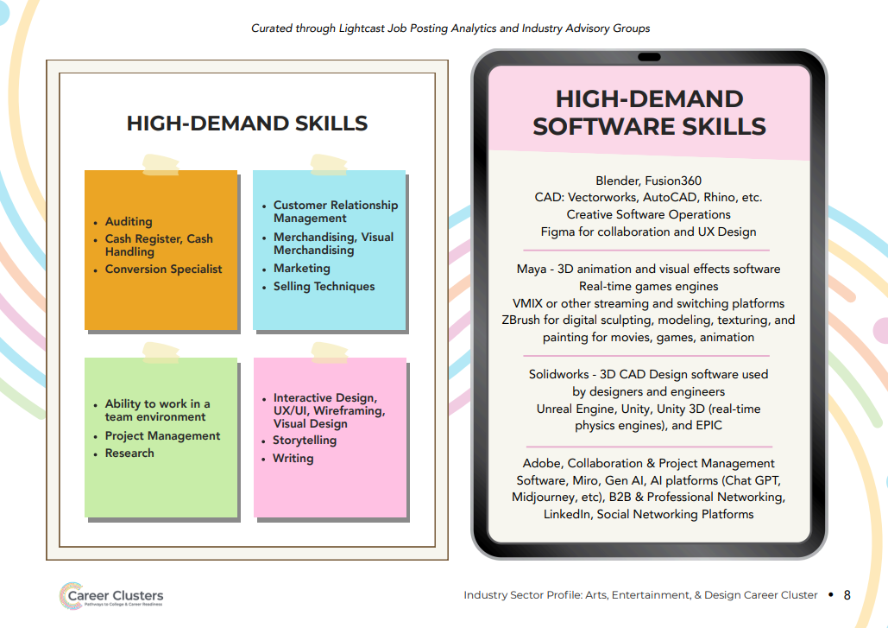
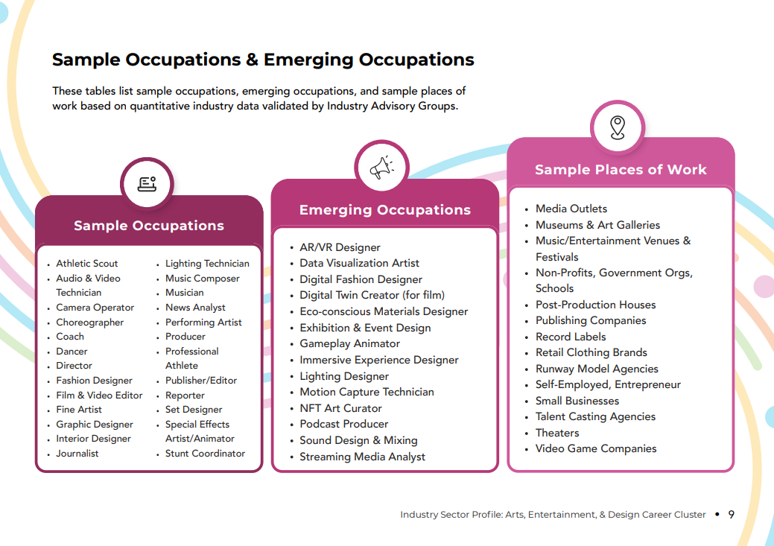

Construction

Cluster Definition:
The Construction Career Cluster focuses on professions involved in designing, planning, managing, and executing projects in the built environment.
It emphasizes sustainable building practices to ensure that structures are both environmentally responsible and resilient.
Careers in this Cluster are pivotal in creating durable infrastructure that meets present needs without compromising future generations’ ability to meet their own, covering a range of roles from architects and engineers to construction managers and skilled tradespeople.

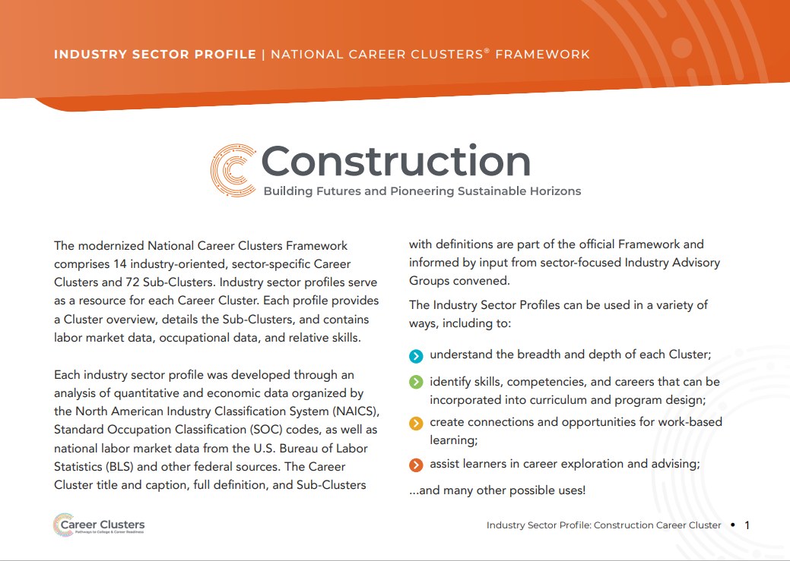
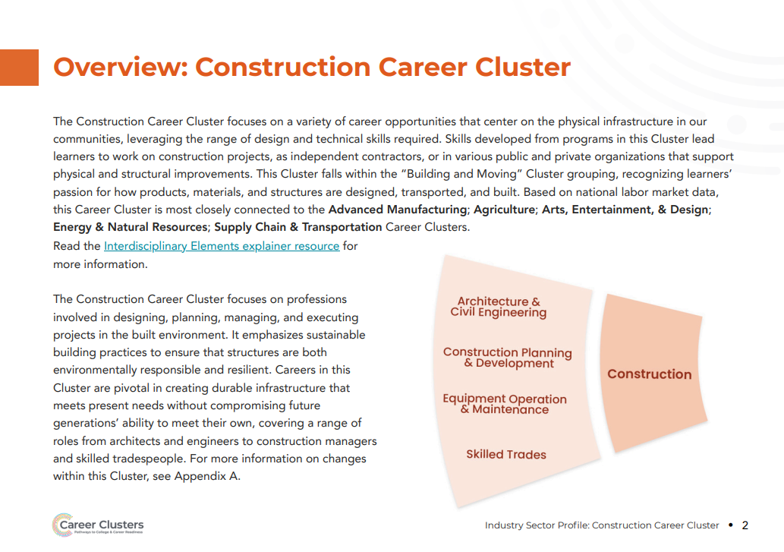
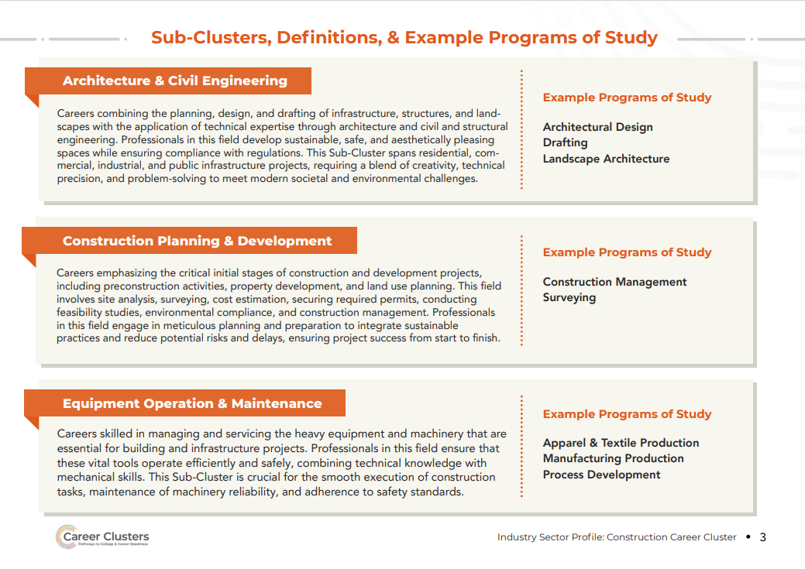

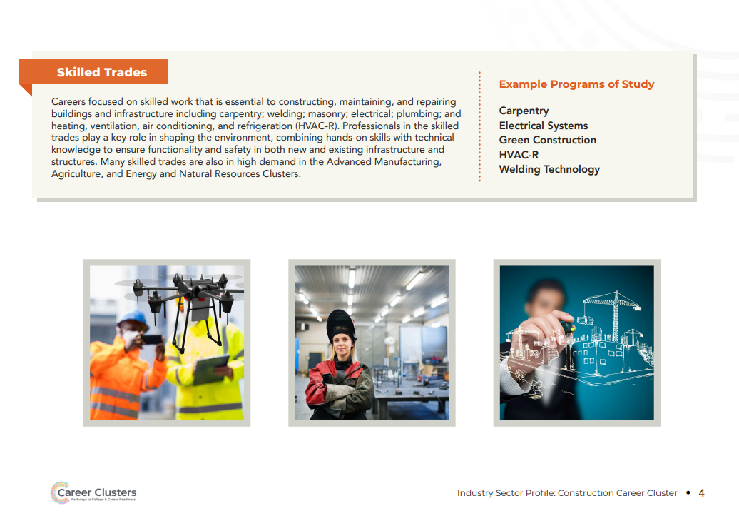
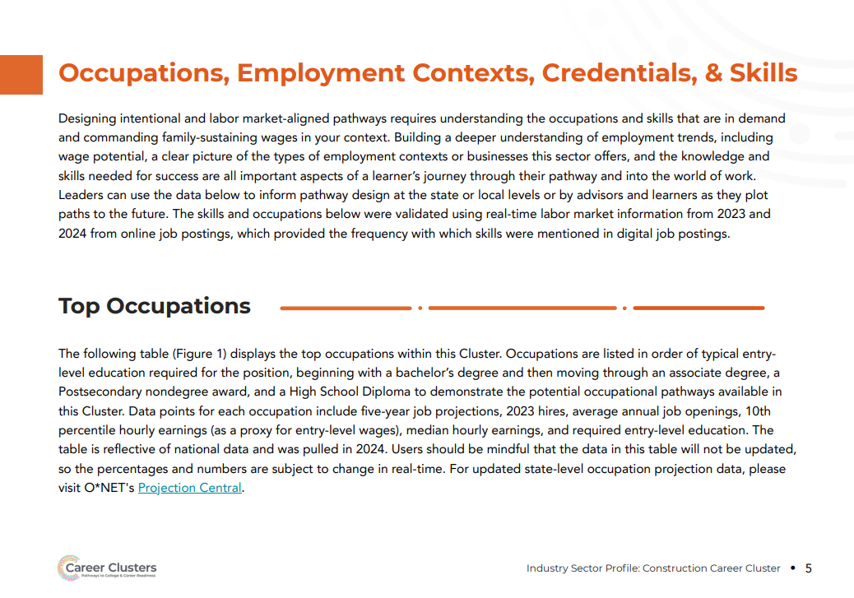

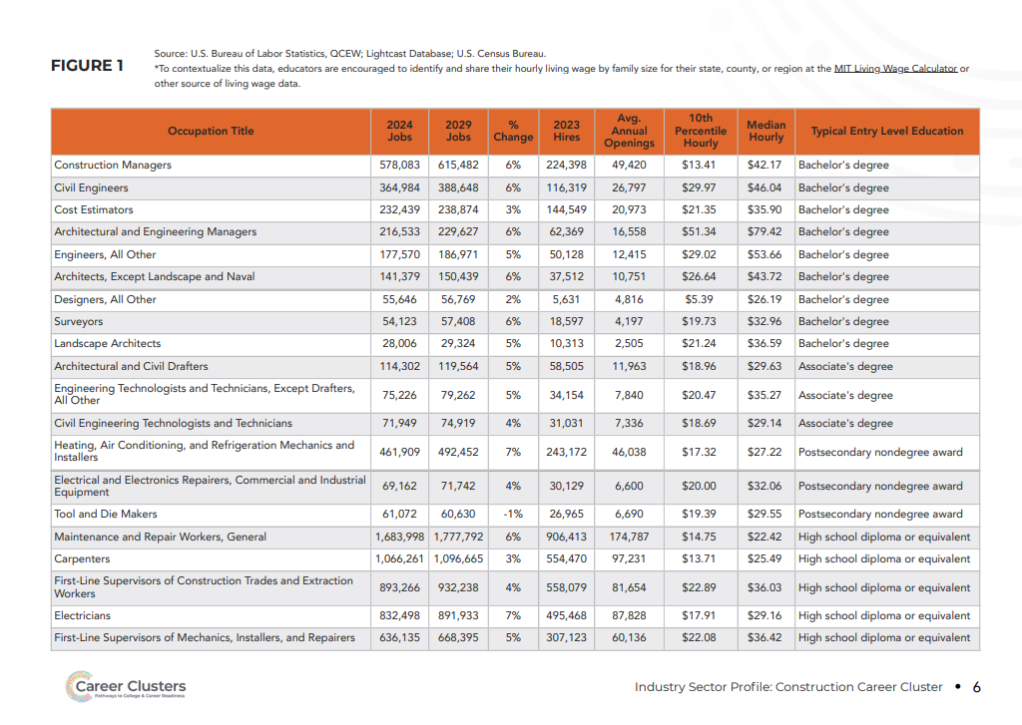
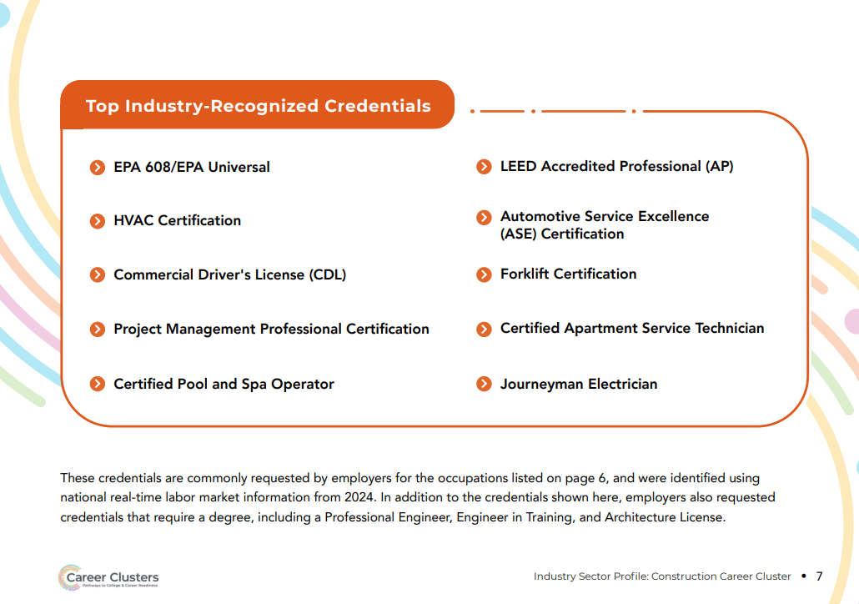
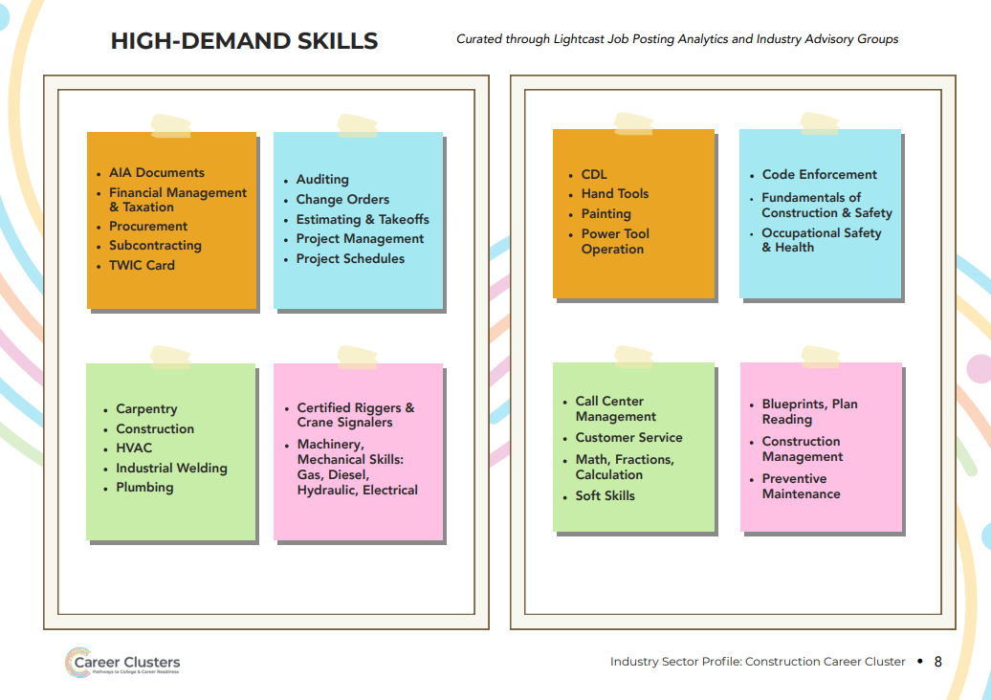
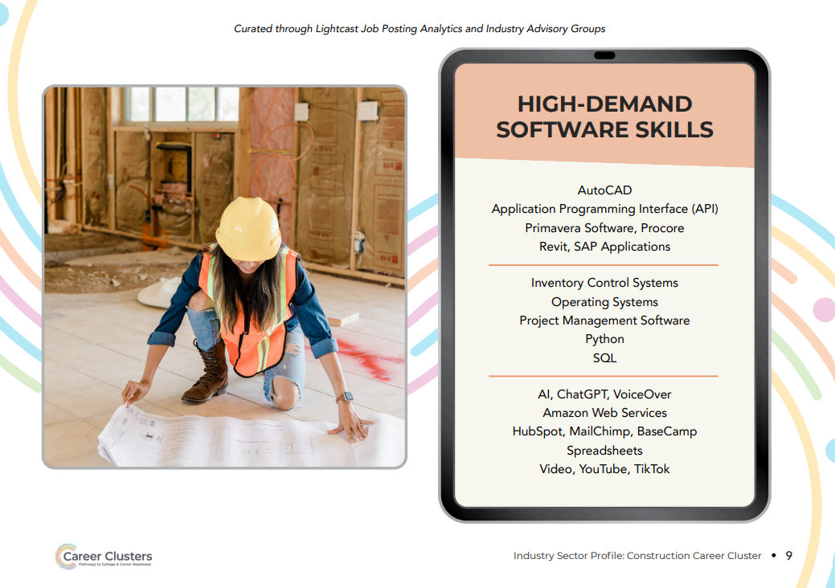
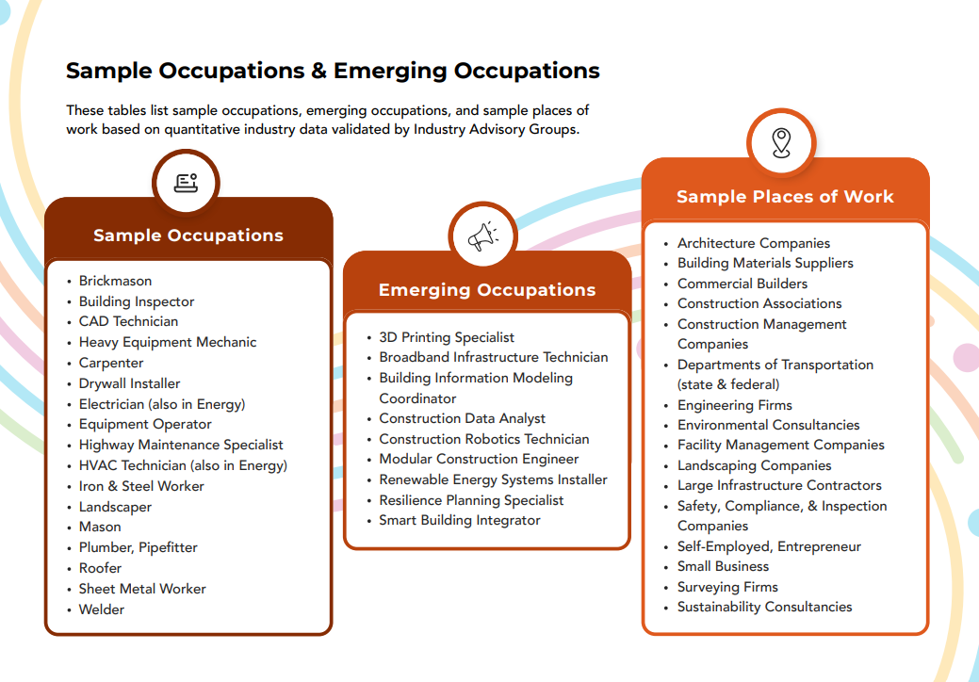

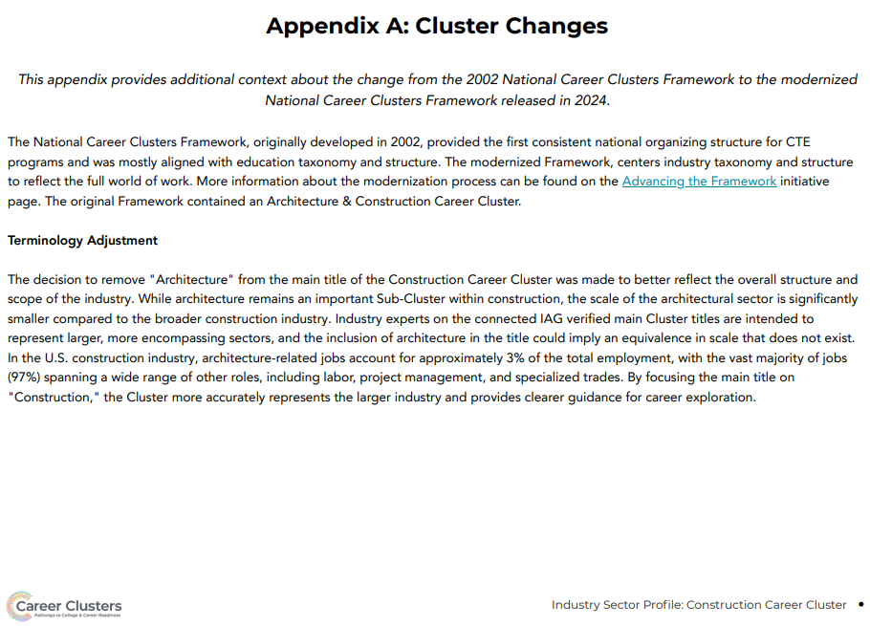

Digital Technologies

Cluster Definition:
The Digital Technology Career Cluster focuses on developing digital systems for communication and data storage using critical technologies such as artificial intelligence (AI), data analytics, and cybersecurity.
This Cluster builds skills necessary for all careers to navigate and lead in the constantly evolving techlandscape and drives innovation across all industries to tackle complex challenges and opportunities in communities and economies.

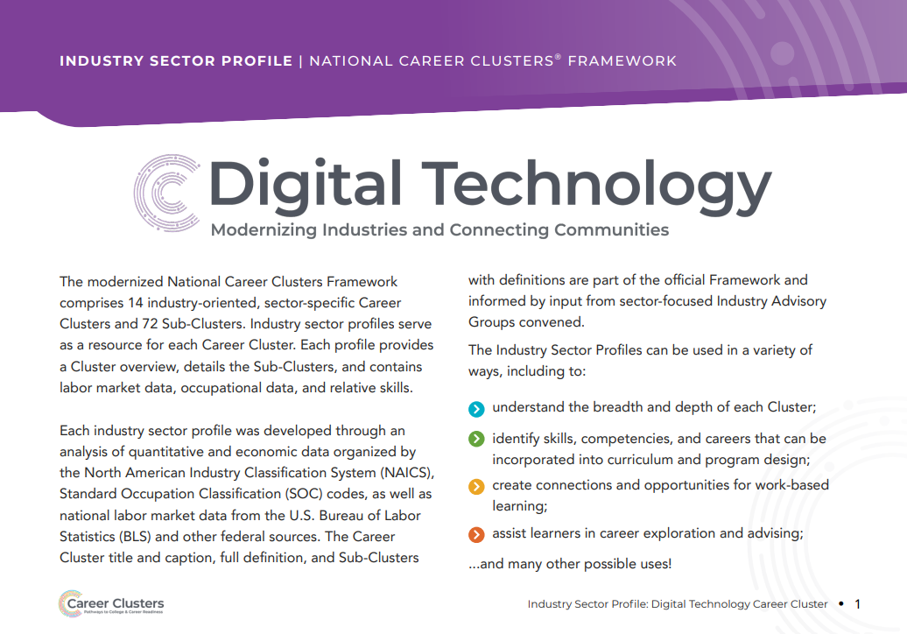
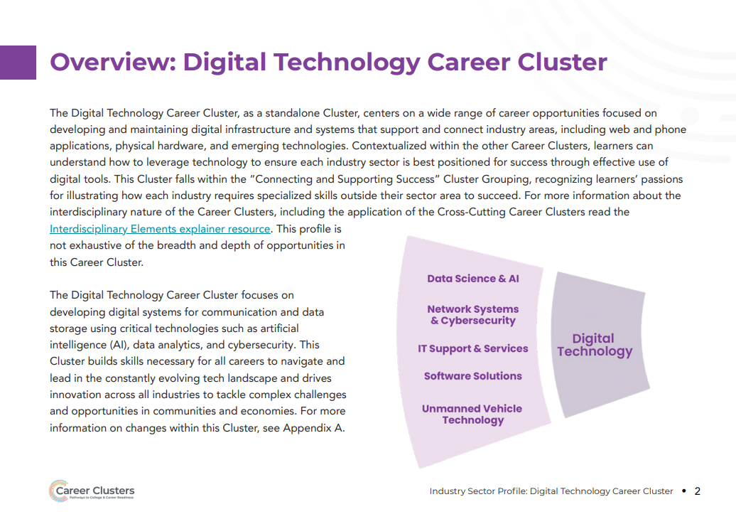
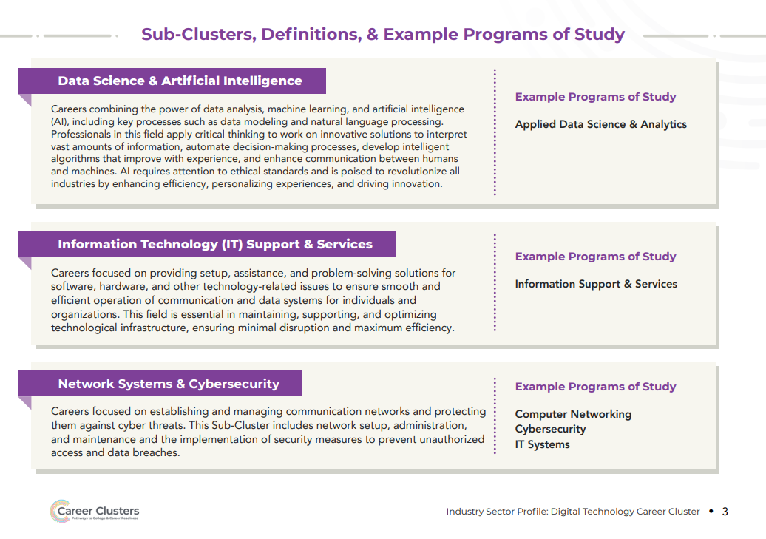
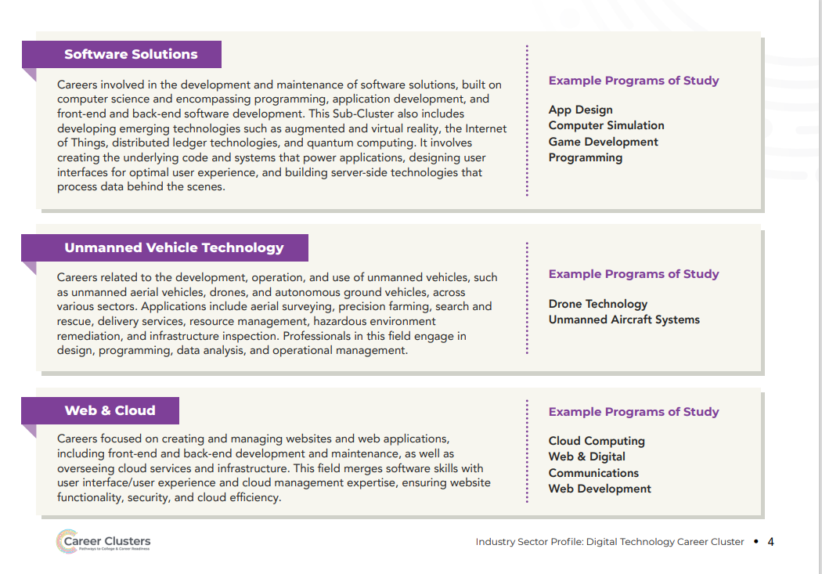
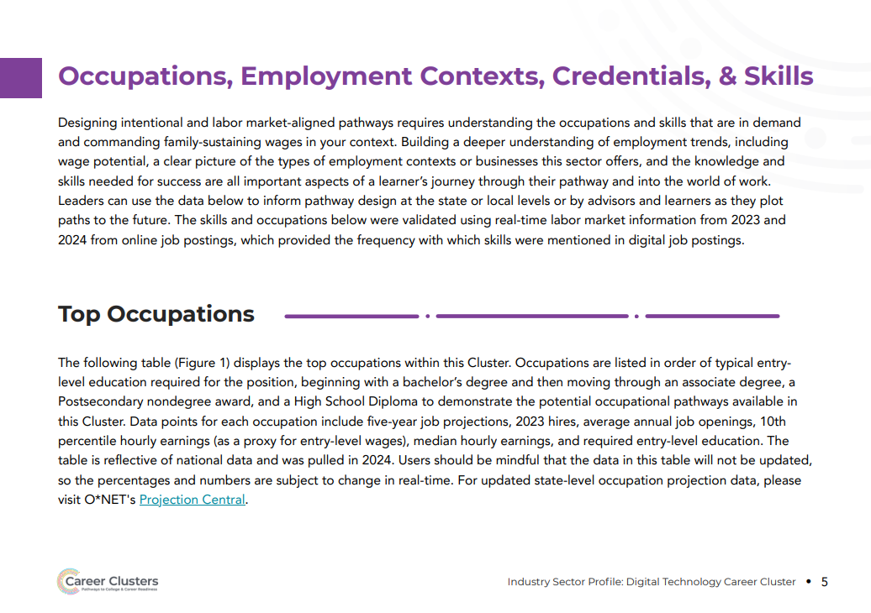
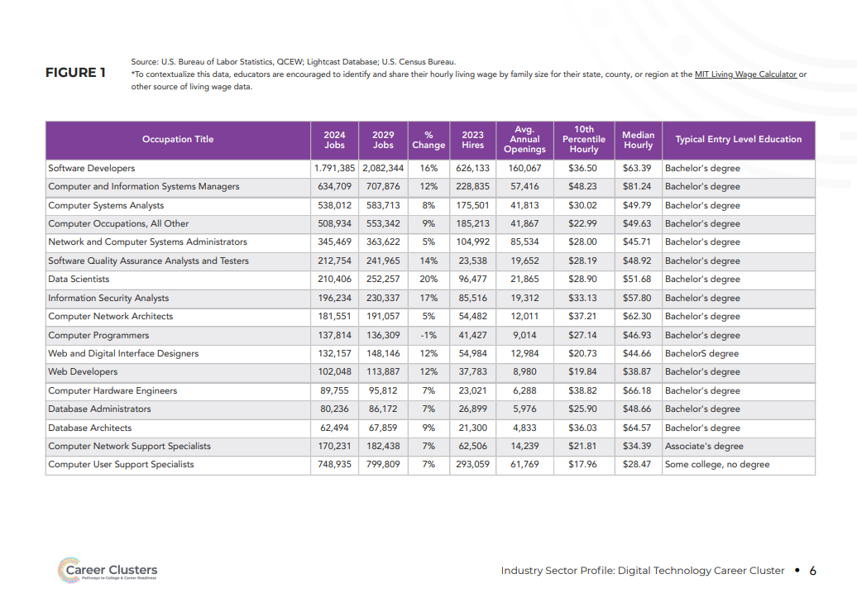
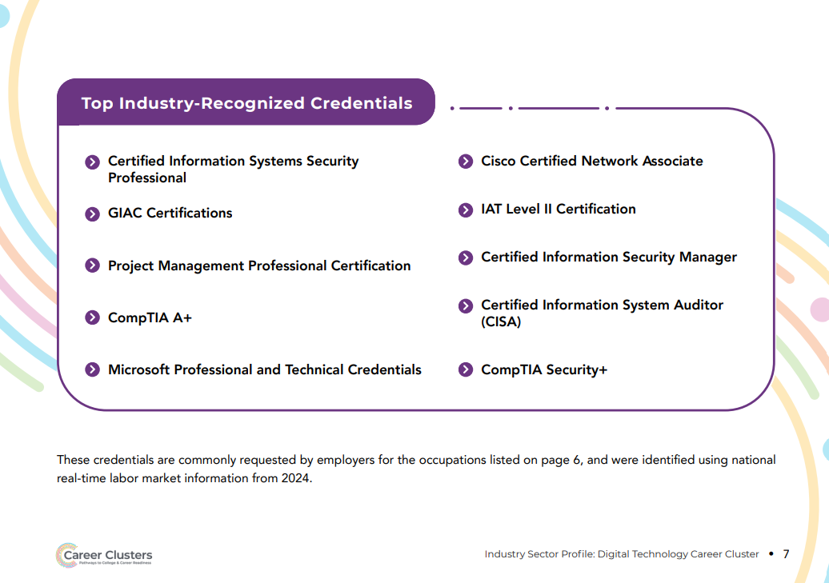
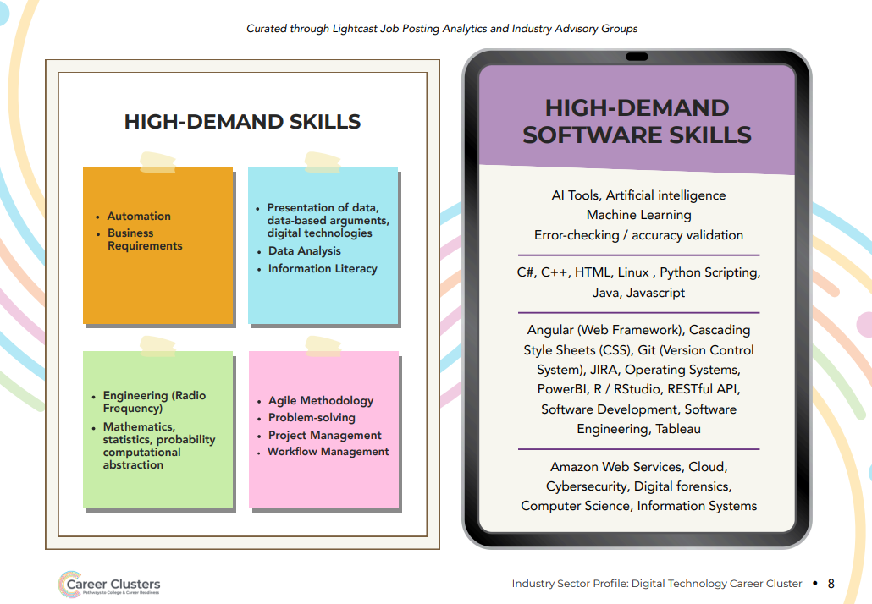
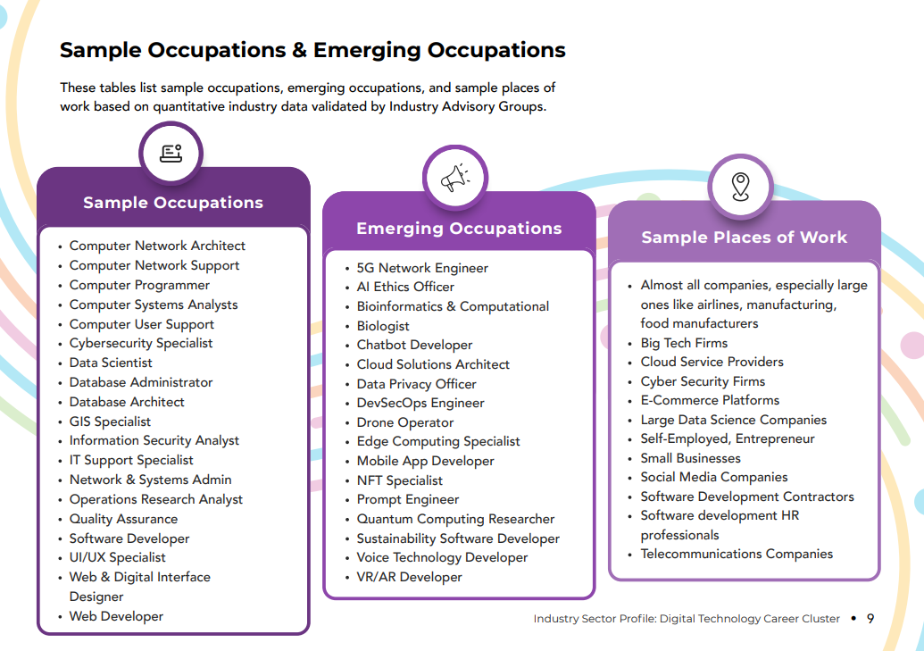

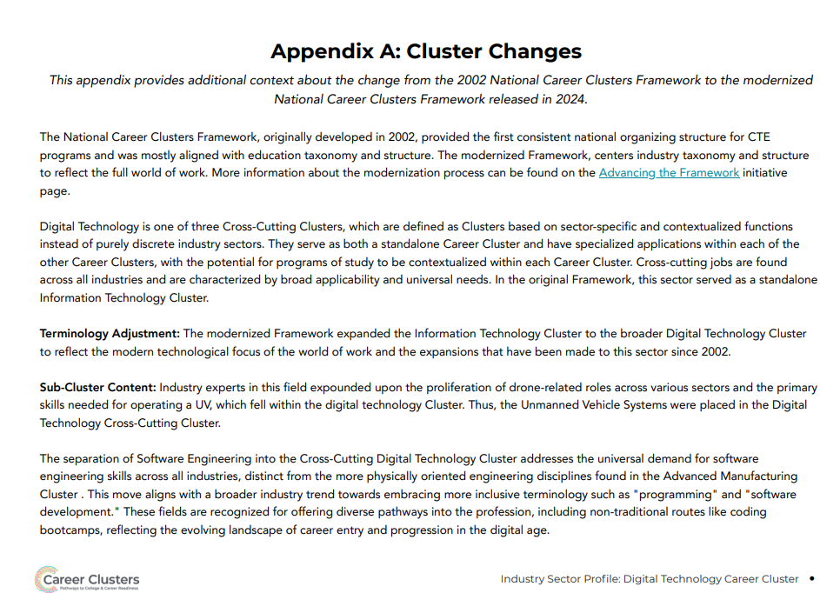

Education

Cluster Definition:
The Education Career Cluster spans careers aimed at fostering learning from early childhood to adulthood, including teaching, instructional design, counseling services, community engagement, learner support, and educator training.
This Cluster emphasizes quality education standards and lifelong learning, preparing individuals for success through all life stages by nurturing knowledge, skills, and critical thinking and encouraging personal and societal growth in a constantly evolving world.

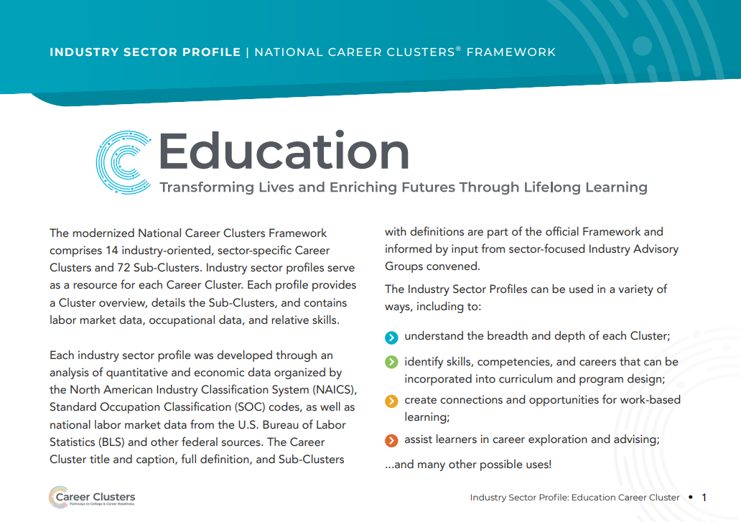
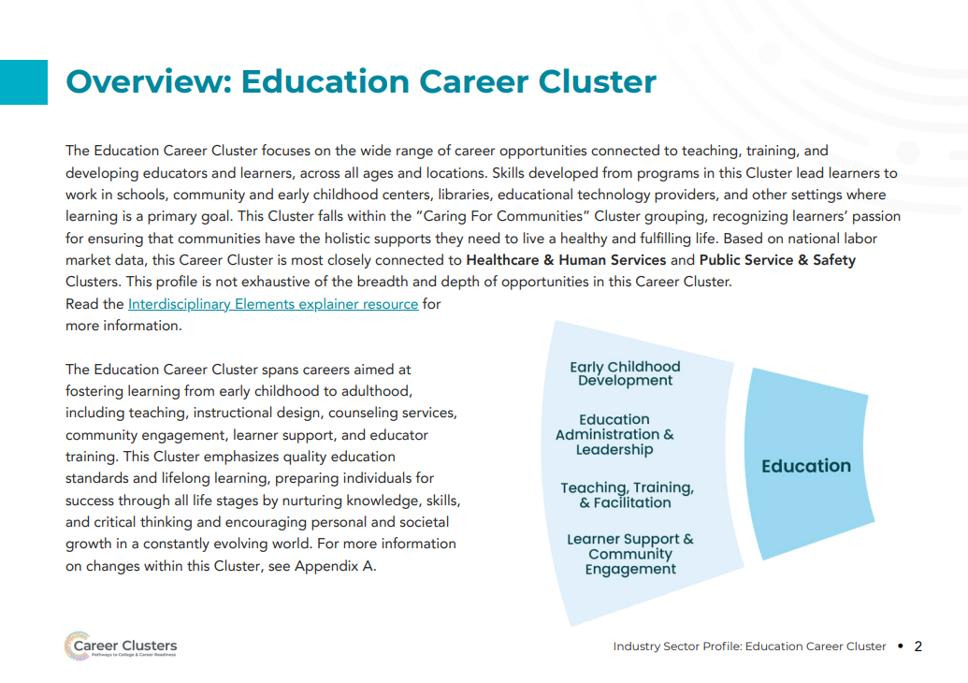

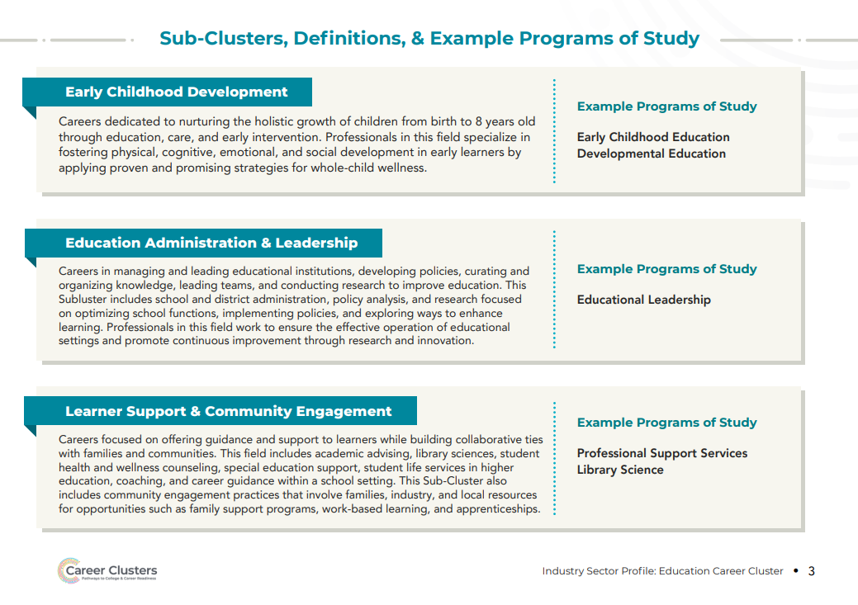
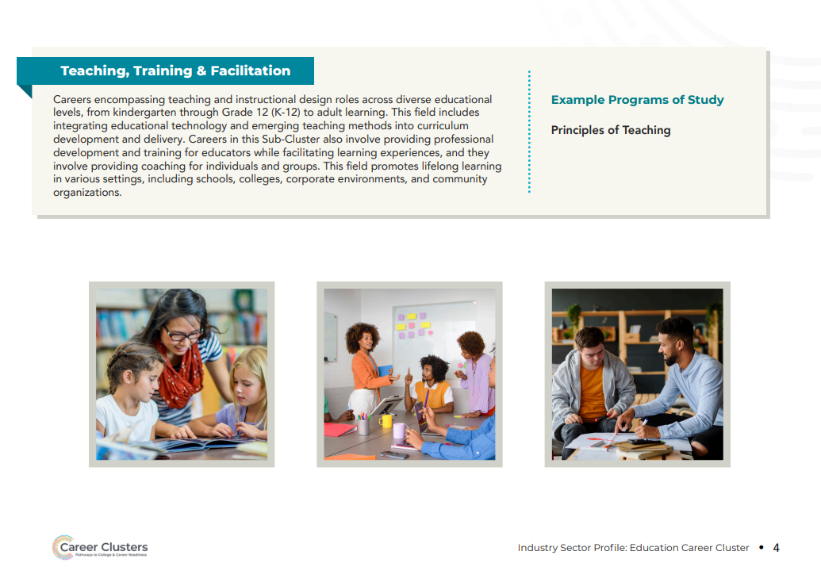
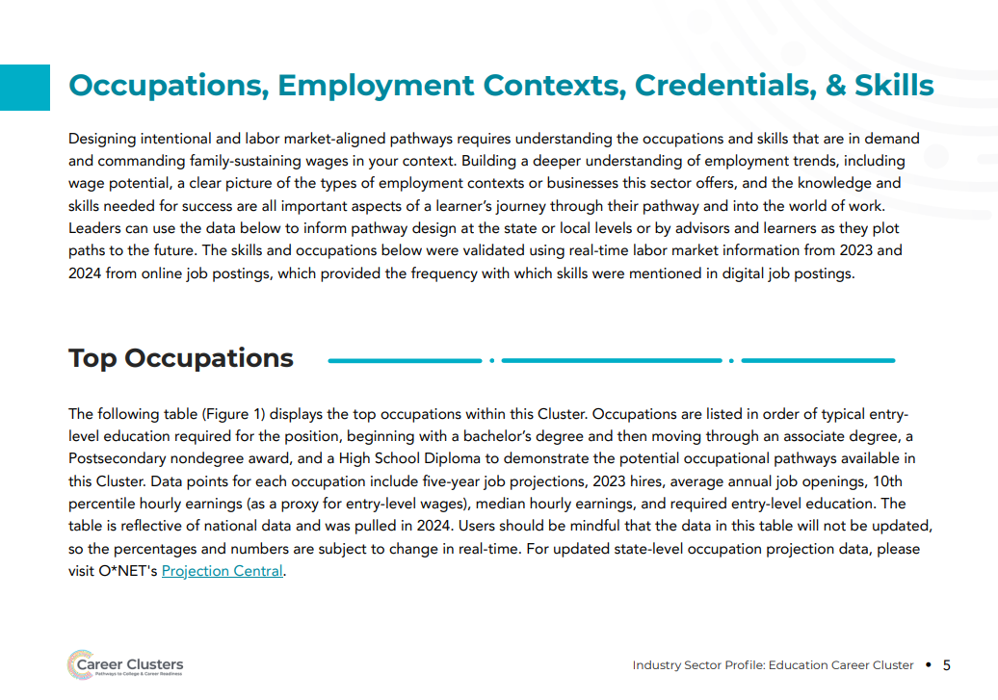
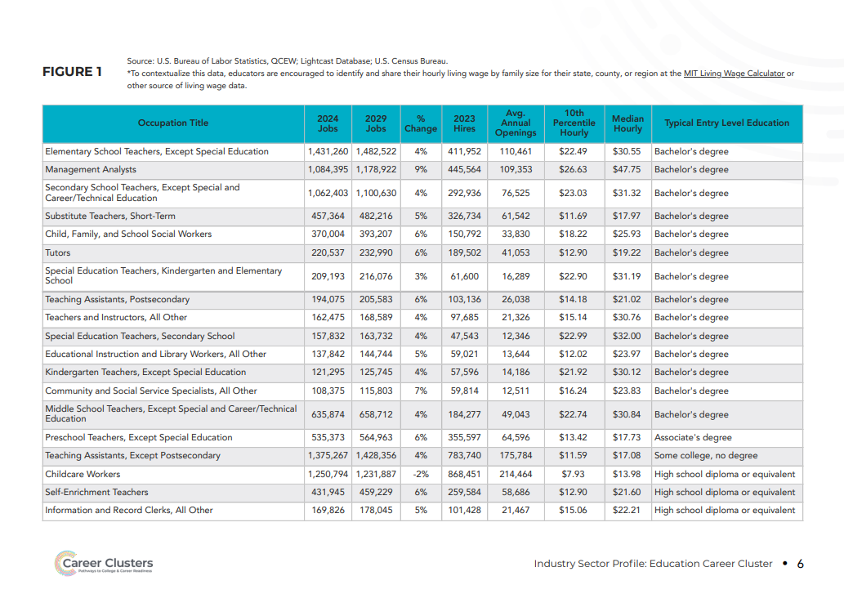

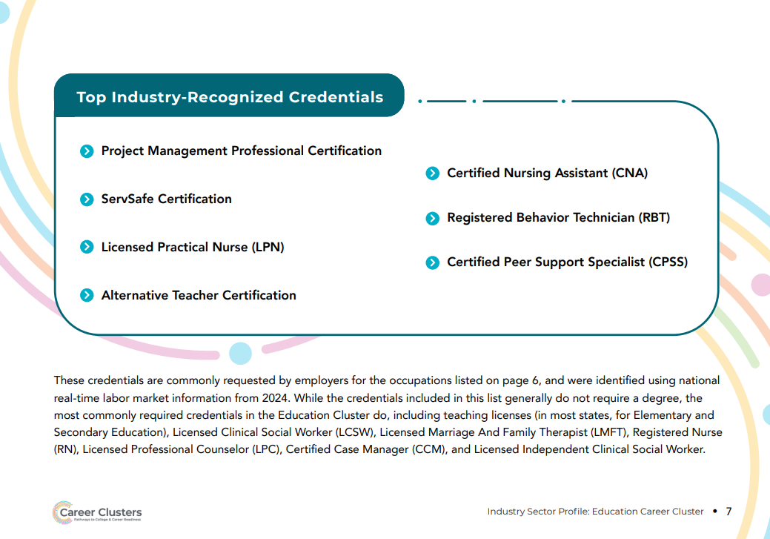
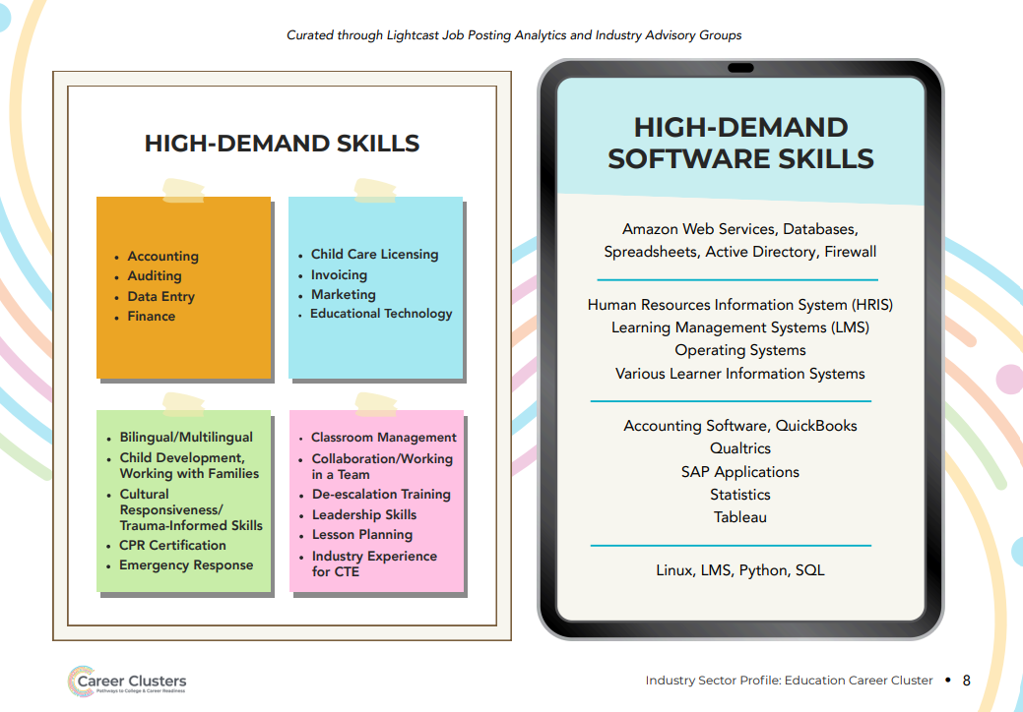
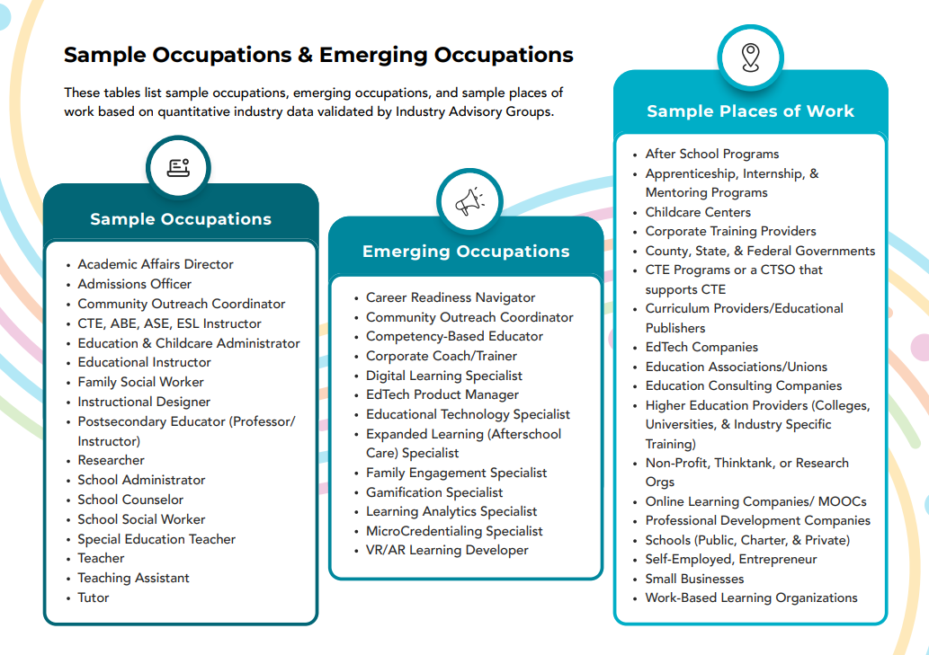

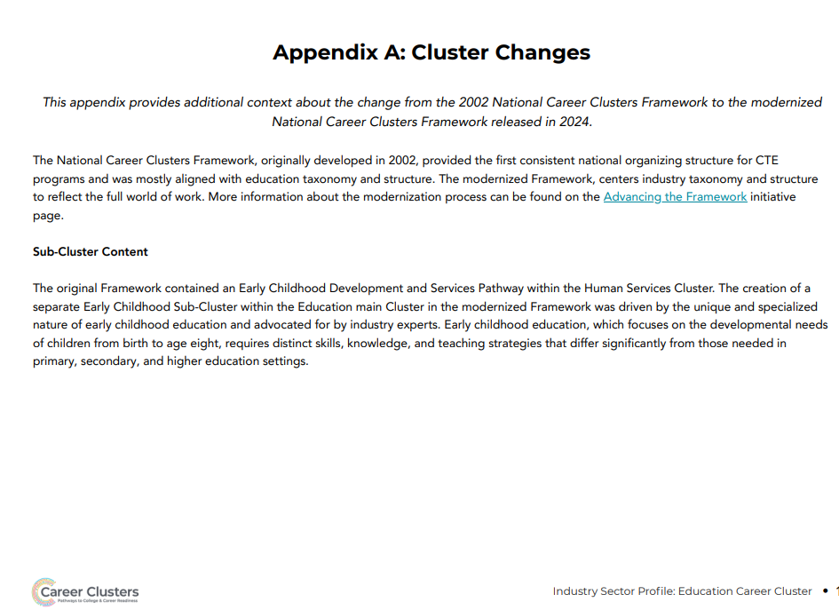

Energy and Natural Resources

Cluster Definition:
The Energy & Natural Resources Career Cluster spans careers in traditional and renewable fuel production, power generation and energy conversion, utilities, environmental preservation, ecological research, and resource extraction.
These industries focus on efficient and responsible resource management, including conservation, transmission, distribution and storage, to minimize environmental impacts and meet global energy needs.
Careers in this Cluster are dedicated to creating a sustainable future, innovating cleaner energy solutions, and preserving our planet's natural resources for generations to come.
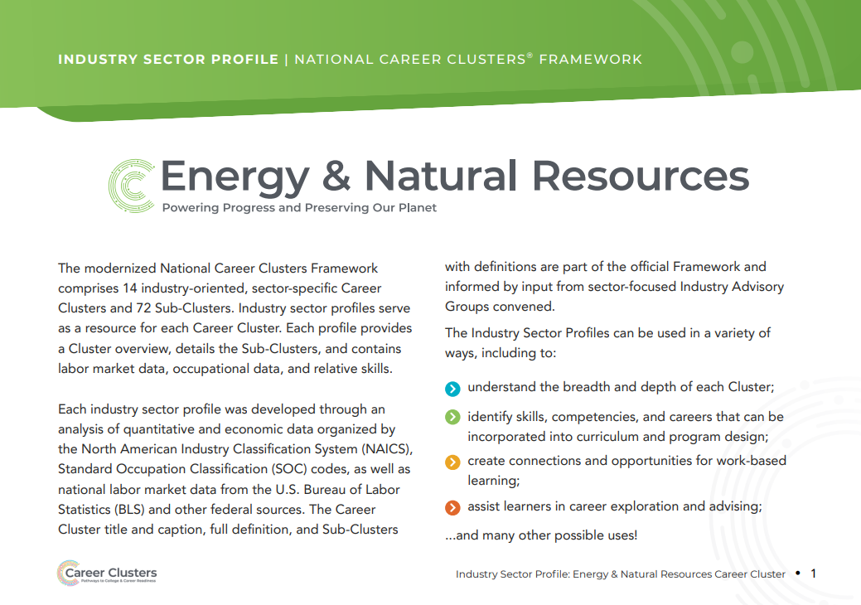
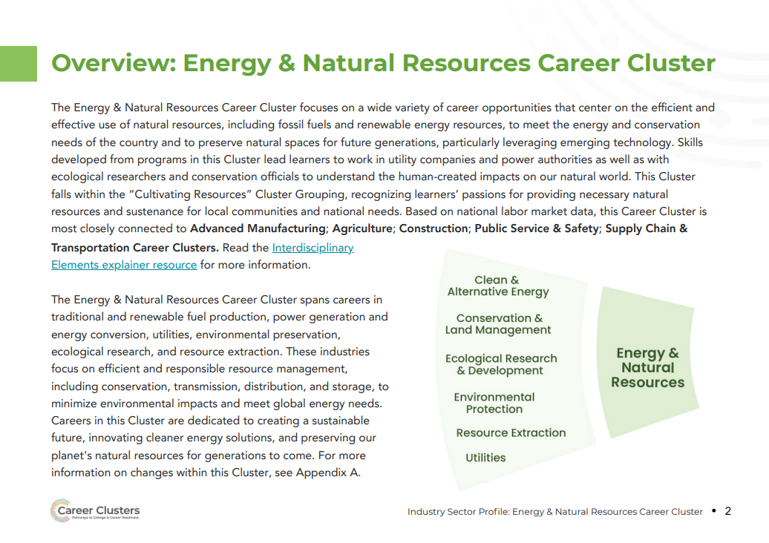
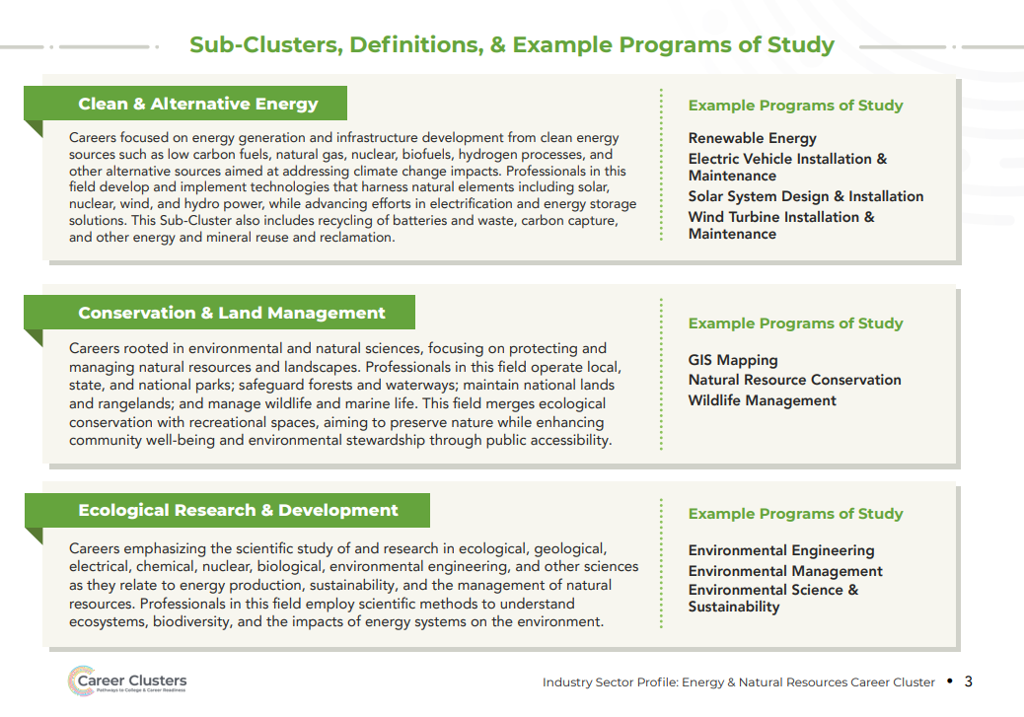
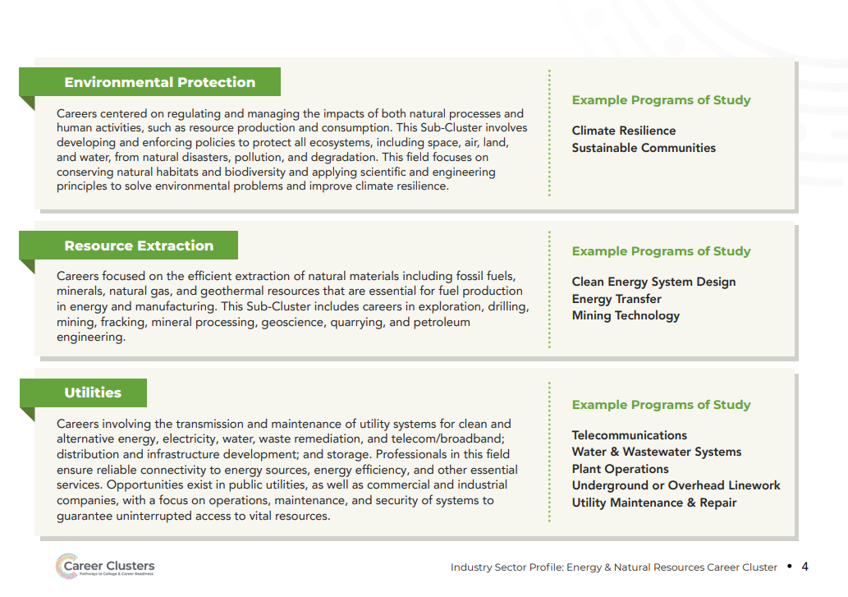
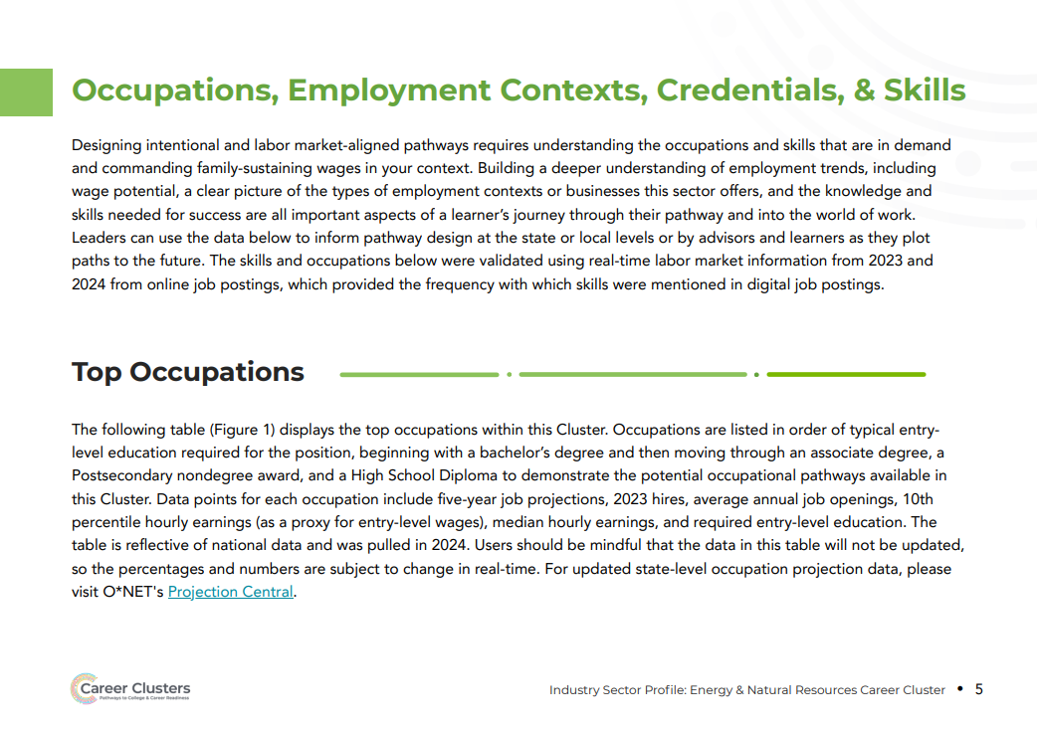
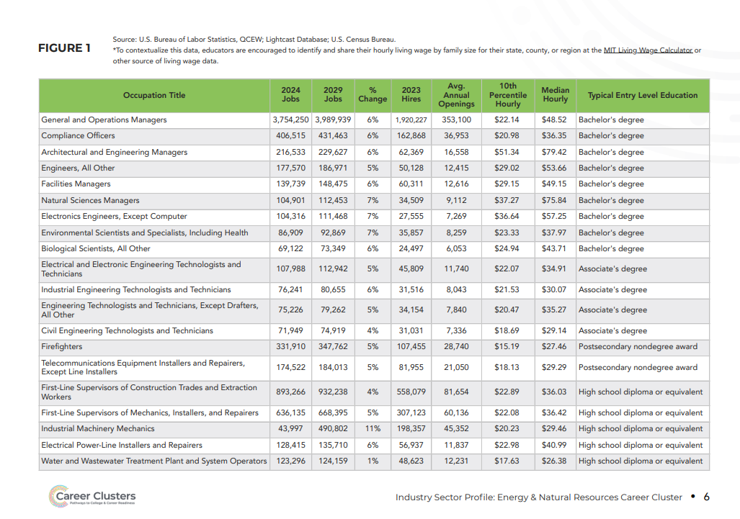
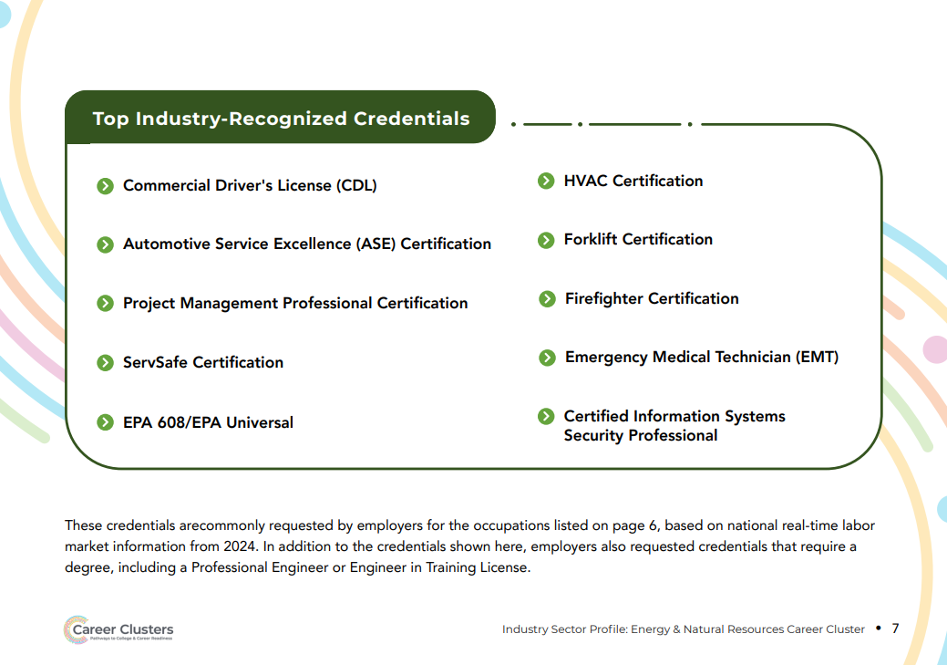
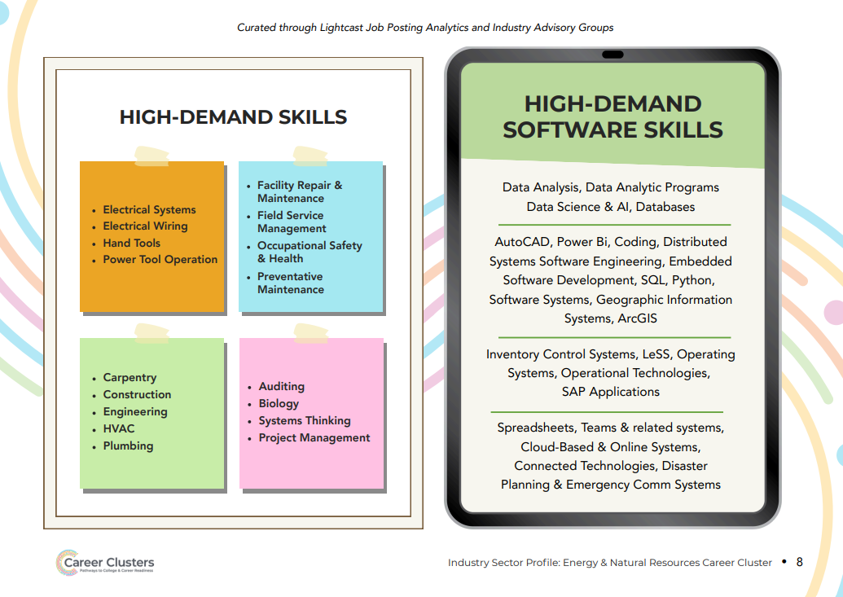
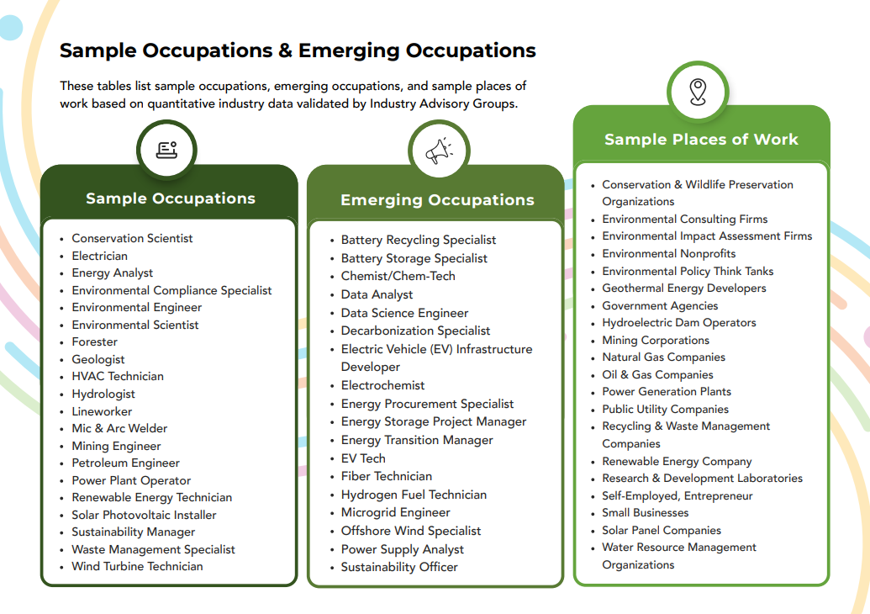

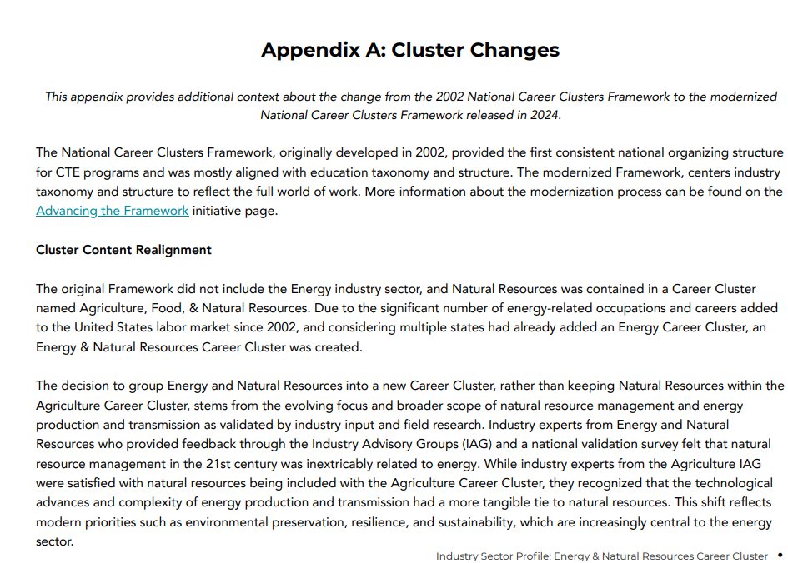

Financial services

Cluster Definition:
The Financial Services Career Cluster encompasses careers in managing and advising financial transactions, including banking, lending, corporate finance, debt management, accounting, insurance, and real estate.
These careers contribute to economic stability and growth by supporting the financial health of individuals and organizations.

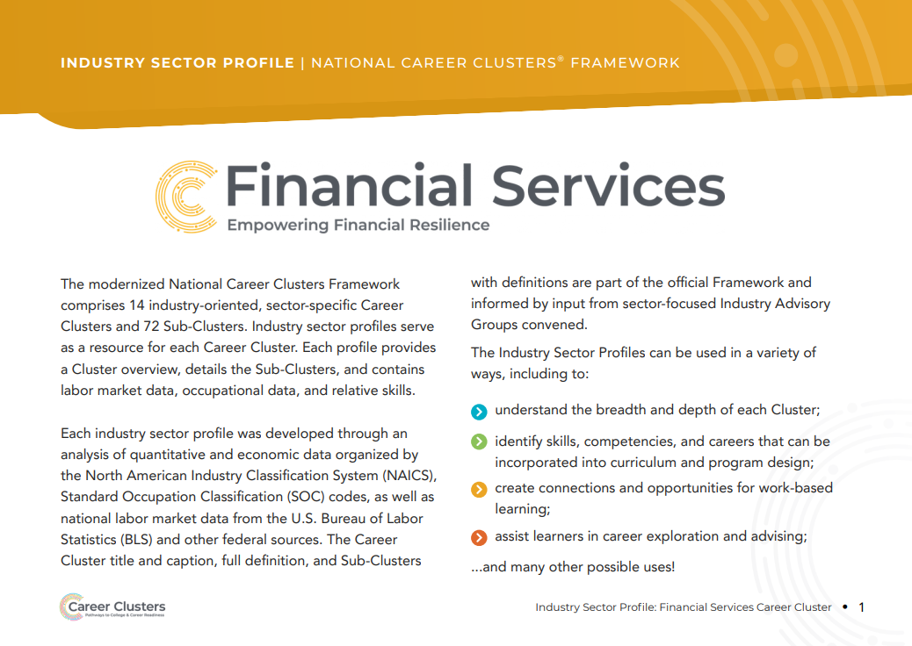
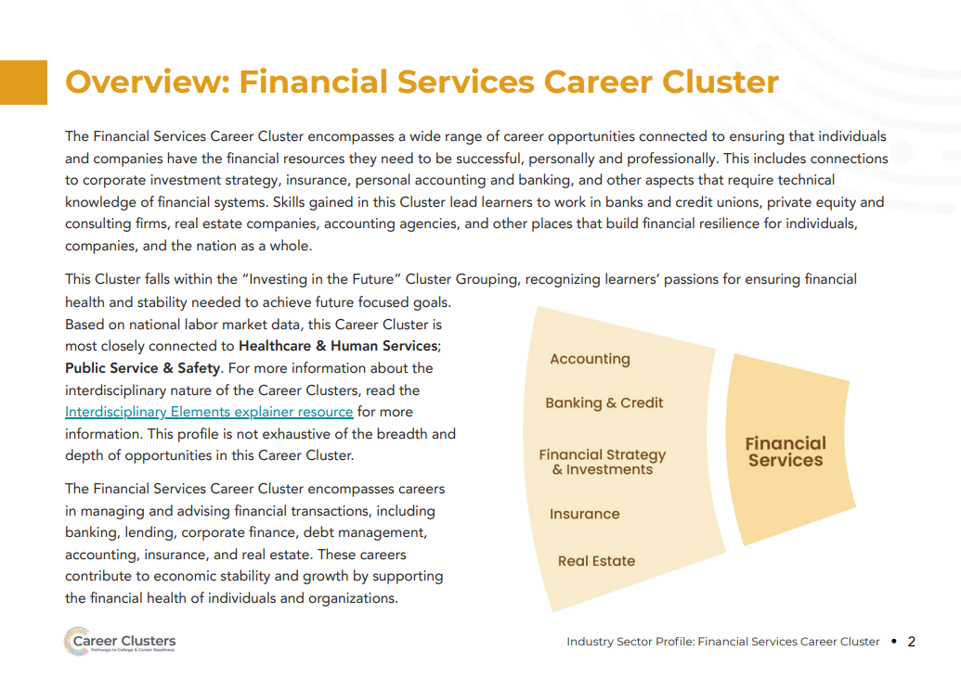
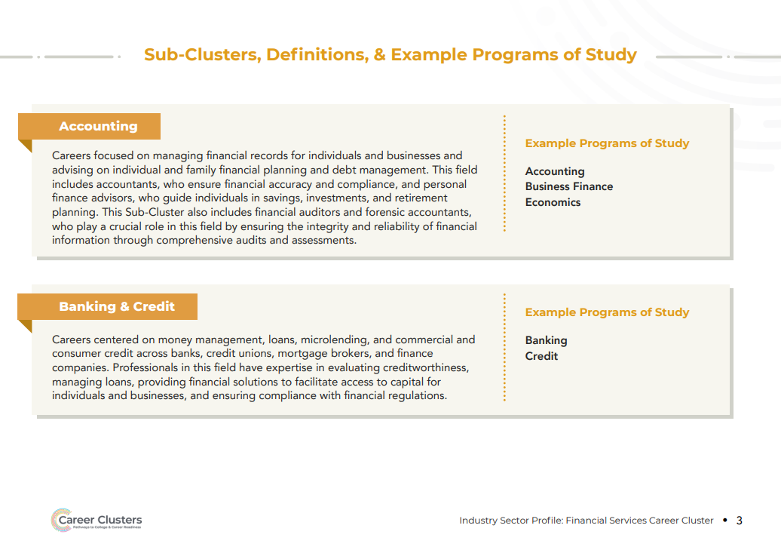
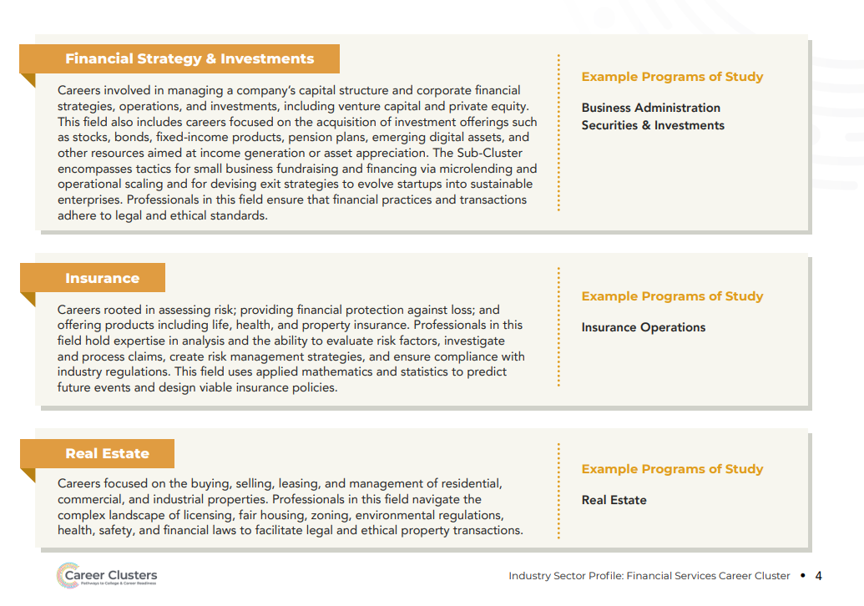
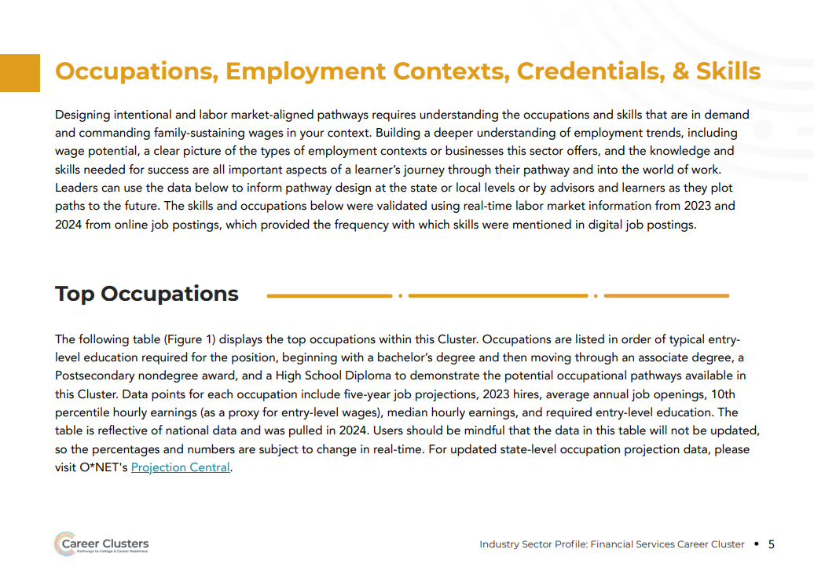
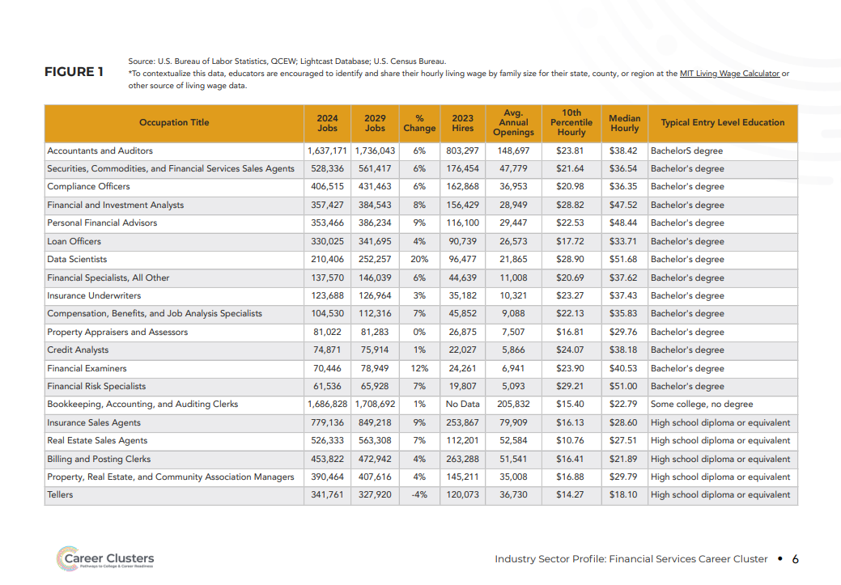
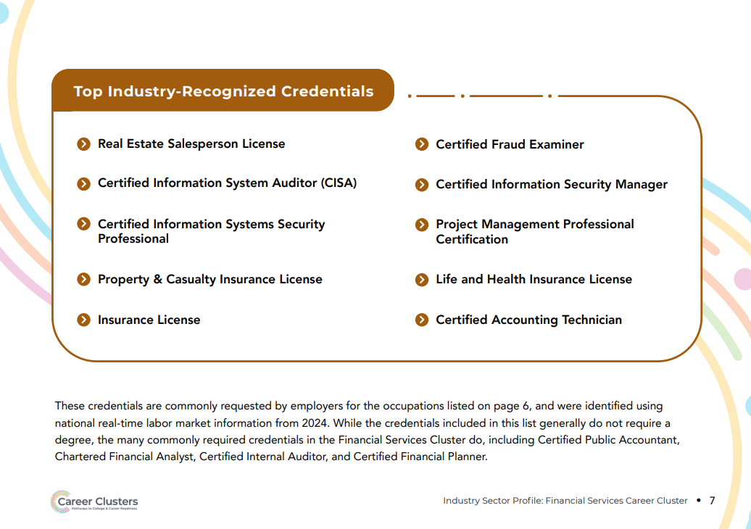
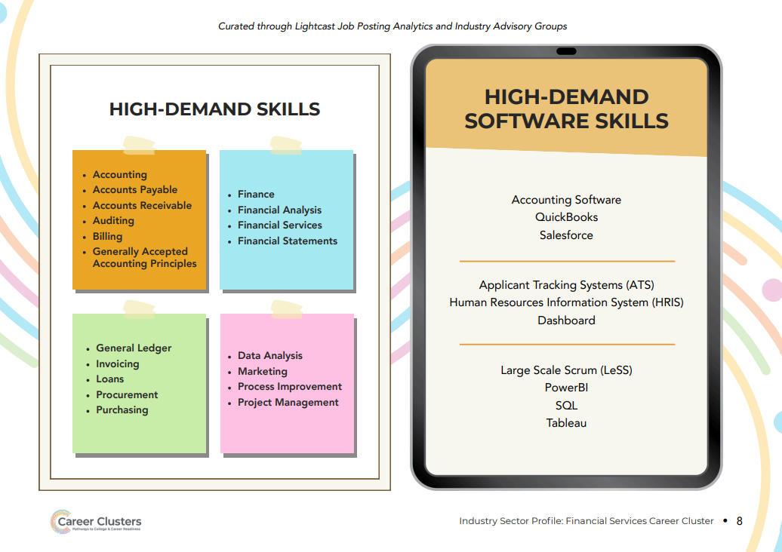
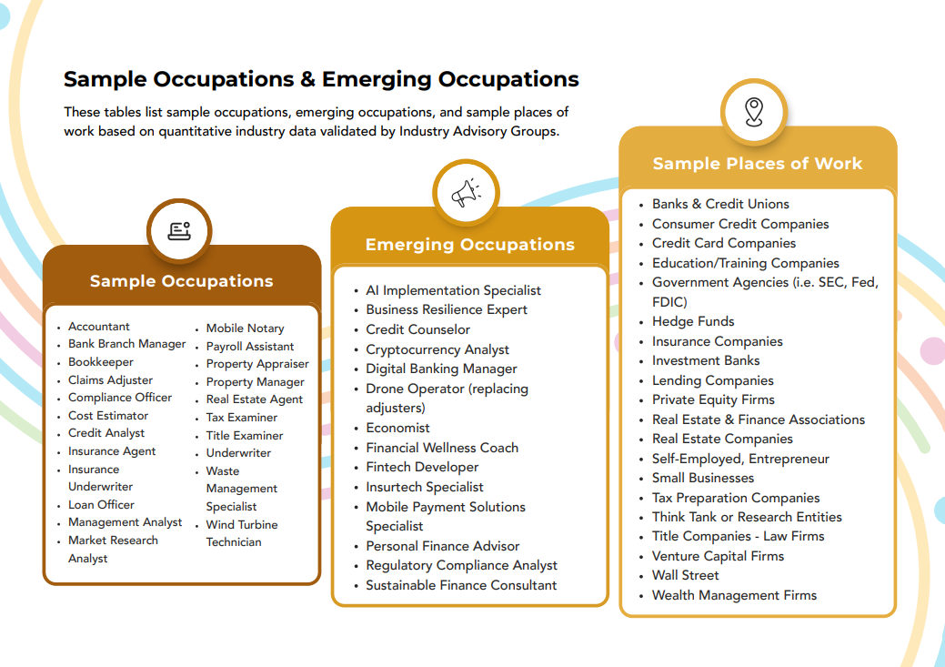

Healthcare

Cluster Definition:
The Healthcare & Human Services Career Cluster promotes whole health in individuals and communities through a diverse array of services.
This sector includes technical, mental, and therapeutic services and personal care, supported by medical and social sciences.
By addressing social determinants of health and leveraging health data and science, this Cluster aims to enhance the overall health and resilience of individuals, families, and communities.

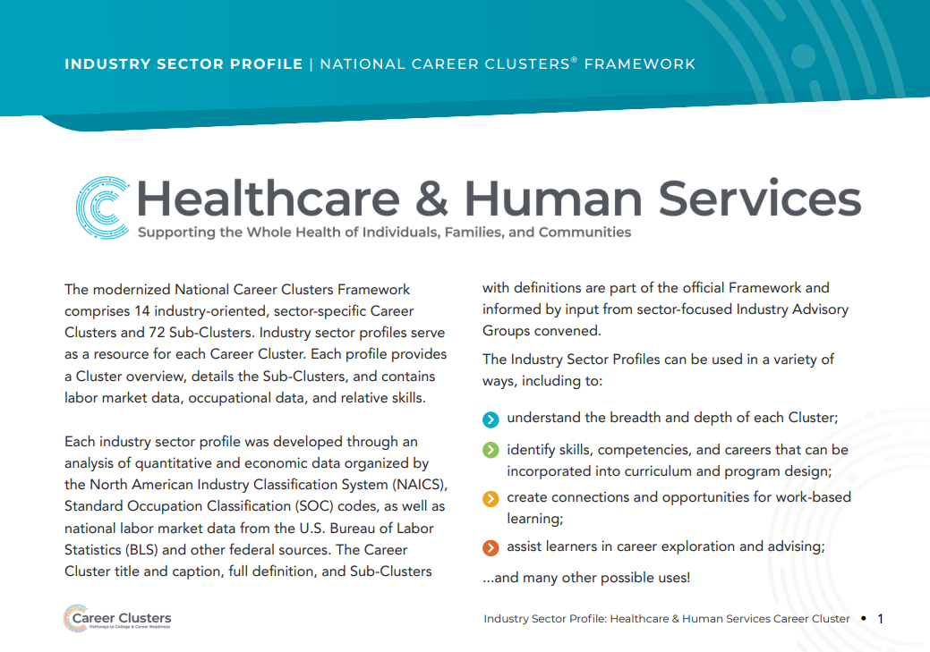
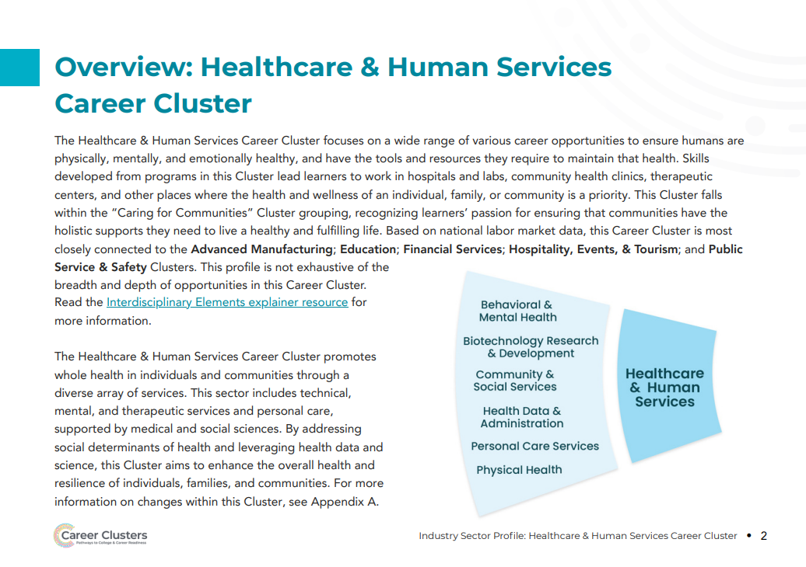
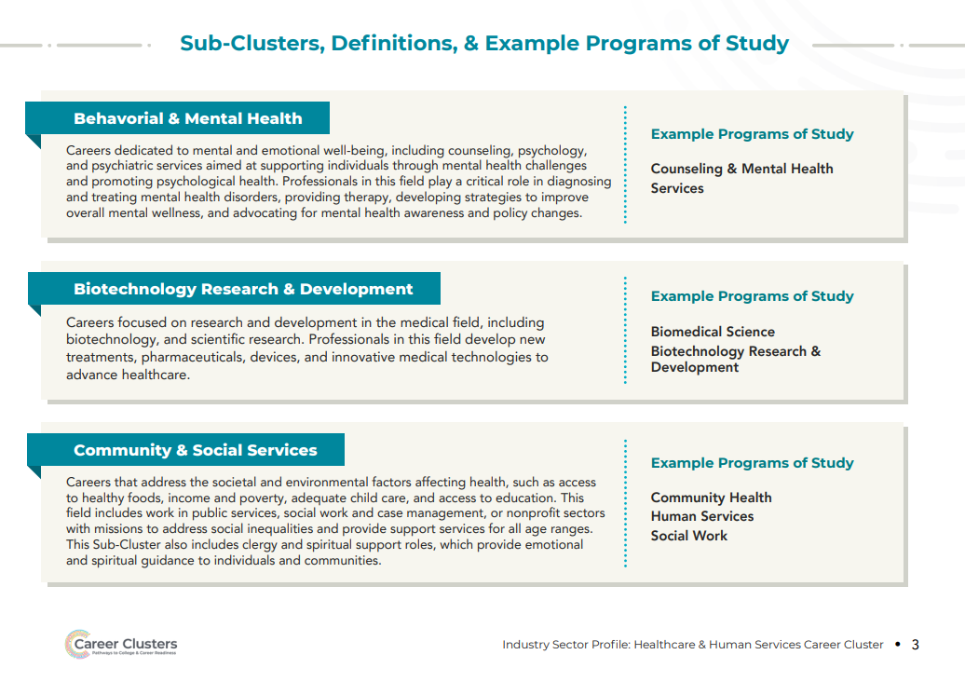
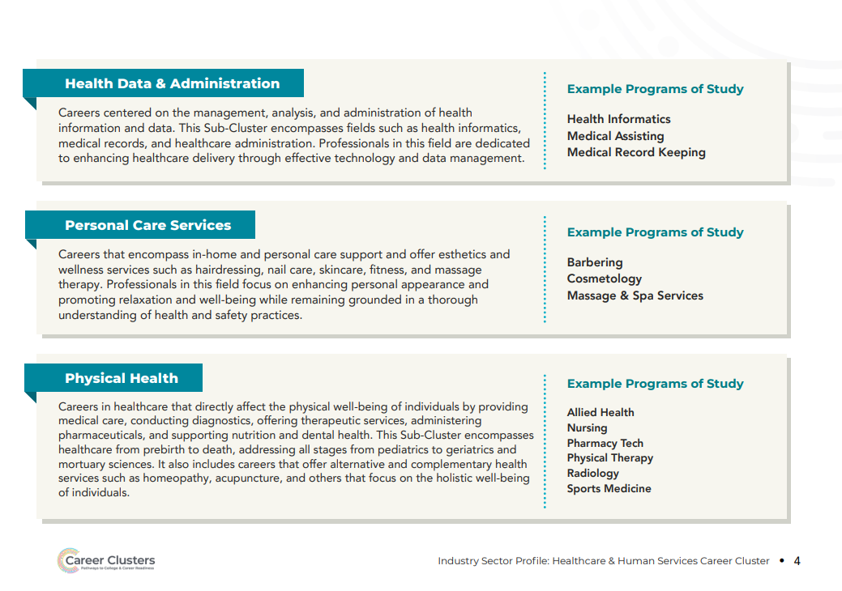
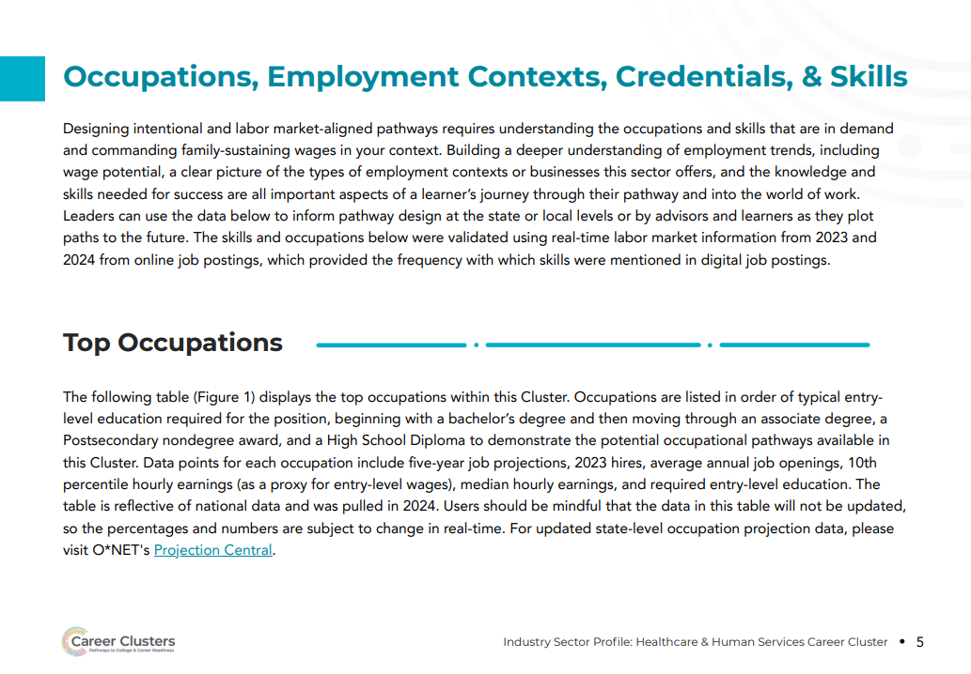
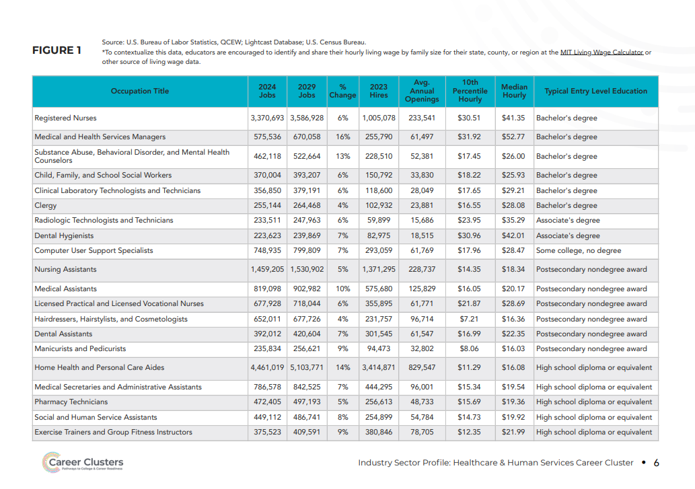
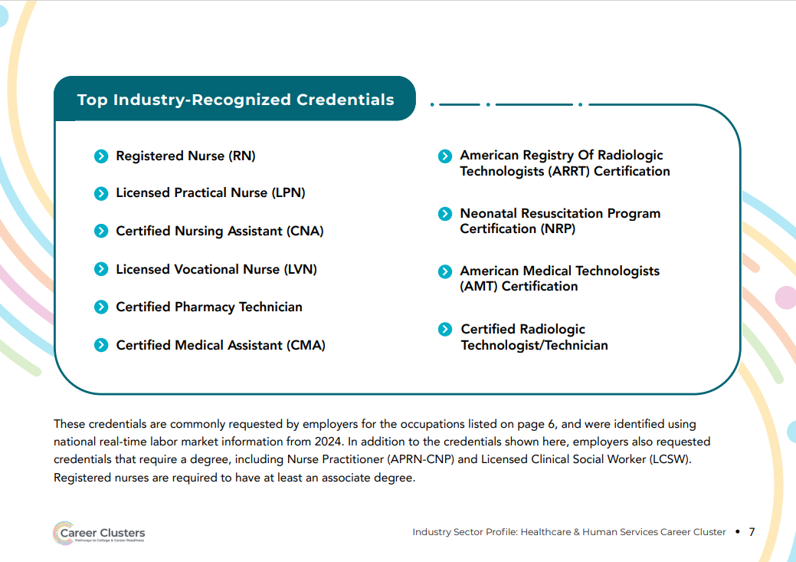
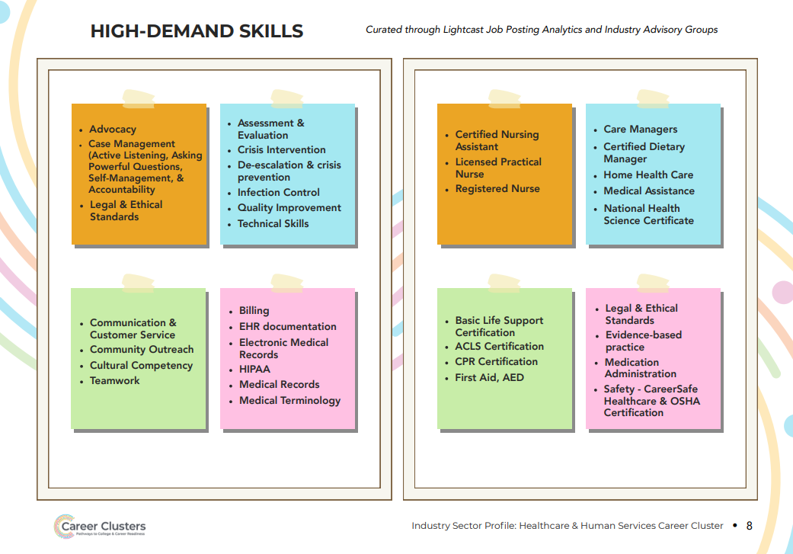
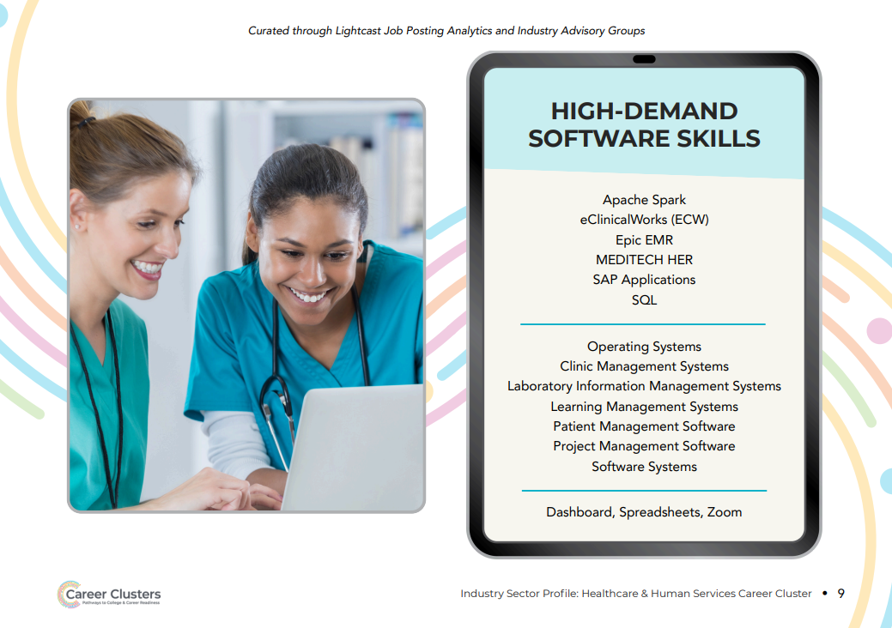
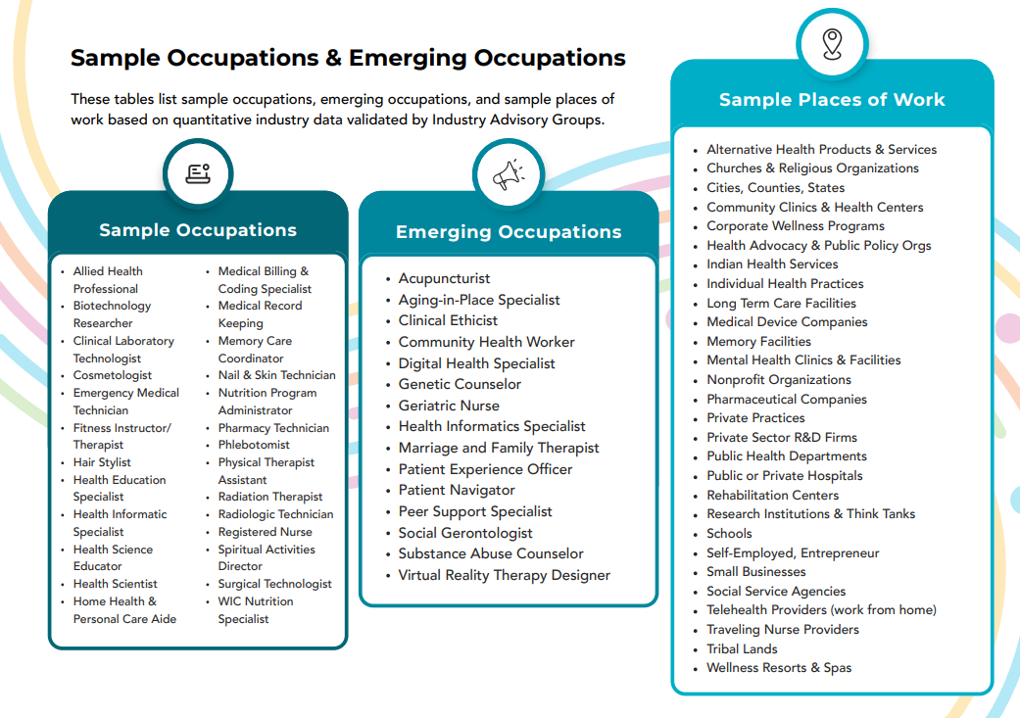

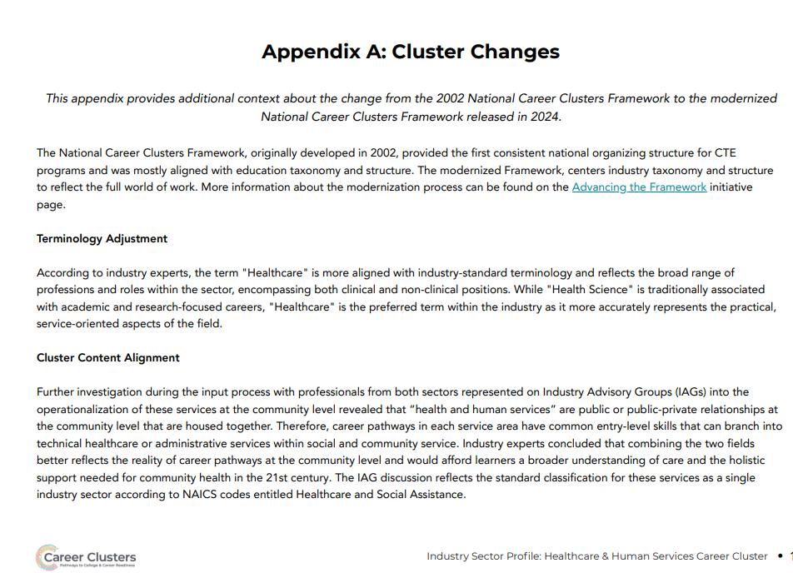

Hospitality events and Tourism

Cluster Definition:
The Hospitality, Events, & Tourism Career Cluster encompasses a broad range of services and experiences related to food and beverage, lodging, travel, events, and conferences.
This Cluster focuses on delivering quality customer service, memorable experiences, and seamless logistics to cater to the needs and preferences of guests, tourists, and event participants.
The Cluster is characterized by its diversity, including everything from luxury hotels and international travel to local dining, cultural events, and business conferences, aiming to enhance the overall experience of visitors and attendees.
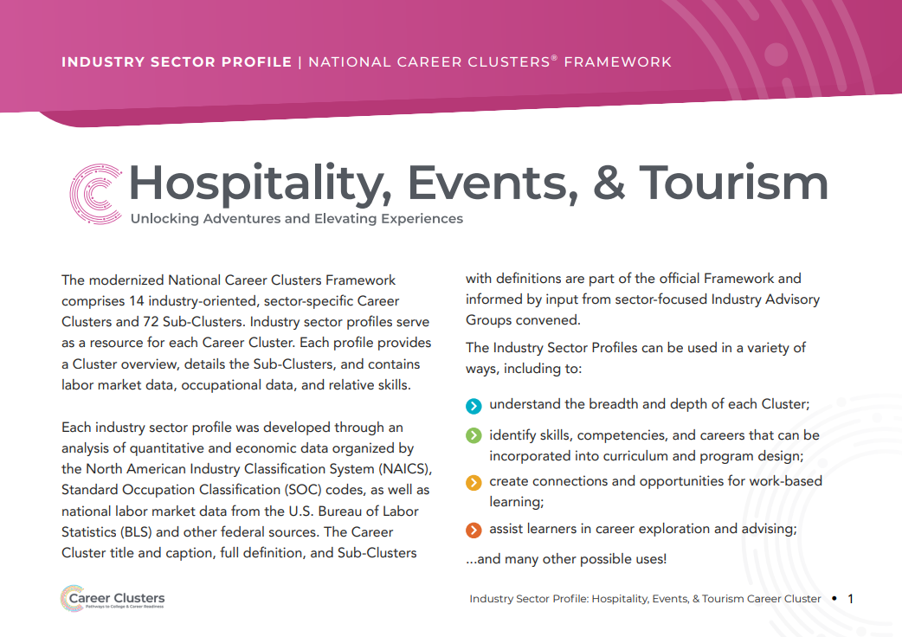
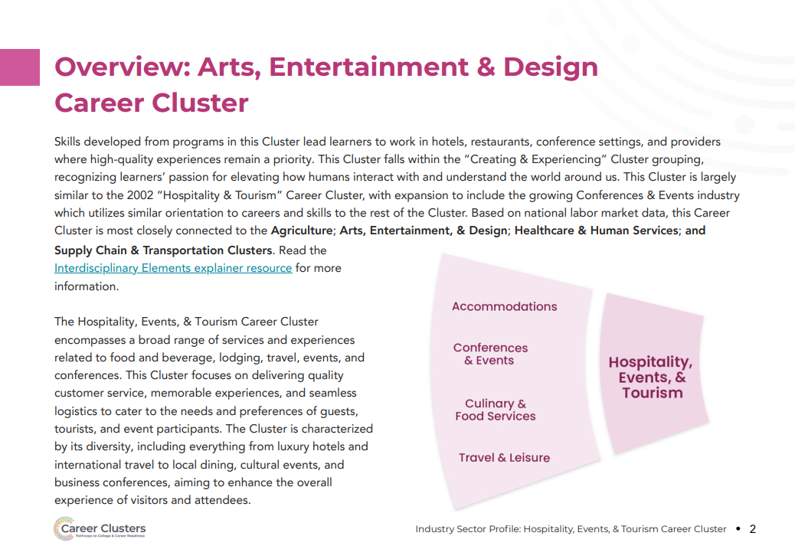
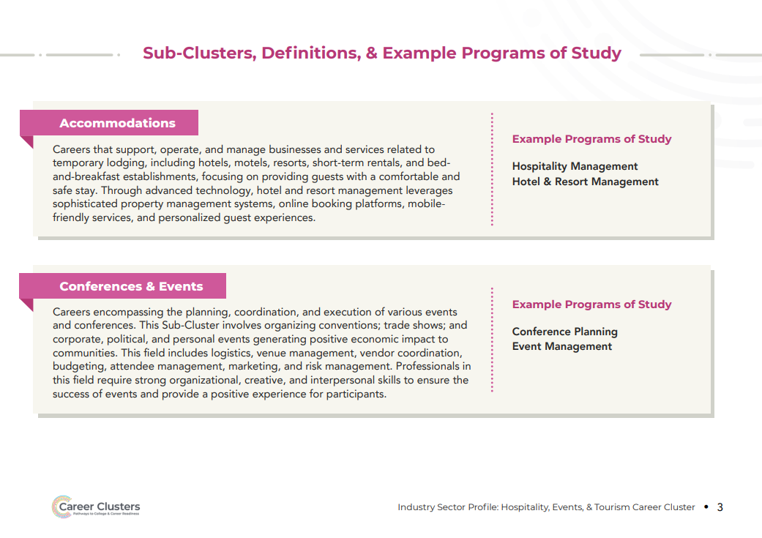
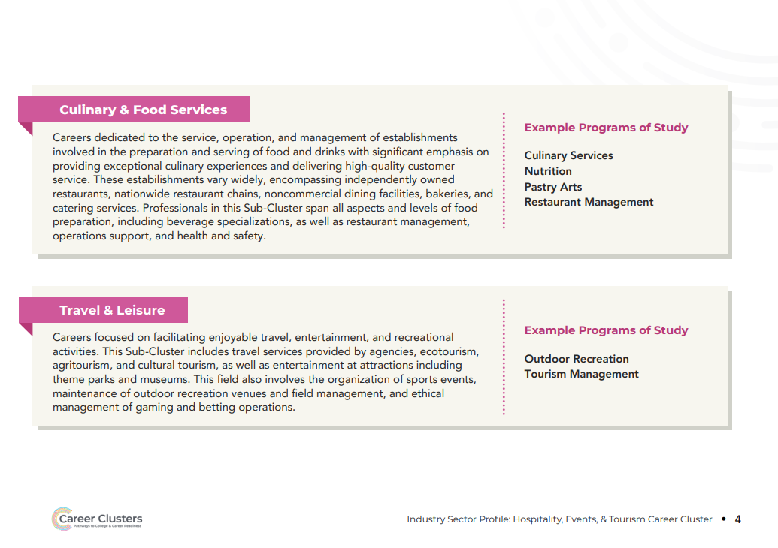

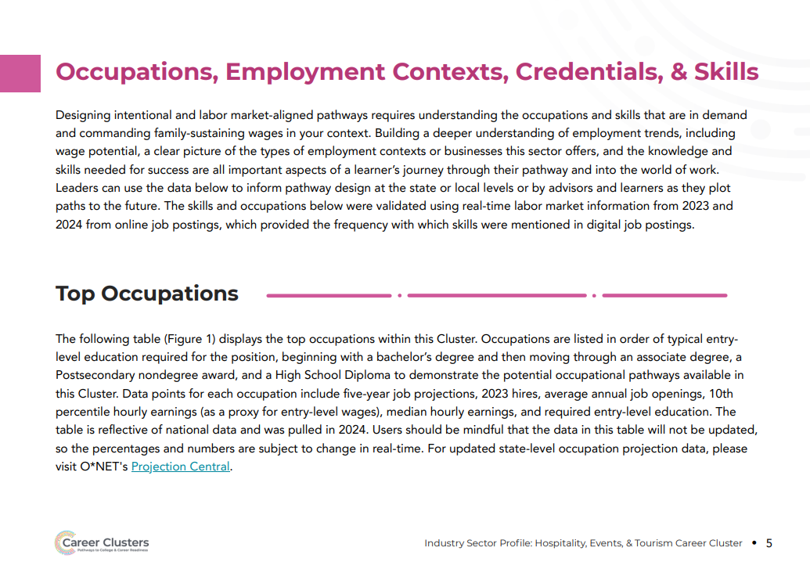
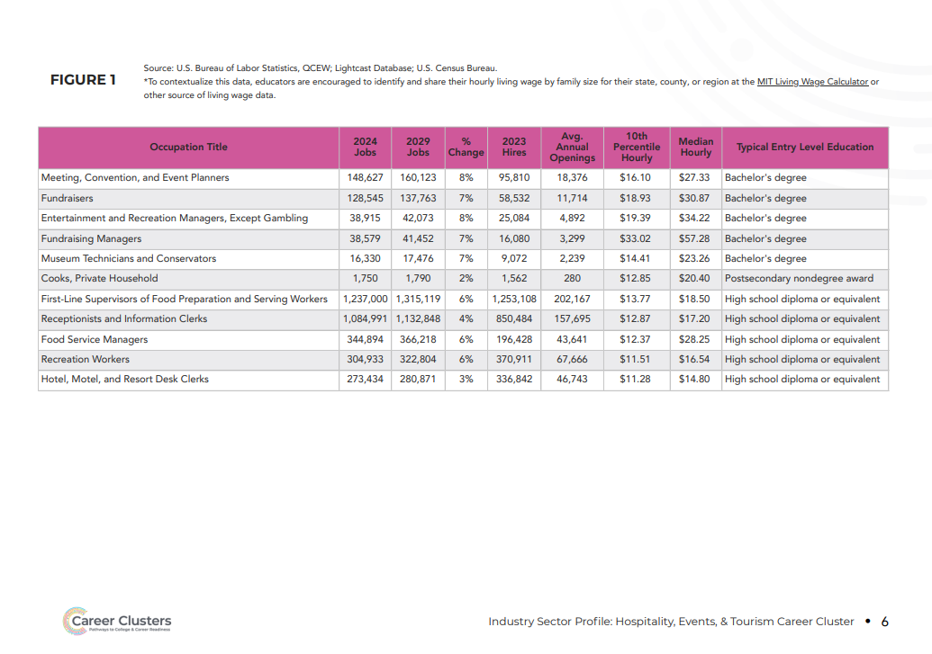
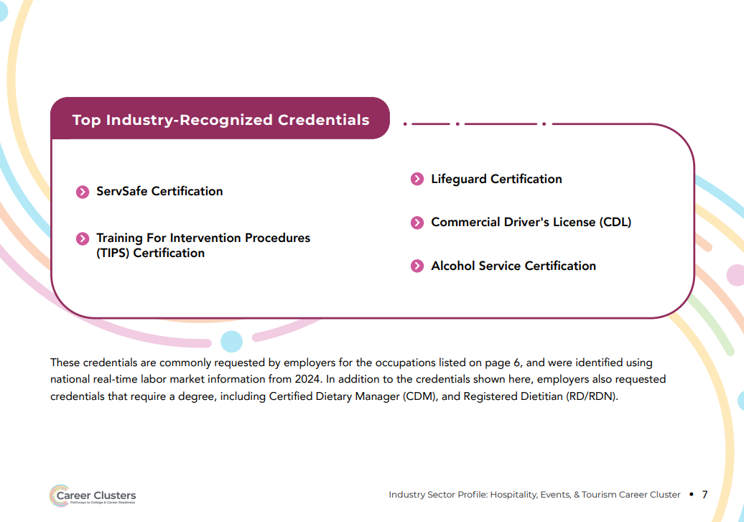
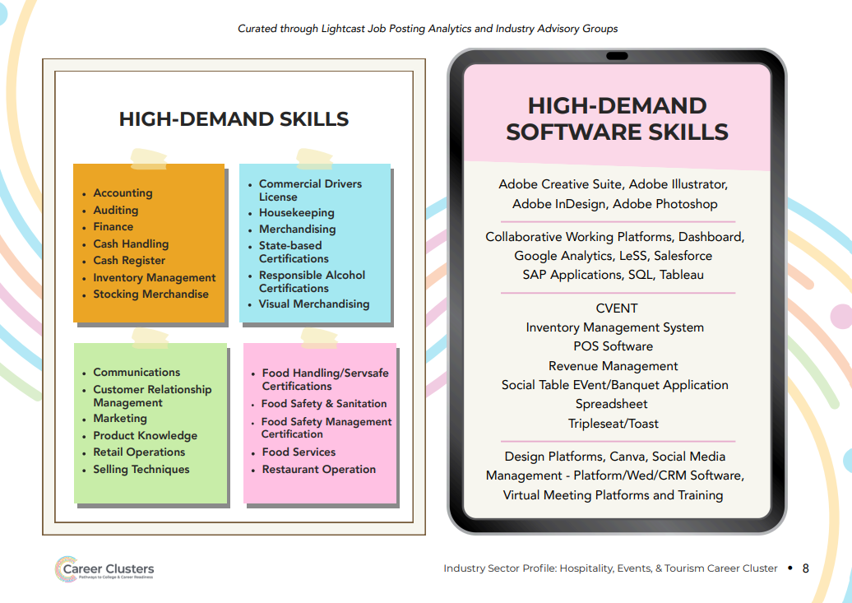
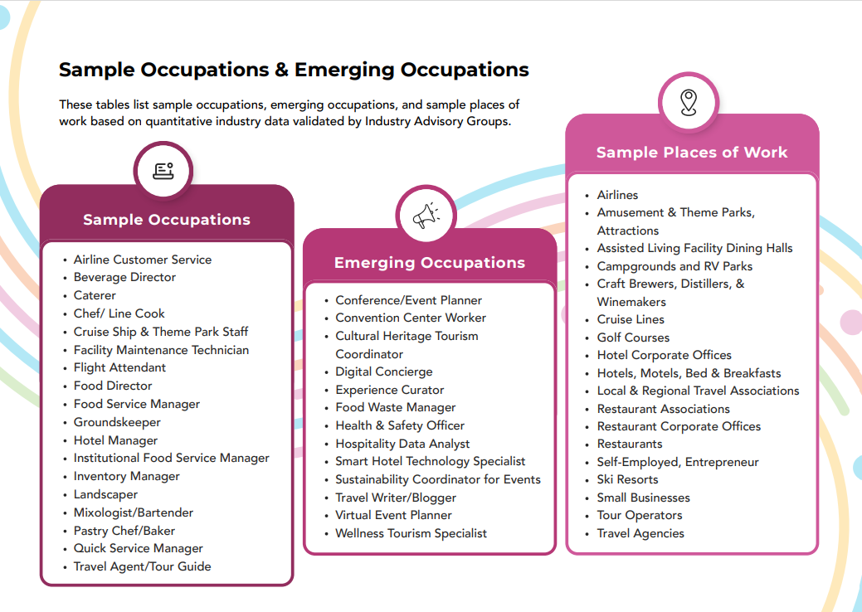

Management & Entrepreneurship

Cluster Definition:
The Management & Entrepreneurship Career Cluster involves skills and occupations that are essential across all industries, focusing on business administration, operations optimization, strategic planning, workforce management, and entrepreneurship.
It merges key areas such as data management and analysis, human resources, general operations, administrative support, project management, and organizational leadership.
This Cluster ensures that businesses across all industries efficiently meet their goals, adapt to market changes, and maintain competitive advantage.
By emphasizing entrepreneurship, this Cluster supports the creation of new ventures, driving economic growth and innovation and making it a cornerstone of modern economies.
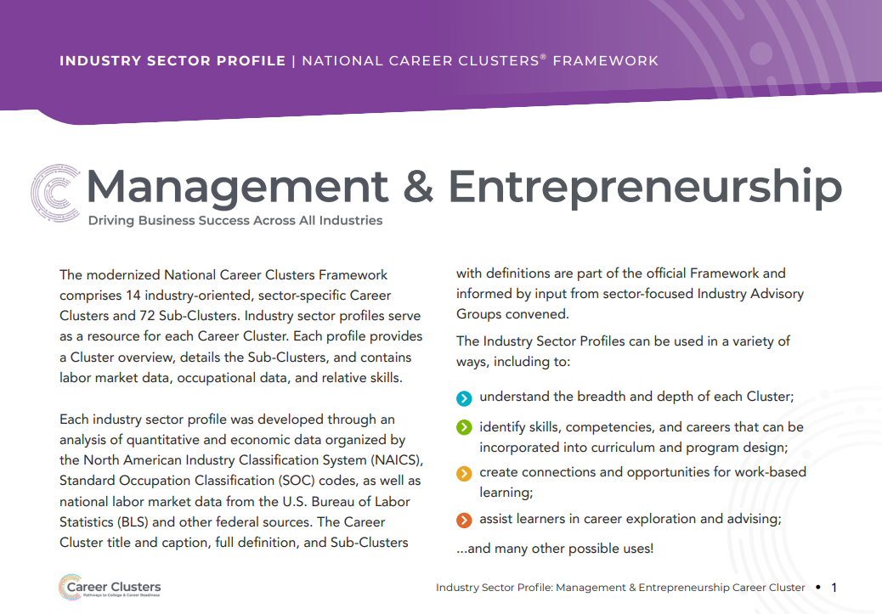
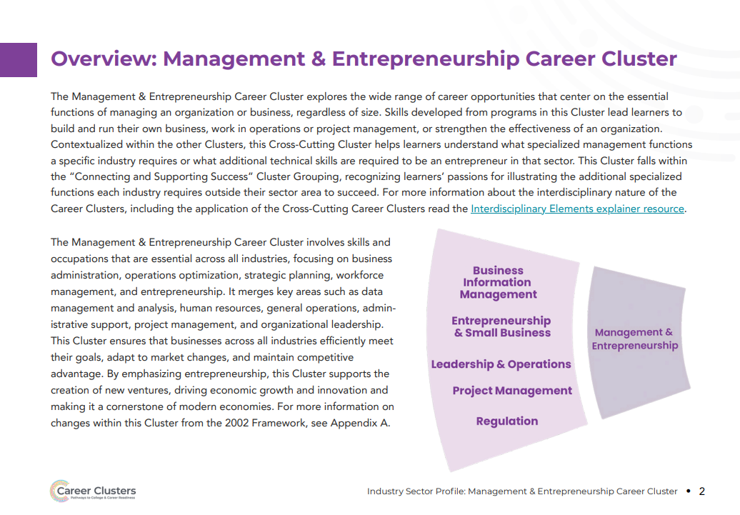
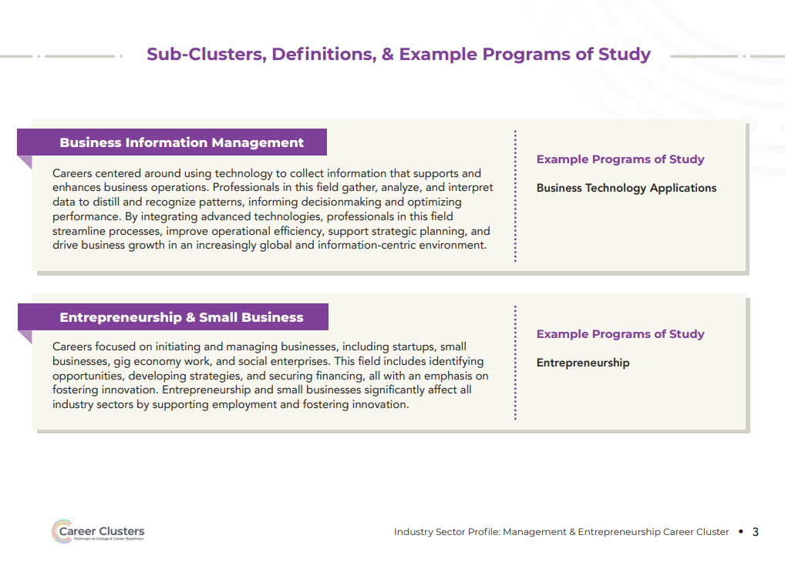
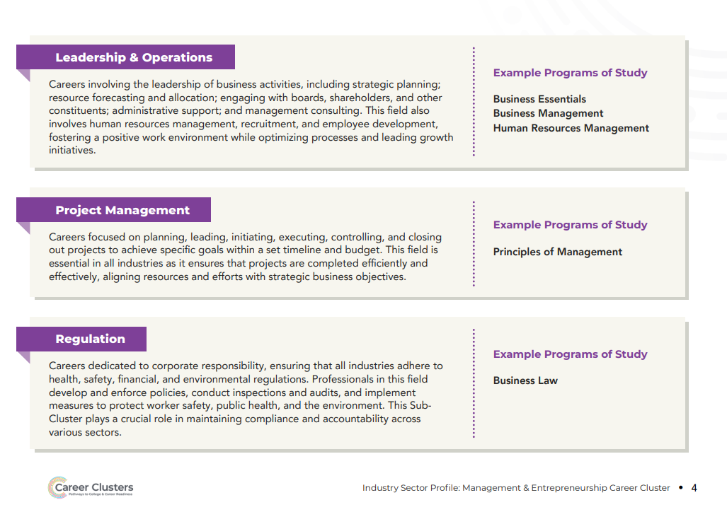
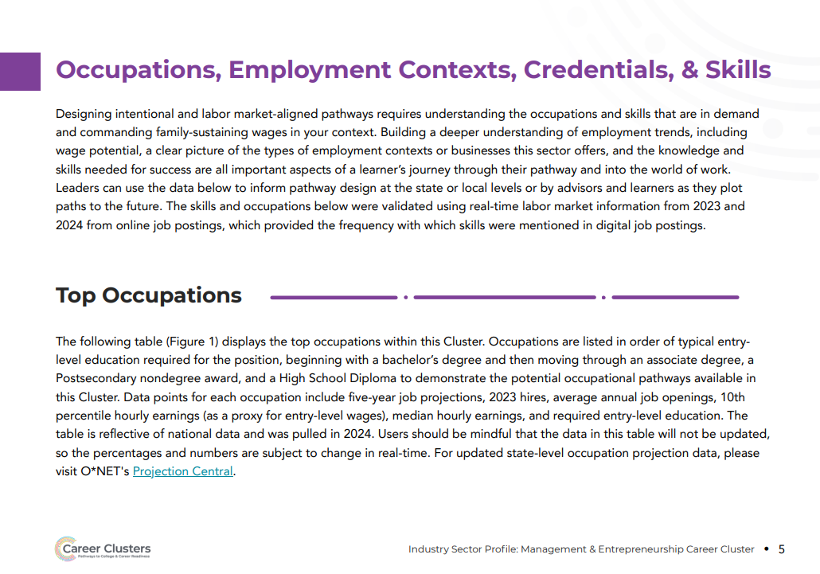

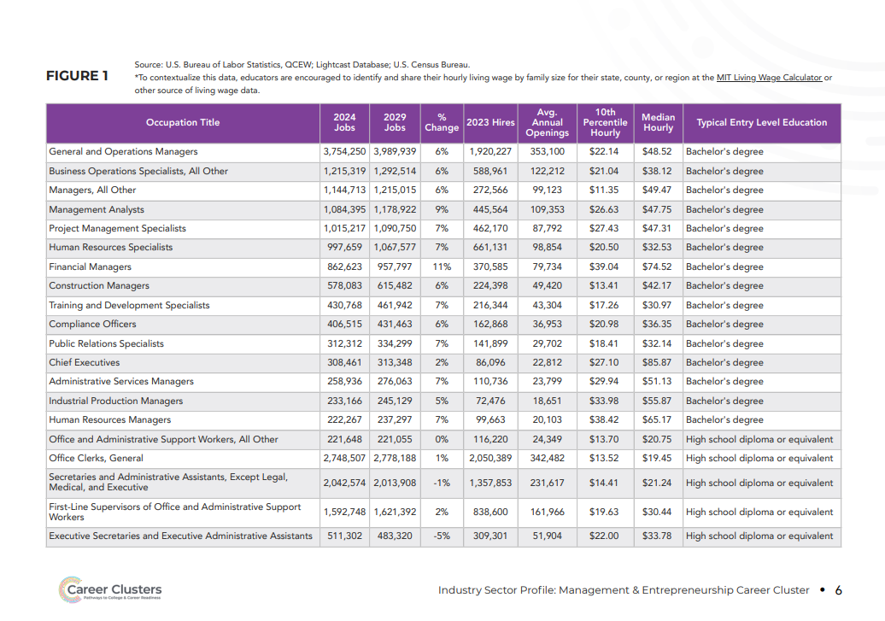
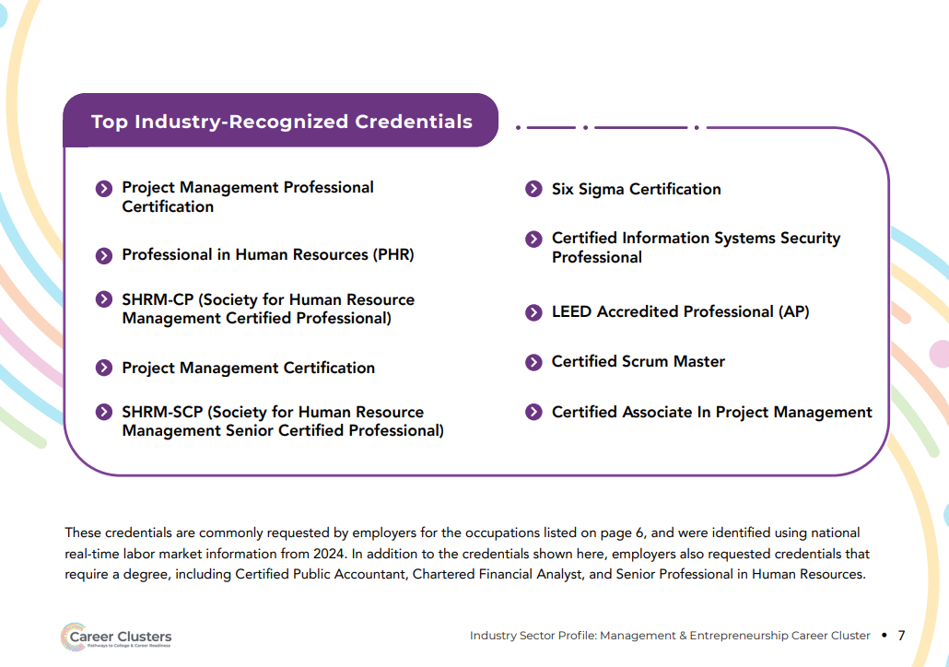

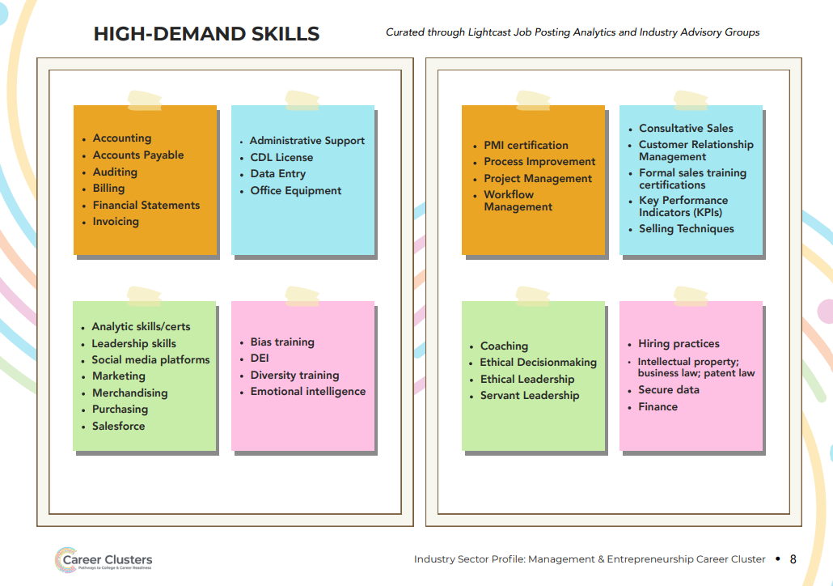
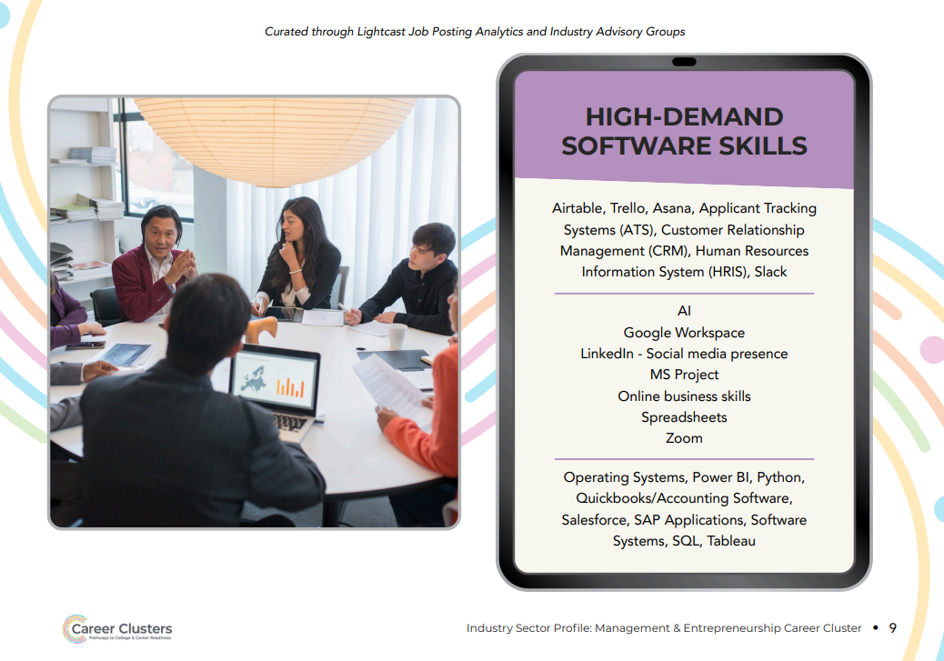
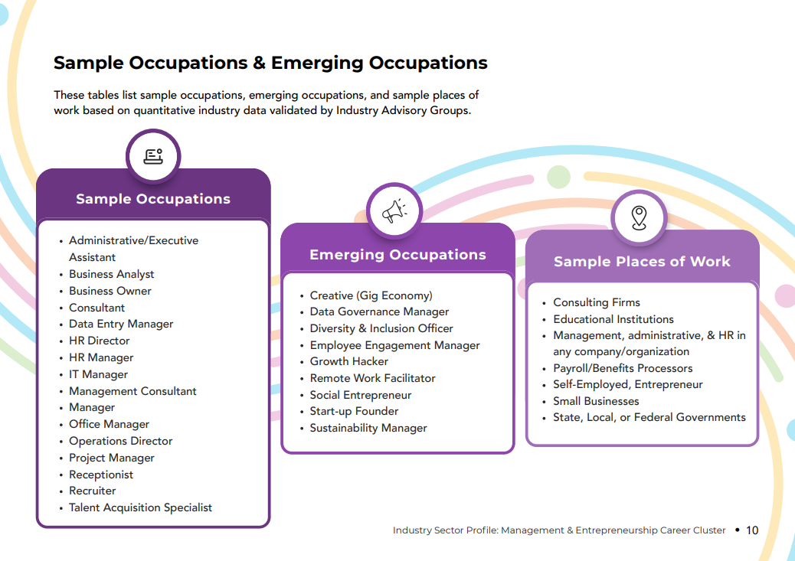
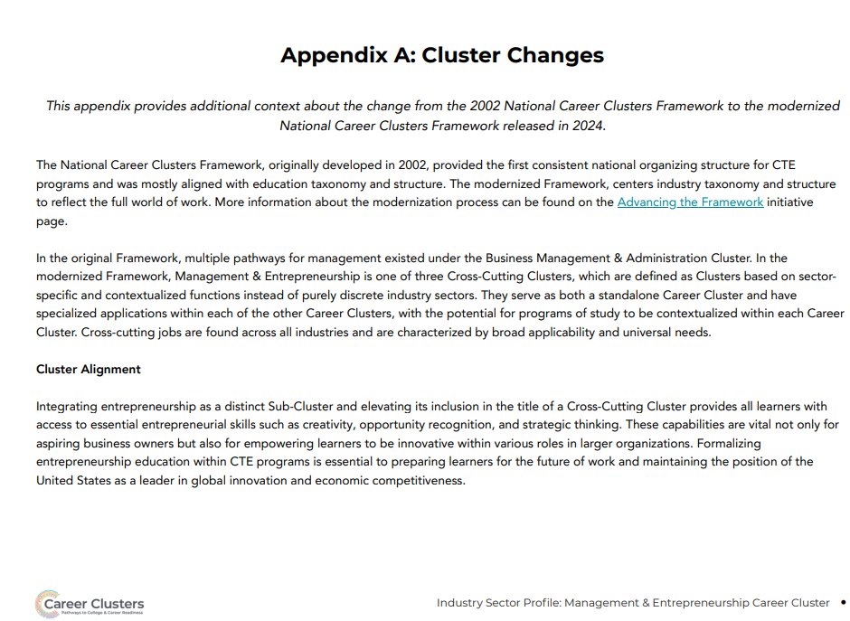

Marketing & Sales

Cluster Definition:
The Marketing & Sales Career Cluster focuses on promoting products, understanding consumer needs, engaging with communities, and driving sales.
It integrates digital marketing, data analysis, brand promotion, customer relationship management, strategic communications, human-centered design, and retail strategies to build strong customer connections and support business growth.
This Cluster is essential in all industries for creating value, effectively reaching and engaging target audiences and achieving commercial success in a competitive marketplace.

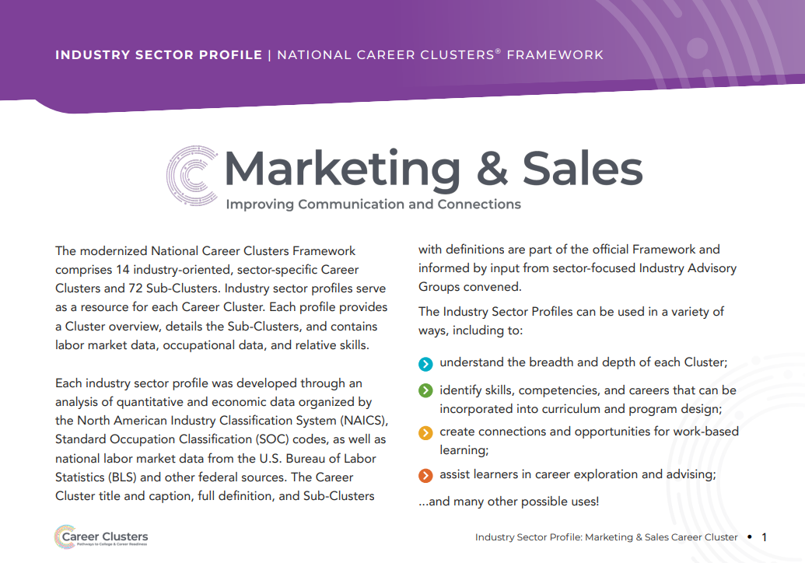

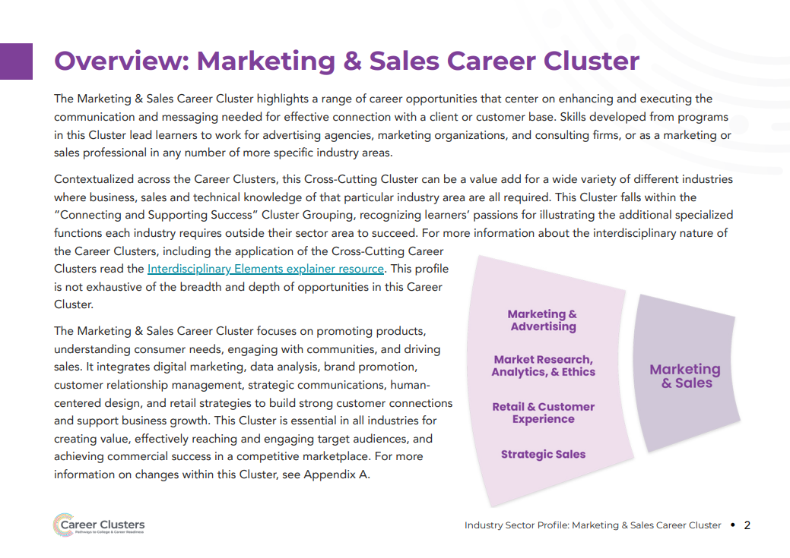
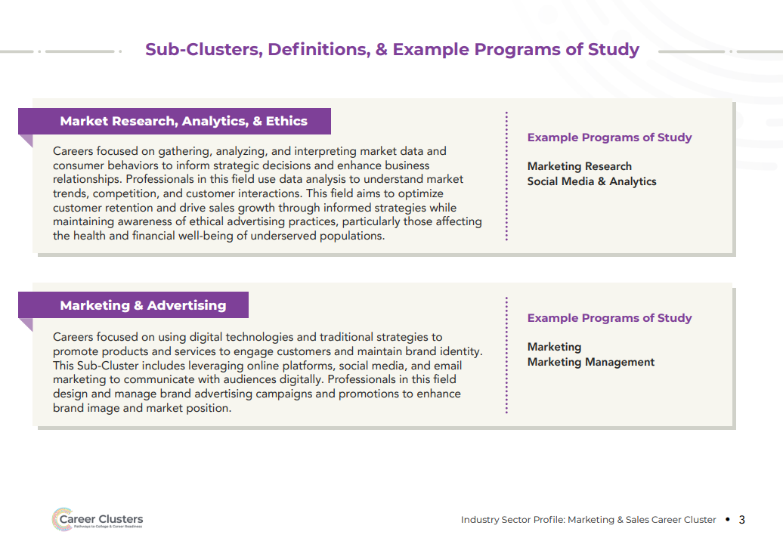
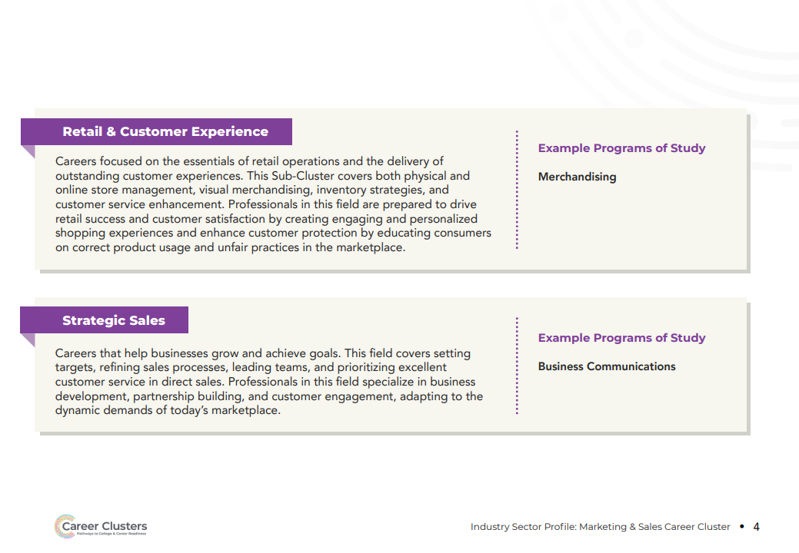
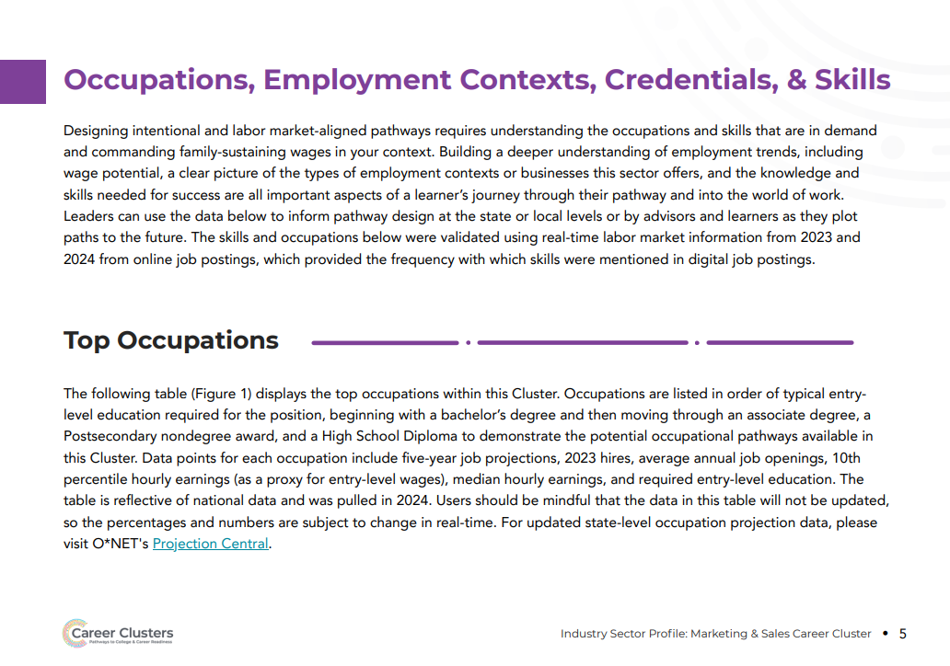
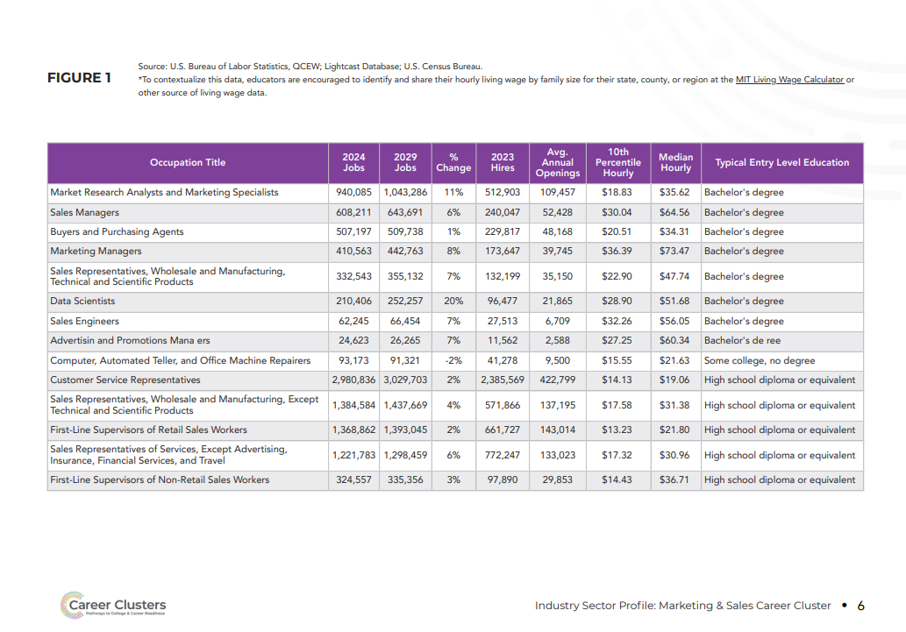
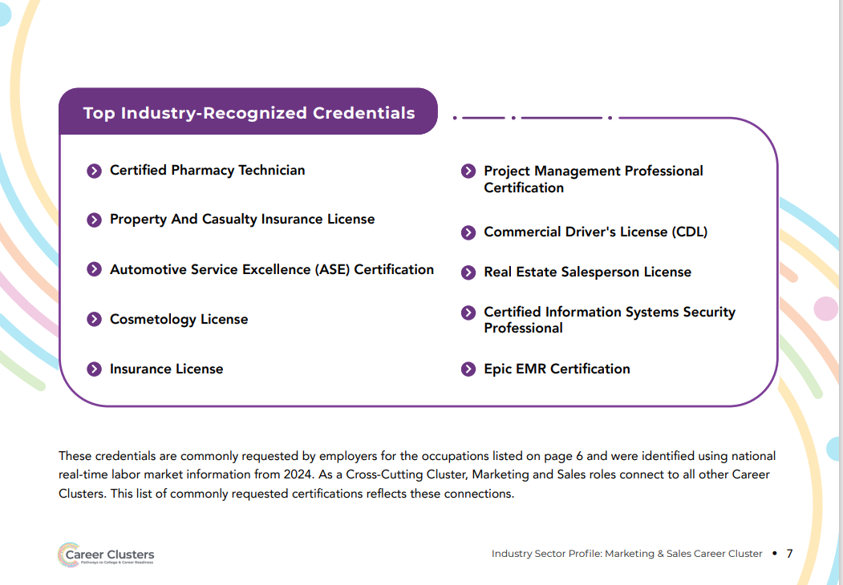
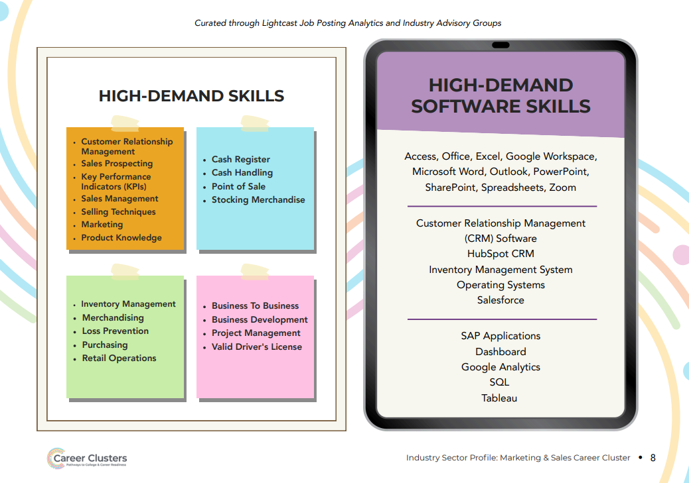
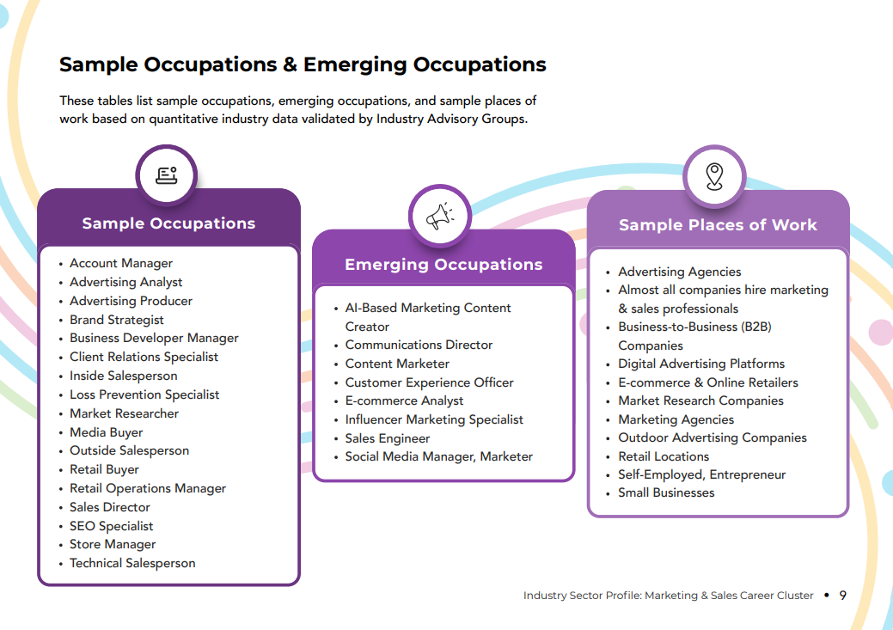

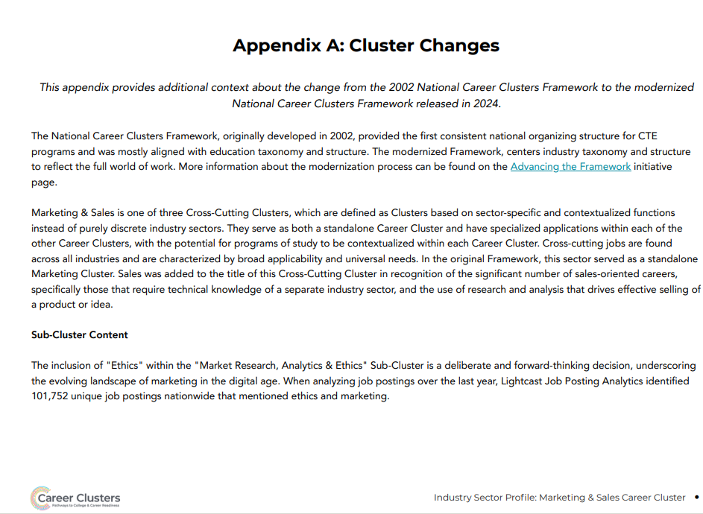

Public Service and Safety

Cluster Definition:
The Public Service & Safety Career Cluster encompasses roles in local, state, and federal government; legal and justice systems; security; and military operations, all aimed at promoting civic responsibility and ensuring the well-being, security, functionality, and resilience of communities, states, and countries.

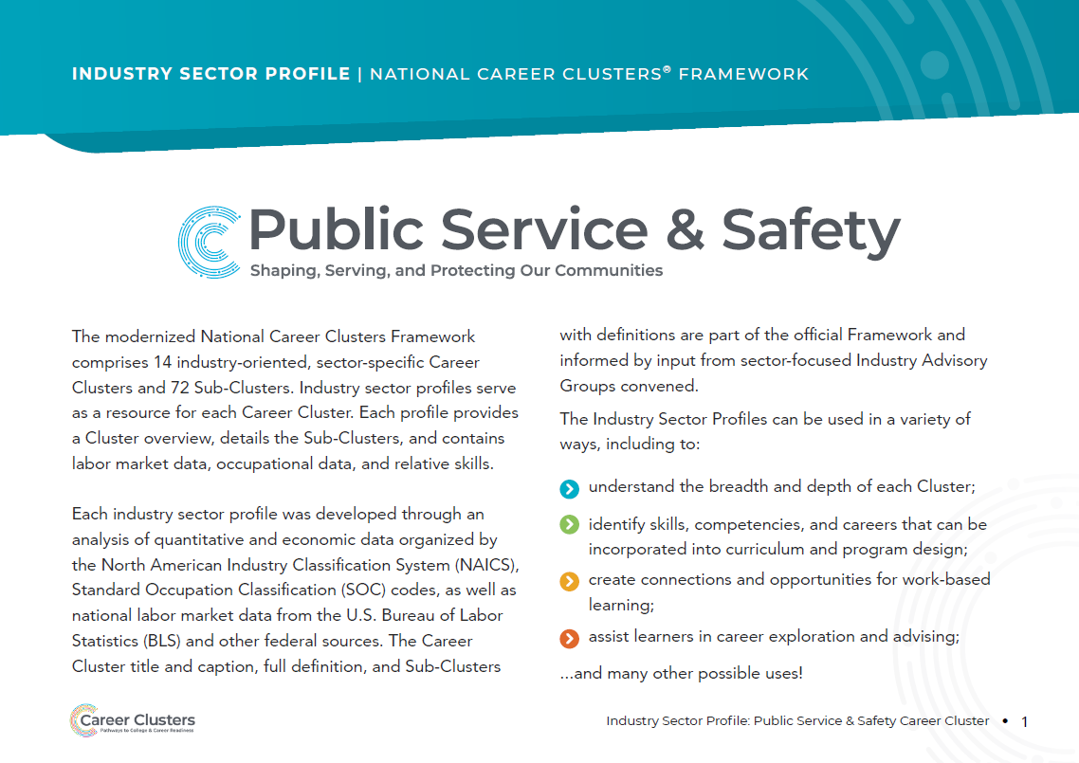
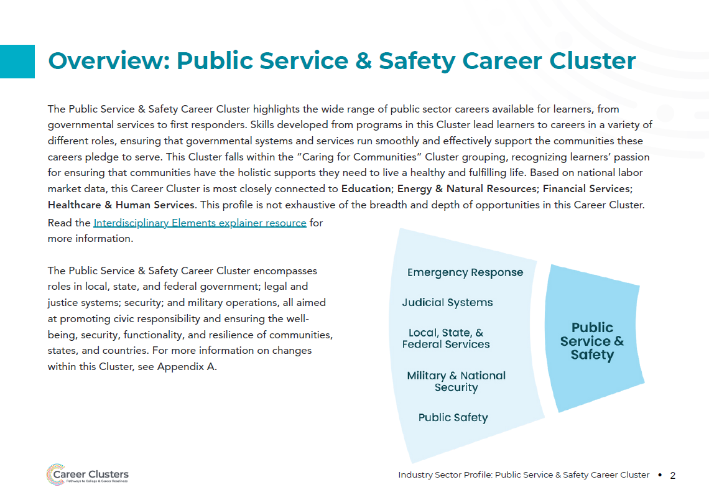
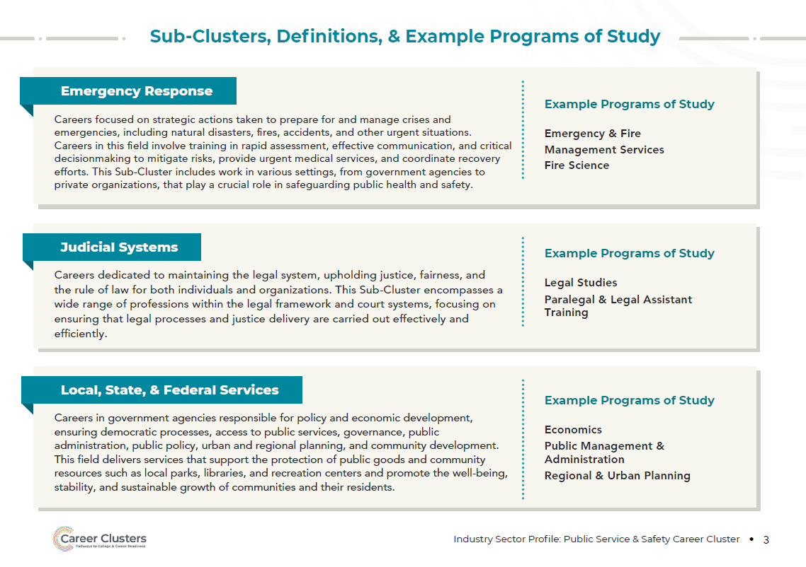

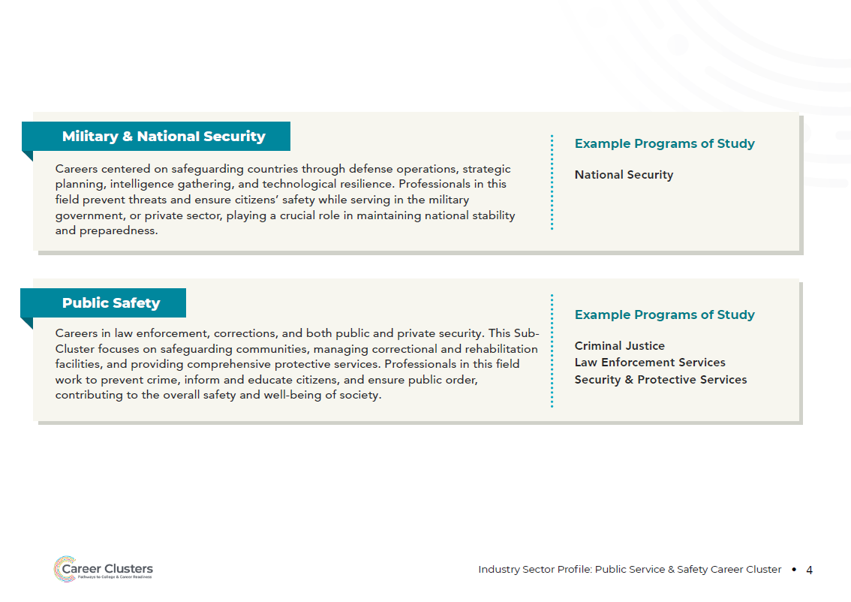
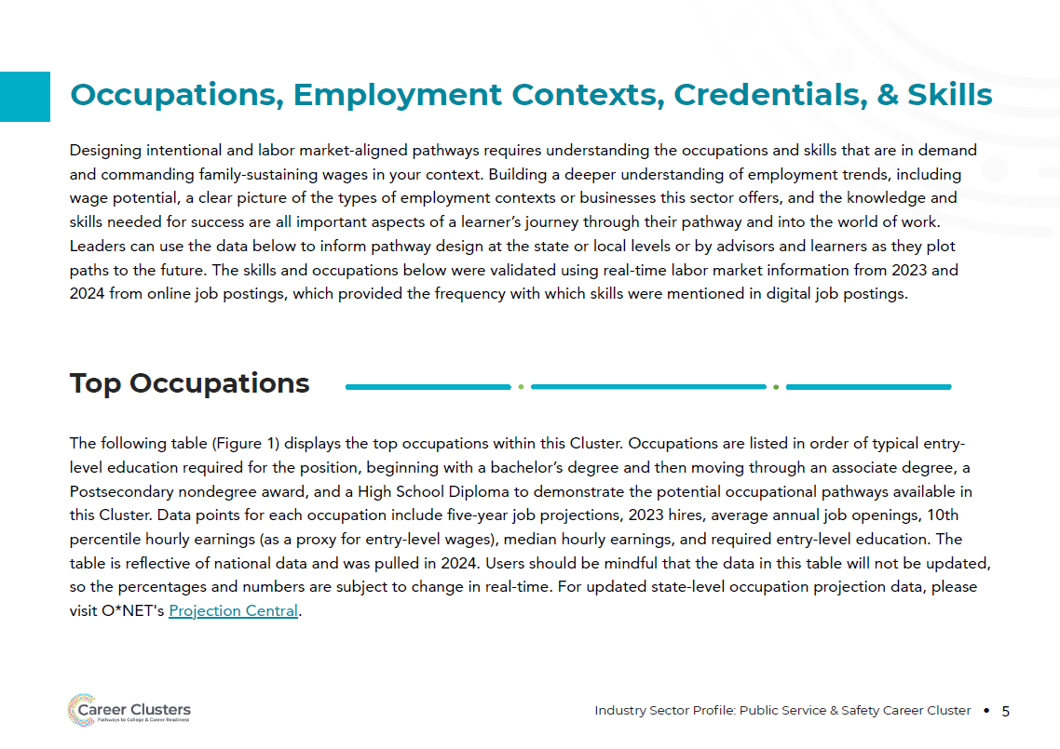
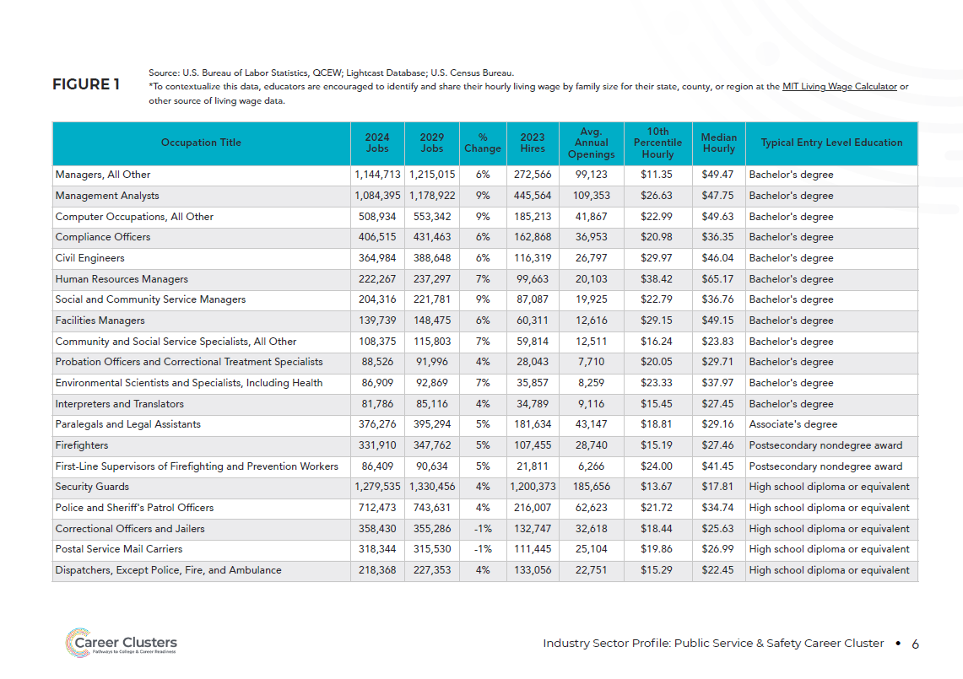

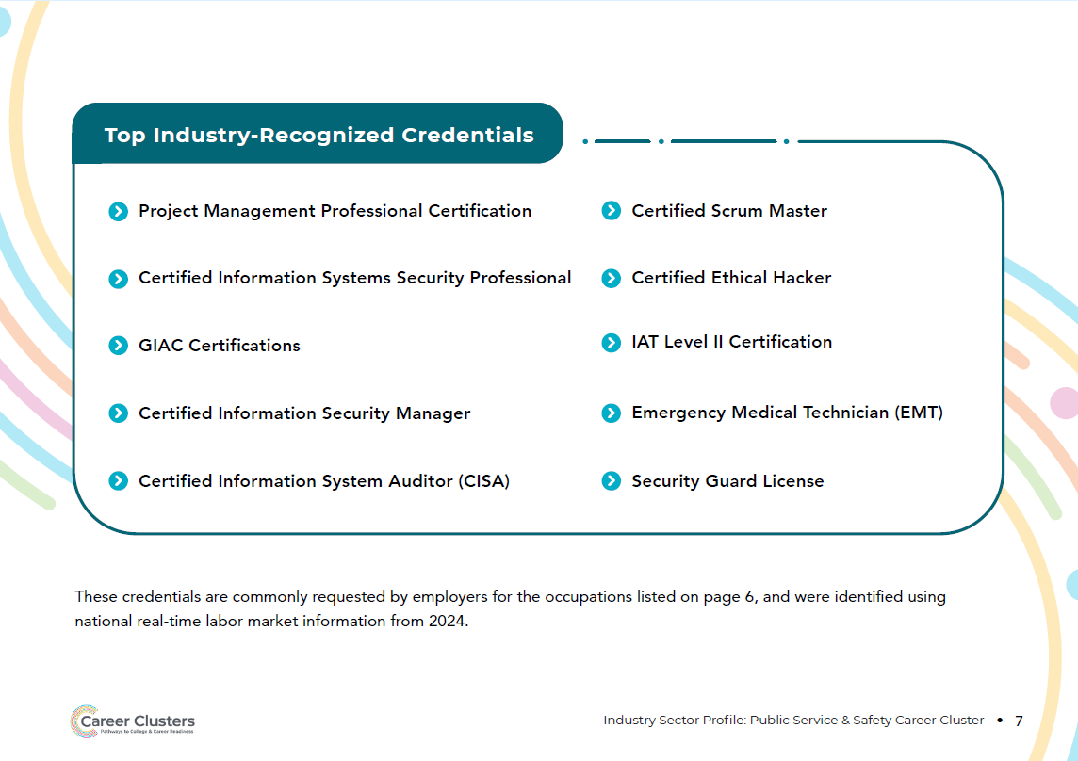
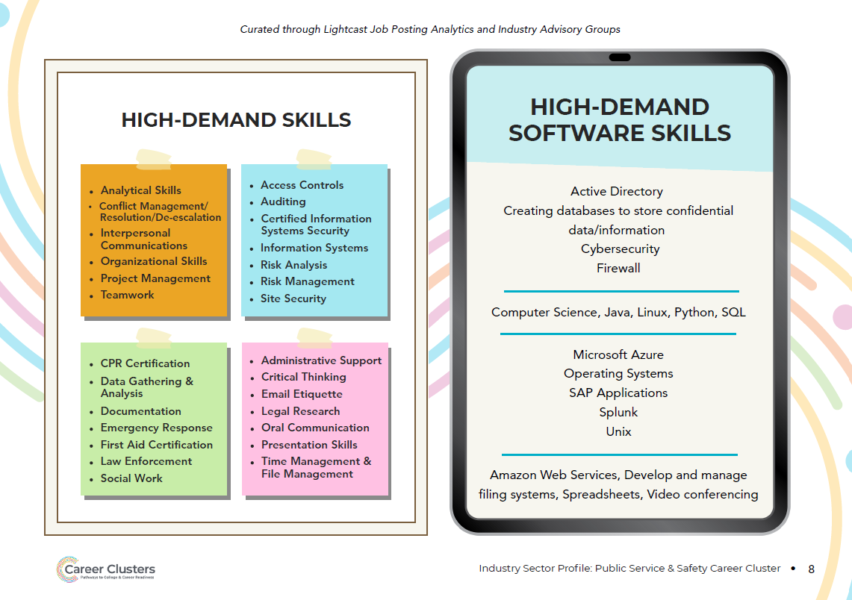
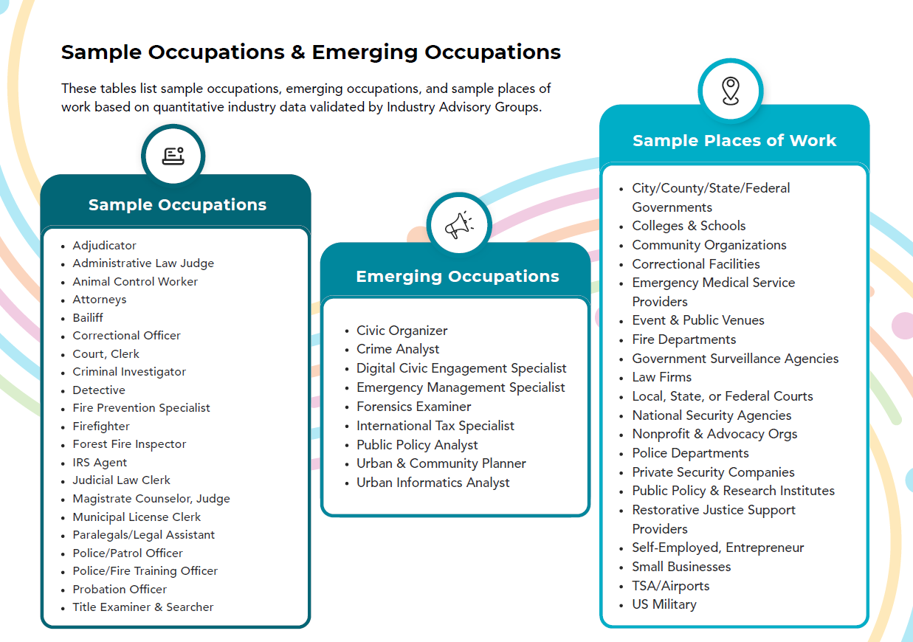

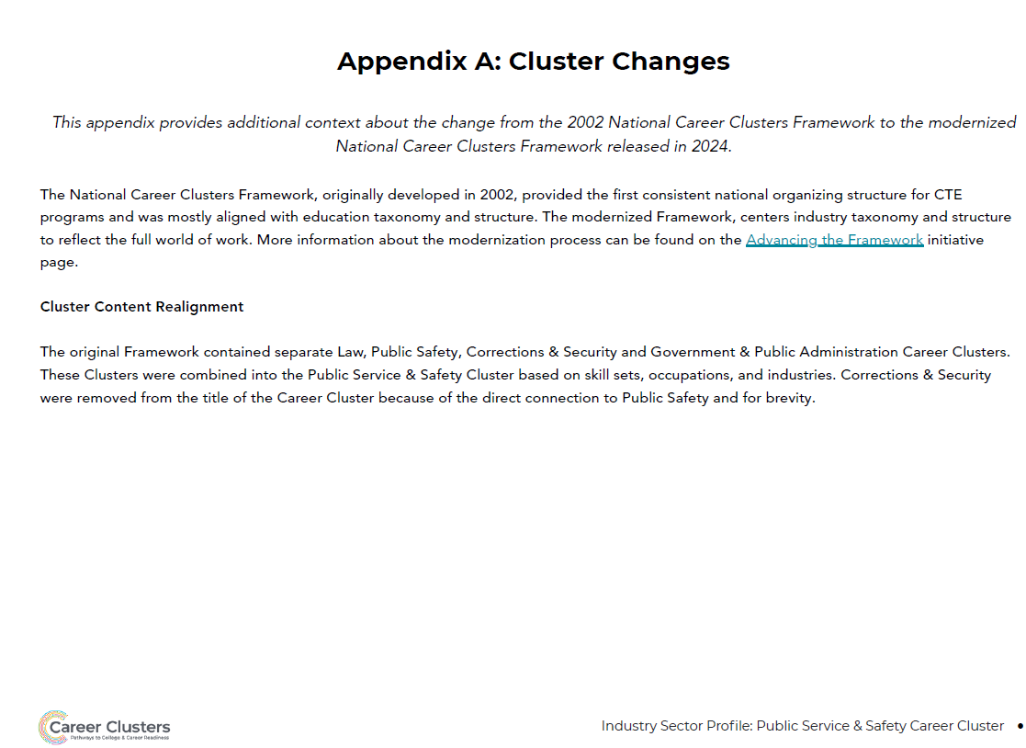

Supply chain and Transportation

Cluster Definition:
The Supply Chain & Transportation Career Cluster encompasses the transfer, coordination, and management of goods from production to consumption, ensuring efficient movement across various modes of transportation including air, ground, and water, as well as maintenance of the respective transport modes.
This Cluster integrates logistics and distribution networks to facilitate the seamless flow of materials and products, playing a crucial role in global commerce, economic development, and community health.

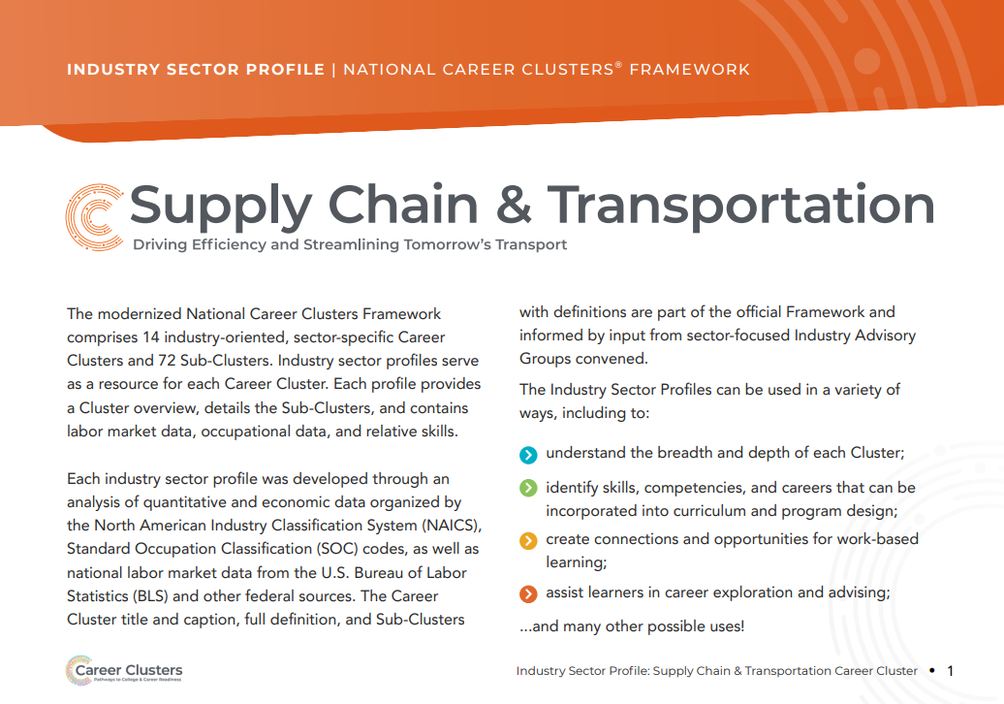
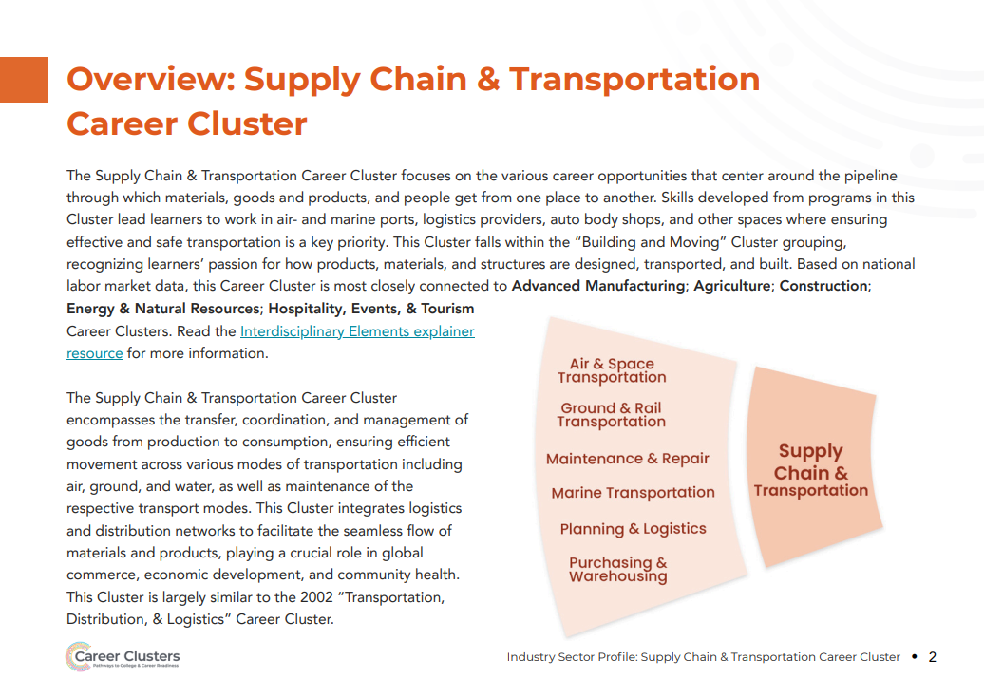
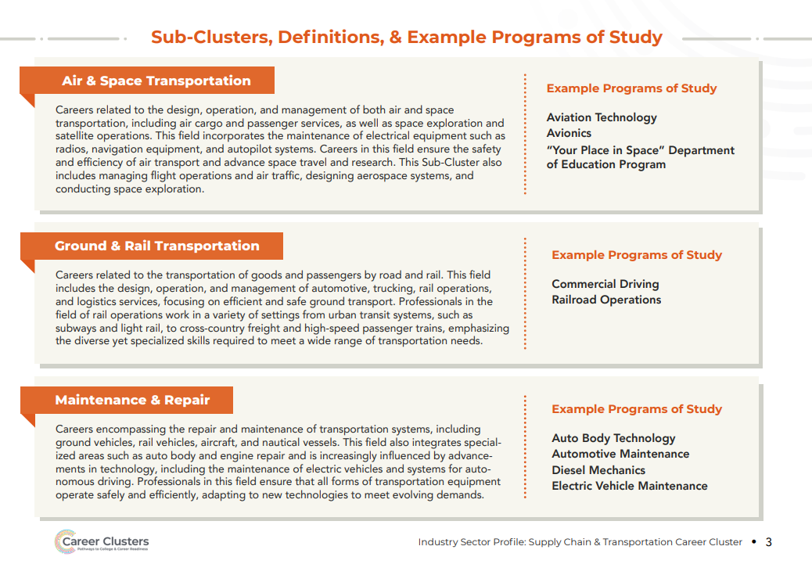
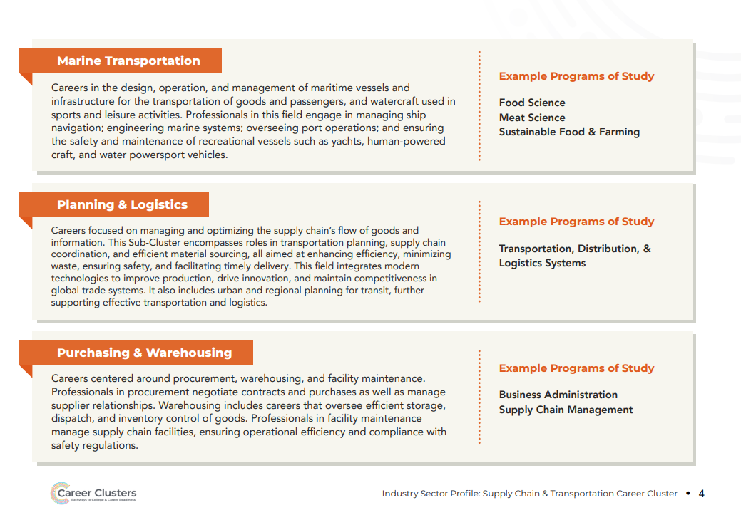
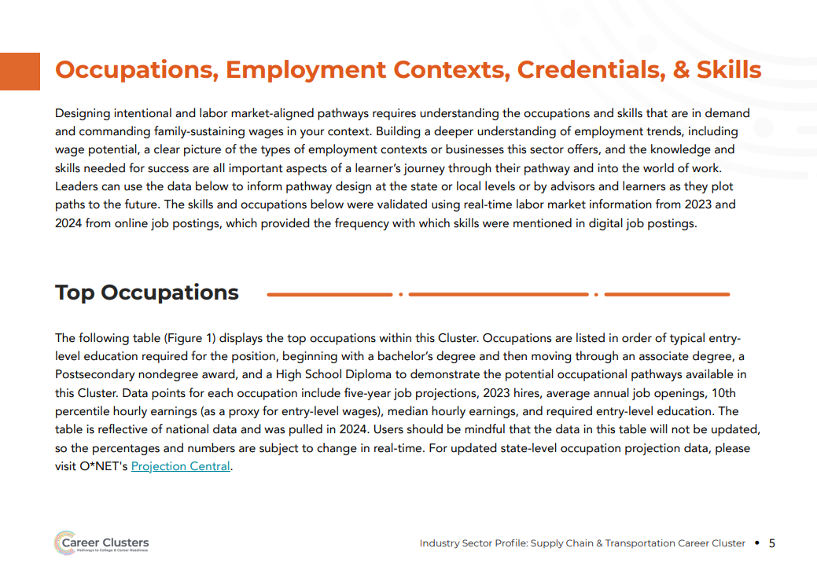
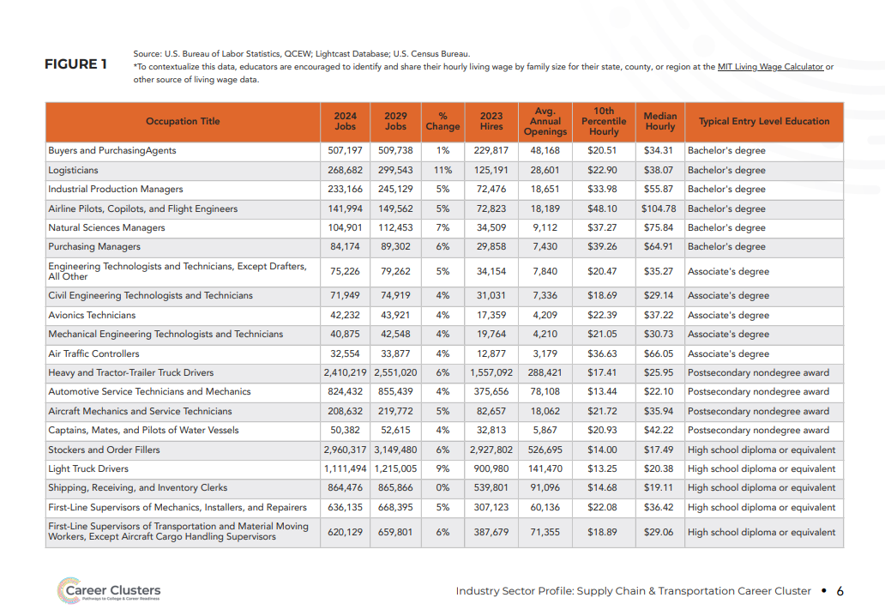
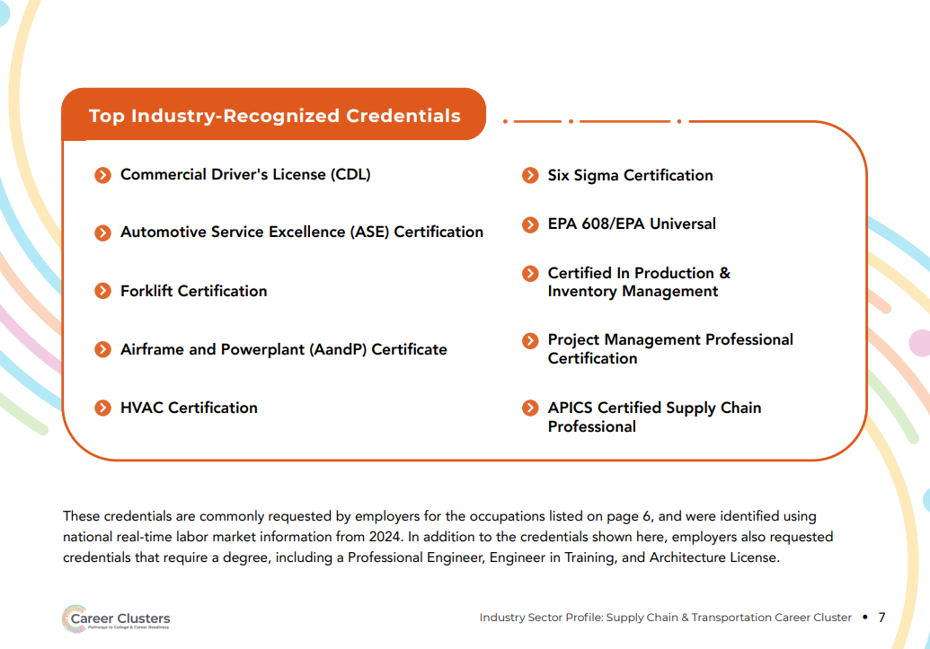
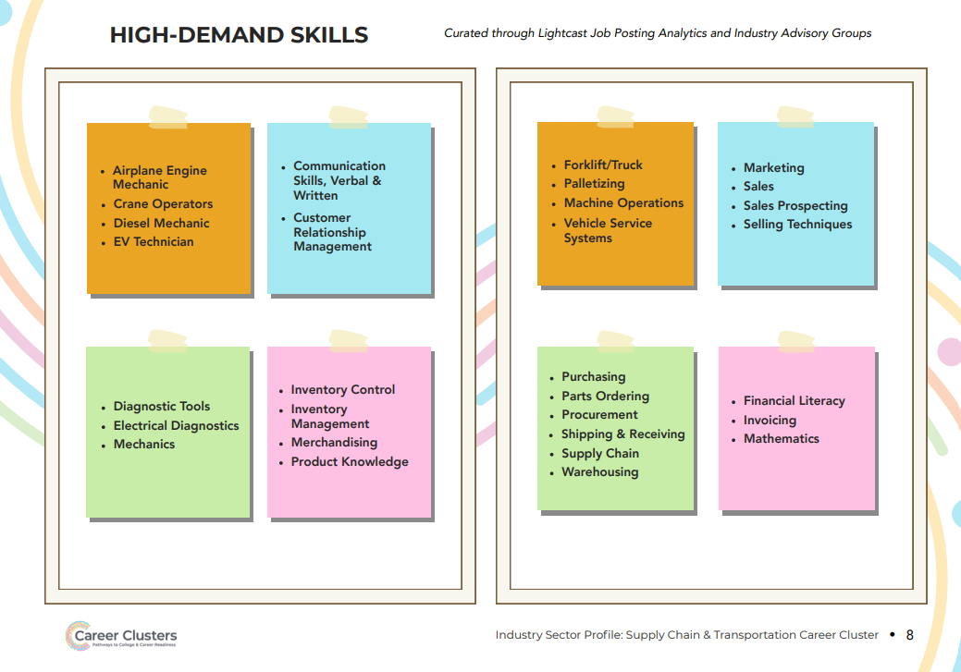
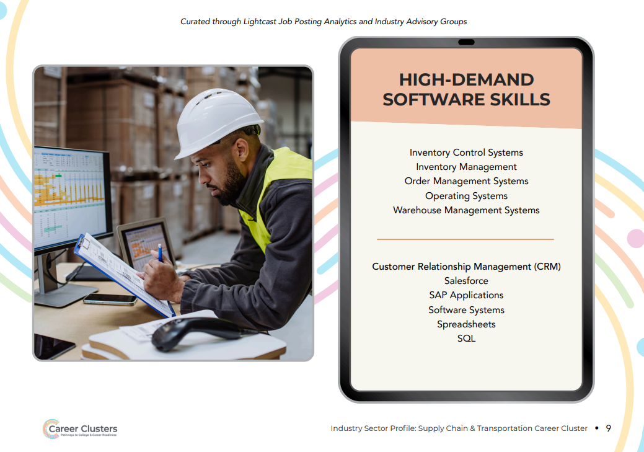
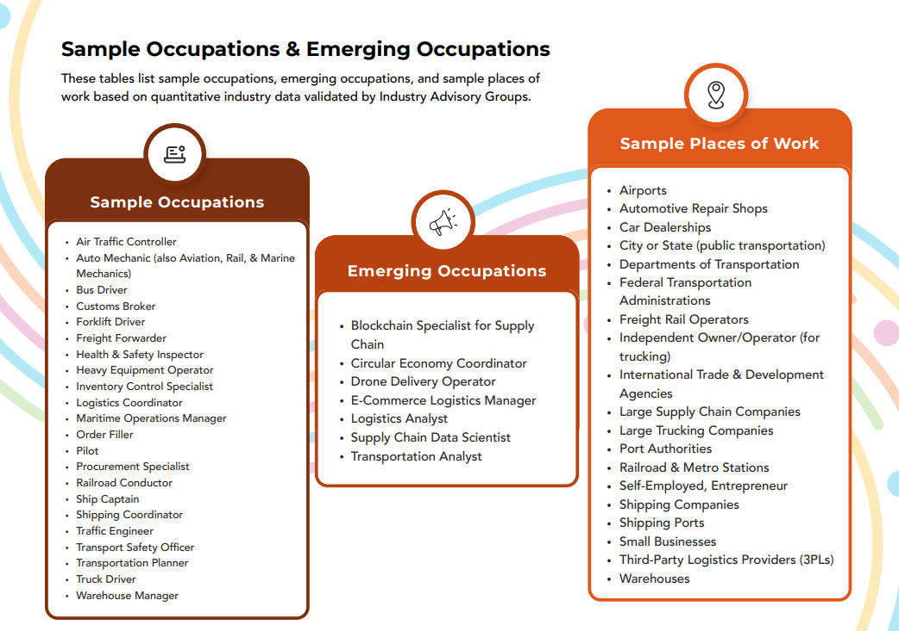

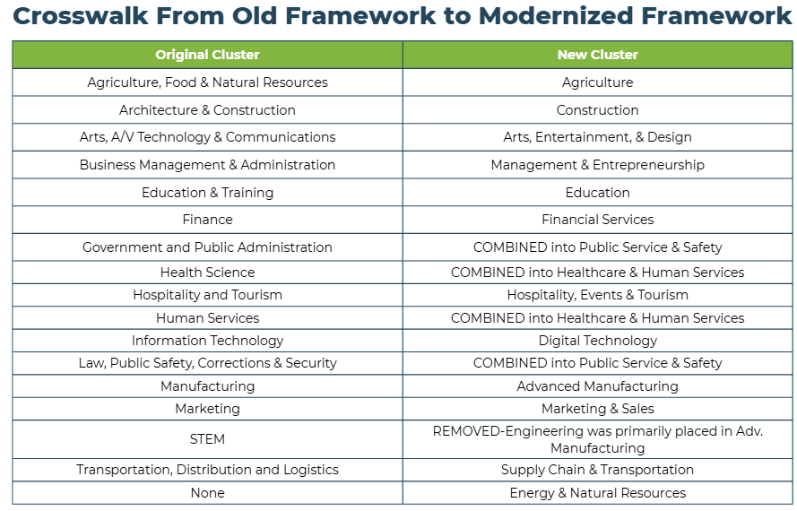

end

