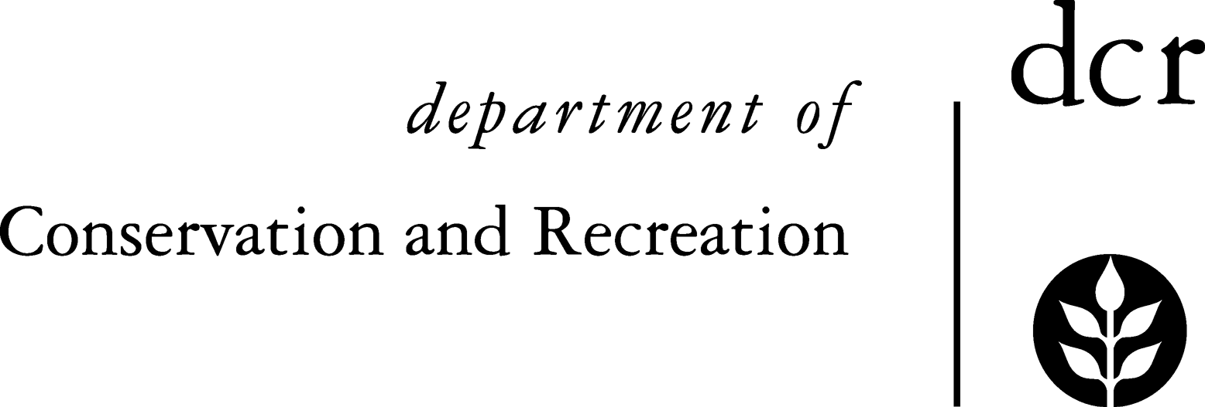


Commonwealth of Massachusetts

DCR Urban and Community Forestry

National Grid Partnership Challenge Grants

Additional Guidelines

Urban and Community Forestry National Grid Partnership Challenge Grants can be used to fund projects which will result in:
- Urban and Community Forestry Management Plans,
- Tree and Forest Ordinances and Policies,
- Strong and Effective Citizen Advocacy and Action Organizations,
- More Highly Trained Professional Staff,
- Strategic Community Tree Plantings,
- Appropriate “Heritage” Tree Care Projects
Below are some additional guidelines to consider as you develop your project ideas and proposals.

Management Plans
These grants can be used to fund the development of Urban and Community Forestry management plans at the community level. These plans can be completed either in-house or using outside consultants. They should include a written final plan, and must be implemented. Plans should address urban and community forestry resources at the community level, but may also include other community natural resources or be integrated into other community natural resource plans (i.e. open space plans). They should include attention to “risk tree” management and utility safety and reliability issues.

Ordinances and Policies
These projects can be used to write and adopt local tree ordinances, zoning bylaws or formal policies that address tree planting, selection (i.e., right tree, right place), protection and maintenance issues, and the protection of tree canopy. For some examples of ordinances and bylaws from other Massachusetts communities see http://www.mass.gov/dcr/stewardship/forestry/urban/urbanFAQs.htm#ordinance.

Tree Plantings
When designing your tree planting project, please adhere to the following guidelines:

Location
In matching trees with sites, grant recipients must consider mature height, spread and growth habit of trees to be planted, and how these will interact with site characteristics such as overhead power lines, existing vegetation, and infrastructure items such as curbs and sidewalks. Trees that grow greater than 30 feet tall should not be planted under power lines. Multi-stemmed and low-growing trees with large spreading crowns should not be planted near traffic intersections, fire hydrants or signs. Plant the largest tree species that the site will accommodate, for maximum environmental benefits, but consider all the obstacles to mature root and crown growth.

Site Map
You must submit a detailed site map with any grant application involving tree planting. Your site map should specifically identify the exact location and species of each tree to be planted and the presence or absence of overhead and underground utilities and widths of available growing space.

Setback Plantings
Trees may be planted up to twenty (20) feet from the side of a public way (on private property), and still be considered a public street tree. Contact abutting neighbors to determine if they want a tree and will water and maintain it for the first several years. If necessary, be sure to get written agreement.

Minimum Distance Standards
In the absence of municipal codes to the contrary, the following minimum placing distance standards are recommended for street trees:

- at least 10 feet from driveways, wheelchair ramps and fire hydrants
- no closer than 10 feet behind or 20 feet in front of signs
- at least 5 feet from underground utility lines
- at least 10 feet from street lights, farther for larger trees
- at least 15 feet from storm sewer inlets
- at least 30 feet from intersections
- adequate distance from existing vegetation on abutting property to avoid affecting growth habits
- do not plant trees near building foundations or walls
- avoid planting trees with “messy” or “large” fruit production in pedestrian or high traffic areas.
- call utility "dig safe" before excavating (888-344-7233)

Restricted Growing Space
All tree lawn (utility strip) and tree pit plantings must include at least a four-foot wide planting area. Consider the natural spread of tree roots when selecting or modifying a site. Provide enough space for root growth and you can be more assured of a successful long-term planting. To reduce long-term maintenance and enhance survival, seek planting sites with a minimum 400 cubic feet of available soil (10' x 20' x 2' deep).

Tree Selection
Please select trees which are appropriate for your site conditions, including available overhead and below ground growing space. You may want to consult some of the following resources:
MA DCR Tree Selection Fact Sheet: www.mass.gov/dcr/stewardship/forestry/urban/treeSelect.pdf
Cornell Recommended Urban Trees: Site Assessment and Tree Selection for Stress Tolerance: http://www.hort.cornell.edu/uhi/outreach/recurbtree/index.html.

Size of Planting Stock
The time required for trees to regain a pre-transplanting growth rate is approximately one year for each one inch of caliper. Consider planting a smaller tree, which establishes its root system and resumes vigorous growth faster than a larger tree, unless vandalism has been a problem.

Tree Planting
Everyone knows how to plant a tree, right? Unfortunately, most landscape trees are planted incorrectly today and most B&B trees are coming with the root flares buried 6-8 inches deep in the root ball. Please insure that your planting is supervised by someone trained in current planting issues and techniques and that your trees are planted with the root flare at grade.

Sample Maintenance Plan for Newly Planted Trees
All trees will be protected from injury and maintained to optimum health for the life of the tree. Trees will be protected from injury that may result from vehicle collisions, bicycle parking, de-icing salts in winter, herbicides, and excessive heat from road resurfacing as best as possible. Over the first three years, the trees will receive extra care so that they may become established at the site. This includes:

Year One:
Upon initial planting, each tree will receive a two to four inch layer of mulch (shredded bark or wood chips) in an area about three feet in diameter around the trunk, but clear from the trunk by three inches. Tags, tape and strings will be removed. Corrective pruning of broken or injured branched will be done. Throughout the growing season, the trees will be watered once or twice a week unless sufficient rain falls to maintain soil moisture. The trees will be regularly monitored for pest, diseases or cultural problems and controlled according to principles of integrated pest management.

Year Two:
Watering and monitoring will take place throughout the growing season as in Year One. Lost mulch will be replaced to maintain a depth of two to four inches. The soil around the trees will be aerated and fertilized during the fall with a 10-10-10 organic fertilizer applied as subsurface injection; or using a granular fertilizer, with a punch bar application or broadcast on the soil surface.

Year Three:
As in year two, water, fertilize, monitor and treat pests and diseases as needed. If necessary, light pruning will be done to build good crown structure and remove low limbs for pedestrian and vehicular clearances.

Heritage Tree Care Projects
For the purposes of this grant program, Heritage trees are those that have trunk diameters greater than 32 inches (DBH) and have documented historic or cultural significance to the community or the State (documentation must be submitted with proposals) or are designated a champion for their species in Massachusetts. Trees must be on public property or with free public access. Trees must be healthy and sound with a reasonable prognosis after treatment.

Eligible Activities
Heritage Tree Care Grants will support the costs associated with treatment of public Heritage trees by a Certified Arborist. Eligible treatments for reimbursement include application of mulch, crown cleaning (pruning), preservation such as cabling and lightning protection, and the costs of interpretive signage.

Certified Arborist
A Certified Arborist (ISA or MCA), must prepare the bid(s) for the application and supervise the Heritage Tree Care work. Multiple arborists may be consulted in preparing the application, but applicants should include the name and certification number of the individual whom they will select to supervise the work if the grant is awarded. Local Tree wardens should also supervise the work.

Photographs
Photos showing the trees in question should be submitted with any application.

Bid Document
A bid document, prepared by a Certified Arborist, must be submitted with any application. This bid must detail tree conditions and proposed treatments.

