INDOOR AIR QUALITY ASSESSMENT

Nauset Regional Middle School
70 Route 28
Orleans, MA



Prepared by:
Massachusetts Department of Public Health
Bureau of Environmental Health
Indoor Air Quality Program
February 2013

Background/Introduction
At the request of Mr. Paul Richard, Head of Maintenance, Nauset Regional Middle School (NRMS), the Massachusetts Department of Public Health (MDPH), Bureau of Environmental Health (BEH) provided assistance and consultation regarding indoor air quality at the NRMS located at 70 Route 28, Orleans, Massachusetts. On November 13, 2012, Cory Holmes and Sharon Lee, Environmental Analysts within BEH’s Indoor Air Quality (IAQ) Program, conducted an assessment at the NRMS. BEH/IAQ staff were accompanied by Christine Gorwood and Jesse Billingham, Environmental Analysts/Risk Communication Specialists in BEH’s Community Assessment Program (CAP). The assessment was prompted by health concerns that staff attributed to the indoor environment.
The NRMS is a two-story, brick complex that consists of a number of interconnected buildings constructed during different eras. The original building was constructed in 1937; additions to the building were reportedly made in 1957, 1971, and 1991/1992. Concurrent with the 1991/1992 addition, the remainder of the complex was renovated, including replacement of interior building components (i.e., carpeting, paint), updates to the majority of mechanical ventilation equipment, and installation of a new roof. At present, a roof survey has reportedly been conducted to determine whether it is near the end of its useful life. A list of capital repairs will likely include a new roof.
The school consists of general classrooms, small rooms for specialized instruction, kitchen, large and small cafeterias, a large and small gymnasium with locker/team rooms, weight room, media center, auditorium, art rooms, music rooms, woodshop, computer rooms and office space. Windows are openable throughout the building.

Methods
Air tests for carbon dioxide, carbon monoxide, temperature and relative humidity were conducted with the TSI, Q-Trak, IAQ Monitor, Model 7565. Air tests for airborne particle matter with a diameter less than 2.5 micrometers were taken with the TSI, DUSTTRAK™ Aerosol Monitor Model 8520. Air testing for total volatile organic compounds (TVOCs) was conducted using a Thermo Environmental Instruments Inc., Model 580 Series Photo Ionization Detector (PID). MDPH staff also performed visual inspection of building materials for water damage and/or microbial growth.

Results
The school houses approximately 650 students in grades 6 to 8 and approximately 105 staff members. Tests were taken during normal school operations and results appear in Table 1.

Discussion

Ventilation
It can be seen from Table 1 that carbon dioxide levels were above 800 parts per million (ppm) in 26 of 81 areas, indicating poor air exchange in a number of the areas surveyed. Elevated carbon dioxide levels are most likely related to deactivated and/or obstructed ventilation equipment, particularly in rooms with full occupancy. Several areas had open windows or were empty/sparsely populated at the time measurements were taken, which can greatly reduce carbon dioxide levels. Carbon dioxide levels would be expected to increase with windows closed and greater occupancy.
Fresh air is supplied to most classrooms by unit ventilator (univent) systems (Picture 1). A univent draws outdoor air through an air intake located on the exterior wall of the building and returns air from the room through an air intake located at the base of the unit (Figure 1). Fresh and return air are mixed, filtered, heated and then delivered to the room through an air diffuser located in the top of the unit. At the time of assessment, BEH/IAQ staff found univents deactivated in a number of areas. When univents are deactivated, no fresh air is mechanically introduced (Table 1). Additionally, airflow was limited by books, furniture and other items placed in front of univent return intakes and on top univent air diffusers (Pictures 1 and 2). In order for univents to provide fresh air as designed, air diffusers and intakes must remain free of obstructions. Importantly, these units must remain on and be allowed to operate while rooms are occupied.
Exhaust ventilation in classrooms is provided by wall- or ceiling-mounted vents ducted to rooftop motors. Exhaust ventilation was found deactivated in a number of areas during the assessment (Table 1), which may indicate that they were shut off or in need of repair. As with univents, in order to function properly, exhaust vents must be activated and allowed to operate while rooms are occupied. Without adequate supply and exhaust ventilation, excess heat and environmental pollutants can build up and lead to indoor air/comfort complaints.
Some exhaust vents are located near classroom doors (Picture 3). Due to their location, the exhaust capabilities of these vents can be diminished when the doors are open. With the classroom doors open, the return/exhaust vents tends to draw air from the hallway into the classroom rather than remove stale air out of the classroom.
Mechanical ventilation is provided to interior and common areas such as the gymnasium and auditorium via air-handling units (AHUs) that are either ceiling-mounted or located in mechanical rooms. AHUs draw in fresh, outside air through a set of intake louvers and then through a bank of filters. Air is then distributed to interior areas via air diffusers. Exhaust ventilation is provided by ceiling or wall-mounted return vents ducted back to AHUs.
To maximize air exchange, the MDPH recommends that both supply and exhaust ventilation operate continuously during periods of school occupancy. In order to have proper ventilation with a mechanical supply and exhaust system, the systems must be balanced to provide an adequate amount of fresh air to the interior of a room while removing stale air from the room. It is recommended that HVAC systems be re-balanced every five years to ensure adequate air systems function (SMACNA, 1994). The last balancing of the HVAC systems reportedly occurred in 1992 upon completion of the addition/renovation project.
Minimum design ventilation rates are mandated by the Massachusetts State Building Code (MSBC). Until 2011, the minimum ventilation rate in Massachusetts was higher for both occupied office spaces and general classrooms, with similar requirements for other occupied spaces (BOCA, 1993). The current version of the MSBC, promulgated in 2011 by the State Board of Building Regulations and Standards (SBBRS), adopted the 2009 International Mechanical Code (IMC) to set minimum ventilation rates. Please note that the MSBC is a minimum standard that is not health-based. At lower rates of cubic feet per minute (cfm) per occupant of fresh air, carbon dioxide levels would be expected to rise significantly. A ventilation rate of 20 cfm per occupant of fresh air provides optimal air exchange resulting in carbon dioxide levels at or below 800 ppm in the indoor environment in each area measured. MDPH recommends that carbon dioxide levels be maintained at 800 ppm or below. This is because most environmental and occupational health scientists involved with research on IAQ and health effects have documented significant increases in indoor air quality complaints and/or health effects when carbon dioxide levels rise above the MDPH guidelines of 800 ppm for schools, office buildings and other occupied spaces (Sundell et al., 2011). The ventilation must be on at all times that the room is occupied. Providing adequate fresh air ventilation with open windows and maintaining the temperature in the comfort range during the cold weather season is impractical. Mechanical ventilation is usually required to provide adequate fresh air ventilation.
Carbon dioxide is not a problem in and of itself. It is used as an indicator of the adequacy of the fresh air ventilation. As carbon dioxide levels rise, it indicates that the ventilating system is malfunctioning or the design occupancy of the room is being exceeded. When this happens, a buildup of common indoor air pollutants can occur, leading to discomfort or health complaints. The Occupational Safety and Health Administration (OSHA) standard for carbon dioxide is 5,000 parts per million parts of air (ppm). Workers may be exposed to this level for 40 hours/week, based on a time-weighted average (OSHA, 1997).
The MDPH uses a guideline of 800 ppm for publicly occupied buildings. A guideline of 600 ppm or less is preferred in schools due to the fact that the majority of occupants are young and considered to be a more sensitive population in the evaluation of environmental health status. Inadequate ventilation and/or elevated temperatures are major causes of complaints such as respiratory, eye, nose and throat irritation, lethargy and headaches. For more information concerning carbon dioxide, consult Appendix A.
Temperature measurements in the building ranged from 63° F to 75° F, which were within or close to the MDPH recommended temperature range in the majority of areas surveyed (Table 1). The MDPH recommends that indoor air temperatures be maintained in a range of 70º F to 78º F in order to provide for the comfort of building occupants. In many cases concerning indoor air quality, fluctuations of temperature in occupied spaces are typically experienced, even in a building with an adequate fresh air supply. In addition, it is difficult to control temperature and maintain comfort without operating the ventilation equipment as designed (e.g., univents/exhaust vents deactivated/obstructed).
The relative humidity measured in the building ranged from 49 to 71 percent, which was above the MDPH recommended comfort range in some areas (Table 1), most likely due to moderate to heavy rainfall (e.g., 100% relative humidity)occurring during the assessment. The MDPH recommends a comfort range of 40 to 60 percent for indoor air relative humidity. Relative humidity levels in the building would be expected to drop during the winter months due to heating. The sensation of dryness and irritation is common in a low relative humidity environment. Low relative humidity is a very common problem during the heating season in the northeast part of the United States.

Microbial/Moisture Concerns
In order for building materials to support mold growth, a source of water exposure is necessary. Identification and elimination of the source of water moistened building materials is necessary to control mold growth. Water-damaged gypsum wallboard was reported by the occupant of room 124, along the rear wall of the classroom adjacent to the univent (Picture 4). Musty odors and periodic water penetration was also reported in an adjacent room, classroom 126. Both rooms are below grade. BEH/IAQ staff examined conditions on the outside of the building and determined that the most likely water source is from breaches in the building envelope and/or subterranean intake pits along the exterior wall in this area (Pictures 5 through 10). The subterranean intake pits had accumulated debris and plant growth inside, which holds water against the foundation and can provide a source of mold growth, which can then be drawn into the building via the univent intake vents.
Visible mold growth was observed on the windowsill around the air conditioner in the Vice Principal’s office (Picture 11), most likely due to leaks around the unit. Visible mold growth was also observed on the gaskets of the refrigerator in home economics room 117.
The US Environmental Protection Agency (US EPA) and the American Conference of Governmental Industrial Hygienists (ACGIH) recommend that porous materials be dried with fans and heating within 24 to 48 hours of becoming wet (US EPA, 2001; ACGIH, 1989). If not dried within this time frame, mold growth may occur. Once mold has colonized porous materials, they are difficult to clean and should be removed/discarded.
A few areas had water-damaged ceiling tiles (Table 1); water-damaged ceiling plaster in the girl’s locker room. Water-damaged ceiling materials are an indication of roof or pipe leaks. As mentioned, the roof is in need of replacement. Staff reported active leaks in room 234. Water-damaged ceiling tiles can provide a source of mold growth and should be replaced after a water leak is discovered and repaired.
A number of classrooms had plants (Table 1), some of which were flowering. Plants can be a source of pollen and mold, which can serve as respiratory irritants for some sensitive individuals. Plants should be properly maintained and equipped with drip pans to prevent water damage to porous building materials. Plants should also be located away from ventilation sources (e.g., univent air diffusers) to prevent the aerosolization of dirt, pollen or mold.
Breaches were noted between countertops and sink backsplashes in a few classrooms (Picture 12; Table 1). Water can penetrate through backsplash seams if they are not watertight. Water penetration and chronic exposure of porous and wood-based materials can cause these materials to swell and show signs of water damage.
Dehumidifiers used for moisture removal during periods of increased relative humidity were observed in several areas. Occupants and/or maintenance staff should periodically examine, clean and disinfect these units as per the manufacturer’s instructions to prevent mold/bacterial growth and associated odors.
Water stains were observed on the carpet of room 228, reportedly from historic roof leaks. Other equipment, such as refrigerators placed on carpets can also result in water damage. Measures should be taken to placing equipment on rubber mats to prevent such damage. When carpets become wet, measures should be taken to ensure they are dried completely.

Other IAQ Evaluations
Indoor air quality can be negatively influenced by the presence of respiratory irritants, such as products of combustion. The process of combustion produces a number of pollutants. Common combustion emissions include carbon monoxide, carbon dioxide, water vapor and smoke (fine airborne particle material). Of these materials, exposure to carbon monoxide and particulate matter with a diameter of 2.5 micrometers (μm) or less (PM2.5) can produce immediate, acute health effects upon exposure. To determine whether combustion products were present in the indoor environment, BEH/IAQ staff obtained measurements for carbon monoxide and PM2.5.

Carbon Monoxide
Carbon monoxide is a by-product of incomplete combustion of organic matter (e.g., gasoline, wood and tobacco). Exposure to carbon monoxide can produce immediate and acute health affects. Several air quality standards have been established to address carbon monoxide and prevent symptoms from exposure to these substances. The MDPH established a corrective action level concerning carbon monoxide in ice skating rinks that use fossil-fueled ice resurfacing equipment. If an operator of an indoor ice rink measures a carbon monoxide level over 30 ppm, taken 20 minutes after resurfacing within a rink, that operator must take actions to reduce carbon monoxide levels (MDPH, 1997).
The American Society of Heating Refrigeration and Air-Conditioning Engineers (ASHRAE) has adopted the National Ambient Air Quality Standards (NAAQS) as one set of criteria for assessing indoor air quality and monitoring of fresh air introduced by HVAC systems (ASHRAE, 1989). The NAAQS are a reference standard used by the US EPA and others to protect the public health from six criteria pollutants, including particulate matter (US EPA, 2006). As recommended by ASHRAE, pollutants in indoor air should not exceed the NAAQS levels (ASHRAE, 1989). The NAAQS were adopted by reference in the Building Officials & Code Administrators (BOCA) National Mechanical Code of 1993 (BOCA, 1993), which is now an HVAC standard included in the Massachusetts State Building Code (SBBRS, 1997). According to the NAAQS, carbon monoxide levels in outdoor air should not exceed 9 ppm in an eight-hour average (US EPA, 2006).
Carbon monoxide should not be present in a typical, indoor environment. If it is present, indoor carbon monoxide levels should be less than or equal to outdoor levels. Outdoor carbon monoxide concentrations were non-detect (ND) at the time of assessment (Table 1). No measurable levels of carbon monoxide were detected in the building during the assessment (Table 1).

Particulate Matter
The US EPA has established NAAQS limits for exposure to particulate matter. Particulate matter (PM) is airborne solids that can be irritating to the eyes, nose and throat. The NAAQS originally established exposure limits to PM with a diameter of 10 μm or less (PM10). In 1997, US EPA established a more protective standard for fine airborne particulate matter with a diameter of 2.5 μm or less (PM2.5). The NAAQS has subsequently been revised, and PM2.5 levels were reduced. This more stringent PM2.5 standard requires outdoor air particle levels be maintained below 35 μg/m³ over a 24-hour average (US EPA, 2006). Although both the ASHRAE standard and BOCA Code adopted the PM10 standard for evaluating air quality, MDPH uses the more protective PM2.5 standard for evaluating airborne PM concentrations in the indoor environment.
Outdoor PM2.5 concentrations the day of the assessment were measured at 11 μg/m³. PM2.5 levels measured in occupied areas ranged from 1 to 24 μg/m³ (Table 1). Indoor PM 2.5 levels were below the NAAQS PM2.5 level of 35 μg/m³ in all areas surveyed at the time of assessment. Frequently, indoor air levels of particulates (including PM2.5) can be at higher levels than those measured outdoors. A number of mechanical devices and/or activities that occur indoors can generate particulate during normal operations. Sources of indoor airborne particulates may include but are not limited to: particles generated during the operation of fan belts in the HVAC system; cooking in the cafeteria stoves and microwave ovens; use of photocopiers, fax machines and computer printing devices; operation of an ordinary vacuum cleaner; and, heavy foot traffic indoors.
A woodshop is located on the ground floor of the NRMS. Although no elevated PM2.5 levels were measured in the woodshop at the time of assessment, the potential exists for higher PM2.5 levels. Flexible ductwork attached to a dedicated wood dust collection system did not appear to be attached properly to several machines (Pictures 13 and 14). Improper connections between the dust collector and the equipment can allow dust to escape. Wood dust is a fine particulate that can be easily aerosolized and become irritating to the eyes, nose, throat and respiratory system. In addition, under certain conditions, wood dust can be a fire hazard. In addition, woodshop odors were detected in adjacent areas of the building. Woodshop doors should be shut to prevent the migration of odors to adjacent areas of the building.

Volatile Organic Compounds
Indoor air can be greatly impacted by the use of products containing volatile organic compounds (VOCs). VOCs are carbon-containing substances that have the ability to evaporate at room temperature. Frequently, exposure to low levels of total VOCs (TVOCs) may produce eye, nose, throat and/or respiratory irritation in some sensitive individuals. For example, chemicals evaporating from a paint can stored at room temperature would most likely contain VOCs. In an effort to determine whether VOCs were present in the building, air monitoring for TVOCs was conducted. An outdoor air sample was taken for comparison. Outdoor TVOC concentrations were ND. No measureable levels of TVOCs were detected inside the building during the assessment (Table 1).
Please note, that the TVOC air measurements are only reflective of the indoor air concentrations present at the time of sampling. Indoor air concentrations can be greatly impacted by the use TVOC containing products. While no measureable levels of TVOCs were detected in the building during the assessment, materials containing VOCs were present in the school. BEH/IAQ staff examined rooms for products containing these respiratory irritants.
Cleaning products were found on countertops in several rooms (Table 1). Cleaning products contain chemicals that can be irritating to the eyes, nose and throat of sensitive individuals. These products should be properly labeled and stored in an area inaccessible to children. Additionally, an MSDS should be available at a central location for each product in the event of an emergency. Consideration should be given to providing teaching staff with school issued cleaning products and supplies to ensure that MSDS information is available for all products used at the school.
Several classrooms contained dry erase boards and related materials. Materials such as dry erase markers and dry erase board cleaners may contain VOCs, such as methyl isobutyl ketone, n-butyl acetate and butyl-cellusolve (Sanford, 1999), which can be irritating to the eyes, nose and throat.
Photocopiers and laminators were in use in several areas. Exhaust ventilation should be activated in these areas to help reduce excess heat and odors. Lamination machines melt plastic and give off odors and VOCs. VOCs and ozone can be produced by photocopiers, particularly if the equipment is older and in frequent use. Ozone is a respiratory irritant (Schmidt Etkin, 1992).

Other Conditions
As mentioned, a wood dust collection system is located on the premises of the school. The main collector is located just outside of the building. In the experience of BEH/IAQ staff, wood dust collectors produce noise and vibrations. Excessive noise and vibrations can cause headaches and dizziness (Pyykkö and Starck, 1985; Schwartz, 2008). Occupants in classrooms above and adjacent to the woodshop reported frequent migraines and dizziness, predominantly in the 2011-2012 school year; similar symptoms were not reported during the school year. School staff indicated that the wood dust collector operated often in the 2011-2012, but not in the current school year. Given the temporal pattern of symptoms and the operation of the wood dust collector, as well as proximity of classrooms where occupants are experiencing such symptoms to the dust collector equipment, it is likely that the migraines and dizziness were caused by noise and vibrations produced by the operation of the wood dust collector. Consideration should be given to working with staff in close proximity to the woodshop and providing alternate teaching arrangements when the wood dust collector is used during the school day.
Other conditions that can affect indoor air quality were observed during the assessment. In several classrooms, items were observed on windowsills, tabletops, counters, bookcases and desks. The large number of items stored in classrooms provides a source for dusts to accumulate. These items (e.g., papers, folders, boxes) make it difficult for custodial staff to clean. Items should be relocated and/or be cleaned periodically to avoid excessive dust build up. In addition, these materials can accumulate on flat surfaces (e.g., desktops, shelving and carpets) in occupied areas and subsequently be re-aerosolized causing further irritation.
Dust was also observed accumulated on the blades of personal fans, univent diffusers and exhaust vents. Univents, exhaust vents and fans should be cleaned periodically in order to prevent them from serving as a source of aerosolized particulates.
Breaches were observed in the wall of the consumer sciences room (Picture 15). These holes should be patched and filled to prevent movement odors and materials from wall cavities into occupant areas.
In some areas carpeting was damaged, worn or soiled (Picture 16). Mr. Richard reported that carpets were installed during the 1991/1992 renovation/addition project and are cleaned by in-house at least once a year and as needed. The Institute of Inspection, Cleaning and Restoration Certification (IICRC), recommends that carpeting be cleaned annually (or semi-annually in soiled high traffic areas) (IICRC, 2005). Since the average lifespan of a carpet in schools is approximately eleven years, consideration should be given to replacing over the next few years (Bishop, 2002).
Some rooms contained portable air purifiers and/or window-mounted air conditioners. This equipment has air filters that should be cleaned or changed as per the manufacturer’s instructions to avoid the reaerosolization of dusts and particulates.
Missing ceiling tiles were observed in a few areas (Picture 17). Missing tiles can allow dirt and dust in the space above to move into occupant areas. Missing ceiling tiles should be replaced, and the tile system should be flush to prevent movement of materials.
Finally, in a few classrooms, exposed fiberglass insulation was observed around pipe insulation (Picture 18) and in the drop ceiling area (Picture 17). Fiberglass insulation can provide a source of skin, eye and respiratory irritation.

Health Concerns
As mentioned, BEH received reports of health concerns among employees working at the NRMS. BEH/CAP conducted interviews with NRMS staff at the time of the IAQ inspection. The type and frequency of the symptoms experienced by some NRMS employees were obtained through administration of a questionnaire by BEH/CAP staff.
The questionnaire was developed by BEH to assess the types of symptoms reported among a group of concerned employees of the NRMS. The questionnaire was closely modeled on surveys used previously by BEH as well as those used by the National Institute of Occupational Safety and Health (NIOSH) and the U.S. Environmental Protection Agency (US EPA). It included questions on specific symptoms (those commonly experienced by occupants of buildings with indoor air problems), on perceived air quality and other behavioral/medical factors. The information collected, in conjunction with the assessment of the indoor environment, can be used to evaluate possible associations between indoor air quality and health and to recommend appropriate follow-up if warranted.
The NRMS has an employee population of approximately 105 individuals. On November 13, 2012, BEH staff offered to conduct in-person interviews with NRMS employees who expressed interest in participating. A total of ten NRMS employees asked to participate in the interviews, however, only nine employees completed the entire interview. The interviews took approximately 30 minutes each. All clinical information/symptoms reported were reviewed to determine the frequency of occurrence, and whether any unusual patterns emerged suggestive of a possible association between reported health problem and indoor environmental conditions in the NRMS (Appendix B).

Employee Interview Results
Information from the ten individuals (representing roughly 10% of the NRMS employees) is summarized below. Under both state and federal regulations, personally-identifying information shared by employees is confidential; therefore, the following discussion provides summary information only.

Health Effects
One of the ten individuals interviewed did not complete the health concern portion of the interview, therefore the information below on health effects summarizes the results for nine individuals. The average age of the employees was approximately 46 years old and the average length of employment with NRMS was about 10 years. Smoking status was obtained in the interviews due to the role of smoking in respiratory health. Among the nine employees, seven reported that they have never smoked and two reported that they were current or former smokers.
The most commonly reported symptoms (with at least 5 of the 9 employees reporting that they experienced the symptom at least once in the last four weeks) were: stuffy or runny nose, or sinus congestion not related to an infection; sore, hoarse or dry throat; and headaches. Almost all of these nine employees reported that their symptoms were more severe while inside the building and many reported that their symptoms persisted when they left the building. Other symptoms that were reported by at least three of the 9 employees to have been experienced at least once in the last four weeks included the following: unusual tiredness, fatigue or drowsiness; dizziness, lightheadedness, or loss of balance; shortness of breath; and sneezing. Respondents were asked if there was a particular time of day or week when their symptoms usually became worse or occurred more frequently; most employees reported no pattern during the course of the day or week when symptoms occurred most often or were worse.
Of the nine participating employees, four reported being diagnosed with hay fever/allergies, one with asthma, one with eczema, and three with migraine headaches. Almost all of the individuals with a reported diagnosis of hay fever/allergies, asthma, or eczema reported to MDPH that they had been diagnosed with their condition prior to working at NRMS. One individual who reported a diagnosis of hayfever/allergies also reported that he/she was diagnosed the same year he/she started working at NRMS.
When individuals who participated in the interviews were asked if they had any other health-related concerns at the NRMS that had not yet been discussed, five of the ten mentioned general concerns about the incidence of different types of cancer diagnosed among current and former staff at the NRMS over the past 25 years. A few other specific health conditions/concerns were expressed; however, these conditions have different risk factors and/or etiologies, and are not likely related to one another.

Building Concerns
All NRMS employees interviewed responded to questions that pertained to their perceptions of environmental conditions in their work environment. Responses that were reported by at least 4 of the employees were as follows:
- the air was too stuffy
- the temperature was inconsistent
- moldy odors
- other unusual odors (3 referred to chemical odors; 1 referred to vehicle exhaust odor)
- the air was too dry
Other responses that were reported include the air is too humid (n = 3) and the presence of unusual or unpleasant dusts (n = 3). When participants were asked if they had any additional building-related concerns at the NRMS that had not yet been discussed, five individuals reported concerns about the condition of the carpeting in the building. Specific concerns regarding the carpets were related to repeated moisture issues and an inability to keep them clean.

Symptomology and Building Location
The locations where individuals reported working in the building and their health concerns were evaluated with respect to the results from the environmental testing conducted by BEH/IAQ staff. Eight of the nine employees reported that there were specific locations within the NRMS where they spend the majority of their time. One individual reported working in numerous areas throughout the building. Eight individuals reported working primarily in one location throughout the course of a given school day.
As previously mentioned, carbon dioxide levels ranged from about 405 ppm to 1371 ppm in the NRMS. Carbon dioxide measurements were available for all but one of the rooms reported as a work space by an NRMS employee. Of the rooms reported as a work location by the 9 individuals interviewed, all but two had carbon dioxide levels above the recommended 800 ppm. Temperature and relative humidity levels were also available for all of the rooms reported as a work space by an NRMS employee. Five of the rooms had relative humidity levels above the recommended range of 40 – 60%. One room had a temperature below the level (70-74F) recommended by IAQ comfort guidelines.

Health Discussion
The irritant symptoms and other health concerns reported among participants in this health investigation are generally those most commonly experienced in buildings with indoor air quality problems. These included stuffy or runny nose or sinus congestion not related to an infection; sore, hoarse or dry throat; headaches; unusual tiredness, fatigue or drowsiness; and shortness of breath. Such symptoms are commonly associated with ventilation problems in buildings, although other factors (e.g., odors, microbiological contamination) may also contribute (Passarelli, 2009; Norbäck, 2009; Burge, 2004; Stolwijk et al., 1991).
During BEH’s inspection on November 13, 2012, twenty-six of the 81 sites tested for carbon dioxide had levels above the recommended 800 ppm. As mentioned, carbon dioxide is not a problem in and of itself; however, it is used as an indicator of the adequacy of the fresh air supply.
Four of the nine individuals who participated in the survey reported having hay fever/allergies. The onset of allergic reactions to mold/moisture can be either immediate or delayed. Allergic responses include hay fever-type symptoms such as runny nose and red eyes. All but one of the individuals were diagnosed with hay fever/allergies prior to working at the NRMS; however, exposure to irritants (e.g., mold/moisture, dust) as well as low relative humidity environments can exacerbate pre-existing allergy symptoms. It is likely that some individuals with pre-existing symptoms may be impacted differently than the general population.

Cancer and Other Health Concerns
As mentioned previously, the incidence of cancer among current and former employees of the NRMS was a concern to some of those interviewed. According to the American Cancer Society, cancer is the second leading cause of death in Massachusetts and the United States. Not only will one out of three women and one out of two men develop cancer in their lifetime, but cancer will affect three out of every four families. For this reason, cancers often appear to occur in “clusters,” and it is understandable that someone may perceive that there are an unusually high number of cancer cases in their neighborhood, workplace or town. Upon close examination, many of these “clusters” are not unusual increases, as first thought, but are related to such factors as local population density, variations in reporting, or chance fluctuations in occurrence. In other instances, the “cluster” in question includes a high concentration of individuals who possess related behaviors or risk factors for cancer. Some, however, are unusual; that is, they represent a true excess of cancer in a workplace, a community, or among a subgroup of people. A suspected cluster is more likely to be a true cancer cluster if it involves a high number of diagnoses of one type of cancer in a relatively short time period rather than several different types diagnosed over a long period of time (i.e., 20 years), a rare type of cancer rather than common types, and/or a large number of diagnoses among individuals in age groups not usually affected by that cancer. These types of clusters may warrant further public health investigation.
The Massachusetts Cancer Registry (MCR) a division in the MDPH Bureau of Health Information, Statistics, Research, and Evaluation, is a population-based surveillance system that that has been monitoring cancer incidence in the Commonwealth since 1982. All new diagnoses of invasive cancer, along with several types of in situ (localized) cancer, occurring among Massachusetts residents are required by law to be reported to the MCR within six months of the date of diagnosis (M.G.L. c.111. s 111b). This information is collected and kept in a confidential database. Data are collected on a daily basis and reviewed for accuracy and completeness on an annual basis. Individuals diagnosed with cancer in Massachusetts are reported to the MCR based on their residence at diagnosis and not their workplace. For that reason, calculating an expected rate of cancer is difficult at best for a place of employment, such as a school. The most practical first step in evaluating cancer in the workplace is to determine the types of cancer reported and whether they represent an unusual pattern (i.e., are the cancers reported the same type and/or are they rare cancers?).
In Massachusetts, breast cancer has been the most common type of cancer diagnosed among female residents for more than a decade and prostate cancer has been the most common type diagnosed among male residents. Each of these cancer types accounts for approximately 28% of new cancers diagnosed among females and males statewide, respectively, during 2004-2008. Lung and bronchus cancers have been the second most common type of cancer diagnosed among both males and females in Massachusetts and account for approximately 14% of new cancers statewide during 2004-2008. Colorectal cancers are the third most common type of cancers diagnosed among males and females and account for approximately 10% of new cancers in Massachusetts during this time period.
It should be noted that because a school’s workforce is often primarily composed of women, it is not unusual for breast cancer to be the most frequently diagnosed cancer type in the school population and that was the case with cancer concerns expressed by NRMS personnel. The chance of developing invasive breast cancer at some time in a woman’s life is about 1 in 8 (12%). A woman’s risk of developing breast cancer increases with age, with age being the strongest risk factor for breast cancer. About 1 out of 8 invasive breast cancers are found in women younger than 45, while about 2 out of 3 are found in women age 55 or older (ACS 2012). Several studies have found that women who work in professional jobs, including teachers, tend to have an increased risk of developing breast cancer (Ruben et al. 1993; Threlfall et al., 1985; MacArthur et al., 2007; King et al., 1994; Pollan and Gustavsson, 1999) while other studies have not (Calle et al., 1998; Petralia et al., 1999). Established risk factors for breast cancer such as later maternal age at first birth and lower parity (the number of times a woman has given birth) may be more prevalent in women working in a professional setting than in women who do not (such as homemakers). Women with more education are also more likely to undergo regular mammograms, increasing the likelihood of earlier detection for breast cancer (NIOSH 2010). A more detailed discussion of breast cancer risk factors can be found in Appendix C.

Conclusions/Recommendations

Health Conclusions
A variety of IAQ issues were noted at the NRMS including evidence of mold, areas where PM levels are likely to be higher during certain times of the year and areas where sub-optimal ventilation was noted. While these conditions can contribute to irritant effects and other symptoms more commonly associated with poor indoor air quality, it is unlikely that indoor environmental conditions at the school have contributed to cancer. Improvements to the indoor environment will serve to reduce symptoms such as headaches, fatigue, and respiratory and other irritant symptoms.

Indoor Air Quality Conclusions/Recommendations
In view of the findings at the time of the assessment, the following recommendations are made to improve indoor air quality in the building:
- Operate all ventilation systems (e.g., univents, exhaust vents and AHUs) throughout the building continuously during periods of occupancy. To increase airflow in classrooms, set univent controls to “high”. School staff should be encouraged not to deactivate classroom univents and to report any temperature/comfort complaints to the facilities department.
- Remove all blockages from the top and front of univents and exhaust vents to ensure adequate airflow. Ensure plants and dust generating items (i.e., pencil sharpeners) are located away from univents.
- Ensure classroom doors are closed for proper operation of HVAC system and to maintain comfort.
- Use openable windows in conjunction with mechanical ventilation to facilitate air exchange. Care should be taken to ensure windows are properly closed at night and weekends to avoid the freezing of pipes and potential flooding.
- Consider adopting a balancing schedule of every 5 years for all mechanical ventilation systems, as recommended by ventilation industrial standards (SMACNA, 1994).
- For buildings in New England, periods of low relative humidity during the winter are often unavoidable. Therefore, scrupulous cleaning practices should be adopted to minimize common indoor air contaminants whose irritant effects can be enhanced when the relative humidity is low. To control for dusts, a high efficiency particulate arrestance (HEPA) filter equipped vacuum cleaner in conjunction with wet wiping of all surfaces is recommended. Avoid the use of feather dusters. Drinking water during the day can help ease some symptoms associated with a dry environment (throat and sinus irritations).
- Ensure roof/plumbing leaks are repaired and replace any remaining water-damaged ceiling tiles. Examine the area above these tiles for mold growth. Disinfect areas of water leaks with an appropriate antimicrobial, as needed. Examine room 234 for active leak reported by occupant.
- Inspect and clear subterranean intake pits periodically of plants and accumulated debris.
- Remove plants/trees/branches close to the exterior of the school.
- Replace/repair water-damaged gypsum wallboard along rear wall in room 124.
- Contact a masonry firm or general contractor to re-point/repair damaged mortar/masonry missing/damaged sealant along the exterior of the building, particularly outside classrooms 124-126.
- Clean mold and make repairs to damaged windowsill in Vice-Principal’s office. Ensure AC is installed in a manner as to not introduce water/drafts into building.
- Clean mold from gaskets in refrigerator in home economics room 117. If they cannot be adequately cleaned, replace.
- Operate dehumidification equipment as needed, particularly in below grade areas, during extended periods of elevated relative humidity (≥ 70%). Ensure dehumidifiers are cleaned and maintained as per the manufacture’s instruction to prevent microbial growth.
- Seal breaches, seams and spaces between sink countertops and backsplashes to prevent water damage and repair/adjust leaking sinks.
- Store cleaning products properly and out of reach of students. Ensure spray bottles are properly labeled. All cleaning products used at the facility should be approved by the school department with MSDS’ available at a central location.
- Ensure local exhaust is operating in areas with photocopiers and lamination machines; if not feasible consider relocating to areas with local exhaust ventilation or install local exhaust ventilation in areas where this equipment is used to reduce excess heat and odors.
- Relocate or consider reducing the amount of materials stored in classrooms to allow for more thorough cleaning of classrooms. Clean items regularly with a wet cloth or sponge to prevent excessive dust build-up.
- Clean air diffusers, exhaust vents and personal fans periodically of accumulated dust.
- Restore operational integrity of the local wood dust collection system in the woodshop, make repairs as needed. Ensure that excess wood dust is cleaned after completion of projects.
- Keep doors to woodshop, as well as hallway doors to this wing, shut to prevent the migration of odors into adjacent areas of the building.
- Clean carpeting annually or semi-annually in soiled high traffic areas as per the recommendations of the Institute of Inspection, Cleaning and Restoration Certification (IICRC). Copies of the IICRC fact sheet can be downloaded at: http://www.cleancareseminars.com/carpet_cleaning_faq4.htm (IICRC, 2005).
- Over the next several years, consider replacing carpeting as it is at end of its useful lifespan with carpet squares or a non-porous surface such as tile.
- Change/clean filters for univents, AHUs, ACs and portable air purifiers in accordance with the manufacturer’s instructions, or more frequently if needed, to ensure proper operation of equipment and to avoid the reaerosolization of dusts and particulates.
- Encapsulate exposed fiberglass insulation in classrooms.
- Consider adopting the US EPA document, “Tools for Schools” to maintain a good indoor air quality environment on the building (US EPA, 2000). This document can be downloaded from the Internet at: http://www.epa.gov/iaq/schools/index.html.
- Refer to resource manual and other related indoor air quality documents located on the MDPH’s website for further building-wide evaluations and advice on maintaining public buildings. These documents are available at: http://mass.gov/dph/iaq.

References
ACGIH. 1989. Guidelines for the Assessment of Bioaerosols in the Indoor Environment. American Conference of Governmental Industrial Hygienists, Cincinnati, OH.
American Cancer Society. 2012. Detailed guide: breast cancer. Available at www.cancer.org.
ASHRAE. 1989. Ventilation for Acceptable Indoor Air Quality. American Society of Heating, Refrigeration and Air Conditioning Engineers. ANSI/ASHRAE 62-1989.
Bishop. 2002. Bishop, J. & Institute of Inspection, Cleaning and Restoration Certification. A Life Cycle Cost Analysis for Floor Coverings in School Facilities.
BOCA. 1993. The BOCA National Mechanical Code/1993. 8th ed. Building Officials and Code Administrators International, Inc., Country Club Hill, IL.
Burge, PS. 2004. Sick building syndrome. Occupational and Environmental Medicine 61:185-190.
Calle, EE et al. 1998. Occupation and breast cancer mortality in a prospective cohort of US women. American Journal of Epidemiology 148(2):191-197.
IICRC. 2005. Carpet Cleaning FAQ 4 Institute of Inspection, Cleaning and Restoration Certification. Institute of Inspection Cleaning and Restoration, Vancouver, WA.
King, AS et al. 1994. Mortality among female registered nurses and school teachers in British Columbia. American Journal of Industrial Medicine 26(1):125-132.
MacArthur, AC et al. 2007. Occupational female breast cancer and reproductive cancer mortality in British Columbia, Canada, 1950-94. Occupational Medicine 57:246-253.
Massachusetts Cancer Registry (MCR). 2011. Cancer incidence in Massachusetts 2004 – 2008: city and town supplement. Massachusetts Department of Public Health, Bureau of Health Statistics, Research, and Evaluation. Boston; August.
MDPH. 1997. Requirements to Maintain Air Quality in Indoor Skating Rinks (State Sanitary Code, Chapter XI). 105 CMR 675.000. Massachusetts Department of Public Health, Boston, MA.
National Institute for Occupational Safety and Health (NIOSH). Letter to Dawn McCarthy from Elena Page concerning cancer incidence in a Transportation Security Administration facility. Cincinnati, OH. May 17, 2010.
Norbäck, D. 2009. An update on sick building syndrome. Current Opinion in Allergy and Immunology 9:55-59.
OSHA. 1997. Limits for Air Contaminants. Occupational Safety and Health Administration. Code of Federal Regulations. 29 C.F.R 1910.1000 Table Z-1-A.
Passarelli, GR. 2009. Sick building syndrome: an overview to raise awareness. Journal of Building Appraisal 5(1):55-66.
Petralia, SA et al. 1999. Risk of premenopausal breast cancer and patterns of established breast cancer risk factors among teachers and nurses. American Journal of Industrial Medicine 35(2):137-141.
Pollan, M and Gustavsson, P. 1999. High-risk occupations for breast cancer in the Swedish female working population. American Journal of Public Health 89(6):875-881.
Pyykkö, I. and J. Starck. 1985. Combined effects of noise, vibration and visual field stimulation on electrical brain activity and optomotor responses. Int Arch Occup Environ Health.; 56(2):147-59.
Ruben, CH et al. 1993. Occupation as a risk identifier for breast cancer. American Journal of Public Health 83(9):1311-1315.
Sanford. 1999. Material Safety Data Sheet (MSDS No: 198-17). Expo® Dry Erase Markers Bullet, Chisel, and Ultra Fine Tip. Sanford Corporation. Bellwood, IL.
SBBRS. 1997. Mechanical Ventilation. State Board of Building Regulations and Standards. Code of Massachusetts Regulations. 780 CMR 1209.0
Schmidt Etkin, D. 1992. Office Furnishings/Equipment & IAQ Health Impacts, Prevention & Mitigation. Cutter Information Corporation, Indoor Air Quality Update, Arlington, MA.
SMACNA. 1994. HVAC Systems Commissioning Manual. 1st ed. Sheet Metal and Air Conditioning Contractors’ National Association, Inc., Chantilly, VA.
Stolwijk, J. 1991. Sick-building syndrome. Environmental Health Perspectives 95:99-100.
Sundell. 2011. Sundell, J., H. Levin, W. W. Nazaroff, W. S. Cain, W. J. Fisk, D. T. Grimsrud, F. Gyntelberg, Y. Li, A. K. Persily, A. C. Pickering, J. M. Samet, J. D. Spengler, S. T. Taylor, and C. J. Weschler. Ventilation rates and health: multidisciplinary review of the scientific literature. Indoor Air, Volume 21: pp 191–204.
Threlfall, WJ et al. 1985. Reproductive variables as possible confounders in occupational studies of breast and ovarian cancer in females. Journal of Occupational Medicine 27(6):448-450.
US EPA. 2000. Tools for Schools. Office of Air and Radiation, Office of Radiation and Indoor Air, Indoor Environments Division (6609J). EPA 402-K-95-001, Second Edition. http://www.epa.gov/iaq/schools/tools4s2.html
US EPA. 2001. Mold Remediation in Schools and Commercial Buildings. US Environmental Protection Agency, Office of Air and Radiation, Indoor Environments Division, Washington, D.C. EPA 402-K-01-001. March 2001.
US EPA. 2006. National Ambient Air Quality Standards (NAAQS). US Environmental Protection Agency, Office of Air Quality Planning and Standards, Washington, DC. http://www.epa.gov/air/criteria.html
Picture 1

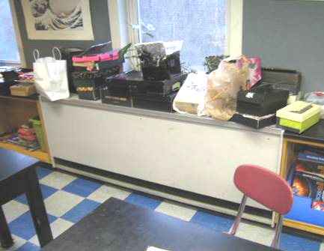

Classroom univent, note materials on top of air diffuser obstructing airflow

Picture 2



Classroom univent, note materials on top/in front obstructing airflow

Picture 3

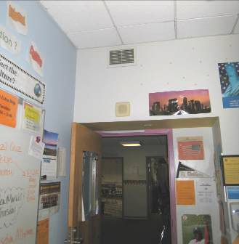

Wall-mounted exhaust vent near open hallway door (arrows)

Picture 4

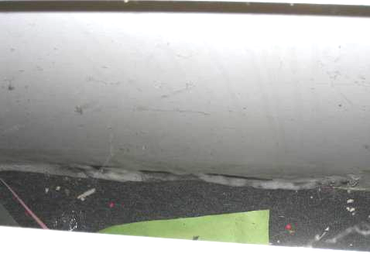

Water-damaged gypsum wallboard behind cabinet/rear wall of classroom 124

Picture 5

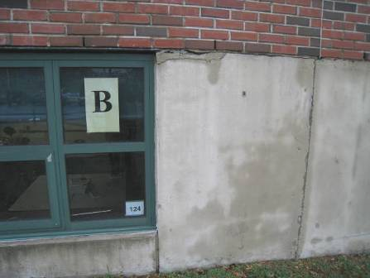

Damaged masonry outside of room 124

Picture 6

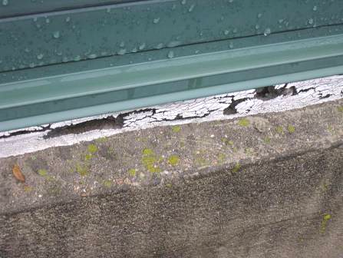

Missing/damaged caulking/sealant along exterior wall

Picture 7

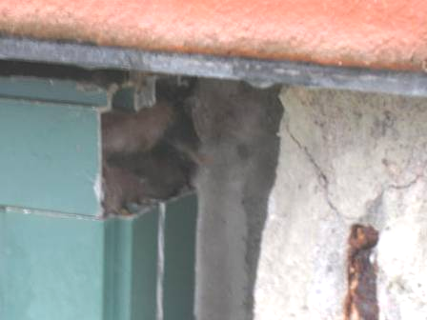

Damaged masonry along exterior wall exposing insulation around window frame (arrow)

Picture 8

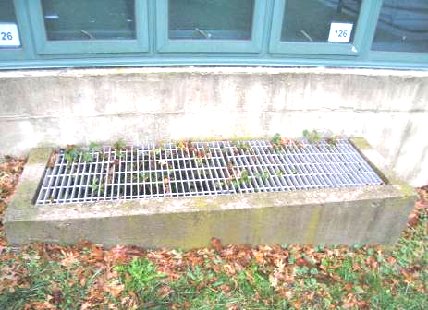

Subterranean intake pit along exterior wall, note plant growth inside

Picture 9

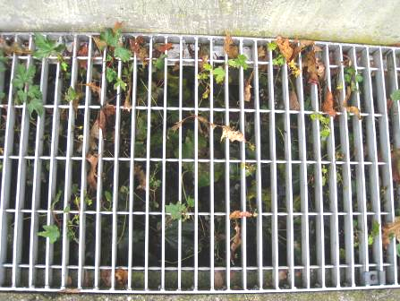

Plant growth and debris in subterranean intake pit along exterior wall

Picture 10

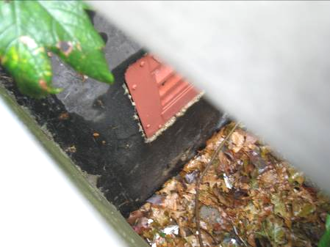

Plant growth and debris in subterranean intake pit along exterior wall

Picture 11

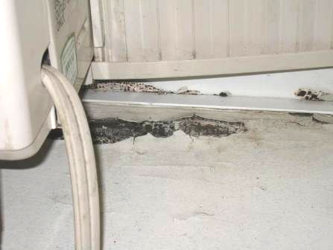

Visible mold growth on windowsill near air conditioner in Vice-Principal’s office

Picture 12

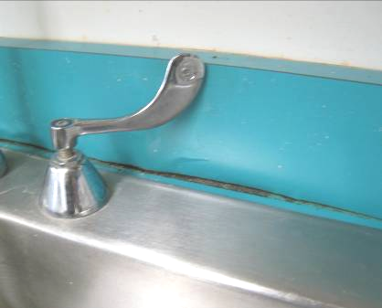

Breaches between backsplash and sink countertop

Picture 13

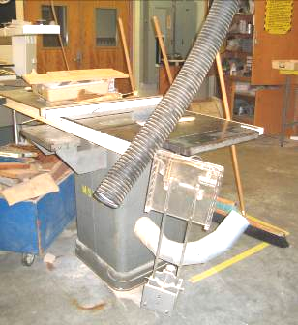

Disconnected flexible ductwork to wood dust collection system

Picture 14

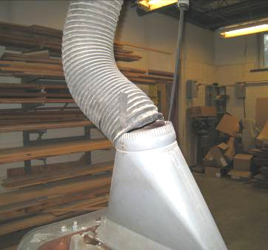

Disconnected flexible ductwork to wood dust collection system

Picture 15

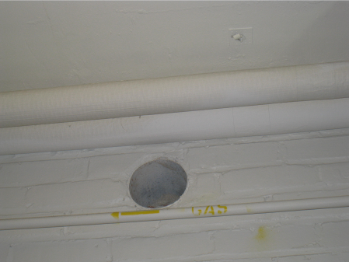

Breach in wall of consumer science room

Picture 16



Worn/damaged carpeting

Picture 17

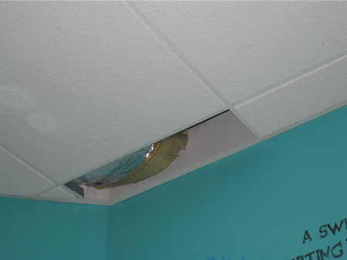

Missing ceiling tile, note exposed fiberglass insulation

Picture 18

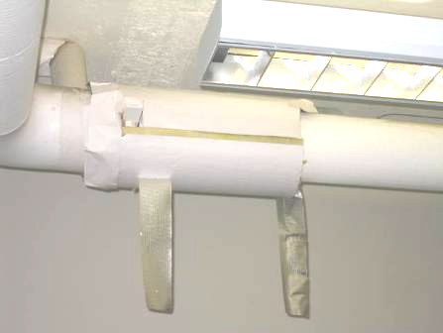

Exposed fiberglass insulation in room 118
Location | Carbon  Dioxide  (ppm) | Carbon Monoxide  (ppm) | Temp  (°F) | Relative  Humidity  (%) | TVOCs  (*ppm) | PM2.5  (ug/m³) | Occupants  in Room | Windows  Openable | Ventilation |  |  | Remarks
 |  |  |  |  |  |  |  |  | Intake | Exhaust |  | Remarks
Background | 380 | ND | 67 | 100 | ND | 11 |  |  |  |  |  | Overcast, intermittent rain
106 music | 545 | ND | 70 | 68 | ND | 1 | 20 | Y | Y |  | Y | DO
107 band | 444 | ND | 70 | 62 | ND | 1 | 0 | Y | Y |  | Y | DO, plants
111 | 600 | ND | 70 | 58 | ND | 3 | 1 | Y | Y  off |  | Y | UV returned blocked, PF
111 A computer lab | 572 | ND | 70 | 60 | ND | 1 | 1 | Y | Y |  | Y | 24 Occupants left ~35 minutes, AC
112 | 538 | ND | 70 | 64 | ND | 2 | 6 | Y | Y |  | Y  off, dusty | WAC, AD, DO, DEM
113 | 609 | ND | 72 | 60 | ND | 3 | 0 | Y | N |  | N | DO
114 | 446 | ND | 70 | 59 | ND | 1 | 0 | Y | Y |  | Y off | WAC
116 | 500 | ND | 72 | 61 | ND | 2 | 2 | Y | Y |  | Y  off | DO
116 | 528 | ND | 72 | 60 | ND | 2 | 1 | Y | Y |  | Y off | DO, 11 computers
117 home ec | 605 | ND | 71 | 63 | ND | 4 | 1 | Y | Y |  | Y off | Breach/sink/damage, fridge gasket mold, plants on UV
118 | 501 | ND | 72 | 60 | ND | 1 | 2 | Y  open | Y |  | Y  off | DO, heat complaints, exposed fiberglass, PF-dusty
119 breakfast café | 610 | ND | 70 | 65 | ND | 2 | 0 | Y | Y rattling |  | Y off | Univent rattling due to paper inside
120 | 453 | ND | 72 | 57 | ND | 3 | 0 | Y | Y  off |  | Y  off | DO
121 | 849 | ND | 71 | 69 | ND | 3 | 7 | Y | Y  off |  | Y  off | DO
124 | 908 | ND | 73 | 69 | ND | 6 | 3 | Y | Y  off |  | Y  off | WD GW behind cabinet adjacent to UV
126 | 552 | ND | 70 | 70 | ND | 4 | 2 | Y | Y dusty |  | Y | Dampness (recommend dehumidifier), PF, broken CT
130 tech | 500 | ND | 69 | 69 | ND | 6 | 0 | Y | Y  off |  | Y | DO, DEM
137 gym A | 693 | ND | 72 | 69 | ND | 9 | 38 | N | Y |  | Y
143 | 854 | ND | 74 | 65 | ND | 4 | 25 | Y | Y |  | Y | Plant over UV
146 | 914 | ND | 75 | 66 | ND | 6 | 24 | Y  open | Y |  | Y
148 | 850 | ND | 75 | 66 | ND | 8 | 21 | Y | Y |  | Y | DO, plants
149 | 781 | ND | 74 | 64 | ND | 6 | 22 | Y 1 of 4 open | Y |  | Y | DO, Items on UV
150 | 940 | ND | 75 | 65 | ND | 7 | 0 | Y | Y |  | Y | DO
151 | 1371 | ND | 75 | 67 | ND | 6 | 22 | Y | Y |  | Y | DO, DEM, 1 WD CT, AD
153A | 1077 | ND | 75 | 64 | ND | 8 | 26 | Y | Y |  | Y | DEM, DO, pine trees outside
154 | 490 | ND | 75 | 64 | ND | 6 | 1 | Y | Y |  | Y | PT on UV, UF
155 | 843 | ND | 74 | 61 | ND | 7 | 0 | Y | N |  | N | Odors, slight, items, carpet
156 | 1301 | ND | 75 | 65 | ND | 7 | 21 | Y | Y |  | Y | Dust mop, DO
206 | 589 | ND | 73 | 58 | ND | 8 | 0 | Y | Y |  | Y | Items on UV, DO, odors from DEM
210 | 631 | ND | 73 | 55 | ND | 1 | 26 | Y | Y |  | Y | DO, PF
213 teachers lounge | 480 | ND | 73 | 57 | ND | 3 | 1 | N | Y |  | Y
219 Assistant principal | 496 | ND | 74 | 50 | ND | 2 | 2 | Y | Y |  | Y | DO, WAC, WD windowsill due to ill fitting WAC
222 Principal | 480 | ND | 74 | 49 | ND | 3 | 1 | Y | Y |  | Y | WAC, DO
223 | 572 | ND | 73 | 51 | ND | 3 | 0 | Y | Y |  | N | Plants
224 nurse | 558 | ND | 73 | 53 | ND | 2 | 3 | Y | Y |  | N
226 | 1057 | ND | 73 | 57 | ND | 24 | 24 | Y  open | Y |  | Y  off | Plants, burning experiment
227 | 758 | ND | 73 | 58 | ND | 5 | 0 | N | Y |  | Y
228 | 824 | ND | 63 | 62 | ND | 9 | 2 | Y | Y |  | Y | Stained carpet (dry), GW –dry, no visible mold above CT
232 | 1303 | ND | 73 | 61 | ND | 8 | 22 | Y | Y |  | Y  off | Plants including on UV, DO
233 | 1008 | ND | 73 | 58 | ND | 2 | 25 | Y | Y |  | Y | CP odors, DO
234 | 1346 | ND | 73 | 60 | ND | 3 | 22 | Y | Y  off |  | Y | WD-CT, active water leaks
235 | 1313 | ND | 73 | 61 | ND | 5 | 22 | Y | Y  off |  | Y | DO
236 | 920 | ND | 73 | 60 | ND | 7 | 21 | Y 1 of 5 open | Y  off |  | Y | DO, plants, items on UV
237 | 1204 | ND | 73 | 61 | ND | 2 | 25 | Y | Y  off |  | Y | DO, plants, AC
239 | 1030 | ND | 73 | 58 | ND | 3 | 1 | Y | Y  off |  | Y  off
241 | 473 | ND | 72 | 54 | ND | 3 | 0 | Y | Y  weak |  | Y | PF
242 | 1030 | ND | 73 | 61 | ND | 3 | 21 | Y | Y |  | Y  off | PF, plants, DO
243 | 1281 | ND | 74 | 65 | ND | 7 | 24 | Y | Y  off |  | Y  off | PF, DO
244 | 1211 | ND | 73 | 60 | ND | 4 | 24 | Y  open | Y  off |  | Y  off
245 | 687 | ND | 73 | 58 | ND | 2 | 0 | Y | Y |  | Y  off | DEM, DO
246 | 711 | ND | 73 | 56 | ND | 2 | 1 | Y | Y  off |  | Y | DO
249 | 725 | ND | 73 | 56 | ND | 3 | 6 | Y | Y  off |  | Y | PF
250 | 1130 | ND | 75 | 59 | ND | 3 | 25 | Y | Y |  | Y | DO
252 | 765 | ND | 71 | 54 | ND | 3 | 2 | Y 2 of 4 open | Y  off |  | Y | Items on UV, plants, musty odor, DO
254 | 688 | ND | 72 | 56 | ND | 2 | 5 | Y 2 of 4 open | Y  off |  | Y | CFs, DO
255 | 624 | ND | 72 | 56 | ND | 3 | 24 left 1 hour ago | Y | Y |  | Y | Items on UV
256 | 920 | ND | 74 | 60 | ND | 2 | 11 | Y | Y |  | Y | DO, PF
257 | 680 | ND | 73 | 55 | ND | 3 | 0 | Y | Y on |  | Y | DEM
259A | 751 | ND | 72 | 56 | ND | 2 | 2 | Y 2 of 2 open | Y  off |  | Y | PF, DO, fridge, items on UV
260 | 664 | ND | 74 | 54 | ND | 1 | 30 gone 10 minutes | Y | Y |  | Y | DO
261 | 606 | ND | 72 | 56 | ND | 3 | 0 | Y | N |  | N | DO, PF
262 | 574 | ND | 73 | 55 | ND | 2 | 1 | Y | Y  off |  | Y | DO
263 | 610 | ND | 72 | 58 | ND | 2 | 1 | Y | Y |  | Y | Rubber mat odors, sink breach
264 | 702 | ND | 72 | 59 | ND | 2 | 1 | Y | Y  off |  | Y | Items on UV, 24 occupants gone 15 minutes
266 | 1021 | ND | 71 | 60 | ND | 1 | 1 | Y | Y |  | Y | 24 occupants gone 12 minutes, accumulation of items on flat surfaces,
267 | 654 | ND | 70 | 61 | ND | 1 | 4 | Y | Y |  | Y | DO
268 | 916 | ND | 71 | 62 | ND | 3 | 1 | Y | Y  off |  | Y | 19 occupants left 12 minutes ago, UV deactivated by occupants, DO
269 | 478 | ND | 69 | 61 | ND | 2 | 0 | N | Y |  | Y  BD | WAC, PF-dusty, DO, DEM
270B storage | 475 | ND | 70 | 58 | ND | 1 | 0 | N | Y |  | N | DO, copier
270 A office | 420 | ND | 69 | 59 | ND | 2 | 0 | N | Y |  | N | Fridge on carpet, food, appliances
273 | 481 | ND | 70 | 61 | ND | 2 | 0 | N | Y |  | Y | MT, odor
273 | 405 | ND | 69 | 61 | ND | 1 | 0 | N | Y |  | Y | Wall to wall carpet
Girls restroom |  |  | 73 | 68 | ND | 12 |  | N | N |  | Y  off | WD stains around exhaust
Girls locker |  |  | 70 | 71 | ND | 8 | 0 | N | Y  off |  | Y  on | WD ceiling
Gym B |  |  | 70 | 71 | ND | 4 | 0 | N | Y |  | Y | CF
Girls |  | ND | 73 | 55 |  | 2 |  | Y | N |  | Y  off
Auditorium | 422 | ND | 69 | 60 | ND | 1 | 0 | N | Y |  | Y
Library | 518 | ND | 70 | 60 | ND | 3 | 22 | Y | Y |  | Y | 2 x Risographs
Reading | 515 | ND | 70 | 60 | ND | 2 | 0 | Y | Y |  | Y | DO
Guidance | 477 | ND | 74 | 50 | ND | 2 | 3 | Y | Y |  | Y | PF, CPs, AD, copier
Small conference room | 527 | ND | 70 | 64 | ND | 4 | 31 | Y | Y |  | Y | WD-CTs, DEM, PF
Wood shop | 442 | ND | 67 | 69 | ND | 6 | 0 | Y | Y  off |  | Y
Boys locker room | 480 | ND | 70 | 65 | ND | 5 | 0 | Y | Y |  | Y | Old UV not replaced-off
Weight room | 473 | ND | 69 | 69 | ND | 5 | 0 | N | Y |  | Y
Cafeteria (Big) | 765 | ND | 70 | 67 | ND | 6 | ~100 | Y | Y |  | Y

How to Use this Factsheet

This risk factor summary was developed to serve as a general fact sheet. It is an overview and should not be considered exhaustive. For more information on other possible risk factors and health effects being researched, please see the References section.

A risk factor is anything that increases a person’s chance of developing cancer. Some risk factors can be controlled while others cannot. Risk factors can include hereditary conditions, medical conditions or treatments, infections, lifestyle factors, or environmental exposures. Although risk factors can influence the development of cancer, most do not directly cause cancer. An individual’s risk for developing cancer may change over time due to many factors and it is likely that multiple risk factors influence the development of most cancers. Knowing the risk factors that apply to specific concerns and discussing them with your health care provider can help to make more informed lifestyle and health-care decisions.

For cancer types with environmentally-related risk factors, an important factor in evaluating cancer risk is the route of exposure. This is particularly relevant when considering exposures to chemicals in the environment. For example, a particular chemical may have the potential to cause cancer if an individual inhales the chemical but that same chemical may not increase the risk of cancer if an individual has skin contact with the chemical. In addition, the dose and duration of time one might be exposed to an environmental agent is important in considering whether an adverse health effect might be expected.

Gene-environment interactions are another important area of cancer research. An individual’s risk of developing cancer may depend on a complex interaction between their genetic make-up and exposure to an environmental agent (for example, a virus or a chemical contaminant). This may explain why some individuals have a fairly low risk of developing cancer as a result of an environmental factor or exposure, while others may be more vulnerable.

Key Statistics

Breast cancer is the most frequently diagnosed cancer among women in the United States, except for skin cancers. The American Cancer Society estimates that in 2012, approximately 226,870 women in the U.S. and 5,480 women in Massachusetts will be diagnosed with breast cancer and the disease will account for approximately 29% of all new cancer diagnoses in females. Between 2004 and 2008, invasive breast cancer accounted for 28.5% of cancer diagnoses in females in Massachusetts.

In the United States, breast cancer rates stabilized in the early 1990s, increased in the latter half of the 1990s, and dropped sharply between 2002 and 2003. The sharp drop has been attributed to decreased use of menopausal hormones following the 2002 publication of the Women’s Health Initiative study results. This study linked the use of hormone therapy to an increased risk of breast cancer. In Massachusetts, the incidence of invasive breast cancer in females remained stable over the years 2004-2008.

The chance of developing invasive breast cancer at some time in a woman's life is about 1 in 8. Women are 100 times more likely than men to develop this disease and risk increases with age. Men can also develop breast cancer, but male breast cancer is rare, accounting for less than 1% of all breast cancer cases. For more information on breast cancer in men, visit the American Cancer Society website at www.cancer.org.

A woman’s risk of developing breast cancer increases with age. About 12-13% invasive breast cancers are found in women younger than 45, while about 66% are found in women age 55 or older. White women are slightly more likely to develop breast cancer than women of other races and ethnicities.

Types of Breast Cancer

The term "cancer" is used to describe a variety of diseases associated with abnormal cell and tissue growth. Cancers are classified by the location in the body where the disease originated (the primary site) and the tissue or cell type of the cancer (histology).

There are several types of breast cancer, although some of them are quite rare. In some cases a single breast tumor can have a combination of these types or have a mixture of invasive and in situ cancer.

In situ breast cancers are considered the earliest stage of cancer, when it is confined to the layer of cells where it began. They have not invaded into deeper tissues in the breast or spread to other organs in the body, and are sometimes referred to as non-invasive breast cancers. The remainder of this risk factor summary pertains to invasive breast cancers. Additional information on in situ breast cancers and other benign breast conditions can be found at www.cancer.org (American Cancer Society).

An invasive, or infiltrating, cancer is one that has already grown beyond the layer of cells where it started (as opposed to carcinoma in situ). Most breast cancers are invasive carcinomas -- either invasive ductal carcinoma or invasive lobular carcinoma.

Invasive ductal carcinoma (IDC) is the most common type of breast cancer and accounts for 75%–80% of all breast cancers. IDCs begin in the cells lining the milk duct of the breast, break through the wall of the duct, and grow into the fatty tissue of the breast. Once this occurs, IDCs may spread (metastasize) to other parts of the body through the lymphatic system and bloodstream.

Invasive lobular carcinoma (ILC) starts in the milk-producing glands (lobules) and account for approximately 10% of invasive breast cancers. Like IDC, it can metastasize to other parts of the body. Invasive lobular carcinoma may be harder to detect by a mammogram than invasive ductal carcinoma.

Other less common types of invasive breast cancer include:

- inflammatory breast cancer
- triple-negative breast cancer
- medullary carcinoma
- metaplastic carcinoma
- mucinous carcinoma
- Paget’s disease
- tubular carcinoma
- papillary carcinoma
- adenoid cystic carcinoma or adenocystic carcinoma
- Phyllodes tumor
- angiosarcoma

Established Risk Factors

Hereditary Conditions

Having a family history of breast cancer increases a woman’s risk of developing the disease. Women who have a first-degree relative (e.g. mother, sister) with breast cancer have about twice the risk of developing breast cancer themselves. Having two first-degree relatives with this disease increases a woman’s risk by five-fold. Overall, about 20-30% of woman with breast cancer have a family member with the same disease. Therefore, 70-80% of women who have breast cancer have no familial link to the disease.

About 5-10% of breast cancer diagnoses are thought to be due to an inherited genetic mutation. Most of these mutations occur in the BRCA1 and BRCA2 genes. Other genes that may lead to an increased risk for developing breast cancer include ATM, CHEK2, p53 and PTEN. Women who inherit these gene mutations have up to an 80% chance of developing breast cancer during their lifetime.

Medical Conditions and Treatments

Certain benign breast conditions may increase one’s risk for breast cancer. Women with proliferative lesions without atypia (i.e., abnormal or unusual cells), which have excessive growth of cells in the ducts or lobules of breast tissue have a slight increased risk of developing breast cancer. Proliferative lesions with atypia, when the cells are excessively growing and no longer appear normal, raise one’s risk by 4 to 5 times. Women with denser breast tissue (as seen on a mammogram) have more glandular tissue and less fatty tissue, and have a higher risk of breast cancer.

A woman with cancer in one breast is 3 to 4 times more likely to develop a new cancer in the other breast or in another part of the same breast. In addition, a previous diagnosis of an in situ breast cancer puts a woman at increased risk for an invasive breast cancer.

Cumulative exposure of the breast tissue to estrogen is associated with breast cancer risk. Several factors can influence estrogen levels. Women who started menstruating at an early age (before age 12) and/or went through menopause at a later age (after age 55) have a slightly higher risk of breast cancer. Also, women who have had no children or those whose first pregnancy occurred when they were over the age of 30 have an increased risk for developing breast cancer. Women who have had more children and those who have breast-fed seem to be at lower risk.

Use of hormone replacement therapy is another factor that may affect breast cancer risk. Long-term use (several years or more) of combined post-menopausal hormone therapy (PHT) increases the risk of breast cancer. The increased risk from combined PHT appears to apply only to current and recent users. A woman's breast cancer risk seems to return to that of the general population within 5 years of stopping combined PHT. The use of estrogen-only replacement therapy (ERT) does not appear to increase the risk of breast cancer significantly but when used long term (for more than 10 years), ERT has been found to increase the risk of both ovarian and breast cancer in some studies.

Women who had radiation therapy to the chest area as treatment for another cancer are at significantly increased risk for breast cancer. This risk appears to be highest if the radiation is given during adolescence or puberty, when the individual’s breasts are developing.

From the 1940s through the 1960s some pregnant women were given the drug diethylstilbestrol (DES) because it was thought to lower their chances of miscarriage. These women have a slightly increased risk of developing breast cancer. A woman whose mother took DES while pregnant may also have a slightly higher risk of breast cancer.

Lifestyle Factors

Alcohol consumption has also been associated with increased risk for breast cancer. Compared with non-drinkers, women who consume one alcoholic drink a day have a very small increase in risk whereas those who have 2 to 5 drinks daily have about 1½ times the risk of women who drink no alcohol.

Possible Risk Factors

Environmental Exposures

A great deal of research has been reported and more is being done to understand possible environmental influences on breast cancer risk. Of special interest are compounds in the environment that have been found in animal studies to have estrogen-like properties, which could in theory affect breast cancer risk. For example, substances found in some plastics, certain cosmetics and personal care products, pesticides (such as DDE), and PCBs (polychlorinated biphenyls) seem to have such properties. To date, however, there is not a clear link between breast cancer risk and exposure to these substances.

Lifestyle Factors

Recent studies have indicated that being overweight or obese may put a woman at increased risk of breast cancer, especially after menopause. Similarly, women who are physically inactive throughout life may have an increased risk of breast cancer. Being active may help reduce risk by preventing weight gain and obesity.

Studies have found that women using oral contraceptives (birth control pills) have a slightly greater risk of breast cancer than women who have never used them, but this risk seems to decline once their use is stopped. Women who stopped using oral contraceptives for more than 10 years do not appear to have any increased breast cancer risk. When thinking about using oral contraceptives, women should discuss their other risk factors for breast cancer with their physician.

Lifetime risk of breast cancer is increased in women of higher socioeconomic status (SES) (e.g. income, education, etc.). Research suggests that this may be due to reproductive and lifestyle factors (age at first full-term birth, physical activity, diet, cultural practices, etc.).

Other Risk Factors That Have Been Investigated

Lifestyle Factors

Though links have been suggested, antiperspirants, bras, and breast implants have all been investigated as possible risk factors for breast cancer but no associations have been found.

The role of cigarette smoking in the development of breast cancer is unclear. Overall, data do not provide strong evidence for an association between active cigarette smoking and breast cancer risk. Some studies suggest a relationship between passive smoking and increased risk for breast cancer; however, confirming this relationship has been difficult due to the lack of consistent results from studies investigating first-hand smoke exposure.

Dietary fat intake is another factor that has been suggested to increase a woman’s risk for breast cancer. Though studies have found decreased breast cancer rates in countries with a diet typically lower in fat, studies in the U.S. have not shown an association between the amount of fat in the diet and increased risk of breast cancer.

References/For More Information

Much of the information contained in this summary has been taken directly from the following sources. This material is provided for informational purposes only and should not be considered as medical advice. Persons with questions regarding a specific medical problem or condition should consult their physician.

American Cancer Society (ACS). http://www.cancer.org
- ACS. 2012. Cancer Facts & Figures 2012.
- ACS. 2012. Detailed Guide: Breast Cancer.
- ACS. 2011. Non-Cancerous Breast Conditions.
- ACS. 2011. Inflammatory Breast Cancer.
- ACS. 2012. Detailed Guide: Breast Cancer in Men.

American Society of Clinical Oncology (ASCO). http://www.cancer.net
- ASCO. 2011. Guide to Breast Cancer.
- ASCO. 2010. Guide to Breast Cancer – Inflammatory.
- ASCO. 2010. Guide to Breast Cancer – Metaplastic.
- ASCO. 2010. Guide to Breast Cancer – Male.

Colditz GA, Baer HJ and Tamimi RM. 2006. Breast Cancer, Chapter 51 in Cancer Epidemiology and Prevention. 3nd ed. Schottenfeld D and Fraumeni JF Jr.,eds. Oxford University Press. pp: 995-1012.

Massachusetts Cancer Registry (MCR), Massachusetts Department of Public Health.
- MCR. 2011. Cancer Incidence and Mortality in Massachusetts 2004-2008: Statewide Report. Available at: http://www.mass.gov/eohhs/docs/dph/cancer/registry-statewide-04-08-report.pdf

National Cancer Institute (NCI). http://www.cancer.gov
- NCI. 2009. What You Need to Know About Breast Cancer.

