1-877-255-7108 (TRS 711)
You can join NaviCare if you:
- Are 65 or older
- Have MassHealth Standard
- Live in the NaviCare service area
As a NaviCare member, you can’t be enrolled in another health insurance plan, except Medicare.
8 a.m.–8 p.m., Monday–Friday (Oct. 1–March 31, seven days a week.)
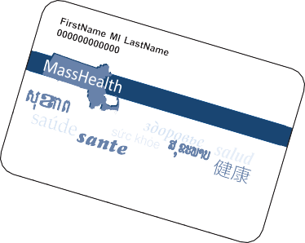fallonhealth.org/navicare

Got these?

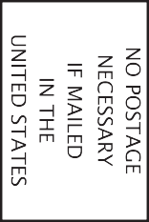
Fallon Health is an HMO plan with a Medicare contract and a contract with the Massachusetts Medicaid program. Enrollment in Fallon Health depends on contract renewal. NaviCare is a voluntary program in association with MassHealth/ EOHHS and CMS.
NAVICARE ACCOUNT EXECUTIVE FALLON HEALTH
H8928_230079_M Accepted 10302022
22-679-101 Rev. 00 9/22
Get more benefits, rewards, and extras for $0!

Look at all you get for $0 with Fallon Health’s NaviCare® program.
With NaviCare SCO or HMO SNP, you’ll get all the benefits of MassHealth Standard and Medicare, plus money-saving extras, such as:

- Free rides to and from your medical appointments, plus free rides to visit friends, run errands, attend religious services, and more―up to 140 one-way trips per year
- Up to $600/year to buy health and hygiene products

- Up to $570/year for new eyeglasses, frames, lenses, or contacts
- Up to $200/year to buy personal care items and food products
- Earn up to $100/year on the Healthy Food card, as a reward for completing certain activities
- $0 dental services including crowns, dentures, implants, oral surgery, and more

Have MassHealth Standard only?
You can join NaviCare SCO, and get all of these benefits!
Take the next step!
To learn about Fallon Health’s NaviCare program, please fill out this
card and mail it to us.

Name Address City State ZIP Phone
Email
I am a: □ Potential member
- Personal Care Assistant (PCA)
- Caregiver
- Call me with information.
- Send me more information:
  - By email
  - To my home
You can also call us or visit our website.
1-877-255-7108 (TRS 711)
8 a.m.–8 p.m., Monday–Friday (Oct. 1–March 31, seven days a week.)
fallonhealth.org/navicare
A NaviCare sales representative may contact you.

