MARTHA’S VINEYARD HOUSING NEEDS
ASSESSMENT
December 2020

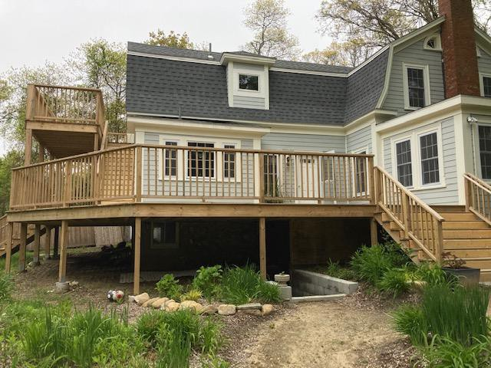

Prepared by the Martha’s Vineyard Commission

Karen Sunnarborg Consulting
Christine Flynn, Economic Development and Affordable Housing Planner With funding from the Massachusetts Office of Travel and Tourism

Photo: Congregate House in Vineyard Haven, Harbor Homes of MV

Martha’s Vineyard Housing Needs Assessment
Table of Contents

Page
- Executive Summary 1
- Demographic Profile 9
Population Growth 9
Age Distribution 11
Race 13
Households 13
- Economic Profile 14
Income and Poverty 14
Employment 17
People with Disabilities 20
Revenue 20
- Housing and Water Quality Profile 23
Housing Growth and Occupancy 23
Types of Structures and Units 25
Water Quality and Nitrogen Loading 26
Housing Costs and Affordability 27
Subsidized Housing Inventory (SHI) 34
- Key Findings and Recommendations 37
Appendix 1: Affordability Gaps 47
Appendix 2: Subsidized Housing Inventory 49
Appendix 3: DCRHA Waitlist/Income Limits 52
Appendix 4: Coastal Ponds Summary Matrix 53

Martha’s Vineyard Housing Needs Assessment 2020 pg. ii

Martha’s Vineyard Housing Needs Assessment
December 2020

Executive Summary
The Martha’s Vineyard Commission (MVC) prepared this Housing Needs Assessment in an effort to gain an updated understanding of affordable and community housing needs and better guide future development in support of local community efforts. Producing affordable housing is a challenge in even the best of times, but it has become more difficult in the context of COVID-19 and intense environmental constraints, especially those related to nitrogen-loading impacts.

As the population continues to grow, more workers will be required to support the expanding population, many of which will be part of the lower-paying service economy, confronting the Vineyard’s widening affordability gap. Rental housing, for both year-round and seasonal workers, is the more responsive approach to accommodating this expanding workforce and remains the Island’s priority. It is also important to note that while those with very limited incomes have the greatest housing needs, it remains an extremely expensive undertaking to provide housing for these households given the amount of subsidy required to make the units affordable. More sources of financing will be required.
Like the 2013 Martha’s Vineyard Housing Needs Assessment and draft Housing Production Plan FY18- FY22, this report also suggests a comparable percentage of rental units be developed to house the Island’s most vulnerable populations with a split of 80% of year-round rental units to 20% affordable homeownership. This recommendation embraces the primary housing goal of the Island Plan’s Housing Section is to “provide a full range of housing options by significantly increasing the number of affordable housing and community housing units on the Vineyard by prioritizing those residents with the greatest need, and by emphasizing the creation of rental units.” It is also reflective of the fact that almost all state and federal funding is for rental unit development.

In the months and years ahead, Islanders will have to make critical decisions as to:

- How can the Vineyard continue to house its year-round and seasonal workers in units that are both safe and affordable?
- How can the towns better stabilize existing year-round residents given escalating real estate prices? What are the impacts to our sense of place and community when residents can no longer afford to remain in their homes?
- How best can the towns invest in its infrastructure and service needs including roads, water, sewer, utilities, public safety and health system?
- What approaches can the Towns adopt to meet affordable and community housing needs such as finding more sources of revenue, adopting new zoning, and better regionalizing investment and regulations for example?

This Housing Needs Assessment provides an updated context for addressing these questions as well as recommendations for making progress in solving them.

Information on demographic, economic and housing shifts, even before COVID, indicated the following major trends:

Demographic Shifts
  - Continuing population growth as the population of Martha’s Vineyard increased by 15.6% between 2000 and 2019, from 14,987 residents in 2000, to 16,535 in 2010, and 17,312 by 2019 according to U.S. census data.
  - Martha’s Vineyard and Nantucket, with the smallest county populations, had the greatest percentage population increases between 2000 and 2019 at 16% and 17%, respectively, comparable to Suffolk County.
  - 2019 census figures suggest relatively stable population numbers for those under age 35 between 2000 and 2019, except for a modest increase in those 18 to 24.
  - Younger middle-age residents decreased in number over these decades with significant increases in residents 65 years of age and older driven by Baby Boomers, retirees, and second-home owners.
  - The Massachusetts Department of Transportation (MassDOT) and University of Massachusetts Donahue Institute (UMDI) have produced several versions of population projections by age through 2040. The third version with a total population forecast of 19,793 residents comes closest to MVC’s projection of 20,000. This represents a 15.5% increase over the 2019 census estimate of 17,312 residents.

Economic Shifts
  - The Island’s socio-economic diversity is eroding as lower income households are dwindling in number and in proportion to the population, beyond normal inflationary trends. Many of these residents are essential to the Island’s seasonal, tourist, and service economy.
  - Between 2000 and 2019, year-round households with incomes of less than $35,000 decreased by 59% while those with incomes of more than $150,000 increased by 558%.
  - A total of 724 seniors, or 31% of those age 65 or older, had incomes of less than $35,000 based on 2019 census estimates. There were also 694 households in this income range with heads younger than age 65. Consequently, there are significant numbers of households who have very limited financial means and are likely confronting enormous challenges affording to live on the Vineyard.
  - In 2019, the Island’s average weekly wage of $1,094 was 70% of the state average and the median home price was more than double the state’s, clearly signaling the disparity between what residents can afford and existing housing costs.

Housing Shifts

The seasonality of the housing stock in combination with a relative lack of multi-family housing contribute to a limited supply of affordable housing and why so many are forced to live off-Island and commute to work by ferry.

Year-round housing occupancy is extremely low, at 38%.

  - Housing growth largely occurred in the seasonal or second home housing stock. While the total number of housing units increased by 4.2% between 2010 and 2019, the year-round occupied housing stock decreased by 8.2%, or by 603 units, while seasonal or occasional units increased by 15.4%, or by 1,428 units, from 9,253 units in 2010 to 10,681 in 2019.

Homeownership
  - The percentage of year-round owner-occupancy increased by 6.9% between 2000 and 2019 while by only 1.5% for year-round rentals.
  - 91% of the Vineyard’s housing stock is in single-family detached homes with an additional 5% in structures of 2 to 4 units.
  - Only 2% of all housing units, or 375 units, were in structures of 5 or more units.
  - Single-family home prices are high and rising with a median of $737,500 in 2018, $807,000 In 2019, $927,835 as of October 2020, and $1,173,000 in November.
  - The affordability gap was $781,500 for the Island as a whole in November 2020, up from $225,000 in 2012, representing a 247% increase, way beyond the inflationary rate of 13.3% during that period.
  - Due to the exceedingly high property values on the Vineyard, in 2004 the State Legislature granted Nantucket and Dukes County the right to place permanent deed restrictions on properties whose owners earn up to 150% of area median income (AMI), but still priced out of the local housing market. A summary of the full range of income limits, from 30% to 150% AMI, is included as Appendix 3.

Rentals
- The median year-round rent was $1,180 in 2010 and increased to $1,459 based on 2019 census estimates. Because 21% of the Vineyard’s rental housing stock is subsidized and another 300 units involve tenants who did not pay rent, the median does not reflect actual market conditions.
- The median rent of $1,459 would require an income of about $66,360 assuming average monthly utility bills of $200 and not paying more than 30% of income on housing. This is well above the median income of renter households of $43,750.
- Rents have risen considerably during the last decade with year-round rentals costing more than $1,500 increasing from 207 units to 710. 26% of rentals were more than $2,000 per month.
- Only a few years ago, there were online listings available for year-round or winter rentals, not anymore. Word of these increasingly limited opportunities is now more typically by word of mouth and at much higher rents, some suggesting in the ballpark of $3,000 per month for a 2- bedroom apartment.
  - While the Cape and Islands have dealt with Short Terms Rentals for decades, such rentals have increased dramatically over the last 5 years across the state and country due to the online platforms. In 2018, the Commonwealth passed legislation to tax Short Term Rentals through the Room Occupancy Tax.
  - In recognition of high housing costs, the state has also allowed the Dukes County Regional Housing Authority to apply exceptional rent levels of 110% of HUD Fair Market Rents as its rent limits.

  - The Dukes County Regional Housing Authority (DCRHA) maintains a waitlist of applicants for their 101 rental units which included 258 applicants as of August 2020. A detailed breakdown is summarized in Appendix 3.
  - In addition to SHI units, communities have produced 166 additional community housing units that are directed to those earning between 80% and 150% of median income and include deed restrictions to ensure long-term affordability.
  - The Island has benefited from 99 rental subsidies through DCRHA’s Rental Assistance Program, Section 8 Housing Choice Vouchers, or Massachusetts Rental Voucher Program (MRVP) managed by the Housing Assistance Corporation (HAC). This, in addition to the 399 SHI units, represents a total of almost 500 subsidized housing units on the Island or 7.5% of its year-round housing stock, although rental vouchers cannot be included in the SHI.
  - It is also worth noting that most projects with affordable units are relatively small with less than a dozen units. Because affordable housing typically depends on some economies of scale and subsidy programs are often geared to larger projects, small developments are challenging to make financially feasible. Additionally, any development has been difficult to site.

Cost Burdens
- A HUD report, based on special census tabulations for 2017, estimates that 2,529 households, or 41% of all households in Dukes County, had cost burdens as they were paying too much for their housing, at more than 30% of their income. This includes 1,294 households, or 21%, who were paying more than half of their income on housing costs.
- The report also estimates that in Dukes County 2,530 or 41% of households counted had incomes at or below 80% of area median income (AMI) and of these 68% had cost burdens, 45% with severe cost burdens.

While affordability gaps between the costs of available housing and what many working residents can afford has always been high, the pandemic has taken extreme conditions into dire ones for many residents.

COVID Economic Impacts
  - While the seasonal nature of the Island’s economy has typically caused significant increases in unemployment during the winter, the arrival of the pandemic in March 2020 immediately resulted in a surge of unemployment, from 501 workers in March to 1,927 in April.
  - The Island’s unemployment rate in spring 2020 remained considerably higher than the state, at 22.6% versus 16.0%.
  - After April 2020, unemployment declined as the economy began to prepare for the summer season, staying about the same in June and declining to about 1,300 workers in June and July.

  - By November 2020, the number of unemployed workers decreased by more than half to 591 workers or 7.2%, considerably higher than 334 workers and 3.9% in November 2019.
  - In November 2020, the Island’s unemployment rate of 7.2% was higher than all other counties with the exception of Hampden County at 7.5%, also higher than the state rate of 6.2%.
  - While some revenue sources have declined due to COVID, such as from Steamship ridership and the meals tax, those from the Local Option Room Occupancy Tax and Short Term Rental Tax have increased from $3,443,980 in FY 20 to $4,604,635 for the first half of FY21 alone.
  - The Martha’s Vineyard Commission conducted a survey of businesses in May 2020 which indicated that 71% of the respondents believed that the pandemic would have a significant to severely negative impact on their operations including 54% that were closed due to COVID-19 at the time of the survey.

COVID Housing Impacts
  - Anecdotally, Island population growth is intensified by the Island’s seasonal economy and more recently by longer stays of families who are renting homes for extended periods of time during the pandemic given the ability to work and attend school remotely. The second factor are investment properties that have been put on the market and sold, displacing either year-round or winter rental tenants.
  - Those with insecure housing, who have relied on winter rentals in the past, have been outbid by more affluent families from off Island or their winter rental has been sold due to the pandemic.

  - The increase in seasonal population beyond the summer months, particularly in late spring and fall 2020, has placed substantial pressures on local infrastructure for roads, water, sewer, and utilities plus public safety and health services while driving up housing prices.
  - COVID has also caused a surge in home sales that are increasing sales prices considerably as more people from outside of the Island are looking for a safer retreat from the pandemic on the Vineyard.
  - By 2020, the number of homes sales increased from 27 in February, down to 19 in May, to as many as 93 in September, and 68 in November based on Banker & Tradesman data. Local realtors were working 12-hour days to accommodate this surge in sales activity.
  - The lull in sales in April and May relates to the lockdowns that were imposed due to the pandemic. The spike in sales in September likely correlates to the beginning of the school season and greater acceptance and technical ability to work remotely. Sales prices have escalated as a result. For example, the Island’s median single-family home was $807,000 in 2019, rising to $1,173,000 by November 2020 based on Banker & Tradesman.

This Housing Needs Assessment recommends the ambitious goal of producing 50 units of affordable or community housing per year. This goal was part of the 2013 Martha’s Vineyard Housing Needs Assessment and close to the recommendation included in the draft Housing Production Plan FY18-FY22. This level of production continues to be challenging given the following constraints:
  - Affordable housing production has been limited, averaging about a dozen units per year between 2001 and 2013 and since then only 8 new units were added to the Island’s Subsidized Housing Inventory (SHI).
  - Despite the remarkable generosity of Islanders; local, state and federal resources to support affordable and community housing are limited and highly competitive. Nevertheless, the

pandemic has brought some new resources in support of housing that can hopefully be maintained and augmented.
  - Zoning and lack of adequate infrastructure are two major stumbling blocks to utilizing land more efficiently. Of particular concern are water quality and nitrogen impacts to the Island’s coastal ponds, especially with the influx of seasonal populations that bring the number of residents to 85,000 residents for July and August with typically 3,000 to 5,000 seasonal workers. Water quality also dictates the location of development and density.
  - Building sites are increasingly difficult to come by, expensive to acquire and develop, and often beleaguered by some local opposition, all resulting in a prolonged and expensive development process.

Key Findings and Recommendations
This Housing Needs Assessment also identified the following key findings that demonstrate some recent progress but also formidable new challenges:

COVID-19 impacts are difficult to estimate but are putting many Island households at risk of losing their homes.
  - The Metropolitan Area Planning Council (MAPC) prepared estimates of local housing need for MA municipalities to gauge the impact of the pandemic as of September 2020. These estimates are based on unemployment claims as of September 5th and the Census Bureau’s biweekly Pulse survey for September 2nd to the 14th. Information was not available for Aquinnah but the estimated amounts of housing assistance needed for affected households ranged from a low of
$2,419 in Chilmark to $32,996 in Tisbury.
  - These figures represent just a fraction of the total need as many affected workers and households are difficult to estimate, particularly for the Vineyard with so many self-employed and seasonal workers.
  - With approximately 1,872 renter households on the Island, the Pulse survey information suggests that approximately 1,572 renter households might have owed back rent in September and 112 were concerned about imminent eviction⁴.
  - The Metropolitan Area Planning Council (MAPC) also reported that 35,200 Massachusetts homeowners with an unemployed person in their household will likely have trouble covering their
housing costs, with a total available income-expense gap of $44 million per month. These households now face increasing risk.
  - Of particular note is the MV COVID-19 Relief Program operated by the Dukes County Regional Housing Authority (DCRHA) which this spring provided emergency rental relief of 1-month’s rent to about 80 tenant households living in market rentals who had demonstrated a loss of income due to the pandemic. DCRHA is introducing another round of funding this winter with continued funding from the Martha’s Vineyard Community Foundation (aka Permanent Endowment of MV), Boston COVID Foundation, as well as other local donations.

Homelessness has been a persistent problem for Martha’s Vineyard but has grown given the
impacts of COVID-19.
Because of the seasonal shifts in the economy and widening affordability gaps, homelessness has been an ongoing problem for Island individuals and families. In recognition of this situation, Harbor Homes of MV was established a couple of years ago as the umbrella organization for all homeless prevention efforts on the Vineyard. While other housing entities have importantly focused on those with incomes of 30% to 150% of HUD’s area median income, Harbor Homes seeks to address those who are “too poor for affordable housing” as they do not have the income or subsidy to access even the Island’s existing subsidized units. Their first effort was to develop a congregate home for formerly homeless men that opened in July 2020.

It had been well known for years that people had been seeking shelter in vehicles, boats, or tents in woods; risking their own health and posing potential fire threats. The “Island Shuffle” and couch surfing have been common practices for the housing insecure. Fears grew that this situation would only worsen with COVID given a potentially increasingly sick population of residents with no place to live. In consequence, additional funding became available from a variety of sources in support of homelessness prevention efforts which has enabled Harbor Homes to expand its operations to include the following programs:

  - Developed cooperative agreements with 3 local hotels to house homeless individuals and families.
  - Merged the House of Grace Winter Emergency Shelter Program and Warming Center Day Shelter into one program under Harbor Homes auspices.
  - Established a Homeless Hotline to provide information and appropriate referrals.
  - Conducts case management services to help the homeless obtain important services and move towards self-sufficiency.
It is hoped that funding will not only continue but increase when COVID-19 is no longer a threat.

Of particular concern are the increasing affordability gaps and cost burdens that, while always high, have been intensified by the pandemic.
This Housing Needs Assessment has identified that Martha’s Vineyard has been encountering widening affordability gaps and increasing cost burdens for decades that have caused many to struggle to live on the Island, have driven others to relocate off-Island and commute to work by ferry, and have forced others into homelessness. Because the Island’s economy relies on a tourist and service economy, it must ensure that there is adequate and affordable housing available to workers who are essential to Island businesses. Some employers are providing housing, but much more needs to be done to retain the Island’s economic viability.

As noted earlier, COVID-19 has accelerated rate of new sales activity as people from even distant places in the country are looking to find a safer retreat on the Vineyard. It has also caused temporary renters to
lengthen their stays on the Island, draining the supply of what has been more affordable winter rentals on which many Island workers rely. The Vineyard is therefore losing a part of its traditional community and gaining many more affluent residents during the off-season. These pressures have pushed housing prices skyward to unprecedented levels and likewise increased affordability gaps and cost burdens.

Priority housing needs identified in previous plans are not only still evident but growing.
The most pressing housing need continues to be rental housing that is affordable to those along a wide range of income levels who are priced out of the Island’s exorbitant housing market with a continued focus on the most vulnerable residents. Emergency rental assistance is needed in the short-run but given increasing market demand pressures, may be a consideration for ongoing funding. Support for those confronting or at risk of homelessness must remain an Island-wide priority embraced by all communities.

This Needs Assessment proposes an ambitious annual housing production goal of 50 affordable and community housing units per year with about an 80% to 20% split between rentals and homeownership. The reasons behind this recommendation were based on the following important benefits of rentals:
  - Better address the needs of lower wageworkers, addressing the more transitory residency of many workers
  - Target the needs of the Island’s most vulnerable residents with very limited financial means.
  - Reduce the negative impacts of the summer’s “Island Shuffle/Couch Surfing” on both individuals and families who are housing insecure and virtually homeless as they do not have stable year- round housing.
  - Provide opportunities for some seniors who are “overhoused” and spending far too much to remain in their homes to relocate to more affordable and less isolated settings, opening up their homes to families requiring more space.
  - Offer better opportunities for financing as most public subsidies are directed to rental housing development.
  - Promote and ensure compliance of accessory units in existing homes that provide small year- round rentals and also offer additional income to owners, particularly those on fixed incomes.
  - Offer opportunities to build new more clustered, mixed-income communities that promote greater affordability through economies of scale in development, reduce the stigma of affordable housing, and help build connections among Island residents.

Many of the recommendations that were part of previous plans still resonate today.
Local communities need to mobilize new resources and adopt new regulations to produce actual units to address the continuing housing crisis on the Island which has just recently been made considerably worse by the pandemic. Additional regional solutions to the housing crisis should be pursued where possible.

Recent progress has been made on the housing front with the establishment of Harbor Homes of MV, the launch of the COVID-19 Emergency Rental Relief Program, and the adoption of Short Term Rental Tax which in part could potentially be directed in support of year-round rental development and infrastructure needs, including water quality, that are so urgently needed. Much more needs to be done, now more than ever. Recommendations for promoting new affordable and community housing are included in Section V of this Housing Needs Assessment but foremost among them are the need to secure more sources of funding, adopt new zoning to better guide and promote affordable housing development, and to regionalize investment and regulations where possible.

Demographic Profile

Population Growth – Continuing increases in population, higher than other counties in the state except Nantucket and Suffolk
  - The total population of Martha’s Vineyard increased by 15.6% between 2000 and 2019, from 14,987 residents in 2000, to 16,535 in 2010, and 17,312 by 2019 according to U.S. census data.
  - About three-quarters of the Island’s population is split relatively evenly among Edgartown, Oak
Bluffs and Tisbury with the other towns comprising approximately the remaining quarter.
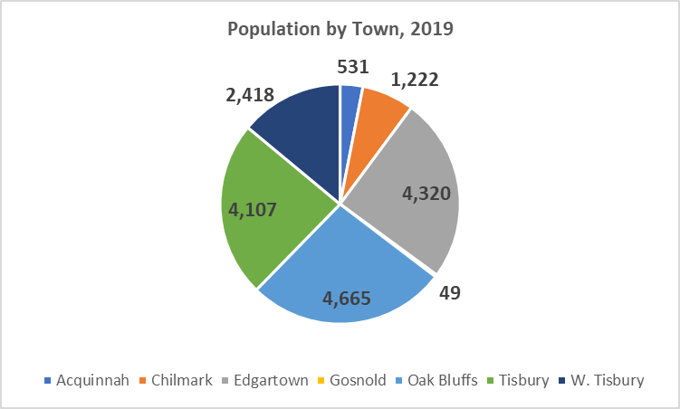
  - Aquinnah and Chilmark experienced the highest level of growth between 2000 and 2019 with growth rates of 54% and 45%, respectively.
  - West Tisbury experienced a modest loss in population during this period.
  - In addition to seasonal visitors and temporary residents, that can bring the population up to about 85,000, the summer brings approximately 3,000 -5,000 seasonal workers to the Vineyard to support the summer’s busy tourist season.
  - Martha’s Vineyard and Nantucket, with the smallest county populations, had the greatest percentage population increases at 16% and 17%, respectively, comparable to Suffolk County. On the other hand, Barnstable and Berkshire County both lost population.

Island population growth is intensified by the seasonality of the economy and most recently by longer stays of second homeowners and families who are renting homes for extended periods of time during the pandemic. Those who have relied on winter rentals in the

past have been outbid by more affluent families from other places. These households are putting substantial pressures on local and regional infrastructure and services while driving up housing prices.

Of particular concern are water quality and nitrogen impacts to the Island’s coastal ponds especially with the influx of seasonal populations that typically account for about 85,000 residents in mid- summer. Water quality also dictates the location of development and density.

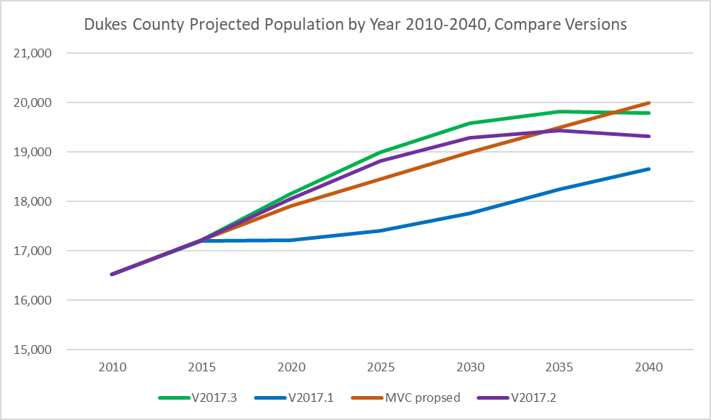
  - The Martha’s Vineyard Commission (MVC) has been working with the Massachusetts Department of Transportation (MassDOT) and University of Massachusetts Donahue Institute (UMDI) on fine- tuning population projections to recognize the effects of the second-home economy and tremendous surges of seasonal and visitor populations. Estimates suggest growth to 19,000 residents in 2030 and 20,000 by 2040, representing a 15.5% increase over the 2019 census estimate of 17,312 residents. This increase is in line with the growth of 16% that occurred during the first 2 decades of the century. The proposed MVC projections are compared with several versions from MassDOT and UMDI below.
  - Greater resources for infrastructure, services and housing will be required to address the needs of these new residents.

Age Distribution – Significant gains in older adults
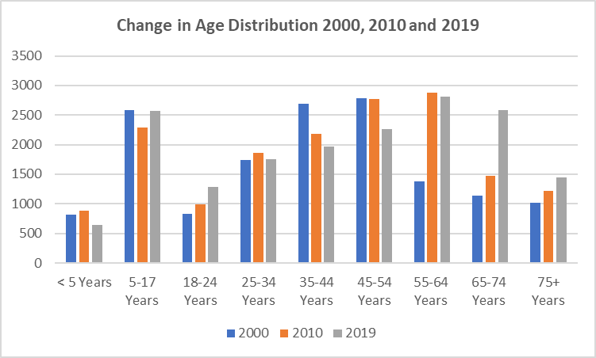

- 2019 census figures suggest relatively stable population numbers for those under age 35 between 2000 and 2019, except for a modest increase in those 18 to 24.
- Younger middle-age residents decreased in number over these decades with significant increases in residents 65 years of age and older driven by Baby Boomers, retirees, and
- second-home owners.

  - Those 65 years and older comprised about 20% of each town’s population with Gosnold and West Tisbury above 30% compared to 23.3% Island-wide.
40.0%
35.0%
30.0%
25.0%
20.0%
15.0%
10.0%
5.0%
0.0%
Percentage of Population 65+ Years by Town, 2019
36.7%
32.4%
22.7%
19.4%
20.3%
19.9%
21.0%
  - Martha’s Vineyard had a higher percentage of older adults than every other county in the state except Barnstable, Berkshire and Franklin.
  - Median age levels have consistently increased from 37.3 years in 1990, to 40.7 years in 2000, 45.3 years by 2010, and 47.1 in 2019.

The substantial growth of aging adults on the Vineyard
suggests that there will be a greater need for services directed to seniors, particularly those related to health care and transportation. There should also be a focus on integrating more handicapped accessibility and supportive services into new and existing housing.

- The Massachusetts Department of Transportation (MassDOT) and University of Massachusetts Donahue Institute (UMDI) have produced several versions of population projections by age through 2040. The third version with a total population forecast of 19,793 residents, as of January 2018, comes closest to MVC’s projection of 20,000. This version is graphically presented below according to time period, showing the highest projected growth of older adults through age 75 between 2025 and 2035.

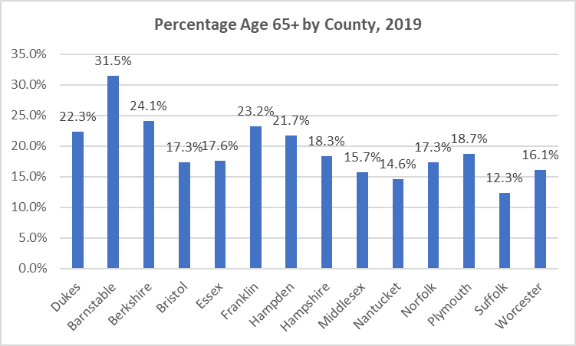

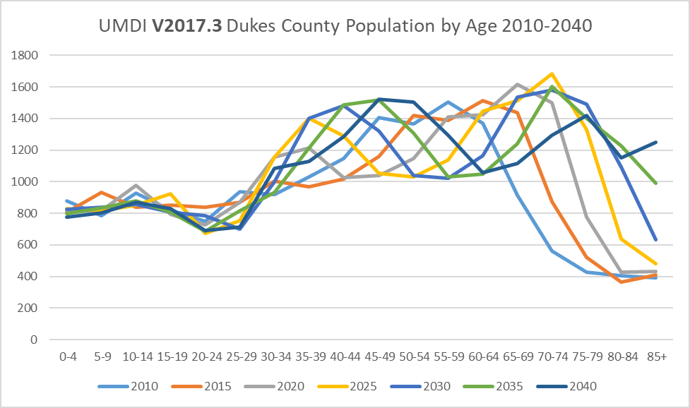

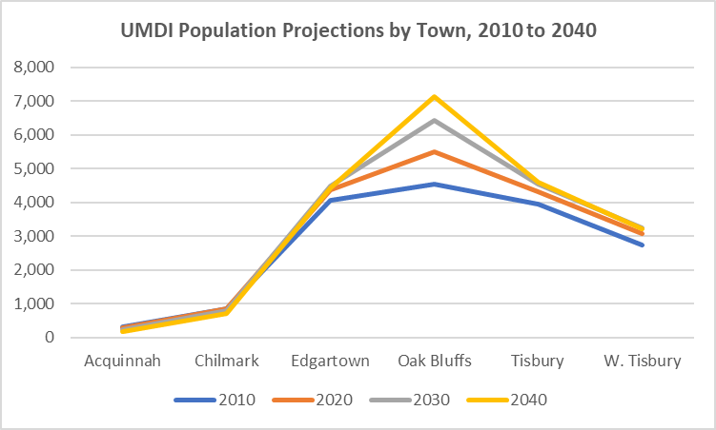
  - MassDOT and UMDI’s third version of population projections by age and Town shows population losses in Aquinnah and Chilmark at -45% and -16%, respectively, between 2010 and 2040.
  - Projections for the other towns include growth levels between 2010 and 2040 of 9% for Edgartown, 57% for Oak Bluffs, 16% for Tisbury, and 18% for West Tisbury.

Race – Modest shifts in racial diversity
- 12.4% of the county’s population identified themselves as non-white in 2010, however, the 2019 census estimates show some proportional decrease to 11.9% with about the same number of residents at 2,043 and 2,060, respectively.
- The 2019 census figures show increases in Black or African American residents and Hispanic or Latino residents accompanied by some losses of Asians and those of Native American descent from the Wampanoag tribe.

Households – Recent increases in larger households
- Census data on numbers of households suggests significant fluctuations over the years, from 5,076 in 1990, 6,431 in 2000, down to 5,530 in 2010 and then up to 6,765 in 2019.

- Martha’s Vineyard had previously demonstrated growing numbers of smaller, non-family households reflective of local and national trends towards fewer numbers of children and “traditional” families, increases in “child-free” and “child-delayed” families, and increases in empty nesters and senior and frail populations, particularly those who are living alone.
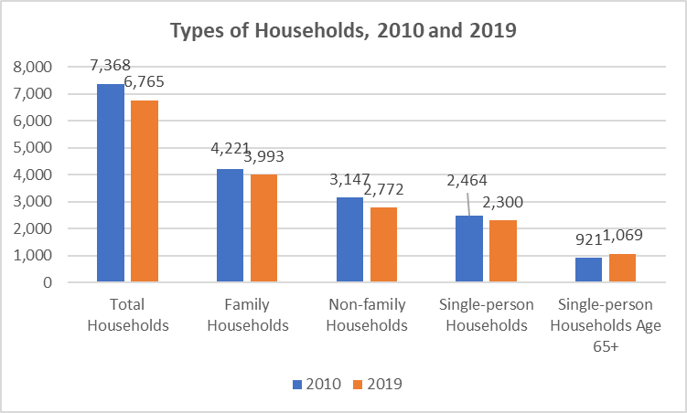
  - 2019 census estimates indicate that while the population grew by 4.7% between 2010 and 2019, total household growth declined by 8.2%, reflecting growth in larger households.
  - The growth in larger households is further reflected in increases in average household size from 2.22 persons to 2.52 persons between 2010 and 2019.

Economic Profile

Income and Poverty – Widening income disparities

The Island’s socio-economic diversity is eroding as lower income households are dwindling in number and in proportion to the population, beyond normal inflationary trends.

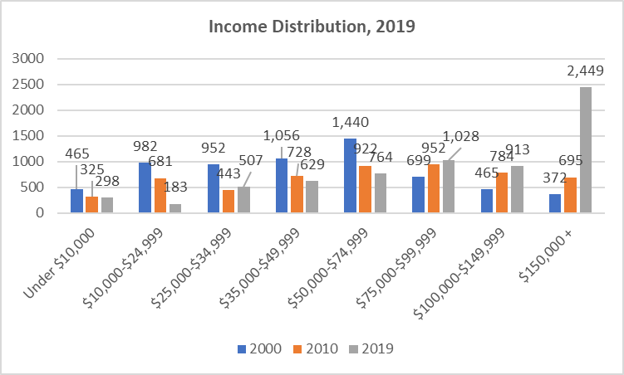
  - Between 2000 and 2019, households with incomes of less than $35,000 decreased by 59% while those with incomes of more than $150,000 increased by 558%.
  - Those with incomes of less than $35,000 declined from 37% of all households in 2000 to 15% by 2019.
  - Households with incomes of $150,000 or more grew from 6% to 36% during this period.
- The median household income for the county grew from $45,559 in 2000, to $62,407 in 2010, and to $71,811 in 2019 or by 58% during this period. This increase was beyond normal inflation of 48% according to the Consumer Price
Median Household Incomes by Town, 2010 and 2019
$120,000
$100,000
$80,000
$60,000
$40,000
$20,000
$0
$95,625 $96,471
$95,351
$78,902 $75,294
$57,500
$72,917 $67,625 $71,667 $71,811
$59,156 $58,551
$51,456
$62,407
2010 2019
Index (CPI).
- Median household incomes increased for all towns between 2010 and 2019 with the exception of Tisbury. Tisbury also had the lowest median of $51,456 in 2019 compared to Chilmark with the highest at $96,471.
- The county’s 2019 median household income of $71,811 is in the middle of the pack when compared to other counties,
between a low of $55,429 in Hampden County and a high of $107,717 for Nantucket. It is also lower than the median of $74,336 for Barnstable County and $85,843 statewide.
- The 2019 median family income is considerably higher at $96,641, up 76% from $55,018 in 2000 and an increase of 25% from $77,230 in 2010. These increases are significantly higher than the inflationary rate of 48% between 2000 and 2019 and 17% between 2010 and 2019.
- The median income of non-family households grew by 20% between 2010 and 2019, from $40,548 to $48,784, and was about half of the median family income level.
- There were also major racial disparities in incomes as the median household income for those identifying themselves as White was almost twice that of Blacks, at $81,597 and $41,020, respectively.
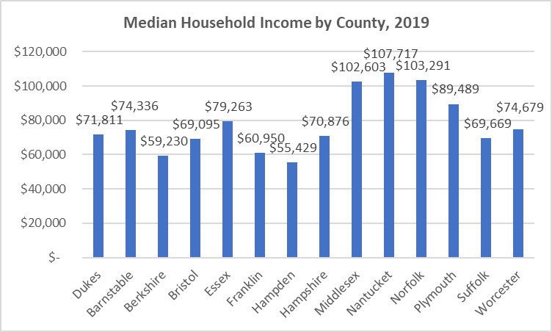
  - The median income of those living alone was $49,194 for men and significantly less at
$34,507 for women.
  - There were significant income discrepancies by age with medians of $79,077 for heads of households age 25 to 44, $95,145 for those 45 to 64 years, and down to $52,630 for older adults age 65 or older, many who are retired and living
on fixed incomes.

724 seniors, or 31% of those 65 or older, had incomes of less than $35,000 based on 2019 census estimates. There were also 694 households with incomes in this range involving heads younger than age
65. Consequently, there are significant numbers of households who have very limited financial means and are likely confronting enormous challenges affording to live on the Vineyard.
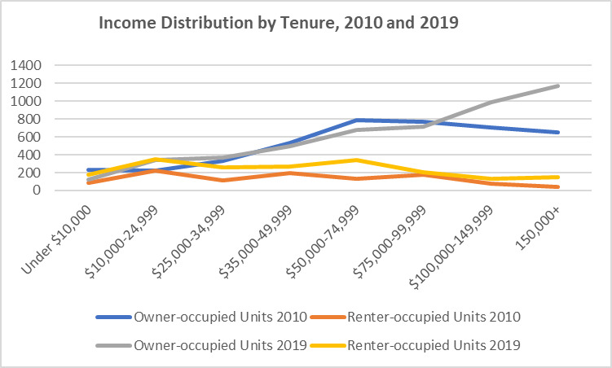
  - Another income disparity involves tenure with the median income of owner-occupants increasing by 24% between 2010 and 2019, or from $71,856 to $89,013. On the other hand, the median for renter-occupants actually decreased from $44,142 to $43,750 during this period.
  - The income distribution for year-round renters remained relatively flat with some declines after $75,000 for both 2010 and 2019.
- The income distribution for year-round owners was relatively comparable in 2010 and 2019 up to the $100,000 level. While there were considerable increases in owners with incomes over this level in 2019, there were marked declines in 2010.
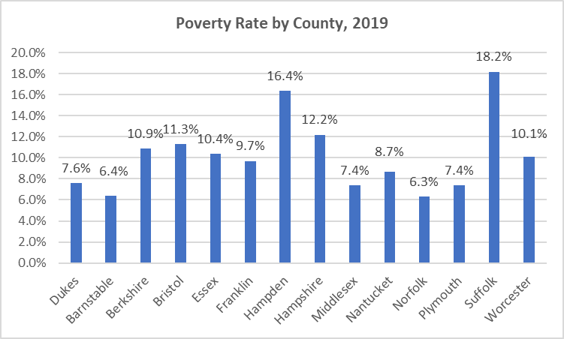
- Martha’s Vineyard poverty rate is relatively low at 7.6%, representing 1,299 residents, down somewhat from 1,422 residents and 8.6% in 2010.
- The poverty rate is somewhat higher than Barnstable and Norfolk Counties which had the lowest levels of 6.4% and 6.3%, respectively. Poverty was highest in Hampden and Suffolk Counties at 16.4% and 18.2%, respectively.
- Poverty levels among Island communities ranged from a low of 3.5% in Edgartown to 11.9% in Chilmark.
- Poverty for those 65 years of age or older ranged from zero in Aquinnah to a high of 13.4% in Tisbury.

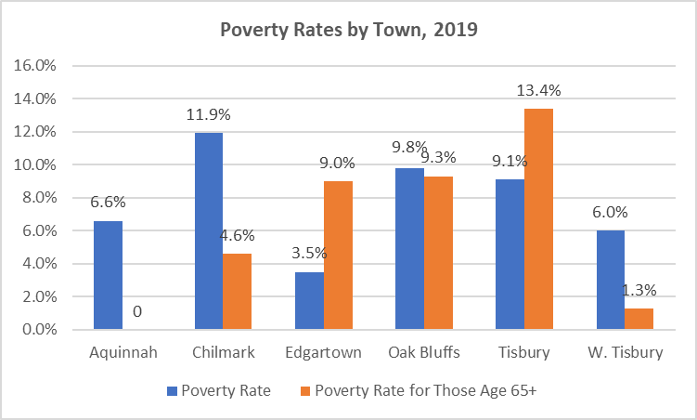
  - For those who work in local businesses, the average weekly wage in 2019 ranged from a low of $867 in Chilmark to a high of $1,131 in Tisbury which roughly translate into annual wages of $45,000 and $59,000, respectively. The county-wide average was $1,094, which was 70% of the state average.

  - Those earning the state minimum hourly wage of $12.75 would have an annual income of $26,520 if they were able to work full-time throughout the year, something minimum wage service workers seldom realize given the Island’s seasonal economy. When the minimum wage increases to $13.50 per hour in the beginning of 2021, this income level would still be low at $28,080. housing problem.

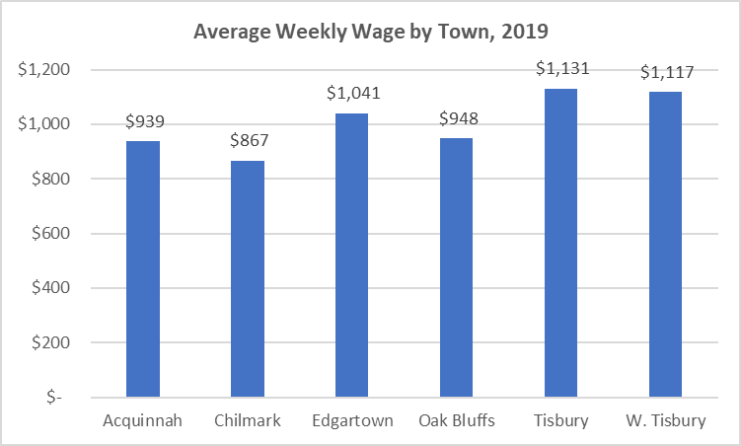
Moreover, all of this income, poverty and wage data represents pre-COVID conditions, and the pandemic has caused significant health and economic challenges for Island residents, including businesses and workers.

Employment – Major impacts of seasonal employment and COVID-19
- Employment has expanded dramatically over the past several decades, going from an average annual employment of 5,085 workers in 1990, to 7,929 in 2000, 8,425 by 2010, and 9,055 by 2019. This job growth was highly correlated to increases in the total population, the seasonal population in particular.
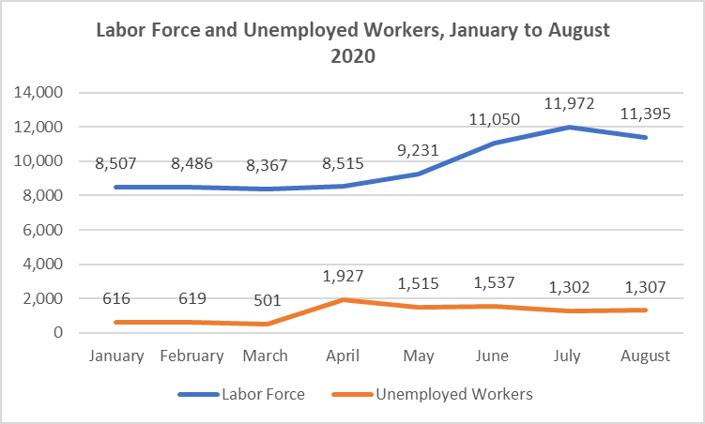
  - While the seasonal nature of the Island’s economy has typically caused significant increases in unemployment during the winter, the arrival of the pandemic in March 2020 immediately resulted in a surge of unemployment, from 501 workers in March to 1,927 in April.

For many Vineyard families, summer is a make-it or break-it period to secure sufficient income to last through the winter. The pandemic has seriously compromised the economic well-being of many of these residents as well as local businesses.

- After April 2020, unemployment declined as the economy began to prepare for the summer season, staying about the same in June and declining to about 1,300 workers in June and July.
- By November 2020, the number of unemployed workers decreased by more than half to 591 workers or 7.2%, considerably higher than 334 workers and 3.9% in November 2019.
- The Island’s unemployment rate in spring 2020 remained considerably higher than the state, at 22.6% versus 16.0%, respectively. In May, however, the state unemployment rate surpassed the Vineyard’s. Unemployment then fell throughout the summer given the wave of seasonal jobs.
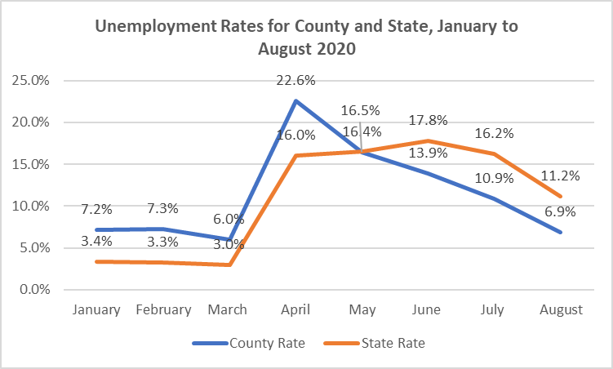
- As of November 2020, the Vineyard’s unemployment rate, at 7.2%, was higher than the state-wide level of 6.2%, both rates much higher than the November 2019 rates of 3.9%
and 2.3%, respectively.
- The Island’s unemployment rate remained the lowest, at 6.9%, in comparison to other counties in the state as of August 2020, with the exception of Nantucket at 6.0%.
- By November 2020, the Island’s unemployment rate of 7.2% was higher than all other counties with the exception of Hampden County at 7.5%.

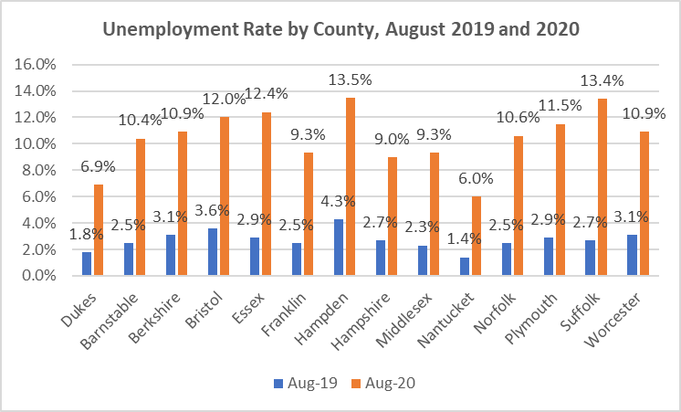
- The sharp increase of unemployment in April occurred in each Island town, and was highest in Tisbury.
- After April, unemployment declined for all communities, increasing somewhat for Aquinnah after August.
- The effects of seasonal jobs are also evident in the changes in the labor force with increases in employment after April. The height of employment occurred in July followed by downturns through October.

  - Some relief for small (5 or fewer employees) local businesses is being offered through a Microenterprise Emergency Assistance Fund, administered by The Resource Inc. for Community and Economic Development.
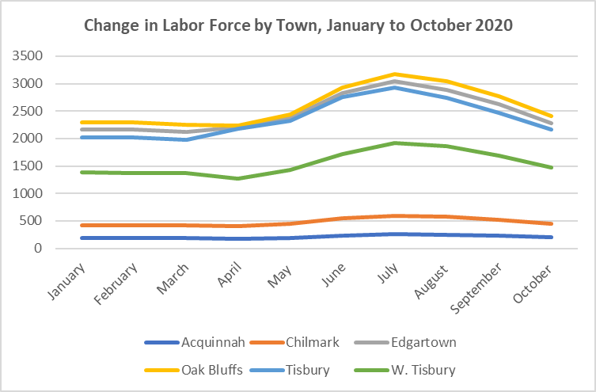
  - The Martha’s Vineyard Commission conducted an on-line survey of Island businesses in May 2020 to help assess the economic impacts of COVID-19 on the local business community in hopes of better addressing and advocating for community needs. Highlights from the 179 survey responses include:
    - 62% operated year-round.
    - 21% provided housing for their workers
    - 15% relied on J1 or H2B Visa workers.
    - 71% indicated that the pandemic will have a significant to severely negative impact on their operations including 54% that were closed due to COVID-10 at the time of the survey.
    - 38% had been forced to lay off employees due to COVID-19.
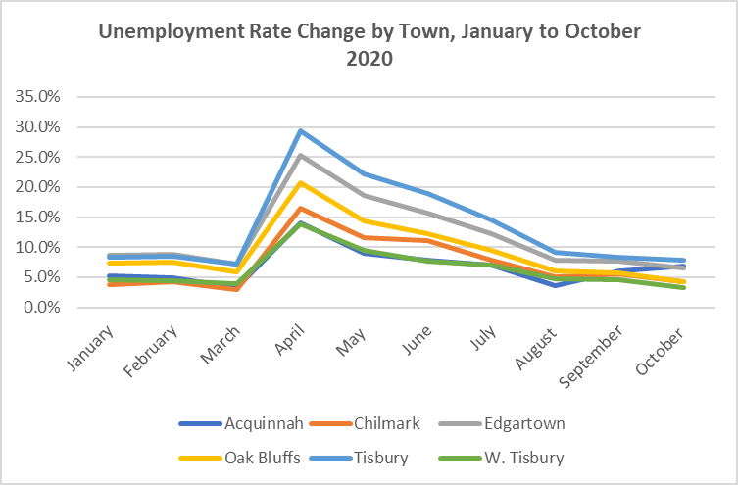
- 70% indicated that their business would reopen within the next 3 months while 19% were unsure of when they would be able to reopen.
- 38% responded that they would lose over half of their projected revenue for 2020.
- 60% of restaurants and 40% of accommodations projected 51% to 75% in
2020 financial losses.
- 67% indicated that they were aware of the federal CARES Act and had consulted a financial advisor.
- 57% responded that they will apply for Payroll Protection Funds and 40% will apply for Economic Injury Disaster Loans.
- Respondents suggested the need for other types of assistance including support in communications, marketing and social media use.

People with Disabilities – 10% of residents, or 1,724 residents, claimed a disability

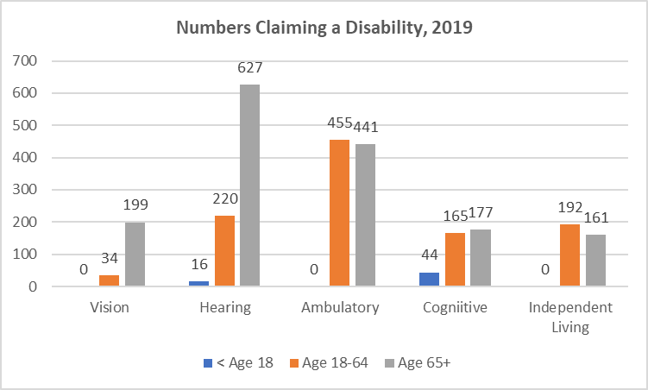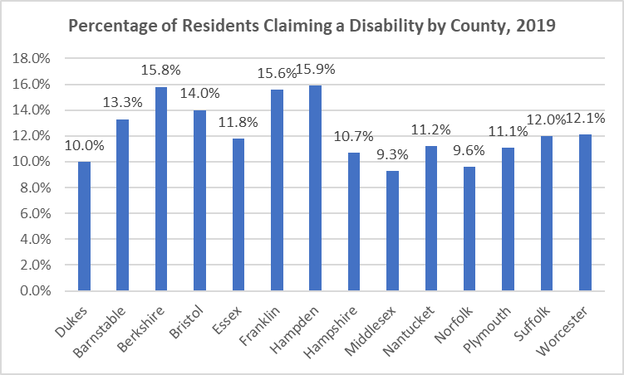
  - Highest levels of disabilities involved hearing loss of those 65 years of age or older and ambulatory challenges for adults.
  - The Island’s 10% level of those claiming a disability is on the low range in comparison to other counties. Middlesex and Norfolk Counties had the lowest levels at 9.3% and 9.6%, respectively. Berkshire, Franklin, and Hampden Counties at over 15%.
  - The statewide rate was 11.6%.
  - Tisbury had the largest number of those with a disability at 598 residents or 14.5% of the population.
  - In recent years most of the communities have prepared ADA Self Evaluation Plans and there has been a push towards adopting universal design standards as part of any new development or retrofit of existing units.

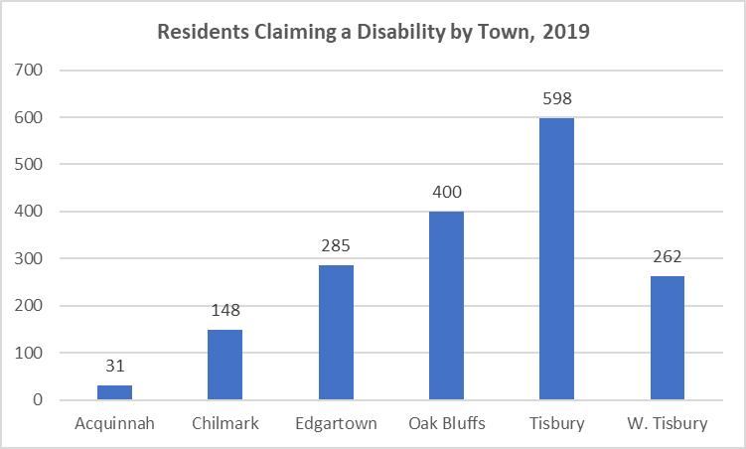

Revenue – COVID-19 causing significant impacts on local resources
Since the Governor’s declaration of a state of emergency due to COVID, anecdotally there was a spike in seasonal residents taking shelter on the Vineyard. Even though Short Term Rental and Room Occupancy FY2021 revenues were up from this time last year, it is difficult to estimate the number of visitors and day trippers.
- SSA passenger ridership was down every month since March and particularly during the months of July when it was down 28%, August down 26%, and September down 16%

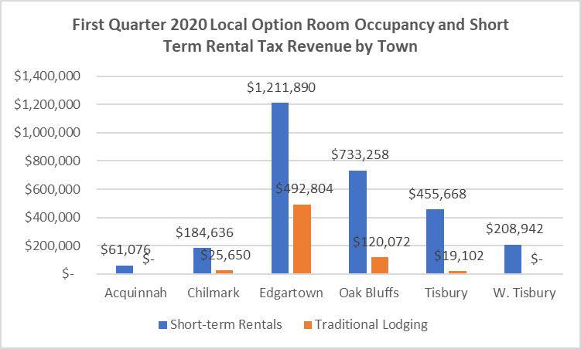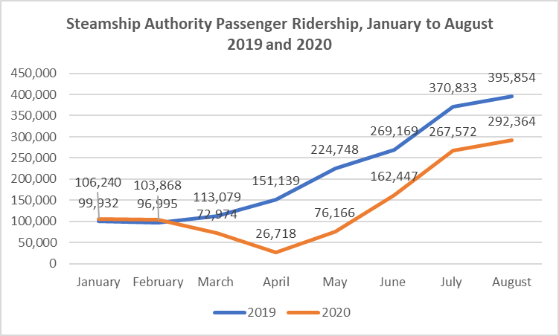compared 2019. Because the Island gets part of the ticket price, this important revenue source has been significantly reduced.
  - Ridership has continued to decline with 107,426 riders in November 2020 compared to 137,219
in November 2019.
  - Tax revenues from short-term rentals, introduced in July 2019, have escalated as visitors have opted to rent beyond the summer season given their ability to work and attend school remotely. Consequently, revenue from the Local Option Room Occupancy Tax and Short Term Rental Tax increased considerably, going from a total of
$2,106,946 in FY19 to $3,443,980 in

FY2020. A total of $3,513,098 was raised in the first quarter of FY21, or as of September 2020, surpassing all FY20 revenue.
- Of the $3,513,098 rental tax revenue raised as of September 2020,
81% came from the Short Term Rental Tax and the remaining 19% from more traditional lodging accommodations.
  - Edgartown experienced the greatest benefit from these rental revenues followed by Oak Bluffs and Tisbury. There is no FY19 data available for West Tisbury.
  - Revenue from the first 2 quarters of FY21 has far surpassed what was raised in the entire FY20, from an Island total of $3,443,980 to $4,604,635.
  - Revenue for the first half of FY21 ranged from a low of
$80,461 in Aquinnah to highs of $1,147,611 and $2,194,566 in Oak Bluffs and Edgartown, respectively.

- Anecdotally, the lengthening of stays by relatively affluent visitors and sudden sales of investments have limited supply of winter rentals on which many local residents have relied from fall to spring.
- The reduction of Meals Tax Revenue reflects the closing and phased re-opening of the economy due to COVID-19 as well as the choice of consumers to stay at home instead of dining out.

Housing and Water Quality Profile

Housing Growth and Occupancy – Continuing erosion of year-round housing stock
  - Housing units on the Vineyard increased by 4.2% or 714 units between 2010 and 2019, from 17,188 units to 17,902. This is only a bit lower than population growth during this period of 4.7%, suggesting little change in household size.
  - Most of the housing growth between 2010 and 2019 was relatively evenly distributed among Oak Bluffs, Tisbury and West Tisbury.
    - Housing growth largely occurred in the seasonal or second home housing stock. While the total number of housing units increased by 4.2% between 2010 and 2019, the year-round occupied housing stock decreased by 8.2% or 603 units while seasonal or occasional units increased by 15.4% or 1,428 units, from 9,253 units in 2010 to 10,681 in 2019.
    - The percentage of year-round owner-occupancy increased by 6.9% between 2000 and 2019 while by only 1.5% for year-round rentals.
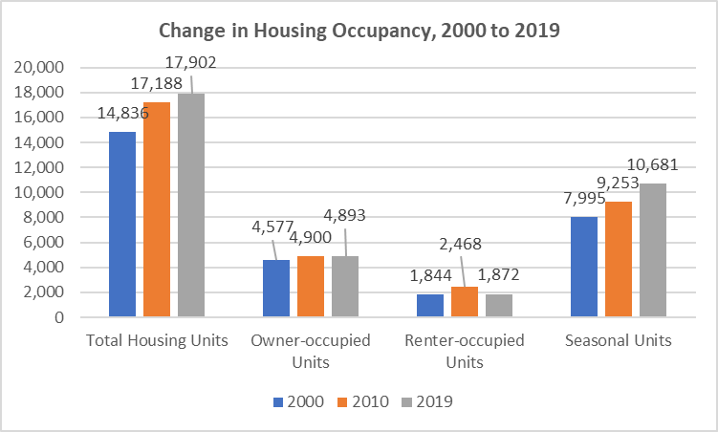
  - The 2019 census estimates indicate a decrease in year-round rentals from 2,468 units in 2010 to 1,872 by 2019 or by 24%. Some of this loss likely involves the conversion of rental housing to owner- occupancy or shift to seasonal or second home use.
  - Seasonal and second home occupancy was not surprisingly the highest among Dukes, Nantucket, Barnstable and Berkshire Counties and negligible for the rest.
  - Because of the Island’s large seasonal and second home stock, it has a low level of year-round housing occupancy of 37.8% compared to other counties with the exception of Nantucket at 36.3%.
  - While having a low year-round occupancy level, Martha’s Vineyard has a relatively high level of owner-occupancy in comparison to other counties, at 72.3%, in between the low of 36.1% for Suffolk County and the high of 95.2% for Norfolk County.

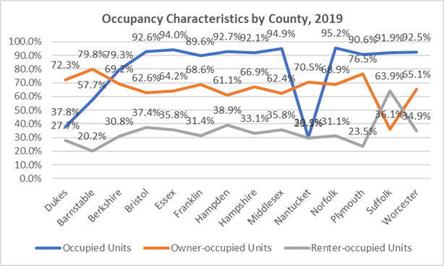

  - Limited new year-round housing production has led to an imbalance between housing supply and demand and in combination with increasing demand for seasonal units or second homes drives housing prices skyward, further eroding the supply of housing for lower wage workers who support the Island’s service economy.
  - Vacancy rates are extremely low at 0.7% for homeownership and 3.1% for rentals based on 2019 census estimates. Given the market pressure of COVID-19, market conditions have most likely further tightened.
  - Residential mobility is very limited for year-round residents with only 4.4% of households moving into their units between 2017 and 2019 and only another 26.4% between 2010 and 2016.
  - Edgartown has one-third of the Island’s 10,681 seasonal or occasional units, representing 69% of its own housing stock.

  - Oak Bluffs has the next highest amount of seasonal or occasional units on the Island, at 25%, followed by Tisbury at 13%. The share of each communities’ housing that is for seasonal or occasional use was 59% and 44%, respectively.
  - While relatively small in number, the seasonal and occasional housing stock in Aquinnah and Chilmark represents a high percentage of its housing at 62% and 71%, respectively, with West Tisbury lower at 54%.

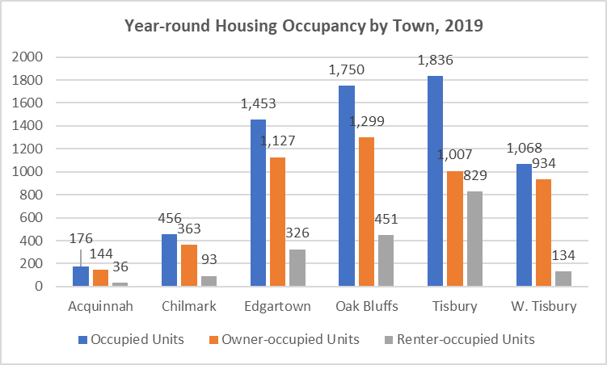
    - Renter-occupancy rates ranged from a low of 12.5% of all occupied units in West Tisbury to a high of 45.2% in Tisbury. Levels in the other communities were in the 20.5% to 25.8% range.

Types of Structures and Units – Very limited multi-family housing stock

  - The seasonality of the housing stock in combination with a relative lack of multi-family housing contribute to a limited supply of affordable housing and why so many have to live outside of the Island and commute to work by ferry.
  - 91% of the Vineyard’s housing stock is in single-family detached homes with 5% in structures of 2 to 4 units.
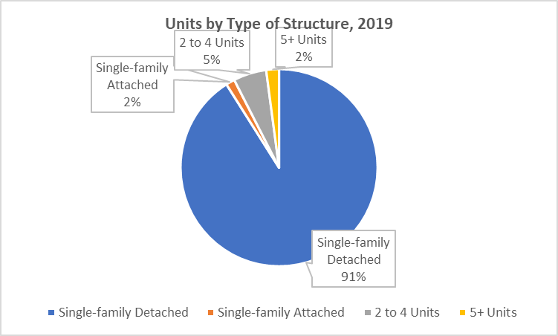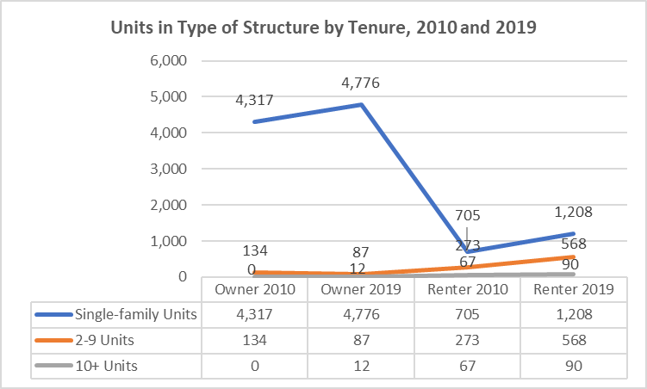
  - Only 2% of all housing units, or 375 units, were in structures of 5 or more units.
  - There was some notable growth in units of more than 2 units between 2010 and 2019, from 407 units to 688 or by 69%.
  - While almost all of the owner-occupied units were in single-family homes, 64% of rental units were also in single-families.
• Because affordable housing typically relies on some economies of scale to make development feasible, the high cost of land on the Vineyard in tandem with local zoning and environmental challenges have severely constrained multi-family housing production with some level of affordability.

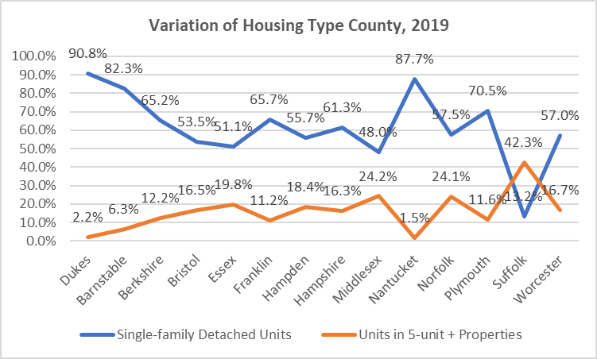
  - At 2.2% of all units, Martha’s Vineyard has the lowest percentage of multi-family housing of 5 or more units than all other counties in the state with the exception of Nantucket at 1.5%.
  - There are no units in structures of 5 or more units in Aquinnah, Chilmark, Edgartown, and West Tisbury and only 12 total units in 2 to 4-unit dwellings in Aquinnah and Chilmark. While environmental constraints, such as nitrogen loading, are serious development concerns, they do not preclude some amount of denser development in appropriate locations and under environmentally-sensitive conditions.

Water Quality and Nitrogen Loading – Need to mitigate negative water quality impacts in coastal ponds
  - The Martha’s Vineyard Commission (MVC) has participated in several studies to assist the 6 Island Towns in wastewater management planning including the Wastewater Management Study prepared in 2010 by Wright-Pierce engineering firm and a follow-up in 2017 as part of the Massachusetts Estuary Project (MEP).

  - The Island has 5 public or quasi-public wastewater facilities with traditional municipal wastewater plants in Edgartown, Oak Bluff, and Tisbury. Dukes County owns a small system serving the airport and nearby commercial uses, and the Housing authority of the Wampanoag Tribe owns another small system in Aquinnah. For the Island as a whole, approximately 1,600 properties are served by these 5 plants.
  - Of particular concern is restoring and maintaining water quality in coastal ponds where excessive nitrogen loading has resulted from on-site wastewater disposal, fertilizer, impervious surfaces, among other causes. There are 15 pond systems, many shared among several communities, all of which were determined to be impaired or somewhat impaired with the exception of Cape Poge that is in good condition.
  - The studies identified a total of 3,852 current housing units in these areas with another 5,662 units that could potentially be developed before buildout based on existing zoning standards. The projects recommend remediation efforts to reduce nitrogen loading, many of which are already underway. See Appendix 4 for more details.
  - Innovative Alternative (IA) Technology denitrifying systems, such as the NITROE systems under provisional permit by Mass DEP, can help address nitrogen reduction problems. While sewering and IA systems will help address nitrogen reduction into the ponds, sewering is highly costly. The Island Housing Trust’s Greenwood Avenue project is using a NITROE system that was paid by the state.
  - Some of the recommendations from these studies include:
- Allocating responsibility for nitrogen load reduction among towns in shared watersheds.
- Using currently unused treatment plant capacity for sewer extension projects.
- Transferring nitrogen load among watersheds and establishing a process for determining costs for dealing with impacts on the receiving pond.
- Establishing regional disposal sites in non-sensitive watersheds.
- Prioritizing needs between nitrogen control and other wastewater needs such as water supply protection, economic growth or housing development for example.
- Building capacity for future growth and determining best ways to pay for the cost of increased capacity.
  - The Massachusetts Estuaries Project (MEP) has increased MVC’s capacity to apply more sophisticated models to estimate nitrogen loads and refine watershed boundaries that are fundamental to good planning.
  - MVC continues to do Island-wide Water Quality and Watershed Planning (EPA’s 208 Equivalent). MVC can help facilitate town participation in the Massachusetts Department of Environmental Protection’s Targeted Watershed Management Plan Program to help address Nitrogen Loading in watersheds that include multiple towns with potential cost sharing options. The Pleasant Bay Targeted Watershed Management Plan is a good example in Barnstable County. It should be noted that Oak Bluffs and Tisbury are updating their Comprehensive Wastewater Management Plans (CWMP).

Housing Costs and Affordability – Extremely high housing market conditions are being exacerbated by COVID-19.
All of the above housing data involves the latest information from the U.S. Census Bureau’s American
Community Survey 5-Year estimates, 2015-2019, and thus reflects pre-COVID conditions. While

affordability gaps between the costs of available housing and what many working residents can afford has always been high, the pandemic has taken extreme conditions into dire ones for many residents.

COVID-19 has brought with it two additional pressures on the housing market. First is the accelerated rate of new sales activity as people from even distant places in the country are looking to find a safer retreat on the Vineyard. The ability to work and attend school remotely makes this far-flung living situation possible. Second, people who moved into summer houses are choosing to stay, draining the supply of what has been more affordable winter rentals on which many Island workers rely. The Vineyard is therefore losing a part of its traditional community and gaining many more affluent residents during the off-season.

Homeownership
  - The number of year-round, owner-occupied units valued below $200,000 has been extremely scarce for decades. In 2010, there were 148 such units counted by the census, decreasing to 65
by 2019 and likely very small and in poor condition if not on the Subsidized Housing Inventory (SHI).
- Those units valued between $200,000 to $499,999 have also been extremely limited but grew from 852 to 1,143 between 2010 and 2019 based on census data.
- Units valued between $500,000 and $999,999 have hovered at about 2,500 over the past decade, not affordable to lower wage service workers as well as many more middle-income residents.
  - Year-round units increased from 939 to 1,114 between 2010 and 2019 for homes valued at more than $1 million, or by about 19%. This is much higher than the approximately 7% rate of housing growth for year- round, owner-occupancy during this period.
  - New pressures on housing demand, most recently driven largely by COVID, are pushing up the numbers and prices of new home sales.
  - By 2020, the number of homes sales increased from 27 in February, down to 19 in May, to as many as 93 in September, and 68 in November based on Banker & Tradesman data. Local realtors were working 12-hour days to accommodate this surge in sales activity.

  - The lull in sales in April and May relates to the lockdowns that were imposed due to the pandemic. The spike in sales in September likely correlates to the beginning of the school season and greater acceptance and technical ability to work remotely.
  - Sales prices have escalated as well. For example, the Island’s median single-family home was
$807,000 in 2019, rising to $1,173,000 by November 2020 based on Banker & Tradesman.
  - Single-family home prices are high in comparison to other counties with a median of $927,835 as of October 2020 and $1,173,000 in November. Only Nantucket had a higher median, soaring above $2 million.
  - While there have been some fluctuations in the median single-family home prices over the past year, particularly for towns with more limited sales and thus a small sample size, the predominant trend is towards much higher prices.

  - As prices continue to rise, so do the affordability gaps, typically defined as the difference between
what a median income earning household can afford and the median house price.
    - Because interest rates are currently relatively low, property taxes are also relatively low for most Island communities, and median incomes for some towns are relatively high; what a median income earning household can afford is greater. These prices ranged from $264,000 in Tisbury (with higher taxes, lower median income level, and lower median house value) to a high of $557,000 in Chilmark (with the highest median income and tax rate).
    - The affordability gap for all towns increased dramatically based largely on rising median incomes, with the exception of Tisbury, but mostly on escalating housing values made recently more extreme, to the point of being absurd, due to COVID-19.
    - The affordability gap was $781,500 for the Island as a whole in November 2020, up from $225,000 in 2012, representing a 247% increase, way beyond the inflationary rate of 13.3% during that period.

Rental Housing
  - The Vineyard’s rental market is complicated by substantial seasonal shifts. Because of the typically high demand for summer rentals, many property owners are economically motivated to rent in the summer season, often for exorbitant prices by the week, and then lower the price significantly during the winter, typically spanning Labor Day through Memorial Day.
  - As noted earlier, anecdotally the increase of seasonal renters staying longer as well as the increase of investment properties put on the market during the pandemic have caused a reduction in the number of winter rentals.

This economic scenario establishes the context for what has been known as the “Island Shuffle”, where many who have relied on winter rentals have been forced to find alternative accommodations during the summer. This has been extended to the winter due to COVID. In essence, many of these renters become homeless in search of a temporary place to live whether doubled up with friends or families, camping, or commuting from off-Island.

- The median rent for year-round rentals was $1,180 in 2010 and increased to $1,459 based on 2019 census estimates.
- Because 21% of the Vineyard’s rental housing stock is subsidized and another 300 units involve tenants who did not pay rent, the median does not reflect actual market conditions.
- The median rent of $1,459 would require an income of about $66,360 assuming average monthly utility bills of $200 and not paying more than 30% of income on housing. This is well above the median income of renter households of $43,750.
- Rents have risen considerably during the last decade with year- round rentals for more than $1,500 increasing from 207 to 710. 26% of rents were more than $2,000.
- Given the pandemic, relatively affordable rentals are difficult if not nearly impossible to find.

  - Only a few years ago, there were online listings available for year-round or winter rentals, not anymore. Word of these increasingly limited opportunities is now more typically by word of mouth at much higher rents, some suggesting in the ballpark of
$3,000 for a 2-bedroom apartment. Word is that a 2- bedroom winter rental is fetching $3,000.
  - Vacation or seasonal rentals are charged by the night or week and can be exorbitant, especially near the water.
  - While the median rent for Martha’s Vineyard was high, it was less than several other counties. Most of these counties, however, with the exception of Nantucket, did not have the majority of their rental stock as seasonal with high if not exorbitant prices. These seasonal units were not factored into the median calculations.
  - Median rents increased considerably for all communities between 2010 and 2019 with the greatest increase occurring in Edgartown, from $1,302 to $1,849.

Cost Burdens
Affordable housing is defined by the income of the household in comparison to housing costs. For example, the state and federal governments identify units as affordable if a household is paying no more than 30% of its income on housing, whether for ownership or rental. If households are paying more than this threshold, they are described as experiencing housing affordability problems or cost burdens; and if they are paying 50% or more for housing, they have severe housing cost burdens.

HUD CHAS Report
  - Every year the U.S. Department of Housing and Urban Development (HUD) obtains custom tabulations of the American Community Survey (ACS) data from the U.S. Census Bureau, known as the CHAS data (Comprehensive Housing Affordability Strategy) to analyze housing problems and needs, particularly for lower income households.
  - The CHAS data for 2013-2017 (latest report available) suggests that of the 6,140 households counted in this report (where data was available), 1,990 year-round owners (42% of these owners) and 539 year-round renters (39% of these renters) were experiencing cost burdens. Of these 1,140 owners and 154 renters had severe cost burdens at 24% and 11%, respectively.

  - The CHAS data estimates that 2,529 households, or 41% of all households in this report, were paying too much for their housing including 1,294 or 21% who were paying more than half of their income on housing costs. This is down somewhat from 47% with cost burdens and 22% with severe cost burdens in 2009.
  - The data estimates that 2,530 or 41% of households counted had incomes at or below 80% Median Family Income (MFI) or Area Median Income (AMI) and of these 68% had cost burdens, 45% with severe cost burdens.
  - There were 765 households with incomes at or below 30% MFI (up from 730 in 2009), referred to by HUD as extremely low-income households, and 515 or 67% were spending too much including 465 households or 61% with severe cost burdens.
  - There were 840 households with incomes between 30% and 50% of median income for Dukes County (up from 610 in 2009), referred to by HUD as very low-income households, and 605
households or 72% had cost burdens including 420 or half with severe cost burdens.
  - Of the 925 households earning between 50% and 80% AMI (up from 905 in 2009), which HUD defines as low- and moderate-income households, 600 or 65% were spending too much on housing with 250 or 27% of these households spending at least half of their income on housing costs.
  - There were 560 households with incomes over 80% and up to 100% median income for Dukes County. Of these, 275 or 49% were overspending on their housing that included 55 or 10% spending more than half their income on housing costs.
  - Even those with incomes of more than 100% AMI are experiencing cost burdens. Of these 3,045 households, 525 or 17% had cost burdens that included 100 or 3% with severe cost burdens.

  - Because there are far more owners than renters on the Island, it is not surprising that there are more owners with cost burdens including all owners with income at or below 30% AMI, representing 86% of all owners in this income range.
  - Altogether 990 or 59% of owner households with incomes at or below 80% AMI were experiencing severe cost burdens.
  - In regard to renter households, 465 or 55% of households with incomes at or below 80% AMI had cost burdens, 150 or 18% with severe cost burdens.

American Community Survey 5-Year Estimates 2015-2019

- There are also more recent census estimates on cost burdens which indicate that 42% of all Vineyard households were spending more than 30% of their income on housing costs, including 35% spending
more than 35%.
- Because there are many more owner households on the Vineyard than renters, it is not surprising that there would be more owners with cost burdens.
- Owners spending more than 30% of income ranged from a low of 21 in Aquinnah to a high of 620 in Oak Bluffs.
- In regard to year-round renters, those with cost burdens ranged from 16 in Aquinnah to 333 in Tisbury.
- Proportionately, those renter households with cost burdens ranged from a low of 43% in Chilmark to a high of 81% in West Tisbury.

Subsidized Housing Inventory (SHI) – Some net loss of SHI units due to expiring affordability restrictions and limited new production

  - The Vineyard has a total of 339 SHI units which is the equivalent of 5.1% of its year-round housing stock of 6,682 units based on the 2010 decennial census data. A breakdown of all SHI units by town is included in Appendix 2.

  - The current figures are down from 411 SHI units and 5.2% in 2013, the loss of units due largely to the expiration of shorter-term deed restrictions from the various Housing Rehab Programs.
  - Only 8 new units were added to the SHI since 2013, 6 rentals as part of Water Street and 2 ownership units at Greenwood Avenue, both in Tisbury.

  - 93% of all SHI units were rentals, comprising 21% of all rental units on the Island where tenants were paying rent.

  - Because Aquinnah’s year-round housing stock is so small, its 33 Tribal Housing SHI units have put it over the 10% state affordability threshold.
  - Oak Bluffs has the next highest SHI percentage at 5.47% with Tisbury close behind at 5.34% with 117 and 105 SHI units, respectively.
  - Chilmark has no state- defined affordable units at this point with West Tisbury at only 11 units.
  - When the 2020 census figures are released, the new year-round housing count will incorporate housing growth and the percentages will decrease accordingly. Even when and if more communities pass the 10% goal, there will still be huge unmet affordable housing needs as documented in this Housing Needs Assessment.
  - A total of 204 units, or 60% of the affordable SHI units, were produced through Chapter 40B comprehensive permits and therefore involved overrides of local zoning. Despite zoning overrides, 40B can be a good permitting tool when the proposed project addresses local housing needs. The Martha’s Vineyard Commission has review responsibilities of these 40B projects that are part of
Developments of Regional Impact (DRI).
  - There are a few projects where the affordability restrictions are due to expire and may lead to some further loss of SHI units interventions to extend the dates are unavailable or unsuccessful. For example, the affordability of the 3 units at the Rectory are still listed as due to expire in 2017, although given HOME Program funding they are unlikely to expire. The 40 units at Hillside Village in Tisbury are listed as due to expire in 2025 with the second phase expiring in 2030. All of the other units, where affordability is not in perpetuity, involve expiring dates beyond the next decade. Nevertheless, restrictions for some of these projects included different terms and

conditions than those currently used and need to be closely monitored to ensure continued affordability.

Due to the exceedingly high property values on the Vineyard, in 2004 the State Legislature granted Nantucket and Dukes County the right to place permanent deed restrictions on properties whose owners earn up to 150% of area median income (AMI), but still priced out of the local housing market. A summary of the full range of income limits, from 30% to 150% AMI, is included as Appendix 3. The state has also allowed the Dukes County Regional Housing Authority to apply exceptional rent levels of 110% of HUD Fair Market Rents as its rent limits.

  - The Dukes County Regional Housing Authority (DCRHA) maintains a waitlist of applicants for their 101 rental units which included 258 applicants as of August 2020. A detailed breakdown is summarized in Appendix 3.
  - In addition to SHI units, communities have produced 166 additional community housing units that are directed to those earning between 80% and 150% of median income and include deed restrictions to ensure long-term affordability.
  - The Island has benefited from 99 rental subsidies through DCRHA’s Rental Assistance Program, Section 8 Housing Choice Vouchers, or Massachusetts Rental Voucher Program (MRVP) managed by the Housing Assistance Corporation (HAC). This represents a total of about 500 subsidized housing units on the Island or 7.5% of its year-round housing stock, although rental vouchers cannot be included in the SHI.
  - It is also worth noting that most projects with affordable units are relatively small with less than a dozen units. Exceptions include Morgan Woods (Pennywise Path) in Edgartown with 60 units, Woodside Village Phase I and II with a total of 63 units, and Hillside Village in Tisbury with 40 units.
  - Because affordable housing typically depends on some economies of scale and subsidy programs are often geared to larger projects, small developments are challenging to make financially feasible. Additionally, any development has been difficult to site.
  - Martha’s Vineyard is fortunate to have strong local capacity to produce affordable and community housing and provide important housing resources and services through a number of local and regional organizations including:
    - Dukes County Regional Housing Authority (DCRHA)
    - Martha’s Vineyard Commission (MVC)
    - Island Elderly Housing (IEH)
    - Island Housing Trust (IHT)
    - Habitat for Humanity of Martha’s Vineyard
    - Harbor Homes of Martha’s Vineyard
    - Aquinnah Wampanoag Tribal Housing Authority
    - The Resource Inc. (TRI)

    - The Community Builders (TCB)
    - Housing Assistance Corporation (HAC)
    - Community Action Committee of Cape Cod and the Islands
    - Almost all of the towns have both an Affordable Housing Committee and Housing Trust

Key Findings and Recommendations

COVID impacts are difficult to estimate but are putting many Island households at risk of losing their homes.
  - The Metropolitan Area Planning Council (MAPC) prepared estimates of local housing need for MA municipalities that attempt to gauge the impact of the pandemic as of September 2020. These estimates are based on unemployment claims as of September 5th and the Census Bureau’s
biweekly Pulse survey for September 2nd to the 14th. Information was not available for Aquinnah but the estimated amounts of housing assistance needed for affected households ranged from a low of $2,419 in Chilmark to $32,996 in Tisbury.
    - These figures represent just a fraction of the total need as many affected workers and households are difficult to estimate, particularly for the Vineyard with so many self-employed and seasonal workers.
    - Unemployment claims by town for September 2020 ranged from a low of 12 claims in Chilmark to a high of 156 in Tisbury.
  - The Pulse survey information also suggested that 16% of renters reported being “currently caught up on rent payments,” and 6% thought it was “somewhat” or “very likely they would have to leave this home in the next 2 months because of evection.”

  - With approximately 1,872 renter households on the Island, the Pulse information suggests that approximately 1,572 renter households might have owed back rent in September and 112 were concerned about imminent eviction⁴.
  - The Pulse survey also indicated that many Massachusetts renters expected that they would have trouble paying their rent in the coming months including 8% who reported that they had “no confidence” they would be able to pay October rent on time, and an additional 14% that they had only “slight confidence” for an on-time payment.
  - Given continuing COVID impacts on the economy, and no additional federal support for households and businesses through the end of 2020, it is likely that conditions have worsened since September.
  - MAPC also reported that 35,200 Massachusetts homeowners with an unemployed person in their household will likely have trouble covering their housing costs, with a total available income- expense gap of $44 million per month. These households now face increasing risk.
  - During the eviction moratorium, missed mortgage payments were deferred to the end of the loan term, so owners have not been accumulating past due bills. When the moratorium expires, those who cannot keep up with their payments could start to fall behind on their mortgage. With the limited for-sale inventory and sky-high prices, banks and lending institutions could feel strong incentives to initiate foreclosure proceedings.
  - There are some brakes on evictions and foreclosures including state and federal moratoria that are only in effect until December 31, 2020 with some extensions.
  - The state also has a number of emergency assistance programs in operation to help businesses as well as those who are behind on their rent and mortgage payments, including the Residential Assistance for Families in Transition Program (RAFT) and Emergency Rental and Mortgage Assistance (ERMA) Program. For more information on housing assistance, go to: Emergency Housing Assistance during COVID-19 | Mass.gov

Of particular note is the MV COVID-19 Relief Program operated by the Dukes County Regional Housing Authority (DCRHA) which this spring provided emergency rental relief of 1-month’s rent to about 80 tenant households living in market rentals who had demonstrated a loss of income due to the pandemic. The program was directed to those with incomes up to 100% of area median income and rents not exceeding 110% of HUD Fair Market Rents (FMRs). Payments were made directly to landlords.

The Program is introducing another round of funding this winter with continued funding from the Permanent Endowment of MV as well as other local donations. The Program recently received $100,000 in funding from the Boston COVID Foundation and, through the good efforts of the MV Community Foundation, has also received a donor’s commitment of $50,000. The income target has changed to 80% AMI.

Homelessness has been a persistent problem for Martha’s Vineyard but has grown given the impacts of COVID-19.
Because of the seasonal shifts in the economy and widening affordability gaps, homelessness has been an ongoing problem for Island individuals and families. In recognition of this situation, Harbor Homes of MV was established a couple of years ago as the umbrella organization for all homeless prevention efforts on the Vineyard. While other housing entities have importantly focused on those with incomes of 30% to 150% of HUD’s area median income, Harbor Homes seeks to address those who are “too poor for affordable housing” as they do not have the income or subsidy to access even the Island’s existing subsidized units.

Initially, the organization focused its efforts on developing congregate for the homeless. It searched for appropriate properties throughout the Island and, despite considerable local push-back on a number of possible locations, was able to buy a property in Tisbury. This home opened in mid-June 2020 to house 6 formerly homeless men, not only providing them with a safe and decent place to live, but also offering case management services and life skills training. In exchange, residents pay a fee of $450 per month and help with property maintenance.

While developing this property, COVID-19 hit and the Island’s sole winter shelter and warming day center in Edgartown, which had been run by clergy and volunteers to house about 13 individuals, closed immediately. Other public places where the homeless had sought refuge, such as libraries, were also closed.

It had been well known for years that people had been seeking shelter in vehicles, boats, or tents in woods; risking their own health and posing potential fire threats. Fears grew that this situation would only worsen with COVID with potentially an increasingly sick population of residents with no place to live. Moreover, the homeless, including those who had contracted COVID, were flooding into the Hospital’s emergency room. Homelessness thus became viewed the Island’s #1 problem.

In consequence, funding became available from a variety of sources in support of homelessness prevention efforts including Martha’s Vineyard Hospital, Martha’s Vineyard Community Services, the Permanent Endowment of MV, Martha’s Vineyard Bank, a state grant to house medically-fragile homeless individuals, among other donations that raised approximately $350,000. This funding enabled Harbor Homes to expand its operations to include the following programs:

  - Developed cooperative agreements with 3 local hotels to house homeless residents. Five of these residents were able to relocate to the congregate house when it was completed in June. Some of these residents are chronically homeless and too mentally ill to go to the Emergency Shelter. Some are also families.
  - Merged the House of Grace Winter Emergency Shelter Program and Warming Center Day Shelter into one program under Harbor Homes auspices. The Emergency Shelter’s capacity is 13 individuals but with COVID, capacity has been reduced to 8 to ensure adequate social distancing. The facility needs 2 staff present at all times, usually split between a paid staff person and a volunteer.
  - Manages a Homeless Hotline to provide information and appropriate referrals.
  - Conducts case management services to help homeless obtain important services and move towards self-sufficiency.

Harbor Homes suggests the following estimates of the extent of the homeless problem on the Vineyard:

  - Between 80 to 100 residents are typically homeless on the Vineyard at any time, often finding shelter where they can, shuffling from place to place, including places without heat and proper plumbing. Many are functional, finding part-time work where they can but, nevertheless, living in poverty.
  - Over this past year, 120 individuals have contacted Harbor Homes and identified themselves as homeless.
  - The organization receives from 1 to 2 new calls each week on its hotline.
  - From July to December, Harbor Homes has provided 38 individuals with direct support.
  - Support has also been provided to 17 additional individuals who have been identified as chronically homeless, typically with substance abuse and/or mental health issues.

While COVID has had serious impacts on the economy and peoples’ lives, it has brought greater attention and resources to the plight of the homeless on the Island. To continue and expand existing efforts, Harbor Homes is planning work on a Strategic Action Plan that will provide guidance on strategies for ending homelessness on the Island. Among the goals is 80 to 100 new units for those who become homeless.

Of particular concern are the increasing affordability gaps and cost burdens that, while always high, have been intensified by the pandemic.

This Housing Needs Assessment has identified that Martha’s Vineyard has been encountering widening affordability gaps and increasing cost burdens for decades that have caused many to struggle to live on the Island, have driven others to relocate off-Island and commute to work by ferry, and have forced others into homelessness. Because the Island’s economy relies on a tourist and service economy, it must ensure that there is adequate and affordable housing available to workers who are essential to Island businesses. Some employers are providing housing, but much more needs to be done to retain the Island’s economic viability.

COVID-19 has been accompanied by two additional pressures on the housing market. First is the accelerated rate of new sales activity as people from even distant places in the country are looking to find a safer retreat on the Vineyard. The ability to work and attend school remotely makes this far-flung living situation possible. Second, people who moved into summer houses are choosing to stay, draining the supply of what has been more affordable winter rentals on which many Island workers rely. The Vineyard is therefore losing a part of its traditional community and gaining many more affluent residents during the off-season.

These pressures have pushed housing prices skyward, likewise increasing affordability gaps, typically defined as the difference between what a median income earning household can afford ($391,500) and the median house price ($1,173,000 as of November 2020). The affordability gap was $781,500 for the Island as a whole as of November 2020, up from $225,000 in 2012, representing a 247% increase and way beyond the inflationary rate of 13.3% during that period. The affordability gap for all towns increased dramatically based largely on rising median incomes, with the exception of Tisbury, but mostly based on escalating housing values made recently more extreme, to the point of being absurd, due to COVID-19.

The 2019 census estimates identify a median rent of $1,459 but because 21% of the Island’s rentals are
subsidized and 300 renters live rent free, this median does not reflect actual market conditions. The

extension of seasonal visitors has eroded the winter rental supply and, while there are almost no current listings of winter or year-round rentals, word is that a 2-bedroom winter unit is fetching $3,000. Because there has been no net increase in year-round rentals since 2000, the lack of production exacerbates the imbalance between supply and demand, thus increasing housing costs.

With such escalating housing prices, it is not surprising the increasing numbers of residents are paying increasing amounts of their income on housing costs. A HUD report with 2017 data (latest report available) identified 41% of all Island households with cost burdens as they were paying more than 30% of their income on housing costs. The 2019 census estimates boost this level to 42%. With much higher unemployment or underemployment due to COVID, incomes have decreased and correspondingly cost burdens have surely increased.

Priority housing needs identified in previous plans are not only still evident but growing.
The most pressing housing need continues to be rental housing that is affordable to those along a wide range of income levels who are priced out of the Island’s exorbitant housing market with a continued focus on the most vulnerable residents. Emergency rental assistance is needed in the short-run but given increasing market demand pressures, may be a consideration for ongoing funding. Support for those confronting or at risk of homelessness must remain an Island-wide priority embraced by all communities.

The Martha’s Vineyard Housing Needs Assessment, that was prepared in 2013 by the Martha’s Vineyard Commission, recommended an annual housing production goal of 50 units and 250 units over a 5-year period. It recognized that the goal was ambitious given past production levels, but it still fell substantially short of the actual need. Without a significant and permanent source of financing, an annual goal of 30 units might be more reasonable in the short-term but still challenging given past results with only 8 new SHI units added since 2013, 6 rentals as part of Water Street and 2 ownership units at Greenwood Avenue, both in Tisbury.

The Needs Assessment also proposed about an 80% to 20% split between rentals and homeownership in the new affordable and community housing units created. The reasons behind this recommendation were based on the following important benefits of rentals:

- Better address the needs of lower wageworkers, addressing the more transitory residency of many workers.
- Target the needs of the Island’s most vulnerable residents with very limited financial means.
- Reduce the negative impacts of the summer’s “Island Shuffle” on both individuals and families.
- Provide opportunities for some seniors who are “overhoused” and spending far too much to remain in their homes to relocate to more affordable and less isolated settings, opening up their homes to families requiring more space.
  - Offer better opportunities for financing as most public subsidies are directed to rental housing development.
  - Promote accessory units in existing homes that provide small year-round rentals and also offer additional income to owners, particularly those on fixed incomes.
  - Offer opportunities to build new more clustered, mixed-income communities that promote greater affordability through economies of scale in development, reduce the stigma of affordable housing, and help build connections among Island residents.

Through a review of key socio-economic trends, changes in the housing stock, and existing affordability gaps, the following priority housing needs were identified for subpopulations of Island residents:
  - Those with the lowest incomes who are not currently living in subsidized housing should be considered the top priority for new affordable unit creation and support services where needed.
  - Direct approximately 60% of new units created to families.
  - Target approximately 20% of all new units created to seniors.
  - Direct approximately 20% of all new units created to singles who were providing essential services on the Vineyard.
  - Incorporate handicapped accessibility and/or supportive services into at least 10% of all new affordable and community housing units created.
  - Continue support for community housing needs should be considered, promoting year-round housing options and mixed-income environments with a somewhat less per unit demand on subsidy funds. (one-third of homeownership units).

More recently, the draft Martha’s Vineyard Housing Production Plan FY18-FY22 also indicated that the Island has unmet local housing needs that are not served with the existing affordable and community housing units. Based on cost burden information, a growing population of older adults, rising housing prices, and a limited supply of year-round housing, rentals in particular; the Plan also identified the Island’s primary housing need as greater year-round rental housing production at all market levels including affordable rental units, especially for households with incomes at or below 50% AMI. Additionally, it called for more diverse housing options such as two-family, townhouses, congregate, multi-family, service enriched, including transitional, and housing options for seasonal workers; a greater supply of year-round housing for both affordable rental and homeownership, especially for households with income less than 80% AMI as well as 80% to 100% AMI; and low/moderate income homeowner rehabilitation assistance.

The draft Plan called for affordable rental unit production of 223 units over 5-years at 45 units per year. It also recommended 71 homeownership units be developed for those with incomes in the 80% to 100% AMI range.

Based on the CHAS data (Comprehensive Housing Affordability Strategy) provided in a HUD report that breaks down households by income range and affordability problems, the table below estimates unmet housing need, updating information that was included in the 2013 Housing Needs Assessment. The unmet housing need is based on those who are spending too much on their housing with the available housing being reported as occupied by those without cost burdens Recommended goals are also based on those included in the 2013 Housing Needs Assessment and close to those in the draft Housing Production Plan.

While the analysis larger deficits for homeownership units than rentals, this Housing Needs Assessment recommends a priority focus on those residents with the most limited financial means that are best accommodated through rentals and where financing is most available. Nevertheless, this Needs Study also incorporates production goals for first-time homeownership opportunities equivalent to 20% of new affordable and community housing units created. This study also recognizes that many of the cost- burdened homeowners are likely ineligible for subsidized housing as the significant equity in their homes would disqualify them from assistance.

Unmet Housing Needs, 2017
Type of Housing | Housing Available | Unmet Need* | Recommended  For Next Year/Five Years**
Rentals  Extremely Low Income  (at or below 30% AMI) | 190 | 145 | 40 units/200 units
Very Low Income (>30% to  50% AMI) | 105 | 95
Low to Moderate Income (>50% to 80%  AMI) | 240 | 225
Community Housing  (>80% to 100% AMI) | 115 | 70
> 100% AMI | 341 | 4
Subtotal | 991 | 539
Ownership  Less than 80% AMI | 425 | 1,265 | 10 units/50 units
80% to 100% AMI | 170 | 205
>100% AMI | 2,180 | 520
Subtotal | 2,775 | 1,990
Total | 3,766 | 2,529 | 50 units/250 units
Sources: US Department of Housing and Urban Development (HUD), SOCDS CHAS Data based on American Community Survey (ACS) 5-Year Estimates for 2-13-2017 (latest report available)

Many of the recommendations that were included as part of pervious plans still resonate today.
Local communities need to mobilize new resources and adopt new regulations to produce actual units to address the continuing housing crisis on the Island which has just recently been made considerably worse by the pandemic. Additional regional solutions to the housing crisis should be pursued where possible.

Recent progress has been made on the housing front with the introduction of the following measures:

  - The establishment of Harbor Homes which has built a congregate home for 6 formerly homeless men and has attracted significant donations to expand its programming considerably in efforts to prevent homelessness.
  - The launch of the COVID-19 Emergency Rental Relief Program to help tenants who have lost income due to the pandemic remain in their homes.
  - The adoption of the Short Term Rental Tax which has resulted in a significant new revenue stream and could be directed in support of year-round rental development and the necessary water quality infrastructure that is so urgently needed.

It is estimated that 29% of the Island is already developed, another 40% is preserved as open space, and the remaining 31% includes potentially developable property, albeit some of this property is likely to have significant development constraints. As the Island continues to grow and the economy rebounds from the pandemic, there will be greater market pressures on what property remains available for development. Consequently, good planning and the pursuit of opportunities that direct growth in

appropriate scale and locations and that are also “needs driven” is fundamental to the future prospects
of each community and the Island as a whole.

This 2020 Housing Needs Assessment provided an opportunity to obtain updated information on demographic, economic and housing changes that have occurred over the past few years and, most recently, with respect to the pandemic. This report also provides recommendations for focusing the Island’s housing agenda on the following key elements in the next few years to come:

  - Identify development opportunities that provide some greater scale and density in appropriate locations. Excellent work has been accomplished by the Towns, employers, and local housing providers; particularly given the heavy reliance on the creative packaging of local subsidies. However, the strong inclination towards small projects and single-family homes has been more expensive than typical off-Island developments, has been difficult to manage across the Island, and has not served those with the greatest needs. This report suggests a balance between larger projects that can take advantage of economies of scale in appropriate locations and continued smaller infill projects with a greater focus on those with more limited income. Specific recommendations include the following:

- Identify developable property that is more conducive to higher densities and economies of scale.
- Continue to respond to development opportunities as they arise.
- Provide deeper subsidies to reach lower income residents.
- Explore additional Island-wide housing programs (the COVID-19 Emergency Rental Relief Program and Harbor Homes efforts are examples of recent programming).

  - Adopt zoning and regulatory changes that will better utilize existing developable property in a “smarter” way and include affordable housing. Zoning is a powerful tool for not only directing growth, but also for ensuring the integration of public benefits such as affordable housing. Growth on Martha’s Vineyard is largely dictated by six separate Zoning Bylaws, which differ significantly in what can and cannot be built. This report suggests the following strategies for supporting more types of mixed-income or affordable housing options in suitable areas, offering essential incentives and regulatory support:

- Allow multi-unit affordable and community housing in appropriate areas.
- Permit the development of smaller and nonconforming lots (or remainder lots) for affordable housing.
- Promote nontraditional forms of housing to meet diverse needs.
- Offer incentives for year-round rental housing.
- Expedite permitting for affordable housing development at the Town and regional levels of government.
- Develop model bylaws that can be adapted in each community to better promote accessory dwelling units, multi-family housing, infill development, mixed-use development, and Natural Resource Protection Zoning (NRPZ).
- Conduct a zoning audit for each town and assist with zoning bylaw updates.
- Develop model Chapter 40B review guidelines.

  - Access new and expanded housing resources to produce housing that best meets housing needs and production goals. The loss of the Island Affordable Housing Fund represented a significant setback with respect to Island resources for housing organizations and various types of initiatives. Island communities have stepped-up and committed significant amounts of local resources, including land and CPA funding, towards housing efforts. However, substantially more resources will be required in the years ahead to meet production goals of 50 units per year and reach those lower income households with the greatest housing needs.

While some options for raising funds for affordable housing have either been political “hot potatoes” or have been stymied in the past, some new funding has recently surfaced in support of preventing homelessness and providing emergency relief from COVID. Resource development strategies should be promoted that enable towns and Island philanthropy to proactively pursue long-term goals instead of reactive temporary fixes. New or renewed efforts to secure sufficient resources include the following:

- Continue to donate publicly owned property for affordable or community housing.
- Recapitalize DCRHA units.
- Explore additional taxes or special fees including directing at least some of the proceeds from the Short Term Rental Tax to affordable housing and water quality infrastructure, Innovative Alternative Denitrifying Technologies such as the NITROE Systems, and other denitrifying methods including shellfish propagation.
- MVC continues to do Island-wide Water Quality and Watershed Planning (EPA 208 Equivalent). MVC can help facilitate town participation in the Massachusetts Department of Environmental Protection’s Targeted Watershed Management Plan Program to help address Nitrogen Loading in watersheds that include multiple towns.
- Reach out to private donors.
- Establish a permanent Emergency Fund for those at risk of homelessness.
- Obtain Dukes County funding for its Associate Commissioner for the Homeless position.
- Secure special funding for CDC’s.
- Adopt fee waivers or reductions for affordable housing.
- Access additional state and federal subsidies.
- Survey year-round and seasonal residents as well as Real Estate Agents to better quantify anecdotal data relating to changing community characteristics and the loss of winter and year-round rentals.

  - Pursue greater regional collaboration. While recognizing the impressive sharing of resources to date through the Rental Assistance Program and DCRHA administrative costs in particular, more opportunities for communities to work together to promote both local and Island-wide interests should be pursued. This will be particularly important in terms of planning as the implementation of many of these recommendations will rely on cooperative planning efforts among the six communities. Such planning will involve closer working relationships among the Affordable Housing Trusts or Committees and Planning Boards across the Island as well as the Martha’s Vineyard Commission in supporting Island-wide planning efforts.

The primary housing goal of the Island Plan’s Housing Section is to “provide a full range of housing options by significantly increasing the number of affordable housing and community housing units on the Vineyard by prioritizing those residents with the greatest need, and by emphasizing the creation of rental units.” While this Housing Needs Assessment documents housing needs along a very wide range of incomes, those who become homeless at any point in the year or are at risk of homelessness should be a focus of Town and Island-wide housing agendas.
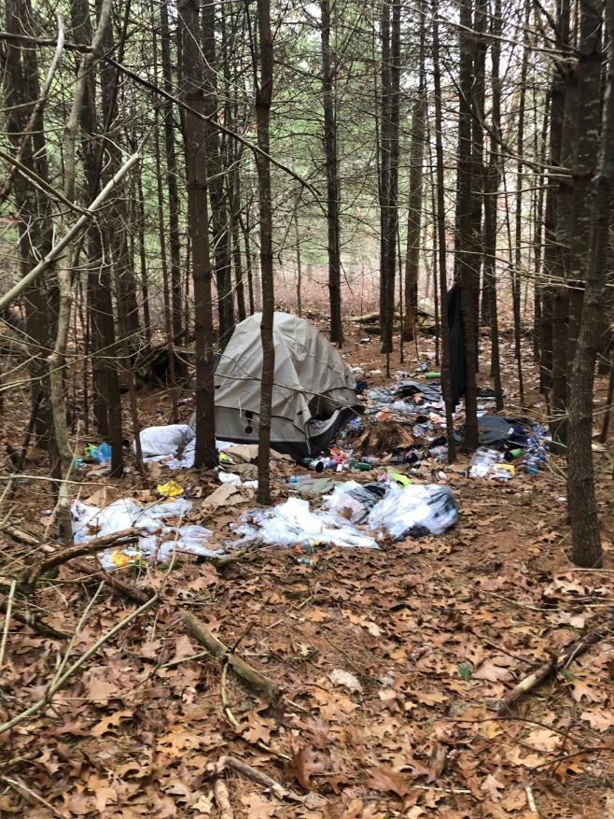

Photo: Camp in State Forest, Philippe Jordi

Appendix 1
Affordability Gaps for Homeownership as of September 2012/November 2020

Town | Median Household  Income* | Affordable Price** | Median House Price*** | Affordability Gap
Aquinnah | $57,500/$95,625 | $290,000/  $513,000 | $642,500/$1,675,000 | $352,500/  $1,162,000
Chilmark | $72,917/$96,471 | $385,000/  $557,000 | $825,000/$1,150,000 | $440,000/  $593,000
Edgartown | $67,625/$78,902 | $347,000/  $451,000 | $653,388/$1,550,000 | $306,388/  $1,099,000
Oak Bluffs | $59,156/$75,294 | $280,000/  $400,000 | $374,000/$1,051,000 | $94,000/  $651,000
Tisbury | $58,551/$51,456 | $275,000/  $264,000 | $430,000/$895,000 | $155,000/  $631,000
W. Tisbury | $71,667/$95,351 | $360,000/  $518,500 | $704,000/$1,300,000 | $344,000/  $781,500
County | $62,407/$71,811 | $310,000/  $391,500 | $535,000/$1,173,000 | $225,000/  $781,500
Source: Calculations provided by Karen Sunnarborg.
* Based on US Census Bureau estimates from its American Community Survey, 2008-2010, for Dukes County and 2006-2010 for the six towns and 2015-2019 5-year estimates for county and six towns.
** For 2012, figures based on interest of 5.0%, 30-year term, annual property tax rate of $5.36 per thousand for Dukes County (this is based on an average of the tax rates for all six towns, weighted by the number of housing units) and the actual tax rates for each town ($3.93 for Aquinnah, $2.08 for Chilmark, $3.43 for Edgartown,
$7.39 for Oak Bluffs, $8.01 for Tisbury, and $4.92 for West Tisbury), insurance costs of $1.25 per $1,000 of combined valuation of dwelling value (value x 0.5), personal property ($100,000 fixed), and personal liability ($100,000 fixed), 80% financing, and spending 30% of income on housing costs. For 2020, based on an interest rate of 3.5%, 30-year term, insurance costs of $6 per thousand, and property tax rates of $6.81 for Aquinnah,
$2.86 for Chilmark, $3.35 for Edgartown, $7.44 for Oak Bluffs, $9.33 for Tisbury, and $6.07 for West Tisbury, also with owners spending 30% of income on housing costs. Annual property tax rate of $5.93 per thousand for Dukes County (this is based on an average of the tax rates for all six towns, weighted by the number of housing units).
*** Based on the Warren Group/Banker & Tradesman Town Stats figures of October 16, 2012 and December 23, 2020.

The chart below shows the difference between the affordable purchase price, based on the median household income for the town or county (based on 2019 census estimates), and the median single- family house price (from Banker & Tradesman as of November 2020), traditionally referred to as the affordability gap. Another chart of the affordability gaps is included on page 30, showing the widening gaps since 2012.

$1,800,000
$1,600,000
$1,400,000
$1,200,000
$1,000,000
$800,000
$600,000
$400,000
$200,000
$0
Affordability Gaps
$1,675,000
$1,550,000
$1,300,000
$1,150,000
$1,173,000
$1,051,000
$895,000
$513,000
$557,000
$451,000
$518,500
$400,000
$391,500
$264,000
Aquinnah Chilmark Edgartown Oak Bluffs Tisbury W. Tisbury County
Affordable Price Based on Median Income
Median House Price

Appendix 2
Subsidized Housing Inventory by Town As of August 14, 2020

Aquinnah’s Subsidized Housing Inventory (SHI)
Project Name | #  Year-  Round  Units | # SHI  Units | Project Type/ Subsidizing Agency | Use of a Comp Permit | Affordability Expiration Date
Tribal Housing |  | 18 | Rental/HUD | Yes | 2048
Tribal Housing |  | 6 | Rental/HUD | Yes | 2049
Mutual Housing |  | 7 | Rental/HUD | Yes | 2051
Tribal Housing |  | 2 | Rental/HUD | Yes | 2054
Total | 158 | 33/20.9% | All SHI were rentals
Source: Massachusetts Department of Housing and Community Development, August 14, 2020 Lost 8 units from 2012 as part of the Housing Rehab Program

Chilmark’s Subsidized Housing Inventory (SHI) by Town
Project Name | #  Year-  Round  Units | # SHI  Units | Project Type/ Subsidizing Agency | Use of a Comp Permit | Affordability Expiration Date
Total | 418 | 0/0.0%
Source: Massachusetts Department of Housing and Community Development, August 14, 2020
* Dukes County Regional Housing Authority units
Down from 3 in 2012 from the Housing Rehab Program.

Edgartown’s Subsidized Housing Inventory (SHI)
Project Name | #  Year-  Round  Units | # SHI  Units | Project Type/ Subsidizing Agency | Use of a Comp Permit | Affordability Expiration Date
Fisher Road  Apartments* |  | 8 | Rental/DHCD & MHP | No | 2027
Pennywise Path/ Morgan Woods |  | 60 | Rental/DHCD & MassHousing | Yes | 2057
High and Pease Point |  | 2 | Ownership/MassHousing | Yes | Perpetuity
Fair Way Village |  | 3 | Ownership/MassHousing | Yes | Perpetuity
Jenney Way (not on  SHI) |  | (3)
N. Summer St. (not on  SHI) |  | (2)
Total | 1,972 | 73/3.72% | 68 or 93% were rentals
Source: Massachusetts Department of Housing and Community Development, August 14, 2020
* Dukes County Regional Housing Authority units Down 16 units from 2012 due to Housing Rehab Programs.

Gosnold’s Subsidized Housing Inventory (SHI)
Project Name | #  Year-  Round  Units | # SHI  Units | Project Type/ Subsidizing Agency | Use of a Comp Permit | Affordability Expiration Date
Total | 41 | 0/0.0%
Source: Massachusetts Department of Housing and Community Development, August 14, 2020

Oak Bluff’s Subsidized Housing Inventory (SHI)
Project Name | #  Year-  Round  Units | # SHI  Units | Project Type/ Subsidizing Agency | Use of 40B | Affordability Expiration Date
Lagoon Heights* |  | 8 | Rental –SRO’s/DHCD | No | Perpetuity
Woodside Village I** |  | 45 | Rental/HUD | No | 2034
Woodside Village II** |  | 18 | Rental/HUD | Yes | 2041
Woodside Village III** |  | 9 | Rental/HUD | Yes | 2042
Aidyberg I** |  | 5 | Rental/HUD | Yes | Perpetuity
Aidyberg II** |  | 5 | Rental/HUD & DHCD | Yes | Perpetuity
Woodside Village IV** |  | 9 | Rental/HUD | Yes | Perpetuity
Woodside Village V** |  | 5 | Rental/HUD | Yes | Perpetuity
Woodside Village VI** |  | 9 | Rental/HUD & DHCD | Yes | Perpetuity
Twin Oaks |  | 1 | Ownership/DHCD | Yes | Perpetuity
Noyes Building* |  | 3 | Rental/DHCD | No | Perpetuity
Total | 2,138 | 117/5.47% | 116 or 99% were rentals
Source: Massachusetts Department of Housing and Community Development, August 14, 2020
- Dukes County Regional Housing Authority units
** Island Elderly Housing units for seniors and individuals with disabilities
Down 29 units since 2012 due to Housing Rehab Program and loss of group home units.

Tisbury’s Subsidized Housing Inventory (SHI)
Project Name | #  Year-  Round  Units | # SHI  Units | Project Type/ Subsidizing Agency | Use of a Comp Permit | Affordability Expiration Date
Greenough House* |  | 6 | Rental/DHCD | No | Perpetuity
Hillside Village** |  | 40 | Rental/RHS | No | 2025
Rectory* |  | 3 | Rental/DHCD | No | 2017
Vineyard Village* |  | 12 | Rental/DHCD | No | 2029
Hillside Village II** |  | 10 | Rental/HUD | Yes | 2030
Hillside Village III** |  | 5 | Rental/DHCD & HUD | Yes | 2035
Love Housing Apts.** |  | 5 | Rental/HUD | Yes | 2042
Fairwinds |  | 3 | Ownership/FHLBB &  MassHousing | Yes | Perpetuity
Kelsey Project |  | 1 | Ownership/DHCD | Yes | 2104
Habitat for Humanity/ |  | 1 | Ownership/DHCD | Yes | 2106
Andrews Road
Lamberts Cove Road |  | 1 | Ownership/DHCD | Yes | Perpetuity
DMH Group Homes |  | 8 | Rental/DMH | No | NA
Lake Street* |  | 2 | Rental/DHCD | Yes | 2110
118 Franklin Street*  (not on SHI) |  | (9) | Rental
Lagoon Pond* (not on  SHI) |  | (4) | Rental
Water Street |  | 6 | Rental/DHCD | Yes | Perpetuity
Greenwood Avenue |  | 2 | Ownership/DHCD | No | Perpetuity
Total | 1,965 | 105/5.34% | 97 or 92% were rentals
Source: Massachusetts Department of Housing and Community Development, August 14, 2020
- Dukes County Regional Housing Authority units
** Island Elderly Housing units for seniors and individuals with disabilities
Net loss of 4 units with 22 units lost due to the Housing Rehab Program and 2 units previously counted as part of Lake Street. A gain of 16 units as part of 8 DMH group home units, 6 units at Water Street, and 2 units at Greenwood Avenue.

West Tisbury’s Subsidized Housing Inventory (SHI)
Project Name | #  Year-  Round  Units | # SHI  Units | Project Type/ Subsidizing Agency | Use of a Comp Permit | Affordability Expiration Date
West Tisbury
Sepiessa Rental  Housing* |  | 4 | Ownership/DHCD | Yes | Perpetuity
Island Cohousing |  | 4 | Ownership/FHLBB | Yes | Perpetuity
Halcyon Way Apts.* |  | 2 | Rental/MassHousing | Yes | 2101
Shovelhead Realty  Trust |  | 1 | Ownership/FHLBB | Yes | Perpetuity
Total | 1,253 | 11/0.88% | 2 or 18% were rentals
Source: Massachusetts Department of Housing and Community Development, August 14, 2020
- Dukes County Regional Housing Authority units
Down 12 units from 2012 due to Housing Rehab Program.

Appendix 3
DCRHA Rental Waitlist and 2020 Income Limits

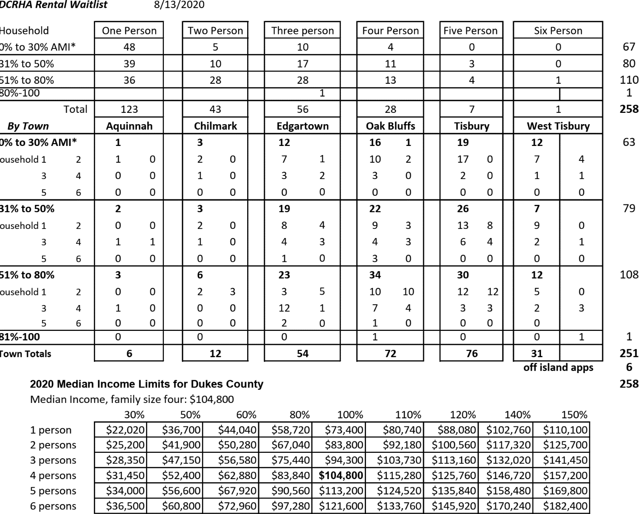

Appendix 4
Martha’s Vineyard Coastal Ponds Summary Matrices

Martha's Vineyard Coastal Pond- Status Report Watershed and Land Use
System | Pond/ Watershed |  |  | Land Use |  |  |  | total houses
System | Pond Area  (acres) | Watershed  Area | Towns contributing to  Watershed | Current Houses  (at time of |  | Projected  Houses (at
Cape Poge | 1560 | 816 | Edgartown | 45 |  | 54 |  | 99
Chilmark Pond | 241 | 3137 | Chilmark | 452 |  | 228 |  | 680
Edgartown Great  Pond | 890 | 4505 | Edgartown West  Tisbury | 910 |  | 1059 |  | 1969
Farm Pond | 42 | 402 | Oak Bluffs | 213 |  | 37 |  | 250
James Pond | 40 | 400 | West Tisbury | 63 |  | 61 |  | 124
Katama Bay | 1700 | 4500 | Edgartown | 1610 |  | 657 |  | 2267
Lagoon Pond | 573 | 3889 | Oak Bluffs Tisbury  West Tisbury | 2089 |  | 1011 |  | 3100
Menemsha Pond | 670 | 1840 | Aquinnah Chilmark | 392 |  | 165 |  | 557
Oak Bluffs Harbor | 36.3 | 382 | Oak Bluffs | 1069 |  | 165 |  | 1234
Oyster Pond | 200 | 2800 | Edgartown  West Tisbury | 137 |  | 209 |  | 346
Pocha Pond | 115 | 900 | Edgartown | 139 |  | 68 |  | 207
Sengekontacket Pond | 716 | 4440 | Edgartown Oak  Bluffs West Tisbury | 1628 |  | 554 |  | 2182
Squibnocket Pond | 600 | 1229 | Aquinnah Chilmark | 85 |  | 211 |  | 296
Tashmoo Pond | 269 | 2658 | Oak Bluffs  Tisbury West Tisbury | 762 |  | 494 |  | 1256
Tisbury Great Pond | 845 | 11102 | Chilmark West  Tisbury | 1101 |  | 689 |  | 1790
current houses- number of houses in the watershed presently, determined from aerial photograph interpretation,Mass GIS included all structures over 400 sq ft, MVC data only included buildings assumed to be primary structures.
projected houses at buildout- estimated based on parcel's current use code, conservation status, pesence of wetlands, lot size relative to min. zoning, and presence of buildings
eel grass- indicator species, trends in distribution to assess habitat stability related to water quality
overall rating- Index measures the nutrient-related health of the pond it is the sum of five health indicators: nitrogen (organic and inorganic), dissolved oxygen, algal pigments, and water clarity
nitrogen load limit- nitrogen level at which pond can maintain eelgrass or healthy benthic habitat. Taken from MEP if available, estimated by MVC using Buzzard's Bay index if MEP not available
nitrogen current- the present nitrogen load taken from MEP if available, estimated by MVC using Buzzard's Bay index if MEP not available
Nitrogen projected- nitrogen load projected to be added by additional buildout
load reduction- amount of nitrogen needed to be reduced to return pond to healthy state and meet water quality standards
TMDL- (Total Maximum Daily Load) the maximum amount of a pollutant that a body of water can receive while still meeting water quality standards

Martha's Vineyard Coastal Pond Status Report MEP Status
System | Mass Estuaries Project
System | Status * |  |  |  | Year MEP | Key Data |  |  |  | Remediation efforts
System | 1 | 2 | 3 | 4 | completed | TMDL  (kg/day) | TMDL  (kg/yr) | TMDL  (lbs/day) | TMDL  (lbs/yr) | Remediation efforts
Cape Poge |  |  |  |  |  |  |  |  |  | shellfish aquaculture
Chilmark Pond |  |  |  |  | Apr-15 | 15.50 | 5657.50 | 34.14 | 12461.45
Edgartown Great Pond |  |  |  |  | Dec-08 | 46.06 | 16812.63 | 101.46 | 37032.22 | upgraded sewage treatment plant, some residences in watershed connected to sewer shellfish aquaculture regularly scheduled  inlet openings
Farm Pond |  |  |  |  | Nov-10 | 4.13 | 1508.55 | 9.10 | 3322.79 | plans underway to replace culvert to  improve flushing
James Pond
Katama Bay |  |  |  |  |  |  |  |  |  | shellfish aquaculture
Lagoon Pond |  |  |  |  | Jun-10 | 74.07 | 27034.09 | 163.14 | 59546.45 | shellfish aquaculture goose egg addling
Menemsha Pond |  |  |  |  | Jun-17
Oak Bluffs Harbor |  |  |  |  | May-13 | 22.63 | 8259.59 | 49.84 | 18192.92 | sewered downtown channel dredging
Oyster Pond
Pocha Pond |  |  |  |  |  |  |  |  |  | shellfish aquaculture
Sengekontacket Pond |  |  |  |  | Jan-11 | 34.56 | 12612.58 | 76.11 | 27781.00 | shellfish aquaculture
Squibnocket Pond |  |  |  |  | Jun-17
Tashmoo Pond |  |  |  |  | Feb-15 | 35.55 | 12975.75 | 78.30 | 28580.95 | regular inlet dredging proposed sewer expanasion BOH regulations requiring I/A systems in new  development, upgrades
Tisbury Great Pond |  |  |  |  | May-13 | 62.78 | 22916.16 | 138.29 | 50476.12 | shellfish aquaculture regular pond openings
TMDL- (Total Maximum Daily Load) the maximum amount of a pollutant that a body of water can receive while still meeting water quality standards
*status key 1 preliminary data collected
- report in progress
- draft report

4 | final report completed
MEP completed

Martha’s Vineyard Commission (MVC), Island Plan: Charting the Future of the Vineyard, December 2009, page 8-1.
These rent levels include $700 for a room, $900 for a room and bath, $1,700 for a studio, $1,800 for a 1-bedroom unit, $2,150 for a 2-bedroom unit, $2,460 for a 3-bedroom, and $2,730 for a 4-bedroom unit.
These rental subsidies include 60 from DCRHA’s Rental Assistance Program, 6 project-based Section 8 subsidies for Morgan Woods, 8 Section 8 subsidies for DCRHA tenants, and 3 Massachusetts Rental Voucher Program (MRVP) subsidies in Island Housing Trust (IHT) rentals. The remaining rental subsidies are managed by HAC including 18 Section 8 Housing Choice Vouchers and 4? MRVPs.
U.S. Department of Housing and Urban Development (HUD) State of the Cities Comprehensive Housing Affordability Strategy (CHAS) based on special tabulations of census American Community Survey data for 2013- 2017 (latest report available).
This past summer 2020, J1 and H2B Visa restrictions placed more pressure on businesses.
Much of this data is from the Metropolitan Area Planning Council’s (MAPC) report entitled, “The COVID-19 Layoff Housing Gap, October Update: The Crisis Continues”, published October 5, 2020.
Undocumented workers are also not included in estimates because they are ineligible to receive either standard unemployment or PUA but it is likely that they have experienced greater impacts from COVID than the general labor force. Estimates also do not include workers who have been unable to access unemployment benefits for some reason, who have reduced hours and wages (but no unemployment benefits), and who are back on the job but do not earn enough to cover past rent and overdue bills.
Self-employed, contract, and seasonal workers are eligible to receive Pandemic Unemployment Assistance (PUA), which provides benefits comparable to standard unemployment, but only through the end of this calendar year, just recently extended. Detailed data is not available for PUA recipients, but based on cumulative claims since March, there are about 6 PUA recipients for every 10 standard unemployment claims. Given 1,307 unemployment claims for the Vineyard as of August 2020, this means almost 800 estimated PUA claims for the week ending September 5.
This Housing Needs Assessment includes the most up-to-date data available the most recent issue of the Census Bureau’s American Community Survey (ACS) data, either 2019 1-year estimates for the county and state and 5-year estimates for the towns. Because the ACS is based on sample data, it is subject to sampling error and variation. When other sources of data are used, the particular source will be identified.
Non-family households include individuals as well as unrelated household members.
Non-family households include single individuals and unrelated household members.
The 2020 federal poverty level from the U.S. Department of Health and Human Services was $12,760 for an individual and $21,720 for a three-person household.
Employment data is largely based on Massachusetts Department of Revenue and Executive Office of Labor and Workforce Development information.
Revenue data is based on Massachusetts Department of Revenue information.
The pond systems include Cape Poge (Edgartown), Chilmark Pond (Chilmark), Edgartown Great Pond (Edgartown and West Tisbury), Farm Pond (Oak Bluffs), James Pond (West Tisbury), Katama Bay (Edgartown), Lagoon Pond (Oak Bluffs, Tisbury and West Tisbury), Menemsha Pond (Aquinnah and Chilmark), Oak Bluffs Harbor (Oak Bluffs), Oyster Pond (Edgartown and West Tisbury), Pocha Pond (Edgartown), Sengetontacket Pond (Edgartown, Oak Bluffs and West Tisbury), Squibnocket Pond (Aquinnah and Chilmark), Tashmoo Pond (Oak Bluffs, Tisbury and West Tisbury), and Tisbury Great Pond (Chilmark and West Tisbury).
HUD Area Median Family Income (HAMFI or MFI) is the equivalent of AMI or area median income in this HUD report.
These rent levels include $700 for a room, $900 for a room and bath, $1,700 for a studio, $1,800 for a 1-bedroom units, $2,150 for a 2-bedroom, $2,460 for a 3-bedroom, and $23730 for a 4-bedroom unit.
These rental subsidies include 60 from DCRHA’s Rental Assistance Program, 6 project-based Section 8 subsidies for Morgan Woods, 8 Section 8 subsidies for DCRHA tenants, and 3 Massachusetts Rental Voucher Program (MRVP) subsidies in Island Housing Trust (IHT) rentals. The remaining rental subsidies are managed by HAC including 18 Section 8 Housing Choice Vouchers and 4? MRVPs.
Aquinnah does not have an Affordable Housing Trust Fund at this time.
Much of this data is from the Metropolitan Area Planning Council’s (MAPC) report entitled, “The COVID-19 Layoff Housing Gap, October Update: The Crisis Continues”, published October 5, 2020.
Undocumented workers are also not included in estimates because they are ineligible to receive either standard unemployment or PUA but it is likely that they have experienced greater impacts from COVID than the general labor force. Estimates also do not include workers who have been unable to access unemployment benefits for some reason, who have reduced hours and wages (but no unemployment benefits), and who are back on the job but do not earn enough to cover past rent and overdue bills.
Self-employed, contract, and seasonal workers are eligible to receive Pandemic Unemployment Assistance (PUA), which provides benefits comparable to standard unemployment, but only through the end of this calendar year, just recently extended. Detailed data is not available for PUA recipients, but based on cumulative claims since March, there are about 6 PUA recipients for every 10 standard unemployment claims. Given 1,307 unemployment claims for the Vineyard as of August 2020, this means almost 800 estimated PUA claims for the week ending September 5.
Martha’s Vineyard Commission (MVC), Island Plan: Charting the Future of the Vineyard, December 2009, page 8- 1.

