INDOOR AIR QUALITY ASSESSMENT

Neil A. Pepin School
4 Park Street
Easthampton, Massachusetts



Prepared by:
Massachusetts Department of Public Health
Bureau of Environmental Health
Indoor Air Quality Program
August 2011

Background/Introduction
In response to concerns regarding potential indoor air quality (IAQ) issues, the Massachusetts Department of Public Health (MDPH), Bureau of Environmental Health (BEH) conducted an indoor air quality (IAQ) assessment at the Neil A. Pepin School (NPS) located at 4 Park Street, Easthampton, Massachusetts. On April 5, 2011, Lisa Hébert, Environmental Analyst/Regional Inspector of BEH’s IAQ Program visited the school to conduct the assessment. On April 19, 2011, Ms. Hébert returned to complete the assessment.
The NPS is a two-story, grey brick building with an occupied basement. It was originally built in 1939 as a high school. Of note is the current attic/storage space in the building, which formerly served as a science lab. Windows throughout the building are openable.

Methods
Air tests for carbon monoxide, carbon dioxide, temperature and relative humidity were conducted with the TSI, Q-Trak, IAQ Monitor, Model 7565. Air tests for airborne particle matter with a diameter less than 2.5 micrometers were taken with the TSI, DUSTTRAK™ Aerosol Monitor Model 8520. BEH staff also performed visual inspection of building materials for water damage and/or microbial growth.

Results
The school houses approximately 220 students in grades K through four. Tests were taken during normal school operations on April 5, 2011, results appear in Table 1.

Discussion

Ventilation
It can be seen from Table 1 that carbon dioxide levels were below 800 parts per million (ppm) in 26 of 31 areas surveyed indicating adequate air exchange throughout most of the building. It is important to note that several classrooms were empty or sparsely populated, which can greatly contribute to reduced carbon dioxide levels. Carbon dioxide levels would be expected to increase with higher occupancy.
Fresh air in classrooms is supplied by unit ventilator (univent) systems (Picture 1). A univent draws air from outdoors through a fresh air intake located on the exterior wall of the building (Picture 2) and returns air through an air intake located at the base of the unit (Figure 1). Fresh and return air are mixed, filtered (Picture 3), heated and provided to classrooms through an air diffuser located in the top of the unit. In several classrooms, items were seen on and/or in front of univents obstructing airflow (Picture 4). In order for univents to provide fresh air as designed, air diffusers, intakes and return vents must remain free of obstructions. Importantly, these units must remain “on” and be allowed to operate while rooms are occupied.
Air is exhausted to the roof by means of ducted, ceiling-mounted exhaust vents. Some exhaust vents were partially obstructed reportedly by a product called “plastic bubbles.” These bubbles were reportedly that were made in the classroom, and floated to the exhaust vent, where they have settled and hardened (Picture 5).

Gymnasium
Fresh air is introduced into the gymnasium by means of two ceiling-mounted air handling units (AHUs) (Picture 6). The gymnasium floor is located at the lowest point of the building, approximately two feet above a crawlspace. Air is exhausted from the gym by means of approximately 20 floor-mounted exhaust vents (Picture 7). Air is pulled from the gym through these vents into the crawlspace and is exhausted outside of the building by means of a ducted mechanical exhaust. It was reported that at one time, the exhaust system for the gym/crawlspace operated continuously. However, in order to reduce operating costs, a humidistat was installed which measures the humidity in the crawlspace (Picture 8). If the humidity in the crawlspace exceeds 55%, the exhaust will begin to operate. When the exhaust is not operating, the gym lacks mechanical exhaust ventilation, with the exception of two large exhaust fans which were not in use at the time of the survey.
To maximize air exchange, the MDPH recommends that both supply and exhaust ventilation operate continuously during periods of occupancy. In order to have proper ventilation with a mechanical supply and exhaust system, the systems must be balanced to provide an adequate amount of fresh air to the interior of a room while removing stale air from the room. It is recommended that HVAC systems be re-balanced every five years to ensure adequate air systems function (SMACNA, 1994). The last time the system was balanced was unavailable at the time of the assessment.
The Massachusetts Building Code requires that each room have a minimum ventilation rate of 15 cubic feet per minute (cfm) per occupant of fresh outside air or openable windows (SBBRS, 1997; BOCA, 1993). The ventilation must be on at all times that the room is occupied. Providing adequate fresh air ventilation with open windows and maintaining the temperature in the comfort range during the cold weather season is impractical. Mechanical ventilation is usually required to provide adequate fresh air ventilation.
Carbon dioxide is not a problem in and of itself. It is used as an indicator of the adequacy of the fresh air ventilation. As carbon dioxide levels rise, it indicates that the ventilating system is malfunctioning or the design occupancy of the room is being exceeded. When this happens, a buildup of common indoor air pollutants can occur, leading to discomfort or health complaints. The Occupational Safety and Health Administration (OSHA) standard for carbon dioxide is 5,000 parts per million parts of air (ppm). Workers may be exposed to this level for 40 hours/week, based on a time-weighted average (OSHA, 1997).
The MDPH uses a guideline of 800 ppm for publicly occupied buildings. A guideline of 600 ppm or less is preferred in schools due to the fact that the majority of occupants are young and considered to be a more sensitive population in the evaluation of environmental health status. Inadequate ventilation and/or elevated temperatures are major causes of complaints such as respiratory, eye, nose and throat irritation, lethargy and headaches. For more information concerning carbon dioxide, consult Appendix A.
Indoor temperatures ranged from 68º F to 74º F, which were within the MDPH recommended comfort range in all but two areas surveyed the day of the assessment (Table 1). The MDPH recommends that indoor air temperatures be maintained in a range of 70º F to 78º F in order to provide for the comfort of building occupants. In many cases concerning indoor air quality, fluctuations of temperature in occupied spaces are typically experienced, even in a building with an adequate fresh air supply.
The relative humidity measured in the building ranged from 32 to 61 percent, which was below the MDPH recommended comfort range in the majority of areas surveyed during the assessment (Table 1). The MDPH recommends a comfort range of 40 to 60 percent for indoor air relative humidity. Relative humidity levels in the building would be expected to drop during the winter months due to heating. The sensation of dryness and irritation is common in a low relative humidity environment. Low relative humidity is a very common problem during the heating season in the northeast part of the United States.

Microbial/Moisture Concerns
Water damage was evident throughout the building. Standing water was observed in the crawlspace beneath the gymnasium floor. Numerous exhaust vents in this floor were opened and dust, hair and other organic debris was noted within (Pictures 9 and 10). When the crawlspace exhaust is not operating, the gym is open to the moisture in the crawlspace below.
The attic/storage area which had been formally utilized as a science lab was highly impacted by water infiltration (Pictures 11 through 14). Severe water damage and efflorescence was evident on the ceiling and walls which, in turn, resulted in chipping, peeling paint observed on the floor and on stored materials. Due to the age of the building, it is likely that this paint contains lead, and if so, must be managed/abated accordingly. The window sills and floor were wet to the touch due to heavy rains and some of the plaster walls were cracked and deteriorating. The floor boards were substantially buckled and plywood flooring had delaminated, likely due to prolonged exposure to moisture (Pictures 15 and 16). Numerous water-damaged, porous materials were also found stored in the attic (Picture 17).
It appears that at some point suspended ceilings were installed beneath the original ceiling tile system (Picture 18). Several classrooms had two layers of water-damaged ceiling tiles which can indicate sources of water penetration from either the building envelope or plumbing system (Picture 19). Water-damaged ceiling tiles can provide a source of mold and should be replaced after a water leak is discovered and repaired. In classroom 208, substantial water damage has occurred above the suspended ceiling adjacent to what appears to be a plumbing cleanout and along the wall below (Picture 20). If this is a plumbing cleanout that leaked, water damage should be considered as “black water” and thereby contaminated. Porous materials exposed to black water must be removed and disposed of. Possible mold colonization was noted on a small area of bubbled paint located above a wooden storage cabinet. Edges of ceiling tiles in this room were buckled as well, likely indicating prolonged exposure to moisture.
In addition, a sizable flood was reported to have occurred several years ago that affected several classrooms, the cafeteria/auditorium and the gymnasium. The flood was created by a broken hot water line in the boys’ rest room on the second floor. It was reported by staff that approximately 8,000 gallons of water was pumped from the crawlspace below the gym. Any porous materials (e.g., carpets, gypsum wallboard) exposed to clean flood water should have been dried within 24 to 48 hours of becoming wet. If this did not occur, it is likely mold has had the opportunity to colonize these materials.
BEH staff examined the exterior of the building to identify breaches in the building envelope and other issues that could provide a source of water penetration. Several potential sources were identified:
- Cracked, broken slate roofing;
- Gutters and downspouts in disrepair resulting in rain deposition on the sides of the building and on the ground adjacent to the foundation (Picture 21);
- Broken exterior windows;
- Deteriorated sections of upper wall and edge of trim under roof;
- Cracked and deteriorated brick and mortar (Picture 22);
- Cracks were evident in the concrete walkway and the tarmac adjacent to the building;
- A large gap between exterior doors (Picture 23);
- Crumbling concrete on stairs;
- Sealant at the base of stairs was not in good repair (Picture 24). Depending on its age, this sealant may contain regulated materials (e.g., asbestos, polychlorinated biphenyls or PCBs). If so, materials should be addressed in accordance with state and federal regulations/guidance. For guidance on addressing PCB-containing materials in schools, consult MDPH guidance (Appendix B). Information on regulatory compliance with asbestos and/or PCBs, in available from the US Environmental Protection Agency (US EPA), Massachusetts Department of Environmental Protection (MA DEP) and the Massachusetts Department of Occupational Safety (MA DOS);
- Sealant lacking between tarmac and stairway (Picture 25);
- Water appears to drain toward the building in some areas;
- Trees were impacting the side of the building and organic material from trees has accumulated on the ground and in some areas limiting drainage;
- Plants existed within the juncture of the foundation and the tarmac; and
- Vines are clinging to the side of the building, which holds moisture against the building foundation.
The aforementioned conditions represent potential water penetration sources. Over time, these conditions can undermine the integrity of the building envelope and provide a means of water entry into the building via capillary action through foundation concrete and masonry (Lstiburek & Brennan, 2001). The freezing and thawing action of water during the winter months can create cracks and fissures in the foundation. In addition, these breaches may provide a means for pests/rodents to enter the building.
The seam behind the sink in the teachers’ room was in disrepair, which can allow water to seep into the wall and cabinet below. Chronic moistening of porous materials can result in mold colonization. Water damage was also observed in the cabinet below the sink, on some classroom window shades, on vinyl wallpaper near main entrance, on shelving in the attic storage closet and on walls throughout building. Finally, efflorescence was observed on walls in the gym instructor’s office and locker room.
The US EPA and the American Conference of Governmental Industrial Hygienists (ACGIH) recommend that porous materials be dried with fans and heating within 24 to 48 hours of becoming wet (US EPA, 2001; ACGIH, 1989). If not dried within this time frame, mold growth may occur. Once mold has colonized porous materials, they are difficult to clean and should be removed and discarded.
Plants were noted in several classrooms. Plants can be a source of pollen and mold which can be respiratory irritants to some individuals. Plants should be properly maintained and equipped with drip pans and should be located away from univents to prevent the aerosolization of dirt, pollen and mold.

Other IAQ Evaluations
Indoor air quality can be negatively influenced by the presence of respiratory irritants, such as products of combustion. The process of combustion produces a number of pollutants. Common combustion emissions include carbon monoxide, carbon dioxide, water vapor, and smoke (fine airborne particle material). Of these materials, exposure to carbon monoxide and particulate matter with a diameter of 2.5 micrometers (μm) or less (PM2.5) can produce immediate, acute health effects upon exposure. To determine whether combustion products were present in the building environment, BEH staff obtained measurements for carbon monoxide and PM2.5.

Carbon Monoxide
Carbon monoxide is a by-product of incomplete combustion of organic matter (e.g., gasoline, wood and tobacco). Exposure to carbon monoxide can produce immediate and acute health effects. Several air quality standards have been established to address carbon monoxide and prevent symptoms from exposure to these substances. The MDPH established a corrective action level concerning carbon monoxide in ice skating rinks that use fossil-fueled ice resurfacing equipment. If an operator of an indoor ice rink measures a carbon monoxide level over 30 ppm, taken 20 minutes after resurfacing within a rink, that operator must take actions to reduce carbon monoxide levels (MDPH, 1997).
The American Society of Heating Refrigeration and Air-Conditioning Engineers (ASHRAE) has adopted the National Ambient Air Quality Standards (NAAQS) as one set of criteria for assessing indoor air quality and monitoring of fresh air introduced by HVAC systems (ASHRAE, 1989). The NAAQS are standards established by the US EPA to protect the public health from six criteria pollutants, including carbon monoxide and particulate matter (US EPA, 2006). As recommended by ASHRAE, pollutant levels of fresh air introduced to a building should not exceed the NAAQS levels (ASHRAE, 1989). The NAAQS were adopted by reference in the Building Officials & Code Administrators (BOCA) National Mechanical Code of 1993 (BOCA, 1993), which is now an HVAC standard included in the Massachusetts State Building Code (SBBRS, 1997). According to the NAAQS, carbon monoxide levels in outdoor air should not exceed 9 ppm in an eight-hour average (US EPA, 2006).
Carbon monoxide should not be present in a typical, indoor environment. If it is present, indoor carbon monoxide levels should be less than or equal to outdoor levels. Outdoor carbon monoxide concentrations ranged from non-detect (ND) to 1.2 ppm the day of the assessment (Table 1). This was likely due to the proximity of the school to heavy traffic observed on Route 10 the day of the assessment (Figure 2). No measureable levels of carbon monoxide were detected in the building during the assessment (Table 1).
While no carbon monoxide was measured in the building, conditions that would allow vehicle exhaust entrainment by univents existed. As can be seen in Picture 2, a truck was parked in close proximity to univent fresh air intakes. While the truck was not idling at the time of the assessment, steps should be taken to ensure motor vehicle idling does not occur near any fresh air intakes in the building to eliminate the possibility of the uptake of vehicle exhaust (called entrainment) by the fresh air intakes of the univents.

Particulate Matter
The US EPA has established NAAQS limits for exposure to particulate matter. Particulate matter is airborne solids that can be irritating to the eyes, nose and throat. The NAAQS originally established exposure limits to particulate matter with a diameter of 10 μm or less (PM10). According to the NAAQS, PM10 levels should not exceed 150 micrograms per cubic meter (μg/m³) in a 24-hour average (US EPA, 2006). These standards were adopted by both ASHRAE and BOCA. Since the issuance of the ASHRAE standard and BOCA Code, US EPA established a more protective standard for fine airborne particles. This more stringent PM2.5 standard requires outdoor air particle levels be maintained below 35 μg/m³ over a 24-hour average (US EPA, 2006). Although both the ASHRAE standard and BOCA Code adopted the PM10 standard for evaluating air quality, MDPH uses the more protective PM2.5 standard for evaluating airborne particulate matter concentrations in the indoor environment.
Outdoor PM2.5 concentrations were ND the day of the assessment (Table 1). PM2.5 levels measured indoors ranged from ND to 8 μg/m³ (Table 1), which were below the NAAQS PM2.5 level of 35 μg/m³. Frequently, indoor air levels of particulates (including PM2.5) can be at higher levels than those measured outdoors. A number of activities that occur indoors and/or mechanical devices can generate particulate during normal operations. Sources of indoor airborne particulates may include but are not limited to particles generated during the operation of fan belts in the HVAC system, use of stoves and/or microwave ovens in kitchen areas; use of photocopiers, fax machines and computer printing devices; operation of an ordinary vacuum cleaner and heavy foot traffic indoors.

Volatile Organic Compounds
Indoor air concentrations can be greatly impacted by the use of products containing volatile organic compounds (VOCs). VOCs are carbon-containing substances that have the ability to evaporate at room temperature. Frequently, exposure to low levels of total VOCs (TVOCs) may produce eye, nose, throat and/or respiratory irritation in some sensitive individuals. For example, chemicals evaporating from a paint can stored at room temperature would most likely contain VOCs. In an effort to identify materials that can potentially increase VOC concentrations, BEH staff examined classrooms for products that may contain these respiratory irritants.
Several classrooms contained dry erase boards and dry erase board markers. Materials such as permanent markers, dry erase markers and dry erase board cleaners may contain VOCs, such as methyl isobutyl ketone, n-butyl acetate and butyl-cellusolve (Sanford, 1999), which can be irritating to the eyes, nose and throat. Laminators and photocopiers were also observed. Lamination machines melt plastic and give off odors and VOCs. VOCs and ozone can be produced by photocopiers, particularly if the equipment is older and in frequent use. Ozone is a respiratory irritant (Schmidt Etkin, 1992).
Air fresheners and deodorizing materials were observed in a number of areas. Air deodorizers contain chemicals that can be irritating to the eyes, nose and throat of sensitive individuals. Many air fresheners contain 1,4-dichlorobenzene, a VOC which may cause reductions in lung function (NIH, 2006). Furthermore, deodorizing agents do not remove materials causing odors, but rather mask odors that may be present in the area. Additionally, a Material Safety Data Sheet (MSDS) should be available at a central location for all school chemicals in the event of an emergency.

Other Conditions
Other conditions that can affect indoor air quality were observed during the assessment. A pipe was observed in the attic storage area that may have once been the drain line for the laboratory sink (Picture 26). If still connected to the school’s drainage system, sewer gas could be entering the building through the uncapped pipe.
An electric kiln was observed in the boiler room. An exhaust to remove waste heat and contaminants from the kiln was not observed. Since kilns can be retrofitted with exhaust mechanisms, it should be given consideration. At the time of the assessment, the kiln was shut down for the remainder of the school year.
Upholstered furniture was noted in some classrooms. Upholstered furniture is covered with fabric that comes in contact with human skin. This type of contact can leave oils, perspiration, hair and skin cells behind. Dust mites feed upon human skin cells and excrete waste products that contain allergens. In addition, if relative humidity levels increase above 60 percent, dust mites tend to proliferate (US EPA, 1992). In order to remove dust mites and other pollutants, frequent vacuuming of upholstered furniture is recommended (Berry, M.A., 1994). It is also recommended that upholstered furniture (if present in schools), be professionally cleaned on an annual basis. If an excessively dusty environment exists due outdoor conditions or indoor activities (e.g., renovations), cleaning frequency should be increased (every six months) (IICRC, 2000).
In several classrooms, items were observed on floors, windowsills, tabletops, counters, bookcases and desks. In the attic, an enormous amount of materials is stored. The large number of items stored in these areas provides a source for dusts to accumulate. These items (e.g., papers, folders, boxes, costumes, old sets) make it difficult for custodial staff to clean. Items should be relocated and/or be cleaned periodically to avoid excessive dust build up. In addition, these materials can accumulate on flat surfaces (e.g., desktops, shelving and carpets) in occupied areas and subsequently be re-aerosolized causing further irritation.
Dust accumulation was noted on the interior of univents, as well as on exhaust vents and personal and ceiling fans. This equipment should be cleaned in order to prevent dust/debris from being aerosolized and redistributed throughout the room.
Large penetrations around utility pipes through walls and floors of univent cabinets were observed (Picture 27). Open utility holes can allow dusts, particulates, odors and vapors to move throughout the building. Measures to seal these breaches should be implemented.
Fluorescent light bulbs were stored in the attic in an area subject to damage. These bulbs contain and can release mercury when broken; therefore, they must be stored, utilized and disposed of with care and in accordance with Department of Environmental Protection guidelines. Three plastic recycle bins of what appear to be old light ballasts were observed in the attic (Picture 28). The visible units displayed stickers indicating that they did not contain PCBs. The status of all of these ballasts should be determined and the ballasts should be disposed of accordingly.

Conclusions/Recommendations
The conditions noted at the NPS raise a number of indoor air quality issues. The primary focus for the initial repairs should be to eliminate water infiltration into the building. In view of the findings at the time of the visit, the following recommendations are provided:
- Consider operating the gymnasium/crawlspace exhaust system during school hours to remove water vapor and associated odors from the gymnasium. Due to the standing water observed in the crawlspace below the gym floor, determine whether two separate ventilation systems, (one for the crawlspace and one for the gym) would be better suited for the gymnasium rather than opening the gymnasium up to the moisture in the crawlspace through the exhaust vents in the floor. If this is the case, consider sealing all penetrations in the gymnasium floor.
- Remedy all exterior building envelope conditions that contribute to water infiltration into the building, such as:
  - Repair roof leaks;
  - Repair downspout and gutter system and ensure rainwater is deposited as far away from the building as practicable;
  - Seal open penetrations into the building;
  - Repair or replace broken/leaking windows;
  - Repair cracked masonry and broken, missing mortar;
  - Seal gaps between exterior doors;
  - Seal cracks in sidewalks and tarmac and between tarmac and building components;
  - Repair crumbling concrete stairs;
  - Determine if sealant on stairs is composed of regulated materials, if so, consult DPH guidance regarding PCBs in schools and EPA regulations;
  - Remove plants/trees/vines from impacting the building; and
  - Ensure areas directly adjacent to the building slope to drain water away from the foundation.
- Repair all sources of water damage on the interior of the building.
- Prior to occupancy this fall, clean dust and organic debris from below crawlspace exhaust vents in the gym.
- Remove and dispose of water-damaged porous materials in attic and throughout the school.
- Dispose of any water-damaged cardboard boxes. Ensure documents stored within them have not been water-damaged or colonized by mold. Restore/replace records as necessary.
- Remediate all previously water-damaged porous materials in accordance with IICRC Standards and in accordance with EPA Guidelines for Mold Remediation in Schools and Commercial Buildings (IICRC, 1999; US EPA, 2001). Carpets and gypsum wallboard saturated for greater than 48 hours by the reported flooding should be removed/replaced. Any porous materials associated with black water should be removed in accordance with IICRC standards.
- Discontinue practice of painting water-damaged ceiling tiles and replace after the source of water damage is identified and remedied.
- Regularly clean the interior of univents (e.g., with regular filter changes).
- Seal utility penetrations through floor of univents and throughout the building.
- Remove obstructions from univents.
- Clean “plastic bubbles” from classroom exhaust vents. Discontinue use of plastic bubbles within the classroom.
- Operate all ventilation systems throughout the building (e.g., gym, cafeteria, classrooms) continuously during periods of occupancy independent of thermostat control to maximize air exchange.
- Use openable windows in conjunction with mechanical ventilation to facilitate air exchange. Care should be taken to ensure windows are properly closed at night and weekends to avoid the freezing of pipes and potential flooding.
- Consider adopting a balancing schedule of every 5 years for all mechanical ventilation systems, as recommended by ventilation industrial standards (SMACNA, 1994).
- For buildings in New England, periods of low relative humidity during the winter are often unavoidable. Therefore, scrupulous cleaning practices should be adopted to minimize common indoor air contaminants whose irritant effects can be enhanced when the relative humidity is low. To control dusts, a high efficiency particulate arrestance (HEPA) filter equipped vacuum cleaner in conjunction with wet wiping of all surfaces is recommended. Avoid the use of feather dusters. Drinking water during the day can help ease some symptoms associated with a dry environment (throat and sinus irritations).
- Consult a specialist in building construction to determine if water-damaged attic area is structurally sound. Make repairs as required.
- Determine if chipping, peeling paint contains lead and if so remove/abate lead paint from walls, floors and stored materials in accordance with applicable lead paint laws and regulations.
- Ensure attic windows are weathertight.
- Seal seam between counter and backsplash in teachers’ room.
- Ensure plants are equipped with drip pans. Examine drip pans periodically for mold growth and disinfect with an appropriate antimicrobial, as needed. Move plants away from fresh air supply sources.
- Ensure all cleaning products used at the facility should be approved by the school department with MSDS’ available at a central location.
- Refrain from using air fresheners or other air deodorizers.
- Consider opening a window and operating a fan in a manner that removes odors and waste heat when operating the laminators.
- Investigate abandoned pipe in attic storage area (Picture 26) and if connected to active drain line, properly cap or remove.
- To avoid entrainment of vehicle exhaust, consider posting signs adjacent to the building instructing vehicle operators to shut off engines as required by Massachusetts General Laws 90:16A.
- Store and dispose of fluorescent light bulbs in accordance with Massachusetts Department of Environmental Protection Guidelines.
- Determine whether old ballasts stored in attic contain regulated materials (e.g., PCBs) and if so, dispose in accordance with applicable regulations.
- Consider installing exhaust for the electric kiln.
- Frequently vacuum upholstered furniture and professionally clean on an annual basis.
- Relocate or consider reducing the amount of materials stored in attic and classrooms to allow for more thorough cleaning of classrooms. Clean items regularly with a wet cloth or sponge to prevent excessive dust build-up.
- Clean accumulated dust and debris periodically from exhaust vents and blades of personal and ceiling fans.
- Consider adopting the US EPA (2000) document, “Tools for Schools”, as an instrument for maintaining a good indoor air quality environment in the building. This document is available at: http://www.epa.gov/iaq/schools/index.html.
- Refer to resource manual and other related indoor air quality documents located on the MDPH’s website for further building-wide evaluations and advice on maintaining public buildings. These documents are available at: http://mass.gov/dph/iaq

References
ACGIH. 1989. Guidelines for the Assessment of Bioaerosols in the Indoor Environment. American Conference of Governmental Industrial Hygienists, Cincinnati, OH.
ASHRAE. 1989. Ventilation for Acceptable Indoor Air Quality. American Society of Heating, Refrigeration and Air Conditioning Engineers. ANSI/ASHRAE 62-1989.
ASHRAE. 1991. ASHRAE Applications Handbook, Chapter 33 “Owning and Operating Costs”. American Society of Heating, Refrigeration and Air Conditioning Engineers, Atlanta, GA.
Berry, M.A. 1994. Protecting the Built Environment: Cleaning for Health, Michael A. Berry, Chapel Hill, NC.
BOCA. 1993. The BOCA National Mechanical Code/1993. 8th ed. Building Officials and Code Administrators International, Inc., Country Club Hill, IL.
IICRC. 1999. IICRC S500. Standard and Reference Guide for Professional Water Damage Restoration, 2nd Edition, Institute of Inspection Cleaning and Restoration, Vancouver, WA.
IICRC. 2000. IICRC S001 Reference Guideline for Professional On-Location Cleaning of Textile Floor Covering Materials Institute of Inspection, Cleaning and Restoration Certification. Institute of Inspection Cleaning and Restoration, Vancouver, WA.
Lstiburek, J. & Brennan, T. 2001. Read This Before You Design, Build or Renovate. Building Science Corporation, Westford, MA. U.S. Department of Housing and Urban Development, Region I, Boston, MA
MDPH. 1997. Requirements to Maintain Air Quality in Indoor Skating Rinks (State Sanitary Code, Chapter XI). 105 CMR 675.000. Massachusetts Department of Public Health, Boston, MA.
NIH. 2006. Chemical in Many Air Fresheners May Reduce Lung Function (#06-11). National Institutes of Health, Research Triangle Park, NC.
OSHA. 1997. Limits for Air Contaminants. Occupational Safety and Health Administration. Code of Federal Regulations. 29 C.F.R 1910.1000 Table Z-1-A.
Sanford. 1999. Material Safety Data Sheet (MSDS No: 198-17). Expo® Dry Erase Markers Bullet, Chisel, and Ultra Fine Tip. Sanford Corporation. Bellwood, IL.
SBBRS. 1997. Mechanical Ventilation. State Board of Building Regulations and Standards. Code of Massachusetts Regulations. 780 CMR 1209.0
Schmidt Etkin, D. 1992. Office Furnishings/Equipment & IAQ Health Impacts, Prevention & Mitigation. Cutter Information Corporation, Indoor Air Quality Update, Arlington, MA.
SMACNA. 1994. HVAC Systems Commissioning Manual. 1st ed. Sheet Metal and Air Conditioning Contractors’ National Association, Inc., Chantilly, VA.
US EPA. 1992. Indoor Biological Pollutants. US Environmental Protection Agency, Environmental Criteria and Assessment Office, Office of Health and Environmental Assessment, research Triangle Park, NC. EPA 600/8-91/202 January 1992.
US EPA. 2000. Tools for Schools. Office of Air and Radiation, Office of Radiation and Indoor Air, Indoor Environments Division (6609J). EPA 402-K-95-001, Second Edition. http://www.epa.gov/iaq/schools/tools4s2.html.
US EPA. 2001. “Mold Remediation in Schools and Commercial Buildings”. Office of Air and Radiation, Indoor Environments Division, Washington, DC. EPA 402-K-01-001. March 2001. Available at: http://www.epa.gov/iaq/molds/mold_remediation.html
US EPA. 2006. National Ambient Air Quality Standards (NAAQS). US Environmental Protection Agency, Office of Air Quality Planning and Standards, Washington, DC. http://www.epa.gov/air/criteria.html.
Figure 2
Location of Neil A. Pepin School, 4 Park Street, Northampton, MA

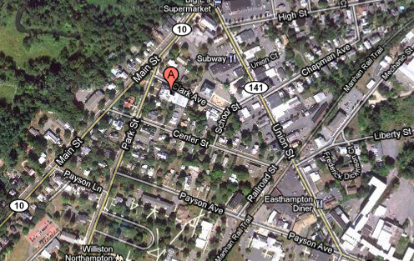
Picture 1

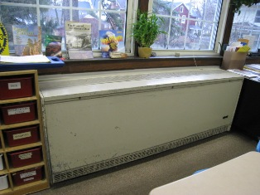

Unit Ventilator (univent)

Picture 2

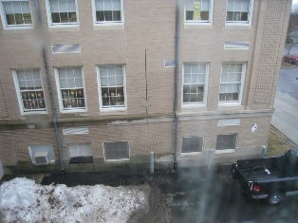

Univent Fresh Air Intakes (Arrows)
Note Truck beneath Fresh Air Intake
Picture 3

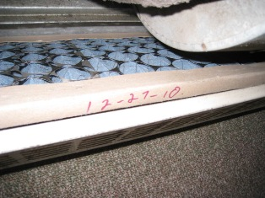

Univent Filter

Picture 4

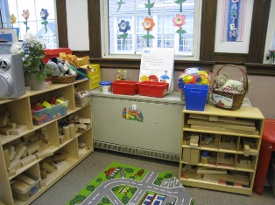

Univent Obstructed by Furniture and Classroom Materials

Picture 5

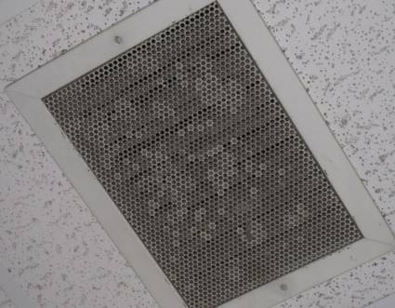

Exhaust Vent Partially Obstructed by Dried “Plastic Bubbles”

Picture 6

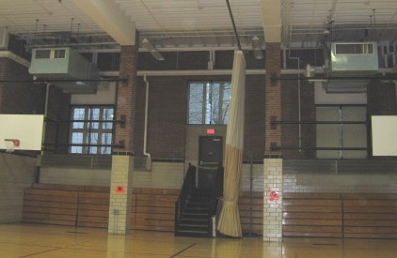

Ceiling-Mounted AHUs in Gym (Arrows)

Picture 7

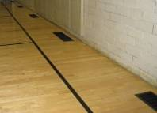

Exhaust Vents in Gymnasium Floor

Picture 8

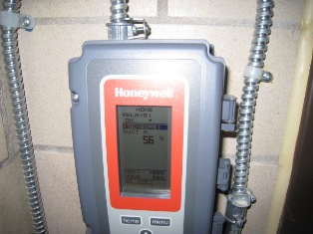

Control Panel to Monitor Crawlspace Humidity

Picture 9

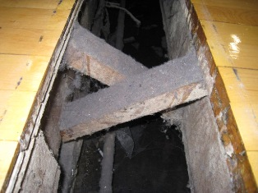

Standing Water in Crawlspace below Gym Floor Exhaust Vents
Picture 10

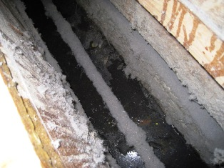

Standing Water and Heavy Dust Accumulation in
Crawlspace below Gym Floor

Picture 11

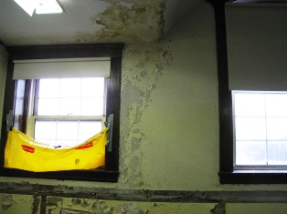

Water-Damaged Ceiling and Walls in Attic
Note Peeling Paint
Picture 12

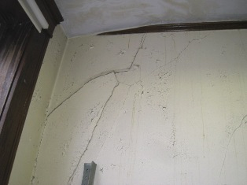

Water-Damaged, Cracked Plaster Walls in Attic

Picture 13

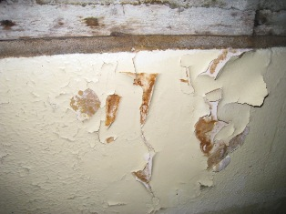

Peeling Paint and Efflorescence in Attic

Picture 14

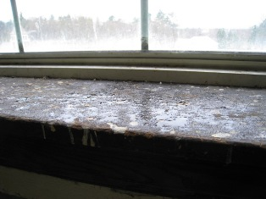

Water Infiltration on Interior Window Sill in Attic

Picture 15

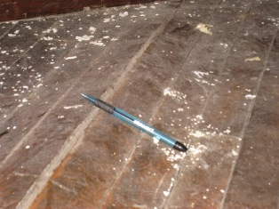

Buckled Wooden Floor in Attic

Picture 16

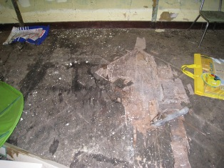

Water-Damaged, Delaminating Plywood in Attic

Picture 17

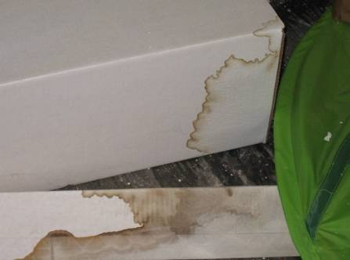

Water-Damaged Porous Materials Stored in Attic

Picture 18

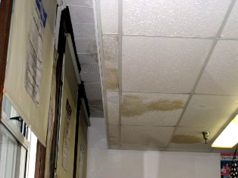

Two Layers of Water-Damaged Ceiling Tiles

Picture 19

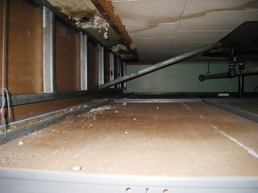

Substantially Water-Damaged Original Ceiling Tiles
Note Water Damage on Suspended Ceiling Tile below (Arrows)
Picture 20

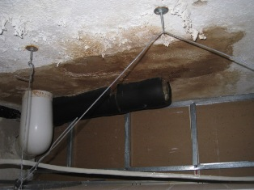

Water Damage above Ceiling in Room 208

Picture 21

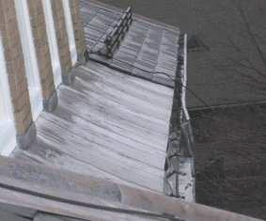

Damaged Portion of Gutter System

Picture 22

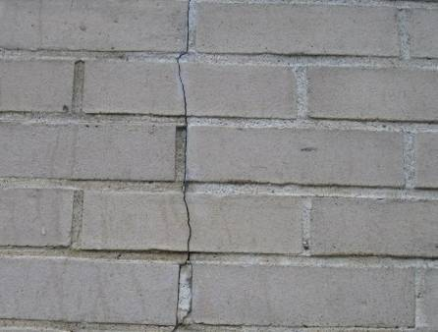

Cracked Masonry and Mortar

Picture 23

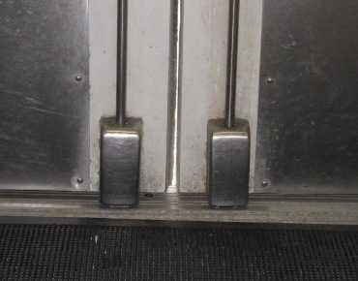

Gap between Exterior Doors

Picture 24

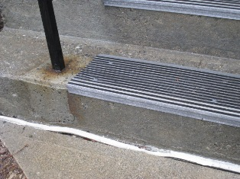

Sealant in Disrepair at Base of Stairs

Picture 25

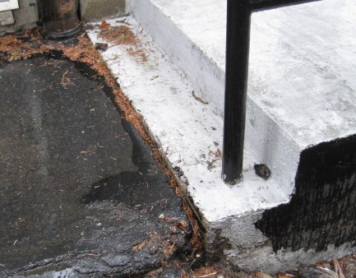

Sealant Lacking between Stairs and Tarmac
Note Gym Instructor’s Office is Directly below Stairs

Picture 26

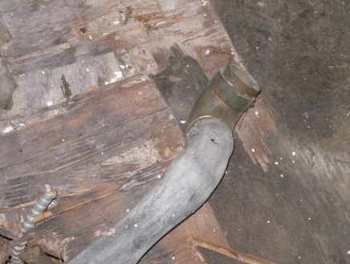

Open Drain in Old Science Lab
Picture 27

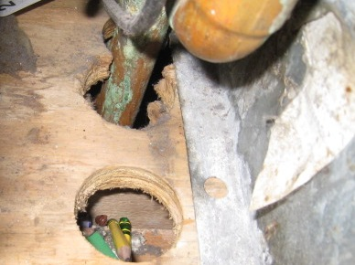

Utility Holes at Base of Univent

Picture 28

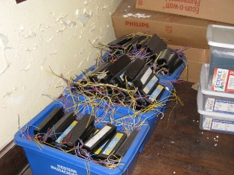

Old Light Ballasts
Location | Carbon  Dioxide  (ppm) | Carbon Monoxide  (ppm) | Temp  (°F) | Relative  Humidity  (%) | PM2.5  (µg/m3) | Occupants  in Room | Windows  Openable | Ventilation |  | Remarks
 |  |  |  |  |  |  |  | Supply | Exhaust | Remarks
Background | 300 | ND-1.2 | 72 | 53 | ND |  |  |  |  | Rain, heavy traffic on street adjacent to school
Main Office | 501 | ND | 73 | 32 | 5 | 1 | Y | Y | Y | DO, plants, cracks in plaster walls, copier
Adj. Counselor | 383 | ND | 69 | 52 | 4 | 0 | Y | Y | Y | DO
Behavioral Support | 489 | ND | 70 | 48 | 8 | 2 | Y | Y | Y | DO, cracked plaster wall
Elevator Room | 759 | ND | 71 | 41 | 7 | 5 | Y | N | N | DO, WD CT, CD
Cafeteria/  Auditorium | 763 | ND | 73 | 44 | 8 | ~200 | Y | Y | Y | DEM, CF
Girls’ Room |  |  |  |  |  |  | N | N | Y
Kitchen | 829 | ND | 74 | 36 | 3 | 0 | Y | N | Y | WD CTs, efflorescence on walls, exhausts obstructed
Library | 623 | ND | 71 | 33 | 5 | 19 | Y | Y | Y | WD CTs, carpeted
Library (upper level) | 530 | ND | 71 | 33 | 5 | 0 | N | N | Y | Copier, 2 laminators
Girls’ Restroom |  |  |  |  |  |  | Y | N | Y
Women’s Locker Room | 794 | ND | 72 | 35 | 4 | 0 | Y | Y | Y
Gym | 605 | ND | 72 | 36 | 3 | 18 | Y | Y | Y
Men’s Room |  |  |  |  |  |  | Y | N | Y
102 | 321 | ND | 68 | 61 | 7 | 0 | Y | Y | Y | DO, AC
105 (Teachers’) | 455 | ND | 70 | 37 | 1 | 6 | Y | Y | Y | Plants on univent and on carpet
106 | 622 | ND | 71 | 38 | 3 | 10 | Y | Y | Y | DO, FC, univent obstructed, peeling paint
107 | 645 | ND | 71 | 37 | 1 | 16 | Y | Y | Y | DO, DEM, univent partially obstructed
108 | 437 | ND | 71 | 38 | 3 | 2 | N | Y | Y | DO
109 | 466 | ND | 72 | 35 | ND | 1 | Y | Y | Y | PF, WD wall
110 (nurse lobby) | 563 | ND | 72 | 35 | 2 | 0 | N | Y | Y | DO
110 (nurse bathroom) | 505 | ND | 72 | 36 | 2 | 0 | N | N | Y | DO
110 | 519 | ND | 73 | 32 | 2 | 1 | Y | Y | N | DO, WD CT
111 | 559 | ND | 73 | 32 | 1 | 3 | Y | Y | Y | Plants
112 | 564 | ND | 73 | 42 | 6 | 23 | Y | Y | Y | DO
113 | 583 | ND | 73 | 41 | 8 | 24 | Y | Y | Y | DO, aqua
200 | 648 | ND | 72 | 39 | 8 | 22 | Y | Y | Y | DO, WD CT, plumbing leak
201 | 451 | ND | 71 | 35 | 3 | 4 | Y | Y | Y | DO
202 | 687 | ND | 73 | 35 | 4 | 20 | Y | Y | Y | DO, DEM, numerous WD CTs, WD on univent
203 | 705 | ND | 73 | 35 | 1 | 25 | Y | Y | Y | DO, CD
204 | 993 | ND | 74 | 36 | 6 | 25 | Y | Y | Y | DO, DEM,UF, WD CTs
205 | 961 | ND | 72 | 40 | 6 | 14 | Y | Y | Y | DEM, PF
205 | 1150 | ND | 74 | 35 | 2 | 19 | Y | Y | Y | DEM, WD ceiling
207 (Music) | 769 | ND | 70 | 41 | 2 | 1 | Y | Y | Y | WD CTs
208 | 1051 | ND | 74 | 36 | 4 | 16 | Y | Y | Y | PF, WD plaster, “plastic bubbles” partially obstructing exhaust vent

An Information Booklet Addressing PCB-Containing Materials in the Indoor Environment of Schools
and Other Public Buildings



Prepared by

Bureau of Environmental Health
Massachusetts Department of Public Health
December 2009
INTRODUCTION
The purpose of this information booklet is to provide assistance to school and public building officials and the general public in assessing potential health concerns associated with polychlorinated biphenyl (PCB) compounds in building materials used in Massachusetts and elsewhere. Recently, the U.S. Environmental Protection Agency (EPA) provided broad guidance relative to the presence of PCBs in building materials, notably PCBs in caulking materials. The most common building materials that may contain PCBs in facilities constructed or significantly renovated during the 1950s through the 1970s are fluorescent light ballasts, caulking, and mastic used in tile/carpet as well as other adhesives and paints.
This information booklet, developed by the Massachusetts Department of Public Health’s Bureau of Environmental Health (MDPH/BEH), is designed to supplement guidance offered by EPA relative to potential health impacts and environmental testing. It also addresses managing building materials, such as light ballasts and caulking, containing PCBs that are likely to be present in many schools and public buildings across the Commonwealth. This is because the Northeastern part of the country, and notably Massachusetts, has a higher proportion of schools and public buildings built during the 1950s through 1970s than many other parts of the U.S. according to a 2002 U.S. General Accounting Office report. The Massachusetts School Building Authority noted in a 2006 report that 53 percent of over 1,800 Massachusetts school buildings surveyed were built during the 1950s through 1970s. This information booklet contains important questions and answers relative to PCBs in the indoor environment and is based on the available scientific literature and MDPH/BEH’s experience evaluating the indoor environment of schools and public buildings for a range of variables, including for PCBs as well as environmental data reviewed from a variety of sources.
1. What are PCBs?
Polychlorinated biphenyl (PCB) compounds are stable organic chemicals used in products from the 1930s through the late 1970s. Their popularity and wide-spread use were related to several factors, including desirable features such as non-flammability and electrical insulating properties. Although the original use of PCBs was exclusive to closed system electrical applications for transformers and capacitors (e.g., fluorescent light ballasts), their use in other applications, such as using PCB oils to control road dust or caulking in buildings, began in the 1950s.
2. When were PCBs banned from production?
Pursuant to the Toxic Substance Control Act (TSCA) of 1976 (effective in 1979), manufacturing, processing, and distribution of PCBs was banned. While the ban prevented production of PCB-containing products, it did not prohibit the use of products already manufactured that contained PCBs, such as building materials or electrical transformers.
3. Are PCBs still found in building materials today?
Yes. Products made with PCBs prior to the ban may still be present today in older buildings. In buildings constructed during the 1950s through 1970s, PCBs may be present in caulking, floor mastic, and in fluorescent light ballasts. Available data reviewed by MDPH suggests that caulking manufactured in the 1950s through 1970s will likely contain some levels of PCBs. Without testing it is unclear whether caulking in a given building may exceed EPA’s definition of PCB bulk product waste of 50 parts per million (ppm) or greater. If it does, removal and disposal of the caulk is required in accordance with EPA’s TSCA regulations (40 CFR § 761).
4. Are health concerns associated with PCB exposure opportunities?
Although the epidemiological evidence is sometimes conflicting, most health agencies have concluded that PCBs may reasonably be anticipated to be a carcinogen, i.e., to cause cancer.
PCBs can have a number of non-cancer effects, including those on the immune, reproductive, neurological and endocrine systems. Exposure to high levels of PCB can have effects on the liver, which may result in damage to the liver. Acne and rashes are symptoms typical in those that are exposed to high PCB levels for a short period of time (e.g., in industry / occupational settings).
5. If PCBs are present in caulking material, does that mean exposure and health impacts are likely?
No. MDPH/BEH’s review of available data suggests that if caulking is intact, no appreciable exposures to PCBs are likely and hence health effects would not be expected. MDPH has conducted indoor tests and reviewed available data generated through the efforts of many others in forming this opinion.
6. How can I tell if caulking or light ballasts in my building may contain PCBs?
If the building was built sometime during the 1950s through 1970s, then it is likely that the caulking in the building and/or light ballasts may contain some level of PCBs. Light ballasts manufactured after 1980 have the words “No PCBs” printed on them. If the light ballast does not have this wording or was manufactured before 1980, it should be assumed that it contains PCBs.
7. What are light ballasts?
A light ballast is a piece of equipment that controls the starting and operating voltages of fluorescent lights. A small capacitor within older ballasts contains about one ounce of PCB oil. If light bulbs are not changed soon after they go out, the ballast will continue to heat up and eventually result in the release of low levels of PCBs into the indoor air.
8. Does the presence of properly functioning fluorescent light ballasts in a building present an environmental exposure concern?
No appreciable exposure to PCBs is expected if fluorescent light ballasts that contain PCBs are intact and not leaking or damaged (i.e., no visible staining of the light lenses), and do not have burned-out bulbs in them.

9. Should I be concerned about health effects associated with exposure to PCBs as a result of PCB-containing light ballasts?
While MDPH has found higher PCB levels in indoor air where light bulbs have burned-out, the levels are still relatively low and don’t present imminent health threats. A risk assessment conducted recently at one school did not suggest unusual cancer risks when considering a worst case exposure period of 35 years for teachers in that school. Having said this, MDPH believes that facility operators and building occupants should take prompt action to replace bulbs and/or ballasts as indicated to reduce/eliminate any opportunities for exposure to PCBs associated with PCB-containing light ballasts.
10. When should PCB-containing light ballasts be replaced?
If ballasts appear to be in disrepair, they should be replaced immediately and disposed of in accordance with environmental regulatory guidelines and requirements. However, if light bulbs burn out, the best remedy is to change them as soon as possible. If light bulbs are not changed soon after they go out, the ballast will continue to heat up and eventually result in the release of low levels of PCBs into the indoor air. Thus, burned-out bulbs should be replaced promptly to reduce overheating and stress on the ballast. As mentioned, ballasts that are leaking or in any state of disrepair should be replaced as soon as possible.
It should be noted that although older light ballasts may still be in use today, the manufacturers’ intended lifespan of these ballasts was 12 years. Thus, to the extent feasible or in connection with repair/renovation projects, the older light ballasts should be replaced consistent with the intended lifespan specified by the manufacturers.
11. Does MDPH recommend testing of caulking in buildings built during the 1950s -1980?
Caulking that is intact should not be disturbed. If caulking is deteriorating or damaged, conducting air and surface wipe testing in close proximity to the deteriorating caulking will help to determine if indoor air levels of PCBs are a concern as well as determining the need for more aggressive cleaning. Results should be compared with similar testing done in an area without deteriorating caulking. In this way, a determination can be made regarding the relative contribution of caulking materials to PCBs in the general indoor environment.
12. What if we determine that caulking in our building is intact and not deteriorating?
Based on a review of available data collected by MDPH and others, the MDPH does not believe that intact caulking presents appreciable exposure opportunities and hence should not be disturbed for testing. As with any building, regular operations and maintenance should include a routine evaluation of the integrity of caulking material. If its condition deteriorates then the steps noted above should be followed. Consistent with EPA advice, if buildings may have materials that contain PCBs, facility operators should ensure thorough cleaning is routinely conducted.
13. Should building facilities managers include information about PCB-containing building materials in their Operations and Maintenance (O&M) plans?
Yes. All buildings should have an O&M plan that includes regular inspection and maintenance of PCB building materials, as well as thorough cleaning of surfaces not routinely used. Other measures to prevent potential exposure to PCBs include increasing ventilation, use of HEPA filter vacuums, and wet wiping. These O&M plans should be available to interested parties.
14. Are there other sources of PCBs in the environment?
Yes. The most common exposure source of PCBs is through consumption of foods, particularly contaminated fish. Because PCBs are persistent in the environment, most residents of the U.S. have some level of PCBs in their bodies.
15. Where can I obtain more information?
For guidance on replacing and disposing of PCB building materials, visit the US EPA website: http://www.epa.gov/pcbsincaulk/. For information on health concerns related to PCBs in building materials, please contact MDPH/BEH at 617-624-5757.

Efflorescence is a characteristic sign of water damage but it is not mold growth. As moisture penetrates and works its way through mortar, brick or plaster, water-soluble compounds dissolve, creating a solution. As the solution moves to the surface of the material, the water evaporates, leaving behind white, powdery mineral deposits.

