Background/Introduction

INDOOR AIR QUALITY ASSESSMENT

NEARI School
70 North Summer Street
Holyoke, MA 01040



Prepared by:
Massachusetts Department of Public Health
Bureau of Environmental Health
Indoor Air Quality Program
October 2008

In response to a request from Steven Bengis, Executive Director of the New England Adolescent Research Institute (NEARI) Inc., the Massachusetts Department of Public Health’s (MDPH), Bureau of Environmental Health (BEH) conducted an indoor air quality assessment at the NEARI School located at 70 North Summer Street, Holyoke, Massachusetts. The request was prompted by employee complaints of symptoms such as headaches and nausea, and the potential relationship with indoor air quality concerns in the building. On April 1, 2008, a visit to assess the NEARI School was made by Lisa Hébert, an Indoor Air Quality (IAQ) Inspector within BEH’s IAQ Program.
The two-story brick building housing the NEARI School was constructed in 1916 as a parochial school. The building operated as the School of the Immaculate Conception until 1971, when it merged with Holy Rosary School to become Mary Immaculate School, which ultimately closed in 1985. At that time, NEARI Inc. leased the building from the Catholic Diocese of Springfield. The windows in the school, excluding the basement, were replaced approximately seven years ago. The footprint of the 2,500 square foot building is rectangular. The building has a walkout basement.

Methods
Air tests for carbon dioxide, carbon monoxide, temperature and relative humidity were taken with the TSI, Q-TRAK™ IAQ Monitor, Model 8551. BEH staff also performed visual inspection of building materials for water damage and/or microbial growth.

Results
The school houses approximately 40 students with approximately 35 staff members. On average the school has 10 visitors a day. Tests were conducted under normal operating conditions and results appear in Table 1.

Discussion

Ventilation
It can be seen from Table 1 that carbon dioxide levels were above 800 parts per million parts (ppm) in 2 of 23 areas at the time of the assessment, indicating adequate air exchange in the majority of areas surveyed. It is important to note that several classrooms had open windows and/or were empty/sparsely populated; each of these factors can result in reduced carbon dioxide levels. Carbon dioxide levels would be expected to increase with full occupancy and with windows closed.
This building does not have a modern mechanical ventilation system; rather, it uses a natural/gravity ventilation system in combination with openable windows to provide airflow to classrooms. Ventilation is provided by a series of louvered vents. Each classroom has a grated vent located near the ceiling, on the center of an interior wall through which warm air is supplied (Pictures 1 and 2). These supply vents are connected by a ventilation shaft to a basement mixing room. A corresponding cool air vent near the base of the wall in each room (Pictures 1 and 3) is connected to an exhaust ventilation shaft that runs from the basement mixing room to a rooftop chimney (Picture 4). Classrooms are constructed around the ventilation shafts. The building has four ventilation shafts connecting the basement mixing rooms to the rooftop chimneys, two shafts are on each side of the building (Picture 5).
Air movement occurs as the result of the stack effect. Heating elements located in the base of the ventilation shaft warm the air, which rises up the warm air ventilation shafts. As the heated air rises, negative pressure is created, which draws cold air from the basement area into the heating elements. This system was designed to draw air from two sources in the basement: fresh air from a window on the exterior wall of the building and return air from the exhaust ventilation shafts. These sources of air mix in a basement mixing room prior to being drawn into the heating elements. The percentage of fresh air to return air is controlled by the window system.
The negative pressure created by the fresh air supply system also provides classroom exhaust ventilation. Each classroom cool air vent is connected by ventilation shafts to the basement mixing room, where the shaft terminates in a hearth-like structure. As the heating elements draw air into the warm air ducts, return air is drawn from the “hearths” at the bottom of the exhaust ventilation shafts. Negative pressure is created in these shafts, which in turn draws air into the exhaust vents from each classroom. The draw of air into these cool air vents is controlled by a pulley chain system.
BEH staff found supply vents sealed with plastic and exhaust vents blocked by wooden doors, furniture and other stored materials (Pictures 3, 6 and 7). In addition, vents have been partially blocked by the construction of walls/rooms within classrooms. Basement mixing rooms (where fresh air is mixed with the return air) are currently used as storage areas. BEH staff found paper, cardboard boxes, and sports equipment stored in the theses mixing rooms (Pictures 8 and 9). These stored materials can prevent fresh air from entering the ventilation system. Without adequate supply and exhaust ventilation, excess heat and environmental pollutants can build up and lead to indoor air/comfort complaints.
A mechanical ventilation system is located in each basement restroom. A grate in the tiled wall behind each toilet provides exhaust (Picture 10). The exhaust vent is ducted to the exhaust system at the top of the tiled wall (Picture 11). Although operational at the time of assessment, it was reported that this ventilation system has been not operating regularly during the period of time NEARI has occupied the building.
Mechanical ventilation has recently been added to the restroom in the main office. This system terminates through a window in the kitchen, where air is exhausted to the exterior of the building (Picture 12). Air conditioning is supplied in the summer months through window-mounted air conditioners.
The boiler room was recently subdivided from one large open room into three small rooms: a room for the boiler; a room for the oil tanks and water main; and a newly created wood shop. As Figures 1 and 2 indicate, the addition of the walls obscures all but one openable window within the wood shop. No mechanical ventilation was observed in this room. Therefore, the only source of fresh air is the one window and the exterior door. Additionally, the shop is not equipped with dust collection systems for all of the power tools, allowing sawdust to escape into the shop environment.
The Massachusetts Building Code requires that each room have a minimum ventilation rate of 15 cubic feet per minute (cfm) per occupant of fresh outside air or openable windows (SBBRS, 1997). The ventilation must be on at all times that the room is occupied. Providing adequate fresh air ventilation with open windows and maintaining the temperature in the comfort range during the cold weather season is impractical. Mechanical ventilation is usually required to provide adequate fresh air ventilation.
Carbon dioxide is not a problem in and of itself. It is used as an indicator of the adequacy of the fresh air ventilation. As carbon dioxide levels rise, it indicates that the ventilating system is malfunctioning or the design occupancy of the room is being exceeded. When this happens, a buildup of common indoor air pollutants can occur, leading to discomfort or health complaints. The Occupational Safety and Health Administration (OSHA) standard for carbon dioxide is 5,000 parts per million parts of air (ppm). Workers may be exposed to this level for 40 hours/week, based on a time-weighted average (OSHA, 1997).
The MDPH uses a guideline of 800 ppm for publicly occupied buildings. A guideline of 600 ppm or less is preferred in schools due to the fact that the majority of occupants are young and considered to be a more sensitive population in the evaluation of environmental health status. Inadequate ventilation and/or elevated temperatures are major causes of complaints such as respiratory, eye, nose and throat irritation, lethargy and headaches. For more information concerning carbon dioxide, consult Appendix A.
Temperature readings ranged from 65° F to 75° F, which were within the MDPH recommended range for comfort in the majority of areas (Table 1). The MDPH recommends that indoor air temperatures be maintained in a range of 70° F to 78° F in order to provide for the comfort of building occupants. In many cases concerning indoor air quality, fluctuations of temperature in occupied spaces are typically experienced, even in a building with an adequate fresh air supply.
The relative humidity measured in the building ranged from 31 to 52 percent, which was within the MDPH recommended comfort range in the majority of areas surveyed (Table 1). The MDPH recommends a comfort range of 40 to 60 percent for indoor air relative humidity. Relative humidity levels in the building would be expected to drop during the winter months due to heating. The sensation of dryness and irritation is common in a low relative humidity environment. Low relative humidity is a very common problem during the heating season in the northeast part of the United States.

Microbial/Moisture Concerns
Several potential sources of water damage/water infiltration were observed in the building. In the school basement, caulking around the interior and exterior window panes/frame was crumbling, missing or damaged (Picture 13). Window frames were found water damaged resulting in peeling paint.
BEH staff observed missing/damaged mortar and exterior brick (Picture 14). Breaches in the building envelope represent potential water penetration sources. Over time, these conditions can undermine the integrity of the building envelope and provide a means of water entry into the building via capillary action through foundation concrete and masonry (Lstiburek and Brennan, 2001). In addition, these breaches may provide a means of egress for pests/rodents into the building.
Of note was water damage, peeling paint and efflorescence on the brick wall in the girl’s restroom (Picture 15) and the plaster ceiling of the multimedia room (Picture 16). Efflorescence is a characteristic sign of water damage, but it is not mold growth. As moisture penetrates and works its way through porous building materials (e.g., brick, plaster, cement), water-soluble compounds in the material dissolves, creating a solution. As this solution moves to the surface of the material, the water evaporates, leaving behind white, powdery mineral deposits. This condition indicates that moisture is penetrating through the building envelope in this area, most likely through the exterior wall around window frames.
A radiator is mounted to the ceiling of the multimedia room; a bucket hanging from the radiator is used to collect water (Picture 17). This bucket should be emptied/cleaned regularly as stagnant water can be a source of odors, and materials (i.e., dust) collected in the water can provide a medium for mold growth.
Plants were located in a number of classrooms, many without drip pans (Picture 18). In some areas, soil has spilled onto windowsills (Picture 19). Plants, soil, and drip pans can serve as sources for mold growth and should be properly maintained. Over watering of plants should be avoided and drip pans should be inspected periodically for mold growth. In addition, flowering plants can be a source of pollen. Therefore, plants should be located away from the air stream of ventilation sources to prevent aerosolization of mold, pollen and particulate matter.
Some rooms are equipped with exterior doors. Several of these doors had damaged weather stripping and light could be seen penetrating through the spaces underneath the door from the outdoors. Further, door casing and frames were damaged (Picture 20). Spaces beneath exterior doors can serve as sources of water entry into the building, causing water damage and potentially leading to mold growth. In addition, these spaces can serve as pathways for insects, rodents and other pests into the building.

Other IAQ Evaluations
Indoor air quality can be negatively influenced by the presence of respiratory irritants, such as products of combustion. The process of combustion produces a number of pollutants. Common combustion emissions include carbon monoxide, carbon dioxide, water vapor and smoke (fine airborne particle material). Of these materials, exposure to carbon monoxide can produce immediate, acute health effects upon exposure. To determine whether combustion products were present in the school environment, BEH staff obtained measurements for carbon monoxide.

Carbon Monoxide
Carbon monoxide is a by-product of incomplete combustion of organic matter (e.g., gasoline, wood and tobacco). Exposure to carbon monoxide can produce immediate and acute health affects. Several air quality standards have been established to address carbon monoxide and prevent symptoms from exposure to these substances. The MDPH established a corrective action level concerning carbon monoxide in ice skating rinks that use fossil-fueled ice resurfacing equipment. If an operator of an indoor ice rink measures a carbon monoxide level over 30 ppm, taken 20 minutes after resurfacing within a rink, that operator must take actions to reduce carbon monoxide levels (MDPH, 1997).
The American Society of Heating Refrigeration and Air-Conditioning Engineers (ASHRAE) has adopted the National Ambient Air Quality Standards (NAAQS) as one set of criteria for assessing indoor air quality and monitoring of fresh air introduced by HVAC systems (ASHRAE, 1989). The NAAQS are standards established by the US EPA to protect the public health from six criteria pollutants, including carbon monoxide and particulate matter (US EPA, 2006). As recommended by ASHRAE, pollutant levels of fresh air introduced to a building should not exceed the NAAQS levels (ASHRAE, 1989). The NAAQS were adopted by reference in the Building Officials & Code Administrators (BOCA) National Mechanical Code of 1993 (BOCA, 1993), which is now an HVAC standard included in the Massachusetts State Building Code (SBBRS, 1997). According to the NAAQS, carbon monoxide levels in outdoor air should not exceed 9 ppm in an eight-hour average (US EPA, 2006).
Carbon monoxide should not be present in a typical, indoor environment. If it is present, indoor carbon monoxide levels should be less than or equal to outdoor levels. On the day of assessment, outdoor carbon monoxide concentrations were non-detect (ND) (Table 1). Carbon monoxide levels measured in the school were also ND.

Volatile Organic Compounds
Indoor air concentrations can be greatly impacted by the use of products containing volatile organic compounds (VOCs). VOCs are carbon-containing substances that have the ability to evaporate at room temperature. Frequently, exposure to low levels of total VOCs (TVOCs) may produce eye, nose, throat and/or respiratory irritation in some sensitive individuals. For example, chemicals evaporating from a paint can stored at room temperature would most likely contain VOCs. In an effort to identify materials that can potentially increase indoor VOC concentrations, BEH staff examined the building for products containing these respiratory irritants.
Several classrooms contained dry erase boards and related materials (Picture 21). Materials such as dry erase markers and dry erase board cleaners may contain VOCs, such as methyl isobutyl ketone, n-butyl acetate and butyl-cellusolve (Sanford, 1999), which can be irritating to the eyes, nose and throat.
Cleaning products were found in a number of classrooms. Like dry erase materials, cleaning products contain VOCs and other chemicals. These chemicals can be irritating to the eyes, nose and throat and should be kept out of reach of students. Products should be kept in their original containers, or should be clearly labeled as to their contents, for identification purposes in the event of an emergency. Further, material safety data sheets (MSDS) for all cleaning products must be available at a central location.
In the art room, BEH staff found a can of Krylon® Workable Fixitif Spray Coating. This product contains VOCs and other chemicals, which can be irritating to the eyes, skin and upper respiratory system (Krylon, 2008). It is recommended that this product be used in areas with local exhaust ventilation (Krylon, 2008). Further, the product is extremely flammable and should be kept out of the reach of students.

Other Conditions
Other conditions that can affect indoor air quality were observed during the assessment. As previously discussed, the basement wood shop lacked a mechanical ventilation system, which allows sawdust to accumulate throughout the room. Additionally, many of the power tools and equipment (i.e., sanders and saws) lacked dust collection systems. Without proper ventilation and dust collection systems, sawdust can accumulate in the wood shop and may cause irritation of the eyes, nose and throat of sensitive individuals. In addition to being an irritant, sawdust is a fire hazard that needs to be cleaned from surfaces on a regular schedule.
It was reported to BEH staff that the school has been experiencing a sewer gas odor emanating from the boys’ restroom. An abandoned sink and a floor drain were noted in the restroom. The traps for these drains can dry out which can lead to sewer gas odors penetrating the room through unsealed traps. The purpose of a drain trap is to prevent sewer system gases and odors from entering the occupied space. When water is poured into a trap, an air tight seal is created by the water in the U-bend section of the pipe. These drains must have water poured into the traps at least twice a week to maintain the integrity of the seal. Without water, the drain opens the room to the sewer system. Sewer gas odors can be irritating to the eyes, nose, and throat. At the time of the BEH assessment, school officials reported that they had already undertaken a process of filling floor drains with water on a regular basis.
BEH staff found basement restrooms used as storage areas. Carpeting, cardboard boxes, file cabinets, and gym equipment were stored in the restrooms (Picture 22). These rooms should have exhaust ventilation operating at all times. Abandoned sinks and drains should be capped. In addition to providing rodent harborage and nesting materials, some of these items, when moistened, can provide an environment that will allow mold colonization to occur.
Open utility holes and penetrations of pipes and conduits through floors, walls and ceilings were not properly sealed, which can provide pathways for drafts, dust and particulates to migrate into occupied areas (Picture 12).
Upholstered furniture was observed in many areas of the building including the lunch room (Picture 23). Upholstered furniture is covered with fabric that comes in contact with human skin. This type of contact can leave oils, perspiration, hair and skin cells. Dust mites feed upon human skin cells and excrete waste products that contain allergens. In addition, if relative humidity levels increase above 60 percent, dust mites tend to proliferate (US EPA, 1992). In order to remove dust mites and other pollutants, frequent vacuuming of upholstered furniture is recommended (Berry, 1994). If an excessively dusty environment exists due to outdoor conditions or indoor activities (e.g., renovations), cleaning frequency should be increased (every six months) (IICR, 2000).
Rodent droppings were observed in the kitchen cabinet below the sink (Picture 24). To penetrate the exterior of a building, rodents require a minimal breach of ¼ inch (MDFA, 1996). Rodent infestation results from easy access to food and water in a building. Evidence of food sources includes the kitchen in general and the stove in particular, which exhibited heavy accumulation of organic material (Picture 25). Food products, appliances and containers were noted in several classrooms (Pictures 26-29). Additionally, food product particles were noted on the upholstered furniture in the kitchen. Rodent infestation can result in indoor air quality related symptoms due to materials in their wastes. Mouse urine contains a protein that is a known sensitizer (US EPA, 1992). A three-step approach is necessary to eliminate rodent infestation:
- removal of the rodents;
- cleaning of waste products from the interior of the building; and
- reduction/elimination of pathways/food sources that are attracting rodents.
To eliminate exposure to allergens, rodents must be removed from the building. Please note that removal, even after cleaning, may not provide immediate relief since allergens can exist in the interior for several months after rodents are eliminated (Burge, 1995). A combination of cleaning and increasing ventilation should serve to reduce rodent associated allergens once the infestation is eliminated. Under current Massachusetts law that went into effect on November 1, 2001, the principles of integrated pest management (IPM) must be used to remove pests in schools (Mass Act, 2000).
In the art room, a toaster oven was used for baking products such as polymer clays (Picture 30). When baked, these polymer clays may generate dusts, fumes and odors that may be irritating to the respiratory tract. The toaster oven utilized to bake these products lacked local ventilation.
Insulation on heating pipes in the boiler room were damaged exposing a white material (Picture 31). Given the building’s age, this insulation may contain asbestos and should be examined by a licensed asbestos abatement contractor to identify and, if necessary, remediate potential exposure issues with regard to these materials. Where asbestos-containing materials are found damaged, these materials should be removed or remediated in a manner consistent with Massachusetts asbestos remediation laws (MDLI, 1993).
A lawn mower was stored in the basement of the school. It is unclear whether the mower contained gasoline at the time of the assessment, but if so, flammable vapors could escape into the room, posing a hazard to the adjacent shop and classroom. Additionally, the storage practice may violate Massachusetts fire prevention regulations.
BEH staff received reports of a broken light ballast. Light ballasts may contain insulating fluid that may contain polychlorinated hydrocarbons (PCBs). School staff should contact the Massachusetts Department of Environmental Protection Regional Office in Springfield, Massachusetts to ascertain whether the light ballast contained PCBs and appropriate clean up measures.

Conclusions/Recommendations
The conditions noted at the NEARI School raise a number of indoor air quality issues. The general building conditions, the poor condition of the natural/gravity ventilation system, maintenance and work hygiene practices, if considered individually, present conditions that could degrade indoor air quality. When combined, these conditions can serve to further degrade indoor air quality. Some of these conditions can be remedied by actions of building occupants. Other remediation efforts will require alteration to the building structure and equipment. For these reasons, a two-phase approach is required for remediation. The first consists of short-term measures to improve air quality and the second consists of long-term measures that will require planning and resources to adequately address the overall indoor air quality concerns within the building.

The following short-term measures should be considered for implementation:
- Consider consulting a ventilation engineer concerning the feasibility of restoring the original gravity feed ventilation system. This may entail repair or replacement of heating elements located in ventilation shafts; repair of broken or missing warm air and cool air pulley chain/louver door systems to provide ventilation in this building as designed; repair of the hinged-pulley system and/or installation of openable windows in basement area to provide fresh air to classrooms.
- Supplement airflow in classrooms by using openable windows to control for comfort. Care should be taken to ensure windows are properly closed at night and on weekends to avoid the freezing of pipes and potential flooding.
- Remove all blockages from warm air supply and cool air exhaust vents to ensure adequate airflow.
- Operate all restroom ventilation systems continuously during periods of school occupancy.
- Install local mechanical ventilation in wood shop.
- Install dust collection devices on all equipment in the wood shop.
- For buildings in New England, periods of low relative humidity during the winter are often unavoidable. Therefore, scrupulous cleaning practices should be adopted to minimize common indoor air contaminants whose irritant effects can be enhanced when the relative humidity is low. To control for dusts, a high efficiency particulate arrestance (HEPA) filter equipped vacuum cleaner in conjunction with wet wiping of all surfaces is recommended. Avoid the use of feather dusters. Drinking water during the day can help ease some symptoms associated with a dry environment (throat and sinus irritations).
- Consider re-pointing exterior of building in areas where mortar has deteriorated.
- Ensure leaks are isolated and repaired. Repair/replace any wall/ceiling plaster and/or other damaged building materials. Examine above and around these areas for mold growth. Disinfect areas of water leaks with an appropriate antimicrobial.
- Consider replacing basement window systems to prevent air infiltration and water penetration.
- Plants should be properly maintained and be equipped with drip pans. Drip pans should be monitored and cleaned as necessary.
- Repair/replace damaged exterior doors and wood work.
- Clean dry erase trays to prevent accumulation of materials.
- Store cleaning products properly and out of reach of students. Ensure spray bottles are properly labeled. All cleaning products used at the facility should be approved by the school department with MSDS’ available at a central location.
- Establish a maintenance plan to check and fill dry floor drains and dry sink traps with water to eliminate the recurrence of sewer gas odors within the building. Any fixtures that are no longer in use should be properly abandoned and plumbing should be capped by a licensed plumbing contractor.
- Kitchen should be cleaned on a routine basis in order to prevent insect and rodent infestations.
- Relocate coffee stations and food related appliances from the classrooms to the kitchen.
- Remove stored materials from basement mixing rooms
- Remove stored materials and accumulated debris from the basement restrooms.
- Seal penetrations of pipes through walls, floors and ceilings throughout the building.
- Consider cleaning carpets and all upholstered furniture on a more frequent basis.
- Use the principles of integrated pest management (IPM) to prevent infestation of pests. A copy of the IPM recommendations from the Massachusetts Department of Food and Agriculture (MDFA, 1996) can be obtained at the following website: http://www.state.ma.us/dfa/pesticides/publications/IPM_kit_for_bldg_mgrs.pdf. Activities that can be used to eliminate pest infestation may include the following:
  - Remove non-food items that could be consumed by rodents.
  - Store food in tight fitting containers.
  - Avoid eating in classrooms. In areas where food is consumed, periodically vacuum to remove crumbs.
  - Clean crumbs and other food residues from ovens, toasters, toaster ovens, coffee pots and other food preparation equipment on a regular basis.
  - Examine each room and the exterior walls of the building for means of rodent egress and seal. Holes as small as ¼” are enough space for rodents to enter an area. If doors do not seal at the bottom, install a weather strip as a barrier to rodents.
  - Reduce harborages (e.g. cardboard boxes) where rodents may reside (MDFA, 1996).
- Consult with local fire prevention officer regarding appropriate storage of flammable materials within a school building.
- Consider adopting the US EPA (2000) document, “Tools for Schools”, as an instrument for maintaining a good indoor air quality environment in the building. This document is available at: http://www.epa.gov/iaq/schools/index.html.
- Refer to resource manual and other related indoor air quality documents located on the MDPH’s website for further building-wide evaluations and advice on maintaining public buildings. These documents are available at: http://mass.gov/dph/indoor_air.

The following long-term measures should be considered:
- Consider having exterior walls re-pointed and waterproofed to prevent water intrusion. This measure should include a full building envelope evaluation.
- Based on the age, physical deterioration and availability of parts for ventilation components, the BEH strongly recommends that an HVAC engineering firm fully evaluate the ventilation system, if longer term use is planned.
- Examine the feasibility of providing mechanical supply and exhaust ventilation in the building. Determine if existing airshafts, vents, ductwork, etc. can be retrofitted for (modern) mechanical ventilation.
- Consider installing local exhaust for the toaster oven located in the art room, or installing an appropriately vented kiln.
- Consider contacting a licensed asbestos abatement contractor in order to determine if the damaged insulation in the boiler room contains asbestos and if so, to remediate the hazard in compliance with applicable asbestos regulations.

References
ASHRAE. 1989. Ventilation for Acceptable Indoor Air Quality. American Society of Heating, Refrigeration and Air Conditioning Engineers. ANSI/ASHRAE 62-1989
Berry, M.A. 1994. Protecting the Built Environment: Cleaning for Health, Michael A. Berry, Chapel Hill, NC

BOCA. 1993. The BOCA National Mechanical Code/1993. 8th ed. Building Officials and Code Administrators International, Inc., Country Club Hill, IL.
Burge, H.A. 1995. Bioaerosols. Lewis Publishing Company, Boca Raton, FL
IICR. 2000. IICR S001 Reference Guideline for Professional On-Location Cleaning of Textile Floor Covering Materials Institute of Inspection, Cleaning and Restoration Certification. Institute of Inspection Cleaning and Restoration, Vancouver, WA.

Krylon. 2008. Material Safety Data Sheet: Workable Fixitif Spray Coating. The Sherwin Williams Company. Krylon Products Group, Cleveland, Ohio. http://www.paintdocs.com/webmsds/webPDF.jsp?SITEID=DBS&UPC=724504013068.

Lstiburek, J. & Brennan, T. 2001. Read This Before You Design, Build or Renovate. Building Science Corporation, Westford, MA. U.S. Department of Housing and Urban Development, Region I, Boston, MA
Mass. Act. 2000. An Act Protecting Children and families from Harmful Pesticides. 2000 Mass Acts c. 85 sec. 6E.
MDFA. 1996. Integrated Pest Management Kit for Building Managers. Massachusetts Department of Food and Agriculture, Pesticide Bureau, Boston, MA.
MDLI. 1993. Regulation of the Removal, Containment or Encapsulation of Asbestos, Appendix 2. 453 CMR 6,92(I)(i).
MDPH. 1997. Requirements to Maintain Air Quality in Indoor Skating Rinks (State Sanitary Code, Chapter XI). 105 CMR 675.000. Massachusetts Department of Public Health, Boston, MA.
OSHA. 1997. Limits for Air Contaminants. Occupational Safety and Health Administration. Code of Federal Regulations. 29 C.F.R 1910.1000 Table Z-1-A.
Sanford. 1999. Material Safety Data Sheet (MSDS No: 198-17). Expo® Dry Erase Markers Bullet, Chisel, and Ultra Fine Tip. Sanford Corporation. Bellwood, IL.

SBBRS. 1997. Mechanical Ventilation. State Board of Building Regulations and Standards. Code of Massachusetts Regulations. 780 CMR 1209.0
US EPA. 1992. Indoor Biological Pollutants. US Environmental Protection Agency, Environmental Criteria and Assessment Office, Office of Health and Environmental Assessment, Research Triangle Park, NC. ECAO-R-0315. January 1992.

US EPA. 2000. Tools for Schools. Office of Air and Radiation, Office of Radiation and Indoor Air, Indoor Environments Division (6609J). EPA 402-K-95-001, Second Edition. http://www.epa.gov/iaq/schools/tools4s2.html

US EPA. 2006. National Ambient Air Quality Standards (NAAQS). US Environmental Protection Agency, Office of Air Quality Planning and Standards, Washington, DC. http://www.epa.gov/air/criteria.html.
Figure 1
NEARI School

door to classroom

oil tanks
boilers

door to outside

windows
windows

Original Configuration of Basement Boiler Room
Figure 2
NEARI School

Newly Created Wood Shop

door to classroom

oil tanks
boiler room

door to exterior
windows
windows

Newly Created Wood Shop

Picture 1

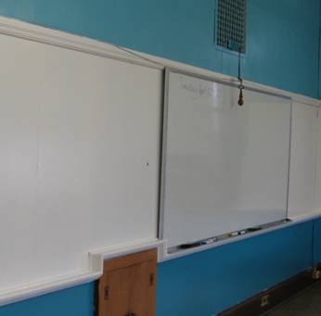

Warm Air Vent (Supply) near Ceiling
Cool Air Vent near Base of Wall, Note Wooden Doors Blocking Vent

Picture 2

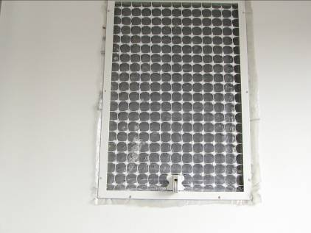

Warm Air Supply Vent

Picture 3

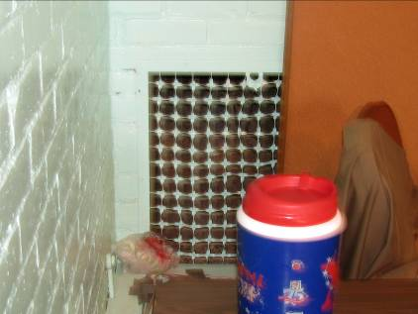

Cool Air Exhaust Vent, Note Stored Materials Blocking Vent

Picture 4

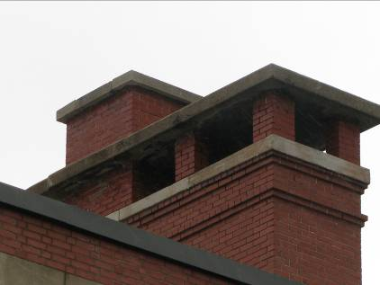

Rooftop Exhaust Chimney

Picture 5

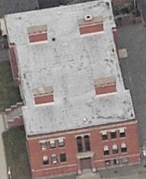

Four Rooftop Chimneys, Two on Each Side of Building

Picture 6

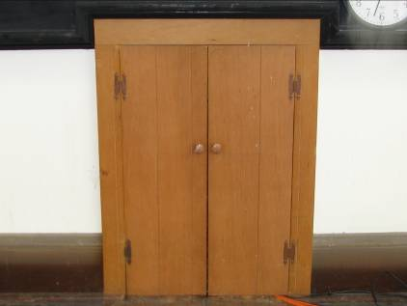

Wooden Doors Blocking Exhaust Vent

Picture 7

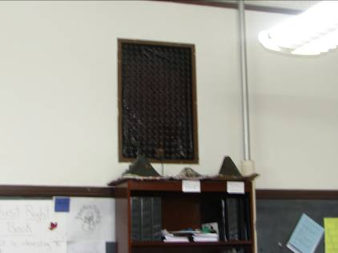

Supply Vent Sealed by Plastic

Picture 8

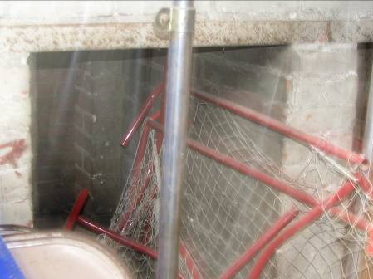

Sports Equipment and other Stored Materials in Mixing Room

Picture 9

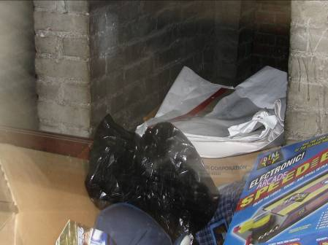

Stored Materials in Mixing Room

Picture 10

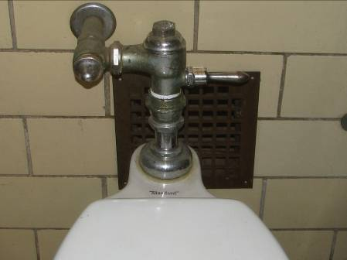

Exhaust Vent in Restrooms

Picture 11

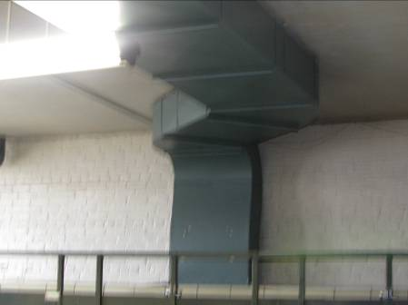

Ventilation System for Restrooms

Picture 12

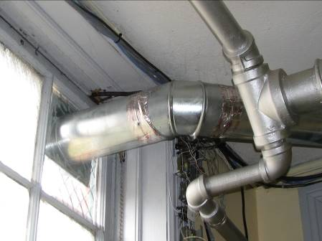

Ventilation System for Office Restroom

Picture 13

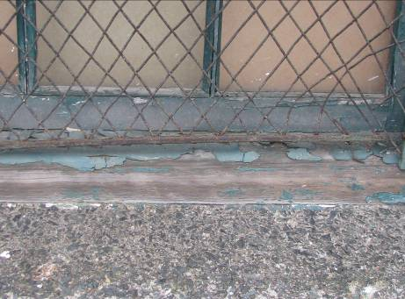

Damaged Window Caulking and Peeling Paint on Window Frame

Picture 14

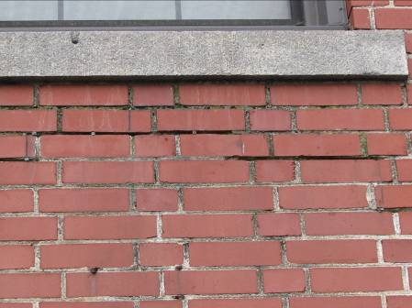

Missing/Damaged Mortar and Exterior Brick

Picture 15

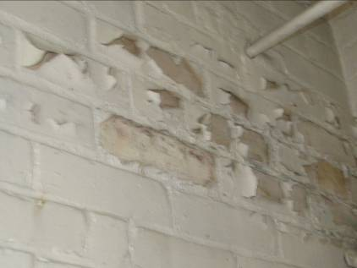

Peeling Paint and Efflorescence on the Brick Wall in the Girl’s Bathroom

Picture 16

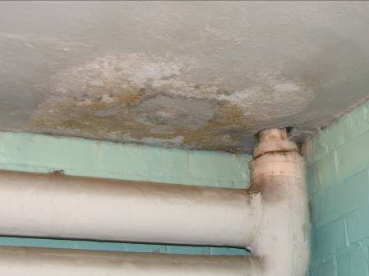
Efflorescence on Ceiling
Note Pipe Penetration Not Properly Sealed

Picture 17

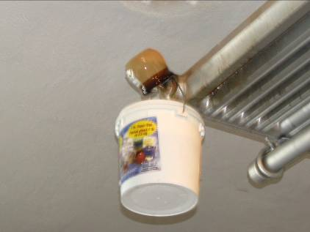

Water Collection System for Radiator

Picture 18

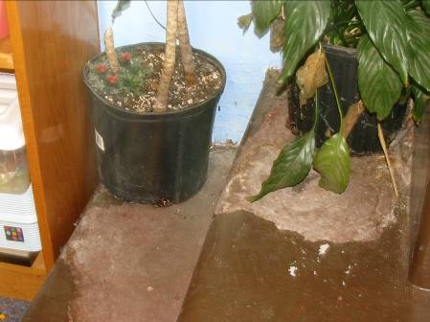

Plants Lacking Drip Pans
Note Peeling/Damaged Paint near Plants

Picture 19

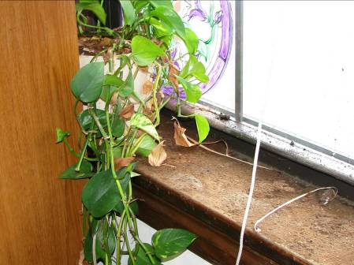

Soil on Window Sill

Picture 20

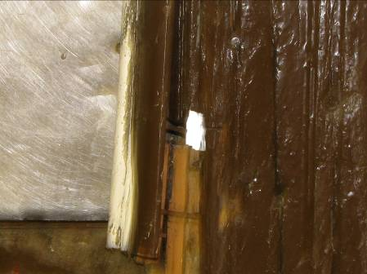

Damaged Door Casing and Frame

Picture 21

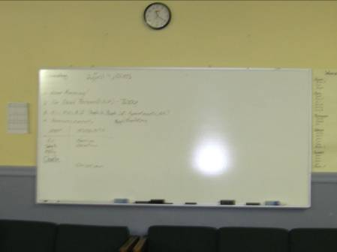

Dry Erase Boards and Materials Located in School

Picture 22

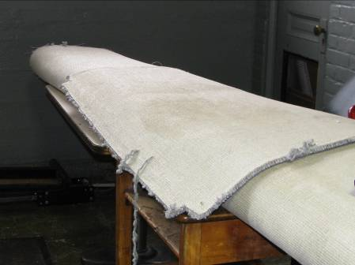

Carpeting and Furniture Stored in Restroom

Picture 23

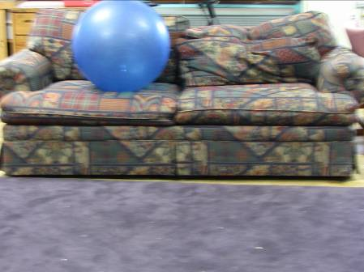

Upholstered Furniture and Carpet

Picture 24

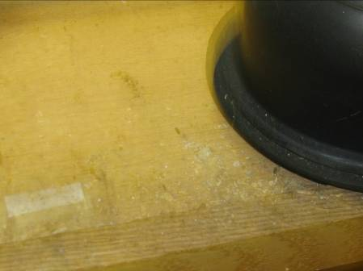

Rodent feces in Kitchen Cabinet

Picture 25

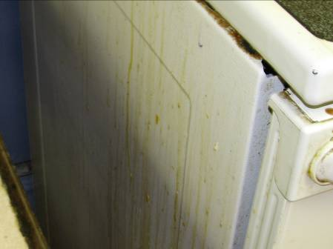

Heavy Accumulation of Organic Matter on Stove

Picture 26



Food Containers and Products at Coffee station

Picture 27

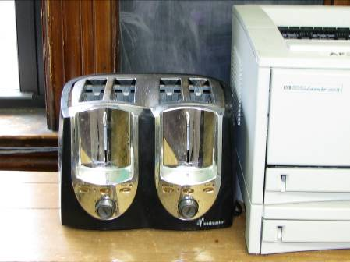

Toaster in Classroom

Picture 28



Table of Food Items in Jump Start Program Room

Picture 29

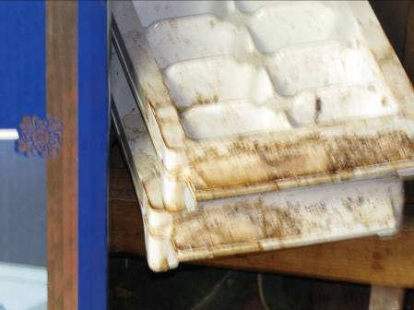

Evidence of Coffee Spill at Classroom Coffee Station

Picture 30

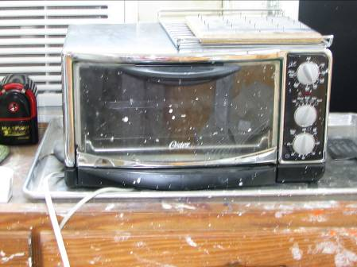

Toaster Oven in Art Room

Picture 31

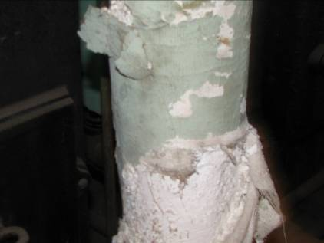

Potential Asbestos Insulation In Boiler Room
Location/ Room | Occupants  in Room | Temp  (°F) | Relative  Humidity  (%) | Carbon  Dioxide  (ppm) | Carbon Monoxide  (ppm) | Windows  Openable | Ventilation |  | Remarks
 |  |  |  |  |  |  | Supply | Exhaust | Remarks
background |  | 63 | 58 | 400 | ND
Room 15 | 1 | 65 | 52 | 659 | ND | Y | N | N | DO, Comp, Copier, Radiator on Carpet
Basement Girls Room | 0 | 68 | 40 | 584 | ND | Y | N | Y  Not in use | DO, UF, Vent. System operational, but not in use
Cafeteria | 2 | 70 | 41 | 568 | ND | Y | Y | Y | DO, UF, PF, No local exhaust for cooking, rodent droppings
Multi Media Room | 3 | 72 | 38 | 690 | ND | Y | Y | Y  Partially blocked | DO, 8 computers, carpet, UF
After School Program | 1 | 73 | 40 | 705 | ND | Y | Y | Y | DC, UF, Carpet, FC
Basement Boys Room | 0 | 72 | 31 | 529 | ND | Y | N | Y  Not in use | DC, Broken window, Dry sink drain, Vent system operational but not in use
Room 11 | 4 | 69 | 43 | 565 | ND | Y | Y  Partially blocked | Y | DC, DEM, UF, carpets, plants
Room 13 | 2 | 71 | 42 | 910 | ND | Y | Y  Blocked by plastic | Y  Blocked | DC, 3 computers, DEM, FC, plants, WDC
Room 17 | 0 | 69 | 39 | 655 | ND | Y | Y | Y  Blocked | DO, Carpet, plant
Room 18 | 0 | 70 | 40 | 712 | ND | Y | Y | Y  Blocked | DC, DEM, Carpets, PF, UF
Room 16 | 6 | 71 | 46 | 745 | ND | Y | Y | Y | DO, DEM, 3 computers, Carpet, UF
Room 14 | 8 | 72 | 44 | 710 | ND | Y | Y  Partially blocked | Y  Blocked | DO, Carpets, DEM
Room 12 | 0 | 71 | 43 | 508 | ND | Y | Y | Y  Blocked | DO, DEM, Carpet
Room 28  (Art Room) | 0 | 72 | 35 | 906 | ND | Y | Y | Y  Blocked | DO, DEM, 3computers, UF
Room 26 | 3 | 72 | 40 | 744 | ND | Y | Y  Blocked by plastic | Y  Blocked | DO, DEM, 3 computers, UF
Room 24 | 0 | 74 | 38 | 597 | ND | Y | Y | Y  Blocked | DO, DEM, Plants
Room 22  Kathy’s Room | 1 | 73 | 43 | 594 | ND | Y | Y | Y  Blocked | DO, DEM, UF, Carpet, Plants
Room 21  Science Room | 7 | 72 | 44 | 629 | ND | Y | Y | Y  Blocked | DO, 3 computers, FEM, Plants, FC
Room 23 | 0 | 71 | 43 | 661 | ND | Y | Y  Blocked | Y  Blocked | DO, Carpet, UF
Room 25 | 2 | 72 | 40 | 757 | ND | Y | Y | Y  Blocked | DO, Carpet, UF, Plants
Room 27 | 4 | 71 | 40 | 793 | ND | Y | Y | Y  Blocked | DC, UF, 4 computers
Wood Shop | 0 | 75 | 41 | 559 | ND | Y | N | N | DC
Boiler Room | 0 | 75 | 41 | 555 | ND | Y | N | N | DC

