Vincent Strully Jr.

Chief Executive Officer and Founder The New England Center for Children®

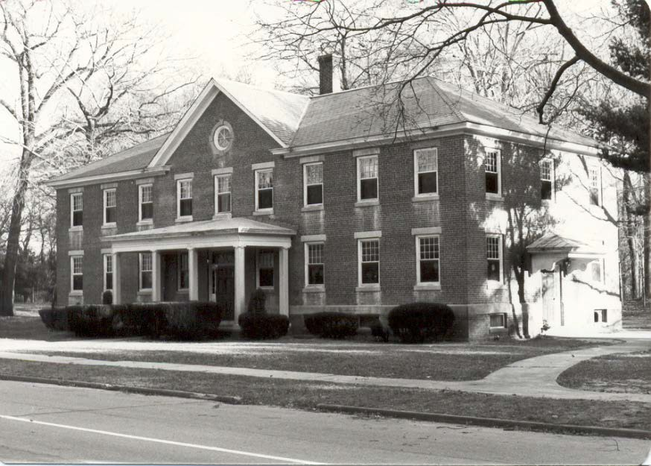NECC® Then

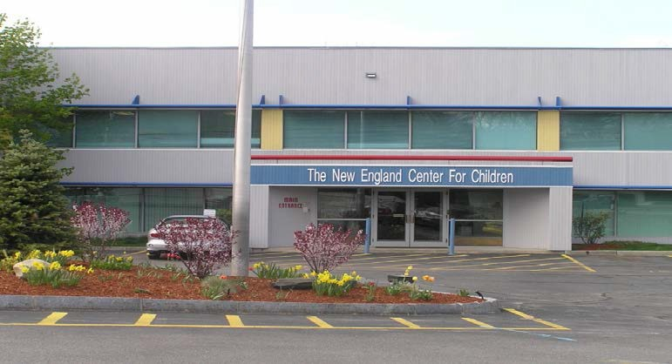NECC® Now

The New England Center for Children®

- The Center serves 686 students (age 18 months through 22 years) diagnosed with Autism Spectrum Disorder.

- Located in Southborough, Massachusetts (123,000 ft2 central school facility, with 16 residential group homes).

- 479 employees are currently enrolled in one of our on-site graduate programs through Simmons or Western New England University.
- Over 1,300 staff received Master’s degrees from one of these programs since 1987.
- We provide consultation services to over 790 students throughout more than 80 schools.
- Over 4,050 students at NECC and in public school districts and agencies around the world use the Autism Curriculum Encyclopedia (ACE®) Application, which was developed at NECC.

- Our faculty have presented 2,004 times at national and international conferences and have published 245 research articles in peer-reviewed academic journals.

- In 2007, we opened a school for children with autism in Abu Dhabi; there are currently 184 students enrolled.

Consulting and Global Dissemination

Kuwait

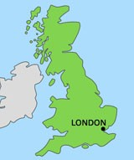Qatar Dubai

Abu Dhabi

Programs at NECC®

Staff Intensive Unit (SIU)

- Residential Program

- Intensive Instruction Program (IIP)

- Home-Based

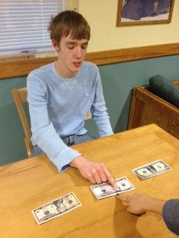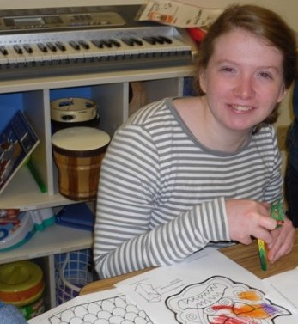Staff Intensive Unit

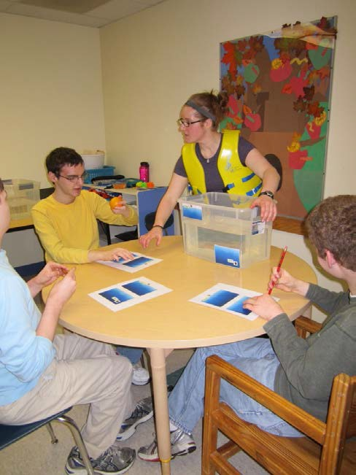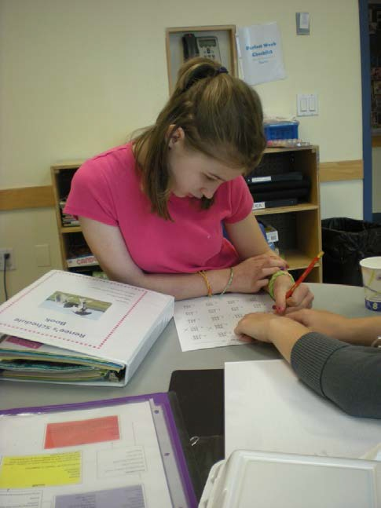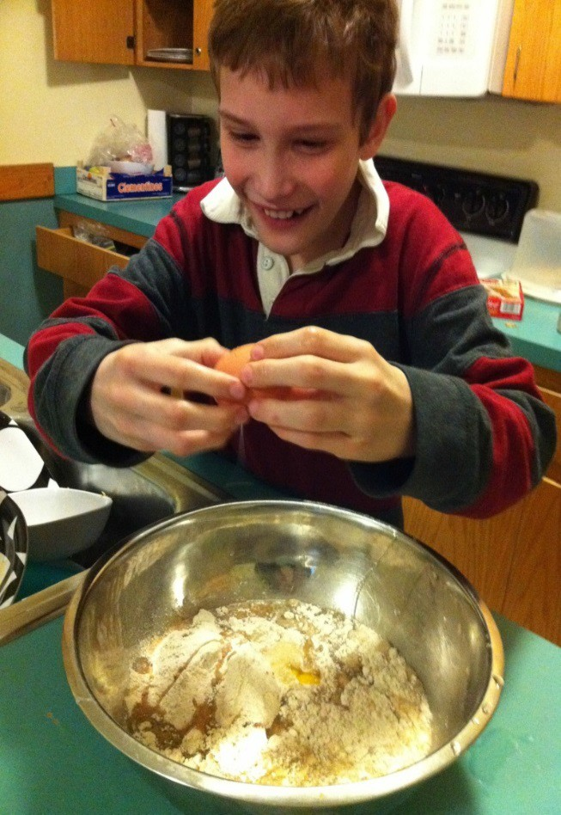Residential and Intermediate Programs

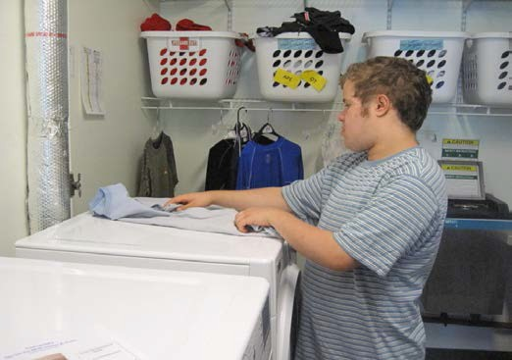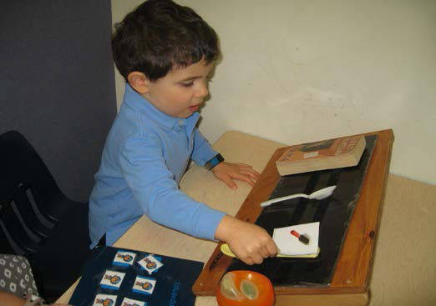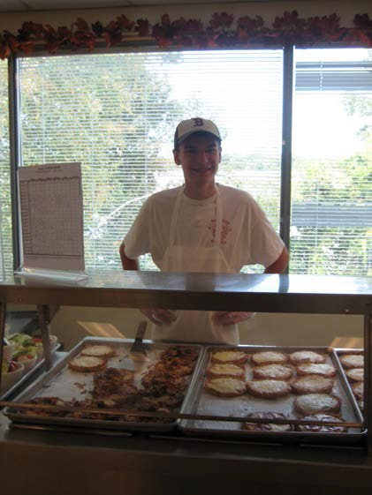Intensive Instruction Program

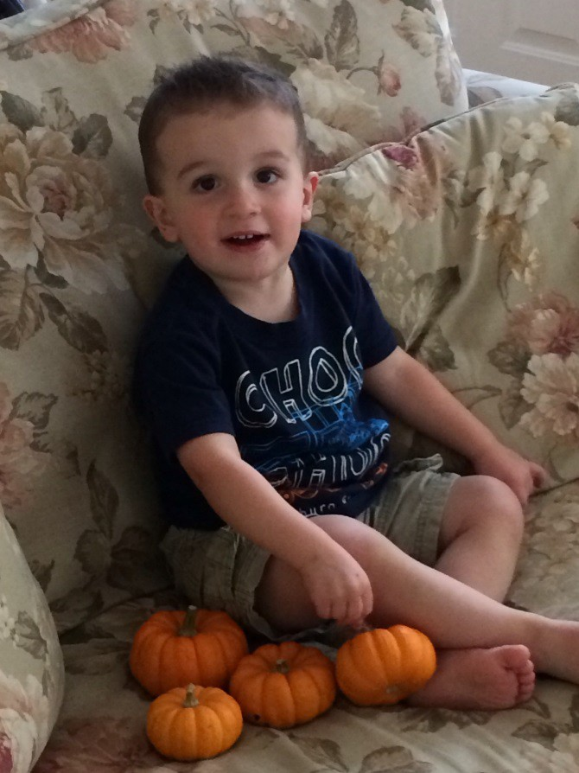Home-Based Program

The New England Center for Children®

Autism Education and Research

Best Practices in Autism Treatment: Research to Practice and Practice to Research
William H. Ahearn
Ph.D., BCBA-0, LABA (MA)

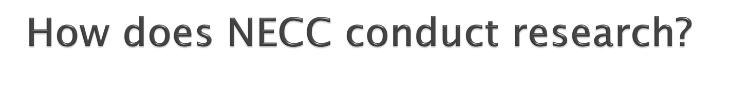

▪ Masters and Doctoral training
  - WNE (in ABA); Simmons (Sp. Ed.)
▪ 10 NECC-based Ph.D. level faculty - WNE
▪ Over 80 ongoing projects
▪ 250 peer reviewed publications
▪ 2nd most contributing authors to JABA
▪ Ongoing collaborative relations
▪ E.K. Shriver Center
▪ Children’s Hospital/Harvard
▪ UNH
▪ UCONN

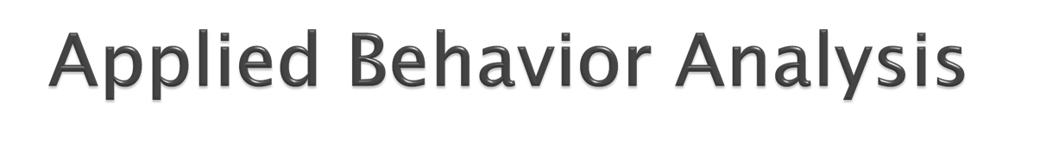
▪EIBI/ABA through the lifespan
- Skill deficits/behavioral excesses
- Skill deficits
  - Function of skills in social environment
  - Specific targeting via appropriate teaching procedures
- Problem behavior
  - Functional assessment to identify cause
  - Validated function-based TXs
  - Heavily focused on appropriate replacement behavior

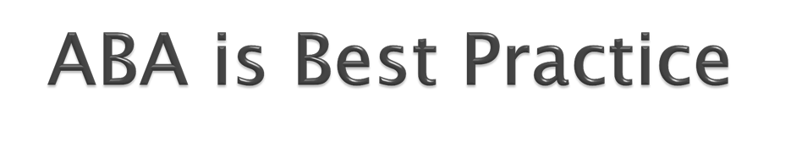
▪From the early days: Lovaas, 1987; McEachin, Smith, & Lovaas, 1993
▪Howard et al. 2005; 2014
▪Meta-analyses – EIBI and techniques
(e.g., Eldevik, Hastings, Hughes, Jahr, Eikseth, and Cross, 2009)
▪Cochrane review by Reichow, Barton,
Boyd, & Hume (2013)

MacDonald, Parry-Cruwys, Dupere,
& Ahearn (2014; RIDD)

Table 5_ Stati.stical comparisons across outcome measures and age groups

RJAPoint | RJAGaz.e | UA | Cognitive | Play
:Nfain Effect (fime) F(l , 91)= 15.14,p<.0] | F(l , 91)=25.14,p<.01 | .F( l,91)=4.06,p<.Ol | F(l , 9'1)= 24 .57,p<.01 | F'(l, 9])=7.92p<.m
:Nfain Effect (Age) F(l , 91)=23.12,p<.0] | F(3, 91)=3.66,p>.m | F(3,91)=8.50,p<.Ol | F(3 , 91)=L66,p>.m | F'(3, 91)=4.36,p>.Ol
Interaction F'(l , 91)= 12.14,p<.0] | F(3, 91)=254,p>.01 | F(3,91)=7.50,p <.Ol | F(3,91)=12.87,p<.OE | F'(3, 91)=14.36,p< .01
Post-hoc tests 1S-23-month-OLds | N/A | 1S-23-month-0Lds | ]8-23-month-olds | 18-23-month..,olds

imp·roved more than all (S<:::ores increased from
other age groups;no Time l to Time 2)
differences betweet11 other age·groups
improved more tJlan. all improved more than .all imprm<ed more than all
other age groups;no other age grol!Jils,24- other age groups no differences benveeo 30-monili-Olds group differences bettweet11 other age groups impm\·ed more than other age·groups
2.5 and 3-ye.ru--old'i

Outcome Analysis - Cognitive Performance
by Age

Cognitive Performance Categorization

80%

.sl
a.
E,.

60%

-.-Low

.0. Middle
c:

40%
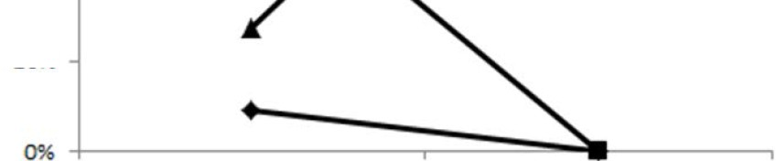l.

-.-High

20%

1Yr Olds at Entry 1Y r Olds at Follow Up

The New England Center for Children

A leader in autism rese.1rch and educ.ation

Outcome Analysis - Cognitive Performance

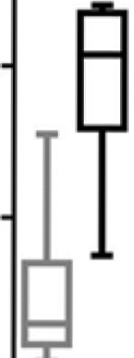4..). 60
0
u
It/)
I,_ 40
+

+:: 20
-
c
C)
0
o o..L..=------:;;;;;;;;;;;...... ---=----
18-23 24-29 30-36

Age at Entry (tm1os.)

D Entry
Dl Exit

The New England Center for Children

A leader in autism research and education

- Behavior analysis works across lifespan
- Problem behavior
FA and F-B TX is a BP
- Skill building
Verbal behavior/Communication skills
Play and social skills
Independent functioning (outcomes)
▪But, BP evolves constantly

▪Established groups in areas of need

▪Provide resources for conducting research

▪Summarize results and disseminate externally

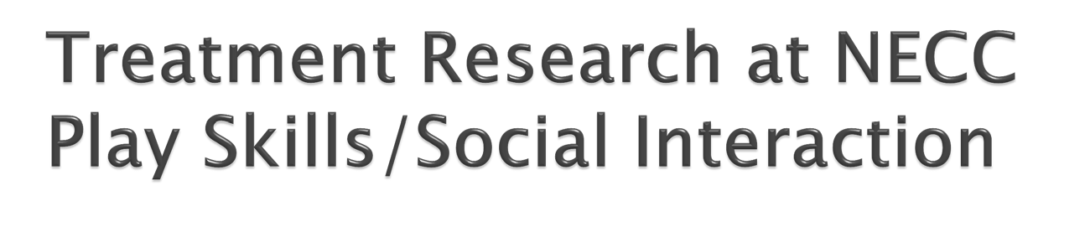
MacDonald, R.P.F., Sacramone, S., Mansfield, R., Wiltz, K., & Ahearn, W.H. (2009). Using video modeling to teach reciprocal pretend play to children with autism. Journal of Applied Behavior Analysis, 42, 43-55.

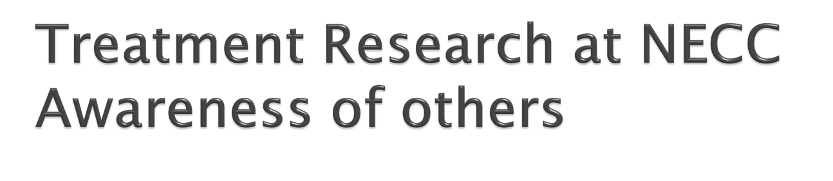

Klein, J.L., MacDonald, R.P.F., Vaillancourt, G., Ahearn, W.H., & Dube, W.V. (2009). Teaching discrimination of adult gaze direction to preschool children with autism. Research in Autism Spectrum Disorders, 3, 42-49.

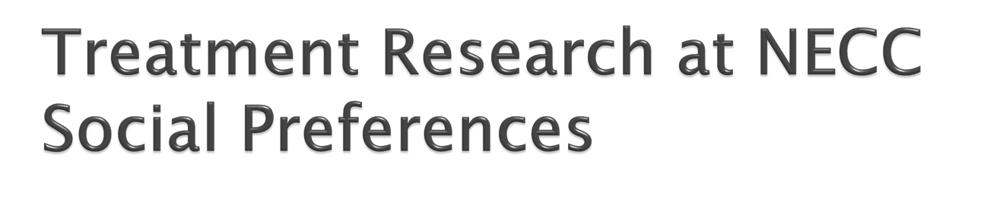

Smaby, K., MacDonald, R.P.F., Ahearn, W.H., & Dube, W.V. (2007). Assessment protocol for identifying preferred social
consequences. Behavioral Interventions, 22,
311-318.

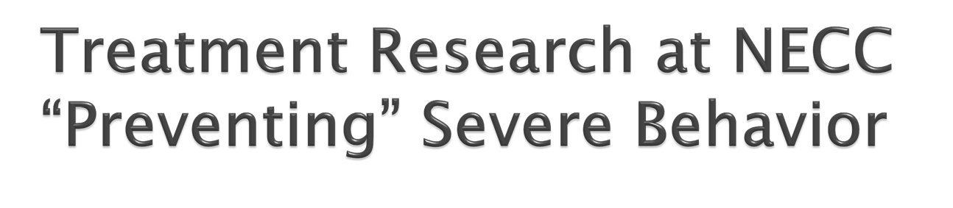

Herscovitch, B., Roscoe, E.M., Libby, M.E., Bourret, J.C., & Ahearn, W.H. (2009). A methodology for identifying precursors to problem behavior. Journal of Applied Behavior Analysis, 42, 697-703.

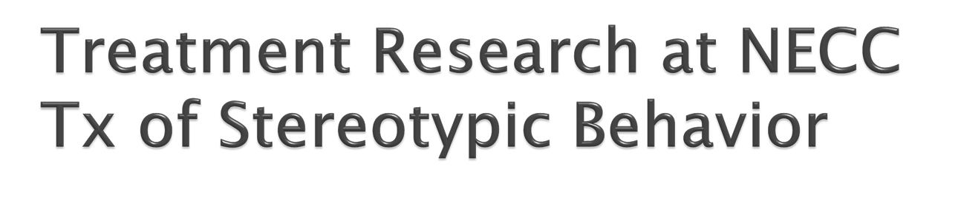

Ahearn, W.H., Clark, K.M., MacDonald, R.P.F., & Chung, B.I. (2007). Assessing and treating vocal stereotypy in children with
autism. Journal of Applied Behavior Analysis, 40, 263-275.

MacDonald et al. (2007)
70

60 CWA

TDC
50
Relative Duration

40

30

20

10

0
2-year-olds 3-year-olds 4-year-olds

▪Stereotypic behavior circa 2000
▪Little sound TX research
▪Manualized recommendations
▪Examined procedures for redirecting
stereotypy in learning environments
▪Ahearn et al. (2007; JABA)
▪Examined procedures for promoting
adaptive behavior
▪Colon et al. (2012; JABA)

How goals are selected and sequenced when providing educational and clinical services?

- Diagnostic evaluations prior to intake
  - Additional assessments conducted (e.g., ESAT)
- CSA (e.g., Dickson et al., 2014; JADD)
  - Foundational skills hierarchically-ordered
  - Observational analysis
- Skill domains
  - Discrimination
  - Verbal behavior/Communication
  - Social behavior
  - Self help
  - Health and safety
  - Physical education
  - Community

ACE® 4.0

Autism Curriculum Encyclopedia

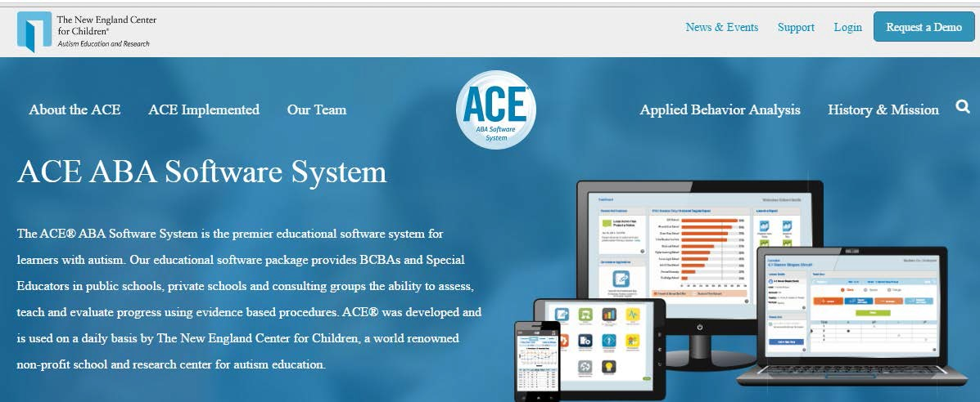

The ACE®

ASSESS

- Identify Key Factors for Individual Success

TEACH

- Build Independence Across the Life Span

EVALUATE

- Document Success Every Day

ACE
Autism Curriculum
Encyclopedia •

The New England Center
App Library
for Children•

.A......C. E
The New England Center
for Children•

Dashboard App Ltbrary Help Logout

Welcome to your App Library John Brown

-e ll

Curriculum Students

Admin Classroom
Resources

Skills Assessment Preference
Assessment
Reports

Core Skills
Assessment
Activity

Challenging
Behavior

Core Skills

Basic Matching and Readiness
Sit and attend Matching Skills

Communication Requesting Respond to name Respond to greeting Request help Request attention
Request termination Accept / reject Respond to “stop” Follow 1-step directions Identify body parts
Identify pictures, objects Label pictures, objects
Social Skills Preferences Waiting Conditioned Sr Imitation Social Distance

Self-Help
Dressing, Undressing
Washing hands, face
Showering
Brushing teeth
Eating skills
Washing hands
Toileting
Health and Safety Medical care skills Exit given fire alarm
Personal identification Privacy

Community
Walk in community
Ride in vehicles

Recreation / Phys Ed Use schedule Exercise Independent tasks

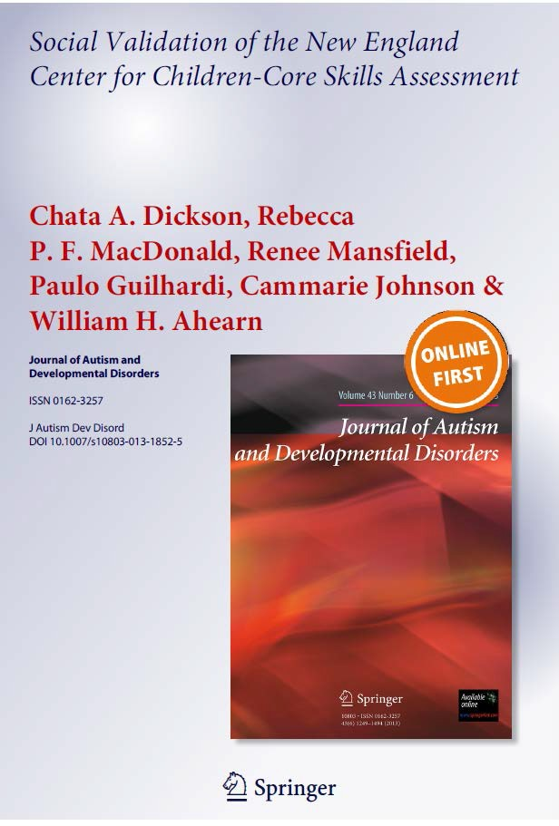Core Skills Assessment

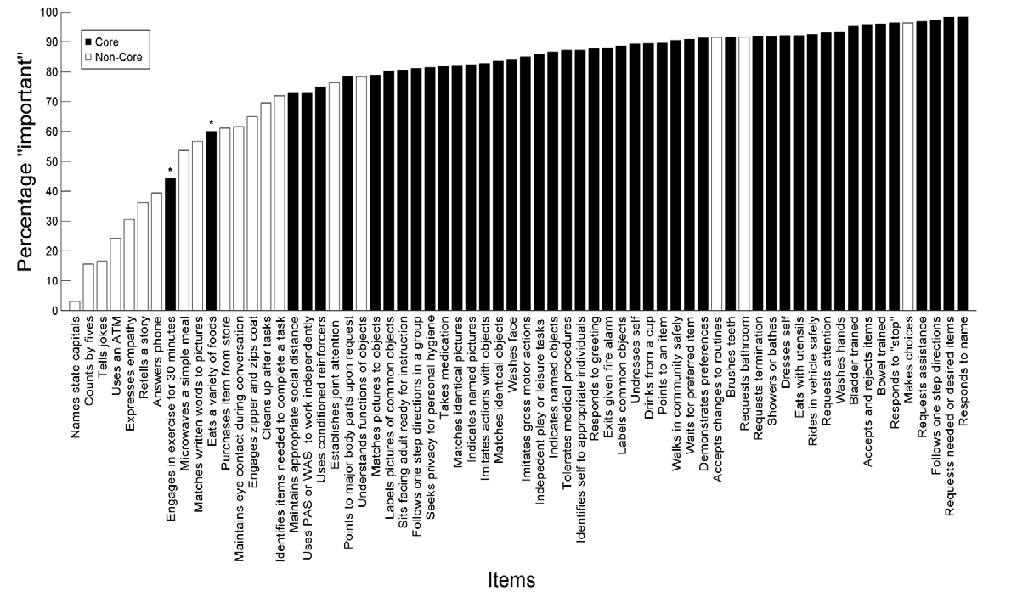

Core Skills Assessment

- 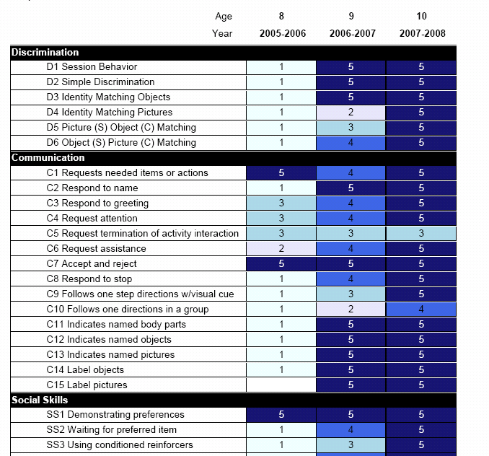Core Skills Assessment

CSA results allow educators to…

  - Identify foundational skill deficits

  - Select ACE curriculum to address areas of need

  - Monitor progress across years

Year 1 Year 2 Year 3

ACE
Autism Curriculum
Encyclopedia •

The New England Center
App Library
for Children•

.........."""""""'
ACE
The New England Center
for Children• Dashboard App L•brary Help Logout

t® IPI

Welcome to your App Library John Brown

Curriculum
Students Reports

lfo
Activity

Admin

Skills Assessment
Classroom Resources

Preference
Assessm ent
Core Skills Assessment
Challenging Behavior

Skills Assessment

- The ACE curriculum scope and sequence includes over 1250 skills for learners with autism.

- The ACE Skills Assessment is an indirect evaluation of all skills within the scope and sequence, including skills in areas that are not assessed in the CSA.

- The ACE Skills Assessment will help users identify broader areas of need than covered in the CSA and provide the “big picture” for curriculum selection.

- All skills link to lesson plans within the ACE Curriculum Bank

- Our recommendation is that this tool be used on a yearly basis prior to planning a new IEP.

ACE
Autism Curriculum
Encyclopedia •

The New England Center
App Library
for Children•

-"'A.,..,.C
ACE
The New England Center
for Chi ldren•

Dashboard

App L•bral) Help Logout

Welcome to your App Library John Brown

Curriculum
Students Reports

lfo
Activity

Admin

Skills Assessment
Classroom Resources

Preference Assessment
Core Skills Assessment
Challenging Behavior

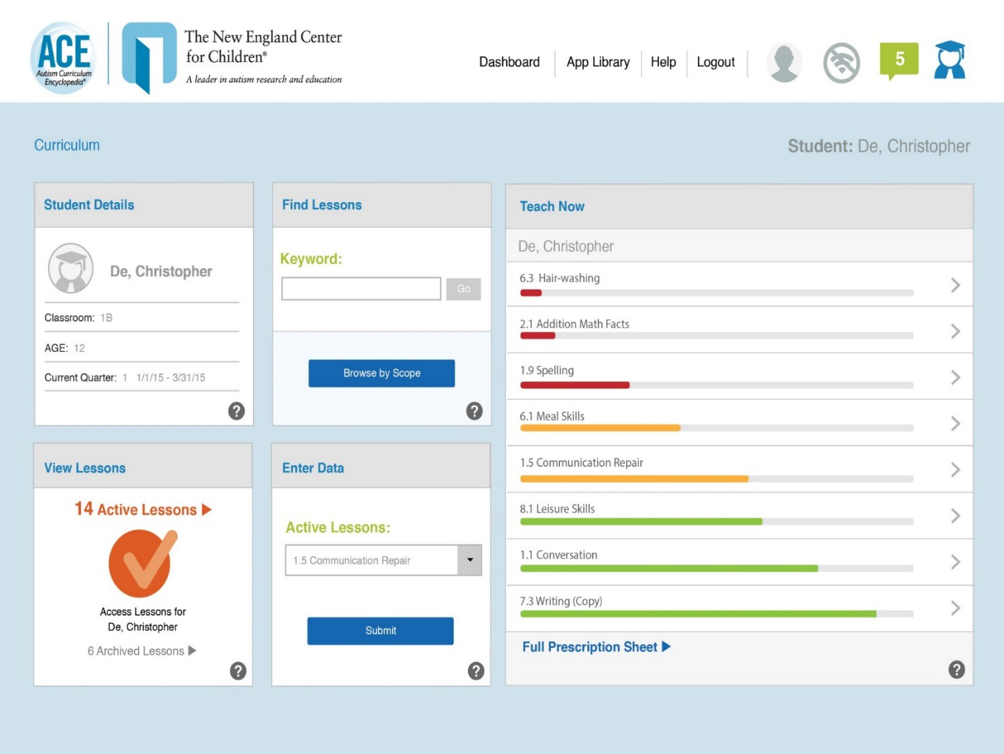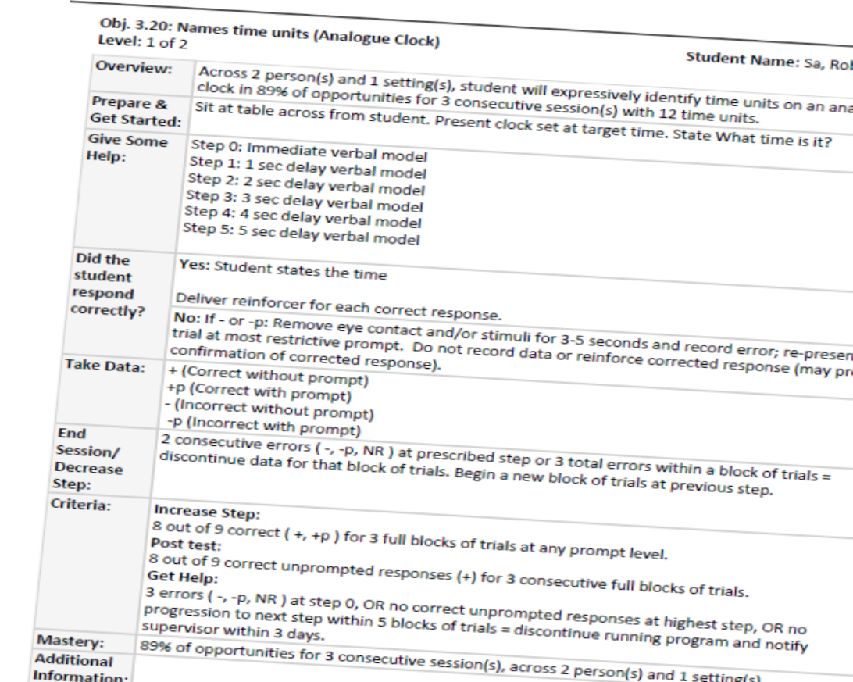ACE® Curriculum

ACE Curriculum Bank
Over 2000 lesson plans linked to NECC Scope and Sequence Common Core
MA Curriculum Frameworks VBMAPP
- 3 lesson formats
  - Discrete Trial
  - Task Analysis
  - Incidental Teaching

ACE® Curriculum

- 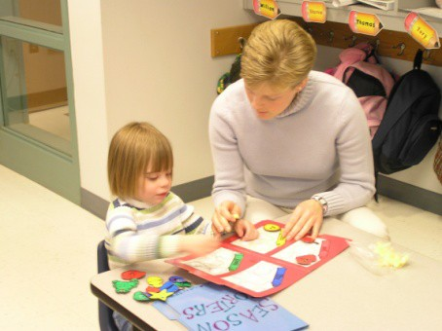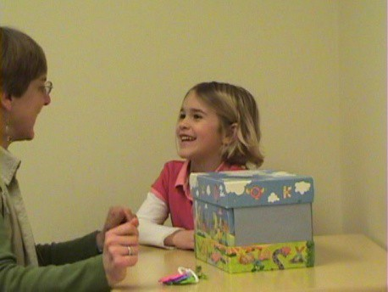Discrimination
- Communication
- Academics
- 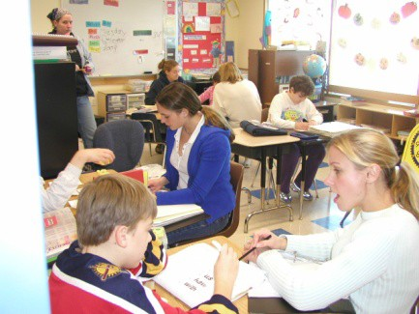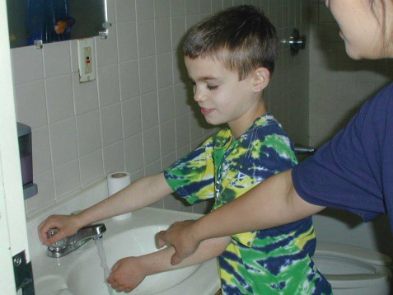Social Skills
- Self-help
- Health & Safety
- Recreation, Leisure, Play
- 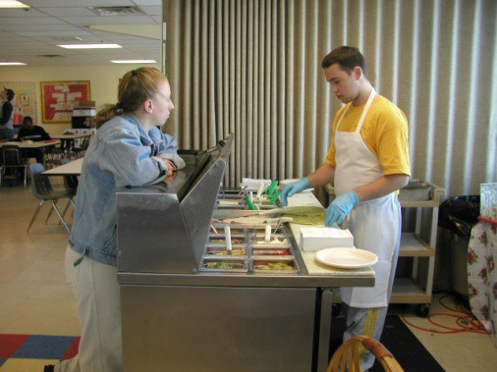Community
- Vocational
- Transition to Adulthood

Teaching Formats

Discrete Trial

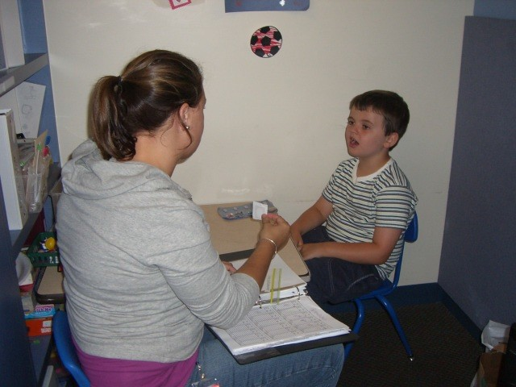

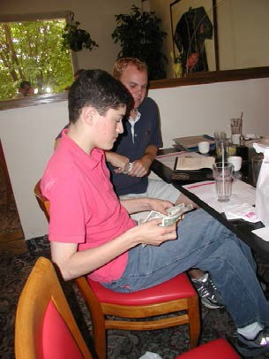Incidental Teaching

Video Modeling

Task Analysis

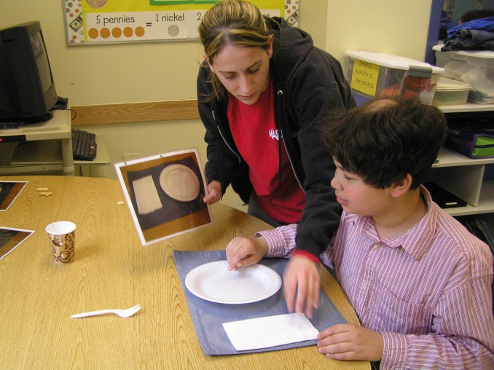

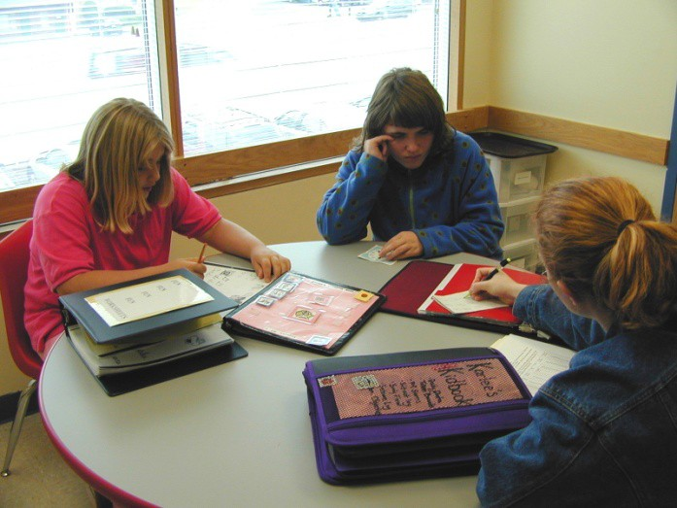Group Instruction

Standardized Lesson Plans

- Standardize format and put in database
  - Easy to find what you’re looking for
  - Increased efficiency
  - Allowed for quality control – lesson plans approved and then shared
  - Standardized objective writing
    - still individualized…
    - but ensured that every objective included measureable outcome, generalization component, for example
  - Easier to enact changes to practice that would impact everyone (change in default prompting procedure)

Online Data Collection

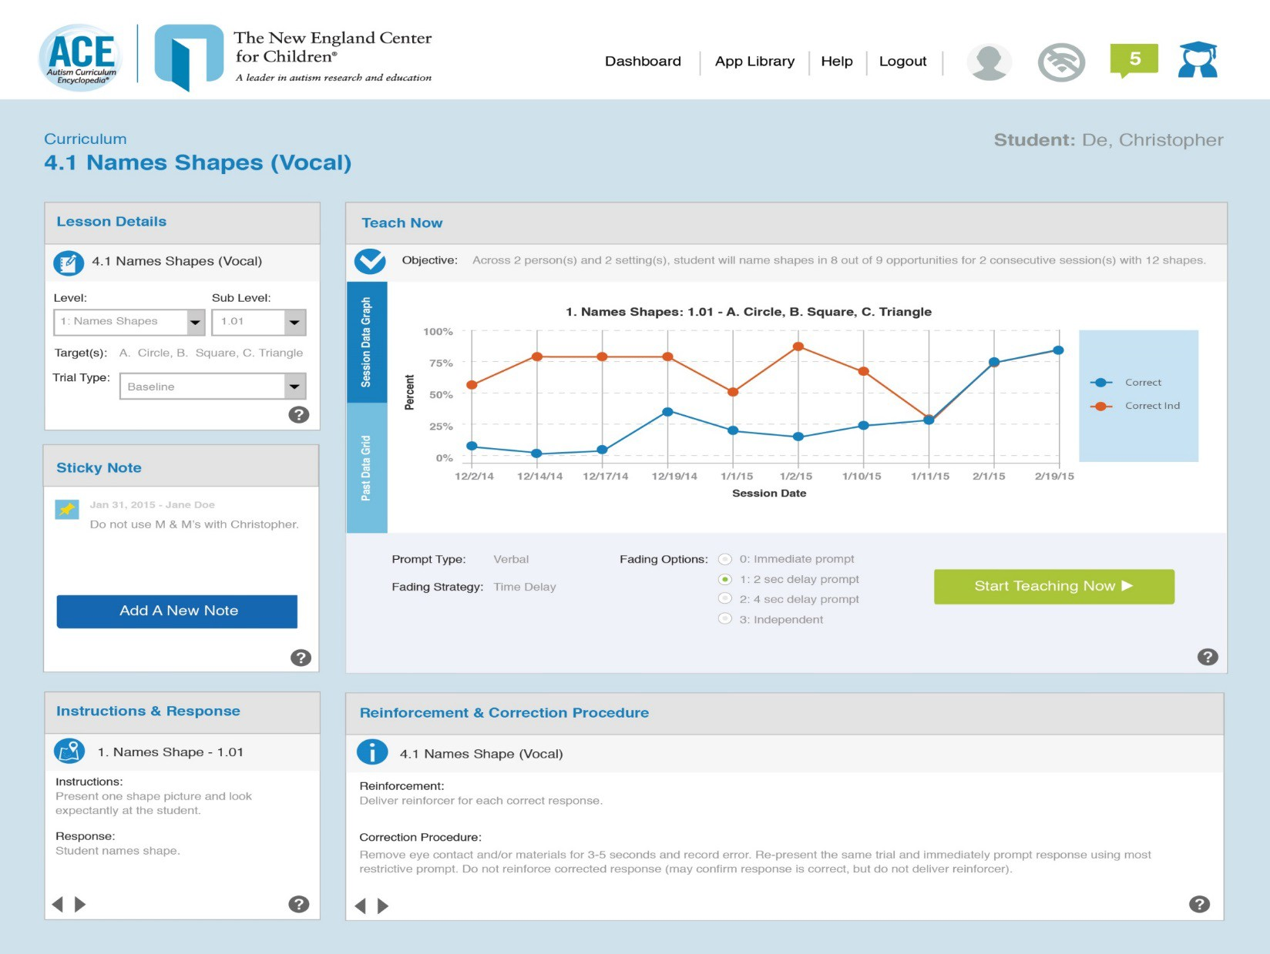

ACE
Autism Curriculum
Encyclopedia •
Lesson Plan Monitoring The New England Center

The New England Center for Children• Dashboard App Library Help Logout
for Children•
ACE

Curriculum >Act1ve Lessons > Calendar Skills (Vocal)

  - Calendar Skills (Vocal)
Student: De Cl"mstopher

Enter Data

Enter Summary Data

I'm Ready to Teach Now
Manage Lesson
PTO Report

31o/o
Of Annual Goal Met
Session Tally

•

5
Week

8 8

Instructional Summary
Lesson Notes
Lesson Log

Sub Level Targets

1 Names Oay
Instruction
Response
J •• 2015

- A AodNew

State.What Is the dato?

Student states the
correct day

•low Demand following vacat>on

Jan 2, 2015

I<S

- A. Add New

State.What os the date• Student states the
correct day

Avoid the use of calendars w th
•
omagos ol animals The:e Images

Jan 1, 2015

lldure was Changed

2. Names Oay
clistract Christopher lrom te ta9<
Jan 1, 2015

as I osweet<

201 A Add Now

State, What Is the data? Student states the
correct day and month

All Lesson Notes .,.

Complete Lesson Log ...
8
8

ACE
Autism Curriculum
Encyclopedia •

Curriculum Monitoring

The New England Center
for Children•

CurriCulum Dashboard
Dy Summer

+ Manage Dashboard

Performance Overview
Teach Now

Dy, Summer
    - •Perc ent of Annual Goal Met •Perc ent of Year Elapsed
101 TBCcgOrder 11
Numbers {rote count or
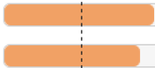sequence)
1.01 Fold Towels

1.01 follow 1-Step Duect1ons With Visual
Support :
12 00 Name Objec ts - -
motor 8 00 Sequence and Descnbe Events 1n a
Story {motor)
6.09 Follow Complex Directions {contau•ng bas1c concepts)
2 00 Match Objec t to
P1cture

80%

37%

33%

20%

0%

0%

0%
0.0 Find Information (internet) 1
>
  - Indicate Named Pictures
>
  - Fold Towels
>
•1.50 CS Match Identical Objects >
  - Match Object to Picture
>
  - Domestic Chore Routine
>

2.01 Domestic Chore
Rout1ne 301 Typing {mav1s
beacon)
<

PTO
0%

0%

Full Prescription Sheet

View Lessons

19 Active Lessons •
Enter Data

Select a Lesson to enter or edit
summarized data for

Active Lessons:
Find Lesson Learner Details

Search by Keyword or Browse by Scope IQIDy, Summer

Keyword:
Account Name: ACE Pract ce

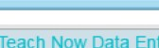

Access Lessons for Dy,Summer

8 Archived Lessons •

-Select Lesson-

Dato Enty

Browse by Stope

School: Test School Classroom: Jay build test Date of Binh: 07/0112012
Date of Admission: 07/07/2014

ACE
Autism Curriculum
Encyclopedia •

The New England Center
App Library
for Children•

ACE
The New England Center

for Children• Dashboard App L1brary Help Logout
-"""""" A t :Jdtr '"autum fnelrdJ tmd r!dut:atlon

Welcome to your App Library John Brown

··"II

Curriculum Students Reports

lfo
Activity

Admin Classroom
Resources
Core Skills Assessment
Challenging Behavior

Skills Assessment Preference
Assessment

Challenging Behavior

- 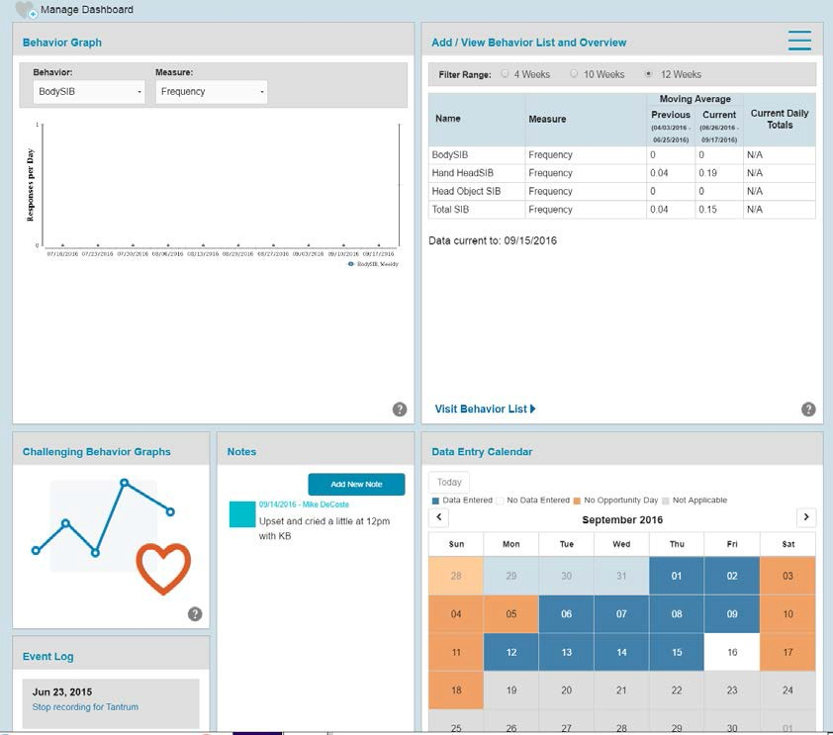The Challenging Behavior App is used to identify and monitor:
  - Challenging behavior (for example, striking others, striking self, spitting).
– Desired behavior (for example, requesting attention, toileting).

- The dashboard provides a snapshot view of challenging behavior data that is being tracked for a student and also provides quick links to manage behavior definitions and measurement, data collection, and reports

Autism Curriculum Encyclopedia•
A
ACE Training and Support

The New England Center
for Children•

ACE

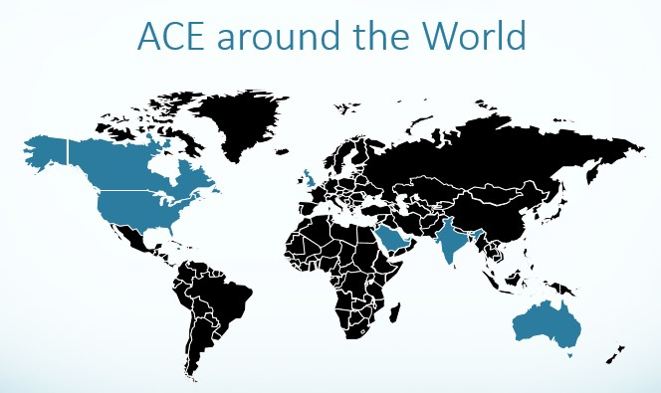ACE® Status

June 2016:
2,072 | Lessons available | 2,839 | Skills Assessments
52,720 | Lessons activated on the ACE | 5,172 | Preference Assessments
6,773 | Core Skills Assessments | 12,027 | Challenging Behaviors

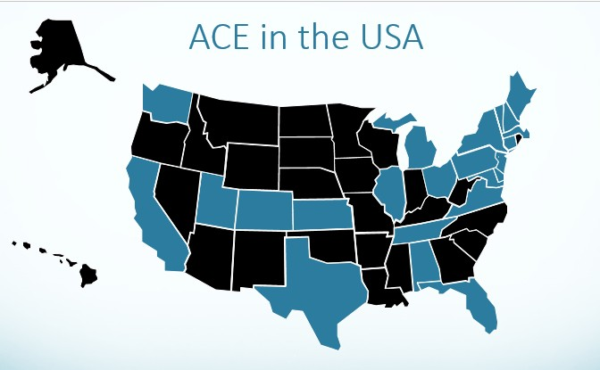

Public School Services

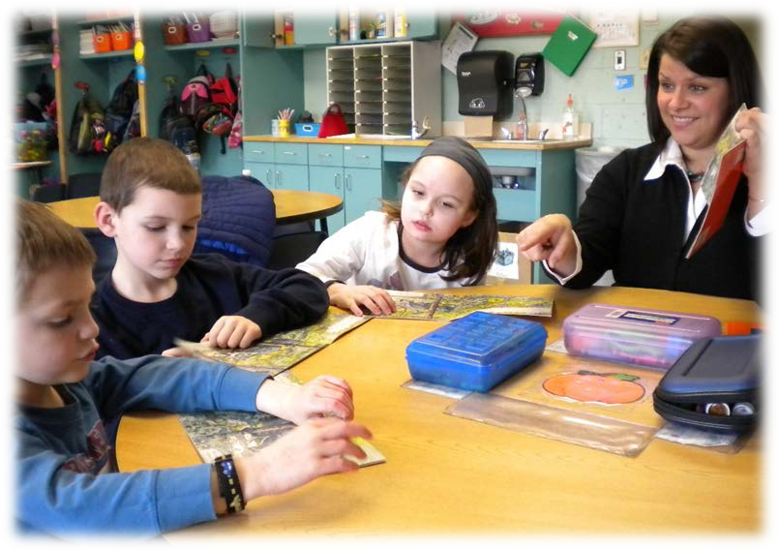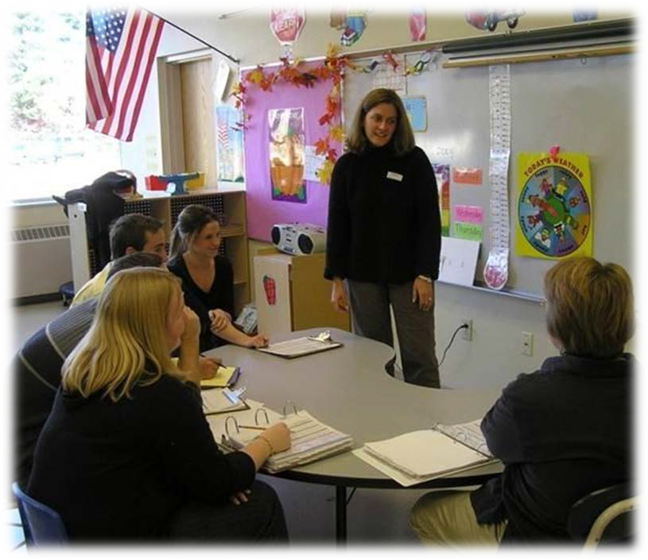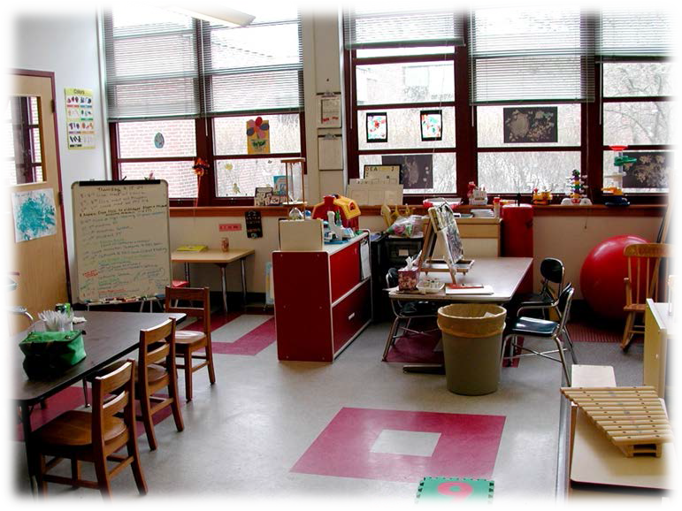

Partner
Program

Partner Program

Direct Care Staff

Administrative Support

Staff Training and Mentorship

ACE®

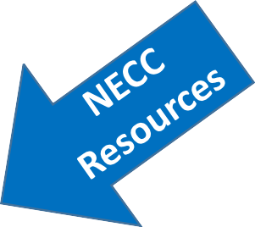

Classroom Systems

Partner Program

Inclusion Classes
Classroom Supervisor

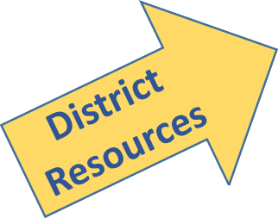Classroom Space

Students
Weekly Support from Senior Consultant

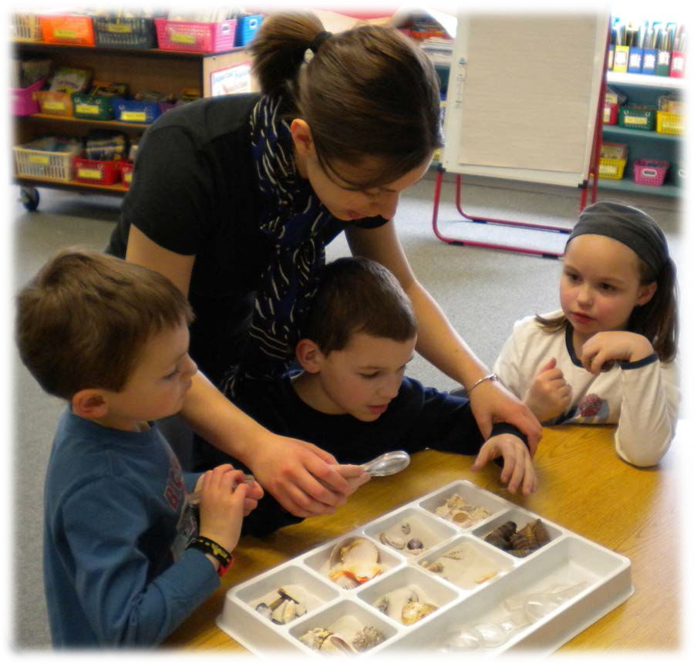Partner Program

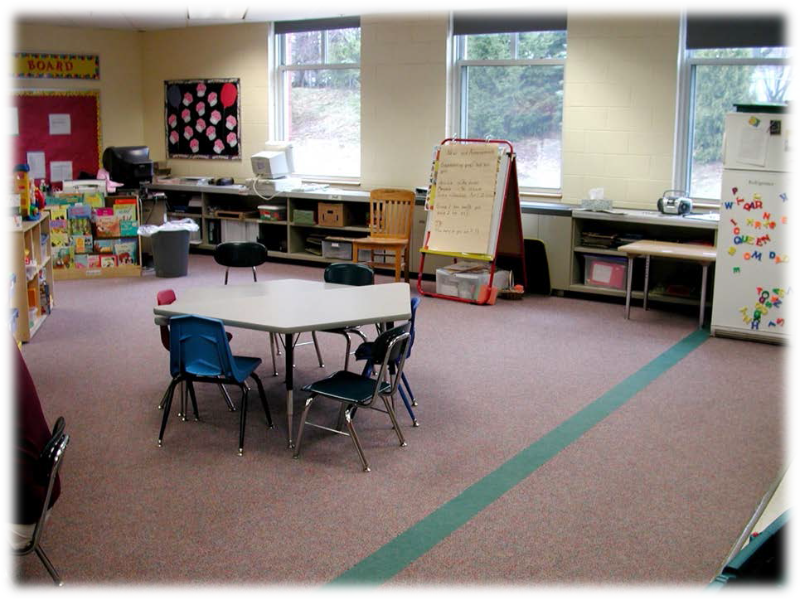

Partner Program

39 Partner Program classrooms

224 students currently served

400+ students served over the past 19 years

Partner Program

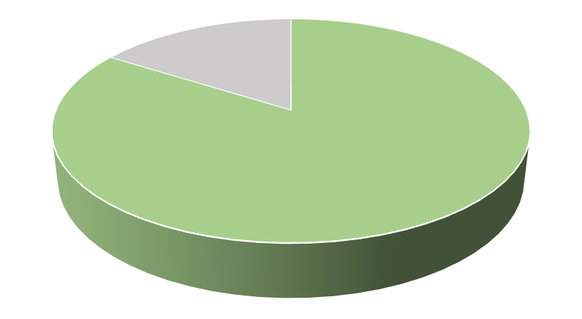 94% of Students’
IEP objectives are met or show progress

91% of Students
In Partner Program are included in

The general education setting
Upon leaving Partner Program
84%
Of students moved to a less restrictive classroom

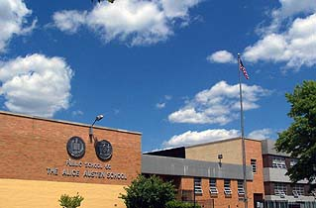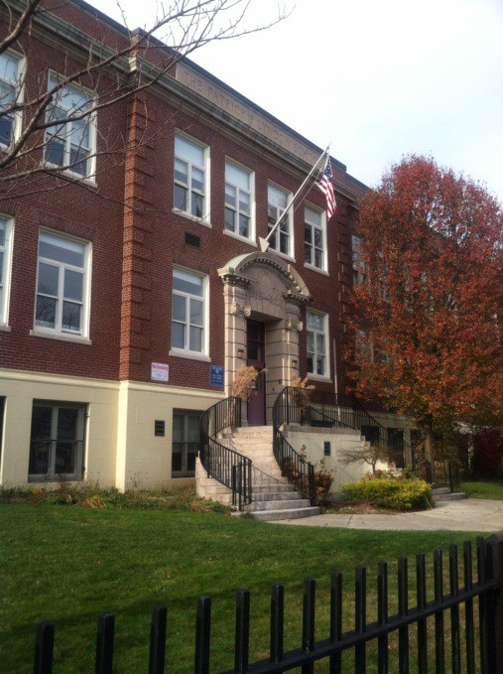City-Wide Projects

City-Wide Projects

Boston Public Schools Project, 2011-2014

SCHOOL YEAR | PROJECT SITES | FULL-TIME NECC CONSULTANTS | STUDENTS ACCESSING THE ACE®
Year 1  2011-2012 | 1 school  4 classrooms | 1 | 30
Year 2  2012-2013 | 5 schools  19 classrooms | 4 | 150
Year 3  2013-2014 | 14 Schools  76 Classrooms | 3 | 500

Ongoing ACE Use
New York City Public Schools – 400 students across 20 schools
Boston Public Schools – 1100 students across 35 schools

Consultation and Evaluation Services

Serving over 400 students across 60 schools in 5 states

Individual Students

Classrooms Programs

Districts

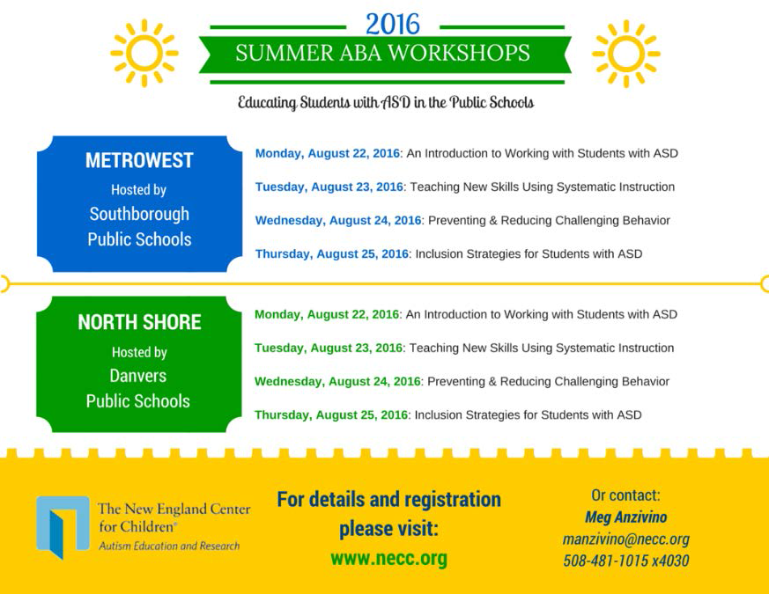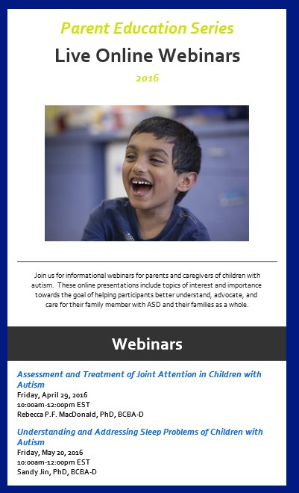Professional Development

Webinars
BCBA’s, educators, and parents

2015-2016
Over 900 participants

ABA Workshop
Series

CALM Training

PUBLIC SCHOOL Partner Program
A comprehensive seNice model p roviding an
alternative to out of district placements

SERVICES

Classrooms • Consultation • Training

f

I•t•

... ·..

39 Partner Programs
currently operating across 5 states

400+ Partner Program Students
served over the past 19 yea rs

94% of Students'
IEP objectives are met or show progress

91% of Students
In Partner Program are included in The generaleducation setting

The New Engla nd Center

100'00

80'16
Upon leaving Partner Program
84%
Of students moved to a

less restrictive classroom

Consultation & Training
Over 60 experienced BCBA•sand Special Edu cators helping districts

Increase student
+
independence

for Children•
Autism Educat,'on and Researcn
ACE

w.. Maximize inclusion op-
A
portunities

MoVID'lO'IY()5(t.llt.l£ t.: Th'k Ccrt0118ooird.lnco'l ·)6oa"":IJlOI"X '·'"'"""""'
0'erKOf'iellle i'IEW [ngtJOOU!tii:«101'C.'llkl rtt ',hrt -.lr torrr•tonct leS!IIomkHtl1e:llloeiet'l.
2

016
lncreasine Social Skills: JJ a

Build

district

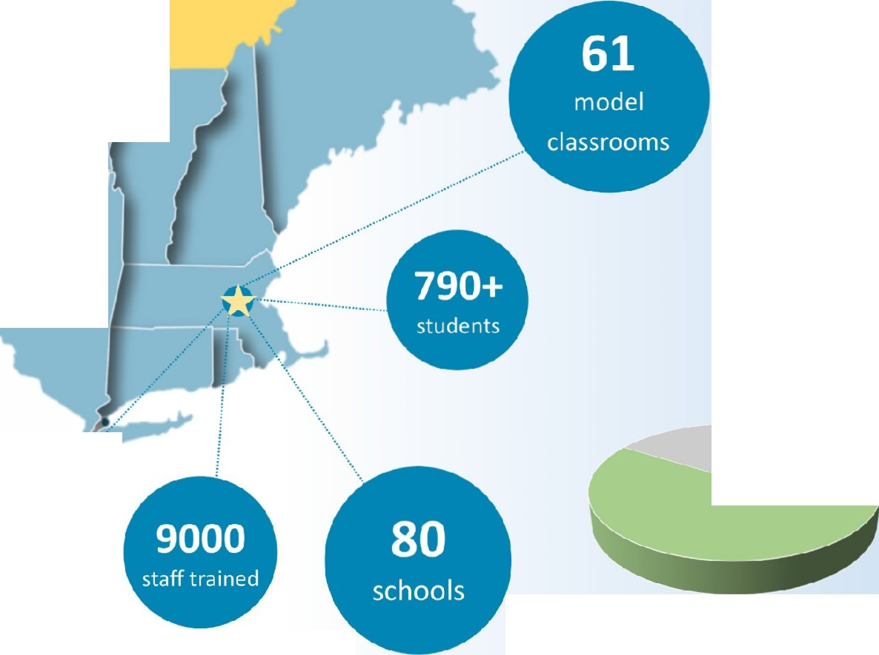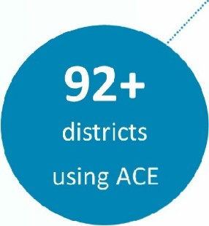JAN FEB MAR APR \AAY JUN me capacity

