INDOOR AIR QUALITY ASSESSMENT

Needham Public Schools Administration Building
1330 Highland Street
Needham, Massachusetts



Prepared by:
Massachusetts Department of Public Health
Bureau of Environmental Health
Indoor Air Quality Program
December 2015

Executive Summary
The building had no detectable levels of volatile organic compounds associated with the oil leak from the underground storage tank in all areas except along the foundation wall in the Production room. It is recommended to install and operate an exhaust fan above this location to vent residual oil odor as well as odor from the photocopiers in this room.

Background
Building: | Needham Public Schools Administration Building (NPSAB)
Address: | 1330 Highland Ave., Needham, MA
Assessment Requested by: | Timothy Muir McDonald  Director, Needham Public Health Department
Date of Assessment: | October 22, 2015
Bureau of Environmental Health/Indoor Air Quality (BEH/IAQ) Program Staff Conducting Assessment: | Michael Feeney, Director, IAQ Program
Date of Building Construction: | 1890s
Reason for Request: | IAQ concerns regarding an outdoor underground leaking oil tank
Building Description
The NPSAB is a two-story, brown brick building originally constructed in 1910 as a school. The basement previously housed the ventilation/air mixing room and boiler room. The uppermost (second) floor contains a gymnasium with stage which is currently used for storage. Windows are openable throughout the building. This space is occupied by approximately 15 employees and can be visited by 20 to 50 individuals daily.

Results and Discussion
Test results are presented in Table 1. Please refer to the IAQ Manual for methods, sampling procedures, and interpretation of results (MDPH, 2015).

Ventilation
It can be seen from Table 1 that carbon dioxide levels were below 800 parts per million (ppm) in all areas, indicating adequate air exchange at the time of assessment. It is important to note that although air exchange appeared adequate, the NPSAB is not equipped with a functioning ventilation system. The NPSAB’s original natural/gravity feed ventilation system has been abandoned, thus the sole source of ventilation in the building is openable windows. In addition, a number of areas were empty/sparsely populated at the time of the assessment, which can greatly reduce carbon dioxide levels. Carbon dioxide levels would be expected to increase with higher occupancy and windows closed.
Ventilation was originally provided by grated, louvered, wall vents (Pictures 1 and 2). The wall vents are connected by a ventilation shaft to vault-like “air-mixing” rooms in the basement (Picture 3). The draw of air into these vents is controlled by a draw chain pulley system. The chains of the pulley system were designed to set the flue in the ventilation shaft at a desired angle to adjust fresh air intake. Air movement in such a system is provided by the stack effect. Heating elements located in the base of the ventilation shaft warm the air, which rises up the ventilation shaft. As heated air rises, negative pressure is created, drawing cold air from the enclosed air-mixing rooms in the basement into the heating elements/ventilation shaft. This system was designed to draw outside air into the air-mixing rooms through windows. The percentage of fresh air into the system was controlled by sash windows in the air mixing rooms; these are currently kept closed. This original system has been abandoned and the mixing rooms are used for other purposes, however most of the ducts/shafts and vents are still present, creating pathways for air to migrate between areas of the building.
Currently ventilation is solely dependent on the use of openable windows. Window-mounted air conditioners (ACs) provide cooling as needed. Window ACs may be able to provide some fresh air when operated in “fan only” mode.

Temperature and Relative Humidity
Temperature measurements were within the MDPH recommended range (Table 1). The MDPH recommends that indoor air temperatures be maintained in a range of 70° F to 78° F in order to provide for the comfort of building occupants. In many cases concerning indoor air quality, fluctuations of temperature in occupied spaces are typically experienced, even in a building with an adequate fresh air supply. In addition, it is difficult to control temperature and maintain comfort without a functioning ventilation system.
The relative humidity measured was within the MDPH recommended comfort range in all areas (Table 1). The MDPH recommends a comfort range of 40 to 60 percent for indoor air relative humidity. Relative humidity levels in the building would be expected to drop during the winter months due to heating. The sensation of dryness and irritation is common in a low relative humidity environment. Low relative humidity is a very common problem during the heating season in the northeast part of the United States.

Other IAQ Evaluations
Indoor air quality can be negatively influenced by the presence of respiratory irritants, such as products of combustion. The process of combustion produces a number of pollutants. Common combustion emissions include carbon monoxide, carbon dioxide, water vapor, and smoke (fine airborne particle material). Of these materials, exposure to carbon monoxide and particulate matter with a diameter of 2.5 micrometers (μm) or less (PM2.5) can produce immediate, acute health effects upon exposure. To determine whether combustion products were present in the indoor environment, BEH/IAQ staff obtained measurements for carbon monoxide and PM2.5.

Carbon Monoxide
Carbon monoxide should not be present in a typical, indoor environment. If it is present, indoor carbon monoxide levels should be less than or equal to outdoor levels. On the day of assessment, outdoor carbon monoxide concentrations were non-detectable (ND) (Table 1). Carbon monoxide was ND indoors (Table 1).

Particulate Matter
Outdoor PM2.5 concentrations were measured at 15 μg/m³ (Table 1). Indoor PM2.5 levels ranged from 9 to 15 μg/m³ (Table 1), which were below the NAAQS PM2.5 level of 35 μg/m³. Frequently, indoor air levels of particulates (including PM2.5) can be at higher levels than those measured outdoors. A number of activities that occur indoors and/or mechanical devices can generate particulate during normal operations. Sources of indoor airborne particulates may include but are not limited to particles generated during the operation of fan belts in the HVAC system, use of stoves and/or microwave ovens in kitchen areas; use of photocopiers, fax machines and computer printing devices; operation of an ordinary vacuum cleaner and heavy foot traffic indoors.

Volatile Organic Compounds
In order to determine if volatile organic compounds (VOCs) were present, BEH/IAQ staff conducted air sampling for total volatile organic compounds (TVOCs) and inspected areas for products containing VOCs. On the day of the assessment, outdoor VOCs were non-detect (ND) (Table 1). No measurable levels of TVOCs were detected in all areas with the exception of the Production room, which had a range of 0.1 to 0.9 ppm at the foundation wall near the outdoor leaking oil tank (Picture 4); air tested at the center of the room had no detectable levels of TVOCs. The oil tank was removed prior to this assessment. The Licensed Site Professional (LSP) was in the process of implementing further methods to reduce/eliminate vapor intrusion from the spill.

Other Conditions
Other conditions that can affect indoor air quality were observed during the assessment. Of note was a photocopier odor in the Production room. This room did not have an operating local exhaust ventilation system. VOCs and ozone can be produced by photocopiers, particularly if the equipment is older and in frequent use. Ozone is a respiratory irritant (Schmidt Etkin, 1992). The production room is adjacent to one of the old air mixing rooms that was part of the original ventilation system of the building (Picture 3). The air mixing room is currently being used for storage and windows in the air mixing room are left closed now that the system has been abandoned. The door to the air mixing room in the Production room was ajar, presumably to have easy access to stored materials. This practice results in the distribution of basement air and photocopier operation by-products into the upper floors of the building through the stack effect.

Conclusions/Recommendations
Based on TVOC measurements, the oil spill from the underground tank is having no effect on indoor air quality except in the area directly adjacent to the foundation wall in the Production room. Based on observations at the time of assessment, a two-phase approach is required for remediation. The first consists of short-term measures to improve air quality and the second consists of long-term measures that will require planning and resources to adequately address overall concerns.

Short-term Recommendations
- Continue with the efforts to remediate the oil spill.
- Close the door between the air mixing room/storage area and the Production room.
- Close all dampers in the vents like those shown in Picture 1 to reduce pathways for odors and particulates to travel to other occupied areas.
- Consider using window ACs in fan-only mode and/or open windows to introduce fresh air during temperate weather. Ensure all windows are tightly closed at the end of the day.
- For buildings in New England, periods of low relative humidity during the winter are often unavoidable. Therefore, scrupulous cleaning practices should be adopted to minimize common indoor air contaminants whose irritant effects can be enhanced when the relative humidity is low. To control for dusts, a high efficiency particulate arrestance (HEPA) filter equipped vacuum cleaner in conjunction with wet wiping of all surfaces is recommended. Drinking water during the day can help ease some symptoms associated with a dry environment (throat and sinus irritations).
- Refer to resource manuals and other related indoor air quality documents for further building-wide evaluations and advice on maintaining public buildings. These materials are located on the MDPH’s website: http://mass.gov/dph/iaq.

Long-term Recommendations
- Consider installing an exhaust fan to vent both the base of the foundation wall and the Production room directly outside.

References
Massachusetts Department of Public Health. (MDPH). 2015. “Indoor Air Quality Manual: Chapters I-III”. Available from: http://www.mass.gov/eohhs/gov/departments/dph/programs/environmental-health/exposure-topics/iaq/iaq-manual/
Schmidt Etkin, D. 1992. Office Furnishings/Equipment & IAQ Health Impacts, Prevention & Mitigation. Cutter Information Corporation, Indoor Air Quality Update, Arlington, MA.
Picture 1
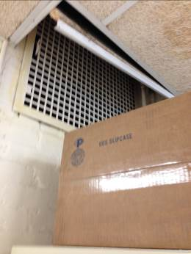
Original fresh air supply vent
Picture 2
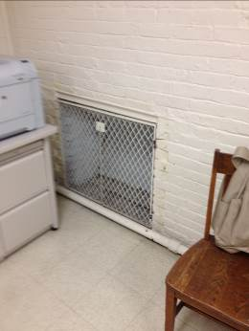
Original exhaust vent
Picture 3
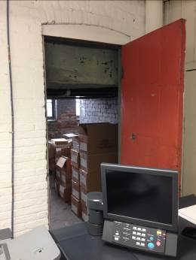
Air mixing room in Production room
Picture 4
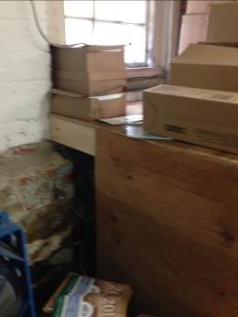
Foundation wall with measureable VOC levels behind wooden structure
Location | Carbon  Dioxide  (ppm) | Carbon Monoxide  (ppm) | Temp  (°F) | Relative  Humidity  (%) | TVOCs  (ppm) | PM2.5  (µg/m³) | Occupants  in Room | Windows  Openable | Ventilation |  |  | Remarks
 |  |  |  |  |  |  |  |  | Intake | Exhaust |  | Remarks
Background (outdoor) | 415 | ND | 48 | 75 | ND | 15
Community Education | 675 | ND | 73 | 52 | ND | 14 | 4 | N | N |  | N
1st floor hallway | 642 | ND | 73 | 51 | ND | 14 | 0 | N | N |  | N
Human Resources | 627 | ND | 74 | 51 | ND | 13 | 2 | N | N |  | N
Transportation | 692 | ND | 73 | 52 | ND | 14 | 1 | N | N |  | N
Payroll | 641 | ND | 73 | 54 | ND | 14 | 1 | N | N |  | N
HR Director | 674 | ND | 72 | 54 | ND | 15 | 2 | N | N |  | N
2nd floor hallway | 774 | ND | 72 | 53 | ND | 14 | 0 | N | N |  | N
Accounting | 650 | ND | 72 | 53 | ND | 13 | 4 | N | N |  | N
Conference room | 636 | ND | 71 | 52 | ND | 13 | 0 | N | N |  | N
Financial | 643 | ND | 71 | 53 | ND | 13 | 0 | N | N |  | N
Lunch | 642 | ND | 71 | 53 | ND | 15 | 0 | N | N |  | N
IT | 573 | ND | 71 | 53 | ND | 9 | 0 | N | N |  | N
Curriculum | 613 | ND | 73 | 54 | ND | 15 | 2 | N | N |  | N
Production | 623 | ND | 70 | 54 | 0.1-0.9 | 15 | 0 | N | N |  | N | Location of foundation wall adjacent to oil spill  Photocopiers
Curriculum office | 671 | ND | 70 | 53 | ND | 10 | 1 | N | N |  | N

