INDOOR AIR QUALITY ASSESSMENT

Needham Town Hall
1471 Highland Avenue
Needham, MA



Prepared by:
Massachusetts Department of Public Health
Bureau of Environmental Health
Indoor Air Quality Program
May 2013

Background/Introduction
At the request of Janice Berns, Health Agent, Needham Public Health Department (NPHD), the Massachusetts Department of Public Health (MDPH), Bureau of Environmental Health (BEH) provided assistance and consultation regarding indoor air quality at the Needham Town Hall (NTH) located at 1471 Highland Avenue, Needham, Massachusetts. On January 11, 2013, Michael Feeney, Director of BEH’s Indoor Air Quality (IAQ) Program, conducted a preliminary assessment at the NTH. The assessment was prompted by health concerns that staff attributed to the indoor environment. Mr. Feeney returned to the NTH on February 21, 2013 to conduct further assessment of the NPHD offices and adjacent hallway.
The NTH was originally a two-story brick building with basement constructed in 1902. An addition was built in 2011. The addition is a free-standing building connected to the original structure by a glass atrium. As part of this renovation, a new heating, ventilating and air-conditioning (HVAC) system was installed in the old building. The area beneath the main steps of the old building was excavated to create an underground chamber which contains a number of HVAC system components, as well as sump pumps. Offices were retrofitted with fan coil units (FCUs). The original window systems were retained in the old building. Windows originally at the rear of the old building are now enclosed within the atrium. Other windows in the building are openable.

Methods
Air tests for carbon monoxide, carbon dioxide, temperature and relative humidity were conducted with the TSI, Q-Trak, IAQ Monitor, Model 7565. Air tests for airborne particle matter with a diameter less than 2.5 micrometers were taken with the TSI, DUSTTRAK™ Aerosol Monitor Model 8520. Surface temperatures of window panes were measured with a ThermoTrace infrared thermometer. BEH/IAQ staff also performed a visual inspection of building materials for water damage and/or microbial growth.

Results
The building has approximately 40 staff members. Tests for carbon dioxide, carbon monoxide, temperature, relative humidity and PM2.5 were taken on January 11, 2013 during normal operations, and results appear in Table 1. Surface temperatures of window panes were measured on February 21, 2013 and results appear in Table 2.

Discussion

Ventilation
It can be seen from Table 1 that carbon dioxide levels were above 800 parts per million (ppm) in 10 of 28 areas, indicating suboptimal air exchange in over a third of the areas in the building at the time of assessment. Note that the building was sparsely populated at the time of testing, which would reduce carbon dioxide levels. Greater occupancy would increase carbon dioxide levels, especially in smaller office areas.
Fresh air to office space in the old building and the first floor of the new addition is supplied by fan coil units (FCUs) that have been configured to approximate the function of a unit ventilator (univent) system (Picture 1). In a traditional design, a univent draws outdoor air through a fresh air intake located on the exterior wall of the building and returns air from the room through an air intake located at the base of the unit (Figure 1). Fresh and return air are mixed, filtered, heated/cooled, and then provided through an air diffuser located in the top of the unit. The design of the fresh air supply using FCUs in the NTH is unique in the experience of the IAQ Program. According to blueprints of the HVAC system, fresh air is provided by an air handling unit (AHU) located in an underground chamber that exists beneath the front stairs of the old building (Figure 2; Picture 2). This AHU is connected to ductwork which has a number of branches of reduced diameter, which terminate beneath the FCUs. It appears that holes were cut into the floor of the original building beneath each FCU, which are connected by ducts to the AHU (Figure 3). The purpose of the AHU in the underground chamber is to drive fresh outdoor air through the ductwork system, which would then be drawn by the FCUs through the openings in the floor.
Fresh air in the second floor of the new building is provided by ceiling-mounted air diffusers connected to an AHU housed in a mechanical room in the attic. Heating and cooling in offices on the second floor is supplemented by the use of FCUs which recirculate and heat/cool the air but do not provide additional fresh air supply. The auditorium of the old building has its own AHU installed in the attic of the old building.
BEH/IAQ staff examined blueprints related to the NTH renovation specifically related to the NPHD offices. Of note was the duct and piping system plans, which indicated the interior rooms were to be heated/cooled using both ceiling-mounted air diffusers and FCUs (Figures 4 and 5). This configuration is unusual; interior areas typically use only ceiling-mounted air diffusers for heating, cooling and fresh air. All other spaces in the building have either FCUs located under windows or are configured to have the ceiling-mounted diffusers as the sole source of fresh air as noted in Figure 3. Excessive airflow from the ceiling-mounted fresh air diffusers and FCUs in interior offices of the NPHD may decrease comfort for some occupants, as well as be a source of continuous noise that some individuals may find irritating.
BEH/IAQ staff examined the interior conditions of FCUs in selected areas of the building. It appeared that the FCUs have two different designs: some FCUs have racks to install filters on a slant (Picture 3), while the FCUs in the NPHD interior offices have tabs to install the filters parallel to the floor (Picture 4). The NPHD FCUs in interior offices had components (the fans and electrical service) installed in a manner that prohibits the proper installation of filters (Picture 5). In this condition, unfiltered air would be circulated with dust and other debris that may become readily aerosolized. Properly fitting filters are needed to remove particulates from the air before it is circulated.
Spaces were also observed in the interior cabinet of FCUs above the filters (Picture 6). These gaps should be sealed with an appropriate fire-rated material to prevent the draw of odors and materials from other areas of the building into the FCUs. Please note, some FCUs are difficult to access due to partition walls that prevent access to the main compartment.
Exhaust ventilation in the building complex could not be readily identified. According to blueprints, the exhaust system is designed to use a combination of floor and ceiling-mounted vents connected to ductwork. Frequently, floor vents can become blocked by furniture or stored materials. Without adequate exhaust ventilation, excess heat and normally-occurring indoor air pollutants can accumulate, leading to indoor air/comfort complaints.
To maximize air exchange, the MDPH recommends that both supply and exhaust ventilation operate continuously during periods of occupancy. In order to have proper ventilation with a mechanical supply and exhaust system, the systems must be balanced to provide an adequate amount of fresh air to the interior of a room while removing stale air from the room. It is recommended that HVAC systems be re-balanced every five years to ensure adequate air systems function (SMACNA, 1994). Balancing of the ventilation system should have occurred prior to the opening of the addition in 2011.
Minimum design ventilation rates are mandated by the Massachusetts State Building Code (MSBC). Until 2011, the minimum ventilation rate in Massachusetts was higher for both occupied office spaces and general classrooms, with similar requirements for other occupied spaces (BOCA, 1993). The current version of the MSBC, promulgated in 2011 by the State Board of Building Regulations and Standards (SBBRS), adopted the 2009 International Mechanical Code (IMC) to set minimum ventilation rates. Please note that the MSBC is a minimum standard that is not health-based. At lower rates of cubic feet per minute (cfm) per occupant of fresh air, carbon dioxide levels would be expected to rise significantly. A ventilation rate of 20 cfm per occupant of fresh air provides optimal air exchange resulting in carbon dioxide levels at or below 800 ppm in the indoor environment in each area measured. MDPH recommends that carbon dioxide levels be maintained at 800 ppm or below. This is because most environmental and occupational health scientists involved with research on IAQ and health effects have documented significant increases in indoor air quality complaints and/or health effects when carbon dioxide levels rise above the MDPH guidelines of 800 ppm for schools, office buildings and other occupied spaces (Sundell, J. et al., 2011). The ventilation must be on at all times that the room is occupied. Providing adequate fresh air ventilation with open windows and maintaining the temperature in the comfort range during the cold weather season is impractical. Mechanical ventilation is usually required to provide adequate fresh air ventilation.
Carbon dioxide is not a problem in and of itself. It is used as an indicator of the adequacy of the fresh air ventilation. As carbon dioxide levels rise, it indicates that the ventilating system is malfunctioning or the design occupancy of the room is being exceeded. When this happens, a buildup of common indoor air pollutants can occur, leading to discomfort or health complaints. The Occupational Safety and Health Administration (OSHA) standard for carbon dioxide is 5,000 parts per million parts of air (ppm). Workers may be exposed to this level for 40 hours/week, based on a time-weighted average (OSHA, 1997).
The MDPH uses a guideline of 800 ppm for publicly occupied buildings. A guideline of 600 ppm or less is preferred in schools due to the fact that the majority of occupants are young and considered to be a more sensitive population in the evaluation of environmental health status. Inadequate ventilation and/or elevated temperatures are major causes of complaints such as respiratory, eye, nose and throat irritation, lethargy and headaches. For more information concerning carbon dioxide, consult Appendix A.
Indoor temperature measurements ranged from 70ºF to 75ºF, which were within the MDPH recommended comfort range (Table 1). The MDPH recommends that indoor air temperatures be maintained in a range of 70ºF to 78ºF in order to provide for the comfort of building occupants. In many cases concerning indoor air quality, fluctuations of temperature in occupied spaces are typically experienced, even in a building with an adequate fresh air supply.
The relative humidity in the building on the day of assessment ranged from 18 to 26 percent, which was below the MDPH recommended comfort range (Table 1). The MDPH recommends a comfort range of 40 to 60 percent for indoor air relative humidity. Relative humidity levels in the building would be expected to drop during the winter months due to heating. The sensation of dryness and irritation is common in a low relative humidity environment. Low relative humidity is a very common problem during the heating season in the northeast part of the United States.

Microbial/Moisture Concerns
FCUs throughout the building are designed to provide both heat and chilled air. The FCUs are equipped with drip pans to collect condensation when the units are operating in cooling mode. As reported by town officials, pipes connected to the cooling coils were retrofitted with insulation to prevent condensation generation. Insulation of coolant supply pipes is essential to prevent condensation on the pipes during hot humid weather. If HVAC system components are not insulated properly, water damage can occur inside FCU cabinets, as well as to building materials through which the pipes pass. Signs of condensation accumulation were seen inside several FCU cabinets. In addition, BEH/IAQ staff noted that FCUs were not installed flush with the floor and do not have insulation on the underside of the cabinet to prevent condensation (Picture 7). BEH/IAQ staff were able to insert a ruler into the space beneath an FCU in the NPHD along the exterior wall, indicating an open air space. Paper instruction manuals were also found in the space beneath FCU cabinets (Picture 8). If moistened, porous materials such as paper can readily grow mold.
Of note is the drain system connected to drip pans. Typically FCUs have a trap installed inside the cabinet. The drains in the FCUs appear to not have traps (Picture 9). The lack of a trap may result in odors and other pollutants from the drain system being drawn and distributed into the room by FCU fans.
Another potential source of moisture is related to the window installation in the addition. During the February 21, 2013 visit, BEH/IAQ staff conducted surface temperature measurement of window frames in the second-floor offices of the addition. If the exterior walls of the building were properly insulated, the temperature of the interior side of exterior walls and floors would be close to the indoor temperature (Table 2), approximately 71°F. The temperature of window frames was measured in a range of 54°F to 62°F (Table 2). These temperatures indicate that the window frames may not be appropriately insulated to prevent heat loss.
The difference in temperature indicates that the window/wall system is not energy efficient and can serve as a thermal bridge. Where a thermal bridge exists, condensation is likely to form on the warm air side of the cold object, which can moisten building materials such as the window well and gypsum wallboard. In hot, humid weather, the lowering of temperature by the cooling system could potentially lead to the accumulation of condensation along the interior/base of window frames.
The wood flooring on the second floor of the addition appears to consist of manufactured wood installed over a cement floor decking (Picture 10). Spaces could be observed along seams formed where the flooring meets the hallway wall (Pictures 11 and 12). Spaces and gaps in the wood flooring can allow moisture and materials to accumulate under the flooring, particularly if the floor is routinely wet mopped. The decking beneath the wood flooring would hold moisture against the underside of the wood, preventing proper drying and potentially allowing mold to grow.
Repeated water damage to porous building materials (e.g., wood, ceiling tiles, carpeting) can result in microbial growth. The US Environmental Protection Agency (US EPA) and the American Conference of Governmental Industrial Hygienists (ACGIH) recommend that porous materials be dried with fans and heating within 24 to 48 hours of becoming wet (US EPA, 2001; ACGIH, 1989). If not dried within this time frame, mold growth may occur. Once mold has colonized porous materials, they are difficult to clean and should be removed.

Other IAQ Evaluations
Indoor air quality can be negatively influenced by the presence of respiratory irritants, such as products of combustion. The process of combustion produces a number of pollutants. Common combustion emissions include carbon monoxide, carbon dioxide, water vapor and smoke (fine airborne particle material). Of these materials, exposure to carbon monoxide and particulate matter with a diameter of 2.5 micrometers (μm) or less (PM2.5) can produce immediate, acute health effects upon exposure. To determine whether combustion products were present in the indoor environment, BEH/IAQ staff obtained measurements for carbon monoxide and PM2.5.

Carbon Monoxide
Carbon monoxide is a by-product of incomplete combustion of organic matter (e.g., gasoline, wood and tobacco). Exposure to carbon monoxide can produce immediate and acute health affects. Several air quality standards have been established to address carbon monoxide and prevent symptoms from exposure to these substances. The MDPH established a corrective action level concerning carbon monoxide in ice skating rinks that use fossil-fueled ice resurfacing equipment. If an operator of an indoor ice rink measures a carbon monoxide level over 30 ppm, taken 20 minutes after resurfacing within a rink, that operator must take actions to reduce carbon monoxide levels (MDPH, 1997).
ASHRAE has adopted the National Ambient Air Quality Standards (NAAQS) as one set of criteria for assessing indoor air quality and monitoring of fresh air introduced by HVAC systems (ASHRAE, 1989). The NAAQS are standards established by the US EPA to protect the public health from six criteria pollutants, including carbon monoxide and particulate matter (US EPA, 2006). As recommended by ASHRAE, pollutant levels of fresh air introduced to a building should not exceed the NAAQS levels (ASHRAE, 1989). The NAAQS were adopted by reference in the Building Officials & Code Administrators (BOCA) National Mechanical Code of 1993 (BOCA, 1993), which is now an HVAC standard included in the Massachusetts State Building Code (SBBRS, 2011). According to the NAAQS, carbon monoxide levels in outdoor air should not exceed 9 ppm in an eight-hour average (US EPA, 2006).
Carbon monoxide should not be present in a typical, indoor environment. If it is present, indoor carbon monoxide levels should be less than or equal to outdoor levels. Outdoor carbon monoxide concentrations were non-detect (ND) at the time of the January 11, 2013 assessment (Table 1). Carbon monoxide levels measured inside the building ranged from ND to 1.5 ppm (Table 1). These low levels of carbon monoxide may be due to fresh air being drawn from the subterranean cement-lined pit located next to a parking space at the front of the building (Picture 13). Under certain wind/weather conditions exhaust from idling vehicles in this location can be entrained by the HVAC system and distributed throughout the original building and the first floor of the addition. Serious consideration should be given to relocating this parking space.

Particulate Matter (PM2.5)
The US EPA has established NAAQS limits for exposure to particulate matter. Particulate matter includes airborne solids that can be irritating to the eyes, nose and throat. The NAAQS originally established exposure limits to PM with a diameter of 10 μm or less (PM10). In 1997, US EPA established a more protective standard for fine airborne particulate matter with a diameter of 2.5 μm or less (PM2.5). The NAAQS has subsequently been revised, and PM2.5 levels were reduced. This more stringent PM2.5 standard requires outdoor air particle levels be maintained below 35 μg/m³ over a 24-hour average (US EPA, 2006). Although both the ASHRAE standard and BOCA Code adopted the PM10 standard for evaluating air quality, MDPH uses the more protective PM2.5 standard for evaluating airborne PM concentrations in the indoor environment.
Outdoor PM2.5 concentrations during the January 11, 2013 visit were measured at 16 μg/m³ (Table 1). PM2.5 levels measured inside the building were between 2 to 9 μg/m³ (Table 1). Both indoor and outdoor PM2.5 levels were below the NAAQS PM2.5 level of 35 μg/m³. Frequently, indoor air levels of particulates (including PM2.5) can be at higher levels than those measured outdoors. A number of mechanical devices and/or activities that occur in buildings can generate particulate during normal operations. Sources of indoor airborne particulates may include but are not limited to particles generated during the operation of fan belts in the HVAC system, cooking in stoves and microwave ovens; use of photocopiers, fax machines and computer printing devices; operation of an ordinary vacuum cleaner and heavy foot traffic indoors.

Other Conditions
There were reports of sewer odors that periodically occur in the south stairwell and elevator area of the addition. At the base of the south stairwell is a sewage ejector pump (Picture 14). In the experience of the IAQ Program, this type of sewage system component may not be airtight, resulting in sewer odors and water vapor escaping from the pump. Odors and water vapor can enter the stairwell and elevator shaft. It is also important to note that other sewage ejector pumps are located in the underground chamber containing the building’s main HVAC system, which could also provide a source of odors.
Finally, the odor of photocopier emissions was noted in room 046 when this equipment was not in use. This area is not equipped with local exhaust ventilation to help reduce excess heat and odors. VOCs and ozone can be produced by photocopiers, particularly if the equipment is older and in frequent use. Ozone is a respiratory irritant (Schmidt Etkin, 1992).

Conclusions/Recommendations
Based on measurements and observations at the time of assessment, the following recommendations are made to improve indoor air quality:
- Discontinue the use of FCUs in the NPHD interior offices. Shut off the coolant supply to these units to prevent condensation generation in hot, humid weather and seal the drip pan.
- Ensure that FCU filters are installed properly. This may require reconfiguring the wiring of some FCUs or retrofitting filter racks so that filters can be installed in a manner to prevent drawn air by-passing filters.
- Seal all holes in the walls of the FCU cabinets to limit filter bypass. Double sided, foil-faced insulation with adhesive or aluminum insulation tape can be applied in a manner to create an airtight seal.
- Repair/install fan speed controls in FCUs.
- Remove all blockages from FCUs to ensure adequate airflow. NTH staff should be encouraged not to deactivate FCUs and to report any complaints concerning temperature control to the facilities department.
- Determine if exhaust vents exist under/behind furniture/stored items as indicated on the plans. If so, ensure that the fans for these vents are functioning to remove stale air and associated pollutants. If no exhaust vents exist, consider discussing the installation of exhaust ventilation with an HVAC engineer.
- Use openable windows in conjunction with mechanical ventilation to increase air exchange. Care should be taken to ensure windows are properly closed at night and weekends to avoid the freezing of pipes and potential flooding. Windows should not be opened when the HVAC system is in cooling mode, particularly during hot, humid weather conditions.
- Consider adopting a balancing schedule of every 5 years for all mechanical ventilation systems, as recommended by ventilation industrial standards (SMACNA, 1994).
- For buildings in New England, periods of low relative humidity during the winter are often unavoidable. Therefore, scrupulous cleaning practices should be adopted to minimize common indoor air contaminants whose irritant effects can be enhanced when the relative humidity is low. To control for dusts, a high efficiency particulate arrestance (HEPA) filter equipped vacuum cleaner in conjunction with wet wiping of all surfaces is recommended. Avoid the use of feather dusters. Drinking water during the day can help ease some symptoms associated with a dry environment (throat and sinus irritations).
- Consult with HVAC engineer/plumber to determine:
  - if traps can be retrofitted into FCU condensate drains; and
  - if FCU components can/should be insulated to prevent/reduce condensation.
- Remove porous materials (e.g., paper) from beneath/within FCUs.
- Clean/disinfect areas of water leaks/condensation within FCU cabinets with an appropriate antimicrobial, as needed.
- Consult with a building engineering contractor to consider adding additional insulation or other modifications to the window systems to prevent energy loss, thermal bridging and related condensation problems.
- Properly seal the edge of flooring in the atrium’s second floor hallway to prevent mop water from moistening the space between the wood and cement decking. Consider other means of cleaning this floor in lieu of wet mopping.
- Refer to “Mold Remediation in Schools and Commercial Buildings” published by the US Environmental Protection Agency (US EPA, 2001) for information concerning mold growth and remediation of water-damaged materials. This document can be downloaded from the US EPA website at: http://www.epa.gov/mold/mold_remediation.html.
- Consider relocating the parking space shown in Picture 13 to prevent products of combustion from being entrained into the HVAC system.
- Render airtight all sewer ejector pumps. If possible, install mechanical exhaust ventilation in mechanical rooms with such equipment.
- Consider installing local exhaust ventilation to remove photocopier pollutants from room 046.
- Refer to resource manual and other related indoor air quality documents located on the MDPH’s website for further building-wide evaluations and advice on maintaining public buildings. These documents are available at: http://mass.gov/dph/iaq

References
ACGIH. 1989. Guidelines for the Assessment of Bioaerosols in the Indoor Environment. American Conference of Governmental Industrial Hygienists, Cincinnati, OH.
ASHRAE. 1989. Ventilation for Acceptable Indoor Air Quality. American Society of Heating, Refrigeration and Air Conditioning Engineers. ANSI/ASHRAE 62-1989.
BOCA. 1993. The BOCA National Mechanical Code/1993. 8th ed. Building Officials & Code Administrators International, Inc., Country Club Hills, IL.
MDPH. 1997. Requirements to Maintain Air Quality in Indoor Skating Rinks (State Sanitary Code, Chapter XI). 105 CMR 675.000. Massachusetts Department of Public Health, Boston, MA.
OSHA. 1997. Limits for Air Contaminants. Occupational Safety and Health Administration. Code of Federal Regulations. 29 C.F.R 1910.1000 Table Z-1-A.
SBBRS. 2011. Mechanical Ventilation. State Board of Building Regulations and Standards. Code of Massachusetts Regulations, 8th edition. 780 CMR 1209.0.
Schmidt Etkin, D. 1992. Office Furnishings/Equipment & IAQ Health Impacts, Prevention & Mitigation. Cutter Information Corporation, Indoor Air Quality Update, Arlington, MA.
SMACNA. 1994. HVAC Systems Commissioning Manual. 1st ed. Sheet Metal and Air Conditioning Contractors’ National Association, Inc., Chantilly, VA.
Sundell et. el. 2001. Sundell, J., H. Levin, W. W. Nazaroff, W. S. Cain, W. J. Fisk, D. T. Grimsrud, F. Gyntelberg, Y. Li, A. K. Persily, A. C. Pickering, J. M. Samet, J. D. Spengler, S. T. Taylor, and C. J. Weschler. Ventilation rates and health: multidisciplinary review of the scientific literature. Indoor Air, Volume 21: pp 191–204.
US EPA. 2001. “Mold Remediation in Schools and Commercial Buildings”. Office of Air and Radiation, Indoor Environments Division, Washington, DC. EPA 402-K-01-001. March 2001. Available at: http://www.epa.gov/mold/mold_remediation.html.
US EPA. 2006. National Ambient Air Quality Standards (NAAQS). US Environmental Protection Agency, Office of Air Quality Planning and Standards, Washington, DC. http://www.epa.gov/air/criteria.html.
Figure 2

Fresh Air is Provided by an Air Handling Unit (AHU) Located in an Underground Chamber

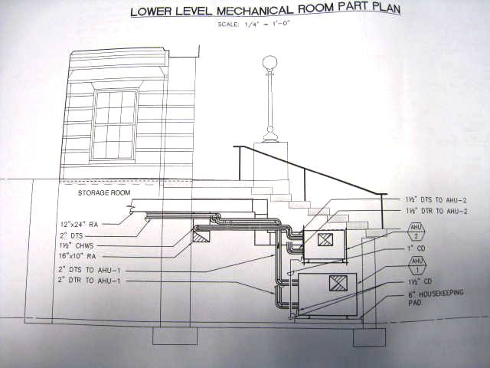

Figure 3

Detail of Design for Floor-Mounted Fresh Air Supplies beneath FCUs

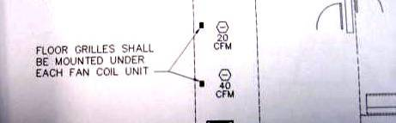
Figure 4

Public Health Department Offices with Ceiling-Mounted Fresh Air Diffusers
(arrow indicates example fresh air diffuser)

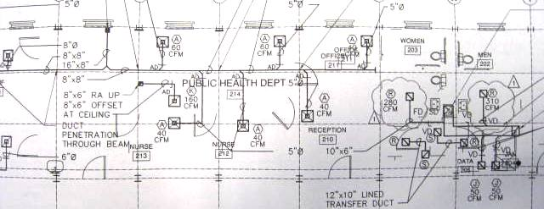

Figure 5

Public Health Department Offices with Ceiling-Mounted Fan Coil Unit (FCU)
(arrow indicates example of FCU)

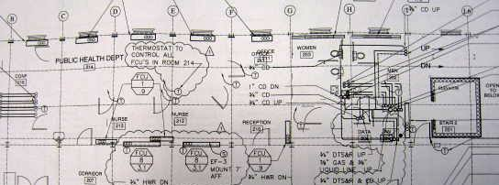

Picture 1

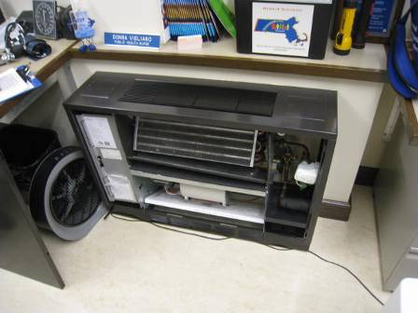

Example of an FCU installation

Picture 2

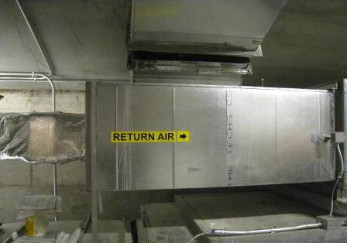

Fresh air AHU located in the underground chamber beneath the front stairs
of the original building

Picture 3

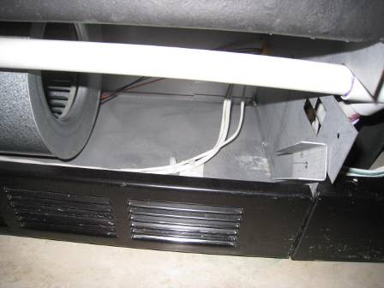

FCU with slanted filter rack, arrow notes hole in cabinet

Picture 4

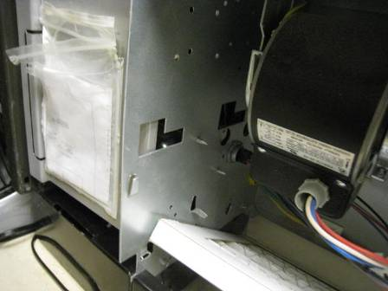

FCU with metal tab (arrow) to install filter parallel to floor

Picture 5

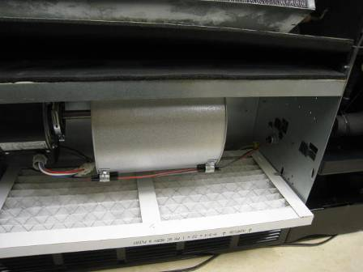

FCUs with interior components that prohibit the proper installation of filters

Picture 6

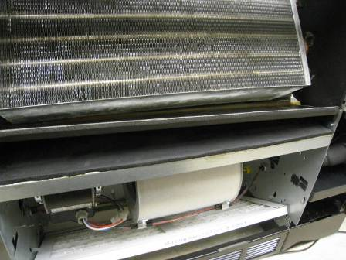

Example of space (arrow) in the interior cabinet of FCU above the filters

Picture 7

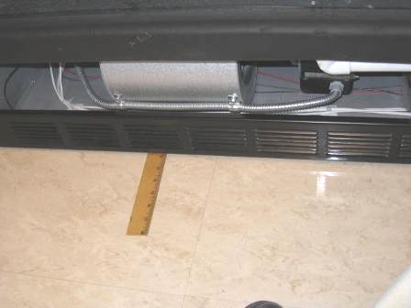

Space beneath FCU as indicated by ruler

Picture 8

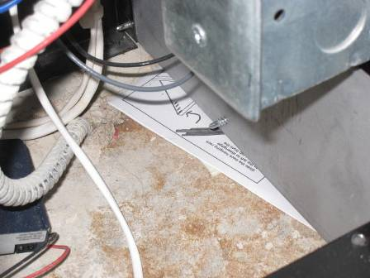

Paper instructions were also found in the space beneath FCU cabinets

Picture 9

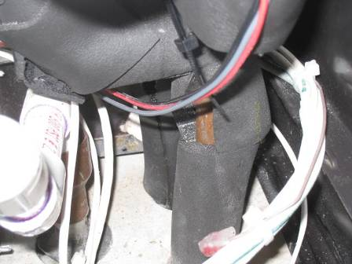

Drains in FCU appear to have no trap

Picture 10

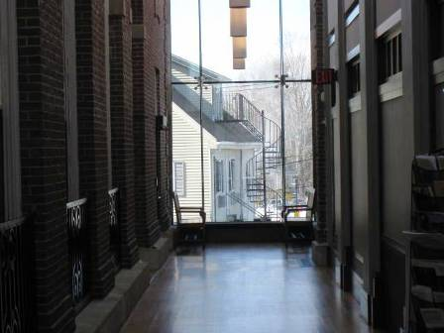

Atrium hallway floor of manufactured wood installed over a cement floor decking

Picture 11

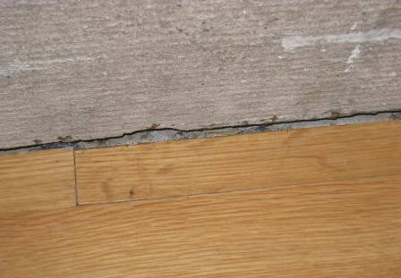

Space (black arrow) along seams where flooring meets hallway wall
(white arrow shows warping floorboard)

Picture 12

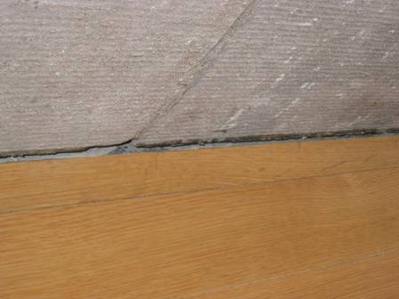

Spaces (black arrow) along seams where flooring meets hallway wall

Picture 13

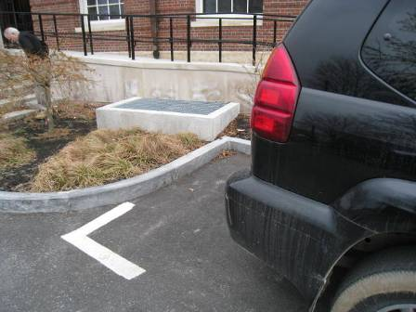

The fresh air intake (in cement lined pit) next to a parking space

Picture 14

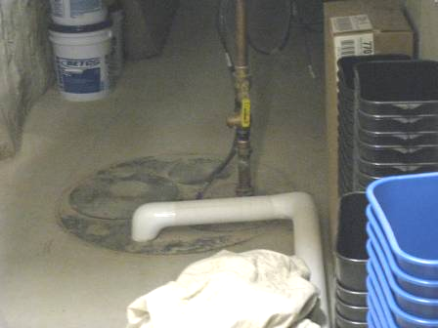

Example of sewage ejector sump pump area
Location | Carbon  Dioxide  (*ppm) | Carbon Monoxide  (*ppm) | Temp  (°F) | Relative  Humidity  (%) | PM2.5  (ug/m³) | Occupants  in Room | Windows  Openable | Ventilation |  |  | Remarks
 |  |  |  |  |  |  |  | Intake | Exhaust |  | Remarks
Background (outdoors) | 431 | ND | 42 | 42 | 16
014 | 570 | ND | 71 | 26 | 8 | 2 | Y | Y |  | Y
021 | 737 | ND | 73 | 22 | 7 | 1 | N | Y |  | Y
022 | 576 | ND | 73 | 21 | 8 | 1 | N | Y |  | N
023 | 802 | ND | 73 | 23 | 7 | 1 | N | Y |  | N
030 | 501 | ND | 70 | 22 | 9 | 0 | N | Y |  | Y
037 | 989 | ND | 73 | 24 | 7 | 4 | Y | Y |  | N
046 | 554 | ND | 72 | 20 | 8 | 1 | N | Y |  | N | Photocopier room
047 | 587 | ND | 73 | 21 | 7 | 0 | N | Y |  | N | Kitchen
048 | 613 | ND | 73 | 22 | 6 | 2 | N | Y |  | N
112 | 660 | 1 | 72 | 21 | 7 | 3 | Y | Y |  | N | Door open
116 | 736 | 1 | 73 | 21 | 4 | 2 | N | Y |  | N
130 | 639 | 1 | 71 | 22 | 7 | 1 | N | Y |  | N
132 | 689 | 1 | 72 | 20 | 6 | 2 | Y | Y |  | N
210 | 1088 | 1 | 74 | 22 | 4 | 1 | N | Y |  | N
214 | 936 | 1 | 75 | 22 | 3 | 2 | N | Y |  | N | FCU  Door open
216 | 848 | 1.5 | 75 | 22 | 3 | 0 | Y | Y |  | N | FCU  Door open
Assessor’s Asst. Dir. | 799 | 1 | 73 | 21 | 5 | 1 | N | Y |  | N | Door open
Assessor’s office | 673 | 1 | 73 | 20 | 6 | 1 | Y | Y |  | N
Assist. Treasurer | 731 | 1 | 73 | 20 | 6 | 1 | Y | Y |  | N
Atrium hallway 2nd floor | 587 | 1 | 74 | 19 | 6 | 0 | N | Y |  | Y
Auditorium | 491 | 1 | 71 | 18 | 6 | 0 | Y | Y |  | Y
Board of Health Main office | 969 | 1 | 74 | 22 | 2 | 0 | Y | Y |  | Y | FCU, Door open
Board of Health Nurse’s room | 947 | 1 | 75 | 22 | 2 | 0 | N | Y |  | Y | FCU
Controller | 861 | ND | 73 | 24 | 7 | 1 | Y | Y |  | N | Door for fire sprinkler system in room
Town Clerk | 731 | 1 | 72 | 21 | 7 | 1 | Y | Y |  | N
Town Clerk | 802 | 1 | 72 | 24 | 6 | 4 | Y | Y |  | N
Town Clerk Asst. | 564 | 1 | 73 | 22 | 5 | 1 | N | Y |  | N
Youth Division | 824 | ND | 73 | 23 | 7 | 3 | Y | Y |  | N | Door open

Location | RoomTemp  (°F) | Relative  Humidity  (%) | Window Sill  Temp  (°F)
216 | 71 | 12 | 54
214 northeast window | 71 | 12 | 54
214 middle window | 71 | 11 | 54
214 southeast window | 71 | 11 | 62
211 | 71 | 12 | 53

Condensation is the collection of moisture on a surface with a temperature below the dew point. The dew point is a temperature determined by air temperature and relative humidity. For example, at a temperature of 73ºF and relative humidity of 57 percent indoors, the dew point for water to collect on a surface is approximately 57ºF.
A thermal bridge is an object (usually metallic) in a wall space through which heat is transferred at a greater rate than materials surrounding it. During the heating season, the window comes in contact with heated air from the interior and chilled air from the outdoors, resulting in condensation formation if the window temperature is below the dew point.

