Massachusetts Maternal, Infant, and Early Childhood Home Visiting (MA MIECHV)
2020 Needs Assessment
Prepared by Tufts Interdisciplinary Evaluation Research (TIER) for the Massachusetts Department of Public Health

October 1, 2020

Jessica Goldberg
Rebecca Fauth
Danyel Vargas Moosmann
Jessica Greenstone Winestone
Marianna Litovich

With many thanks to our Community Evaluators:
Lisa Baumbach, Elizabeth Bostic, Crystal Evans, Shenell Ford, Nneka Hall, Susan Lemere,
Nina McDonald, Consuelo Perez, Janelle Pocowatchit, Nicole Rioux,
Gloria Vasquez, & Christian White

Suggested citation: Goldberg, J., Fauth, R.C., Vargas Moosmann, D., Greenstone Winestone, J, & Litovich, M (2020). Massachusetts Maternal, Infant, and Early Childhood Home Visiting (MA MIECHV) 2020 Needs Assessment. Report to the Massachusetts Department of Public Health (MDPH): Medford, MA: Tufts Interdisciplinary Evaluation Research (TIER).

Acknowledgements
Many thanks to our students and interns:
- Justin Birudavol
- Andrea Bucciarelli
- Naomi Dulit-Greenberg
- Rashmitha Edem
- Tierra Holmes
- Melissa Lovitz
- Anna Marin
- Akriti Pandit
- Mindy Rosengarten
- Lauren Stargel
- Olivia Ward

Thank you to our colleague, Melissa Colón, who played a critical role in the conceptualization of the community evaluator model. She outlined the vision for the community evaluator collaboration, led the recruitment process, and led the early training of community evaluators.

Much appreciation to the organizations, community leaders, and community members who supported this project.

Thank you to our colleagues at the Massachusetts Department of Public Health, for their support, collaboration, and valuable feedback.

Finally, and most important, thank you to the home visitors and families for their time and wisdom.

Contents
Section I. Introduction 1
Section II. Methods 1
II.A. State Needs Assessment Review 1
II.B. Analysis of Data Indicators 2
II.B.1. Unit of Analysis 2
II.B.2. Domains and Indicators 2
II.B.3. Data Analysis 2
II.C. Home Visiting Capacity Survey 4
II.C.1. Distribution 4
II.C.2. Respondent Samples 5
II.C.3. Data Coding and Analysis 5
II.D. Focus Groups 6
II.D.1. Community Evaluator Model 6
II.D.2. Identification of Focus Group Populations, Recruitment, and Procedures 6
II.D.3. Samples 7
II.D.4. Coding and Analysis 7
II.E. Substance Use Sub-Study 7
II.E.1. SUD Services Data Mapping 7
II.E.2. FIRST Steps Together Exceptions Summary 8
II.E.3. SUD-Focused Interviews and Focus Groups 8
II.E.4. Summary of MA MIECHV Site Visit Reports FYs 2016 to 2018 8
II.F. Cause and Effect “Fishbone” Diagram with the Addition of Cards (CEDAC) Exercise with MA MIECHV Grantees 9
II.G. Coordination with the Head Start, Title V, and CAPTA Needs Assessments 9
II.H. Methods Summary 10
Section III. Results 10
III.A. Identifying Communities with the Greatest Public Health Challenges 11
III.A.1. State-Level Findings 11
III.A.2. City/Town-Level Findings 19
III.A.3. Additional Communities Experiencing Challenges Related to Specific Indicators 23
III.B. Identify the Quality and Capacity of Existing Programs or Initiatives for Early Childhood Home Visiting in the State. 24
III.B.1. Massachusetts Home Visiting Landscape: Programs and Populations 24
III.B.2. Meeting the Needs of Massachusetts Families Through Home Visiting 29
III.B.3. Early Childhood Systems of Care: Coordination and Collaboration 32
III.C. State’s capacity for providing substance abuse treatment and counseling services 36
III.C.1. SUD-Related Needs and Service Availability across Massachusetts 36
III.C.2. Training needs 38
III.C.3. Collaborations with Other Services 38
III.C.4. The Role of DCF 38
III.C.5. Promising Approaches in Home Visiting for Participants Experiencing SUD 39
Section IV. Conclusions and Recommendations 40
IV.A. Identifying Communities with the Greatest Public Health Challenges 40
IV.B. Home Visiting Capacity and Community Systems of Care 42
IV.B.1. Build Home Visiting Coalitions at the Community Level 42
IV.B.2. Ensuring a Continuum of Care 44
IV.B.3. Value and Cultivate the Home Visiting Workforce 46
IV.C. Providing Supportive Services to Families Experiencing Challenges Related to Substance Use 47
IV.D. Addressing Racial Equity Through MA MIECHV 48
References 51

Tables
Table II.1. Data Collection Activities and Needs Assessment Area 10
Table III.1. Region, County, and Ranking by Public Health Challenges Across the Nine Domains for the 17 Communities 20
Table III.2. Region and County for Additional Communities 23
Table III.3. Families served, by Percent Ethnicity, Race, and Language Across Programs 26
Table III.4. MassHealth Use and DCF Involvement (program sample, n = 132) 28
Table III.5. Municipalities Ranked in the Top Ten for SUD-Related Challenges, with Overall City/Town Ranking 36

Figures
Figure III.1. Massachusetts Cities and Towns with the Highest Rankings in the SES Domain 12
Figure III.2. Massachusetts Cities and Towns with the Highest Rankings in the Housing Domain 13
Figure III.3. Massachusetts Cities and Towns with the Highest Rankings in the Populations of Special Interest Domain 14
Figure III.4. Massachusetts Cities and Towns with the Highest Rankings in the SUD Domain 15
Figure III.5. Massachusetts Cities and Towns with the Highest Rankings in the Crime Domain 15
Figure III.6. Massachusetts Cities and Towns with the Highest Rankings in the Unintentional Injuries Domain 16
Figure III.7. Massachusetts Cities and Towns with the Highest Rankings in the Child Maltreatment Domain 17
Figure III.8. Massachusetts Cities and Towns with the Highest Rankings in the Adverse Perinatal Outcomes Domain 18
Figure III.9. Massachusetts Cities and Towns with the Highest Rankings in the Child Development and Health and School Outcomes Domain 19
Figure III.10. Ranking by Public Health Challenges Across the Nine Domains for the 17 Communities 20
Figure III.11. Program Dosage by Prevention Continuum (program sample, n = 225) 25
Figure III.12.Most Common Reasons Staff Leave Home Visiting Programs (respondent sample, n = 136) 26
Figure III.13. Differences in Race and Ethnicity, by Program Type 27
Figure III.14. Differences in Race and Ethnicity, by Region 27
Figure III.15. MassHealth Receipt and DCF Involvement, by Program Type (program sample, n = 132) 28
Figure III.16. Most Pressing Challenges Facing Participants (respondent sample, n = 153) 29
Figure III.17. Program Screens (program sample, n = 199) 29
Figure III.18. Program Foci (program sample, n = 92) 30
Figure III.19. Services with Which Programs are Co-located (program sample, n = 85) 34
Figure III.20. Distribution of positive and challenging relationships (excluding service types with 5 or fewer mentions; respondent sample, n = 112) 35

Introduction
In early 2019, TIER was contracted by MDPH to assist with the Title V needs assessment and to conduct the MA MIECHV needs assessment. The goals of the MA MIECHV needs assessment as stated by HRSA are to: (1) Identify communities with concentrations of risk; (2) Identify the quality and capacity of existing programs or initiatives for early childhood home visiting in the state; (3) Discuss the state’s capacity for providing substance use treatment and counseling services to individuals and families in need of such treatment or services; and (4) Coordinate with and take into account requirements of the Title V, CAPTA, and Head Start needs assessments.
While ensuring that we satisfied these goals, our broader aims were to generate a comprehensive understanding of the needs of families with young children across Massachusetts within the context of racial inequities, to determine whether existing family support programs and services are sufficient to both meet families’ needs and effect change at a structural level, and to identify strategies to strengthen the state’s early childhood systems of care. Our mixed methods needs assessment comprised the following activities:
- Needs assessment review synthesizing findings from 26 community and government assessments conducted in Massachusetts between 2015 and 2019
- Analysis of extant state-, county-, and town-level indicators to identify those communities in Massachusetts that are experiencing the greatest public health challenges across multiple domains
- Survey of home visiting programs across Massachusetts to understand scope of home visiting, service gaps, and potential opportunities to enhance home visiting at the state and local levels
- Focus groups and meetings with families, providers, and other key home visiting stakeholders (some of this qualitative data collection was done as part of the Title V needs assessment; this is explained later in the report)
- Mapping of available treatment services in Massachusetts for families experiencing SUD-related challenges
- Review of MA MIECHV site visit reports to describe SUD-related challenges within home visiting programs
- Case studies of two innovative home visiting approaches for parents in SUD recovery
We also draw upon relevant findings from past evaluations examining the quality and capacity of the MA MIECHV programs throughout this assessment.

Methods
In this section we describe the methods used for each of the needs assessment activities listed in the introduction.

State Needs Assessment Review
The purpose of this review was to ensure that our work built upon and was informed by needs assessments that had already been conducted—both across the state and within particular communities—by other community and government organizations in Massachusetts. Our review focused on synthesizing information on the following: (1) the existing health-related needs and barriers experienced by Massachusetts residents; (2) how racial and ethnic, regional, and socioeconomic inequities are differentially linked to health-related outcomes for the population generally, and for mothers and children (including CYSHCN), specifically; and (3) the strengths and resources of communities and healthcare across the Commonwealth.
We conducted a Google search using keywords and Boolean operators for existing needs assessments from community and government agencies, coalitions, and organizations that serve families and children across Massachusetts. We searched for assessments that were conducted within the past 5 years (2015 to 2019) to focus this summary on the most recent information available. Initially, we found and screened 38 documents, keeping those that were most relevant to women and children (including CYSHCN). We extracted and summarized information from 26 documents. See Appendix II.1 for the full state needs assessment review.

Analysis of Data Indicators
As approved by HRSA on July 25, 2019, we used an independent method to carry out a detailed analysis of data indicators across nine domains including SES, housing, populations of special interest, SUD, crime, child unintentional injuries, child maltreatment, adverse perinatal outcomes, and child development and health and school outcomes. Our analysis of 42 indicators available for each of Massachusetts’ 351 cities and towns was used to identify the 17 towns with the greatest public health challenges in Massachusetts, which would be prioritized for MA MIECHV funding. The methodology used for the analysis of data indicators is: 1) aligned with HRSA guidance as outlined in the Supplemental Information Request as an Independent Method; 2) informed by findings from our State Needs Assessment Review; and 3) builds on the methods and findings from the 2010¹ and 2016² MA MIECHV needs assessments.

Unit of Analysis
An analysis of data indicators at the county-level in Massachusetts, as suggested in the HRSA needs assessment guidance, would not yield the necessary level of detail needed to make programming decisions. Massachusetts comprises 14 counties, each covering large and/or populous geographic areas. Because counties are quite large, they are not typically used to describe communities in Massachusetts, nor are they the geographic unit upon which most programming and services are based, including MA MIECHV programming. We thus designated the 351 Massachusetts cities and towns as the unit of analysis for this community-level assessment.

Domains and Indicators
We retrieved data on state- and city/town-level indicators from nine domains, comprising 46 sub-domains related to family and child health and well-being, including: (1) SES; (2) housing; (3) populations of special interest; (4) SUD; (5) crime; (6) child unintentional injuries; (7) child maltreatment; (8) adverse perinatal outcomes; and (9) child development and health and school outcomes. See Appendix II.2 for table of the domains and sub-domains. For these domains, we retrieved data on 87 indicators available at the state level and a subset of 42 indicators at the level of Massachusetts’ 351 cities and towns. See Appendix II.3 for the crosswalk of all data indicators retrieved at the state- and city/town-levels for the nine domains.

Data Analysis
Data were retrieved primarily from DESE, MDPH, and the U.S. Census Bureau. See Attachment 1 for a full list of data sources. For both state- and city/town-level indicators, the data retrieved were the most recent available at the time of retrieval (spring and summer of 2019). Our primary analysis describes the 17 communities in Massachusetts with the greatest public health challenges to be prioritized for MA MIECHV funding. Our approach to standardizing and ranking the 42 indicators available at the city/town-level was based on the method used in the 2010 MA MIECHV needs assessment and a community risk ranking of 59 community districts in New York City.³ We outline our approach below:
- For all indicators, higher values are indicative of greater challenges (e.g., higher poverty rates). Three indicators—children’s ELA and math achievement test scores and residential stability—were reverse-coded.
- We calculated the range for each indicator and divided the range by 100 to create 100 equal increments for each indicator: (maximum indicator value – minimum indicator value) / 100
  - Example: The range for poverty (percent of individuals living below the federal poverty level in the past 12 months from 2013 and 2017) was 32.70 (minimum = 0.50, maximum = 33.20). Dividing the range by 100, the 100 equal increments are 0.327.
- Cities/towns with the maximum values in the range for each indicator received a score of 100 (indicative of the greatest challenge), and cities/towns with the minimum values in the range received a score of one. All other cities/towns received ranking scores (whole numbers between 1 and 100) aligned with their relative ranking in the indicator range.
  - Example: The city/town with a poverty rate of 0.50 was given a ranking of one; the city/town with a poverty rate of 32.70 was given a ranking of 100. The city/town with a poverty rate of 20.50 (Boston) was given a ranking of 62. This was determined by the following formula: if poverty rate > (increment * rank₁₋₁₀₀ – 1) + minimum & poverty rate < (increment * rank₁₋₁₀₀) + minimum, then rank = rank₁₋₁₀₀. Looping from possible rank 1 to 100, the rank for Boston is 62 out of 100: 20.50 > (0.327*61) + 0.50 & 20.50 < (0.327*62) + 0.50.
- Once each indicator value was standardized on the 1 to 100 scale, we computed the sum of standardized scores for each city/town. We computed a weighted sum to account for any missing indicator values. The weighting adjusted for the fact that summed values with fewer than 42 standardized indicators will likely be lower than summed values that include all 42 standardized indicators.
- We sorted the summed values in descending order to select the 17 cities/towns with the highest summed values across the 42 standardized indicators.
We conducted sensitivity analyses by ranking z-scores for each indicator and received comparable results. Using the z-scores, we also used the method recommended by HRSA, whereby we calculated an indicator variable for each domain flagging whether the city/town had z-scores of one or greater for at least 50% of the indicators in that domain. HRSA recommended selecting communities where at least two domains had z-scores of one or greater for at least 50% of the indicators in that domain. The HRSA criterion resulted in 61 cities/towns meeting the criteria. The 17 cities/towns from our primary method were embedded within the 61. Within our 17 selected cities/towns, each had at least four domains with z-scores of one or greater for at least 50% of the indicators in that domain (the HRSA criteria was two domains), and 16 of the 17 had 6 domains or more. These sensitivity analyses validated our methods, which elucidated the 17 communities experiencing the most significant public health challenges and inequities in Massachusetts. Detailed data tables are included in the MA MIECHV Needs Assessment Data Summary document.
In Section III.A.2, we focus on the 17 MA MIECHV communities identified using our primary method of summing the values of the standardized indicators. We also mention several cities/towns that were not within the highest-ranked 17 communities but experienced challenges within specific domains or across several indicators.
Prior to the in-depth analysis of the 17 MA MIECHV communities, we provide a state snapshot in Section III.A.1 using the state-level indicators within each domain. We also provide a list of the cities/towns with the highest summed standardized indicator scores within each domain (based on the method described above). In some cases, the cities/towns experiencing the most challenges within a domain are distinct from the 17 cities/towns with the highest overall summed standardized indicator scores. The within domain cities/towns provide information to inform support and programming, particularly for cities/towns that are not already receiving MA MIECHV funding.

Home Visiting Capacity Survey
TIER collaborated with MDPH on a survey of home visiting programs currently operating in Massachusetts. Our aim was to understand the scope of home visiting services across the state, service gaps, and potential opportunities to enhance home visiting at the state and local levels. The survey included questions about: (1) program’s models and services (e.g., eligibility criteria, visit frequency, screenings); (2) populations served (e.g., total families served, capacity, demographics, challenges); (3) staffing and supervision; (4) co-location and collaboration with other providers in the surrounding community systems of care; and (5) suggested changes/enhancements to existing home visiting programs.
We created separate versions of the survey for distribution to three different respondent samples: 1) MA MIECHV home visiting program coordinators; 2) MA MIECHV home visitors; and 3) non-MIECHV-funded home visiting program coordinators. The main difference in these versions was in the sections pertaining to program services and populations served; because we had much of these data for MA MIECHV programs (total families, demographics, service models, screenings, etc.), we only needed to ask these questions of the non-MIECHV programs. See Appendix II.4 for the survey, with questions highlighted to indicate sample type. The MA MIECHV versions took 15–20 minutes to complete, while the non-MIECHV surveys took 20–25 minutes. Participant incentives for all versions included a $5 gift card upon survey completion and an opportunity to enter a raffle for three $100 gift cards.

Distribution
MDPH compiled a list of MA MIECHV-funded and non-MIECHV-funded home visiting programs in Massachusetts, including any early childhood programs that use home visiting as a primary intervention strategy for providing services to pregnant and parenting families with children birth to five years old. The final list included 226 home visiting programs (i.e., LIAs, sites), representing 29 models (e.g., HFA, PAT, EHS, Parent Child+). While our aim was to create an exhaustive list, we cannot be certain that every home visiting program in Massachusetts was included, given how many different homegrown models exist in the state, and the lack of any kind of central clearinghouse or registry for home visiting programs.
We used Qualtrics to administer the survey, providing an anonymous link in an email to one contact person per program. We administered the surveys in two waves, first to the MA MIECHV programs in late 2019, and then to the non-MIECHV programs in early 2020. For the MA MIECHV coordinator and non-MIECHV coordinator surveys, our stated aim was to have one response per program. For the MA MIECHV home visitor survey, our aim was to have as many home visitors as possible complete the survey, so we used a snowball sampling approach, asking MA MIECHV coordinators to forward the home visitor survey link to their staff.
Although survey links were anonymous, we did ask respondents to provide their program name. The MA MIECHV coordinator and home visitor versions were available online until the end of December 2020, and the survey to non-MIECHV programs was available until the end of August 2020. To bolster the survey sample, we sent follow-up emails to non-respondents and announced the survey at MA MIECHV and other stakeholder meetings (e.g., the MA MIECHV Advisory Committee). We recognize that there are other smaller homegrown home visiting programs that may have been missed in our recruitment and outreach strategies. Based on TIER’s and MDPH’s collective knowledge of home visiting programs across Massachusetts, email bounce-backs, and word of mouth, our educated estimate is that the survey reached around 85%–90% of the home visiting programs that currently exist in the state.

Respondent Samples
A total of 169 individuals completed the survey, as follows: 29 MA MIECHV coordinators, 48 MA MIECHV home visitors, and 92 non-MIECHV coordinators. These respondents represented 40% (n = 92) of the home visiting programs we surveyed, and 63% (n = 19) of program models (see Appendix II.5 for list of programs and models, by response). There was a higher response rate (79%, n = 19) among the 24 MA MIECHV programs in the state. The range of respondents per program was 1–15.

Data Coding and Analysis
All qualitative responses (i.e., desired changes to programs, organizations with which programs are co-located, benefits and challenges of co-location, organizations with which programs collaborate) were coded into indicator variables. Because we did not have responses from each program, we supplemented the survey data when possible with data from programs’ management information systems (MIS; i.e., Participant Data System, used by HFM and the MA MIECHV EHS program; Penelope, used by PAT programs; Efforts to Outcomes [ETO], used by the HFA program and one PAT program; and the Welcome Family and EI data systems, both managed by MDPH), follow-up conversations with program coordinators, and internet searches. As MIS data are more objective than survey responses, we prioritized information from MIS for certain items (i.e., number of families served, race and ethnicity, number of families using MassHealth [the Massachusetts Medicaid agency]).
We ran descriptive analyses (e.g., frequencies, means, and crosstabulations) for most survey items. Depending on the item, we used different units of analysis. For questions that drew on home visiting providers’ personal feelings or assessments (e.g., participants’ greatest challenges, desired changes to programs, relationships with other service providers) we used the respondent sample. In those cases, some programs were over-represented since there were programs with multiple respondents. For questions we wanted to assess at the program level (e.g., focus of programs, co-location) we used the program sample. The program database was aggregated from the full respondent sample so we had one respondent per program (depending on the variable, we aggregated data based on means, frequencies, and/or most common answer). Samples are noted throughout. We examined differences in selected indicators (e.g., program foci, screens, staff retention, collaborations) by both program type and region (described below) using bivariate statistics (i.e., chi-squares, ANOVAs, and t tests).
Program Type. We grouped programs into four categories:
- MIECHV programs are those evidence-based models funded through MA MIECHV. The models funded in Massachusetts are HFM, PAT, HFA, and EHS: specifically, 14 HFM programs, eight PAT programs, one HFA program, and one EHS program. For the purpose of this needs assessment, however, we include all 24 HFM programs in the MIECHV EBHV sample. HFM is a robust state home visiting system, with consistent policies, trainings, practices, and accountability procedures across its 24 sites, regardless of funding source. Exceptions to this categorization (i.e., maps) are footnoted when applicable.
- National Home Visiting Models (NHVM) do not receive MA MIECHV funding in Massachusetts but are either considered through HomVEE’s systemic review to be evidence-based (i.e., EHS), or on the cusp of being evidence-based (i.e., Parent Child+).⁴
- Homegrown programs are local or statewide programs. This category includes Welcome Family, a model funded through MA MIECHV but not considered EBHV.
- Early Intervention (EI) programs, because they did not fit neatly into the other three groupings, comprise their own category. Early Intervention in Massachusetts is a robust statewide, integrated, developmental service available to families of eligible children from birth to three years of age. The EI system comprises community-based programs certified as EI providers by MDPH.
Regions. Based on LIA address, we assigned each program to one of six geographic regions, as determined by the Massachusetts EOHHS—1) Boston; 2) Central; 3) Metro West; 4) Northeast; 5) Southeast; and 6) Western. See Appendix 11.6, map one, for regions.

Focus Groups
We conducted a series of focus groups for the Title V and MA MIECHV needs assessments with a diverse representation of community members from regions across Massachusetts. The goals for these focus groups were as follows: understand the needs and social determinants of health of unique populations across the state, assess whether existing family support programs and services are being equitably offered and distributed, identify gaps in the system of care, and (for MA MIECHV focus groups only), learn about the place of home visiting within systems of care and how home visiting can be optimized for distinct populations. While this report primarily draws on findings from the MA MIECHV focus groups, we integrate findings from the Title V focus groups wherever relevant. To generate an authentic, grassroots understanding of the service needs of families and children, we used a CBPR approach to inform our design, whereby TIER researchers trained, mentored, and learned from a cohort of community evaluators, representative of some of the key populations and communities MA MIECHV and Title V aimed to support.

Community Evaluator Model
With the goal of creating an opportunity for members of communities most impacted by public health inequities to contribute to the development and implementation of MDPH’s Title V and MA MIECHV needs assessments, as well as broader programming planning, community evaluators partnered with TIER to lead focus groups with families across Massachusetts. The community evaluator approach is grounded in CBPR models that require equitable involvement by all partners in the research process. CBPR emphasizes the importance of: 1) placing knowledge production in the hands of those most directly affected by the issues being studied; 2) forming academic-community partnerships that are genuinely based on a commitment to co-learning; 3) building evaluation capacity in communities (training community members in research); and 4) proposing program and policy solutions that represent communities’ goals and aspirations.⁵ To ensure the needs assessment was grounded in the perspective of community members, we worked closely with a cohort of community evaluators on protocol development, data collection, and analysis.
A recruitment call was distributed to MDPH and TIER staff and leaders at community-based organizations inviting applicants who live and work in Massachusetts, had experiences working with or being a member the MA MIECHV focus populations, were currently engaged with those populations, and were interested in working on behalf of children, youth and families. No professional or academic training was required to be selected as a community evaluator. Of more than 140 applicants, 12 were invited to work with TIER. Community evaluators attended a full-day in-person summit in September 2019 focusing on the foundations of research, evaluation and CBPR, the MDPH Title V and MA MIECHV needs assessments, focus group methodology, and roles and responsibilities of community evaluators. Community evaluators completed two virtual training modules focused on focus group facilitation, research ethics, and notetaking during focus groups and received one-on-one coaching from a TIER research associate throughout the research process; they were each paid a stipend for their time and expertise.

Identification of Focus Group Populations, Recruitment, and Procedures
In alignment with the MA MIECHV focus populations, community evaluators each selected a population with whom they felt comfortable and confident leading a focus group. Focus group participants were recruited primarily through community networks, agencies, and organizations. In some cases, the researchers and/or MDPH identified an informal recruitment liaison at a community organization, who was able to identify and share a recruitment flier to potential participants who met the criteria (aged 18 years or older and fit the population requirements of the specific focus group). Community evaluators took the lead on recruitment for the focus groups they led, and TIER staff (in partnership with MDPH staff) were principally responsible for recruitment for other focus groups.
Community evaluators created their own interview protocols for the focus groups they led, based on their community expertise and interest, and were also asked to align some of their questions with the following goals: (1) identify service needs and gaps in communities; (2) identify strengths and assets in communities; (3) understand how and why families access services, resources, and information; (4) understand families’ experiences with health and social services; (5) understand barriers and inequities experienced by families based on their identities (e.g. race, age, sex, sexual orientation, country of origin, etc.) and various lived experiences; (6) understand how home visiting programs can help address service needs and gaps in communities; (7) understand the role of home visiting in the network of supports for families; and (8) dissect how home visiting could address families’ needs within a system of care.
Between two and twelve individuals participated in each of the focus groups, which were held at various community locations, including public libraries, meeting rooms within community organizations, and a community college. At the beginning of each focus group, participants were asked to complete a brief demographic survey; the survey was anonymous and included open-ended questions about participant’s age and gender, as well as forced choice questions about ethnicity, race, primary language and secondary language. Most focus group discussions were approximately 90 minutes. All focus group participants received incentives for their participation.

Samples
Across the Title V and MA MIECHV needs assessments, we conducted 23 focus groups, of which community evaluators had primary responsibility for 12. See Appendix II.7 for the populations, community, language, and sample size for each focus group.

Coding and Analysis
Focus groups were not audio-recorded; rather, two note-takers documented participants’ responses. Immediately after each focus group, data were cleaned and synthesized based on a protocol developed by TIER, which proceeded through the following steps: (1) individual processing, during which each notetaker went through their notes to check for completeness and clarity, and both facilitators and notetakers generated a list of key takeaways from the group; (2) group data debrief, during which researchers who were present at each focus group discussed reactions, observations, key takeaways, and recommendations/implications; and (3) focus group summary and notes synthesis, during which one notetaker merged the two notes documents into a single document, and then a team member summarized key findings based on the group and the debriefing discussions. We then conducted a thematic analysis of the major categories of discussions across focus group notes and summaries, looking for categories of information that informed the goals of the MA MIECHV needs assessment. In this report, we highlight those findings that are most relevant to home visiting and early childhood systems of care.

Substance Use Sub-Study
In addition to information gleaned from the data indicator analysis and home visiting capacity survey, we conducted several additional activities to deepen our understanding of the SUD treatment landscape in Massachusetts. Quantitative analyses included mapping of available SUD service centers and review of eligibility requirements for a homegrown home visiting program serving families with OUD. Qualitative data were drawn from interviews with the staff of a recovery coach pilot overlay, focus groups with parents who experienced OUD, and MA MIECHV site visit reports. Each is described below.

SUD Services Data Mapping
Since 2003, CAPTA mandates that each state’s Governor provide assurance for policies and procedures to address the needs of substance-exposed infants, including the development of POSC for infants affected by substance use and their families. The primary components of a POSC are a comprehensive assessment of the health and SUD treatment needs of the infant and affected caregiver or family, and the provision and documentation of referrals and service delivery by a POSC coordinator. POSC coordinators are any providers (i.e., recovery coaches, case managers, home visitors, doulas, early intervention staff, treatment providers, medical providers, etc.) who work with perinatal clients to create and maintain a plan for identifying and accessing desired resources.⁶
To facilitate the work of POSC coordinators, MDPH has supported the development of a statewide resource repository through IHR. To provide a visual perspective on the spatial distribution of SUD and available supports in Massachusetts, we created maps of the locations of available SUD service centers (i.e., treatment, recovery, and wrap-around) included in the repository alongside city/town-level data on four SUD-related indicators, including the average annual rate of enrollment in BSAS/MDPH-funded substance addiction services for all residents, the average annual rate of opioid overdose death occurrences among residents, and focusing on pregnant women, the average annual rate of enrollment in BSAS/MDPH-funded substance addiction services among pregnant women and the rate of infants born with NAS.

FIRST Steps Together Exceptions Summary
MDPH’s BFHN, in partnership with BSAS, developed FIRST Steps Together to enhance services and access to treatment and recovery supports for pregnant and parenting families (with at least one child under the age of 5) impacted by OUD. FIRST Steps Together services include integrated home-based peer recovery support, evidence-based individual and group parenting interventions, care coordination, and clinical support. As of March 2020, FIRST Steps Together had served more than 300 families since its inception in 2018. The implementing agencies are permitted to request exceptions to the FIRST Steps Together eligibility requirements to serve families with recovery support needs who may have children older than five years of age or are affected by a SUD other than an OUD. We examined the exceptions list (n = 37) to better understand which populations are being missed by this OUD-focused home visiting program.

SUD-Focused Interviews and Focus Groups
Interviews. MA MIECHV is currently piloting an overlay of EBHV and recovery coaching in one LIA implementing PAT to recruit and train home visitors with lived experience in recovery to partner with parents navigating recovery while pregnant or parenting. A home visitor with lived experience with substance use and recovery was hired in September 2018 and received training in recovery coaching and the PAT curriculum in Fall 2018. To understand the initial implementation of the PAT recovery coach overlay, we conducted a joint key informant interview with the home visitor and her supervisor. The semi-structured interview focused on providing home visiting to families in recovery, community system of care for families in recovery, and experiences with the pilot.
Focus groups. Here, we draw upon findings from our two focus groups conducted with mothers with OUD, as well as our focus groups with foster parents and grandparents raising grandchildren, both populations that have been indirectly impacted by OUD. All of the participants in the two focus groups with mothers with OUD had experience with both home visiting and DCF, offering unique perspectives around how OUD had affected their parenting, as well as their interactions with other community services.

Summary of MA MIECHV Site Visit Reports FYs 2016 to 2018
We conducted a rapid review of 61 site visit reports completed for LIAs across 17 MA MIECHV communities between FYs 2016–2018. The focus of the rapid review was to extract information pertaining to the substance use-related challenges of home visiting programs across the state, home visitors’ experiences screening and supporting families with SUD, and gaps in training and services for programs and home visitors. It is notable that the reports contained such rich information related to SUD, given that there is no specific question about the topic in the site visit protocol. The rapid review was structured by MA MIECHV community; in each site visit report, we highlighted all SUD-relevant information and completed a community summary with themes that spanned across EBHV models. The community summaries were then reviewed by the project team to generate key themes. Finally, we compared key themes across MA MIECHV communities noting commonalties and differences. The key themes generated from our review include: (1) substance use among families in home visiting, (2) screening for substance use, (3) challenges related to SUD, and (4) services and supports for SUD.

Cause and Effect “Fishbone” Diagram with the Addition of Cards (CEDAC) Exercise with MA MIECHV Grantees
In November of 2019, TIER led a discussion at the MA MIECHV All Grantees Meeting (MA MIECHV AGM) among more than 50 coordinators, supervisors, and home visitors spanning 24 EBHV programs and four Welcome Family programs. The discussion was organized using a CEDAC, a Lean Six Sigma technique aimed at identifying the root causes and different facets of a particular problem, and then generating solutions for each of the root causes. In this exercise, both causes and solutions were organized along a fishbone shape into seven “buckets”: interpersonal/personal, place/environment, policy/procedures/process, culture, power, equity, and other (for causes and solutions that do not neatly fit into any of the above). In small groups of eight to ten, grantees identified the problem they wanted to focus on and then used colored (yellow for cause, blue for solution) post-it notes to fill the fishbone diagram in with causes and solutions. We used this exercise as an opportunity to delve into some of the findings from the home visiting capacity survey; four of the small groups chose to focus on collaborations with DCF, two on collaborations with public schools, and two on staff retention. We coded and synthesized causes and solutions across sets of diagrams pertaining to each topic area. Given the larger sample of DCF diagrams, as well as the emergent themes around DCF collaborations from our other data collection activities, we only present findings from this set of four in this report.

Coordination with the Head Start, Title V, and CAPTA Needs Assessments
The needs assessment was undertaken through careful coordination with other state programs, both within and outside MDPH. We worked collaboratively with MDPH on developing the methods for the needs assessment and ensuring we had access to a broad range of data to provide a nuanced examination of Massachusetts. Our mixed methods approach allowed us to triangulate findings across methods, and our strong relationships in the state enabled us to speak to diverse populations and garner views from different perspectives. We also were able to obtain feedback on methods and emergent findings through participation in regular meetings with other MDPH staff and bureaus and MA MIECHV stakeholders and grantees across the state, including the MA MIECHV Advisory Committee, which comprises representatives from several state agencies, including MassHealth, DCF, the Children’s Trust of Massachusetts (the CAPTA designee), Office of Head Start, and EEC. This advisory committee provided planning and oversight of the MA MIECHV needs assessment process through meetings and ad hoc consultation.
While coordination with Head Start and CAPTA largely took the form of the stakeholder engagement and feedback described above, coordination with the Title V needs assessment was a central component of our process. From the beginning of the project the Title V and MA MIECHV teams at MDPH collaborated with TIER to ensure the two needs assessments were aligned conceptually, practically, and strategically. Conceptually, both needs assessments were informed by an overarching focus on racial and health equity, social determinants of health, structural racism, and systems coordination. In terms of logistics, the two projects shared qualitative data collection methods and populations; while the Title V focus groups had a greater emphasis on health and the MA MIECHV groups on home visiting, all groups comprised populations relevant to both programs, and illuminated from multiple perspectives the ways in which both programs fit into larger systems of care. As another practical consideration, the MDPH leadership teams for Title V and MA MIECHV (the same personnel) and a subset of the TIER evaluation team worked on both needs assessments. Finally, the projects are aligned strategically; as MDPH uses findings from this needs assessment for program planning purposes, a key aim is to leverage MA MIECHV as a tool for implementing Title V priorities. In the final section of this report, we note recommendations that map onto Title V priorities. The Title V, Head Start, and CAPTA representatives on the MA MIECHV Advisory Committee will work to ensure that findings and data from their respective needs assessments will be shared on an ongoing basis and used to inform program and policy decisions.

Methods Summary
See Table II.1 for an overview of data collection activities mapped onto HRSA needs assessment goal areas.
Table II.1. Data Collection Activities and Needs Assessment Area
Evaluation Activity | Description | Needs Assessment Goal
 |  | Identify Communities Experiencing the Greatest Public Health Challenges | Assess Home Visiting Capacity | Discuss State Capacity for SUD Treatment
Needs Assessment review | Synthesized findings from 26 community and government assessments conducted in MA 2015 and 2019 | X
Data indicator analysis | Used data from DESE, MDPH, and U.S. Census Bureau to determine which communities in MA experience most challenges | X
Family focus groups | Conducted 22 focus groups with families, 12 of which were facilitated by TIER-trained community evaluators |  | X | X
Home Visiting Capacity Survey | Surveyed 226 home visiting programs to understand scope of home visiting, service gaps, and potential opportunities to enhance home visiting at the state and local levels |  | X | X
Substance Use Sub-study | - Used data from statewide resource repository to map available services for families experiencing SUD  - Examined exception requests for OUD-focused home visiting program  - Synthesized data from SUD-focused interviews and focus groups  - Conducted review of 61 MA MIECHV site visit reports to describe SUD-related challenges of home visiting programs |  |  | X
CEDAC Exercise | Facilitated focused discussion at the MA MIECHV AGM aimed at identifying root causes of, and generating solutions for, a particular problem |  | X

Results
The findings presented in this section are drawn from the evaluation activities described above and organized by MA MIECHV needs assessment requirements. It is important to note that in this section we present quantitative data related to selected indicators without an analysis of the root causes for the inequities described therein. Unfavorable outcomes are not attributed to individual behavior, but rather understood as being the manifestations of structures and systems (e.g., redlining, incarcerations, disenfranchisement) that have historically marginalized and oppressed certain populations and communities. A more nuanced discussion and interpretation of the findings can be found in Section IV. Conclusions and Recommendations.

Identifying Communities with the Greatest Public Health Challenges
Despite Massachusetts standing as the U.S. leader in in K–12 education and health insurance coverage for children, many families living in the Commonwealth face significant racial and ethnic, regional, socioeconomic, and health-related inequities.⁷ This section of the report provides an overview of Massachusetts, highlighting the populations and communities facing the most challenges. We begin with a detailed state-level description of Massachusetts based on the needs assessment review and information from 87 data indicators we analyzed, noting racial/ethnic inequities as relevant. For each domain, we provide a map of the ten cities and towns in Massachusetts that ranked highest for challenges associated with that domain. See Appendix III.1 for state-level data for each indicator. We then focus on the 17 communities and towns identified by our detailed data indicator analysis as most in need of MA MIECHV funding. We conclude by turning our attention to the additional cities and towns—outside of the top 17—that also experience significant challenges to children’s and families’ well-being. In the section below, we provide a state-level synopsis by domain and sub-domain.

State-Level Findings
Massachusetts is the third most densely populated U.S. state. With 6.9 million residents, it ranks fifteenth in population size,⁸ and its population includes a higher percentage of White alone residents than the U.S. overall (71.0% vs. 60.2%, respectively);^{9,10} about 12% of Massachusetts residents are Hispanic or Latino of any race, 7% are African American or Black alone, 7% are Asian alone, and fewer than 1% are American Indian or Alaska Native alone, with remaining residents identifying as either multi-racial or some other race or ethnicity.⁹
The Massachusetts birthrate is 52 per 1,000 women aged 15 to 44 years, amounting to slightly more than 71,000 live births per year.¹¹ A fifth of the Massachusetts population is under 18 years of age, with 5% under five years.¹² Relative to the Massachusetts population overall, a higher proportion of Massachusetts children identify as BIPOC: 60% are White non-Hispanic, 19% Hispanic or Latino, nearly 10% are African American or Black, 7% are Asian, 0.3% are American Indian or Alaska Native, and 6% are another race/ethnicity.¹³

SES
About 11% of the Massachusetts population lives below the FPL (approximately $25,000 a year for a family of four). Residents of color are inequitably impacted by poverty, whereby 8% of White residents live in poverty versus a quarter of Hispanic or Latino residents, about a fifth of American Indian and Alaskan Native residents, and about 18% Black or African American residents.¹⁴ Although Massachusetts’ poverty rate is lower than the national average, there is a sizable income gap between residents with greater versus lower income as indicated by average Gini coefficient of 0.48.^{15,} Poverty disproportionately affects young children, as nearly 15% of Massachusetts children under the age of five live below the FPL.¹⁶ Stark racial and ethnic inequities are apparent here as well; while just 11% of White young children live in poverty,¹⁷ 16% of Asian children,¹⁸ 25% of Black or African American children,¹⁹ and 32% of Hispanic or Latino children²⁰ live in poverty. Across Massachusetts, just over 30% of students are deemed to experience economic disadvantage,²¹ and nearly a third of children 18 years of age and under reside in single parent-headed households.²²
Since 2006, the Commonwealth has provided access to affordable health insurance to its residents through MassHealth.²³ In 2018, the Commonwealth had the lowest rate of uninsured individuals in the nation (3%).²⁴ Just under 40% of women who recently gave birth receive MassHealth, ranging from about a quarter of White women, just under 30% of Asian women, nearly 65% of Black women, and just under three quarters of Hispanic women.¹¹ Nearly 61% of children less than 17 years of age have a medical home, down to just under 52% for children with special healthcare needs.²⁵
Fewer than 5% of Massachusetts residents 16 years of age and older are unemployed, ranging from about 4% of White and Asian residents, respectively, to 8% of African American or Black residents.²⁶ Despite relatively strong labor force participation, many Massachusetts residents work in low-paying jobs.⁸ Just under 9% of Massachusetts families receive cash assistance from TAFDC.²⁷ About 9% of adults aged 25 years and older in Massachusetts do not have a high school diploma (or equivalent),²⁸ with Hispanic or Latino adults having the highest percentage (28%).²⁹ Nearly 11% of 18- to 24-year-olds living in Massachusetts did not graduate high school (or equivalent).³⁰ Three percent of 16- to 19-year-olds are neither enrolled in school nor are high school graduates,³¹ and just 2% of high school students did not graduate, with Hispanic, Black, and Native American youth having higher rates (5%, 3%, and 3%, respectively).³² See Appendix III.2 for state-level SES data by race and ethnicity. Figure III.1 displays the Massachusetts cities and towns with the highest rankings in the SES domain, using the methods described in Section II.B.2, indicative of the most SES-related challenges across the state.
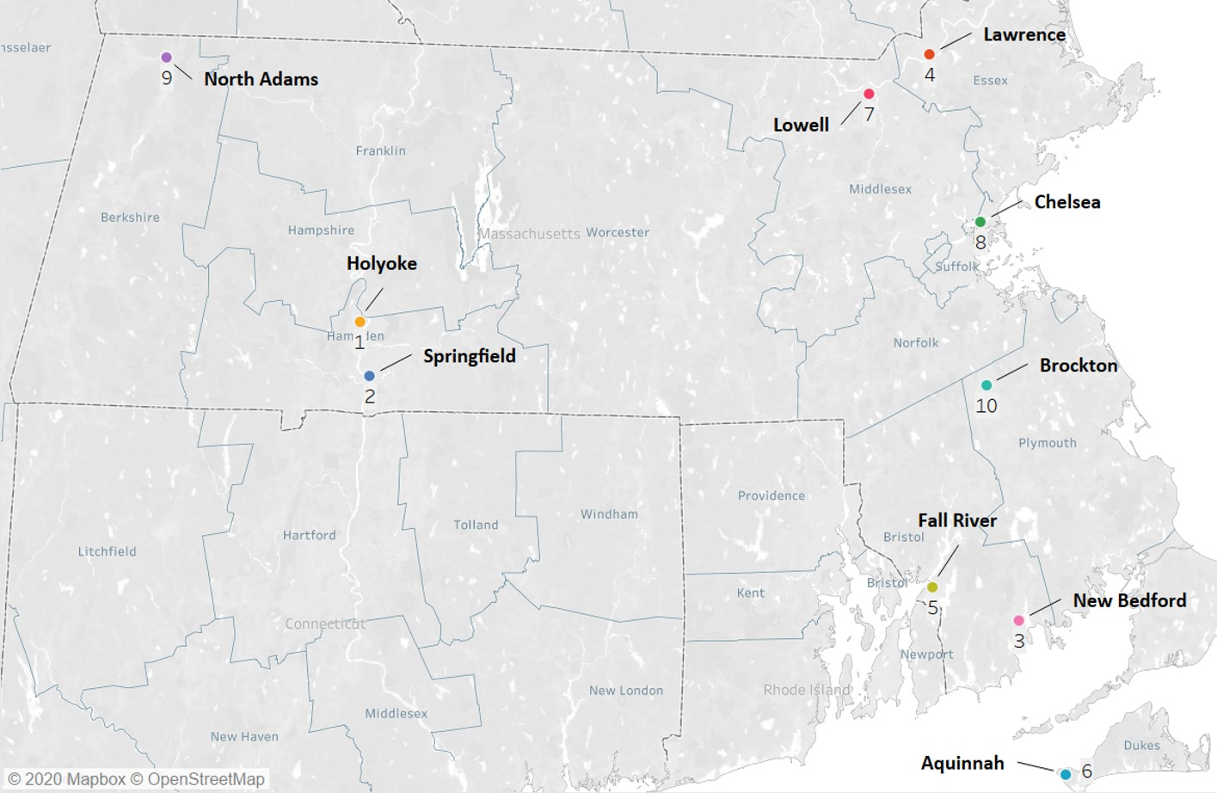
Figure III.1. Massachusetts Cities and Towns with the Highest Rankings in the SES Domain

Housing
Most of Massachusetts residents experience residential stability, with only 12% moving at least once within the past year.³³ Nearly 40% of housing units in Massachusetts are renter-occupied vs. owner-occupied, a ratio of 0.60 renter-occupied residences for each owner-occupied residence,³⁴ with ratios considerably higher for Hispanic or Latino,³⁵ Black or African American,³⁶ and American Indian and Alaska Native³⁷ residents upwards of two to three. Unaffordable housing is a prevalent issue across Massachusetts; 38% of homeowners and 50% of renters are cost-burdened,³⁸ paying more than 30% of income on housing costs. Massachusetts ranks among the top 10 states with the largest gap between average wages and rental costs for a two-bedroom apartment in a fair market.²
According to data from HUD, Massachusetts has the seventh highest rate of homelessness in the U.S. as nearly 18,500 residents experience homelessness, and one-fifth are families.³⁹ In 2018, a little more than 7,300 families applied for emergency housing assistance, and nearly 4,000 families entered homeless shelters and hotels.⁴⁰ Based on recent school records, more than 24,000 homeless children are enrolled in public schools,⁴¹ and 12% of children under the age of six experiencing homelessness are served by Head Start or EHS.⁴² According to the housing department, about 100 children are homeless and unaccompanied in Massachusetts.⁴⁰ See Appendix III.3 for state-level housing data by race and ethnicity. Figure III.2 displays the Massachusetts cities and towns with the highest rankings in the housing domain.
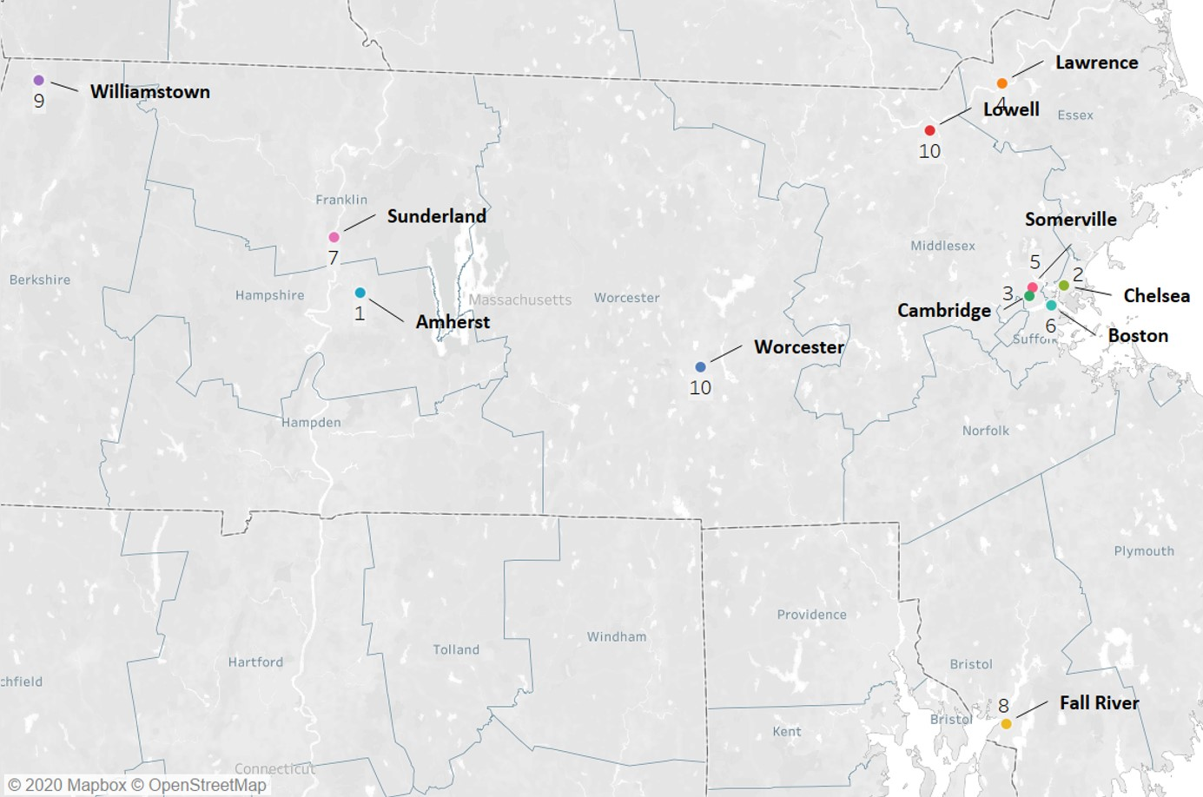
Figure III.2. Massachusetts Cities and Towns with the Highest Rankings in the Housing Domain

Populations of Special Interest
Nearly 17% of Massachusetts residents are foreign-born,⁴³ defined as anyone who is not a U.S. citizen at birth, with 69% of Asian residents,⁴⁴ 36% of Black or African American residents,⁴⁵ and 30% of Hispanic or Latino⁴⁶ being foreign-born. Among mothers, specifically, about 30% are born outside of the U.S., with about half of Hispanic mothers who gave birth in 2016 born outside of the U.S., nearly 60% of Black women, and 83% of Asian women.¹¹ Massachusetts also has the eighth highest percentage of immigrant or refugee residents in the U.S., the majority of whom come from near East and South Asia, Africa, Latin America, and the Caribbean^{8,38} with slightly fewer than 2,000 refugees living in Massachusetts.⁴⁷
Massachusetts has a relatively low teen birth rate. About 3% of mothers who give birth are less than 20 years of age, a rate of 8.5 per 1,000 women, with rates being highest among Hispanic mothers, followed by American Indian mothers; Asian mothers had the lowest teen birth rate.¹¹
In terms of other special population categories, 4% of children in Massachusetts have a parent who has spent time in jail⁴⁸ and just under 6% of adults in Massachusetts are veterans,⁴⁹ with the highest percentages being among White residents⁵⁰ and the lowest among Asian residents.⁵¹ See Appendix III.4 for state-level data on populations of special interest by race and ethnicity. Figure III.3 displays the Massachusetts cities and towns with the highest rankings in the populations of special interest domain.
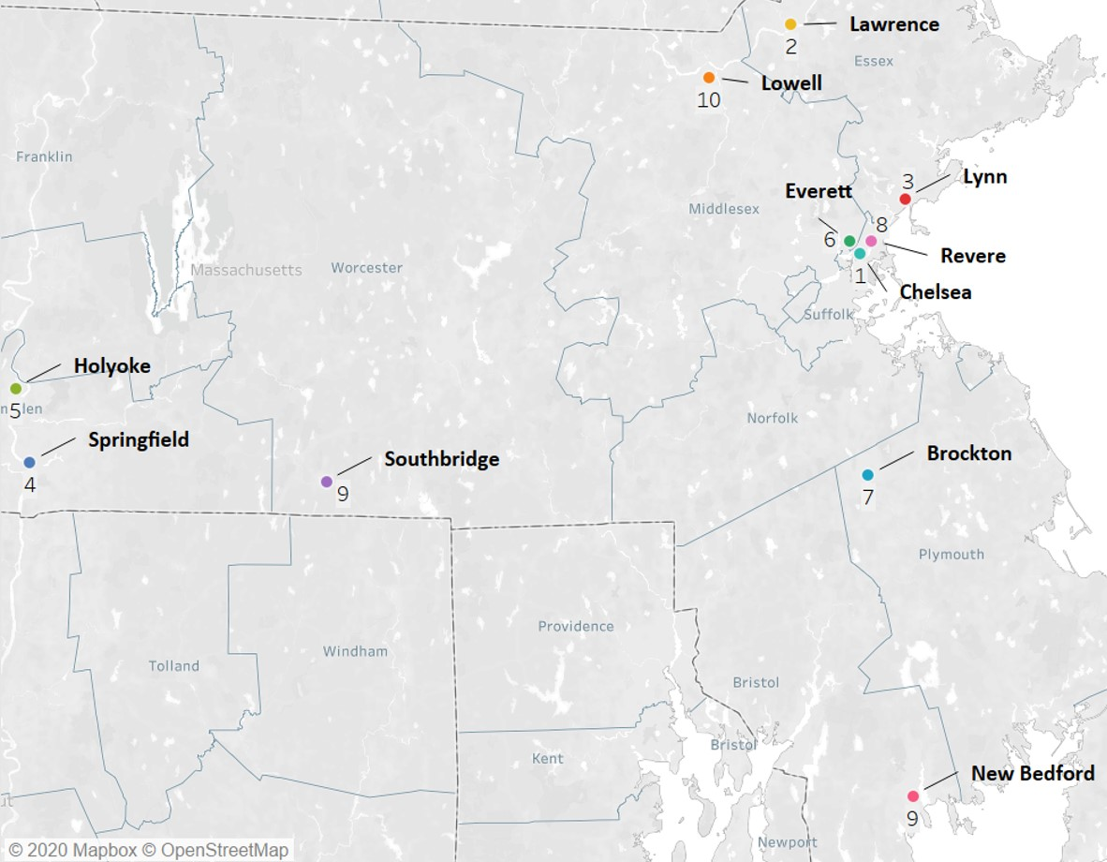
Figure III.3. Massachusetts Cities and Towns with the Highest Rankings in the Populations of Special Interest Domain

SUD
About 7% of Massachusetts residents aged 12 years and older experienced alcohol use disorder in the past year, 13% used marijuana in the past month, about 3% used cocaine in the past year, fewer than 1% reported heroin use in the past year, and nearly 4% reported misusing pain relievers.⁵² The prevalence of OUD and deaths due to overdoses in Massachusetts is among the highest in the nation.⁵³ On average, nearly 24 per 100,000 residents die from opioid overdose annually⁵⁴ and nearly 1,600 per 100,000 residents enroll in BSAS/MDPH-funded or licensed substance addiction service programs.^{55,} Figure III.4 displays the Massachusetts cities and towns with the highest rankings in the SUD domain.
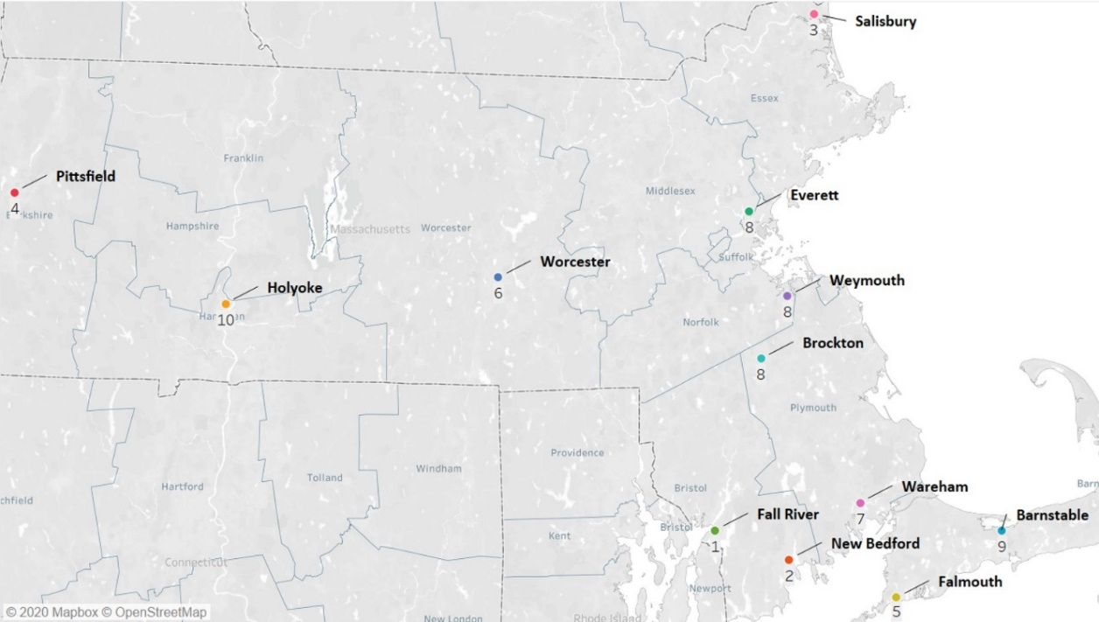
Figure III.4. Massachusetts Cities and Towns with the Highest Rankings in the SUD Domain

Crime
The violent crime rate in Massachusetts, including rape, robbery, assault, and murder is 358 per 100,000 residents.^{56,} Figure III.5 displays the Massachusetts cities and towns with the highest rankings in violent crime.
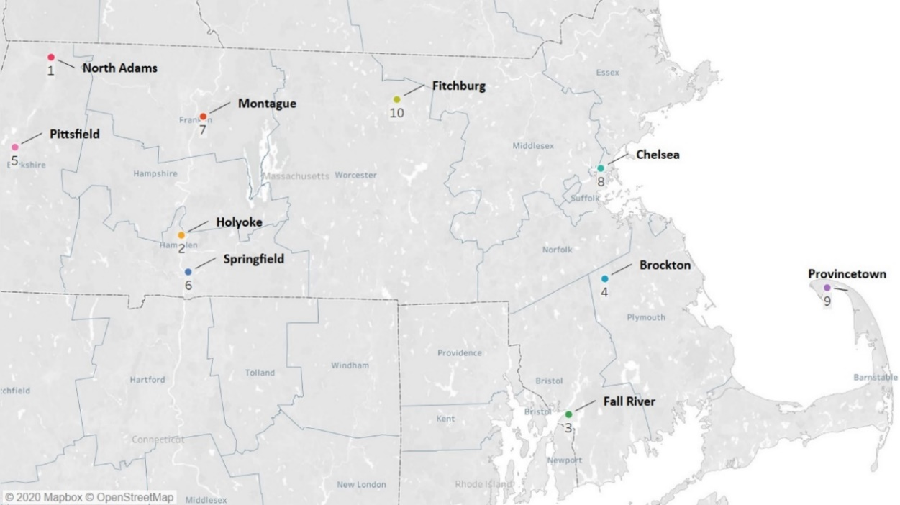
Figure III.5. Massachusetts Cities and Towns with the Highest Rankings in the Crime Domain

Child Unintentional Injuries
About 54 infants per 100,000 experience SUID,⁵⁷ and nearly 10,000 per 100,000 children less than 10 years visit a hospital emergency department for an unintentional injury,⁵⁸ with a rate for children under 3-years-old of about 11,600 per 100,000 children.^{59,} Figure III.6 displays the Massachusetts cities and towns with the highest rankings in the child unintentional injuries domain.
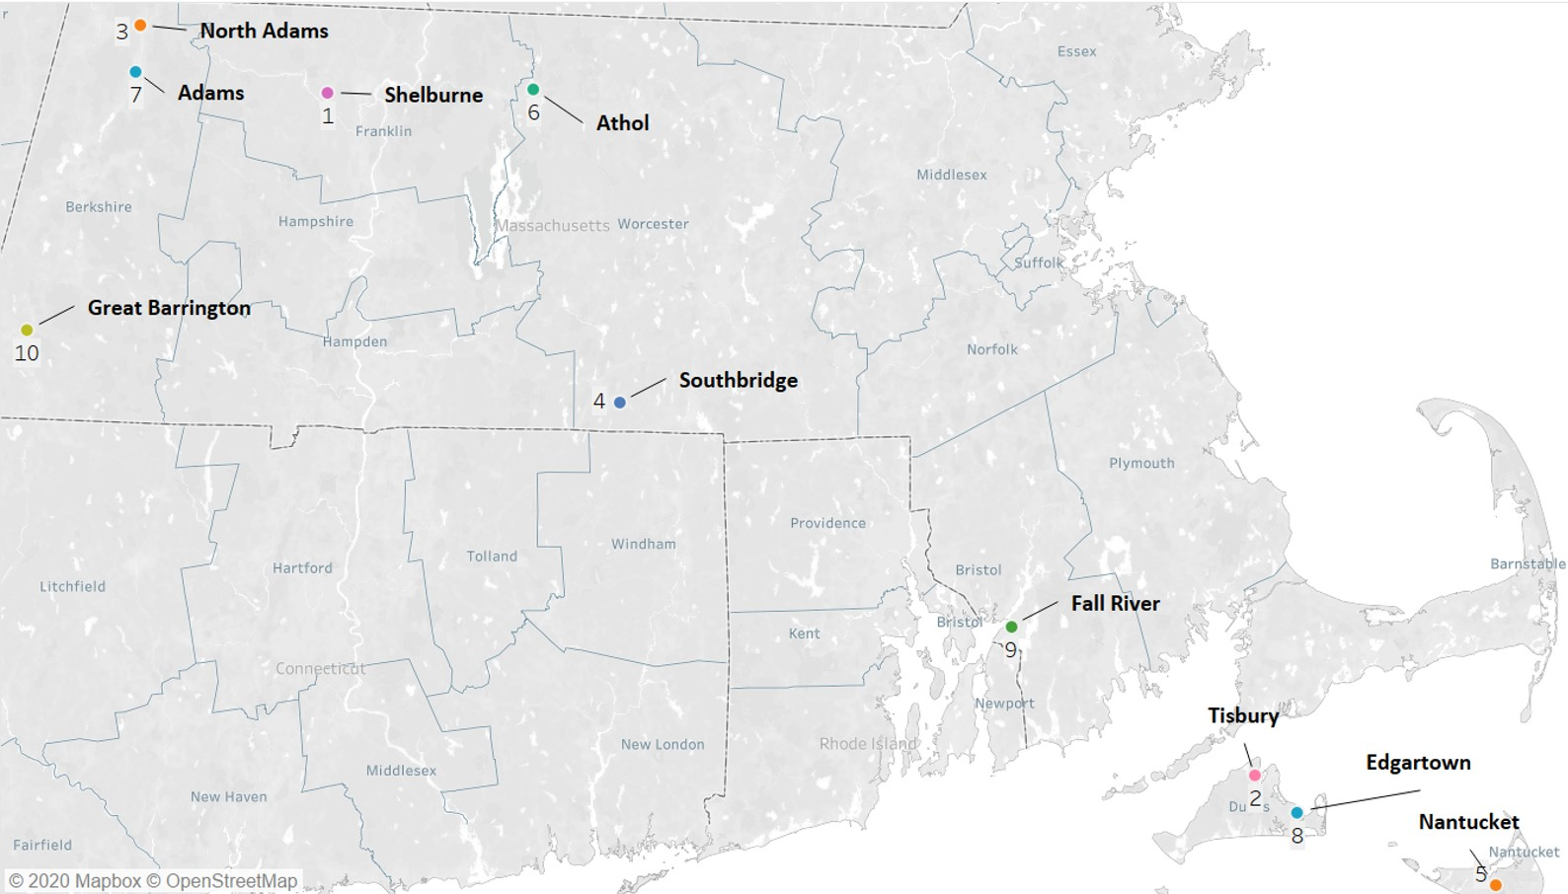
Figure III.6. Massachusetts Cities and Towns with the Highest Rankings in the Unintentional Injuries Domain

Child Maltreatment
On average, 22 per 1,000 children aged birth to 17 years of age experience a substantiated child maltreatment report.^{60,} Figure III.7 displays the Massachusetts cities and towns with the highest rankings in the child maltreatment domain.
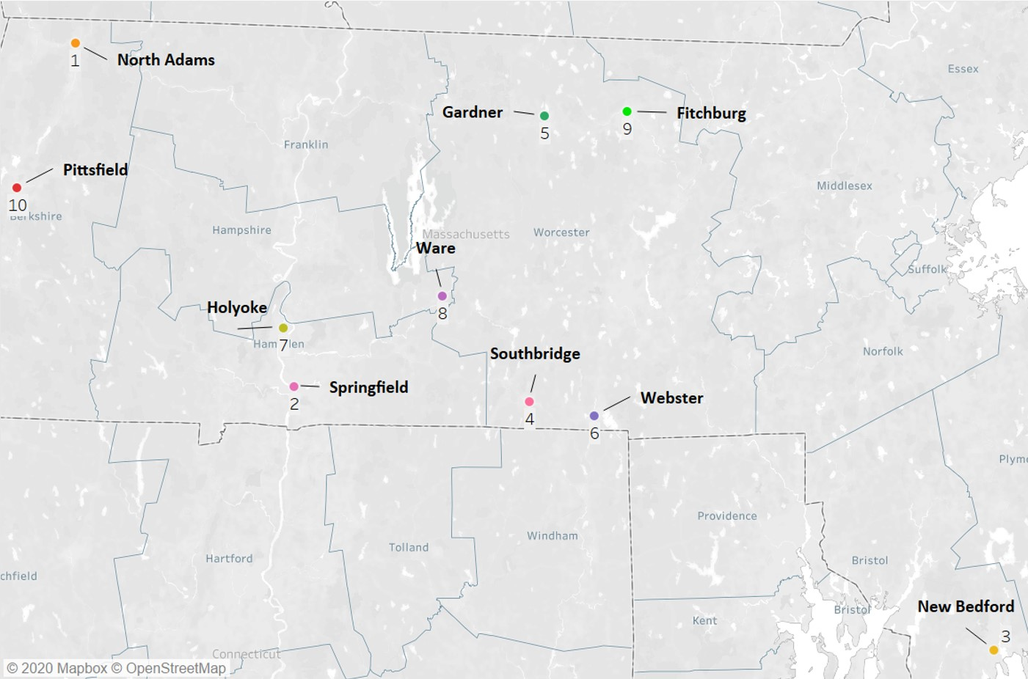
Figure III.7. Massachusetts Cities and Towns with the Highest Rankings in the Child Maltreatment Domain

Adverse Perinatal Outcomes
Across Massachusetts, nearly 18% of women receive less than adequate prenatal care, ranging from 14% of White women, 17% of Asian women, about a fifth each of Hispanic and American Indian women, and just under a third of Black women.¹¹ About 40 per 100,000 women die while pregnant or within one year of termination of pregnancy,⁶¹ and acute or chronic substance use contributes directly to 41% of pregnancy-associated deaths. Nearly two-thirds of substance use-related pregnancy-associated deaths are attributed to opioids and almost all of them occur in the postpartum period.⁶² Just under half of women across Massachusetts are overweight or obese prior to pregnancy in 2018, closer to 60% for Black and Hispanic women.⁶³
Ten percent of women experience postpartum depressive symptoms, ranging from about 8% of White women, 11% of Hispanic women, 14% of Asian women, and nearly a fifth of Black women. About 5% of women reportedly smoke or vape during pregnancy, with higher rates reported among White women than Black, Hispanic, or Asian women. Two-thirds of women drink alcohol in the months prior to their pregnancy, going upwards of 85% for White women, with much lower rates reported among other racial/ethnic groups. Notably, about a fifth of White women reported binge drinking in the three months prior to pregnancy.⁶³ Most pregnant women who are enrolled in the BSAS treatment system reportedly use heroin (71%), other opioids (20%), crack/cocaine (44%), marijuana (37%), and alcohol (35%).⁸ In Massachusetts, 14 babies per 1,000 live births have NAS.⁶⁴
Nearly 9% of infants are born preterm, before 37 weeks gestation, and about 8% are low birth weight, weighing less than 2,500 grams at birth. Among Black babies, 11% are preterm and low birth weight, respectively, higher than the state average. The percentage of preterm births is nearly 10% for Hispanic or Latino babies.¹¹ Nearly four per 1,000 infants die before their first birthday, with infants of color having disproportionately higher rates; non-Hispanic White infants have death rate of 2.91, whereas Non-Hispanic Black infants have a rate of 6.82, and Hispanic infants have a rate of 5.22.⁶⁵
Almost 40% of young mothers less than 20 years of age become pregnant again within 12 months (vs. 16% of 20- to 34-year-olds and 11% of women older than 34 years).⁶⁶ After giving birth, most women (86%) breastfed their infants during their hospital stay.¹¹ See Appendix III.5 for state-level data on adverse perinatal outcomes by race and ethnicity. Figure III.8 displays the Massachusetts cities and towns with the highest rankings in the adverse perinatal outcomes domain.
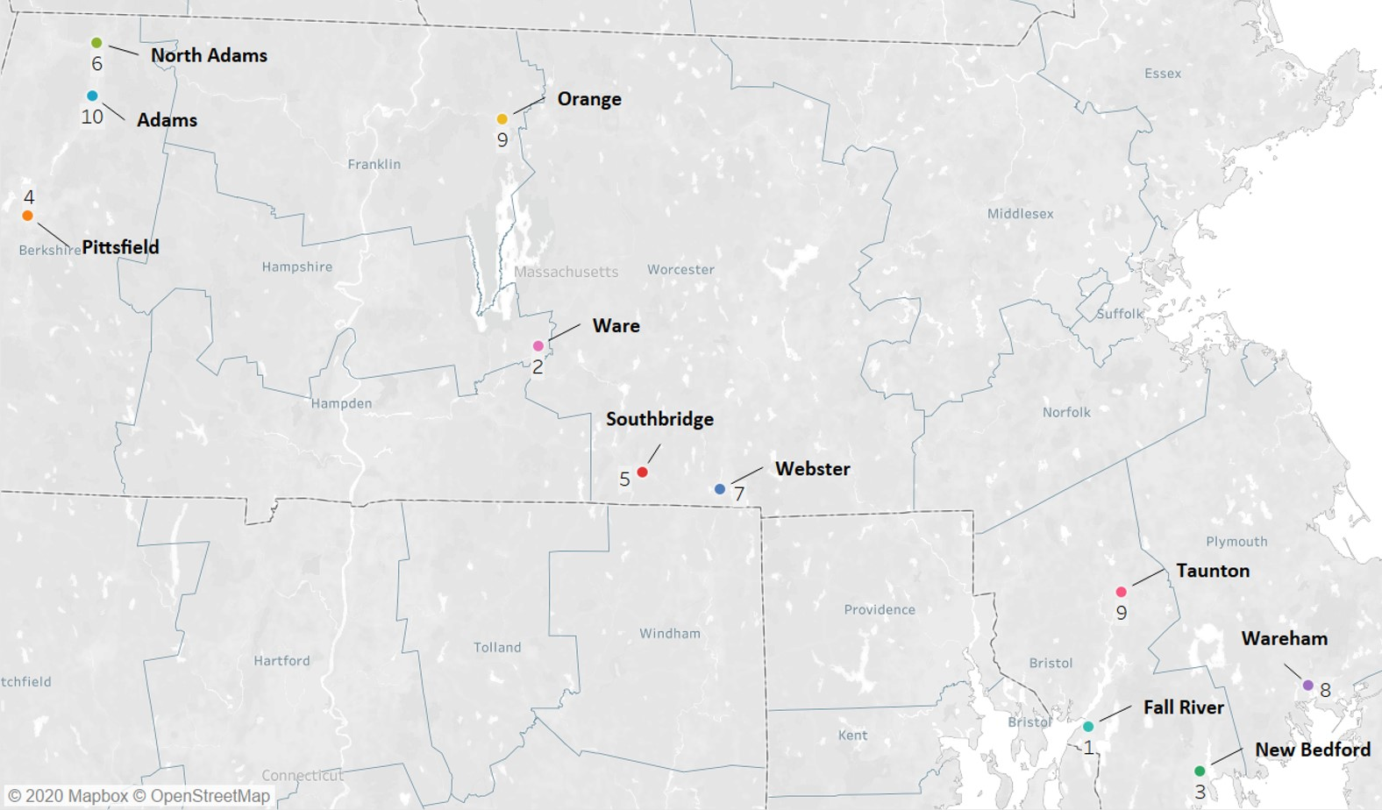
Figure III.8. Massachusetts Cities and Towns with the Highest Rankings in the Adverse Perinatal Outcomes Domain

Child Development and Health and School Outcomes
In Massachusetts, nearly one-fifth of children (18.5%) less than three years of age enroll in EI services.⁶⁷ Nearly two-thirds of early education and care programs are at the QRIS level one in 2018, indicating most programs have the basic foundation in curriculum and learning, safety, workforce qualifications and professional development, family and community engagement, and leadership and administration to build upon to reach higher levels. A further 29% reach level two, 4% level three, and fewer than 1% level four.⁶⁸ Most Massachusetts children are enrolled in full-day kindergarten.⁶⁹
Focusing on school-age children, nearly half of students are considered “high needs,” which includes students with disabilities, ELs and former ELs students, and low-income students. Nearly 11% of school-age children are ELs, with a language other than English being the first language for more than a fifth of students. About 18% of students experience a disability, with higher rates observed among Native American, Native Hawaiian or Pacific Islander, Hispanic, and Black students; only 9% of Asian students experience a disability.²¹ Nearly 13% of students experience chronic absenteeism,⁷⁰ indicating that they were absent for 10% or more school days, and just under 17% are truant, with more than nine unexcused absences.⁷¹ Chronic absenteeism and truancy are highest among Hispanic or Latinos students, followed by American Indians or Alaskan Natives, Blacks or African Americans, and Native Hawaiians or Pacific Islanders.^{70,71} On average, third graders in Massachusetts score 504 on the ELA MCAS and 499 on the math.^{72,} Based on aggregated MCAS scores, absenteeism rates, English proficiency among ELs, and advanced coursework in grades 11 and 12, about 5% of Massachusetts’ school districts require assistance or intervention with the respect to improving student performance.⁷³
Nearly half of EPSDT and PPHSD service claims for infants less than six months and three-quarters for children aged six months to 12 years include a behavioral health screen.⁷⁴ Slightly more than 8% of children less than six years old experience two or more ACEs, about 17% of six- to 11-year-olds, and 21% of 12- to 17-year-olds.⁷⁵ On average, nearly 691,000 children are insured through MassHealth with 6% of these children being disabled.⁷⁶
Among students in kindergarten to eighth grade, 12% are affected by asthma,⁷⁷ and about 164 per 100,000 children less than 20 years are hospitalized due to an asthma-related issue.⁷⁸ About 15 per 1,000 young children (aged nine months to three years) experience EBLLs, and three per 1,000 children experience lead poisoning.⁷⁹ Nearly 30% of young children less than five years of age participating in the WIC program are overweight or obese,⁸⁰ increasing slightly to 31% for school-age children.⁸¹ Obesity rates for young children were highest among Hispanic children.⁸⁰ See Appendix III.6 for state-level data on child development and health, and school outcomes by race and ethnicity. Figure III.9 displays the Massachusetts cities and towns with the highest rankings in the child development and health and school outcomes domain.
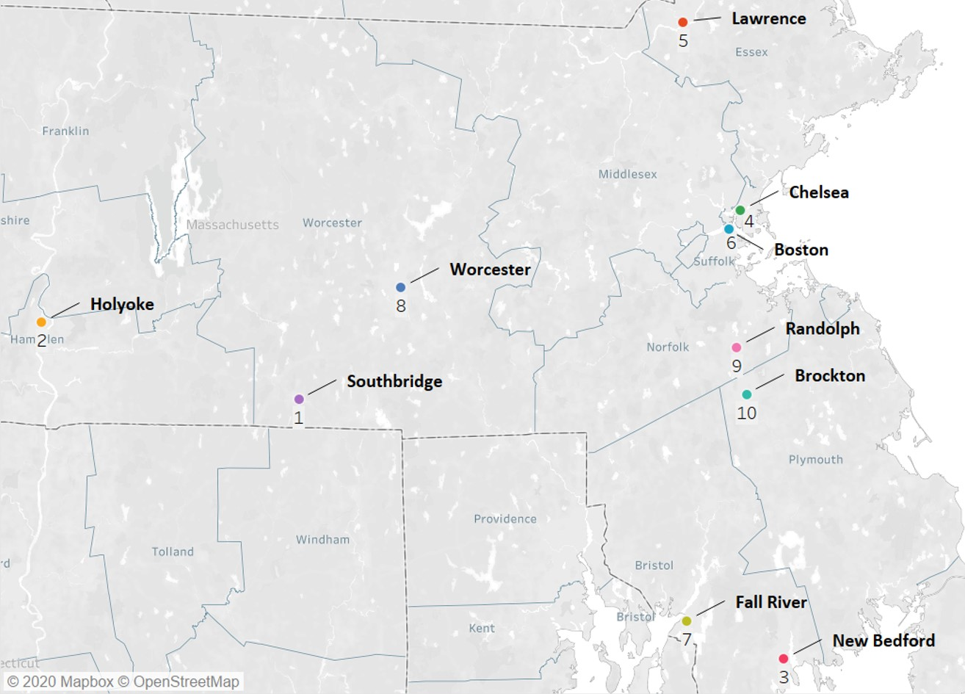
Figure III.9. Massachusetts Cities and Towns with the Highest Rankings in the Child Development and Health and School Outcomes Domain

City/Town-Level Findings
In this section, we provide profiles of the 17 highest-ranked communities across the nine domains, organized by EOHHS region,⁸² highlighting notable challenges in each community. The 17 communities are located within five of the six Massachusetts’ regions and dispersed across eight of the 14 Massachusetts’ counties (see Table III.1 and Figure III.10).
Table III.1. Region, County, and Ranking by Public Health Challenges Across the Nine Domains for the 17 Communities
Region | County | Community | Ranking
Western | Berkshire | North Adams | 9
 |  | Pittsfield | 15
 | Hampden | Holyoke | 1
 |  | Springfield | 5
Central | Worcester | Southbridge | 2
 |  | Worcester | 8
 |  | Fitchburg | 11
 |  | Webster* | 16
Northeast | Essex | Lawrence | 6
 |  | Lynn | 13
 | Middlesex | Lowell | 12
 |  | Everett | 17
Boston | Suffolk | Chelsea | 7
 |  | Boston | 14
Southeast | Plymouth | Brockton | 10
 | Bristol | New Bedford | 3
 |  | Fall River | 4
Note. *Webster was not included in the 17 MIECHV Communities in the MA MIECHV 2010 needs assessment.
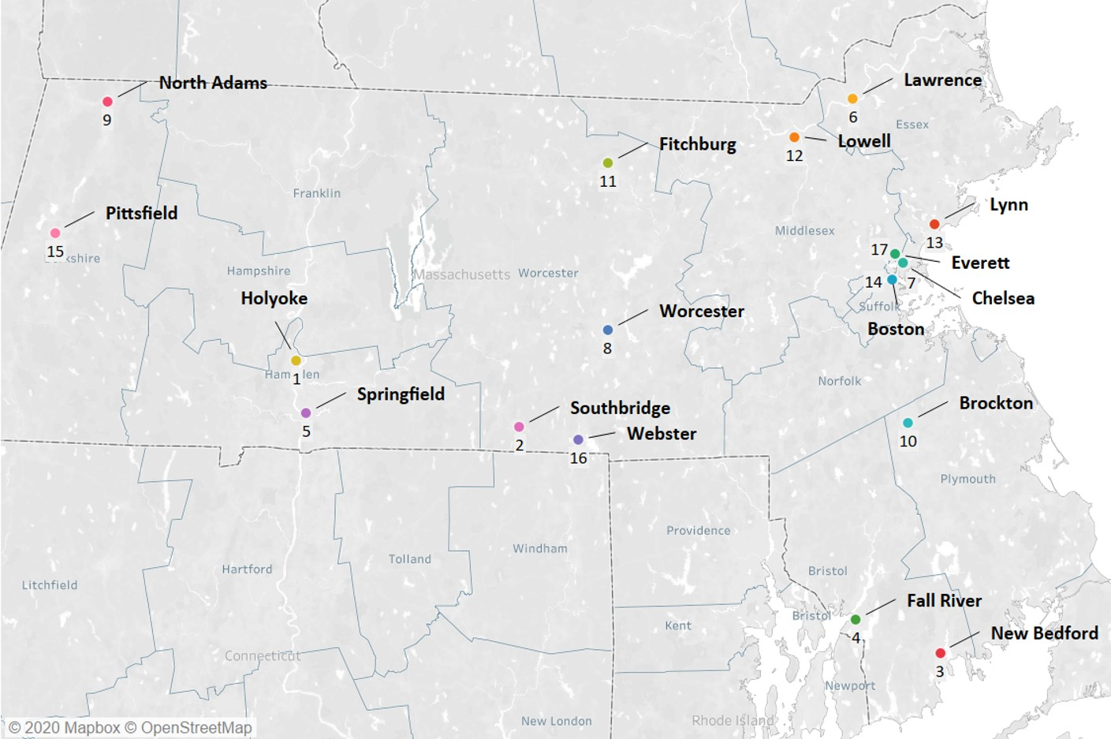
Figure III.10. Ranking by Public Health Challenges Across the Nine Domains for the 17 Communities

For a detailed description of each of the 17 highest-ranked communities across the nine domains and the 42 city/town-level indicators, see Appendix III.7.
At the end of this section, we discuss cities and towns that did not rank among the top 17 communities across all nine domains, but experienced challenges within specific domains or across several indicators.

Western Massachusetts: Holyoke, Springfield, North Adams, and Pittsfield
In the Western Massachusetts region, four communities in Berkshire and Hampden counties—Holyoke, Springfield, North Adams, and Pittsfield—were ranked within the top 17 cities/towns. Although these four communities each experience unique challenges, residents across the communities have high rates of enrollment in substance addiction service programs, violent crime, and maltreatment among children and youth. Three of the four cities—Holyoke, Springfield, and North Adams—have high rates of unemployment, single parent-headed households, and teen births.
In Holyoke (rank one) and Springfield (rank five), both in Hampden County, residents have high rates of poverty and family receipt of TAFDC cash assistance. Sizable proportions of mothers in both communities received publicly financed prenatal care, did not complete high school, and are BIPOC. Holyoke has a high ratio of renter- vs. owner-occupied residences, and its students have high rates of asthma, truancy, chronic absenteeism, and disabilities. Holyoke has low third grade MCAS scores in both ELA and math, and its school district requires assistance or intervention concerning student performance improvement. Springfield students have a high rate of overweight and obesity.
In North Adams (rank nine) and Pittsfield (rank 15), both in Berkshire County, pregnant women have high rates of smoking and enrollment in substance addiction service programs. North Adams struggles with high rates of infant NAS, emergency department visits due to unintentional injuries among children, and EBLLs among young children; also, many students have disabilities. Pittsfield has high rates of infant mortality and chronic student absenteeism.

Central Massachusetts: Southbridge, Worcester, Fitchburg, and Webster
In the Central Massachusetts region, four communities in Worcester County—Southbridge, Worcester, Fitchburg, and Webster—ranked within the top 17 cities/towns. Three of the four—Southbridge, Fitchburg, and Webster—have high rates of child and youth maltreatment.
Southbridge (rank two) and Fitchburg (rank 11) have high rates of teen births, infant mortality, and chronic student absenteeism. Southbridge has high rates of poverty among young children, family receipt of TAFDC cash assistance, children's emergency department visits due to unintentional injuries, children's and youth's hospitalization due to asthma-related issues, and student asthma and truancy. Southbridge has low third-grade MCAS scores in both ELA and math, and its school district requires assistance or intervention concerning student performance improvement.
In Southbridge and Worcester (rank eight), many students are ELs and categorized as having high needs. Worcester residents have high rates of poverty and enrollment in substance addiction service programs and are more likely to be renters than owners. Worcester and Fitchburg students have high rates of overweight and obesity. Fitchburg has high rates of unemployment and violent crime. Worcester and Webster (rank 16) has low third-grade MCAS scores in math. In Webster, pregnant women have a high rate of smoking, and its school district requires assistance or intervention concerning student performance improvement.

Northeast Massachusetts: Lawrence, Lowell, Lynn, and Everett
In the Northeast region, four cities or towns in Essex (Lawrence and Lynn) and Middlesex counties (Everett and Lowell), ranked within the top 17 cities/towns. All four communities have high proportions of BIPOC mothers and students who are ELs. Lawrence, Lowell, and Everett have high ratios of renter- vs. owner-occupied residences, and mothers in Lawrence, Lynn, and Everett have high proportions of low educational attainment and residents who are non-US-born. Children and youth in Lawrence, Lowell, and Lynn have high rates of asthma-related hospitalizations.
In Lawrence (rank six; Essex County) and Lowell (rank 12; Middlesex County), residents have high rates of poverty. In Lawrence, there are high rates of unemployment, receipt of TAFDC cash assistance among families, and teen births. Children and youth have high rates of single parent-headed households and asthma, and students have a high rate of chronic absenteeism and low ELA MCAS scores; Lawrence's school district requires assistance or intervention concerning student performance improvement. Mothers in Lowell have a low intention to breastfeed postdelivery.
In Lawrence and Lynn (rank 13; Essex County), mothers are likely to have received publicly financed prenatal care, and students are likely to be categorized as having high needs. In Lynn, young children have a high rate of EBLLs.
In Everett (rank 17; Middlesex County), residents have a high rate of opioid overdose deaths, and students have high rates of overweight and obesity, as well as truancy.

Boston: Chelsea and Boston
In the Boston region, two communities in Suffolk County ranked within the top 17 cities/towns. Overall, Chelsea (rank seven) and Boston (rank 14) experience unique challenges but share some similarities. Both communities have a high ratio of renter- vs. owner-occupied residences, as well as high rates of asthma-related hospitalizations among children, and students who are ELs and categorized as having high needs.
Mothers in Chelsea have high rates of having received publicly financed prenatal care, teen births, low educational attainment, and overweight and obesity during pregnancy; families have high rates of receipt of TAFDC cash assistance. Many mothers are BIPOC and non-US-born. Chelsea also struggles with high rates of violent crime and student truancy, and its school district requires assistance or intervention concerning student performance improvement. Boston struggles with high rates of poverty and student chronic absenteeism.

Southeast Massachusetts: New Bedford, Fall River, and Brockton
In the Southeast Massachusetts region, three communities in Bristol and Plymouth counties ranked within the top 17 cities/towns experiencing the greatest challenges in Massachusetts across the nine domains. Although these communities experience unique challenges, all three communities have high rates of opioid overdose deaths, and a sizable portion of mothers who received publicly financed prenatal care and did not complete high school.
In New Bedford (rank three) and Fall River (rank four), both in Bristol County, residents have high rates of poverty and enrollment in substance addiction service programs and are more likely to be renters than owners. Pregnant women have high rates of enrollment in substance addiction service programs, and infants have high rates of NAS. Families have high rates of TAFDC cash assistance receipt, and mothers have high rates of teen births and low intentions to breastfeed postdelivery. Students have high rates of truancy, chronic absenteeism, and being categorized as having high needs. New Bedford children and youth have high rates of single parent-headed households, maltreatment, being overweight and obese, and being ELs; its school district also requires assistance or intervention concerning student performance improvement. In Fall River, children have a high rate of emergency department visits due to unintentional injuries, and students have a high rate of asthma.
In New Bedford and Brockton (rank ten; Plymouth County), children and youth have high rates of being hospitalized due to asthma-related issues and young children have high rates of EBLLs. Both communities of Fall River and Brockton have high rates of unemployment and violent crime. Many mothers in Brockton are BIPOC and third graders have low MCAS scores in both ELA and math.

Additional Communities Experiencing Challenges Related to Specific Indicators
Based on our analysis, several other cities and towns located within specific regions faced significant challenges in several indicators, despite not falling into the top 17 rankings (see Table III.2). We briefly mention these communities here for consideration for current and future programming. One of these communities—Revere—is a current MIECHV community, and two others—Adams and Wareham—are within an extant MA MIECHV catchment area.
Table III.2. Region and County for Additional Communities
Region | County | Community
Western | Berkshire | Adams
 | Franklin | Orange
 | Hampden | Ware
 | Worcester | Athol
Boston | Suffolk | Revere
Southeast | Plymouth | Wareham
 | Barnstable | Barnstable
 |  | Falmouth
 |  | Provincetown
 | Dukes | Aquinnah
 |  | Edgartown
 |  | Tisbury
 | Nantucket | Nantucket

Western region
In Adams (Berkshire County) on the far-Western side of Massachusetts, challenges are concentrated among children and youth, including high rates of: NAS among infants, emergency department visits due to unintentional injuries among children, student disabilities, and overweight and obesity.
In Orange (Franklin County) and Athol (Worcester County), two bordering towns but in separate counties, challenges are widespread across populations, including high rates of: unemployment (Athol and Orange); smoking among pregnant women (Athol and Orange); teen births (Orange); emergency department visits due to unintentional injuries among children (Athol); and student asthma, disabilities, and chronic absenteeism (Athol). Additionally, third graders in Orange have low MCAS scores in both ELA and math, and at least one school district serving Orange requires assistance or intervention with respect to improving student performance.
In Ware (Hampden County), although challenges are widespread across populations, there is also concentration of challenges among children, including high rates of: opioid overdose deaths among residents; smoking among pregnant women; infant mortality and NAS; child and youth maltreatment; EBLLs among young children; and student overweight and obesity.

Boston region
In Revere of Suffolk county, which was identified as a MA MIECHV community in the 2010 needs assessment, a large proportion of mothers are non-US-born, and students have a high rate of overweight and obesity.

Southeast region
Eight communities in Southeast Massachusetts experience significant challenges; one is Wareham (outside of Cape Cod), three are on Cape Cod (Barnstable, Falmouth, and Provincetown), three are on Martha’s Vineyard (Aquinnah, Edgartown, and Tisbury), and the other is Nantucket.
In Wareham (Plymouth County) and on the Southwestern to Mid-Cape Cod areas (Barnstable County), challenges are widespread across populations, with a concentration of SUD-related challenges, including high rates of: (1) opioid overdose deaths (Wareham only); (2) enrollment in substance addition services among residents (Falmouth) and pregnant women (Wareham and Barnstable); (3) infant NAS (Barnstable only); and (4) student disabilities (Wareham only).
On the peninsula region of Cape Cod, Provincetown’s (Barnstable County) challenges are widespread across populations, with a concentration of SES-related challenges, including high rates of: (1) single parent-headed households; (2) publicly financed prenatal care among mothers; and (3) violent crime.
On Martha’s Vineyard (Dukes County), in Edgartown and Tisbury, children have high rates of emergency department visits due to unintentional injuries. In Aquinnah, challenges are widespread across populations, with a concentration of SES-related challenges, including a sizable income gap between residents with greater versus lower income, as well as high rates of: (1) poverty among all residents and young children; and (2) youth who are not currently enrolled in school or high school graduates. On Nantucket (Nantucket County), a large proportion of mothers are non-US-born, and children have a high rate of emergency department visits due to unintentional injuries.

Identify the Quality and Capacity of Existing Programs or Initiatives for Early Childhood Home Visiting in the State.
As previously mentioned in Section II.B, county-level analyses are not useful for assessing population needs and gaps in Massachusetts home visiting services. To supplement the capacity data required for Table 7 in the MA MIECHV Needs Assessment Data Summary Document, we assessed home visiting capacity using a variety of other methods. In this section we present findings from the home visiting capacity survey, integrating focus group findings, as well as findings from past MA MIECHV evaluations, whenever appropriate. When reporting survey data, we note any differences between program type or region that meet standard criteria for statistical significance (p < .05).
We begin with a general description of the home visiting landscape in Massachusetts, including basic program characteristics, the populations served by home visiting, staffing, and budget. The next section focuses on highlighting some of the most pressing challenges experienced by families. This is followed by findings related to how home visiting programs appear to respond to families’ needs, and areas that could be improved upon. Finally, we discuss findings related to the early childhood system of care, using survey and focus group data to describe the many systems with which families interface, and the extent to which home visiting is able to coordinate and collaborate with these systems.

Massachusetts Home Visiting Landscape: Programs and Populations
The following paragraphs provide basic descriptive information about Massachusetts home visiting programs, including estimates of the scope of home visiting across Massachusetts and characteristics of programs, staff, and families served.

Massachusetts Home Visiting Programs
Of the program sample (n = 226) 11% of programs were MA MIECHV-funded, 30% of programs NHVM, 33% of programs were Homegrown, and 27% were EI. See Appendix III.8, map one, for distribution of program types across the state. Programs are concentrated in the Boston and Metro West regions, as well as the Springfield/Holyoke area in the Western region of the state. See Appendix III.8, map two, for the catchment areas for MA MIECHV-funded programs only.

Prevention Continuum and Dosage
Using the Institute of Medicine’s health planning framework⁸³ as a guide, we grouped home visiting models according to where they fall on the “prevention continuum.” Universal programs are available to all families, with no eligibility criteria; selective programs are targeted toward subgroups (e.g., teen parents, families experiencing poverty) that are potentially more vulnerable to negative outcomes; and indicated programs are targeted toward individuals (children with special needs, families involved in child protective services) who are vulnerable to negative outcomes. The majority of the 226 programs in our sample (47%) are indicated, more than a third (38%) are selective, and only 13% offer services universally.
Using a combination of expected visit frequency and maximum program duration, we categorized programs as low dosage: duration 6 months or less/visit frequency weekly or less; medium dosage: (1) duration three to six months/visit frequency twice weekly; (2) duration seven to 12 months/any visit frequency; and (3) duration greater than six months/visit frequency monthly; or high dosage: duration more than 12 months/visit frequency at least biweekly. Most programs (73%) were high dosage, with 18% medium dosage, and 9% low dosage. Figure III.11 shows the distribution of low, medium, and high dosage programs by prevention continuum. Programs that are low dosage appear more likely to be universally available, medium dosage programs are more likely to be indicated, and high dosage programs are more likely to be selective or indicated (χ² (4) = 89.67, p < .001).
Figure III.11. Program Dosage by Prevention Continuum (program sample, n = 225)

Staff Retention
We asked respondents how much of a problem their program had with retention on a four-point scale, from “no problem at all” to “a huge problem.” Of those who responded (n = 145), 61% reported that staff retention was not much of a problem or no problem at all, 27% said it was somewhat of a problem, and only 12% reported it being a huge problem. Of the program types, respondents from MIECHV and EI were more likely to indicate problems with retention than those from the NHVM and the Homegrown programs (χ² (9) = 19.36, p < .05).
See Figure III.12 for the most common reasons staff leave, according to respondents. Low pay was by far the most common answer; the median home visitor salary ranges from $32,909 to $41,430, according to respondents (program sample, n = 70). For MIECHV programs only (n = 34), the median salary ranges from $32,700 to $34,850. There were overall differences in program type for pay (χ² (3) = 28.18, p < .001) and burnout (χ² (3) = 10.67, p < .05). Homegrown programs were less likely to indicate pay as a reason for leaving and MIECHV and NHVM less likely to indicate burnout.

Figure III.12.Most Common Reasons Staff Leave Home Visiting Programs (respondent sample, n = 136)

Funding
We asked respondents about their program’s distribution of funding sources (e.g., federal, state, third party billing). Excluding EI programs for this analysis (the only program type that indicated they use third party billing), distribution of funding sources for the remaining sample (n = 139) is as follows: 68% state funding, 28% federal funding, 2% municipal funding, and 2% foundation funding. We also asked how confident respondents felt that they would have at least level funding over the next three years; 38% of the respondent sample (n = 103) said they were very confident and 54% somewhat confident. The Homegrown programs were the least confident in future funding (χ² (9) = 20.00, p < .05).

Home Visiting Populations
Of the programs for which we had enrollment data (n = 142), the average number of active participants
was 369.8, (Range = 3–1,936; SD = 412.8). Excluding the EI programs, the number is much lower at 118.0 (n = 82; Range = 3–1,000; SD = 159.1).
With the exception of EI programs, which by policy accommodate any families seeking services, (32%) of programs (n = 71) indicated that they had to turn families away due to insufficient capacity during FY20. Slightly less than half of programs (46%) indicated that they generally are able to refer families to another home visiting program in the area when they cannot serve those families themselves (the specific programs most commonly mentioned were HFM, EI, EHS, and PAT). It should be noted that we do not know what proportion of these referrals resulted in a successful connection to services.

Participant Demographics
Table III.3 shows the average percent of families served by programs in FY20 by their identified race, ethnicity, and primary language.
Table III.3. Families served, by Percent Ethnicity, Race, and Language Across Programs
 | Race or Ethnicity | n | M | SD | Range
Ethnicity | Hispanic all races | 138 | .33 | .24 | .1–1.0
Race | White | 135 | .50 | .26 | .2–1.0
 | Black | 132 | .14 | .18 | .0–.95
 | Asian | 130 | .06 | .09 | .0–.71
 | Multiracial | 129 | .11 | .13 | .0–.68
Language | Primary language not English | 140 | .34 | .25 | .0–.89
Note. These categories are not mutually exclusive. “Other” and “unknown” excluded from table.
Differences by program type: In comparison to EI programs: MIECHV programs had a higher proportion of Hispanic families (F (3, 134) = 5.453, p < .01) and a lower proportion of White families (F (3, 131) = 4.452, p < .05); Homegrown programs had a slightly higher proportion of Black families (F (3, 128) = 3.185, p < .05); and MIECHV and NHVM programs had a higher proportion of Multiracial families (F (3, 125) = 17.477, p < .001). In comparison to MIECHV programs, both EI and NHVM programs had a higher proportion of Asian families (F (3, 126) = 4.306, p < .05; see Figure III.13). Finally, in comparison to EI programs, MIECHV and NHVM programs had a higher proportion of families whose primary language is not English (F (3, 136) = 10.183, p < .001).

Note. These categories are not mutually exclusive. “Other” and “unknown” excluded from analyses.
Figure III.13. Differences in Race and Ethnicity, by Program Type
Differences by region: Programs in the Boston and Northeast regions had a higher proportion of Hispanic families than programs in the Metro West and Southeast regions (F (5, 132) = 5.171, p < .001). Programs in the Central, Southeast, and Western regions had a higher proportion of White families than those in the Boston region (F (5, 129) = 8.009, p < .001). Programs in the Boston region had the highest proportion of Black families (F (5, 126) = 10.792, p < .001) and programs in the Metro West region had the highest proportion of Asian families (F (5, 124) = 9.552, p < .001; see Figure III.14).

Note. These categories are not mutually exclusive. “Other” and “unknown” excluded from analyses.
Figure III.14. Differences in Race and Ethnicity, by Region
Of the 57 program sample respondents who indicated whether they had staff who could provide services in families’ preferred languages, 61% answered in the affirmative.

MassHealth receipt and DCF involvement
As shown in Table III.4, home visiting programs reported that the majority (69%) of families used MassHealth, and more than a quarter of families (25.7%) are involved with DCF.

Table III.4. MassHealth Use and DCF Involvement (program sample, n = 132)
 | n | M | SD | Range
MassHealth | 132 | .69 | .23 | .1–1.0
DCF | 132 | .26 | .23 | .0–.88

Differences by program type: MIECHV and Homegrown programs had a higher proportion of DCF-Involved families than NHVM and EI programs (F (3, 128) = 18.774, p < .001). MIECHV programs had a higher proportion of families enrolled in MassHealth when compared to EI programs (F (3, 128) = 26.403, p < .001; see Figure III.15.

Figure III.15. MassHealth Receipt and DCF Involvement, by Program Type (program sample, n = 132)
Differences by region: Programs in the Western region had the highest proportion of DCF-Involved families (F (5, 126) = 4.098, p < .001). There were no differences in MassHealth enrollment by region.

Most Pressing Challenges Facing Families
When asked to select the top five most pressing challenges their participants face, respondents (n = 153) identified housing, behavioral health, poverty, and childcare (see Figure III.16).
Differences by program type: There were overall differences among program types in the following focus areas: behavioral health (χ² (3) = 20.71, p < .001), intimate partner violence (χ² (3) = 17.60, p < .001), poverty (χ² (3)= 14.15, p < .001), employment (χ² (3)= 14.15, p < .001), immigration (χ² (3)= 27.04, p < .001). MIECHV programs were more likely to identify all of these as the most pressing challenges.
Difference by region: Substance use was more likely to be identified as a challenge by programs located in Western Massachusetts than in other regions of the state (χ² (3) = 11.96, p < .05), Boston programs were more likely to identify immigration as a major challenge facing families (χ² (3) = 12.92, p < .05), and transportation emerged as a top issue in the Central and Southeast regions of the state (χ² (3) = 16.85, p < .001).

Figure III.16. Most Pressing Challenges Facing Participants (respondent sample, n = 153)

Meeting the Needs of Massachusetts Families Through Home Visiting
This section focuses on the more specific range of supports provided by home visiting programs across Massachusetts. We describe screenings and key program foci as way to understand the diversity of home visiting service delivery. The section concludes with survey and focus group findings about gaps in home visiting services, and obstacles to accessing services.

Focus of home visiting services
We asked programs what types of formal screens and assessments they administered to families to identify families’ needs. We also inquired about the primary issues and topics they focused on with families.

Screenings
See Figure III.17 for the distribution of screenings conducted by home visiting programs across the state. Parent-child interaction and child development screenings are most common, followed by safe sleep.
Differences by Program Type. MIECHV programs screen for the widest range of issues among the four home visiting program types, and are more likely than the other programs to screen for alcohol (χ² (3) = 120.89, p < .001), safe sleep (χ² (3) = 101.72, p < .001), medical home (χ² (3) = 82.23, p < .001), depression (χ² (3) = 76.28, p < .001), and smoking (χ² (3) = 124.12, p < .001).

Figure III.17. Program Screens (program sample, n = 199)

Home Visiting Program Focus Areas
As seen in Figure III.18, referrals and care coordination and parenting were the most frequently reported focus areas of home visiting programs.
Differences by program type. As with screens, MIECHV programs had the most wide-ranging program foci when compared to the other program types. MIECHV programs were more likely to include a focus on breastfeeding (χ² (3) = 12.19, p < .05), crisis management (χ² (3) = 27.79, p < .001), economic stability (χ² (3) = 27.79, p < .001), education (χ² (3) = 19.78, p < .001), and, along with the NHVM programs, material assistance (χ² (3) = 9.01, p < .05).
Differences by region. Programs in Boston and the Western region were more likely to indicate a focus on substance use (χ² (5) = 11.41, p < 0.05).

Figure III.18. Program Foci (program sample, n = 92)

Obstacles to Receiving Home Visiting Services
In general, focus group participants enrolled in a MA MIECHV home visiting program were very positive about their experiences with home visiting. Across focus groups, however, families (including those who have not received home visiting) articulated two key obstacles to participating in home visiting services—language/cultural barriers and fear of judgement/experience with bias. These insights shed light on why some families may not be accessing home visiting in Massachusetts.

Language and Cultural Barriers
A limited number of Spanish-speaking participants described challenges with accessing healthcare and other services due to lack of bilingual providers, but most agreed that they could usually find either Spanish-speaking providers or an interpreter when needed. For the Laotian, Cambodian, and Vietnamese populations in the state, however, language continues to be an acute obstacle to receiving services. Participants observed that there is a decided lack of resources for Southeast Asian groups, preventing focused outreach and other efforts to address service gaps. One Vietnamese mother stated, “For me it’s a language barrier. I’m afraid to ask because I don’t understand what they said fully. So I can’t always know what questions to ask [next]. ...I wish there was a place I could go where they translated for me…It would help me create bridge across all the different teams, to coordinate services.” Particularly among BIPOC participants, there was a preference for having people of similar backgrounds to theirs engage in outreach, recruitment, and service-provision. A father stated, “It’s one thing to have someone come translate, but another to have someone visit who speaks your language and understands your culture. That might be where programs are lacking. You can’t just ignore the needs of the population because of the cost of doing that. We need someone who can help us understand what services are.” Among BIPOC participants, very few recalled ever having been offered home visiting at all.

Fear of Judgment and Experience with Bias
For many participants across focus groups, fear of home visitors scrutinizing their parenting practices and contextual factors in their homes (e.g., the physical conditions of the home or behaviors of others who live there), and thereby becoming at risk for child maltreatment reports and loss of custody, was a disincentive to participate in home visiting services. One mother said that people are “fearful that you’re coming in and something might happen and then you’ll take my kid away. It’s the unknown. I’ll come to you; my house is my house.” This perception was especially pronounced among BIPOC participants, and participants experiencing OUD. Many participants had negative experiences with other in-home services in the past (for example, DCF, EI), and were skeptical of whether a MA MIECHV home visiting program would be different. Across focus groups with participants who had been offered home visiting, there was a sense that home visiting services are not always presented as optional. A number of participants were introduced to home visiting services in the context of a DCF report (e.g., related to IPV or OUD) or other concerns about the baby’s well-being (e.g., participants felt like they were assumed to be incompetent parents based solely on their youth or disability) as reported to DCF by hospital personnel. Some participants reported that they were not always certain what services they would be receiving, why the services were being offered to them, why the services were important for them or their child, or how the services could help their families. These factors led parents to perceive that services were compulsory without the option to decline services. When parents enrolled under these circumstances, their initial feelings about their home visitors were marred by distrust and resentment, compromising the ability of the home visitor-parent dyad to form a positive connection. One participant stated, “I didn’t have a choice… They didn’t ask, they just said here’s what’s going to happen.…[the home visitor] felt very invasive, the way they came into my space.”
Many participants felt like what should be perceived as typical parenting challenges were often viewed by providers through a different lens, based on parents’ race or unique circumstances. Many had encountered professionals who doubted their competence as parents, and some parents feared that their circumstances would raise doubt about their parenting fitness and put custody of their children at risk. Mothers who experienced OUD felt that postpartum adjustment difficulties they had experienced were inaccurately assumed to be a sign of a relapse by providers who did not view them through a strengths-based lens. One participant noted, “That feeling of being believed is hard to find. It is more that a person in a position of authority is coming in; I am here to help because there is something you don’t know or can’t do. Power dynamics is a tricky piece.”

Gaps in the Home Visiting Continuum of Care
Many families expressed frustration and disappointment about the transition out of home visiting programs when services ended due to changes in eligibility. There was a range of reasons behind these feelings, such as emotional attachment to the home visitor and concerns about an interruption in services that successfully scaffolded their children’s development. Parents of children with disabilities said that when EI services ended, they experienced a gap in critical services for their children. Across many of the focus groups, parents expressed concern about the lack of availability in services for certain age groups of children—particularly those who are three to five years. In relation to her HFM services ending, one mother said “I think it is unfair; you spent three years with one family, they love you and are comfortable with you. …There’s no way I’m letting you go.”
To objectively examine gaps in the continuum of care based on child’s age, we designated programs’ upper age limits for children (i.e., the age at which children “graduate” from or “age out” of the program): 1–3 years old, 4–5 years old, and >5 years. Sixty-one percent of programs do not serve children older than three years old, 21% do not serve children older than five, and 19% of programs serve children past their fifth birthdays. See Appendix III.9, map one, which shows the cities and towns in Massachusetts, shaded by how many programs serve children over age three in that city or town. Appendix III.9, map two is shaded by programs serving children over age five.
Programs available to children who age out between four and five years old are more likely to be selective, and those available to children older than five are primarily indicated (see Figure III.19; χ² (4) = 59.36, p < 0.01). serve only young parents; χ² (3) = 26.43, p < .001); ease requirements related to re-engagement and visit frequency (χ² (3) = 14.72, p < .001); and allow visits without children present to “count” toward model fidelity (attributable to PAT programs, which historically has not counted visits without children; χ² (3) = 12.56, p < .05).

Early Childhood Systems of Care: Coordination and Collaboration
A universal theme across the focus groups was the intersection of participants’ identities and experiences with various state systems with which they interacted. Foster parents, grandparents, mothers with OUD, and survivors of IPV, for example, are regularly interfacing with DCF, and juvenile or probate court. A number of fathers from both the Title V and MIECHV fathers focus groups also discussed the involvement of DCF in theirs and their children’s lives. Other focus group participants discussed their criminal histories and their personal interactions with the criminal justice system. Some undocumented immigrants described their concerns over immigration enforcement. Parents of CYSHCN were vocal about challenges of interfacing with the school and healthcare systems in which their children were being served. Some participants also discussed their families’ ongoing reliance on social safety net programs, such as food stamps or WIC. In this section we present findings on participants’ and home visitors’ perceptions of the systems of care.

Family Perspectives on Community Systems of Care
Families spoke about many local and state services and systems, but the most often mentioned were transportation, mental health, and housing, with more general discussion about the inadequacies of crisis support systems, and how difficult it is to learn about available resources.

Transportation Needs
Across many communities, transportation was raised repeatedly as an obstacle to accessing available services, attending to healthcare needs, and even participating in family recreational activities. Families—particularly those living in the more rural areas of the state, such as the Western, Central, and Southeast regions—talked about how hard it was for them to get around given the absence of reliable and convenient (or, in some cases, any) public transportation. This creates significant obstacles to applying for and receiving services, a problem that is compounded when participants have no available alternatives due to financial insecurity that prevents them from obtaining a driver’s license and a car.

Mental Health Needs
The effect of various forms of trauma and oppression on participants—including racism, disability discrimination, immigrant status discrimination, economic oppression, and interpersonal and societal violence—was a nearly universal theme across the focus groups. Many of the participants had experienced homelessness, poverty, and a lack of access to services and supports. Each population described challenges related to these issues, often with significant mental health consequences for participants. Trauma often engenders or exacerbates significant mental health challenges experienced by the populations of focus here. For example, participants who had experienced IPV and unhealthy relationships indicated that the abuse they endured, their court involvement, and the stress of single parenting have led to sleep problems, anxiety and depression. Lack of access to mental health care was an especially frequent theme among families who lived in the Western region of the state, who described a shortage of providers and/or long waitlists to access services. These barriers were particularly pronounced when parents discussed seeking services for children. In this case, an additional challenge was a high turnover of clinicians, which impeded continuity of care. In addition to a lack of access, participants across the focus groups expressed cultural and contextual reasons for unmet mental health needs, including stigma and fear. Some parents described a cultural norm against seeking mental health care in their communities as a disincentive for seeking therapy. Some participants also voiced concern that professionals would not be able to help them, fearing potential bias or lack of clinician aptitude, sometimes based on previous negative experiences. Lastly, some participants simply voiced feeling overwhelmed about how to meet their needs and not knowing where or how to access resources that could be helpful.

Lack of Affordable Housing
Shortage of safe, affordable housing was highlighted as an especially critical concern across almost all of the focus groups. A number of participants noted that the state suffers from limited housing options for families experiencing poverty in the absence of extreme circumstances, forcing families to submit to alternatives, including seeking housing out of state, entering the shelter system and residing there long-term, remaining in housing situations that are unsafe or unhealthy for themselves and their children, or being homeless. Participants also observed that existing programs for families who experiencing poverty, such as Section 8 and HomeBASE, are laden with barriers, such as excessively long waiting lists and arduous documentation requirements for establishing eligibility. When families experience drastic circumstances and have an urgent need for emergency housing, the eligibility criteria are stringent, and proving eligibility can be very difficult. The families who needed emergency housing described being unfamiliar with how the system worked, and most had no advocates to guide them through the process. One participant said, …”my housing experience has been a rollercoaster. If I’m asking for services, no one tells me what’s available, or refusing to give me applications. Going to different housing authorities, and they don’t want to speak to me or they don’t want to give me applications.”

Inadequacy of Crisis Supports
Families also highlighted the fact that it often requires a crisis before they can qualify for services and voiced a wish for services that prevent a crisis from occurring. Crisis services can sometimes perpetuate unstable and dangerous circumstances for families, who find themselves only qualifying for support when situations are dire. For example, related to the above housing findings, parents who experienced housing insecurity and threats to theirs and their children’s safety faced an onerous process of proving that they qualified for assistance at a time when they are critically in need and without resources nor advocates to support them. When families sought services to avoid homelessness or physical harm, they were turned away for not proving those conditions. Without intermediate options for crisis prevention, families are forced to endure circumstances that can endanger themselves and their children. One participant who had experienced IPV said, “I think anyone who went through what I went through should not have to dig the way I do. Those services should have been readily available.” Several of the groups reported a reluctance to access the emergency supports that are available to them due to the threat of abuse or violence (from the police) or the fear of losing custody of their children. This was especially the case among BIPOC participants, mothers who had experienced IPV, and parents with OUD.

Limited Knowledge About Community Services
In almost all focus groups, participants indicated having limited information about the services and supports that were available to them. Most were not participating in community services that could be helpful to them, primarily because they did not know about them. Parents living in shelters with young children, for example, reported not knowing where to seek information about support services. Participants voiced a desire to have easier access to information that would help them learn about and access the resources and services that could improve their quality of life. Of those participants who were involved with some community supports, most indicated learning about them through peers and social networks. Indeed, many focus groups themselves became resource and referral sources, as participants shared this information in the moment.

Home Visiting and Local Community Systems of Care
To better understand the extent to which home visiting programs are embedded in their local systems of care, we asked survey respondents about their co-locations and collaboration with other community providers. We report findings for these questions below, followed by results from the CEDAC exercise we led at the MA MIECHV AGM.

Program Co-location with Other Community Services
Co-location represents one method of promoting a more seamless system of care for families, particularly in terms of access to services. Sixty-eight percent of the 85 programs that responded to the question of whether they were co-located with any other programs indicated that they were. Figure III.21 shows the distribution of the types of organizations with which programs indicated sharing physical space. EI programs were less likely to be co-located than the other three program types (χ² (3) = 17.15, p < .01). There were no meaningful differences in the types of services programs were co-located with, either by program type or region.

Figure III.19. Services with Which Programs are Co-located (program sample, n = 85)
Respondents indicated some of the benefits that co-location brings. Of those that described benefits (n = 65), a third identified ease of referrals as a benefit of co-location, and 22% identified access to services for families. Smaller percentages of respondents perceived provider collaboration (14%), resource sharing (13%), communication about shared services and cases (11%), and opportunities for outreach and visibility (7%) as benefits of co-location. Only 21 respondents identified any downsides. Perceived downsides included lack of space (62%), building restrictions (24%), and challenges related to confidentiality (14%).
Of the 84 respondents that answered whether they would like to be co-located with another service or agency, 39% indicated they would; MIECHV programs were more likely than the other program types to endorse that answer (χ² (3) = 15.16, p < .05).

Collaboration with other Community Services
We asked respondents to list the community programs with which they had the most positive and most challenging working relationships. We coded their responses by service type. Of respondents who reported positive relationships (n = 112), the most common programs mentioned were other home visiting and family support programs (55%), WIC (37%), EI (37%), health (23%), and EEC (20%). Of negative relationships (n = 112), the most commonly mentioned were DCF (51%), health (40%), schools (28%), and housing (22%). Figure III.22 shows the balance between positive and challenging relationships. As can be seen, respondents indicated the most difficult relationships are with DCF, health, schools, DTA, housing, and behavioral health, areas in which survey findings also suggested are among home visiting populations’ most pressing needs.

Figure III.20. Distribution of positive and challenging relationships (excluding service types with 5 or fewer mentions; respondent sample, n = 112)

MA MIECHV Staff Discussion about DCF Collaborations
We were able to delve into this finding about collaboration with DCF during the MA MIECHV AGM, using the CEDAC exercise described in Section II.F. About 50% of the participants identified strained relationships with DCF as a pressing issue and worked together in small groups to generate the following root causes and solutions related to this problem.

Root Causes. Across each participating group, the most frequent reason cited for home visitors’ challenges collaborating with DCF was DCF’s strained relationship with families, which in turn affected home visitors’ perception of the agency. On the post-it notes, home visitors described negative attitudes from the case workers (e.g., “Disrespectful, insensitive to parent’s feelings, unsupportive, not looking at strengths”; “Nit-picking; abuse of power”), and a reluctance to accommodate, communicate, and partner with families (e.g., “[Families] not knowing the service plan”; “They blanket participants with too many mandated services”). They posited that the absence of strengths-based or trauma-informed training may be contributing factors to DCF staff’s strained relationship with families (e.g., “Not well trained in child development, parenting or health”).
The groups also observed as major challenges to collaboration DCF’s geographically inconvenient and unwelcoming office environments, and an apparent lack of willingness among DCF staff to meet in alternate, more family-friendly places; a misunderstanding among DCF staff around the purpose, requirements and role of home visiting programs (e.g., “Make referrals mandatory when we are a voluntary program”; “DCF doesn’t see the value of home visitors”); and strained communication with DCF staff, noting feelings that DCF is unwilling to share information and/or work together (e.g., They never call back”; “Not providing consistent schedule, visit time changing”; “Won’t give master list of emails for workers”; “Not collaborating with programs around goals of Family Action Plan”).
Solutions. Participants brainstormed solutions to address the issues they identified as root causes. To improve their working relationship with DCF moving forward, they made the following procedural recommendations: Learn more about internal and external policies that guide DCF’s work to better understand how their staff work (e.g., “home visiting programs can make effort to learn more about DCF policies & procedures”; “[Home visiting] [a]gency should have a firm policy of when to file 51-A and how to work with DCF specifically”); share streamlined and up-to-date information on the home visiting program and the role of its staff with DCF agencies (e.g., “Provide clear and consistent info about [our] services”); and explore new ways to facilitate partnership between the two systems, including an appointed home visiting liaison to work with DCF, shared trainings, and more opportunities to meet with each other (e.g., “Make a concerted effort to welcome DCF to brainstorm how to better collaborate”; “1x year DCF training at sites to learn process and build relationships”). Participants identified ways they can mitigate strained relationships between DCF and families, including being physically present during interactions with DCF and encouraging parents to self-advocate (e.g., “Co-visit with social worker and help with conflicting messages”). They also suggested that DCF could institute trainings to foster relationships with involved families (e.g., “mandated training around cultural humility, awareness, & trauma”).

State’s capacity for providing substance abuse treatment and counseling services
Here we use a range of methods and data sources to provide an overview of Massachusetts’ capacity to provide SUD treatment and counseling services, focusing on whether the available services, programs, and resources meet the needs of pregnant women and families with young children across the state. Our review includes analysis of data indicators pertaining to SUD including mapping of existing SUD services and programs in Massachusetts to gauge alignment between needs and the availability of SUD services across the state and within particular communities. We also used data from the home visiting capacity survey, our review of MA MIECHV site visit reports, and interviews and focus groups to further explore needs and service gaps centered on families eligible for or enrolled in home visiting who also experience SUD. We also describe collaborations between home visiting programs and SUD service providers.

SUD-Related Needs and Service Availability across Massachusetts
The prevalence of OUD and deaths due to overdoses in Massachusetts is among the highest in the nation. As described in Section III.A.1.d, nearly 24 per 100,000 residents die from opioid overdose annually and nearly 1,600 per 100,000 residents enroll in BSAS/MDPH-funded or licensed substance addiction service programs, on average.
As shown in Table III.5, five of the 12 cities and towns with the most significant challenges related to SUD did not meet the overall cut-off needed to be included in the 17 MA MIECHV communities experiencing the greatest public health challenges, with a majority located in the Southeast region of Massachusetts. Further, as summarized in Section III.A.3, high NAS rates and opioid overdose deaths were observed in several communities in Western Massachusetts.
Table III.5. Municipalities Ranked in the Top Ten for SUD-Related Challenges, with Overall City/Town Ranking
Towns experiencing the most significant challenges related to SUD | SUD Ranking | City/town ranking from data indicators analysis
Fall River | 1 | 4
New Bedford | 2 | 3
Salisbury | 3 | —
Pittsfield | 4 | 15
Falmouth | 5 | —
Worcester | 6 | 8
Wareham | 7 | —
Everett | 8 | 17
Weymouth | 8 | —
Brockton | 8 | 10
Barnstable | 9 | —
Holyoke | 10 | 1

Note. City/town ranking provided only for the 17 MA MIECHV communities experiencing the greatest public health challenges.
In Appendix III.10, maps one through four present a detailed look at city/town rates of the two indicators within the SUD domain and the two SUD-related indicators within the adverse perinatal outcomes domain. The maps present each SUD data indicator by quintile classification alongside SUD services provided, according to the IHR resource, across the Commonwealth. Below we highlight key findings of the four maps.
The average annual rate of enrollment in BSAS/MDPH-funded substance addiction services from 2014–2018 ranged from zero to 5,288.97 per 100,000 residents, with about one-fifth of cities and towns (n = 70) having a rate greater than 1,669.65 (lower-bound of top quintile; see Appendix III.10, map one). The average annual rate of opioid overdose death occurrences among residents from 2013–2017 ranged from zero to 76.09 per 100,000 residents, with about one-fifth of cities and towns (n = 69) having a rate greater than 19.93 (lower-bound of top quintile; see Appendix III.10, map two). Cities and towns in the top quintiles for both indicators are spread throughout Massachusetts. Focusing on SUD indicators for pregnant women and infants, Appendix III.10, map three presents the average annual rate of enrollment in BSAS/MDPH-funded substance addiction services among pregnant women from 2014–2018. These rates ranged from zero to 220.32 per 100,000 women residents, with about one-sixth of cities and towns (n = 59) having a rate greater than 23.83 (lower-bound of top quintile). Finally, the rate of infants born with NAS from 2012–2016 ranged from zero to 59.82 per 1,000 live births, with about 7% of cities and towns (n = 26) having a rate greater than 25.29 (lower-bound of top quintile; see Appendix III.10, map four).
As seen on all four maps, most available SUD services in Massachusetts focus on recovery or treatment, with only a handful providing more comprehensive wrap-around services. There are many pockets in the state, notably in the Southeast, Western, and Central regions, where rates are high and availability of services appears insufficient to meet the local needs of the population.
Findings from the review of MA MIECHV site visit reports revealed that across Massachusetts, marijuana use was mentioned as an emerging issue for many LIAs, with programs noting that many parents do not perceive marijuana to have unfavorable or harmful physical or mental effects. Comorbid SUD and mental health issues among participants and/or family members was also a challenge for LIAs across the state. Moreover, opioid and prescription drug misuse were perceived as challenges by programs in many Massachusetts communities. Specifically, a few LIAs in the Southeast and Western regions of the state mentioned increases in cocaine and/or crack use alongside heroin use Alcohol use was flagged as a significant issue by only a handful of LIAs in Central and Northeast Massachusetts.
Based on home visiting survey data, only 18% of respondents identified SUD as one of the top five challenges families experience and 46% of programs selected SUD as one of their focus areas (see Section III.B). Of programs that reported hosting groups for special populations (n = 33), 52% reported that they provided groups to families experiencing SUD. But these findings were not distributed equally across the state; programs in the Western region were more likely to endorse all three of these items.

Training needs
Based on findings from the MA MIECHV site visit reports, many staff across the state indicated a need for specific SUD-related training, including: working with families who comorbidly experience SUD and mental health issues, signs and symptoms of substance use, marijuana use, NARCAN administration, substance exposed newborns, recovery, and advanced substance use training, including a focus on new and emerging drugs. Home visitors expressed a need for additional clinical supports, both within the home visiting program and through partnerships with mental health providers, to strengthen their work with families who experience both SUD and mental health challenges. LIAs varied in their implementation and perceptions of the utility of a comprehensive substance use screening tool that captures more than tobacco use. LIAs in the Southeast and Metro West perceived participants to be reticent discussing potential substance use and SUD. A key challenge mentioned by several LIAs in the Southeast was around determining sensible and effective strategies to support participants who do not disclose known substance use during the screen, and an LIA in the Northeast mentioned concerns with how home visitors can avoid stigmatizing or re-traumatizing participants who are experiencing SUD.

Collaborations with Other Services
The review of MA MIECHV site visit reports included a review of the Levels of Cooperative Activities Chart, a program self-assessment that captures the nature of collaborations with community partners, that programs submit prior to their annual site visits. Based on this chart, many LIAs reported some level of collaboration with several community SUD programs or services, whereas one LIA in the Northeast had a strong collaboration with just one program. Several LIAs identified SUD programs and services in their communities but were in the early stages of developing strategic and collaborative relationships. LIAs identified service gaps for families experiencing SUD, including long waitlists for services (Central and Western Massachusetts), and the need for translation services (Northeast Massachusetts), residential and in-patient programs (Southeast and Western Massachusetts), and long-term recovery support (Western Massachusetts).
Findings from the review of MA MIECHV site visit reports revealed that DCF involvement and SUD are inextricably linked in many communities across Massachusetts, making DCF a key collaborator of home visiting programs serving families experiencing SUD or in recovery. As revealed in the findings related to collaborations (see Section III.B.3), however, we know that this relationship can be very challenging.

The Role of DCF
Every participant in the two focus groups with mothers with OUD expressed great frustration with, and fear of, DCF. The threat of custody loss was a constant anxiety among parents in recovery, and home visitors’ role as mandated reporters sometimes made it very hard for families to accept home visitors as helpers. Here we report some of the most common themes across focus group participants.
Relapse as part of the pathway to recovery. Contrary to the ways in which SUD treatment programs view relapse—as a natural part of the recovery process—DCF workers, according to participants, see relapse as indicative of failure, and in many cases as eliminating the possibility of reunification. Although it is not an official DCF stance or perspective, most participants reported that individual case workers were quick to “write them off” as incapable of working toward sobriety and reunification with their children if they experienced a relapse. Furthermore, participants voiced hopelessness about their reunification potential if they did relapse, which decreased their motivation to continue to work on their recovery, almost a self-fulfilling prophecy.
Inadequacies of the foster care system. Participants voiced great apprehension about the effects of the foster care system on their children. Participants believed that children’s needs were left out of the service plan, which eliminated some opportunity for parents to hold DCF accountable for ensuring those needs were met. Rather, parents felt that DCF leaves much of the responsibility for meeting children’s needs to foster parents. Participants felt that, in some cases, foster parents were not adequately caring for their children, leaving parents without any mechanism to advocate on their children’s behalf. Parents whose children were in foster care agreed that their children would benefit from addressing the trauma in their lives. When parents and children are separated, participants voiced dissatisfaction with the amount of time they were able to visit their children while they were in foster care. Most stated they were able to see their children for one hour per week, at most. This amount of time, they felt, was not enough to maintain a bond and connection. Participants felt that if they were provided more opportunities to to connect with their children, as well as additional resources to support their parenting before and during these interactions , fewer family disruptions would occur while parents actively engaged in substance use treatment, which would reduce the burden on the child welfare system.
Lack of clarity about the reunification process. Many participants voiced having no clear understanding of what they needed to do in order to regain (or maintain) custody of their children. In many cases, participants stated they felt they had done everything asked of them, only to be told they had new or additional requirements to complete, on a perpetual basis. Others stated they never had a good sense of what they needed to do, and felt that DCF would find their progress insufficient no matter what they did. In some cases, participants passionately stated their belief that DCF would never allow them to reunify, preferring to have their children adopted. Some participants believed strongly that DCF benefits financially from adoptions, and that this was at least partial motivation for social workers to deny parents a clear path to reunification. Service plans are the primary document that outlines the requirements of both DCF and parents who have had their children removed from their custody. Although the document exists, participants’ perceptions were that DCF workers had minimal accountability to their requirements as part of this service plan. These findings underscore participants’ larger concerns around a lack of adequate communication from DCF. They felt their workers neither keep them informed about what steps parents need to take in particular nor about their case in general. This includes how their children are doing in foster care and what needs they have, what the trajectory for the case is, and the possibilities for resolution.

Promising Approaches in Home Visiting for Participants Experiencing SUD
We examined two novel approaches that embed recovery support within home visiting to comprehensively address recovery, pregnancy, and parenting needs among families with young children in Massachusetts. First is an examination of a MA MIECHV pilot of an overlay of peer recovery coaching in one PAT LIA. Second is the previously mentioned FIRST Steps Together program, funded by BSAS through the SOR. FIRST Steps Together enhances services and access to treatment, recovery, and parenting supports for pregnant and parenting families impacted by OUD using a peer recovery workforce cross-trained in parenting support.

PAT Recovery Coach Overlay
To date, the pilot PAT overlay has involved one parent educator/recovery coach with lived SUD and recovery experience in Berkshire County who was hired and trained in both recovery coaching and the PAT curriculum in Fall 2018. She is “living proof” of how it is to be a mother and a woman in recovery, helping families work through trauma and gain confidence to fully embrace parenting. The program supervisor also completed recovery coach training and attended a recovery coach supervisor academy. Families in recovery were recruited and enrolled in PAT and began receiving home visits and group services in early 2019. The pilot is gaining momentum in the community, with a range of new referral sources from various sectors including health, mental health, and DCF. Through this unique pilot, the PAT program in Western Massachusetts is striving to eliminate stigma associated with parenting in recovery. Part of this work involves collaborating with DCF, including trying to help families meet the multiple requirements the state agency places on them. Socioeconomic inequities in the region, including intergenerational poverty, hinder self-sufficiency, and a lack of transportation makes it challenging for families to access employment or training programs. A further unintended consequence of these demands and mandates from DCF is that they constrain the time parents have for home visiting. Recovery coaches have a clearer understanding of recovery in the context of parenting, understanding that relapse is often part of the process. The home visitor cross-trained in recovery coaching frequently supports parents during supervised visits with their children and provides consultation after these supervised visits to debrief and facilitate deeper discussion about the visit. While the implementation of the recovery coaching element to PAT has been welcomed in the community, the staff we spoke with expressed concern that one staff member alone cannot meet the demand for recovery support services of the entire community. They said they would welcome the funding to hire a second recovery coach, who could not only provide direct services, but would also provide additional support and peer mentoring for the existing staff member and help to reduce feelings of isolation.

FIRST Steps Together
Since 2018, the homegrown FIRST Steps Together model has served parents who experience OUD in strengths-based, flexible, individualized, and recovery-minded ways, combining elements of home visiting and recovery coaching to support participants to simultaneously strengthen their parenting skills and focus on their recovery efforts. Our discussions with FIRST Steps Together participants and providers reveal great enthusiasm for the benefits of the program, but also some frustration with what is seen as strict eligibility criteria (mother experiencing OUD and has a child under five years). To better understand which populations desired and were not eligible for the program we reviewed the FIRST Steps Together exception request data. First, the focus on mothers leaves out two important populations: fathers experiencing OUD, and grandparents who have custody of their children due to their children experiencing OUD. Families with children older than five years of age impacted by OUD also requested exceptions; these were granted in instances where caregivers were identified as high risk for relapse, but were denied in other circumstances. Finally, there were many people who were turned away from the program because their SUD centered around alcohol and substances other than opioids.

Conclusions and Recommendations
In this section we offer high-level conclusions and recommendations, organized again by the three needs assessment goal areas. We end this section with observations regarding racial equity.

Identifying Communities with the Greatest Public Health Challenges
The results of our analyses of the 42 indicators across 9 domains identified essentially the same 17 cities/towns that had been identified in past MA MIECHV needs assessments as facing the most challenges in Massachusetts. These are also the same cities and towns that were often identified as having the highest concentrations of public health challenges in the 26 state and local needs assessments we reviewed prior to conducting our own analyses. This is not surprising, given the structural inequities—the result of decades of redlining, disenfranchisement, and other manifestations of systemic racism—that have historically characterized these communities. The consistency of these findings affirms the decisions MDPH has made about allocation of resources. In many ways this is reassuring, given how well-established the MA MIECHV-funded programs in those 17 communities are, and how potentially disruptive it would be to engage in any major redirection of funding at this point.
There are, however, several limitations of relying on this methodology to guide funding. First, global rankings obscure important findings within each domain; our method also identified other communities that experience significant challenges—overall or within certain domains—that would benefit from home visiting. These additional communities tended to cluster in Western, Southeast, and Central Massachusetts, and were also mentioned by the MA MIECHV Advisory Committee and other experts in the state as areas with heightened need. Second, family challenges are not neatly conscribed within a town’s boundaries. Findings from the focus groups, site visit reports, and the home visiting capacity survey strongly confirmed the reality that populations vulnerable to poor health outcomes exist in communities across the state. Using per capita rates leaves out communities whose overall affluence masks substantial poverty, racial and ethnic inequities, and substandard housing experienced by many of its residents. Finally, while robust, our method excluded some important indicators given lack of data availability. For example, we did not incorporate disproportionate incarceration rates or some other proxy of inequities in the criminal justice system. Additionally, we did not include indicators that explicitly examine inequities at the community level, such as air pollution and residential displacement.
Decisions must be made about how to allocate scarce public health resources, and a thorough analysis of administrative data is a valid approach to informing this calculus. However, these indicators are only a gauge; they dilute significant discrepancies in communities with both significant affluence and significant poverty, they oversimplify the complexities of families’ lives and experiences, and they do not take into account the economic and social upheavals that have characterized the COVID-19 pandemic. Results confirm that the current MA MIECHV communities are appropriate for focus, given they experience the greatest public health challenges according to the indicators and methods agreed upon by HRSA and MDPH. The question is not whether and how to re-allocate funding away from these communities. Rather, our purpose in raising these considerations is to encourage MDPH to think strategically about how to maximize MA MIECHV’s impact, given the limitations inherent in being able to select only a subset of the 351 communities in the Commonwealth. We offer some recommendations below.
Extending MA MIECHV’s Reach Beyond the Top 17. Considering whether and how to adapt programming to address needs outside of the 17 MA MIECHV communities is a challenging conundrum. Although MDPH could potentially expand the procurement process to include communities beyond the 17, it would then run the risk of spreading resources too thin, and potentially disrupting well-established programming in the existing MA MIECHV communities. Along those lines, while Revere did not rise to the top 17 in this current analysis, it has been particularly hard hit by COVID-19 in the past six months, and it may be imprudent to redirect services away from that community. One more feasible way for MA MIECHV to extend its reach might be to reserve a small portion of funding to dedicate to collaborations with early childhood and family support initiatives already on the ground in non-MIECHV communities that rose as communities experiencing challenges related to specific indicators. Examples of these include SAFE Child Communities on Cape Cod, Family Centers in three of the communities identified by our analysis as facing challenges (i.e., Athol, Greenfield, and Martha’s Vineyard), and the Opioid Task Force in Franklin County. Further, findings and lessons learned through MA MIECHV programming and evaluation can be disseminated to non-MIECHV communities through publications, best practice toolkits, trainings, and collaborations with other family support programs that are established in those areas. MA MIECHV could create more deliberate resource-sharing partnerships with, for example, FIRST Steps Together, for families affected by OUD; Family Resource Centers, which are present in many of the non-MIECHV communities and primarily serve families involved with DCF; and the EI system, available in every community across the state.
Change the Unit of Analysis. In the future, MDPH may want to consider revisiting the unit of analysis when using data to identify community strengths and challenges. In Massachusetts, the county-level is too large and broad, but the city/town-level may be too granular to allow for a more nuanced understanding of families’ experiences. One possibility is to consider using existing home visiting catchment areas for statewide programs (e.g., those used by EI, or HFM) and other indicator data to create new units of analysis that would better overlap with the catchment areas of home visiting programs. This analysis may enable us to better understand the clustering of social, economic, and public health challenges, as well as available services or service gaps, impacting families, with the aim of ensuring MA MIECHV programming serves the broadest range of families possible. As we describe in more detail in a later section (see Section I.D.), we should also add a domain looking specifically at racial inequities in communities.

Home Visiting Capacity and Community Systems of Care
The home visiting models funded through MA MIECHV play a unique role in the state’s early childhood system of care. They report screening for a broader range of challenges and offering a wider range of programming foci than do other types of home visiting programs. MIECHV home visiting staff’s understanding of participant challenges is also broader—more likely than other models to be inclusive of domestic violence, behavioral health, education, and employment. In many ways the advent of MIECHV—with its comprehensive screening requirements and performance measures focused on referrals and service linkage—has codified this more eclectic approach to service delivery into policy. The survey findings that referrals and coordination were as important a focus for programs as parenting confirms our earlier research documenting the depth and breadth of MA MIECHV home visitors’ work to help families connect to needed services.⁸⁴ We have documented, as well, how much families rely on their home visitors—with some participants indicating this as the only model of a healthy relationship in their lives—and how much families value the role that home visitors play in helping them to navigate these complicated service systems.⁸⁵
Home visiting, with its relational approach and willingness to meet families where they are, is uniquely well-positioned to be flexible and responsive to emergent needs. The focus of home visiting is on parenting, but it is also on parenting “in the context of…”. The context has been laid bare in the past six months: in the context of racism; of crowded housing; of dangerous working conditions; of being undocumented; of lack of access to transportation, education, food, upward mobility; and of myriad other seemingly insurmountable barriers for families’ livelihood and well-being. While our needs assessment data collection predated COVID-19, we have observed in recent months how home visiting has risen to the tremendous challenges posed by the pandemic. The focus of home visiting has in many ways shifted to the bottom of Maslow’s hierarchy of needs—attempting to ensure families’ access to housing, nourishment, safe environments and, during this life-threatening pandemic, health. As the pandemic continues to unfold, and the economic costs become greater, home visitors will continue to serve these complicated roles, and in many ways to be a lifeline for their families.
Despite the wide reach of home visiting, clear gaps emerged. Families with older children are not well-served by home visiting programs. For families that do not meet the eligibility criteria for indicated or selective programs, but could still benefit from home visiting services, programs can be sparse. Focus group findings also suggested that many families who do meet eligibility criteria for home visiting are not being reached or are reluctant to engage in services—a clear implication for outreach and referral coordination efforts. Families across Massachusetts cited both language and transportation barriers as reasons why they are not enrolled in home visiting, as well as confusion about which home visiting programs are the best fit for them. They also mentioned a fear of judgment, and worse, of losing custody of their children. For many families, especially families whose lives have intersected with non-voluntary statutory services, such as child welfare, the offer of home visiting did not always feel voluntary. This is concerning, given that being voluntary is a cornerstone of MIECHV home visiting programs.
In this section we discuss some of the areas in which MA MIECHV may be poised to increase enrollment in home visiting for the families that need it most, and to use its position as a state system to strengthen state- and community-level collaborations to create more seamless continua of care.

Build Home Visiting Coalitions at the Community Level
When considering home visiting capacity in Massachusetts, the challenge is not quantity; as suggested by our sampling for the home visiting capacity survey, the state has (at least) 226 home visiting programs. Rather, the challenge is one of efficiency, collaboration, and equity. In many communities across the state, our research has consistently revealed competition between programs to maintain caseloads, and concerns among programs that they cannot fill their allocated slots. This needs assessment has demonstrated substantial inequities in Massachusetts and has identified where particular challenges may be clustered. We know that there are more than enough families in Massachusetts who could benefit from home visiting; these findings should give MA MIECHV and individual communities insight into whether their current caseloads mirror the needs in the community. There are hard-to-reach families (e.g. due to language, culture, immigration status) in all these communities who have not been offered home visiting services, and do not know how to begin to access them. To minimize competition, maximize outreach and enrollment, and ensure that families are recruited into the home visiting programs that best meet their needs, there needs to be deliberate, consistent collaboration among home visiting programs within communities and catchment areas. Ideally, these local home visiting program coalitions should include the following:
- Regular meetings. There should be formal, funded mechanism for home visiting providers to regularly meet with each other, share information about programming, discuss caseloads and recruitment efforts, and address challenges as they arise. Participants in these meetings should be paid for their time.
- Shared understanding of programs. Coalition members should have a shared understanding of each home visiting program’s model, curriculum, eligibility, capacity (including language capacity), and priority populations. There should be a common document that clearly delineates these program features.
- Shared vision for how families should move through the home visiting system. Collectively, coalitions should create a community-wide home visiting decision tree, mapping out eligibility requirements and criteria for each program alongside families’ needs, and providing prescriptive guidance on how best to refer families to programs. The decision tree should be holistic, considering families’ entry into home visiting starting prenatally, in some cases, and continuing to school entry. This decision tree would need buy-in from all participating programs and would need to be updated as program eligibility and community needs shift. Finally, and most importantly, families who have participated in home visiting should be included in the process for developing this decision tree, as they are most well-suited to articulate an ideal pathway of services.
- Shared intake and outreach strategy with consistent understanding and messaging about the array of home visiting services available. Ideally, there can be one intake and outreach coordinator who could serve as the point of entry into home visiting for the community, understanding the strengths of programs and the needs of families, and maximizing the match between the two. As part of outreach, a flow chart could be created and disseminated to referral sources, to help them make informed choices with families. This would ensure that community partners do not always refer families to the known entity, but rather make an intentional choice with the families’ needs and preferences at the center.
- A deliberate, data-driven communication structure in place that allows programs to follow the families they refer and allows administrators to make sure that families are not falling through the cracks. There are platforms that home visiting programs could use to facilitate a more seamless intake and referral process for families. Some examples include 413cares, currently being used by some home visiting programs in Springfield; IRIS, which was developed for use with Kansas MIECHV programs and is being implemented by the Massachusetts Early Childhood Comprehensive Systems initiative in Chelsea; and NowPow, currently being adapted for use with the Families First program in Washington, DC. While supporting platforms like these may be beyond the scope of what MA MIECHV can do on its own, collaboration with other state agencies and early childhood initiatives could make wide-spread adoption of such platforms possible.

Ensuring a Continuum of Care
Referral and outreach enhancements are only effective if there are programs to which families can be referred. While at least some kind of home visiting is available in every community in Massachusetts, some cities and towns have access only to EI and HFM, both of which serve very particular populations and stop providing services once children turn three years old. Parents in the focus groups talked about how hard it is when their children age out of home visiting, and home visitors expressed a desire to be able to serve families with older children. While simply extending age limits for existing programs is impractical financially, and also not conducive to model fidelity (i.e., the evidence base is with the ages they currently serve), it is worth considering how to add robust programming for three to five-year-olds into existing or new home visiting programs. This could be general school readiness support for families with preschool-aged children, or more targeted support for children experiencing developmental, behavioral, or socio-emotional challenges. MA MIECHV programs also have a critical role to play in helping families transition in and out of programs as children grow older. There are a number of ways home visitors can ease these often difficult transitions, including articulating clear feeder pathways into community programs that serve older children, developing a plan for “warm hand-offs” with these organizations (e.g., offering to do a shared home visit with the new provider), and (for those programs serving five-year-olds), helping families understand and plan for kindergarten entry, including familiarizing families with school-based resources and supports.

Collaborating with Other Community Providers: Challenges and Opportunities
One of the Massachusetts Title V priorities is to “eliminate health inequities caused by unjust social, economic, and environmental systems, policies and practices.” Home visitors, as a key entry point into these systems for families, have firsthand knowledge about the inadequacy of supports for families, the inequitable distribution of resources, and the morass of policies and eligibility requirements families often are expected to wade through in order to access a needed service. While home visitors are not care coordinators, this role is increasingly a substantial part of their jobs, and one that home visitors may be uniquely poised to fill. Home visitors engender trust among their families, encouraging even the most reticent participants to connect with other services. Our past research revealed that home visitors had an average of 171 conversations per participant related to service coordination and referrals as a typical part of their service delivery.⁸⁴
Findings from the survey and focus groups highlighted major gaps in the local and state service systems of care. Affordable housing, mental health, and involvement with child protective services consistently emerged as among the most pressing concerns for families, and there is a sense across all of the populations we spoke with that their family has to reach a crisis point before the supports they need are made available to them. Families spoke about the lack of preventive services, about their lack of knowledge about and access to services like home visiting, and about how hard it is to navigate the extremely complicated service systems in the state. For home visitors to support families, triage and manage care, and prevent crises, they need a better coordinated system at the state-level. This state-level system needs to keep the whole family in mind, creating a safety net and system of supports that prevents avoidable crises and does not let families with children fall through the cracks.

Address Housing Needs
In this needs assessments and our past research on MA MIECHV and HFM, housing has emerged as a driving unmet need, a time-consuming focus of care coordination for home visitors,⁸⁴ and, on a more hopeful note, as an area in which HFM had a strong positive impact for families; in a study of HFM impact, those who received home visiting were less likely to experience homelessness than families in the control group.⁸⁶ We know that home visitors supported families’ housing needs through a variety of activities, including help with housing applications, ensuring families are on waiting lists for affordable housing, referring families to (and in some cases, physically helping them to move into) shelters, and advocating on behalf of families when they have been denied housing services to which they are entitled.⁸⁴ For home visitors to be effective, however, there needs to be housing stock to which they can actually refer their families, and this is simply not the case in many communities across the state.⁸⁷ While MA MIECHV home visitors are well-positioned to help families navigate this service need at the individual level, the systemic barriers home visitors and families experience are considerable. Housing is a problem that requires state- and community-level coordination. Without concerted state efforts to coalesce around the critical need for housing support for families, the state is unlikely to move the needle on this intractable challenge—a challenge, like so many others, that has worsened during the COVID-19 pandemic. As one initial step in this process, MA MIECHV should strongly consider including representatives from the Department of Housing and Community Development, as well as selected local housing authorities, as part of its advisory committee.

Address Mental Health Needs
This is an area in which MA MIECHV is well-poised to support MDPH’s Title V priority to “strengthen the capacity of the health system to promote mental health and emotional well-being.” Significant work can be done by state systems, community organizations, and service providers to reduce stigma associated with mental health receipt, and to normalize and promote families’ connections to counseling, treatment, and other related services. Home visiting programs have found ways to leverage scarce resources to support families, for instance cultivating strong partnerships with trusted community organizations, which can sometimes help families access needed services more easily than if there were no such collaboration in place. Some home visiting programs have been able to establish formal subcontracts with clinical specialists and other mental health providers who advise home visitors on when and where to refer families who need mental health supports, and who come to groups and other events to educate families directly about available resources in their communities. These formalized, funded contracts between home visiting and service providers in the community may help make referrals and service connections a smoother and more seamless experience for families; helping to support these types of arrangements is one way in which MA MIECHV can address this perpetually pressing need in Massachusetts.

Support Families Who are Involved with DCF
According to MA MIECHV survey respondents, almost 40% of the families in their caseloads are involved with DCF, with families affected by substance use feeling the agency’s presence most keenly. Because of this high level of DCF involvement, home visitors are frequently called upon to interact with this system; indeed, it was one of the most frequent collaborations mentioned by home visitors. Of those who reported this collaboration, however, 72% characterized the relationship as a challenging one, a finding that was expanded upon by MA MIECHV staff at the MA MIECHV AGM. Given the high rate of DCF involvement by home visited families in Massachusetts, a strained relationship between the two entities—both of which share the goal of helping families create safe, stable, and nurturing home environments for themselves and their children—represents a missed opportunity. Strengthening the collaborations between DCF and MA MIECHV has the potential to help families feel more globally supported in their parenting, and to make the work of both DCF workers and home visitors more efficacious and rewarding.
MA MIECHV can support better collaboration with DCF at multiple levels. First, it seems important to strengthen and make more robust the partnership between DCF and MDPH at the state level. DCF is represented on the MA MIECHV Advisory Committee, but one-on-one meetings between the two agencies would likely be a more appropriate setting to identify how to coordinate to support families involved with both systems. More concerted collaboration at the state level could pave the way for more consistent collaboration at the regional and local levels. At the regional and local levels, MA MIECHV could host meetings, supported by MDPH, with DCF workers to develop consistent policies for communication and transparency (to the extent possible). Clear and consistent messaging to families is important—about expectations, requirements, and the path to reunification with their children. It also would be helpful to have opportunities for home visitors to educate DCF workers about the role home visiting plays for families (highlighting its voluntary nature). Together, home visitors and DCF workers should identify those key junctures in families’ DCF action plans where it makes the most sense for home visitors and DCF workers to collaborate with each other, and to identify mechanisms through which communication can effectively occur.
Parents with past DCF involvement should sit on advisory committees with DCF and home visiting programs, informing how to improve outreach and communication, how to put children and parents at the center of services, and how to avoid further stigmatizing parents. These parents could also be trained as peer mentors to parents who are currently involved in the child welfare system, helping to offer direct support, but also just a listening ear. Intentional hiring of home visitors who have directly experienced DCF in their lives—as children or as parents—would offer a critical, and often underrepresented, perspective to home visiting. These home visitors would understand how the child welfare system works and how best to navigate it, as well as being uniquely able to offer empathy and encouragement to families involved in the system.

Resource Advocate for Families
Finally, LIAs may want to consider appointing someone within their MA MIECHV program as a resource advocate who could act as the point person for care coordination and community collaborations. A resource advocate role may be a useful middle ground between a designated case manager, which may be perceived as too impersonal to families, and the current practice of home visitors taking on this role as an add-on to their many other duties. Ideally, this person would have personal lived experiences with local services and systems; would understand eligibility requirements, application processes, and service components; and would have established points of contact at the other community agencies. This resource advocate could do some of the logistical legwork for home visitors working to connect families to services, which would help ease the burden for home visitors. They also could represent home visiting in community meetings and events, and create and maintain close relationships with programs and services across the community.

Value and Cultivate the Home Visiting Workforce
To recruit the best home visiting workforce—a compassionate, dedicated cadre of individuals from the communities in which they work, sharing many of the same experiences as the families they serve—programs need to offer wages commensurate with their knowledge, training, and experience. Our survey revealed that MA MIECHV home visitors’ median salary is $32,700 to $34,850. When one considers the intensive work home visitors do with families, this salary—$5,000 less than the state median in 2018—is unacceptably low. The Office of Planning, Research & Evaluation’s Home Visiting Career Trajectories: Final Report⁸⁸ documented low pay as a key reason home visitors view home visiting as an unsustainable long-term career, and findings from our survey confirmed this reality in Massachusetts. In addition to enhancing job satisfaction and retention, raising home visitors’ wages makes economic sense. Programs spend a great deal of time and resources training home visiting staff. If home visitors are leaving programs just when they have become well-versed in the policies, curriculum, and requirements of the model, programs are losing their investment without reaping the benefits. Families are losing out as well; the participant-home visitor relationship is at the heart of these programs, and turnover of staff often disrupts families’ engagement in services and the quality of service delivery. Additionally, given the complicated challenges facing many families who are eligible for or enrolled in home visiting, having a home visitor who is experienced, and has been working in the community for a long time, contributes to high quality services.
MA MIECHV and the other organizations funding and administering home visiting and other early childhood programs are well-aware of this issue. Funding is limited, LIAs each have their own salary structures in which they need to operate, and the problem of undervaluing the early childhood and home visiting workforce in many ways feels intractable. There are ways, however, that MA MIECHV can join with other agencies to take a role in sustaining the home visiting workforce in Massachusetts, helping LIAs to create opportunities for professional development, promotion and progress that position home visiting as a long-term career. At the state-level, home visiting systems can partner with community colleges and local universities to grant paraprofessional home visitors access to early childhood education post-secondary programs, adapting the curriculum to address issues salient to both fields. Home visitors should receive bonuses or salary raises in line with their tenure, in recognition that families' engagement and retention can often be attributed to their relationship with their home visitors, regardless of curriculum and other model components. Finally, and relatedly, we need to push for hiring, promotion and compensation structures that value lived experience on a par with advanced education and certification. Home visitors are a critical linchpin in the system of care for Massachusetts, and their hard work and emotional labor should be more appropriately compensated.

Providing Supportive Services to Families Experiencing Challenges Related to Substance Use
The current findings suggest that although Massachusetts is working to address the needs related to substance use, families continue to face challenges that are impacted by systemic limitations in the state. First, the prevalence of OUD and deaths due to overdoses in Massachusetts is among the highest in the nation, but findings from our data indicator analysis and home visiting capacity survey highlight how regionally defined these rates are. Communities in the Southeast and Western regions of the state have higher rates of SUD than do other regions. Treatment options, however, are not adequately available in those communities, as resources tend to be concentrated mostly in the Boston area. Second, the federal focus on OUD, and the considerable funding that has flowed into states as a result, is a welcome resource, but focusing primarily on OUD (excluding other forms of substance use, including alcohol) leaves out swaths of the population who could also benefit from more generalized SUD treatment. Finally, the inextricable link between SUD and DCF involvement poses both challenges and opportunities for home visiting programs working with this population. Focus group participants who experienced SUD overwhelmingly described feeling judged by child welfare agencies and service providers based on their prior history of substance use rather than their current recovery progress or potential for future growth. Participants felt that such a stance does not support a therapeutic relationship, nor does it foment an effective change model within a service delivery program.
MA MIECHV – nor any single program – cannot directly solve the problem of the OUD/SUD crisis in Massachusetts. However, as a primary support to families who are struggling with this issue, and a potential liaison within a community system of care that is providing direct SUD-related services to these families, home visiting has a critical role to play in the implementation of the Title V priority to “prevent the use of substances, including alcohol, tobacco, and marijuana, among women and youth.” Below we outline some recommendations that may be feasible for MA MIECHV to implement.
Strategic Partnerships with Recovery Coach Models. When working with families experiencing challenges related to SUD, there needs to be a two-pronged focus, addressing both recovery and parenting issues simultaneously and in collaboration. Several such models are currently being piloted, including a PAT recovery coach overlay in Berkshire County, and a close collaboration between FIRST Steps Together and PAT in Springfield and Fitchburg. While there have been no formal evaluations of these particular approaches to date (TIER is starting an evaluation in Fall 2020), anecdotal evidence suggests there is great promise in these amalgam approaches to supporting families who are experiencing SUD.
Focus on Messaging During Outreach and Recruitment. A strengths-based, non-judgmental approach to service provision is crucial, from the time that parents are first learning of these services. Parents need to be approached about services – particularly home visiting services – at the right time and in the right way. This approach needs to make clear that services are completely voluntary, not punitive, and designed to support children and families, rather than supervise them. Communicating this effectively can be extremely challenging if recruitment into the program occurs simultaneously with a report to DCF due to SUD (often immediately after the birth). Specific training for home visitors on how to frame home visiting to these populations could be helpful, as well as a focused campaign to better educate other referral sources on how to present home visiting as a voluntary, non-judgmental, option.
Programs need to respond to the fact that family constellations are increasingly complicated in light of the opioid epidemic. Due to parents’ SUD, children are often living with alternate caregivers, such as grandparents or foster parents, who are not traditionally served by family stabilization programs. It is important for programs serving parents without custody of their children to be flexible and creative in how to support family stabilization and reunification. This might mean increasing attention paid to fathers, or creatively engaging alternate caregivers as part of the treatment team. Our findings show that a handful of programs offer groups for grandparents and families affected by SUD. Given the diversity of family constellations, it may make sense to more explicit require these specialized groups. Widening the scope of service provision aligns with the Title V priority to “engage families, fathers and youth with diverse life experiences through shared power and leadership to improve MCH services.”
There are not enough treatment options. Existing services do not appear to overlay geographically onto the areas most in need (at least, according to the IHR data on which we based our maps). Providers and families alike describe the existing system of care for families struggling with SUD as insufficient. The availability of treatment centers, MAT options, and behavioral health supports for families in recovery are nowhere near commensurate with the demonstrated need at the community level. To varying degrees, home visiting programs find themselves sidestepping their mission to bridge this gap. Given that SUD is outside of their direct professional purview, such a practice is not a reasonable long-term solution, and home visiting programs would need additional supports and resources to continue responding to this gap.
Home visitors often do not feel equipped to provide families experiencing SUD the supports that they need. Providers raised several concerns about working with families experiencing SUD that are of particular importance here, including: how challenging it is to focus on both parenting and recovery at the same time; the inadequacy of received training to deal with emerging SUD issues; and finally, the lack of available clinical supports within either their agency or community at large. Providers agree that a two-pronged focus addressing both recovery and parenting issues simultaneously and in collaboration, as well as more comprehensive training opportunities, are requirements for effectively working with families with SUD. Approaches integrating peer recovery coaching with home visiting programs, as described above, have to potential to provide specialized services to home visited families experiencing SUD, while easing the burden on the rest of the home visiting staff, who may not feel as comfortable working with these populations.

Addressing Racial Equity Through MA MIECHV
Findings from this report highlight racial inequities on almost every indicator, including poverty, education, employment, maternal morbidity, maternal mortality, homelessness, and infant death. These inequities are the manifestations of systemic and structural racism, of economic and political structures that, by design, elevate some by oppressing others. And, as has been the case across the country, these existing inequities have widened exponentially in the wake of the COVID-19 pandemic. Massachusetts residents who are Black and Latinx are more likely than White residents to be essential workers, to live in crowded and substandard housing, to rely on public transportation, and to experience racial bias from medical providers. Not surprisingly, these populations are also more likely to contract, and to die from, COVID-19. Relatedly, those Massachusetts communities that have the highest populations of BIPOC—most of which were identified as MA MIECHV communities in this needs assessment—are disproportionately bearing the brunt of the pandemic’s socioeconomic devastation.
When George Floyd was murdered by the police in May 2020, it catalyzed a national reckoning around systemic racism against a backdrop of the COVID-19 pandemic. This social discourse is likely having a real-time impact on the perceptions of home visitors for which our data cannot account. For example, on the home visiting survey, completed by most respondents before the social upheaval of the spring and summer began, not a single respondent selected the option “challenges related to racism” as one of the most pressing challenges their families face. But were we to administer the survey now, in this current climate, it is possible that home visitors would answer differently, reflective of the growing public understanding of not only how structural racism directly affects families, but also of how structural racism affects programs, institutions, and policies—even those with the explicit goal of supporting families. Home visitors may now be more aware of how racism has consciously or unconsciously infiltrated their everyday work and relationships with families, and perhaps have a renewed commitment to learning about explicitly anti-racist approaches and practices.
Educators from the Racial Equity Institute would describe this deepening understanding as bringing us closer to what they term a “groundwater approach” to addressing structural racism.^{89,90,} This approach is underscored by three realities: “racial inequity looks the same across systems; socioeconomic difference does not explain the racial inequity; and inequities are caused by systems, regardless of people’s culture or behavior” (p. 4) In their metaphor for this framing, a dying fish in a lake represents individual circumstances or behaviors (e.g., a failing student) and the lake represents the system in which the circumstances are occurring (e.g., the school system). What social service providers generally do, the authors observe, is attempt to fix the fish. Sometimes we try to fix the water in the lake. But rarely do we extend our analyses and interventions to the groundwater (structural racism) feeding these lakes. Without addressing the groundwater—the racist foundations of systems and institutions—change will not occur. Just as our society at large is grappling with ways to address systemic racism and its consequences, MIECHV has a role to play at the federal, state, community, and individual levels in addressing racism.
The Role of Researchers. The population-level indicators we used for this needs assessment, highlighting racial inequities, suggest the impacts of systemic racism on families. Even when disaggregated by race, however, this set of indicators did not allow us to use quantitative data to examine structural inequities in a more deliberate and nuanced way. Future MIECHV assessments should include a 10th domain examining issues of racial equity at the community level. Indicators can include incarceration rates, displacement from gentrification, air pollution, rent burden, segregation, and police brutality. In future needs assessments, and evaluations of home visiting in general, we need to think more creatively about how to provide the data necessary for true systemic reform. Recent community-level measures, such as the Child Opportunity Index 2.0⁹¹ based on 29 education, health and environment, and social and economic indicators known to influence children’s health and well-being, may add specificity to existing metrics. It is also feasible to download publicly available data on indicators of interest and compute the racial disproportionality index, which compares the percentage of children or adults by race in the general population to their percentage on the selected indicator.⁹² Inclusion of metrics of racial inequities in reports assessing communities is imperative moving forward.
The Role of State Agencies. MDPH’s BFHN has dedicated a great deal of time and resources toward establishing a racial equity framework for their work. Indeed, there are two Title V priorities that explicitly center ending the deleterious effects of racism on institutions, programming, and populations. It is likely that other state agencies that are part of families’ systems of care (EEC, DTA, DCF, DHCD) are similarly engaged in equity work. This work, however, is too often done in isolation. As underscored in this needs assessment, families move between and within multiple systems, all of which are rooted in and play a role in perpetuating racial inequities. Agency work that is siloed does not address this “groundwater” and will not be sufficient to change policies and practices across systems. With collaboration, providers and programs have a mutual opportunity and responsibility to facilitate each other’s growth and best practices and hold one another accountable. Establishing (or joining, if one exists) a racial equity taskforce with representatives from each agency may be a way forward. The taskforce could be responsible for planning cross-sector trainings, and for agreeing on common language and approaches that embody an anti-racist perspective. The taskforce could take on a statewide root cause examination of how each agency has created and upheld institutional and structural racism, and how they can collectively reframe their work going forward. We know this recommendation reaches far beyond what MA MIECHV can do on its own, but it is worthwhile to mention here; without a community of peers working to the same end, individual agencies’ own impact and progress will inevitably be stymied, and systemic reform will remain out of reach.
At a more direct administrative level, the MDPH team has an important role to play. The team should articulate a vision for how the MA MIECHV LIAs could address racial equity, and work to communicate this vision (and related requirements) to agencies on the ground. Several guiding questions can serve to direct this process. For example: How does racism contribute to different aspects of programming, policies, and practice, and how should LIAs address this? Should there be direction about who to include on advisory boards, such as expectations about racial representation based on the needs and demographic of surrounding communities? Should anti-racist training be included in the core training requirements for all home visitors? Progress in addressing the consequences of and reforming systemic racism within MA MIECHV programming requires guidance and oversight, and MDPH is well-positioned to offer this support to programs on the ground.
The Role of Home Visiting Programs. It is incumbent on MA MIECHV LIAs not only to hire home visitors that reflect the demographics and lived experiences of the home visited families, but also to create work environments that are fully supportive of these staff. Program coordinators and supervisors, many of whom are white and are in the position of supervising BIPOC staff, would likely benefit from education and trainings focused on managing these dynamics. Similarly, programs could likely use guidance and support around having honest (and often difficult) workplace conversations about how racism impacts their work, and their own lives. At a more operational level, programs need to value and remunerate lived experience just as we do college degrees. Ideally, programs could work in innovative ways to hire parents who have graduated from home visiting themselves as home visitors. We know this happens organically at some programs, with significant benefits; piloting a formal program to recruit and train home visited parents could be an important step in building a strong home visiting workforce that is reflective of MA MIECHV’s priority populations. Finally, as mentioned earlier, it is crucial that we address the unacceptably low salaries MA MIECHV home visitors are currently paid. Home visitors and early childhood educators, overwhelmingly women and disproportionately BIPOC, comprise one of the most underpaid workforces in our country. Although it can be difficult to move the needle on this issue, it is a strategy that would lead to a more diverse and well-supported workforce and to improved outcomes for families.
The Role of Families. Home visiting programs work to empower families to meet their own needs. They can also help to facilitate opportunities for families to use their voices as decision-makers in spaces where programs are being designed and policies are being written. They can encourage families to name and resist bias when they see and experience it. Joining with families in these efforts—affirming families’ recognition of when they are being discriminated against and validating their rights to resist—will empower both home visitors and families to be strong and effective advocates for themselves and their communities in the face of systemic racism.

References
1. The Massachusetts Home Visiting Initiative Task Force and Work Group. Massachusetts Statewide Needs Assessment for Maternal, Infant, and Early Childhood Home Visiting Programs. 2010.
2. University of Massachusetts Donahue Institute and Massachusetts Department of Public Health. Maternal, Infant, and Early Childhood Home Visiting (MIECHV) Initiative 2016 Needs Assessment. 2016. https://tufts.box.com/s/ivximys6w5i5km492iq4fd68iyovtfyz.
3. Citizens' Committee for Children (CCC) of New York. CCC's community risk ranking: Measuring Child-well being in New York city's 59 community districts. 2015; https://www.cccnewyork.org/data-and-reports/publications/ccc-community-risk-ranking-child-well-being-in-new-york-citys-59-community-districts/. Accessed June 5, 2019.
4. Adirim T, Supplee L. Overview of the federal home visiting program. Pediatrics. 2013;132(Supplement 2):S59-S64.
5. Israel BA, Schulz AJ, Parker EA, et al. Critical issues in developing and following CBPR principles. Community-based participatory research for health: Advancing social and health equity. 2017:31-46.
6. Mass.gov. Infomation about Plan of Safe Care (POSC). https://www.mass.gov/info-details/information-about-plan-of-safe-care-posc. Accessed December 15, 2019.
7. Moosmann DAV, Fauth, R.C., Marin, A.S., and Goldberg, J. Needs assessment review across Massachusetts, 2015–2019. Medford, MA: Tufts Interdisciplinary Evaluation Research (TIER);2019.
8. Massachusetts Department of Public Health. 2017 Massachusetts State Health Assessment. https://www.mass.gov/files/documents/2017/11/03/2017%20MA%20SHA%20final%20compressed.pdf. Accessed June 1, 2019.
9. U.S. Census Bureau. 2018: American Community Survey 1-Year Estimates Data Profiles. Demographic and housing estimates | TableID: DP05 – Massachusetts. . https://data.census.gov/cedsci/table?q=nonwhite%20hispanic&hidePreview=true&tid=ACSDP1Y2018.DP05&t=Hispanic%20or%20Latino&y=2018&g=0400000US25&moe=false. Accessed December 1, 2019.
10. U.S. Census Bureau. 2018: American Community Survey 1-Year Estimates Data Profiles. Demographic and housing estimates | TableID: DP05 – United States. . https://data.census.gov/cedsci/table?q=DP05&tid=ACSDP1Y2018.DP05&hidePreview=true. Accessed December 5, 2019.
11. Massachusetts Department of Public Health | Registry of Vital Records and Statistics. Massachusetts Births 2016. 2018; https://www.mass.gov/doc/2016-birth-report/download. Accessed July 1, 2019.
12. U.S. Census Bureau. 2018: American Community Survey 1-Year Estimates Data Profiles. Age and sex | TableID: S0101 – Massachusetts. Children. https://data.census.gov/cedsci/table?g=0400000US25&tid=ACSST1Y2018.S0101&t=Age%20and%20Sex&hidePreview=true&cid=DP05_0001E&vintage=2018. Accessed December 5, 2019.
13. U.S. Census Bureau. 2018: American Community Survey 1-Year Estimates Subject Tables. Children characteristics | TableID: S0901 – Massachusetts. Race and ethnicity for children. https://data.census.gov/cedsci/table?q=children&g=0400000US25&tid=ACSST1Y2018.S0901&t=Children&hidePreview=true. Accessed December 5, 2019.
14. U.S. Census Bureau. 2017: American Community Survey 1-Year Estimates Subject Tables. Poverty status in the past 12 months | TableID: S1701 – Massachusetts. Data indicator – Percent of individuals living below the federal poverty level (FPL) in the past 12 months in 2017. https://data.census.gov/cedsci/table?q=poverty&hidePreview=true&tid=ACSST1Y2017.S1701&t=Poverty&vintage=2018&g=0400000US25. Accessed July 1, 2019.
15. U.S. Census Bureau. 2017: American Community Survey 5-Year Estimates Detailed Tables. Gini index of income inequality | TableID: B19083 – Massachusetts. Data indicator – Gini coefficient of income inequality from 2013–2017. https://data.census.gov/cedsci/table?q=gini%20coefficient&tid=ACSDT5Y2017.B19083&hidePreview=true&g=0400000US25. Accessed July 1, 2019.
16. U.S. Census Bureau. 2017: American Community Survey 5-Year Estimates Subject Tables. Poverty status in the past 12 months | TableID: S1701 – County subdivisions of Massachusetts. Data indicator – Percent of children under the age of 5 living below the federal poverty level (FPL) in the past 12 months from 2013–2017. https://data.census.gov/cedsci/table?q=poverty&g=0400000US25.060000&hidePreview=true&tid=ACSST5Y2017.S1701&t=Poverty&vintage=2018. Accessed July 1, 2019.
17. U.S. Census Bureau. 2017: American Community Survey 1-Year Estimates Detailed Tables. Poverty status in the past 12 months by sex and age (White alone). | TableID: B17001A – Massachusetts. Data indicator – Percent of children under the age of 5 living below the FPL in the past 12 months. https://data.census.gov/cedsci/table?q=b17001&g=0400000US25&tid=ACSDT1Y2017.B17001A&vintage=2018&hidePreview=true. Accessed July 1, 2019.
18. U.S. Census Bureau. 2017: American Community Survey 1-Year Estimates Detailed Tables. Poverty status in the past 12 months by sex and age (Asian alone). | TableID: B17001D – Massachusetts. Data indicator – Percent of children under the age of 5 living below the FPL in the past 12 months. https://data.census.gov/cedsci/table?g=0400000US25&t=Children%3ARace%20and%20Ethnicity&tid=ACSDT1Y2017.B17001D&vintage=2017&text=children&hidePreview=true&cid=B17001A_001E. Accessed July 1, 2019.
19. U.S. Census Bureau. 2017: American Community Survey 5-Year Estimates Data Profiles. ACS demographic and housing estimates | TableID: DP05 – County subdivisions of Massachusetts. Total population from 2013–2017. https://data.census.gov/cedsci/table?q=population&g=0400000US25.060000&tid=ACSDP5Y2017.DP05&hidePreview=true&vintage=2018. Accessed July 1, 2019.
20. U.S. Census Bureau. 2017: American Community Survey 1-Year Estimates Data Profiles. Poverty status in the past 12 months by sex and age (Hispanic or Latino). | TableID: B17001I – Massachusetts. Data indicator – Percent of children under the age of 5 living below the FPL in the past 12 months. https://data.census.gov/cedsci/table?g=0400000US25&t=Children%3ARace%20and%20Ethnicity&tid=ACSDT1Y2017.B17001I&vintage=2017&text=children&hidePreview=true&cid=B17001A_001E. Accessed July 1, 2019.
21. Massachusetts Department of Elementary & Secondary Education. Selected Populations. 2018–2019 Selected Populations Report (District). http://profiles.doe.mass.edu/statereport/selectedpopulations.aspx. Accessed July 1, 2019.
22. U.S. Census Bureau. 2017: American Community Survey 1-Year Estimates Data Profiles. Selected social characteristics in the United States | TableID: DP02 – Massachusetts. Data indicator – Percent of children under the age of 18 living in single parent households (sum of single male-headed, and single female-headed) out of all children under the age of 18 living in households in 2017. https://data.census.gov/cedsci/table?q=single%20parent&tid=ACSDP1Y2017.DP02&hidePreview=true&g=0400000US25. Accessed July 1, 2019.
23. MassHealth. MassHealth: Roadmap to 2014 | Affordable Care Transition Plan (Revised). 2013; https://www.mass.gov/files/documents/2017/12/18/aca-transition-plan-draft-05-01-13.pdf. Accessed May 1, 2019.
24. U.S. Census Bureau. 2018: American Community Survey 1-year Estimate Subject Tables. Selected characteristics of health insurance coverage in the United States. | TableID: S2701. https://data.census.gov/cedsci/table?q=S2701&g=0400000US25_0100000US&tid=ACSST1Y2018.S2701&hidePreview=true. Accessed December 1, 2019.
25. Data Resource Center for Child & Adolescent Health. 2016–2017 National Survey of Children’s Health. Child and family health measures: health care access and quality – Massachusetts. https://www.childhealthdata.org/browse/survey/results?q=5457&ampr=23&r2=23&g=664. Accessed July 1, 2019.
26. U.S. Census Bureau. 2017: American Community Survey 1-Year Estimates Subject Tables. Employment status | TableID: S2301 – Massachusetts. Data indicator – Percent of population 16 years of age and older who were unemployed in 2017. https://data.census.gov/cedsci/table?q=unemployment&tid=ACSST1Y2017.S2301&vintage=2018&hidePreview=true&g=0400000US25. Accessed July 1, 2019.
27. Department of Transitional Assistance. Public records request – Transitional Aid to Families with Dependent Children (TAFDC) and Supplemental Nutrition Assistance Program (SNAP) families data. Data indicator – Percent of families who received cash assistance from TAFDC out of all families from 2014–2018 (Custom Report). 2019.
28. U.S. Census Bureau. 2017: American Community Survey 1-Year Estimates Subject Tables. Educational attainment | TableID: S1501 – Massachusetts. Data indicator – Percent of persons 25 and older without a high school diploma in 2017. https://data.census.gov/cedsci/table?q=high%20school&g=0400000US25&hidePreview=true&tid=ACSST1Y2017.S1501&vintage=2018. Accessed July 1, 2019.
29. U.S. Census Bureau. 2017: American Community Survey 1-Year Estimates Data Profiles. Sex by educational attainment for the population 25 years and over (Hispanic or Latino). | TableID: B150021 – Massachusetts. Data indicator – Percent of persons 25 and older without a high school diploma. https://data.census.gov/cedsci/table?q=B15002I&g=0400000US25&tid=ACSDT1Y2017.B15002I&hidePreview=true. Accessed August 10, 2019.
30. U.S. Census Bureau. 2017: American Community Survey 1-Year Estimates Subjects Tables. Educational attainment | TableID: S1501 – Massachusetts. Data indicator – Percent of population aged 18–24 who did not graduate from high school in 2017. https://data.census.gov/cedsci/table?q=high%20school&g=0400000US25&hidePreview=true&tid=ACSST1Y2017.S1501&vintage=2018. Accessed June 1, 2019.
31. U.S. Census Bureau. 2017: American Community Survey 1-Year Estimates Subject Tables. Sex by school enrollment by educational attainment by employment status for the population 16 to 19 years old | TableID: B14005 – Massachusetts. Data indicator – Percent of 16 to 19-year-old individuals not enrolled in school and not a high school graduate out of same age residents in 2017. https://data.census.gov/cedsci/table?q=high%20school%20graduate&tid=ACSST1Y2017.S1501&vintage=2017&hidePreview=true&moe=false&g=0400000US25. Accessed July 1, 2019.
32. Massachusetts Department of Elementary and Secondary Education. High School and Beyond. 2018–19 Dropout Report (District) All Students. Data indicator – Percent of students in grades 9–12 who stopped going to high school out of all students enrolled in grades 9–12 during the 2018–2019 school year. http://profiles.doe.mass.edu/statereport/dropout.aspx. Accessed August 1, 2019.
33. U.S. Census Bureau. 2017: American Community Survey 1-Year Estimates Detailed Tables. Geographical mobility in the past year by tenure for current residence in the United States | TableID: B07013 – Massachusetts. Data indicator – Percent of the population (1 year and over) in housing who lived in the same house 1 year ago out of total householders in 2017. https://data.census.gov/cedsci/table?q=B07013&tid=ACSDT1Y2017.B07013&vintage=2018&hidePreview=true&g=0400000US25. Accessed June 1, 2019.
34. U.S. Census Bureau. 2017: American Community Survey 1-Year Estimates Data Profiles. Selected housing characteristics | TableID: DP04 –Massachusetts. Data indicator – Ratio of renter-occupied to every 1 owner-occupied residence in 2017. https://data.census.gov/cedsci/table?q=rent&tid=ACSDP1Y2017.DP04&vintage=2018&hidePreview=true&g=0400000US25. Accessed July 1, 2019.
35. U.S. Census Bureau. 2017: American Community Survey 1-Year Estimates Data Profiles. Tenure (Hispanic or Latino Householder). | TableID: B250031 – Massachusetts. Data indicator – Ratio of renter-occupied to every 1 owner-occupied residence. https://data.census.gov/cedsci/table?q=B25003I&g=0400000US25&tid=ACSDT1Y2017.B25003I&hidePreview=true. Accessed July 1, 2019.
36. U.S. Census Bureau. 2017: American Community Survey 1-Year Estimates Data Profiles. Tenure (Black or African American alone Householder). | TableID: B25003B – Massachusetts. Data indicator – Ratio of renter-occupied to every 1 owner-occupied residence. https://data.census.gov/cedsci/table?q=B25003B&g=0400000US25&tid=ACSDT1Y2017.B25003B&hidePreview=true. Accessed July 1, 2019.
37. U.S. Census Bureau. 2017: American Community Survey 1-Year Estimates Data Profiles. Tenure (American Indian and Alaska Native alone Householder). | TableID: B25003C – Massachusetts. Data indicator – Ratio of renter-occupied to every 1 owner-occupied residence. https://data.census.gov/cedsci/table?q=B25003C&g=0400000US25&tid=ACSDT1Y2017.B25003C&hidePreview=true. Accessed July 1, 2019.
38. Health MDoP, Executive Office of Health and Human Services. Maternal and Child Health Services Title V Block Grant: Massachusetts - FY 2016 Application/FY 2014 Annual Report. 2016. https://tufts.box.com/s/d3vbj1fpvkzp9guk4zcxxxd09477aum9.
39. United States Interagency Council on Homelessness. Massachusetts Homelessness Statistics. 2019; https://www.usich.gov/homelessness-statistics/ma. Accessed January 5, 2020.
40. Department of Housing and Community Development Massachusetts. Emergency Assistance, HomeBASE (Building Alternatives to Shelter) and Residential Assistance for Families in Transition (RAFT) Programs | Fiscal year 2018, fourth quarterly report. 2018; https://www.mass.gov/files/documents/2018/11/27/FY18Q4EA.pdf. Accessed July 1, 2019.
41. Massachusetts Department of Elementary and Secondary Education. Homeless Student Program Data 2017–2018. Data indicator – Count of homeless children and youth enrolled in Massachusetts' public schools during the 2017–2018 school year. http://www.doe.mass.edu/sfs/mv/2017-18districtdata.html. Accessed July 1, 2019.
42. Department of Health & Human Services USA, Administration for Children & Families. Early childhood homelessness in the United States: 50-state profile. Data indicator – Percent of children under 6 experiencing homelessness were served by Head Start/Early Head Start or McKinney-Vento-funded ECE programs from 2014–2015. 2017; https://www.acf.hhs.gov/sites/default/files/ecd/epfp_50_state_profiles_6_15_17_508.pdf. Accessed July 1, 2019.
43. U.S. Census Bureau. 2017: American Community Survey 1-Year Estimates Data Profiles. Selected social characteristics in the United States | TableID: DP02 – Massachusetts. Data indicator – Percent of all residents who were non-US-born in 2017. https://data.census.gov/cedsci/table?q=social%20characteristics&tid=ACSDP1Y2017.DP02&vintage=2018&hidePreview=true&g=0400000US25. Accessed June 1, 2019.
44. U.S. Census Bureau. 2017: American Community Survey 1-Year Estimates Detailed Tables. Sex by age and nativity and citizenship status (Asian alone). | TableID: B05003D – Massachusetts. Data indicator – Percent of all residents who were non-US-born in 2017. https://data.census.gov/cedsci/table?q=B05003D&g=0400000US25&tid=ACSDT1Y2017.B05003D&hidePreview=true. Accessed July 1, 2019.
45. U.S. Census Bureau. 2017: American Community Survey 1-Year Estimates Detailed Tables. Sex by age and nativity and citizenship status (Black or African American alone). | TableID: B05003B – Massachusetts. Data indicator – Percent of all residents who were non-US-born in 2017. https://data.census.gov/cedsci/table?q=B05003B&g=0400000US25&tid=ACSDT1Y2017.B05003B&hidePreview=true. Accessed July 1, 2019.
46. U.S. Census Bureau. 2017: American Community Survey 1-Year Estimates Detailed Tables. Sex by age and nativity and citizenship status (Hispanic or Latino). | TableID: B05003I – Massachusetts. Data indicator – Percent of all residents who were non-US-born in 2017. https://data.census.gov/cedsci/table?q=B05003I&g=0400000US25&tid=ACSDT1Y2017.B05003I&hidePreview=true. Accessed July 1, 2019.
47. Massachusetts Office For Refugees and Immigrants. Massachusetts Office For Refugees and Immigrants Annual Report 2017. Data indicator – Count of new refugees and individuals with other qualifying immigration statuses in Massachusetts during the fiscal year of 2017. 2017; https://www.mass.gov/files/documents/2018/06/11/MORI_4_27_2018.pdf. Accessed July 1, 2019.
48. Foundation TAEC, Kids Count Data Center. National Survey of Children’s Health (NSCH) survey findings 2016-2017. Data indicator – Percent of children who ever had a parent or guardian who served time in jail during their lifetime. https://datacenter.kidscount.org/data/tables/9734-children-who-had-a-parent-who-was-ever-incarcerated-by-race-and-ethnicity?loc=1&loct=2#detailed/2/23/false/1603/13/18996. Accessed July 1, 2019.
49. U.S. Census Bureau. 2017: American Community Survey 1-Year Estimates Subject Tables. Veteran status | TableID: S2101 – Massachusetts. Data indicator – Percent of residents 18 years of age and older who were veterans in 2017. https://data.census.gov/cedsci/table?q=veterans&g=0400000US25&tid=ACSST1Y2017.S2101&t=Veterans&hidePreview=true. Accessed July 1, 2019.
50. U.S. Census Bureau. 2017: American Community Survey 1-Year Estimates Detailed Tables. Sex by age by veteran status for the civilian population 18 years and over (White alone) | TableID: B21001A – Massachusetts. Data indicator – Percent of residents 18 years of age and older who were veterans in 2017. https://data.census.gov/cedsci/table?q=B21001A&g=0400000US25&tid=ACSDT1Y2017.B21001A&hidePreview=true. Accessed July 1, 2019.
51. U.S. Census Bureau. 2017: American Community Survey 1-Year Estimates Detailed Tables. Sex by age by veteran status for the civilian population 18 years and over (Asian alone) | TableID: B21001D – Massachusetts. Data indicator – Percent of residents 18 years of age and older who were veterans in 2017. https://data.census.gov/cedsci/table?q=B21001D&g=0400000US25&tid=ACSDT1Y2017.B21001D&hidePreview=true. Accessed July 1, 2019.
52. Substance Abuse and Mental Health Services Administration (SAMHSA). National Survey on Drug Use and Health (NSDUH) model-based prevalence estimates 2016-2017 – Massachusetts. 2018; https://www.samhsa.gov/data/report/2016-2017-nsduh-state-prevalence-estimates. Accessed June 1, 2019.
53. National Institute on Drug Abuse. Opioid Summaries by State. 2018 Opioid-Involved Overdose Death Rates (per 100,000 people) - Massachusetts. https://www.drugabuse.gov/drugs-abuse/opioids/opioid-summaries-by-state. Accessed July 1, 2019.
54. Massachusetts Department of Public Health (MDPH) Bureau of Substance Addiction Services (BSAS). Opioid-related overdose deaths – Massachusetts. Data indicator – Average annual rate of occurrence of opioid overdoses per 100,000 residents from 2013–2017 (Custom Report). 2019.
55. Health MDoP, Bureau of Substance Addiction Services. Fiscal years 2014–2018 BSAS program enrollment rates per 100,000 – Massachusetts. Data indicator – Average annual rate of enrollment in BSAS/MDPH funded and/or licensed substance addiction service programs per 100,000 residents based on 2016 MA population estimates from 2014–2018 (Custom Report). 2019.
56. Federal Bureau of Investigation. Crime in the United States by State, 2017. Data indicator – Rate of all reported crimes categorized as violent (i.e., rape, robbery, assault, murder) per 100,000 residents in 2017. https://ucr.fbi.gov/crime-in-the-u.s/2017/crime-in-the-u.s.-2017/topic-pages/tables/table-5. Accessed June 1, 2019.
57. Centers for Disease Control and Prevention. Sudden Unexpected Infant Death and Sudden Infant Death Syndrome – Massachusetts. Data indicator – Rate of SUIDs per 100,000 live births 2013–2017. https://www.cdc.gov/sids/data.htm. Accessed July 1, 2019.
58. Massachusetts Department of Public Health. Injury Surveillance Quality Improvement 5-year Estimates – Massachusetts. Data indicator – Rate of emergency department events for children aged 0–9 associated with unintentional injuries per 100,000 same age residents during the 2010–2015 fiscal years (Custom Report). 2019.
59. Massachusetts Department of Public Health. Injury Surveillance Quality Improvement 5-year Estimates – Massachusetts. Data indicator – Rate of emergency department events for children aged 0–3 associated with unintentional injuries per 100,000 same age residents during the 2010–2015 fiscal years (Custom Report). 2019.
60. Department of Children and Families Massachusetts. Total maltreatment counts for 0–17-year old children from 2014–2018 – Massachusetts. Data indicator – Average rate of substantiated maltreatment reports for children aged 0–17 per 1,000 same age residents from 2014–2018 (Custom Report). 2019.
61. Massachusetts Department of Public Health. Bureau of Family Health and Nutrition 1-year Estimates – Massachusetts. Data indicator – Rate of the death of a woman while pregnant or within one year of termination of pregnancy, irrespective of the cause per 100,000 live births in 2014 (Custom Report). 2017; https://www.mass.gov/files/documents/2018/05/07/maternal-mental-health-data-brief.pdf. Accessed July 1, 2019.
62. Massachusetts Department of Public Health. Maternal Mortality and Morbidity Review in Massachusetts, A bulletin for Health Care Professionals | Substance Use among Pregnancy-Associated Deaths – Massachusetts, 2005–2014. Data indicator – Percent of pregnancy-associated deaths in which acute or chronic substance use contributed directly to the death as indicated on the death certificate in 2014. 2018; https://www.mass.gov/doc/substance-use-among-pregnancy-associated-deaths-massachusetts-2005-2014/download. Accessed July 1, 2019.
63. Massachusetts Department of Public Health. Pregnancy Risk Assessment Monitoring System (PRAMS) 2018 Survey Findings - Massachusetts. (Custom Report). 2019.
64. Health MDoP, Bureau of Family Health and Nutrition. Neonatal abstinence syndrome (NAS) rate by community. Data indicator – Rate of Infants NAS Per 1,000 Live Births from 2012–2016 (Custom Report). 2019.
65. Kochanek KD, Murphy, S L., Xu, J., Arias, E. National Center for Health Statistics. National Vital Statistics Reports, Vol. 67, No.8 – Massachusetts. Data indicator – Rate of infant (under 1 year) deaths per 1,000 live births in 2017.68(June 24, 2019):1-76. https://www.cdc.gov/nchs/data/nvsr/nvsr68/nvsr68_09-508.pdf.
66. Health MDoP, Office of Data Translation. Pregnancy to Early Life Longitudinal Data System (PELL) Findings 2015 – Massachusetts (Custom Report).
67. Massachusetts Department of Public Health. Early Intervention Information System, Enrolled IFSP Children – Massachusetts. Data indicator – Average percent of children <3 years of age enrolled in early intervention (EI) out of all children <3 years of age during fiscal years 2015–2017 (Custom Report). 2019.
68. Commonwealth of Massachusetts. Massachusetts Department of Early Education and Care (EEC), 2018 Annual report. Data indicator – Percent of EEC programs that received a Quality Rating and Improvement System (QRIS) of: Level 1, 2, 3, or 4 in 2018. 2019.
69. Massachusetts Department of Elementary and Secondary Education. Kindergarten Enrollment Report. 2019 Kindergarten Enrollment Report (District) - All Students. Data indicator – Percent of students who were enrolled in a full day kindergarten program out of all students in kindergarten in the 2018–2019 school year. http://profiles.doe.mass.edu/statereport/kgenrollment.aspx. Accessed August 1, 2019.
70. Massachusetts Department of Elementary and Secondary Education. Student Attendance Report. 2018-19 Attendance Report (District) - All Students – Massachusetts. Data indicator – Percent of students who were absent 10% or more of their total number of student days of membership in a school out of all students enrolled for the 2018–2019 school year. http://profiles.doe.mass.edu/statereport/attendance.aspx. Accessed July 1, 2019.
71. Massachusetts Department of Elementary and Secondary Education. Student Attendance Report. 2018-19 Attendance Report (District) - All Students – Massachusetts. Data indicator – Percent of students who were truant with more than 9 unexcused absences out all of students enrolled for the 2018–2019 school year. http://profiles.doe.mass.edu/statereport/attendance.aspx. Accessed July 1, 2019.
72. Massachusetts Department of Elementary & Secondary Education. Next Generation MCAS Achievement Results by School District for 2019 Third Grade Students. http://profiles.doe.mass.edu/statereport/nextgenmcas.aspx. Accessed August 1, 2019.
73. Massachusetts Department of Elementary and Secondary Education. Accountability Report - District 2019. Data indicator – Percent of school districts across MA that required assistance or intervention during the 2018–2019 school year. http://profiles.doe.mass.edu/statereport/accountability.aspx. Accessed August 1, 2019.
74. Commonwealth of Massachusetts. Children’s Behavioral Health Initiative data reports | Behavioral Health (BH) screening cumulative quarterly report. 2012-2018; https://www.mass.gov/info-details/cbhi-data-reports. Accessed July 1, 2019.
75. Data Resource Center for Child & Adolescent Health. 2016–2017 National Survey of Children’s Health. https://www.childhealthdata.org/browse/survey/results?q=5545&=amp&r2=23&g=646. Accessed August 1, 2019.
76. Commonwealth of Massachusetts. MassHealth Dashboard | All MassHealth Members - Snapshot Report for December 2018. 2019; https://www.mass.gov/lists/masshealth-measures#2019-masshealth-monthly-caseload-reports-. Accessed August 1, 2019.
77. Health MDoP, Bureau of Environmental Health. Pediatric asthma – Massachusetts. Data indicator – Prevalence of pediatric asthma per 100 students for children in kindergarten through 8th grade for the 2016–2017 school year. https://www.mass.gov/guides/phit-data-pediatric-asthma#-explore-pediatric-asthma-data-. Accessed July 1, 2019.
78. Database MHD, Massachusetts Center for Health Information and Analysis. Asthma prevention and control program 5-year estimates – Massachusetts. Data indicator – Rate of hospitalizations for asthma or asthma-related issues per 100,000 residents aged 0–19 from 2010­–2014 (Custom Report). 2019.
79. Health MDoP, Bureau of Environmental Health. PHIT Data: Childhood Lead Poisoning. https://www.mass.gov/guides/phit-data-childhood-lead-poisoning. Accessed August 1, 2019.
80. Massachusetts Department of Public Health. Obesity and WIC participants – Massachusetts. Data indicator – Percent of overweight or obese children (< 5 years of age) of active WIC participants as of July 2019 (Custom Report). 2019.
81. Massachusetts Department of Public Health. Results from the Body Mass Index screening in Massachusetts public school districts, 2014. Data indicator – Percent of students in grades 1, 4, 7, and 10 considered overweight or obese in the 2013–2014 school year out of all students screened. https://www.mass.gov/files/documents/2016/08/pv/status-childhood-obesity-2014.pdf. Accessed August 1, 2019.
82. Mass.gov. Map: Executive Office of Health and Human Services Regions. https://matracking.ehs.state.ma.us/eohhs_regions/eohhs_regions.html#MyPopup. Accessed December 5, 2019.
83. Springer JF, Phillips J. The Institute of Medicine Framework and its implication for the advancement of prevention policy, programs and practice. California, Community Prevention Initiative. 2007.
84. Goldberg J, Winestone JG, Fauth R, Colón M, Mingo MV. Getting to the warm hand-off: A study of home visitor referral activities. Maternal and child health journal. 2018;22(1):22-32.
85. Goldberg JL, M. Massachusetts Maternal, Infant, and Early Childhood Home Visiting (MA MIECHV) Formula Grant Evaluation: Final report to the Massachusetts Department of Public Health. Medford & Shrewsbury, MA: Tufts Interdisciplinary Evaluation Research,Tufts University & UMass Donahue Institute;2018.
86. Stargel L, E., Fauth, R. C., & Easterbrooks, A., M,. Home visiting program impacts on reducing homelessness among young mothers. Journal of Social Distress and the Homeless. 2018;27(1):89-92.
87. Fauth RC, Winestone, J. G., & Goldberg, J, . Home visiting for system involved young mothers: A longitudinal investigation of risks, supports, and outcomes. 2018. https://ase.tufts.edu/tier/documents/2018AECF-HFM-Roundtable.pdf. Accessed August 2, 2020.
88. Sandstrom H, et al. Office of Planning, Research, and Evaluation, Administration for Children and Families, U.S. Department of Health and Human Services | Home visiting career trajectories: Final report (OPRE Report #2020-11). 2020; https://www.urban.org/sites/default/files/publication/101641/home_visiting_career_trajectories_0.pdf. Accessed September 1, 2020.
89. Jones CP. Levels of Racism: A Theoretic Framework and a Gardener's tale. American Journal of Public Health. 2000;90(8):1212.
90. Hayes-Greene F, & Love, B. P. The Groundwater Approach: Building a Practical Understanding of Structural Racism. 2018; https://static1.squarespace.com/static/578fa7e3d482e9af82f8f507/t/5c1b08a50ebbe8eec9f38d21/1545275564106/REI+Groundwater+Approach.pdf Accessed November 11, 2020.
91. Noelke C, McArdle, N., Baek, M., Huntington, N., Huber, R., Hardy, E., & Acevedo-Garcia, D. diversitydatakids.org | Child opportunity index 2.0 technical documentation. 2020; diversitydatakids.org/research-library/research-brief/how-we-built-it. Accessed September 1, 2020.
92. Groos M, Wallace M, Hardeman R, &, Theall KP. Measuring inequity: a systematic review of methods used to quantify structural racism. Journal of Health Disparities Research and Practice. 2018;11(2):13.

To learn more about TIER, visit our website: https://ase.tufts.edu/tier/

A list of acronyms and a glossary of terms used throughout this report can be found in Appendices I.1 and I.2, respectively.
In this needs assessment, we avoid, when possible, using the phrase “risk.” We consider this term to be coded language that implies individual responsibility for the inequities that exist in public health outcomes. Instead, we see the challenges experienced by these communities as the direct result of policies and systems that are rooted in racism and perpetrated by structural inequities. Throughout this needs assessment, we refer to communities experiencing the greatest public health challenges in Massachusetts as MIECHV communities.
Most data collection activities were completed by the spring of 2020, just before the COVID-19-related shutdowns in Massachusetts began.
Based on findings from the 2010 Needs Assessment and available resources, MDPH initially identified 17 communities in which to focus MA MIECHV programming efforts.
We did not have matching state- and city/town-level data for 5 indicators; see the crosswalk in Appendix II.3 for details.
Missing values were typically due to suppression rules for small sample sizes. Only three indicators were missing values for more than six cities/towns: violent crime rate, children’s asthma hospitalization rate, and school-age children’s overweight and obesity rate.
For the three domains with just one representative indicator, cities/towns that had z-scores greater than one on that indicator were flagged.
These are the 17 MA communities experiencing the greatest number of public health challenges across the nine domains.
The first two indicators are included in the SUD domain, and the latter two are included in the adverse perinatal outcomes domain given their focus on pregnant women and infants.
This sample provides context on unmet needs, but does not account for the full universe of unmet needs, as some sites more readily submit exception requests than others, or programs may not submit requests if they know the family will not qualify for an exception.
As described in footnote b in Section II.B, we have reworded this from the stated HRSA goal of “identifying communities with concentrations of risk.”
The Gini Index is a measure of income inequality, which summarizes the dispersion of income across the entire income distribution, ranging from 0, which indicates perfect equality (everyone receives an equal share) to 1, which indicates perfect inequality (only 1 recipient or group of recipients receives all income).
For all maps presented in Section III, the numbers reﬂect state ranking, where one is the city/town with the highest score.
Data not available by race and ethnicity.
Data not available by race and ethnicity.
Data not available for race and ethnicity.
Data not available for race and ethnicity.
The possible range for the MCAS assessments is 440–560. Scores < 470 indicate a child is not meeting grade-level expectations in the relevant subject.
Within each city/town, we highlight indicators that were ranked within the top 10 across the state.
Note that the majority of programs characterized as universal theoretically are available to all families but in reality do not have the capacity to enroll all families.
It is important to note that these are not the age groups programs serve; that is, a child upper age limit of four to five does not mean that the program only serves children between four and five-years-old. Instead, it means that the program stops providing services either when the child turns four-years-old, or when the child turns five-years-old.
The shading does not represent the location of the home visiting program per se but whether that town is included in the program’s catchment area. Catchment area is defined as the cities and towns that each LIA serves.
Although PAT has historically defined visits as visits with parents and children, in 2019 PAT released a technical assistance brief introducing the flexibility to “count” parent-only visits when parents are experiencing child custody disruptions. In Fall 2020, TIER will begin an evaluation, funded by PAT National, on the use of parent-only visits within MA MIECHV PAT programs to inform formal implementation guidance and policy change.
Quintiles are equal-sized classes of the population, with the population being the 351 Massachusetts cities and towns; when at least 20% of the population had a rate of zero on any one indicator, cities and towns with rates of zero were classified into the first quintile (i.e., bottom 20%), and the remaining cities and towns with rates greater than zero were distributed into the second, third, fourth, and fifth quintiles equally.
Existing programs per the Institute for Health and Recovery's Resource Page.
https://childrenstrustma.org/our-programs/safe-child-communities
https://www.opioidtaskforce.org/
www.413cares.org
https://connectwithiris.org/
https://www.nowpow.com/
For more information, go to https://www.racialequityinstitute.com
Title V Priority: Eliminate institutional and structural racism in internal DPH programs, policies, and practices to improve maternal and child health. Title V Priority: Eliminate health inequities caused by unjust social, economic, and environmental systems, policies and practices.

