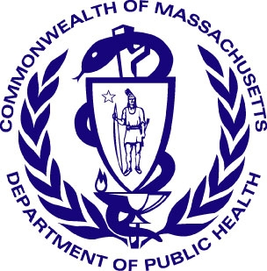
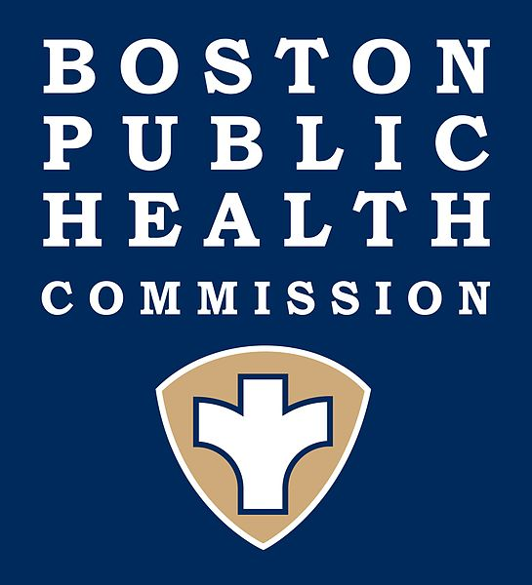

Boston Public Health Commission

Massachusetts Department of Public Health

Public Health Alert

Neurologic Illness with Limb Weakness

Recently, cases of neurologic illness with limb weakness have been reported in children in the United States. These cases have been reported concomitant with widespread respiratory illness due to enterovirus D68 (EV-68), but EV-68 has not been established as the cause of the neurologic illness. Enteroviruses in general can cause similar neurologic illness and enterovirus infections are more common at this time of the year; but whether EV-68 is causing these neurologic illnesses is not yet known.

Recent cases of neurologic illness have been characterized by weakness (paralysis or paresis) of one or more limbs, with evidence of spinal cord abnormalities of the gray matter on magnetic resonance imaging (MRI). The clinical picture is similar to that which occurs in poliomyelitis; however polio virus (neither vaccine-derived nor wild virus) has not been identified. Although some of the cases have had prior respiratory tract infection with EV-68, this virus was also causing widespread respiratory tract infection at the same time as cases of neurologic illness were observed, so it is unclear if EV-68 infection is associated with the neurologic illness or coincidental. Enteroviruses are also a cause of aseptic meningitis and meningoencephalitis, but neurologic findings in the recent cases have not included symptoms consistent with meningitis.

In order to assess the incidence of neurologic illness with limb weakness, and to investigate possible causes for this syndrome, the Centers for Disease Control and Prevention (CDC) is working with state and local public health to identify cases, collect information and expedite laboratory studies to identify possible etiologic agents.
If you have identified a case of acute onset neurologic disease with limb weakness in a patient 21 years of age or younger that meets the following case definition:

has an acute onset of focal limb weakness occurring on or after August 1, 2014

AND

has an MRI demonstrating spinal cord lesion(s) restricted to the gray matter

we ask that you do the following:

- Contact the Massachusetts Department of Public Health (MDPH, 617-983-6800), or in Boston, the Boston Public Health Commission (BPHC, 617-534-5611) and report the case immediately.
- Complete a case report form that will be provided.
- Submit a stool specimen collected from the patient, and submit it to the MDPH Hinton State Laboratory Institute for viral culture according to instructions that will be provided.
- Collect and submit other specimens (CSF, respiratory) as clinically indicated.

This is an emerging health concern affecting children, and your assistance is critical to the investigation of and introduction of prevention and control measures for this outbreak. The CDC is convening an expert panel to consider treatment guidelines. These will be provided when available.

If you have any questions, please contact MDPH and/or BPHC at the telephone numbers above.

