INDOOR AIR QUALITY ASSESSMENT

New Bedford District Court
75 North 6th Street
New Bedford, MA

Prepared by:
Massachusetts Department of Public Health
Bureau of Environmental Health
Indoor Air Quality Program
June 2016

Background
Building: | New Bedford District Court
Address: | 75 North 6th Street, New Bedford, MA
Assessment Requested by: | Chris McQuade, Administrative Attorney  Administrative Office of the Trial Court
Reason for Request: | General indoor air quality (IAQ) concerns.
Date of Assessment: | April 22, 2016
Massachusetts Department of Public Health/Bureau of Environmental Health (MDPH/BEH) Staff Conducting Assessment: | Mike Feeney, Director and Ruth Alfasso, Environmental Engineer/Inspector, IAQ Program
Building Description: | Stone and brick courthouse with first floor and occupied lower level/basement area containing courtrooms, offices, waiting areas and a lockup. Building has a flat ballasted roof. The courthouse is located near downtown New Bedford and major roadways.
Building Population: | Approximately 280 employees and is visited by over 1200 members of the public daily.
Year of Construction: | 1984
Windows: | Openable in most areas.

METHODS
Please refer to the IAQ Manual for methods, sampling procedures, and interpretation of results (MDPH, 2015).

IAQ Testing Results
The following is a summary of indoor air testing results (Table 1).
- Carbon dioxide levels were above 800 parts per million (ppm) in 52 out of 89 areas tested, indicating inadequate fresh air in more than half of the areas.
- Temperature was within the recommended range of 70°F to 78°F in almost all areas tested with a few areas, including the Judges’ chambers, slightly above the recommended range.
- Relative humidity was within or close to the lower end of the recommended range of 40% to 60% in all areas tested.
- Carbon monoxide levels were non-detectable in all indoor areas tested.
- Fine particulate matter (PM2.5) concentrations measured were below the National Ambient Air Quality Standard (NAAQS) level of 35 μg/m³ in most areas tested with 7 readings above the limit; this is discussed further in the Other IAQ Evaluations section of this report.

This sampling indicates that the ventilation system is not providing adequate fresh air for the occupancy in the building. To maximize air exchange, the BEH recommends that mechanical ventilation systems operate continuously during periods of occupancy. Without the system operating as designed, normally occurring pollutants cannot be diluted or removed, allowing them to build up and lead to IAQ/comfort complaints.

Ventilation
A heating, ventilating and air conditioning (HVAC) system has several functions. First it provides heating and, if equipped, cooling. Second, it is a source of fresh air. Finally, an HVAC system will dilute and remove normally occurring indoor environmental pollutants by not only introducing fresh air, but by filtering the airstream and ejecting stale air to the outdoors via exhaust ventilation. Even if an HVAC system is operating as designed, point sources of respiratory irritation may exist and cause symptoms in sensitive individuals. The following analysis examines and identifies components of the HVAC system and likely sources of respiratory irritant/allergen exposure due to water damage, aerosolized dust and/or chemicals found in the indoor environment.
Fresh air is provided by air handling units (AHUs) located in a penthouse on the roof (Picture 1). Air from the AHUs is filtered, heated/cooled and delivered to rooms via ducted supply vents (Picture 2). In rooms along the exterior walls, supply vents were smaller (Picture 3) and circulation is supplemented by fan coil units (FCUs, Picture 4) that only recirculate and heat/cool air rather than supplying fresh air. Many of these FCUs were turned off, obstructed with items or furniture, or had filters that were not set unto the unit properly (Picture 5). FCUs were blocked or obstructed by desks, boxes and other items (Picture 6). Airflow to FCUs should be unrestricted in order for this equipment to function properly. Internal components were also found to be in poor condition with corrosion and damage. Note that these units were likely installed sometime around 1983 which would make them over 30 years old. Function of equipment of this age is difficult to maintain, since compatible replacement parts are often unavailable. According to the American Society of Heating, Refrigeration and Air-Conditioning Engineers (ASHRAE), the service life for a unit heater, hot water or steam, is 20 years, assuming routine maintenance of the equipment (ASHRAE, 1991). Despite attempts to maintain the FCUs, the operational lifespan of the equipment has been exceeded.
Many areas did not appear to have exhaust ventilation (Table 1). Review of plans for the building suggests that restroom exhaust vents were part of the plan to remove stale air from the building. However most restroom exhaust vents were not functioning at the time of the visit. Fans were examined on the roof and only two out of the eight vents were activated. Paper signs suggesting the use of air fresheners indicate that restroom exhausts have been non-functioning for a considerable length of time (Picture 7). Operating exhaust vents in restrooms and other areas that are a source of water vapor and odors and are necessary to prevent these from migrating into occupied areas. Other equipment on the roof appeared to be retrofitted to provide increased exhaust ventilation (Picture 1).
It is recommended that HVAC systems be re-balanced every five years to ensure adequate air systems function (SMACNA, 1994). It was unknown when the last time these systems had been balanced.
The sally port garage area had a manually-activated exhaust vent retrofitted into the wall next to the garage doors to remove vehicle exhaust that may be created during use (Picture 8). This vent appears to be inoperable. Note that a vehicle was idling in the space at the time of the visit.

Temperature
In buildings with inadequate supply and exhaust ventilation, temperature control becomes difficult. Change of seasons can be more difficult, as the day of the visit was warm outside, but the systems had not yet been turned to cooling mode. In addition, some areas had windowsills in direct sunlight that were sources of heat from solar gain, which may make occupants feel warmer. The use of blinds to moderate heat from sunlight may help with temperature control.

Microbial/Moisture Concerns
Stained ceiling tiles were observed in several places (Picture 9; Table 1). It was reported that the roof had leaked in the past. Water-damaged ceiling tiles can provide a source of mold and should be replaced after a water leak is discovered and repaired.
A significant source of water damage that exists in the building is related to the installation, maintenance and operation of the FCUs during hot, humid weather. FCUs with cooling capacity are equipped with a drip pan installed beneath the cooling coils to drain condensation. The drain pan empties into a condensation collector, which is connected to a plastic drainage hose within the pipe chase. The following conditions regarding the condition of the FCUs were noted:
- Drip pans were found corroded, indicating poor drainage of condensation and that it is unlikely that the drip pan or coils of each FCU have been routinely cleaned.
- Plastic hoses connected to drip pans (Picture 10) and condensation collectors were coated with scale, dust and the remnants of biofilm. Biofilm is a layer of slime created by microorganisms in wet or damp environments including coils, drip pans and drains. Biofilm can produce odors and can be resistant to cleaning and disinfection.
- Pipes supplying chilled water to coils lacked insulation and were corroded. Uninsulated chilled water pipes will collect condensation during hot, humid weather that can drip into the pipe chase.
- Entry of hot, humid outside air during the cooling season due to opening of exterior windows also contributes humidity that leads to condensation and the issues described above.
- Standing water inside FCUs can lead to microbial growth and odors.

The roof of the building was also examined. This building has skylights, which can often be a source of leaks, often through improperly fitted or maintained flashing. Roof drains were noted to be damaged (Picture 11) which can impede drainage from the roof, leading to water build up and an increased chance of leaking. It was reported that the roof is original to the building and therefore may need replacement.
Several of the bathrooms in the Judges’ Chambers area had showers which are reportedly never used. If water is not poured into these drains regularly, the traps will dry out and allow sewer gases and odors into occupied areas.
Plants were observed in a few areas (Picture 12; Table 1) including on porous surfaces (e.g. carpet). Plants can be a source of pollen and mold, which can be respiratory irritants to some individuals. Plants should be properly maintained and equipped with drip pans to prevent water damage to porous materials. Plants should also be located away from air diffusers to prevent the aerosolization of dirt, pollen and mold. Water coolers, fountains, and small refrigerators were found located on carpet, where they can moisten the carpet and lead to microbial growth (Pictures 13 and 14; Table 1).
Doors to the exterior lacked weather-stripping which can allow moisture and pests into the building (Picture 15).

Other IAQ Evaluations

Particulate Matter
Levels of particulate matter in some areas were above the NAAQS limit of 35 μg/m³. There are several conditions contributing to this. The lack of effective circulation and filtration in the FCUs (e.g., Picture 5) prevents these units from effectively removing airborne particles generated in the space. The lack of effective exhaust ventilation also prevents the removal of particular matter.
The carpeting in much of the building is original and thus approximately 30 years old, which is well over the service life for this type of carpet and use. The usable life of carpeting is approximately 10-11 years (IICRC, 2002). Carpeting was visibly worn, wrinkled, stained and otherwise damaged in numerous places (Pictures 16 through 18). Carpeting this worn can no longer be effectively cleaned to remove particulate matter, and disintegration of the carpet and backing fibers contribute to particulates in the indoor environment when stepped on or otherwise disturbed. It was demonstrated during the visit that footsteps on worn carpeting caused a measurable increase in the particulate level in the breathing zone. Carpet replacement is in progress; as this carpeting is replaced, carpet squares should be used. Carpets should be cleaned regularly in accordance with Institute of Inspection, Cleaning and Restoration Certification (IICRC) recommendations (IICRC, 2012).
Other factors that may contribute to elevated levels of particulate matter include the presence of numerous stored items, including paper, boxes and other items which make it harder for custodial staff to clean. Personal fans, supply vents and FCUs also had dust and debris on them which can be reaerosolized and cause irritation. The courtrooms are equipped with ceiling fans which also need to be cleaned regularly.

Volatile organic compounds
Exposure to low levels of total volatile organic compounds (TVOCs) may produce eye, nose, throat, and/or respiratory irritation in some sensitive individuals. To determine if VOCs were present, BEH/IAQ staff examined rooms for products containing VOCs. BEH/IAQ staff noted air fresheners, hand sanitizers, cleaners, and dry erase materials in use within the building (Table 1). All of these products have the potential to be irritants to the eyes, nose, throat, and respiratory system of sensitive individuals. In several areas, scented products such as candles (Picture 19) and plug-in air fresheners were observed. These items not only can produce irritating fumes, but they do not remove the source of the odors.

Other conditions
AOTC personnel reported concerns regarding seagulls on the roof (Picture 20). BEH staff noted the presence of seagull waste on skylights (Picture 21) and windowsills (Picture 22) adjacent to the roof. No bird waste was found in or around fresh air intakes (Picture 23). No evidence of bird roosting inside the HVAC system ductwork was found. Bird screens installed over fresh air intakes were intact (Picture 24).
Building staff reported that mice are sometimes an issue in this space. The principals of Integrated Pest Management (IPM) which include the removal of sources of food, water, warmth and harborage in the building, should be followed. Enhanced cleaning and reduction in clutter can assist in pest control, as well as removing pests and pest wastes which can be irritants or allergens. A certified pest control professional may be needed to assist with these issues. The document “Integrated Pest Management Kit for Building Managers” provides additional strategies for IPM (MDFA, 1996).

Conclusions/Recommendations
Based on observations at the time of assessment, a two-phase approach is required for remediation. The first consists of short-term measures to improve air quality and the second consists of long-term measures that will require planning and resources to adequately address overall concerns.

Short-term Recommendations
- Operate supply and exhaust ventilation in all areas during occupied periods.
- Repair all exhaust vents including the one in the sally port.
- To the extent possible, remove blockages and obstructions from the front/top of FCUs to allow these units to operate.
- Repair FCU housings so that filters can be installed inside the cabinet and held flush with the bottom to provide filtration.
- Repair/replace/clean condensation collectors, hoses and drip pans inside FCUs.
- Insulate chilled water supply pipes in FCUs.
- Change filters 2 to 4 times a year and vacuum FCUs to remove debris during each filter change.
- Have the HVAC system balanced every 5 years in accordance with SMACNA recommendations (SMACNA, 1994).
- Use blinds to moderate temperature in areas subject to direct sunlight.
- Repair roof/plumbing leaks and replace stained ceiling tiles.
- Repair roof drains.
- Clean bird waste from the skylights and window sills adjacent to the roof. Installation of bird spikes on flat surfaces (e.g., windowsill) should be considered.
- Ensure drains in unused showers and other seldom-used locations are filled with water periodically to prevent dry drain traps.
- Keep plants in good condition, avoid overwatering, and avoid placing them on porous items such as carpets or paper.
- Replace weather-stripping on exterior doors so that they fit tightly and do not allow light/drafts around them.
- Keep windows closed during the air conditioning season to prevent entry of hot, humid air.
- Clean existing carpeting in accordance with IICRC recommendations (IICRC, 2012).
- Reduce stored materials and store in an organized manner to allow for thorough cleaning.
- Clean supply and exhaust vents and personal fans regularly to prevent aerosolization of debris.
- Reduce the use of VOC-containing cleaners and sanitizers.
- Avoid the use of air fresheners and scented candles.
- Ensure bird screens to the AHUs remain intact.
- Use the principles of IPM to reduce pest issues in the building, including the sealing of pathways and reduction in sources of food and harborage. Contract with a certified pest control professional if needed. Consult “Integrated Pest Management Kit For Building Managers” (MDFA, 1996), http://www.mass.gov/eea/docs/agr/pesticides/publications/ipm-kit-for-bldg-mgrs.pdf.
- Refer to resource manual and other related IAQ documents located on the MDPH’s website for further building-wide evaluations and advice on maintaining public buildings. These documents are available at: http://mass.gov/dph/iaq.

Long-term recommendations:
- FCUs have exceeded their expected service life. Replacement of HVAC components should be a part of long-term planning for this building.
- Consider hiring an HVAC consultant to assess if the HVAC system as it is built can supply the needs of this building and determine what modifications would be needed to improve overall air circulation in the building.
- Repair/replace the roof.
- Replace all remaining original carpet. Consider using carpet squares.

References
ASHRAE. 1991. ASHRAE Applications Handbook, Chapter 33 “Owning and Operating Costs”. American Society of Heating, Refrigeration and Air Conditioning Engineers, Atlanta, GA.
IICRC. 2002. Institute of Inspection, Cleaning and Restoration Certification. Carpet Cleaning: A Life-cycle Cost Analysis for Floor Coverings in School Facilities. Retrieved from https://www.carpet-rug.org/Documents/Scientific_Resources/0203_IICRC_Life-Cycle-Cost-Analysis.aspx
IICRC. 2012. Institute of Inspection, Cleaning and Restoration Certification. Carpet Cleaning: FAQ. Retrieved from http://www.iicrc.org/consumers/care/carpet-cleaning/#faq.
MDFA. 1996. Integrated Pest Management Kit for Building Managers. Massachusetts Department of Food and Agriculture, Pesticide Bureau, Boston, MA.
MDPH. 2015. Massachusetts Department of Public Health. Indoor Air Quality Manual: Chapters I-III. Available at: http://www.mass.gov/eohhs/gov/departments/dph/programs/environmental-health/exposure-topics/iaq/iaq-manual/.
SMACNA. 1994. HVAC Systems Commissioning Manual. 1st ed. Sheet Metal and Air Conditioning Contractors’ National Association, Inc., Chantilly, VA.
Picture 1
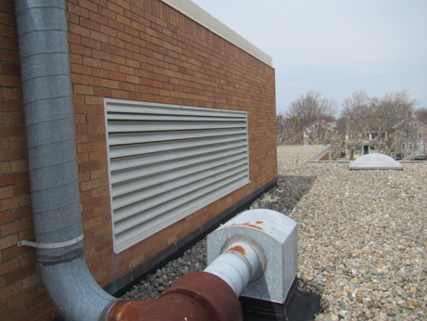
Fresh air vent for penthouse air handling units (AHU) and add-on exhaust venting
Picture 2
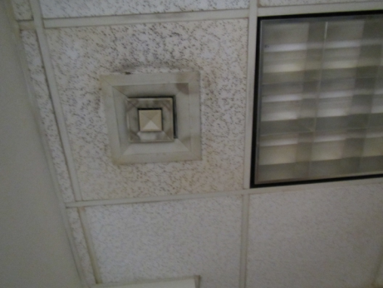
Supply vent, note dust
Picture 3
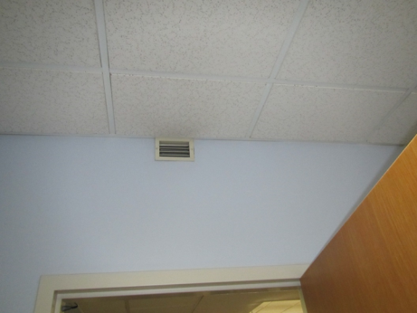
Small supply vent in room with fan coil unit (FCU)
Picture 4
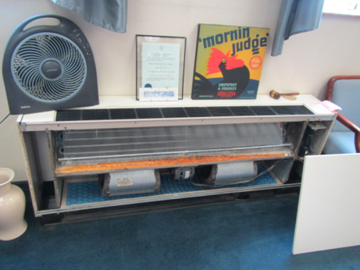
FCU with cover off showing interior
Picture 5
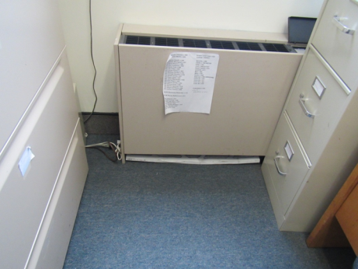
Obstructed FCU with filter on the floor
Picture 6
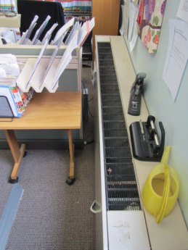
FCU obstructed by furniture and with debris on the top
Picture 7
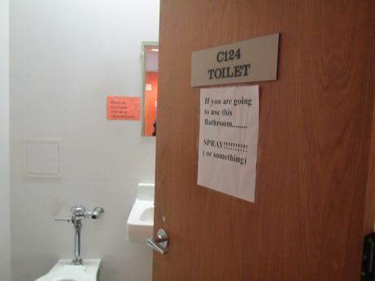
Sign on bathroom suggesting that exhaust venting has not worked in some time
Picture 8
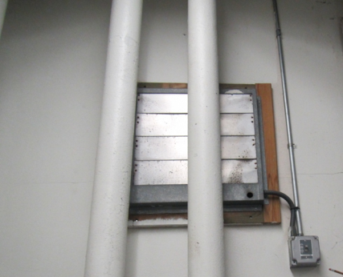
Sally port exhaust vent
Picture 9
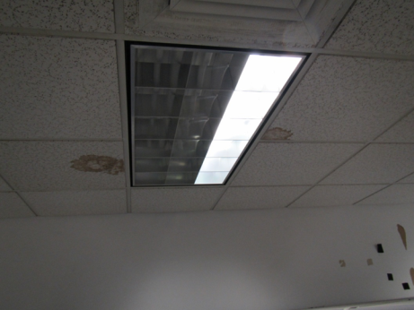
Water-damaged ceiling tiles
Picture 10
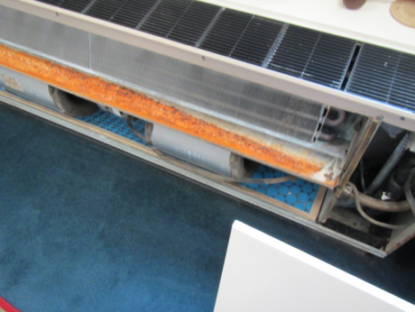
Interior of FCU, note corroded drip pan and discolored drain hose
Picture 11
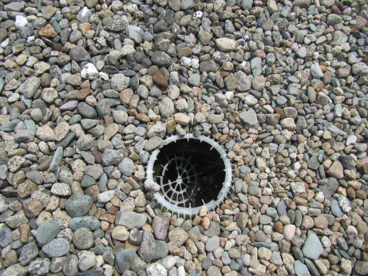
Damaged roof drain
Picture 12
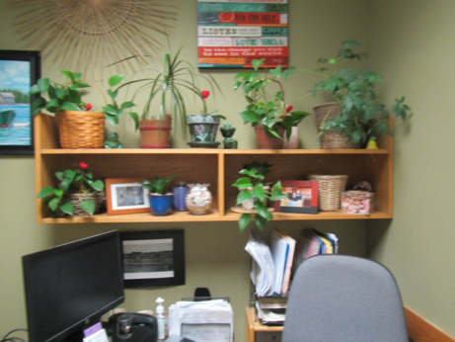
Plants in an office
Picture 13
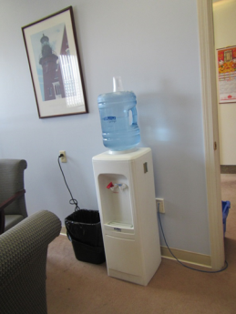
Water cooler on carpet
Picture 14
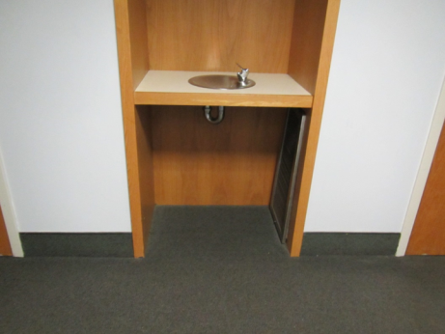
Drinking fountain in carpeted area
Picture 15
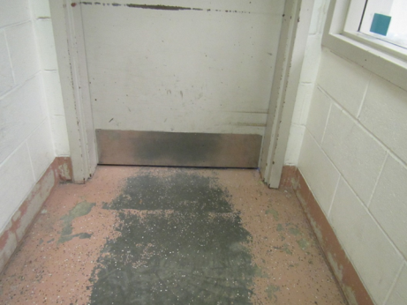
Exterior door missing weather-stripping
Picture 16
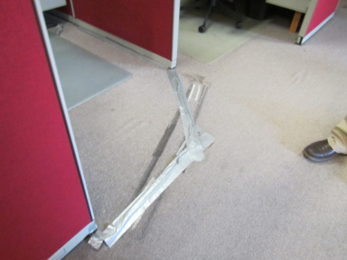
Worn, wrinkled, stained carpeting held together with tape
Picture 17
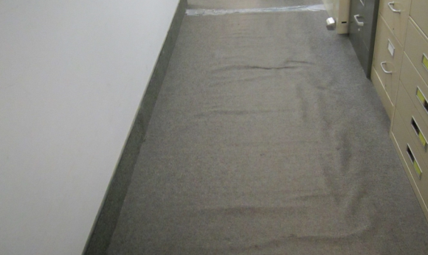
Wrinkled carpeting with tape
Picture 18
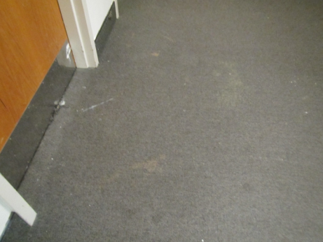
Stained, worn carpeting
Picture 19
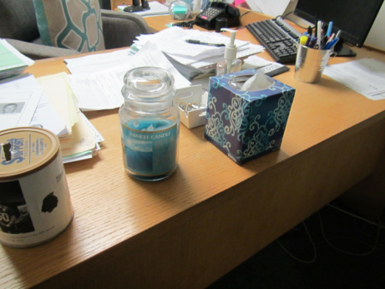
Scented candle
Picture 20
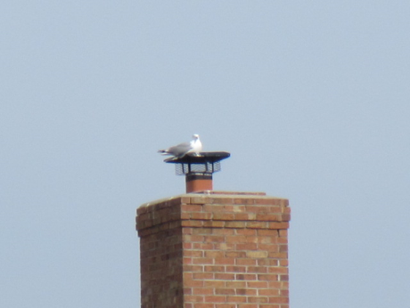
Seagull on chimney cap
Picture 21
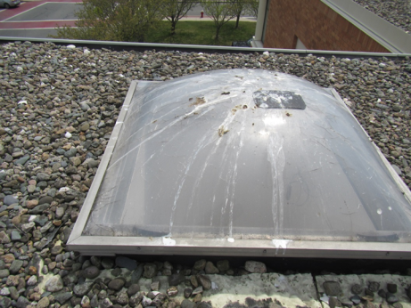
Bird waste on skylight
Picture 22
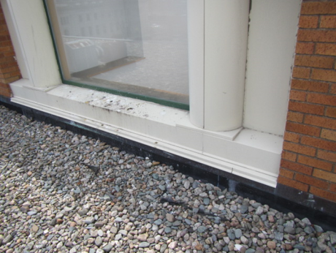
Bird waste on windowsill
Picture 23
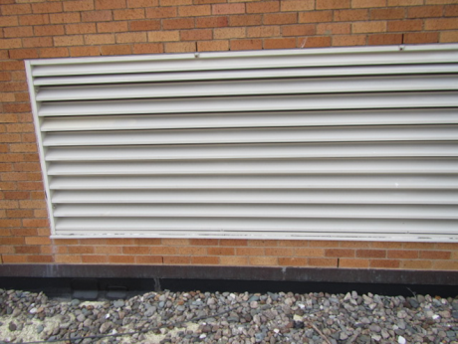
Fresh air intake vent, note no bird waste on louvers
Picture 24
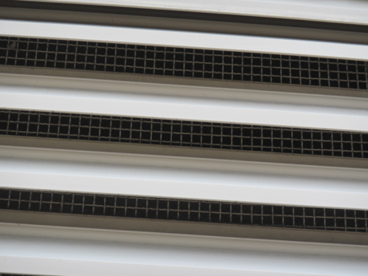
Bird screen inside fresh air intake
Location | Carbon  Dioxide  (ppm) | Carbon Monoxide  (ppm) | Temp  (°F) | Relative  Humidity  (%) | PM2.5  (µg/m³) | Occupants  in Room | Windows  Openable | Ventilation |  | Remarks
 |  |  |  |  |  |  |  | Supply | Exhaust
Background | 344 | 0.7 | 75 | 38 | 45 |  |  |  |  | Collected in the parking lot, breezy and cloudy
Lockup area
GC 12 lock up office | 777 | ND | 75 | 38 | 11 | 0 | N | Y | Y
GC 14 interview room | 732 | ND | 74 | 41 | 11 | 0 | N | Y | Y | WD CT
GC 57 | 772 | ND | 75 | 39 | 20 | 1 | N | Y | Y | WD CT, old carpet
GC 60 Kitchen |  |  |  |  |  |  |  |  |  | Food prep equipment
GC 245 (Chief) | 741 | ND | 75 | 38 | 16 | 0 | N | Y | Y | NC
Lockup guardroom | 705 | ND | 77 | 37 | 18 | 3 | N | Y | Y | NC, Equipment, door to sally port
Sally Port | 882 | ND | 73 | 37 | 34 | 0 | Door | N | Y not on | Car idling inside, new exhaust fan not operating
First Floor
103 | 515 | ND | 77 | 37 | 35 | 1 | Y | Y | Y | PC, carpet, DO, fridge
110 | 1176 | ND | 76 | 39 | 22 | 1 | Y | Y | Y | Carpet, storage closet, WD CT
112 | 899 | ND | 77 | 36 | 15 | 0 | N | Y | Y | PF on, plant
113 interview | 811 | ND | 77 | 36 | 17 | 0 | N door to hallway | Y | Y
114 | 1003 | ND | 77 | 36 | 20 | 0 | Y | Y | Y | DO, FCU
115 | 980 | ND | 77 | 37 | 16 | 1 | Y | Y | Y | DO, obstructed, dusty FCU
116 | 965 | ND | 77 | 38 | 17 | 0 | Y | Y | Y | FCU
117 | 943 | ND | 77 | 36 | 26 | 0 | N | Y | Y | FCU, PF on
118 | 945 | ND | 77 | 36 | 18 | 0 | Y | Y | Y | FCU, plant, HS
119 | 868 | ND | 77 | 38
119 | 850 | ND | 77 | 37 | 23 | 0 | Y | Y | Y | FCU, filter ajar, DO, AF, fridge
120 | 890 | ND | 77 | 37 | 13 | 0 | Y open | Y | Y | FCU on, DO
120 | 875 | ND | 77 | 38 | 28 | 0 | Y open | Y | Y | Filter not in FCU, DO
121 | 912 | ND | 77 | 49 | 19 | 0 | Y | Y | Y | FCU off, filter on floor, fridge on carpet
122 | 852 | ND | 77 | 38 | 19 | 0 | Y | Y | Y | PF, candy
123 | 842 | ND | 77 | 38 | 14 | 1 | Y open | Y | Y | FCU on
125 | 913 | ND | 78 | 38 | 19 | 2 | Y | Y | Y | FCU on, filter on floor
127 | 861 | ND | 78 | 38 | 12 | 1 | Y open | Y | Y | WD CT
147 | 467 | ND | 78 | 34 | 48 | 0 | Y | Y | Y | DO, boxes on floor
Adult probation office open area | 806 | ND | 77 | 37 | 19 | 10 | N door to hallway | Y | Y | PF, CP, DEM
Assistant chief clerk office | 477 | ND | 77 | 37 | 39 | 0 | Y | Y | Y
Assistant clerk admin suite | 599 | ND | 77 | 36 | 28 | 1 | Y open | Y | Y
Attorney room | 1024 | ND | 76 | 34 | 25 | 0 | Y | Y | Y | Toilet room, carpet
C107 | 566 | ND | 77 | 35 | 36 | 0 | N | Y | Y
C112 jury | 731 | ND | 79 | 37 | 14 | 0 | N | Y | Y | Dusty fan, stained carpet
C125 | 973 | ND | 79 | 38 | 13 | 1 | N | Y | Y | NC, used to have carpeting (now bare mastic)
C133 | 783 | ND | 78 | 36 | 20 | 0 | N | Y | Y | 2 WD CT, PF dusty
C134 | 1099 | ND | 78 | 39 | - | 0 | N | Y | Y
C140 | 965 | ND | 77 | 37 | 19 | 1 | N | Y | Y | DO
C142 | 800 | ND | 77 | 37 | 18 | 0 | N | Y | Y | Was formerly conference room now office, DO
C143 | 860 | ND | 77 | 37 | 18 | 0 | N | Y | Y | HS, candles, area rug, DO
Civil clerk | 503 | ND | 77 | 36 | 43 | 0 | Y open | Y | Y | CF, WD CT
Clerk area back | 450 | ND | 78 | 35 |  | 1 | Y | Y | Y | PF
Clerk area front | 436 | ND | 78 | 35 | 31 | 5 | N | Y | Y | PFs, HS
Clerk food area | 366 | ND | 76 | 35 | 34 | 0 | Y open | Y | Y | NC, fridge, microwave
Clerk office | 491 | ND | 77 | 36 | 21 | 0 | Y | Y | Y | NC
Clerk office manager | 411 | ND | 77 | 35 | 33 | 1 | Y open | Y | Y | Reports of mice, debris on FCU, food, HS
Clerk supervisor | 481 | ND | 78 | 36 | 33 | 0 | Y | Y | Y | FCU, DO
Copy, lounge in Judges’ area | 749 | ND | 79 | 37 | 38-88 | 0 | Y | Y | Y | FCU, carpet is old/worn, PCs, toaster, fridge and other equipment
Courtroom 1 | 931 | ND | 76 | 42 | 10 | >20 | N | Y | Y | CF, stains on supply vent
Courtroom 2 | 911 | ND | 76 | 42 | 15 | 10 | N | Y dusty |  | Carpet worn, taped, CF-on
Courtroom 3 | 1007 | ND | 79 | 39 | 11 | >20 | N | Y | Y | CF
CR 4 | 675 | ND | 76 | 38 | 24 | 8 | N | Y | Y | Carpet
Dist A | 557 | ND | 77 | 37 | 32 | 0 | Y | Y | Y | WC on carpet
Judge office | 700 | ND | 79 | 37 | 25 | 0 | Y | Y | Y | WC on carpet, toilet and shower room (drains)
Judge office –entry | 652 | ND | 79 | 35 | 38 | 0 | Y | Y | Y | Plant, toilet and shower room (drains), WD CT
Judges’ library | 646 | ND | 78 | 37 | 34 | 0 | Y open | Y | Y | FCU on
Judges’ lobby | 843 | ND | 79 | 37 | 28 | 2 | Y | Y | Y | FCU, on, shredder, plants, DEM
Judges’ lobby | 771 | ND | 79 | 37 | 24 | 0 | Y | Y | Y | 2 WD CT
Jury room (1) | 1333 | ND | 79 | 41 | 21 | 9 | N | Y | Y | NC, PF on
Juvenile court | 678 | ND | 74 | 39 | 17 | 0 | N | Y | Y | NC
Juvenile court 2 | 796 | ND | 76 | 39 | 16 | 2 | Y | Y | Y | Old carpet
Juvenile jury area | 804 | ND | 76 | 38 | 23 | 0 | Y | Y | Y | Plants on carpet, toilet and shower room, AF odor
Juvenile magistrate back area | 868 | ND | 75 | 38 | 29 | 1 | N | Y | Y
Juvenile magistrate office front | 852 | ND | 75 | 38 | 21 | 2 | N | Y | Y
Mechanical room |  | ND |  |  |  |  |  |  |  | WD pipe wrap
Police liaison | 920 | ND | 76 | 40 | 36 | 2 | Y open | Y | Y | Carpet
Probation office | 1013 | ND | 77 | 37 | 12 | 4 | Y | Y | Y
Public ladies room |  |  |  |  |  |  |  | Y | Y off | CP, AF, exhaust vent dusty
Public viewing | 607 | ND | 77 | 38 | 33 | 3 | N | Y | Y | NC, large plant
Staff lunch | 844 | ND | 77 | 38 | 23 | 1 | Y | N | Y | DO, NC, fridge and microwave
Vault upstairs | 514 | ND | 76 | 33 | - | 0 | N | N | N
Lower Level
G5 | 833 | ND | 74 | 41 |  | 1 | N | Y | Y
G6 | 846 | ND | 75 | 39 | 15 | 1 | N | Y | Y | Carpet
G8 | 906 | ND | 75 | 39 | 15 | 1 | N | Y | Y | Carpet
G9 | 852 | ND | 73 | 40 | 15 | 0 | N | Y | Y | WC on carpet, DO
G10 | 900 | ND | 73 | 40 | 19 | 0 | N | Y | Y | DO
G11 | 854 | ND | 73 | 41 | 20 | 0 | Y | Y on | Y | DO
G12 | 791 | ND | 74 | 38 |  | 0 | N | Y | Y | Boxes on floor, DO
G13 | 815 | ND | 73 | 38 | 15 | 0 | Y | Y on | Y
G14 | 782 | ND | 74 | 37 | 16 | 0 | N | Y | Y | Dusty
G15 | 805 | ND | 74 | 38 | 15 | 0 | N | Y | Y | WD CT, many plants, CP, DO
G16 | 799 | ND | 74 | 38 | 15 | 0 | N | Y | Y | Plants, DO
G17 | 885 | ND | 74 | 39 | 15 | 0 | Y | Y on | Y | DO
G18 | 927 | ND | 74 | 39 | 15 | 0 | Y | Y on | Y | DO
G19 | 820 | ND | 76 | 38 | 15 | 0 | Y | Y on | Y | DO
G21 | 805 | ND | 75 | 38 | 19 | 0 | Y | Y |  | Candle, WD CT, carpet
G22 | 827 | ND | 76 | 38 | -- | 1 | Y | Y |  | FCU, DO, old stained carpet, WD CT
GC23 | 847 | ND | 74 | 40 | 18 | 0 | Y | Y | Y | Duct tape on carpet
GC24 | 808 | ND | 74 | 41 | 17 | 0 | Y | Y | Y
GC28 | 1014 | ND | 75 | 39 | 24 | 1 | Y | Y on | Y
GC35 | 749 | ND | 75 | 41 | 16 | 0 | N | Y on | Y | Duct tape on carpet
GC48 | 825 | ND | 74 | 39 | 15 | 0 | N | Y | Y | DO, PC
GC50 | 800 | ND | 75 | 37 | 18 | 0 | N | Y | Y | Plant, DO
GC 52 men’s restroom |  |  |  |  |  |  |  |  | Y off
Juvenile court | 710 | ND | 75 | 40 | 15 | 0 | N | Y | Y | Duct tape on carpet

