Title Slide:
MassPAT Bulk Patient Search Tutorial regarding Advanced Functionality for Multi-Supervisor Selection.
Slide 2 Tutorial Outline
The purpose of the tutorial is to review the Bulk Patient search functionality and the New Supervisor Search function.

Slide 3 Overview
What is a Bulk Patient Search?
Unlike conducting single patient searches through the Rx Search request, a bulk patient search allows a delegate user to search the PMP system for multiple patients at one time. This can be done by manually entering the patient first name, last name, and date of birth into the bulk search fields and running the report. Or the delegate can upload a list of those patients into the system and run the report.
The Problem
Delegates often have more than one supervisor. These delegates often select one supervisor and conduct a single bulk search that includes patients for multiple supervisors. When this happens one supervisor is credited with all the searches and the other supervisors appear to have no PMP utilization.
Slide 4 Overview
MGL Ch. 94C, sec. 24A requires a prescriber to utilize the PMP before prescribing a Schedule II-III narcotic or a benzodiazepine. When a delegate does not credit the correct supervisor for a patient search the prescriber appears to be in violation of the law.
The Fix
MassPAT has deployed advanced functionality on the bulk patient search page to allow the delegate to conduct a bulk patient search and easily attribute each patient search appropriately to the correct prescriber.
This tutorial will help you conduct a bulk search that credits each supervisor appropriately.

Slide 5 Bulk Patient Search
To navigate to the Bulk Patient Search page go to menu then click on Rx Request and then click Bulk Patient Search This screen will appear.
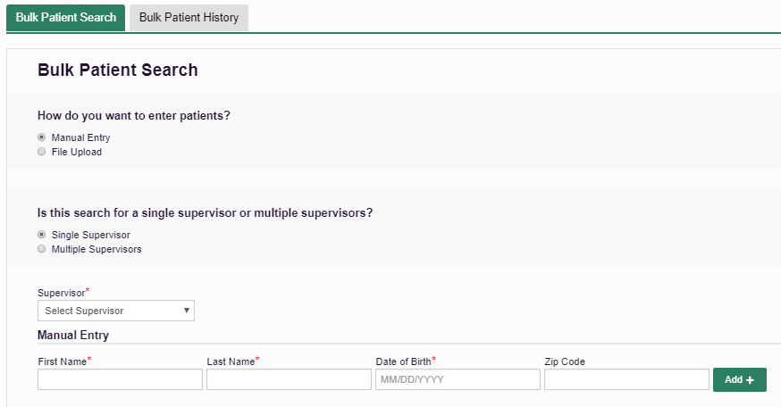
Indicate which type of search. In this example is a manual search for a single supervisors.
- There is a drop feature from which you can find as supervisor and then manually enter patient information,

Slide 6 Bulk Patient Search
This slide depicts Multi-Supervisor Selection Entry.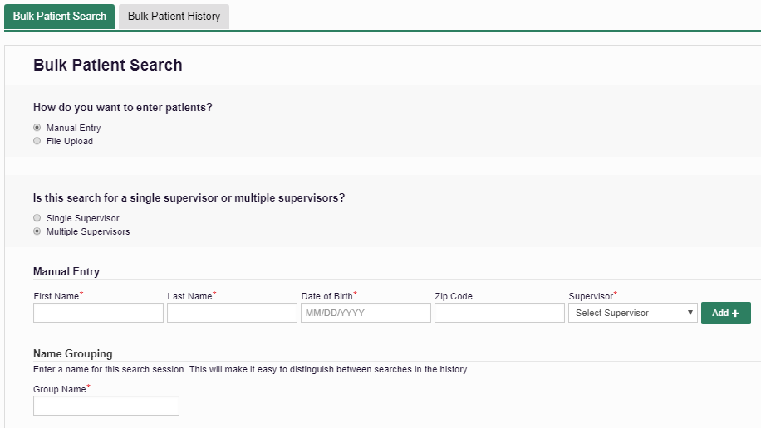
In this case the supervisor drop down is aligned with manual patient information and you need to name the group to make it easy for you to distinguish between searches.
Slide 7 Multi-Supervisor Manual Entry
When you select “Multiple Supervisors” a dropdown Supervisor List will appear on each patient line. Select the correct Supervisor for each patient!
Slide 8 Bulk Search – File Upload
When you choose the File Upload option you must include the correct supervisor's DEA for each patient!
Be sure to view the sample file to ensure your list is aligned with the required date elements, including the Prescriber’s DEA number in the last column.
Slide 9 Bulk Patient Search
Using the advanced multi-supervisor setting you can opt to validate the file before running the report by selecting “Validate Format”(see green at the bottom right) The system will populate the uploaded file and display any errors pertaining to the entry for each row, or record.

Slide 10 Bulk Patient Search
To retrieve a Bulk Patient History they are kept historically within the Bulk Patient History table. The output reports are viewable and stored. Each patient searched will be added to the attributed supervisor’s “Request History” table for their review.

Slide 11 Final Steps for all Bulk Patient Searches
Regardless of the method that you use for conducting a Bulk Patient Search, there are a few final steps to complete before the system will run the query. The system requires you to name the Bulk Patient Search in the field entitled “Group Name”.
Also, you have the opportunity to reduce the date range for the search, or continue with the default (past 12 months).
Finally, if you wish to expand the system search to any applicable States, you can do so under the PMP InterConnect Search options.

Slide 11 Bulk Search
Give PMP utilization credit where credit is due!
Your Supervisors will thank you!
If you have any questions, contact us at:
mapmp.dph@MassMail.state.ma.us

