CCFA User Guide: Income Detail
This guide will assist CCFA users on how to add income to authorizations. This functionality applies to all authorizations in CCFA, including New and Reauthorization as well as Temporary and Non-Temporary Changes.

Below are the steps to add income to an authorization:

- On the Additional Information page, use the “add” link under income to add income for the parent/guardian.
  - Note: for parents with multiple activities, separate income details are required. For example, the parent is working two jobs. Two separate income details must be added.
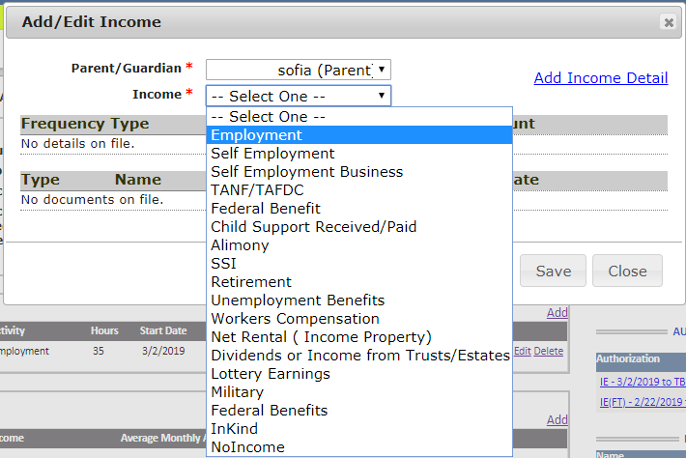
- Select the parent/guardian and the income source from the drop down.

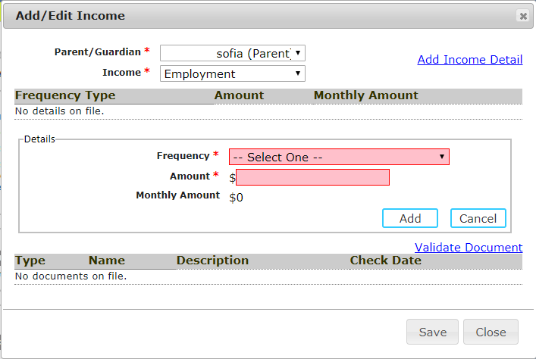
- Click “add income detail” to add the income frequency and amounts.
  - Use this section to enter individual income detail amounts.
  - The available frequencies require exact income detail entries:
Annual | 1
Bi-monthly | 2
Bi-weekly | 2
Monthly | 1
Weekly | 4

- Click “validate document” to add the supporting documentation related to the income frequency.
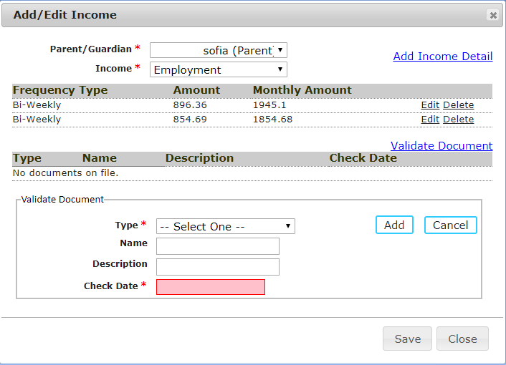
  - Check Date is a new and required field.
  - Documents cannot be older than 45 days from the current date.
  - The number of documents entered must match the frequency selected.
    - For Example, bi-weekly frequency requires 2 supporting documents.
- Save the income detail
  - CCFA will ask you to validate that all the information you have entered is correct.
  - If the income detail does not match the frequency, an error message will appear.
  - If the documents do not match the frequency, an error message will appear.
  - If the check date is not valid, an error message will appear.
- Add all additional information before clicking “next.”
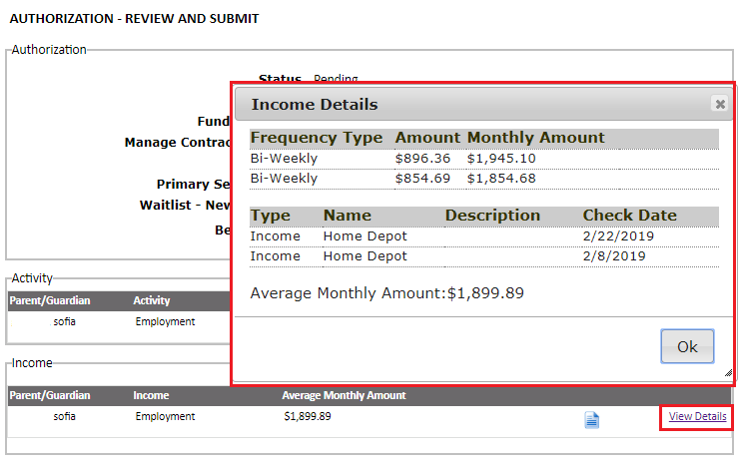
- On the Review and Submit page, click the “view details” link to validate the income detail.
  - Note: any information entered for “name” and “description” on the validated documents will appear here.
  - Note: this view is also available on the Sub Authorization Details page after the authorization has gone through the rules engine.

