CCFA User Guides: Temporary Changes
This guide will assist CCFA users on adding temporary changes to authorizations. Temporary changes can be added to the following authorizations: IE, DTA-T, DTA-PT, Homeless referrals. For information about Temporary changes, please refer to both the Policy Guide and the Procedures Manual.

Below are the steps to add a temporary change to an authorization.

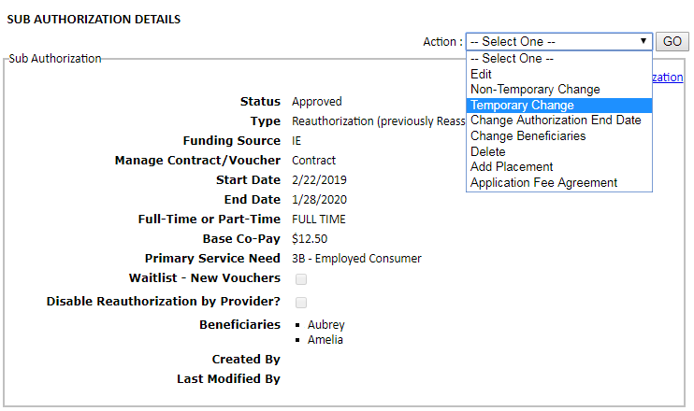
- Select “Temporary Change” from the Action Drop Down menu on the Sub Authorization Details page.

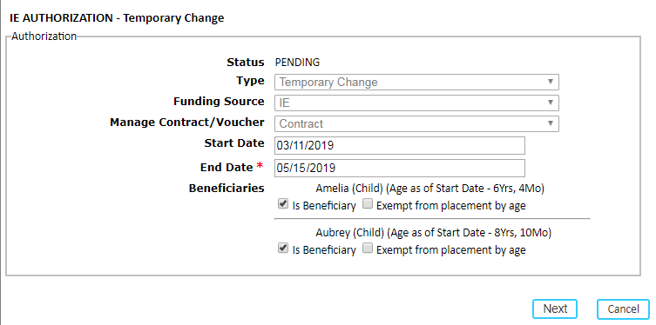
- Fill in the “Start Date” and “End Date” for the Change and click “next.”
- Click the “add” link to enter the service need, activity, and document for the parent(s)/guardian(s)
  - The available Temporary Change Service needs and associated activities are as follows:
6M – Maternity/ Paternity Leave | Maternity/ Paternity Leave
PML – Parent’s Medical Leave | Parent’s Medical Leave
FL – Family Leave | Family Leave
SE – Seasonal Employment | Seasonal Employment
RH – Reduction in Hours | Reduction in Hours
OB – Other Break | Other Break
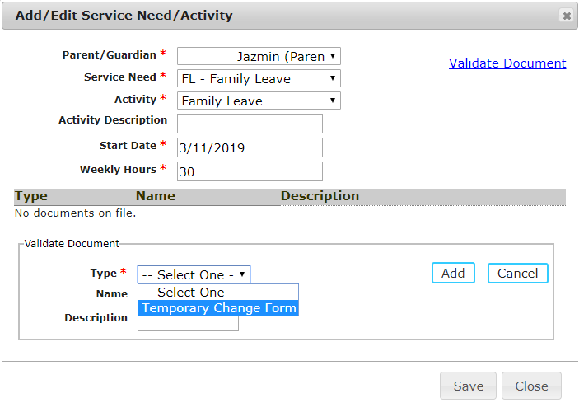

- Add the income.
  - See the CCFA User Guide on Income Detail for more information on adding income to authorizations.
- Click “next” to go to the Review and Submit page.
- Review the information entered before submitting to the rules engine.
- The Sub Authorization Details with the result will show.
  - The start and end dates will reflect those entered.
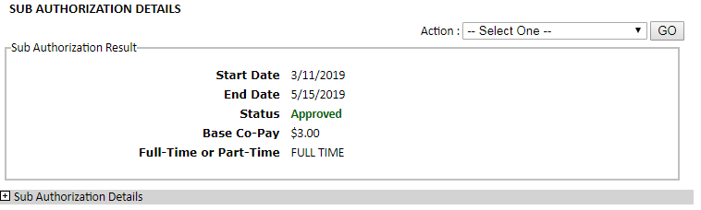
  - If applicable, the base co-pay will recalculate.
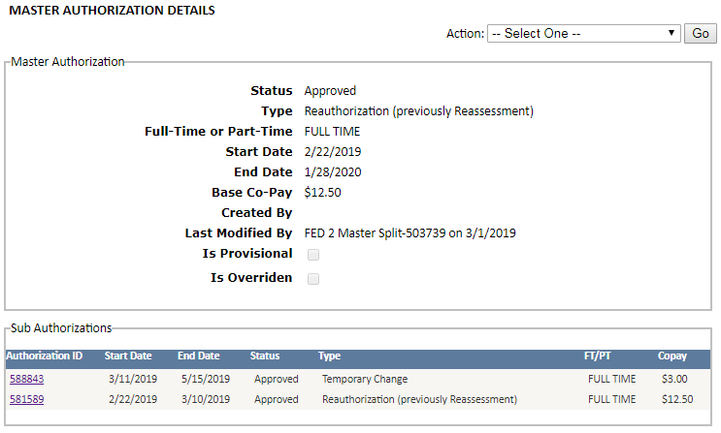
- The Temporary Change Sub Authorization will appear under the Master Authorization on both the Master Authorization Details page and Family Details page.

