Acknowledgment of Receipt of Determination of Need and Attestation Regarding Participation in MassHealth

Pursuant to 105 C.M.R. § 100.310(A)(2) we, the undersigned chief executive officer and board chair of New England Surgery Center, LLC (the "Holder"), hereby acknowledge that the Holder is in receipt of the Determination of Need Notice of Final Action, dated January 27, 2021 , issued by the Massachusetts Department of Public Health (the "Department") with respect to Application No. DoN # 20072809-AS . This attestation is being provided to the Department and to all Parties of Record within thirty (30) days of the Determination of Need Notice of Final Action.

In addition, pursuant to 105 CMR 100.310(A)(11), we hereby attest that New England Surgery Center, LLC ----------- -- th Care Facility or Facilities for which the Notice of Determination has been issued) articipate , or intends to participate] in MassHealth pursuant to 130 CMR 400.000 through 49 .

IN WITNESS WHEREOF, the undersigned have duly executed this Attestation on this
•cicy a.1,arl«l (date)

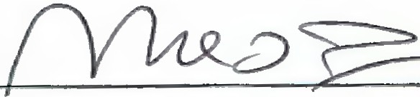Michael]. Zachareas, M.D.
Name, Chief Executive Officer and signature
2

Michael]. Zachareas, M.D. Name, Board Chair and signature

New
........
England W Surgery Center
,·

New England Surgery Center, LLC DoN# 20072809-AS
Attestation to Participation in MassHealth

,

Pursuant to 105 CMR 100.310 (A) (11), New England Surgery Center, LLC provides this written attestation of participation in MassHealth since April 4, 2012 and also attests to continued participation in the future pursuant to 130 CMR 400.000 through 499.00.

In WITNESS WHEREOF, the undersigned has duly executed this Attestation on the ninth day of February, 2021.

Norma L. Bacon 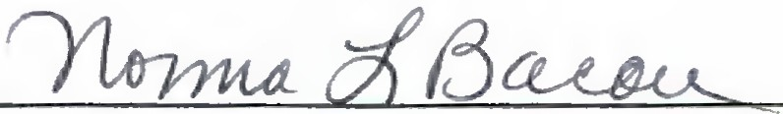 Name, Administrator and signature

Michael J. Zachareas 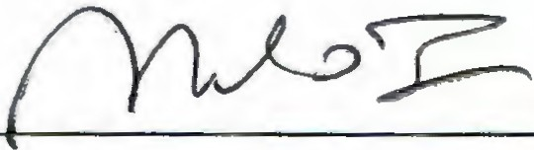 Name, Board Chair and Signature

900 Cummings Center, Suite 122U • Beverly, MA 01915 • Phone: 978-922-4670

