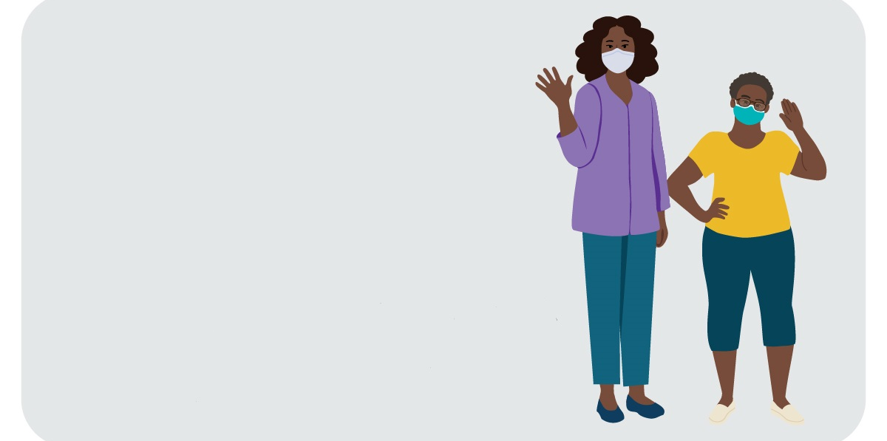
Thank you for your support in promoting our new suite of COVID-19 materials—including posters, social stories, videos, and interactive activities—for people with intellectual and developmental disabilities (IDD) who have extreme low literacy (ELL)! We are excited to introduce these materials with the aim of giving people with IDD and ELL and their caregivers the information they need to help them stay safe from COVID-19. These materials cover five behaviors that are important to prevent COVID-19: getting vaccinated, getting a COVID-19 test, handwashing, wearing a mask, and keeping a safe distance until fully vaccinated.
New from CDC
COVID-19 Materials for People with Intellectual and Developmental Disabilities
Help spread the word!
Why get involved?
People with IDD have a higher incidence of COVID-19 than people without IDD. They are also more likely to be admitted to the hospital from COVID-19 complications, have higher rates of stays in intensive care units, and are more likely to die from COVID-19. Yet people with IDD often do not have the information they need to protect themselves. To fill this gap, CDC created materials about COVID-19 and emergency preparedness that are specifically designed to meet this population’s needs.
Who should use this promotion kit?
Explore the materials
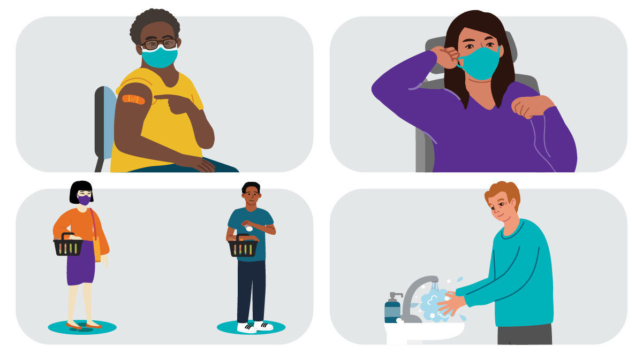
This kit is for disability service and advocacy groups, health care and public health organizations, and anyone else who is committed to improving communication and messaging about COVID-19 for people with IDD and ELL, their caregivers, and the organizations that support them.
How do I use this promotion kit?
To help us raise awareness of these resources, you can use the sample language and images that follow when sharing the materials on social media or by email, newsletters, websites, blogs, or other methods. You are welcome to customize the promotional text as needed.

How can I help?
1 | Post on social media  Help generate interest in these COVID-19 materials on social media! We developed posts for several different audiences. When you share, please tag @CDC_NCBDDD on Twitter and @CDC on Facebook and LinkedIn and use #COVID19DisabilityInclusion to help us track engagement. These posts are just examples — you can edit the language to meet your organization’s needs. We encourage you to include an image with each post, as people are more likely to share posts with pictures.
Posts for Twitter, Facebook, and LinkedIn
Post – English | Post – Spanish | Image Options | Audience
Learn how to stay safe from #COVID19! Check out CDC’s free materials: https://go.usa.gov/xFvXw | ¡Aprende cómo mantenerte a salvo del #COVID19! Consulta los materiales gratuitos de los CDC: https://go.usa.gov/xFvXw | 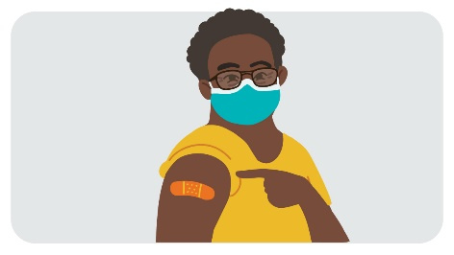 | People with IDD / Self-Advocates
CDC has new materials on how to stay safe from #COVID19! Check them out: https://go.usa.gov/xFvXw | ¡Los CDC tienen nuevos materiales sobre cómo protegerse del #COVID19! Consulte: https://go.usa.gov/xFvXw | 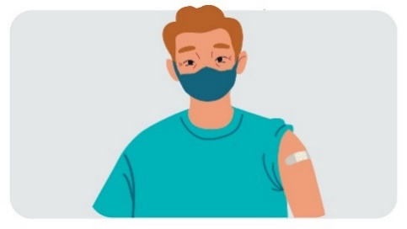 | People with IDD / Self-Advocates
Learn how you and your friends can stay safe from #COVID19! Take a look at CDC’s free materials: https://go.usa.gov/xFvXw | ¡Aprende cómo tú y tus amigos pueden protegerse del #COVID19! Consulta los materiales gratuitos de los CDC: https://go.usa.gov/xFvXw | 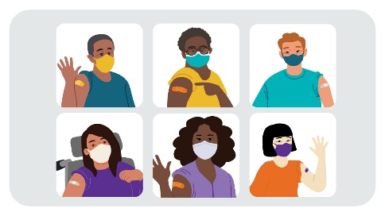 | People with IDD / Self-Advocates
Stay safe from #COVID19! Watch CDC’s video to learn about getting a COVID-19 shot: https://www.youtube.com/watch?v=XPWMDN8aI7s | ¡Protégete del #COVID19! Mira el video de los CDC para aprender sobre cómo obtener una vacuna contra el COVID-19: INSERT | Embed vaccination video
Stay safe from #COVID19! Watch CDC’s video to learn about washing your hands: https://www.youtube.com/watch?v=fpB77As0QmA | ¡Protégete del #COVID19! Mira el video de los CDC sobre cómo lavarte las manos: INSERT | Embed handwashing video
Stay safe from #COVID19! Watch CDC’s video to learn about keeping a safe distance: https://www.youtube.com/watch?v=86kywRzPIpk | ¡Protégete del #COVID19! Mira el video de los CDC sobre cómo mantener una distancia segura: INSERT | Embed social distancing video
Stay safe from #COVID19! Watch CDC’s video to learn about getting a COVID-19 test: https://www.youtube.com/watch?v=k6YOS2guAtM | ¡Protégete del #COVID19! Mira el video de los CDC para aprender sobre cómo hacerte la prueba del COVID-19: INSERT | Embed testing video
Stay safe from #COVID19! Watch CDC’s video to learn about wearing a mask: https://www.youtube.com/watch?v=mShHUgBwq5s | ¡Protégete del #COVID19! Mira el video de los CDC para aprender sobre cómo usar una mascarilla: INSERT | Embed masking video
Does your loved one have an #IntellectualDisability? Check out CDC’s new materials to help protect your loved one from #COVID19: https://go.usa.gov/xFvXw | ¿Tu ser querido tiene una #DiscapacidadIntelectual? Consulta nuevos materiales de los CDC para ayudar a proteger a tu ser querido del #COVID19: https://go.usa.gov/xFvXw | 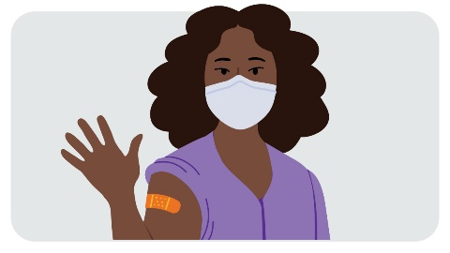 | Caregivers of people with IDD
Do you care for someone with an #IntellectualDisability? Check out CDC’s new #COVID19 materials for you and the person you care for: https://go.usa.gov/xFvXw | ¿Cuidas a alguien con una #DiscapacidadIntelectual? Consulta nuevos materiales de los CDC sobre el #COVID19 para ti y la persona a la que cuidas: https://go.usa.gov/xFvXw | 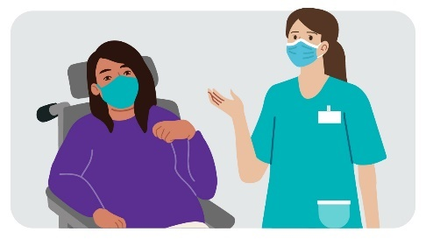 | Caregivers of people with IDD
Want to help protect your loved one from #COVID19? Download CDC’s free materials—including social stories, posters, videos, and interactive activities—for people with #IntellectualDisabilities! https://go.usa.gov/xFvXw | ¿Quieres ayudar a proteger a tu ser querido del #COVID19? ¡Descarga los materiales gratuitos de los CDC, que incluyen historias sociales, carteles, videos, y actividades interactivas, para personas con #DiscapacidadesIntelectuales! https://go.usa.gov/xFvXw | 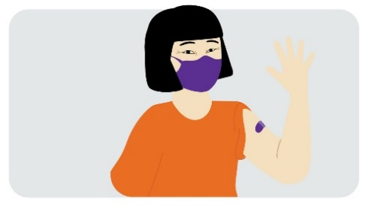 | Caregivers of people with IDD
Have you talked to your loved one about how to stay safe from #COVID19? Access CDC’s free materials for people with #IntellectualDisabilities to help you start the conversation: https://go.usa.gov/xFvXw | ¿Has hablado con tu ser querido sobre cómo protegerse del #COVID19? Accede a los materiales gratuitos de los CDC para personas con #DiscapacidadesIntelectuales para ayudarte a iniciar la conversación: https://go.usa.gov/xFvXw | 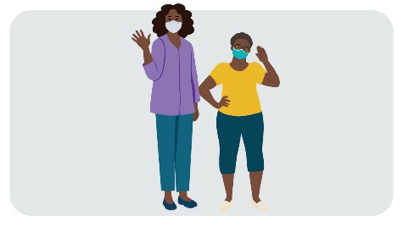 | Caregivers of people with IDD
Have you talked to your loved one about the #COVID19Vaccine? Watch CDC’s video for people with #IntellectualDisabilities to help you start the conversation: https://www.youtube.com/watch?v=XPWMDN8aI7s | ¿Has hablado con tu ser querido sobre la #VacunaCOVID19? Mira el video de los CDC para personas con #DiscapacidadesIntelectuales para ayudarte a iniciar la conversación: INSERT | Embed vaccination video
Do you care for someone with an #IntellectualDisability? Watch CDC’s video on how to wash your hands to stay safe from #COVID19: https://www.youtube.com/watch?v=fpB77As0QmA | ¿Cuidas a alguien con una #DiscapacidadIntelectual? Mira el video de los CDC sobre cómo lavarse las manos para protegerse del #COVID19: INSERT | Embed handwashing video
Have you talked to your loved one about keeping a safe distance? Watch CDC’s video for people with #IntellectualDisabilities to help you start the conversation: https://www.youtube.com/watch?v=86kywRzPIpk | ¿Has hablado con tu ser querido sobre cómo mantener una distancia segura? Mira el video de los CDC para personas con #DiscapacidadesIntelectuales para ayudarte a iniciar la conversación: INSERT | Embed social distancing video
Do you care for someone with an #IntellectualDisability? Watch CDC’s video on how to wear a mask to stay safe from #COVID19: https://www.youtube.com/watch?v=mShHUgBwq5s | ¿Cuidas a alguien con una #DiscapacidadIntelectual? Mira el video de los CDC sobre cómo usar una mascarilla para protegerse del #COVID19: INSERT | Embed masking video
Have you talked to your loved one about getting a #COVID19Test? Watch CDC’s video for people with #IntellectualDisabilities to help you start the conversation: https://www.youtube.com/watch?v=k6YOS2guAtM | ¿Has hablado con tu ser querido sobre la #PruebaCOVID19? Mira el video de los CDC para personas con #DiscapacidadesIntelectuales para ayudarte a iniciar la conversación: INSERT | Embed testing video
Need help educating your patients with #IntellectualDisabilities on how to stay safe from #COVID19? Check out CDC’s new materials—including social stories, posters, videos, and interactive activities! https://go.usa.gov/xFvXw | ¿Necesitas ayuda para enseñarle a tus pacientes con #DiscapacidadesIntelectuales a protegerse del #COVID19? ¡Consulta nuevos materiales de los CDC, que incluyen historias sociales, carteles, videos, y actividades interactivas! https://go.usa.gov/xFvXw | 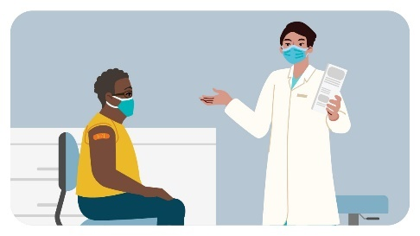 | Providers of patients with IDD
Health care providers are a trusted source of #COVID19 information for patients with #IntellectualDisabilities. Download CDC’s new suite of COVID-19 materials for you and your patients: https://go.usa.gov/xFvXw | Los proveedores de atención médica son fuentes confiables de información sobre el #COVID19 para pacientes con #DiscapacidadesIntelectuales. Descarga nuevos materiales de los CDC sobre el COVID-19 para ti y tus pacientes: https://go.usa.gov/xFvXw | 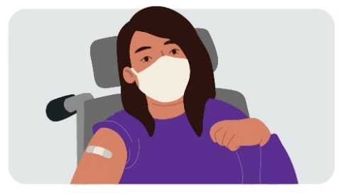 | Providers of patients with IDD
Help support the caregivers of your patients with #IntellectualDisabilities by sharing CDC’s free materials on how to stay safe from #COVID19! Check them out: https://go.usa.gov/xFvXw | ¡Apoya a los cuidadores de tus pacientes con #DiscapacidadesIntelectuales al compartir los materiales de los CDC sobre cómo protegerse del #COVID19! Consulta: https://go.usa.gov/xFvXw |  | Providers of patients with IDD
We’re excited to help [@CDC_NCBDDD/@CDC] introduce a new #COVID19 materials designed especially for people with #IntellectualDisabilities! Check out these free materials: https://go.usa.gov/xFvXw | ¡Nos complace ayudar a [@CDC_NCBDDD/@CDC] a presentar nuevos materiales sobre el #COVID19 diseñados especialmente para personas con #DiscapacidadesIntelectuales! Consulta estos materiales gratuitos: https://go.usa.gov/xFvXw | 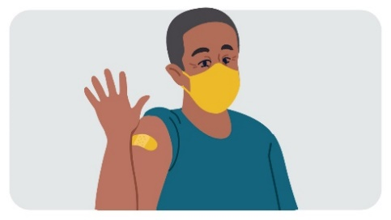 | Professional organizations/ adovcacy groups who serve people with ID
We’re excited to announce CDC’s new materials to help people with #IntellectualDisabilities stay safe from #COVID19! Take a look: https://go.usa.gov/xFvXw | ¡Nos complace presentar nuevos materiales de los CDC para ayudar a las personas con #DiscapacidadesIntelectuales a protegerse del #COVID19! Consulta: https://go.usa.gov/xFvXw
Want to help people with #IntellectualDisabilities stay safe from #COVID19? Share CDC’s new materials—including social stories, posters, videos, and interactive activities—with your networks: https://go.usa.gov/xFvXw | ¿Quieres ayudar a las personas con #DiscapacidadesIntelectuales a protegerse del #COVID19? Comparte los nuevos materiales de los CDC, que incluyen historias sociales, carteles, videos, y actividades interactivas, en tus redes: https://go.usa.gov/xFvXw
Did you know that people with #IntellectualDisabilities are more likely to get #COVID19 and have worse health outcomes than people without IDD? CDC has created materials on how to stay safe from #COVID19 specifically designed for people with IDD. Check them out: https://go.usa.gov/xFvXw | ¿Sabías que las personas con #DiscapacidadesIntelectuales tienen más probabilidades de contraer el #COVID19 y tienen peores resultados de salud que las personas sin discapacidades intelectuales? Los CDC han creado materiales sobre cómo protegerse del #COVID19 diseñados específicamente para personas con discapacidades intelectuales. Consulta: https://go.usa.gov/xFvXw | 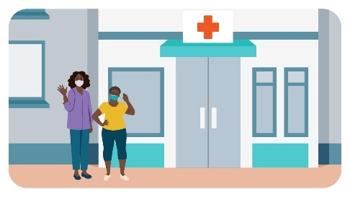 | Providers of patients with IDD and professional organizations/ adovcacy groups who serve people with IDD
People with #IntellectualDisabilities are more likely to get #COVID19 and have worse health outcomes than people without IDD. Help keep people with IDD safe by sharing CDC’s new materials with your networks: https://go.usa.gov/xFvXw | Las personas con #DiscapacidadesIntelectuales tienen más probabilidades de contraer el #COVID19 y tienen peores resultados de salud que las personas sin discapacidades intelectuales. Ayuda a proteger a las personas con discapacidades intelectuales al compartir nuevos materiales de los CDC en tus rede: https://go.usa.gov/xFvXw

Send an email
Do you maintain an active email list, listserv, or e-newsletter? Send a short email or include a blurb about the CDC’s new COVID-19 materials for people with IDD and ELL. You can use the image options provided above in your email as well! Here’s a sample email you can edit and send:

Email Subject Line / Header – English
New CDC COVID-19 Materials for People with Intellectual and Developmental Disabilities
Body of the Email – English
We need your help! Did you know that people with intellectual and developmental disabilities (IDD) in the United States are more likely to get COVID-19 and have worse health outcomes than people without IDD?
We are excited to share that the Centers for Disease Control and Prevention’s (CDC) National Center on Birth Defects and Developmental Disabilities (NCBDDD) has developed a new suite of COVID-19 materials—including videos, posters, social stories, and interactive activities—specifically designed for people with IDD who have extreme low literacy and their caregivers. These free materials use simple illustrations and easy-to-read messages to explain five key COVID-19 prevention behaviors: getting vaccinated, getting a COVID-19 test, handwashing, wearing a mask, and keeping a safe distance until fully vaccinated.

Explore CDC’s new materials and share them with your networks!

We appreciate your help in promoting these materials.

2

Email Subject Line / Header – Spanish
Nuevos materiales de los CDC sobre el COVID-19 para las personas con discapacidades intelectuales y del desarrollo
Body of the Email – Spanish
¡Necesitamos tu ayuda! ¿Sabías que, en los Estados Unidos, las personas con discapacidades intelectuales y del desarrollo (IDD, por sus siglas en inglés) tienen más probabilidades de contraer el COVID-19 y tienen peores resultados de salud que las personas sin IDD?

Nos complace comunicar que el Centro Nacional de Defectos Congénitos y Discapacidades del Desarrollo (NCBDDD, por sus siglas en inglés) de los Centros para el Control y la Prevención de Enfermedades (CDC) ha desarrollado un nuevo conjunto de materiales sobre el COVID-19, que incluye videos, carteles, historias sociales, y actividades interactivas, diseñados especialmente para personas con IDD que tienen un nivel de alfabetización extremadamente bajo y sus cuidadores. Estos materiales gratuitos tienen imágenes sencillas y mensajes fáciles de leer para explicar cinco comportamientos protectores claves de COVID-19: vacunarse, hacerse una prueba de COVID-19, lavarse las manos, usar una mascarilla, y mantener una distancia segura de otras personas.
ِ¡Explora los nuevos materiales de los CDC y compártelos en tus redes!

Agradecemos que nos ayudes a compartir el contenido de estos materiales.

