Instructor Certification Application – Web Form
Anyone looking to apply for an instructor certification should utilize this WebForm via the MPTC Acadis Portal
- Step 1: On your MPTC Acadis Portal homepage, move your cursor over the “Resources” heading and click on “Find & Complete a Webform”

- Step 2: Select the webform pertaining to whatever discipline you are interested in applying for
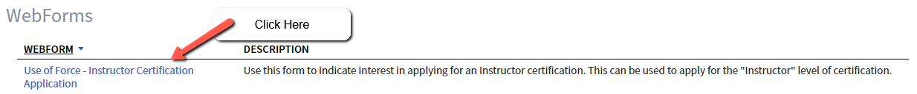
- Step 3: Complete/fill in the required information and click “Submit”
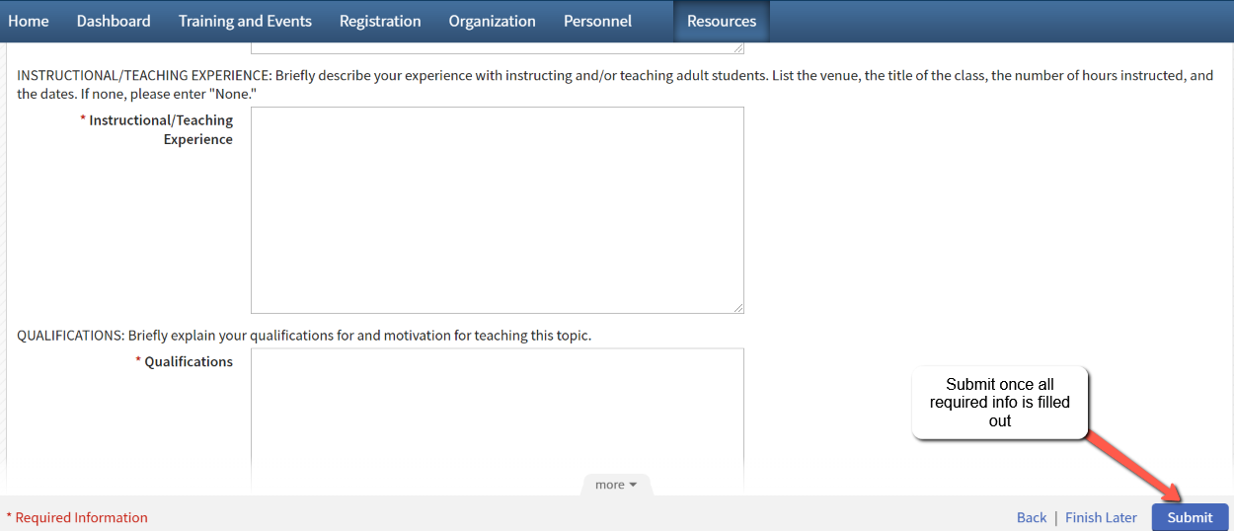

Step 4: At this point you will need to wait for the Instructor Certification Manager to review your application. If/once the application is approved, please follow the following steps for uploading your instructor payment documents.
- Step 5: Once approved, you will receive an email from the address: MPTC [no-reply-MPTC@acadisonline.com] letting you know that you will now need to review and fill out the instructor payment forms. Click link in the email to bring to you the website with all the forms. The link has also been attached here (https://www.mass.gov/how-to/receive-payment-for-instructional-services-instructor-contract)
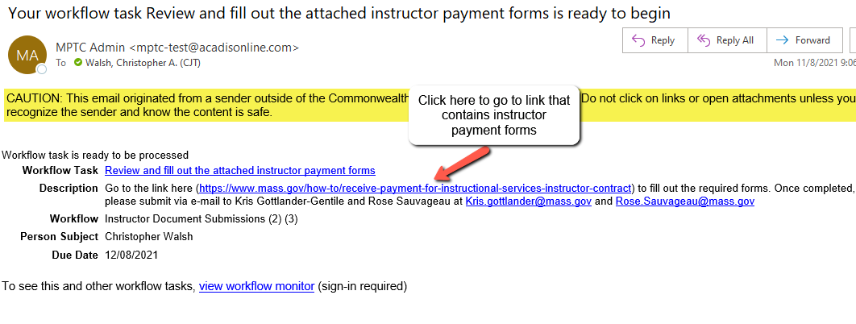
- Or you can get to the link with the payment forms by clicking on “Dashboard” in your Acadis portal then “view all” in the box that states Next 5 Workflow Tasks. Or you can select on the “Instructor Applicant Document Submissions” task itself
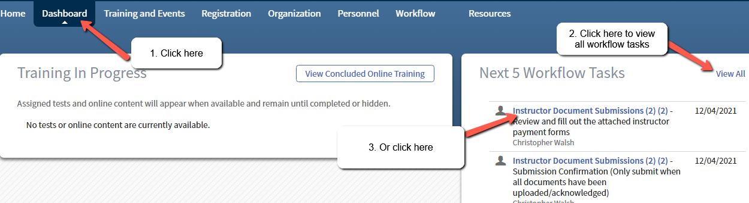
- From there it will bring you to the screen pictured below, where if you click on the symbol under the Resources column will bring you to the website
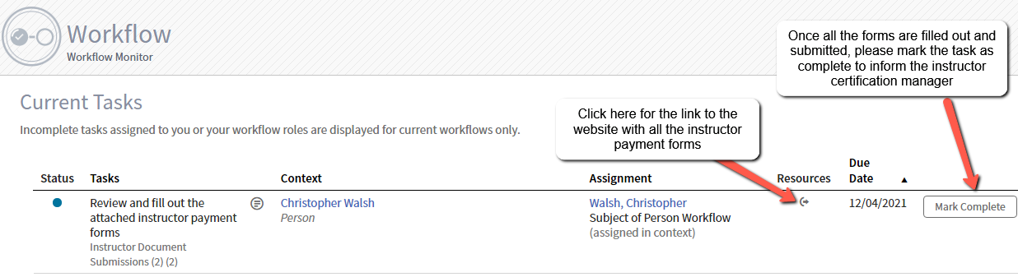
- Step 6: Complete all of the instructor payment forms and submit them via e-mail to Kris Gottlander-Gentile and Rose Sauvageau at Kris.gottlander@mass.gov and Rose.Sauvageau@mass.gov. Once the forms have been submitted, please click “Mark Complete” to inform the instructor certification that you have finished your paperwork

- Step7: Once marked complete, the instructor certification manager will get notified. She will then check her email for the paperwork you submitted and review upon receipt. If accepted, the certification will be issues, and your agency head will be notified

