Job Aid: Create a Pre-admission Screening Request

This job aid describes how to create and submit a pre-admission screening (PAS) request using the MassHealth Provider Online Service Center (POSC). The PAS authorizes elective/nonemergency acute or chronic hospital stays.
You must have the Provider ID (PID) and Service Location (SL) for both the attending physician and facility provider to create a PAS request. Click on the Providers tab and enter the national provider identifier (NPI) to obtain the PID and SL.
- If you are a Registered User, click the Login button on the POSC landing page.
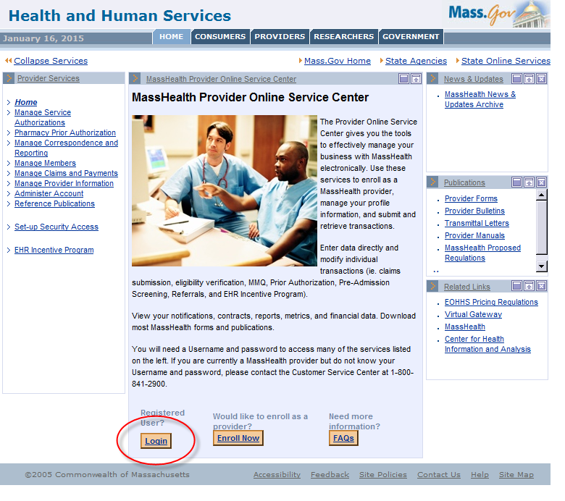
- In the Provider Login section, enter your username and password. Click Submit.

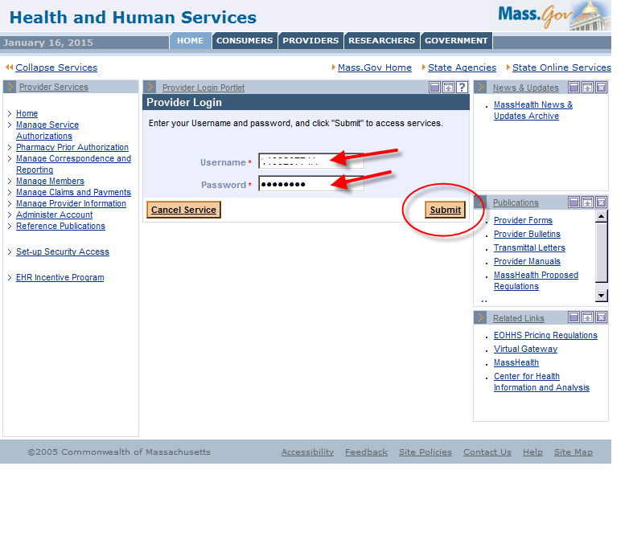
- Click on Manage Service Authorizations on the left section of the page.
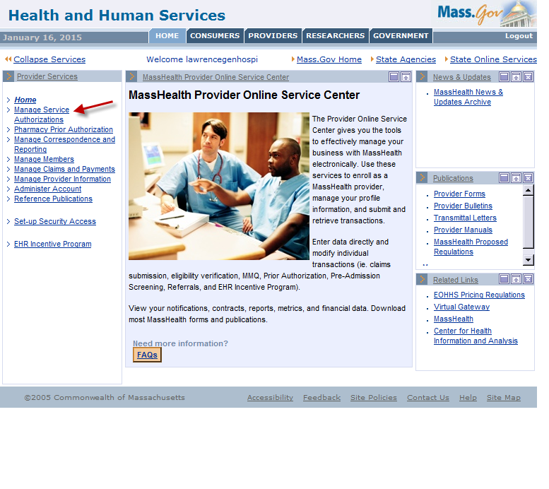
- Click on Enter PAS Request.
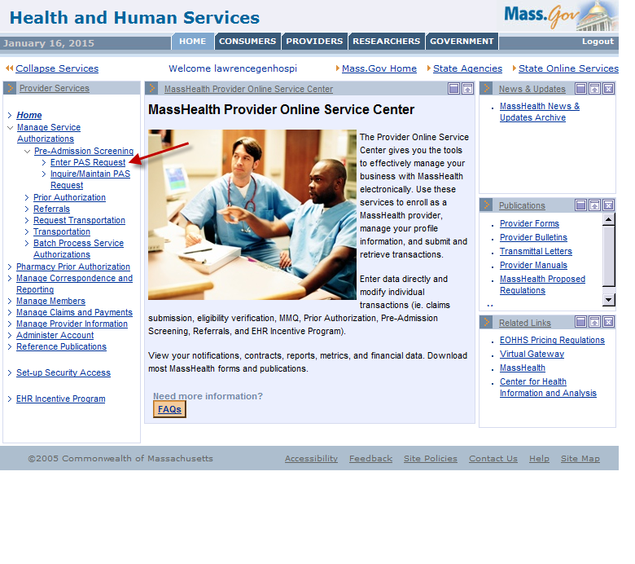

Base Information Instructions
Below is the Base Information page on the PAS Information tab. (See detailed instructions on the next page of this job aid.)
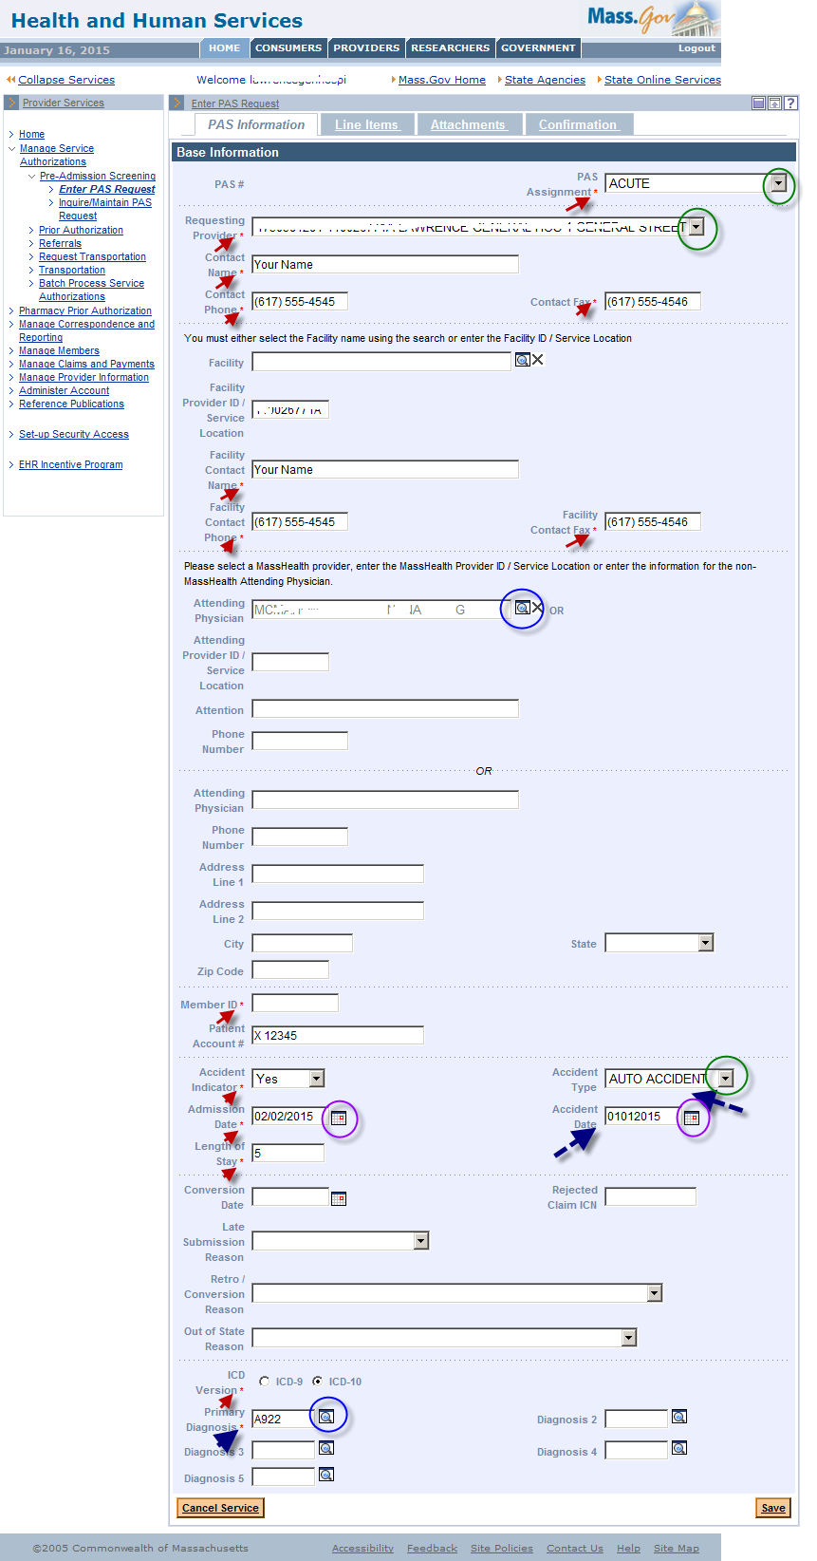

Base Information Instructions, continued:
- Fill in the required fields. Required fields are denoted with an asterisk (*).
- Fields with dropdown lists allow you to pick an option from a list of valid values.
You must choose “Acute,” “Acute with Rehab,” or “Chronic” from the PAS Assignment field.
- Fields with a magnifying-glass icon have a pop-up search option. Selecting a value from the search result will populate this field for you. You may also manually enter details.
- Include PID and SL when entering information in the Facility Provider ID and Attending Provider ID fields.
- If the Accident Indicator field is set to Yes, you must fill in the Accident Type and Accident Date fields.
- Use the Provider Comments box (see below) to note any additional details about the procedure. If you have more than five CPT codes to enter, you can enter them here.
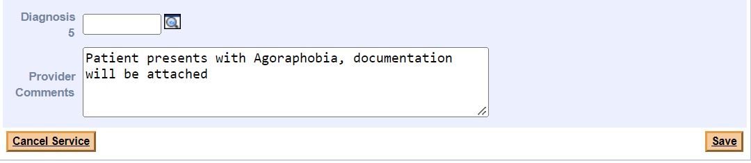
- Click Save.

Line Item Instructions
The Line Items panel allows the provider to enter specifics about the requested stay.
- Click the Line Items tab.
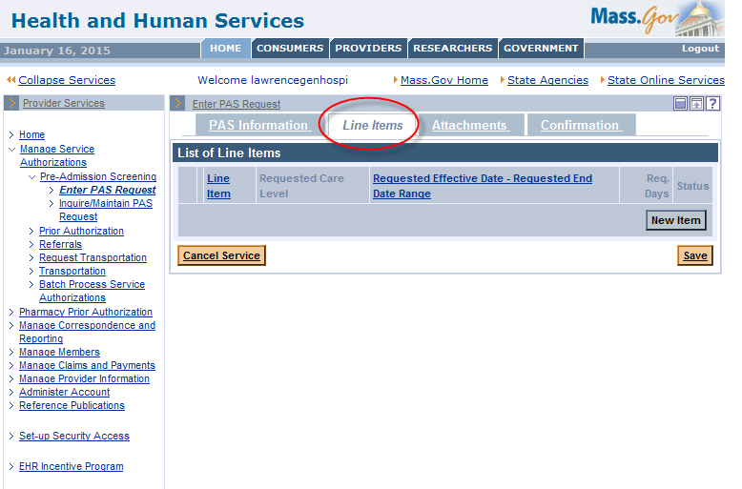
- Click the New Item button.
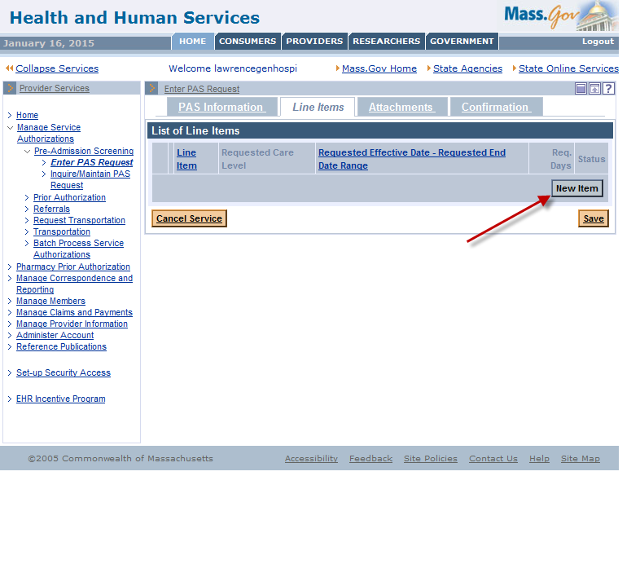

- Complete all required fields indicated with an asterisk.
CPT codes must be numerals only. You may enter up to five CPT procedure codes on the Line Item tab using the Proc. Code field. Additional CPT codes may be noted on the Base Information tab in the Provider Comments field.
CPT codes and primary procedure date are not applicable for CDRH admissions.
- Click the Add button to add the line-item data to the request.
Do not add more than one line item.
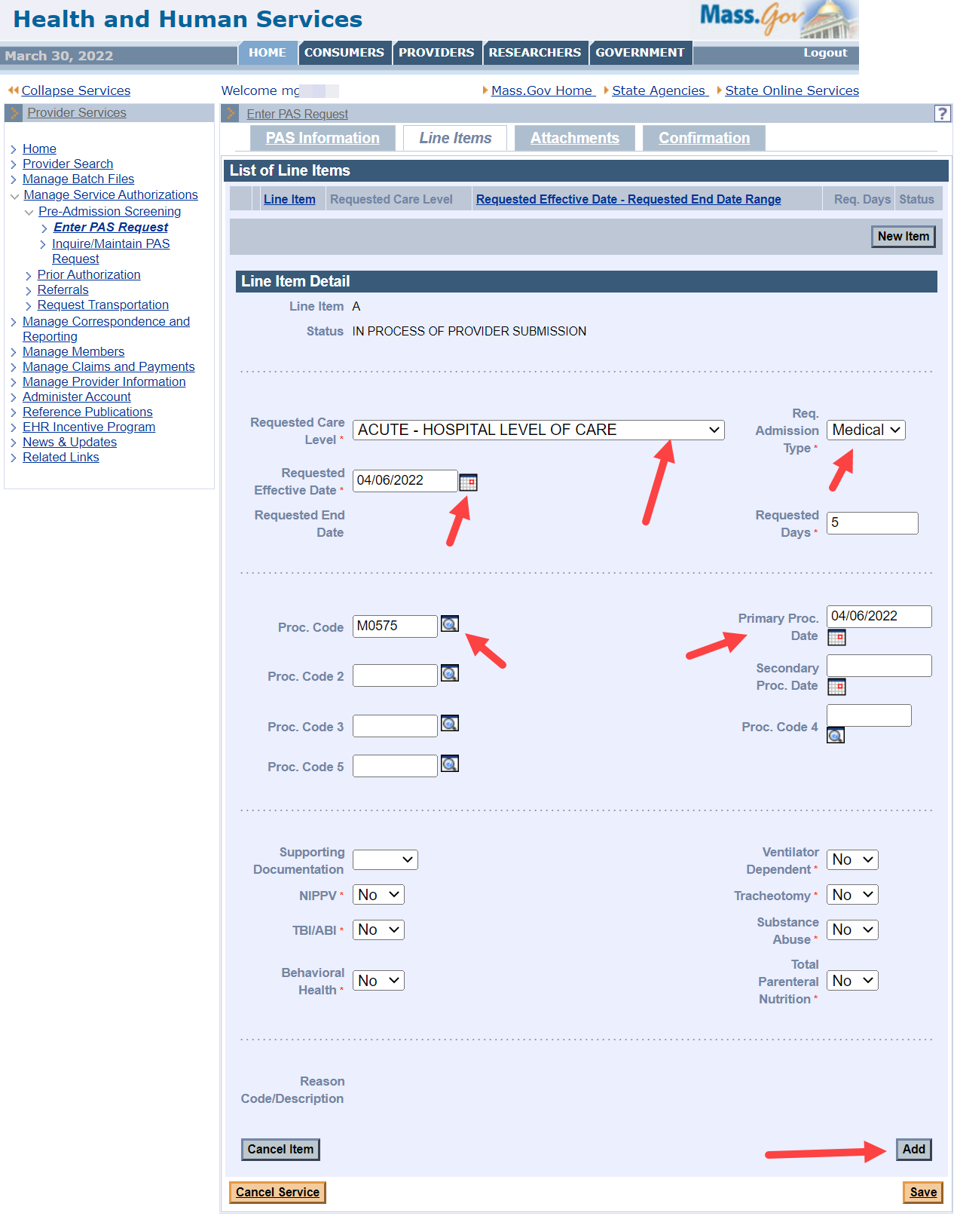
- Click Save.

Attachments Instructions
You may include clinically pertinent documentation with your PAS request.
- Click on the Attachments tab.
- Click the New Item button to add an attachment to the PAS request.
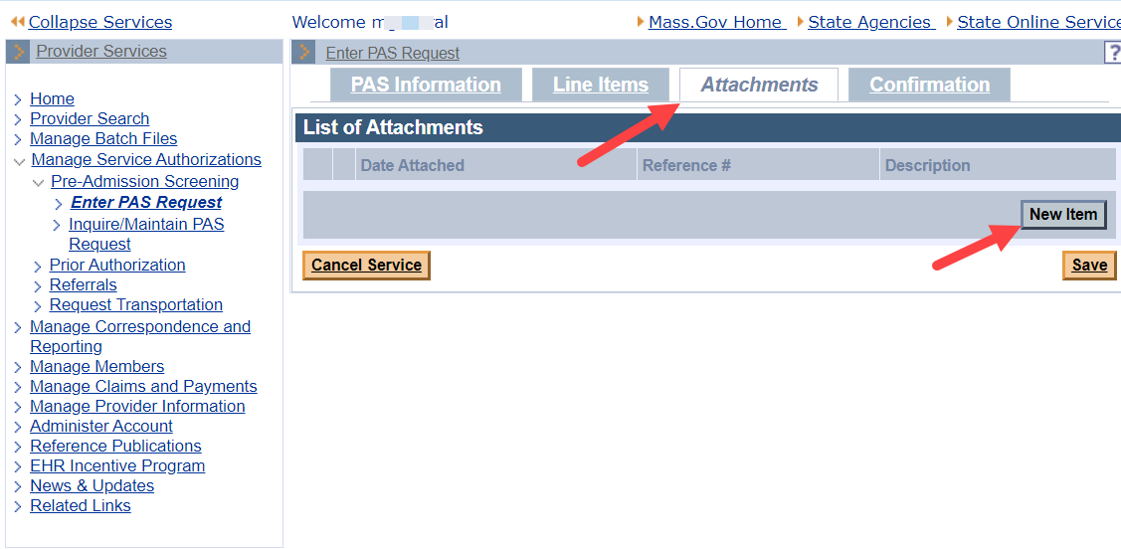
- On the Attachments Detail panel, select the Report Type from the dropdown list.
- Select ELECTRONICALLY ONLY from the Transmission Code dropdown list.
- In the Description field, enter a brief description of the document you are attaching.
- Click the Browse button to locate the electronic document on your computer.
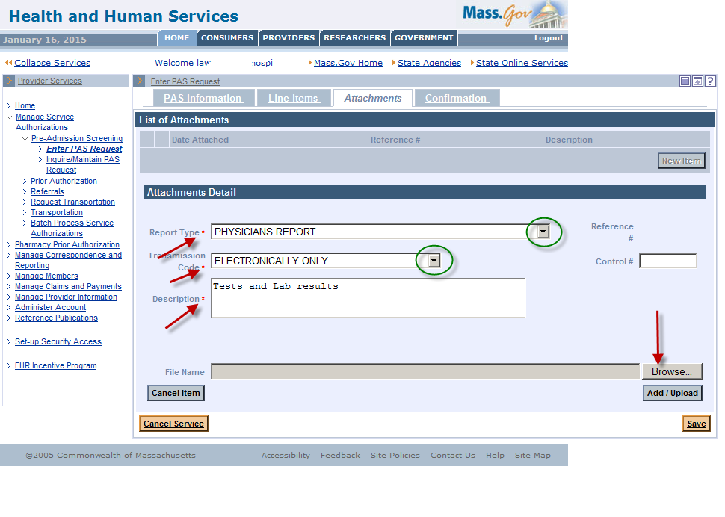
- Select a file on your computer and click Open. This will populate the file name on the panel.
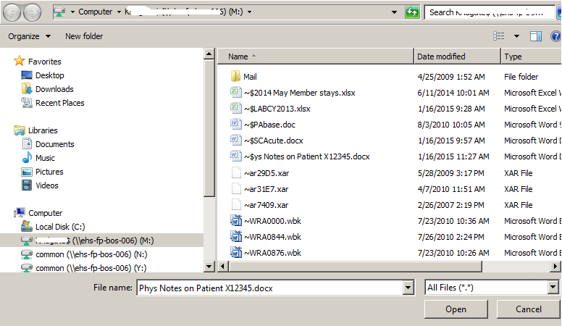
- Click Add/Upload to attach your selected file to the PAS request.
- You may attach additional documents by repeating the process. We recommend noting the specific report type. For example:
  - Medical Record Attachment
  - Physicians Report
  - Radiology Report
- Click Save.
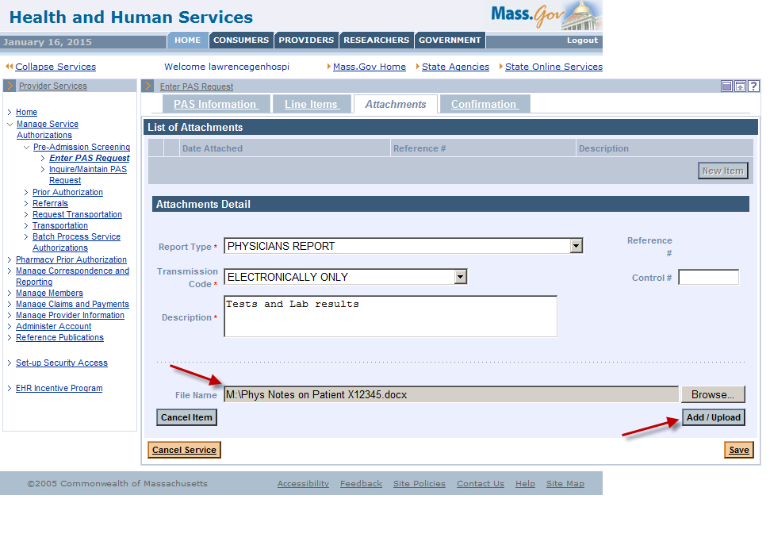

Confirmation/Completion Instructions
- Click on the Confirmation tab. This is where you will submit the new request for review.
- Click Submit.
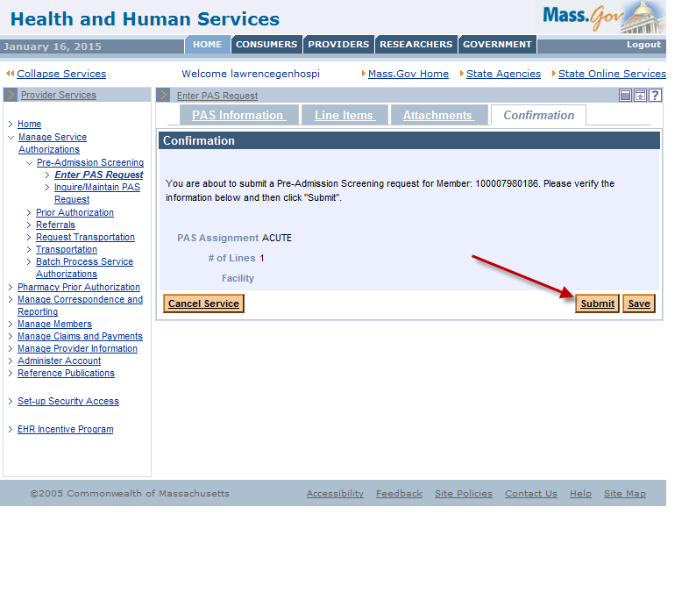
IMPORTANT:
- If you click Save, the data you entered will be saved in the system for completion and submission at a later time. The status of the saved request will say, “In Process of Provider Submission.”
- Once you click Submit, the request will say, “Ready for Review.”
The PAS reviewers will not be able to see PAS requests until you hit Submit and the requests are in “Ready for Review” status.

- When you click Submit, the data you entered is edited and validated.
- If you receive any errors, you must fix them before the request can be resubmitted.
Open the tab where the field in error is found and correct the error or add missing required values.

- If you receive warnings, you must acknowledge them by adding a check to the checkbox.
- After you have corrected the errors and acknowledged the warnings by checking the checkbox, you will see a new page called the Pre-Admission Screening Response page.

The Pre-Admission Screening Response
This page will give you the PAS number and confirm successful submission of your PAS request.
