Job Aid: Create a Prior Authorization Request

This job aid describes how to:
- Create a prior authorization (PA) request using the MassHealth Provider Online Service Center (POSC); and
- Submit the request.
You must have the Provider ID (PID) and Service Location (SL) for both the servicing and requesting provider to create a PA request. Click on the Provider tab and enter the national provider identifier (NPI) to obtain the PID and SL.
____________________________________________________________________________
            - Click the Login button on the POSC landing page.
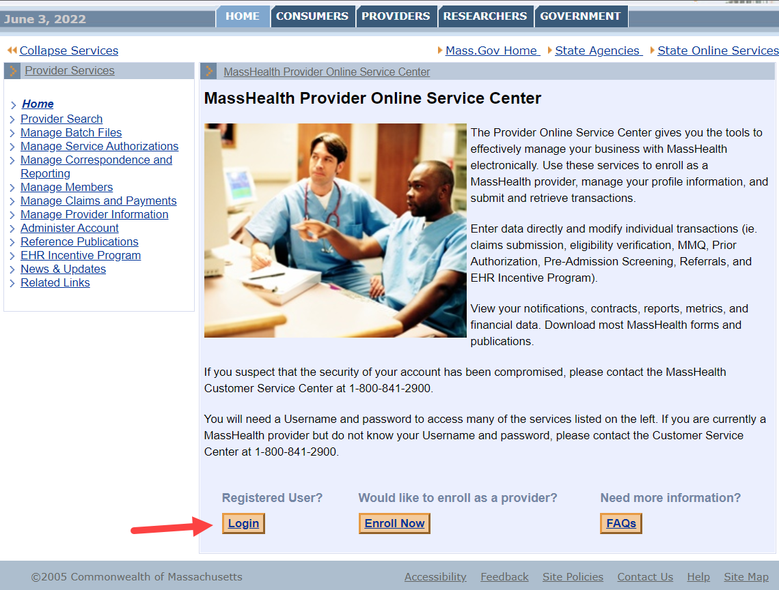

Search for a Deferred PA Request
From the Provider Online Service Center home page:
- Click Manage Service Authorizations.
- Click Prior Authorizations.
- Click Enter a PA Request. The Prior Authorization Templates panel is displayed.

Select Assignment Type
The assignment types are grouped into three categories: Basic Medical, Durable Medical Equipment, and Therapy Services.
On the Prior Authorization Templates panel:
- Select the designed assignment type under Basic Medical Assignment Category.
- For Hearing, select Hearing Services.
- For Vision, select Vision Services.
- For Surgical/Medical Procedures, select Physician Adult or Physician Pediatric.
- Click Continue.
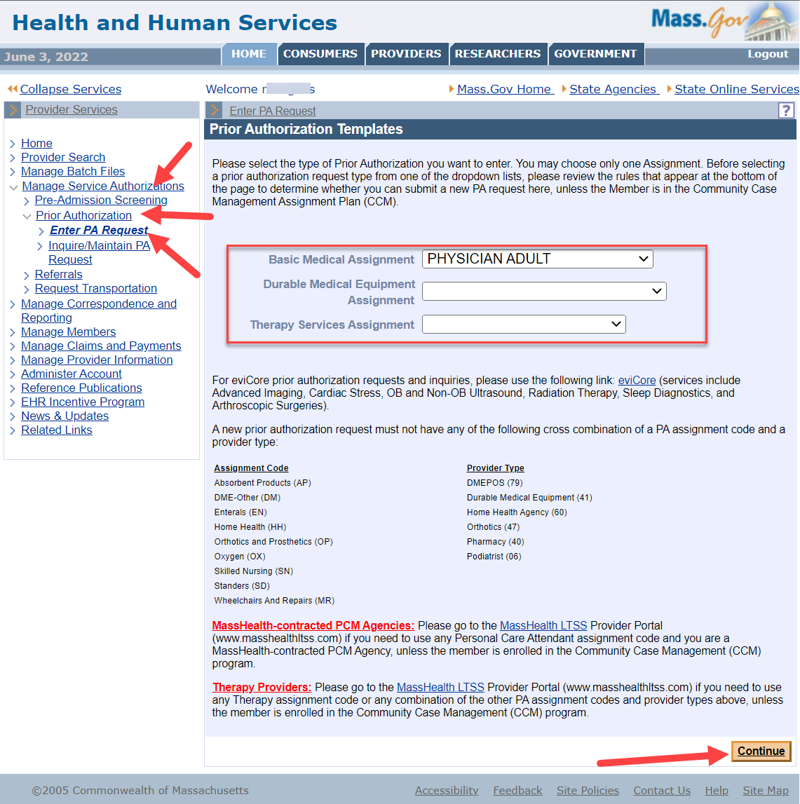

Search for and Select Requesting Provider
On the Base Information panel:
- Enter the Member ID.
- Select the Requesting Provider from the dropdown list.
- Enter the Contact Name.
- Enter the Contact Phone Number.
- Enter the Primary Diagnosis Code.
Do not include the dot.
- Enter any optional information, such as Clinical Rationale or Provider Comments.
If desired, you can click the Field Search button to perform a search for the correct diagnosis code.
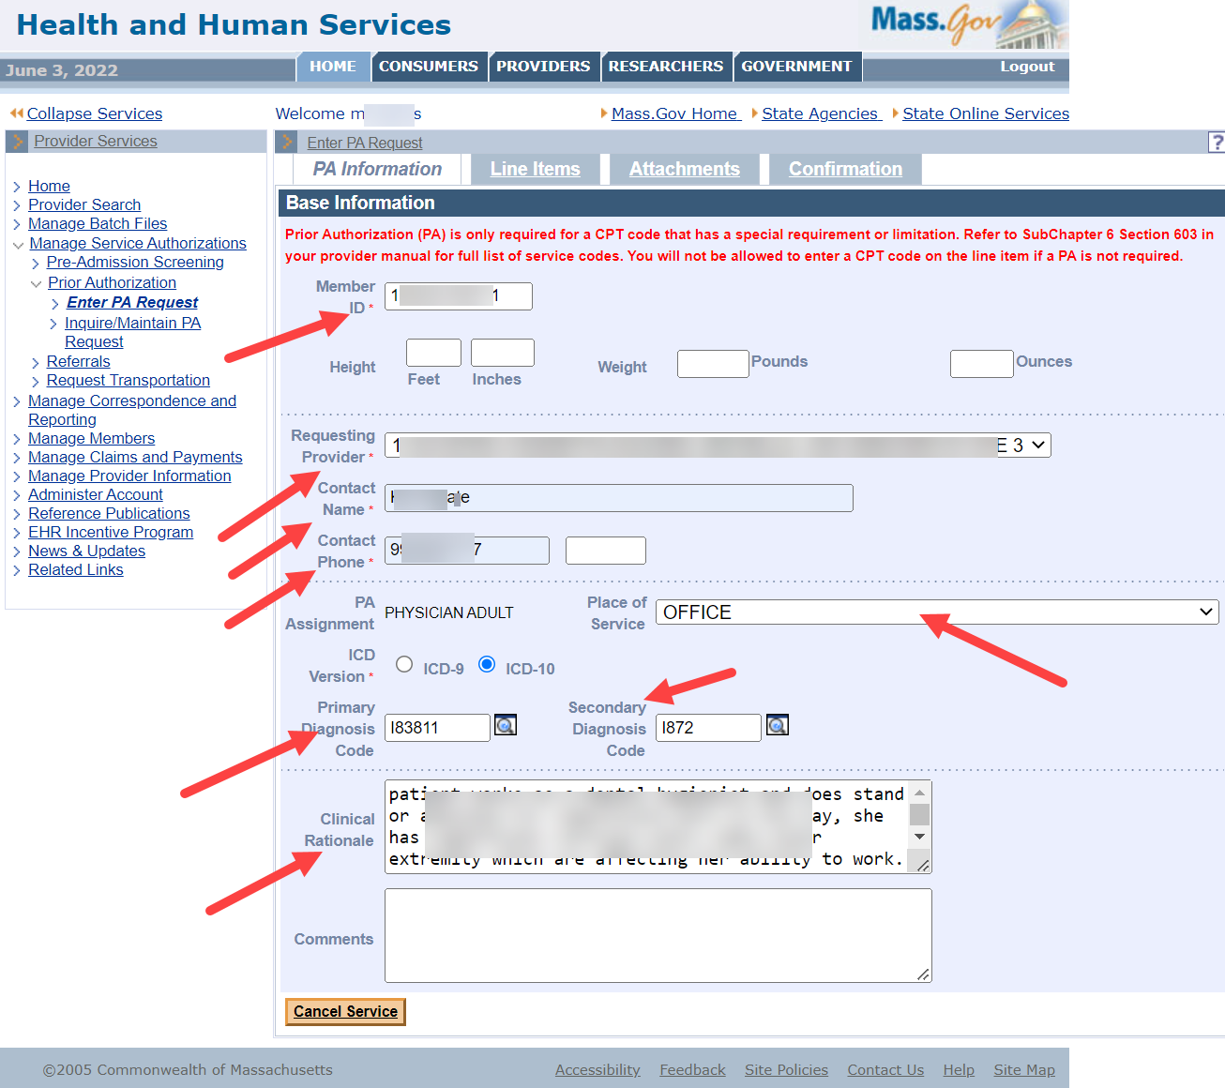

Add a Line Item
- Click the Line Items tab.
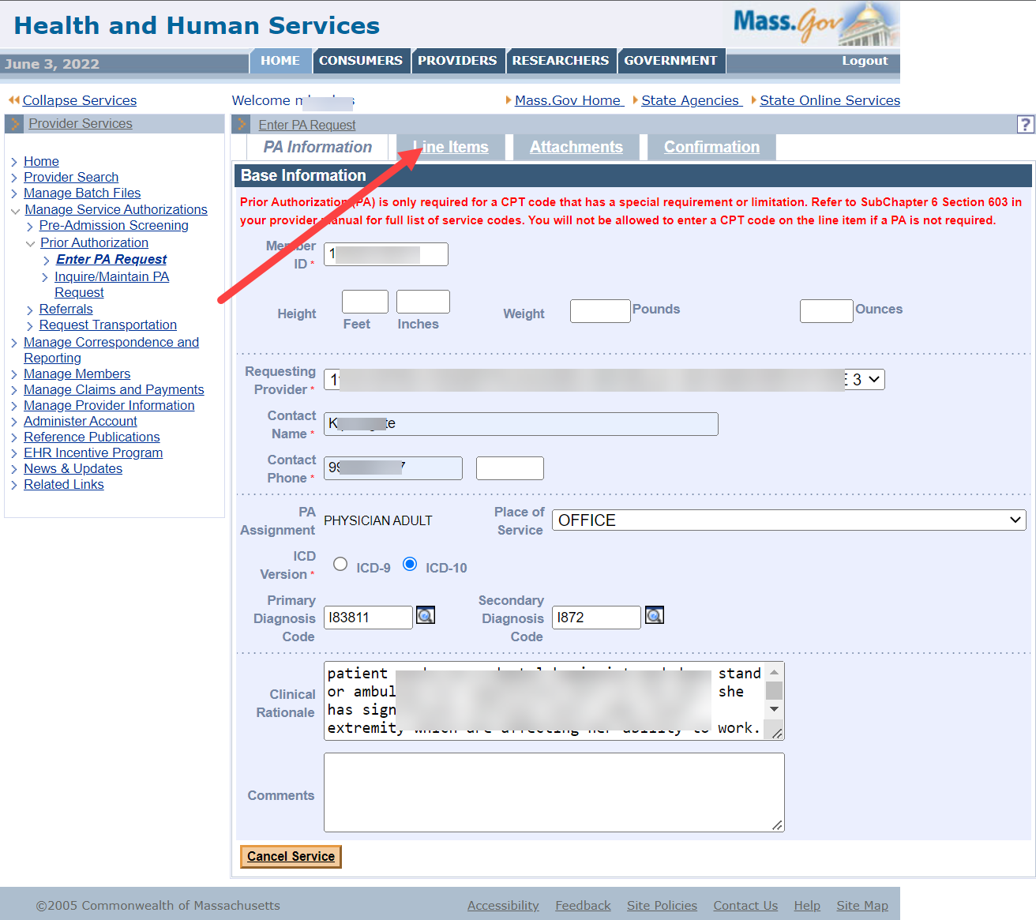
- Click New Item. The Basic Medical Details panel is displayed.
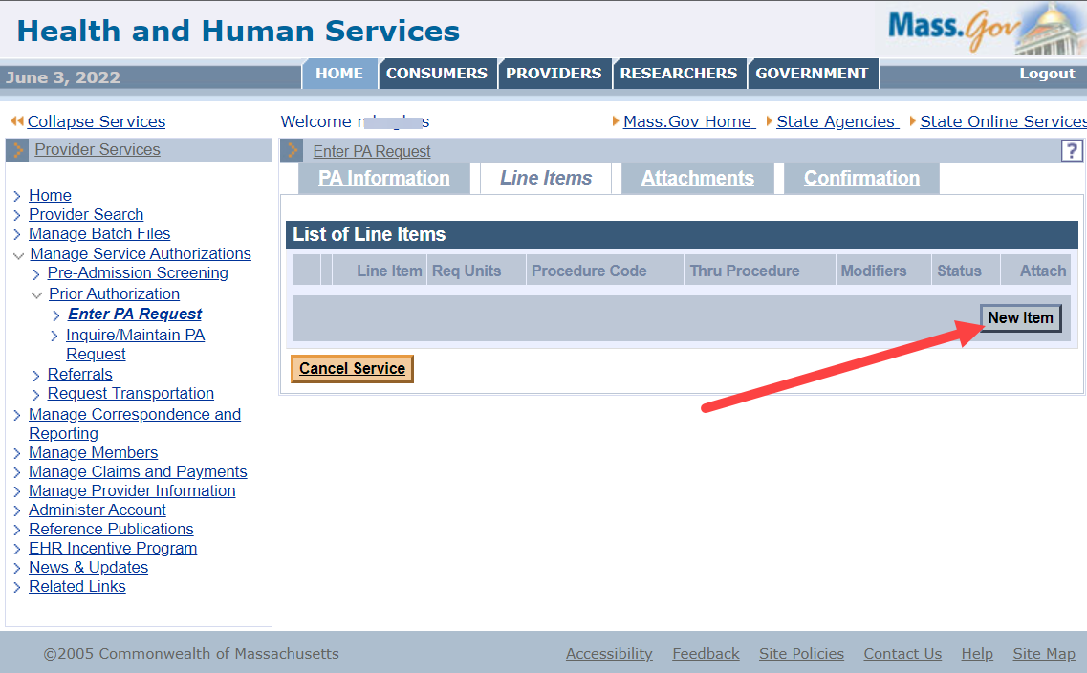

- Enter the Procedure Code. Each CPT Code must be entered on a separate line item.
All procedures are reviewed individually. The Thru Procedure field is invalid.
- Enter the Requested Effective Date.
- Enter the Requested End Date.
- Enter the number of Requested Units.
- If the Service Provider is the same as the Requesting Provider, select the Same as Requesting Provider checkbox. If the Service Provider is different from the Requesting Provider, select Serve Provider from the dropdown list.
- Click Add.
- In the List of Line Items panel, click the New Item button to add additional Line Items. Repeat until all are added.
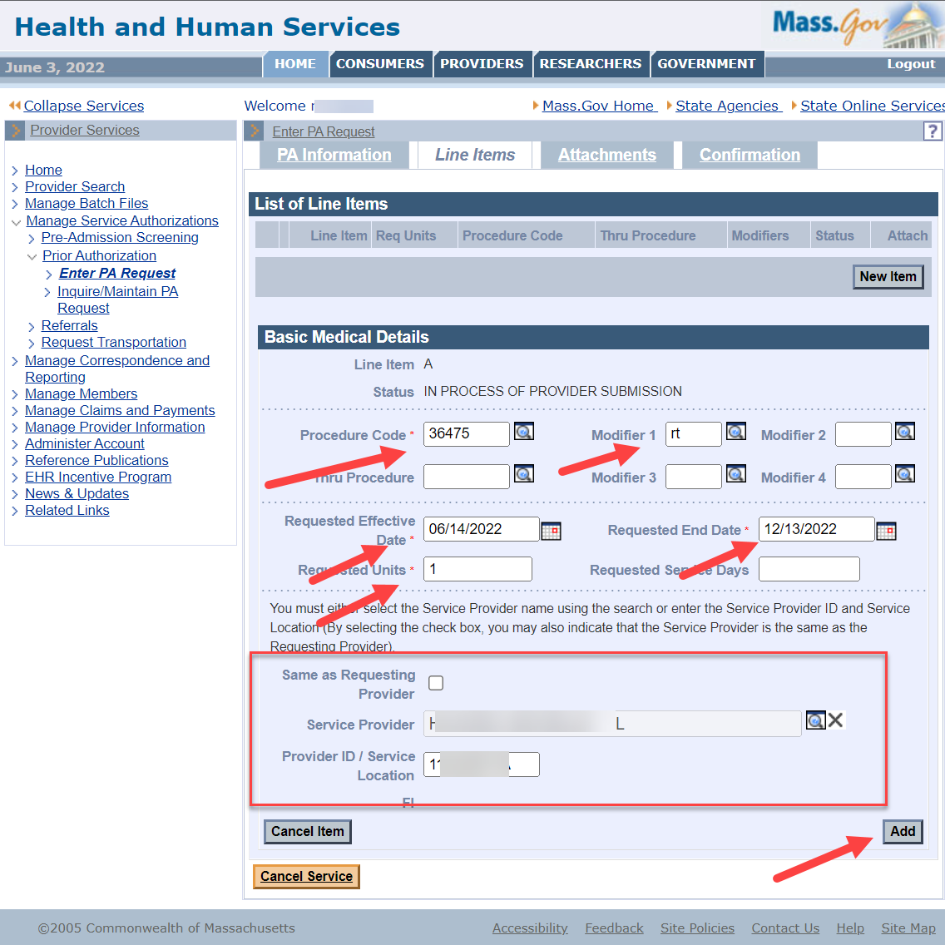

Add an Attachment
- Click the Attachments tab.
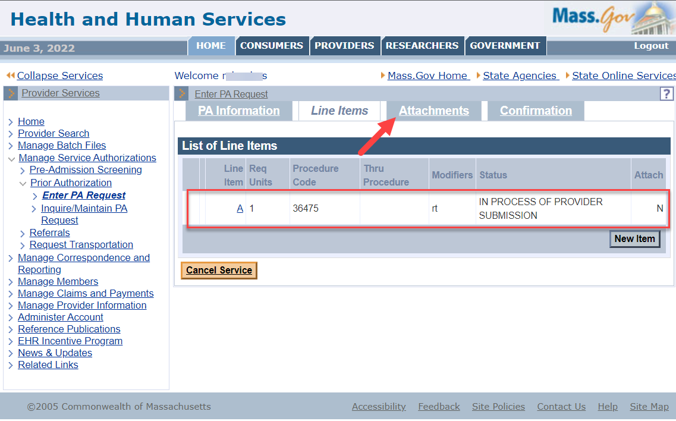
- Click New Item in the List of Attachments panel.
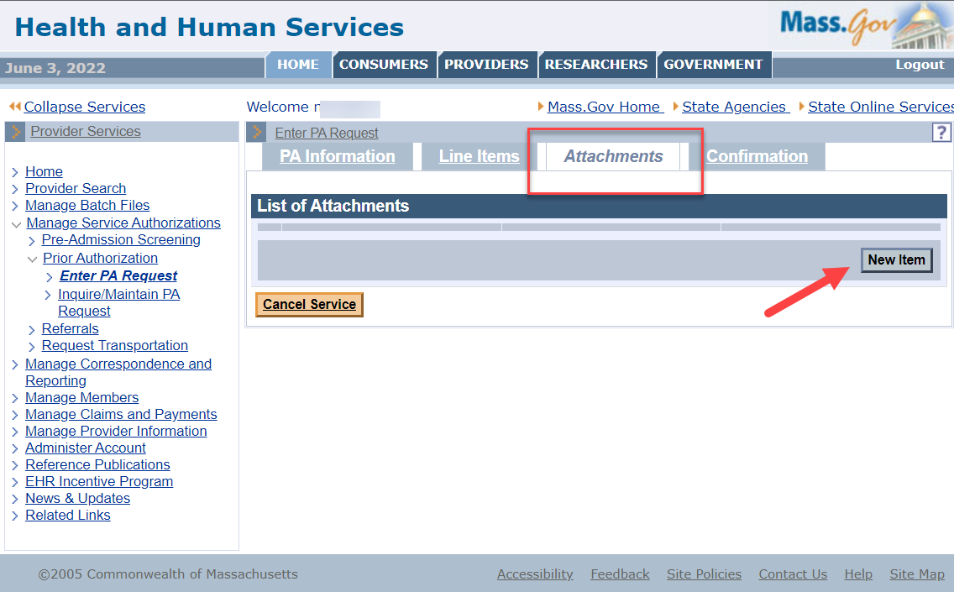

On the Attachment Details panel:
- Select the Report Type from the dropdown list.
- Select the Transmission Code (ELECTRONICALLY ONLY) from the dropdown list.
- Leave the Control Number field blank.
- Enter a brief description or comment in the Description field.
- Click Choose File.
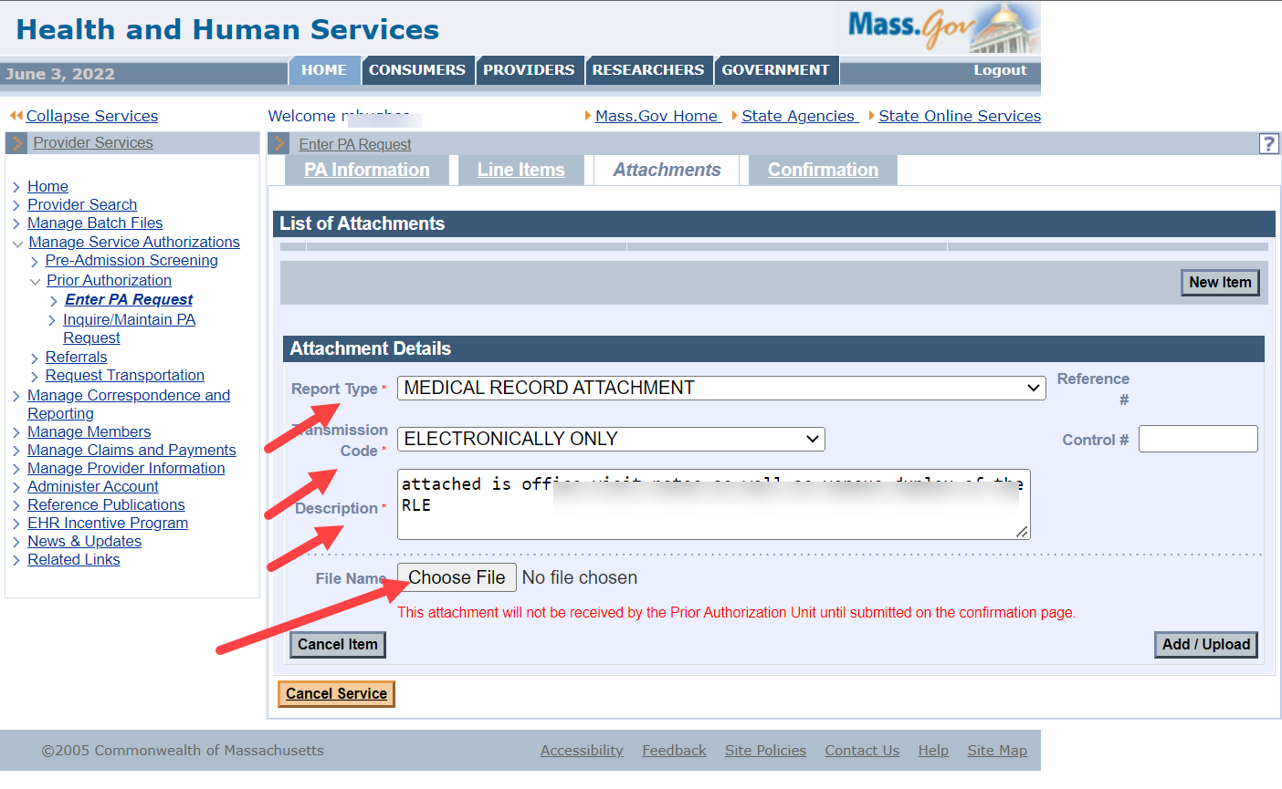
- Navigate to the file you want to attach. Click the file to populate the File name field, then click Open. This will close the file selection window.
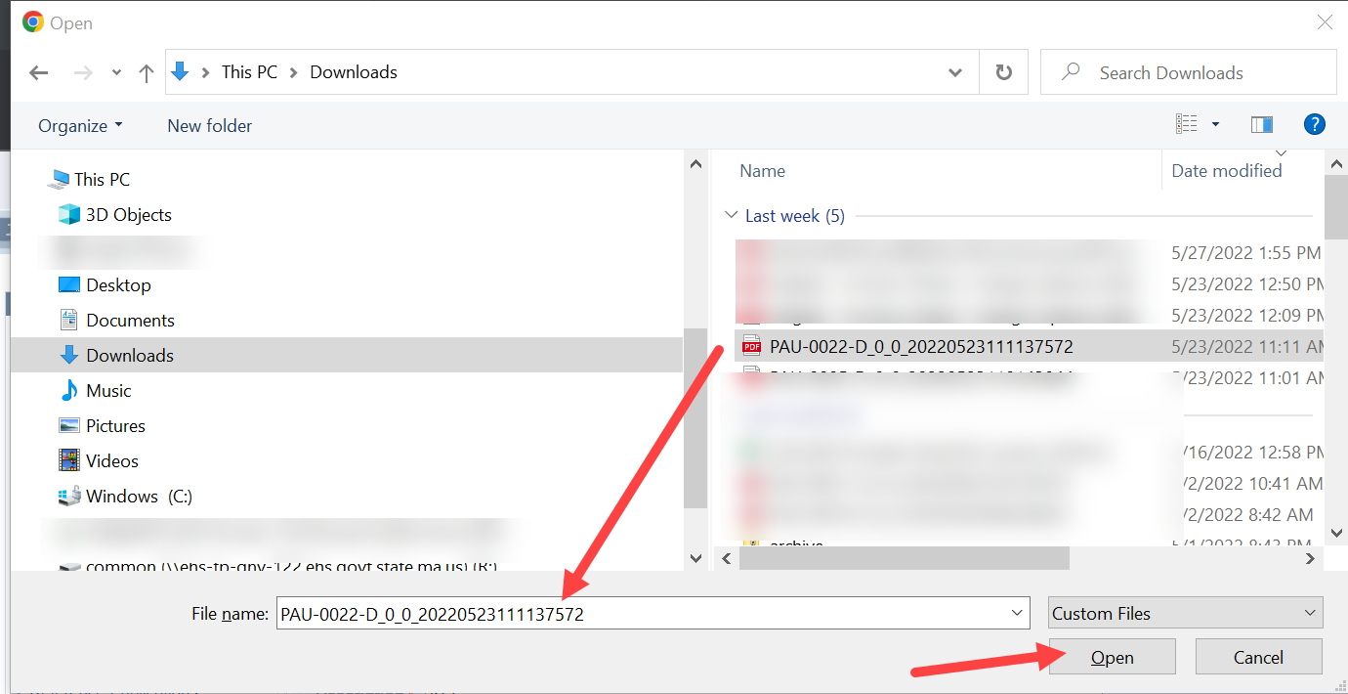

- When the Attachments Panel reappears, verify that the file selected is in the File Name field. Click Add/Upload to attach the file.
- View the List of Attachments. If more attachments are to be added, click New Item, and repeat the previous steps.
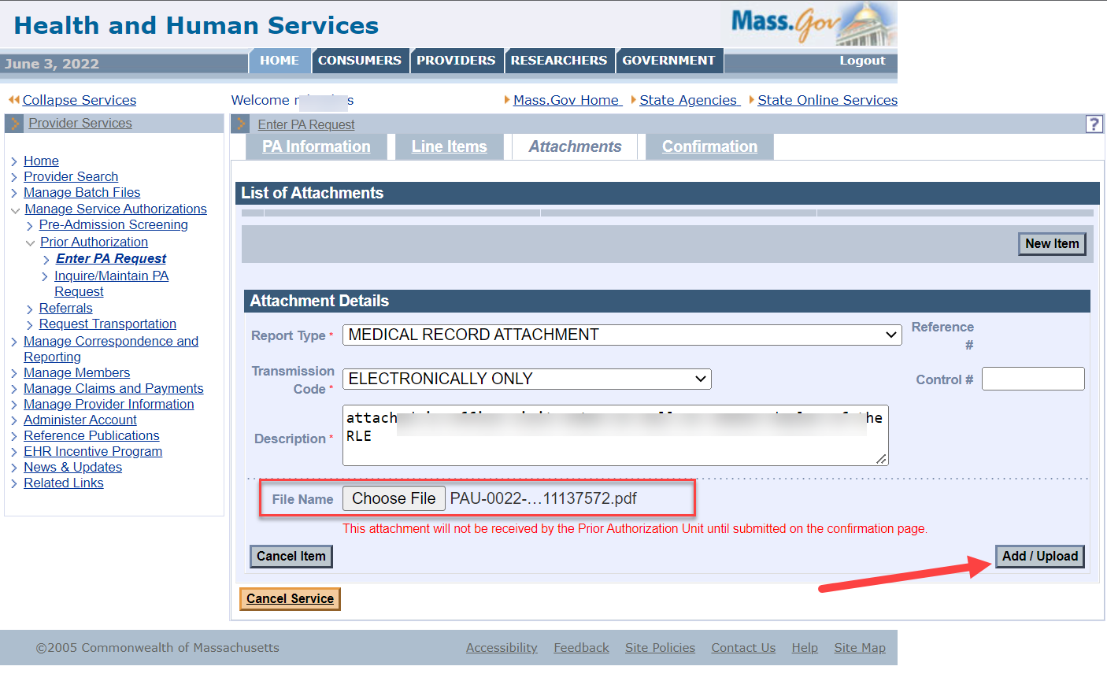

Confirm Submission
- Click the Confirmation tab.
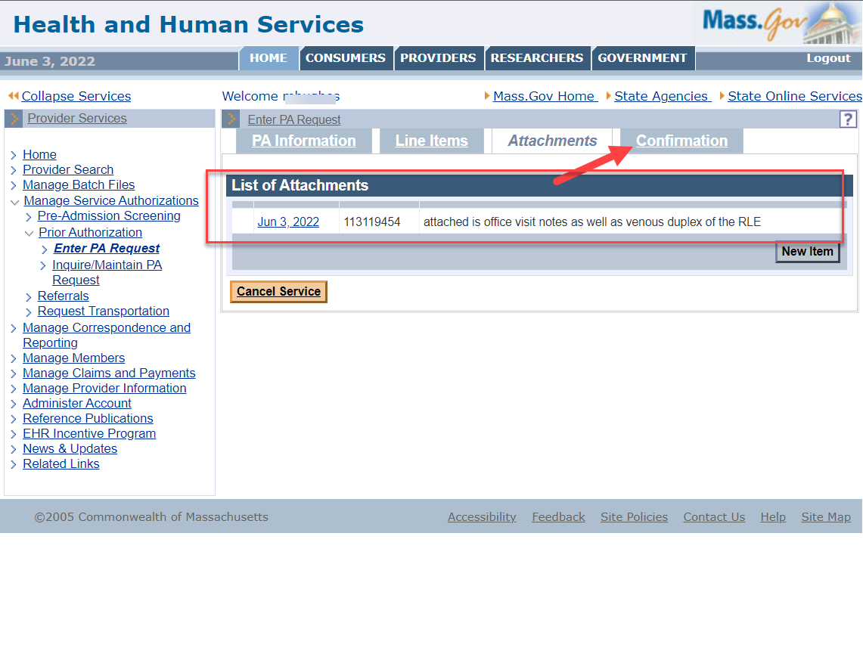

Submit Your PA Request to MassHealth
- Review the request information on the Confirmation tab to ensure that it is correct.
- Click Submit to MassHealth.
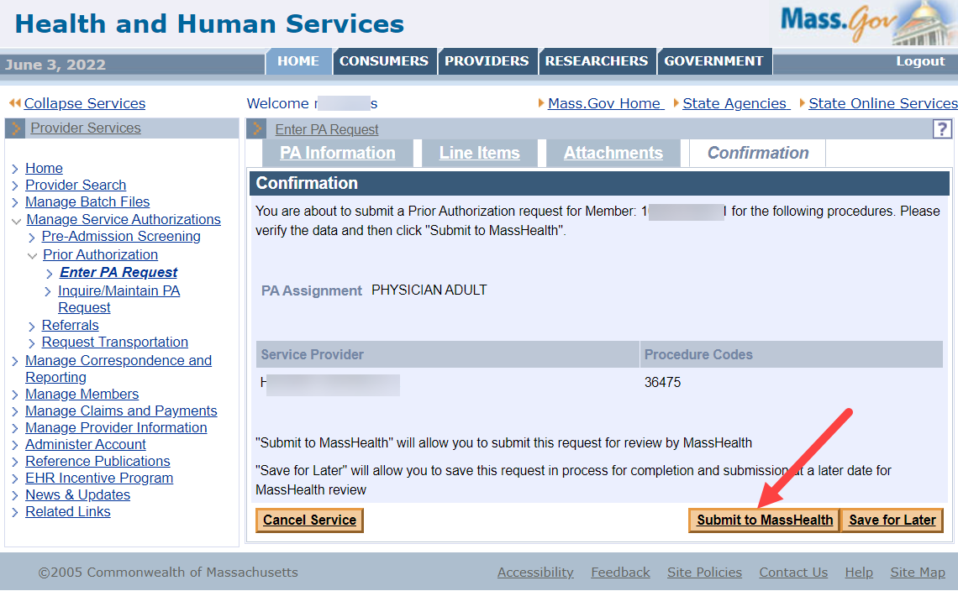
- Acknowledge any warning messages and correct any errors. If necessary, complete any missing required information.
- Click Submit to MassHealth again. The Prior Authorization Response panel will display, indicating that the request was successfully submitted. The tracking number will be provided.
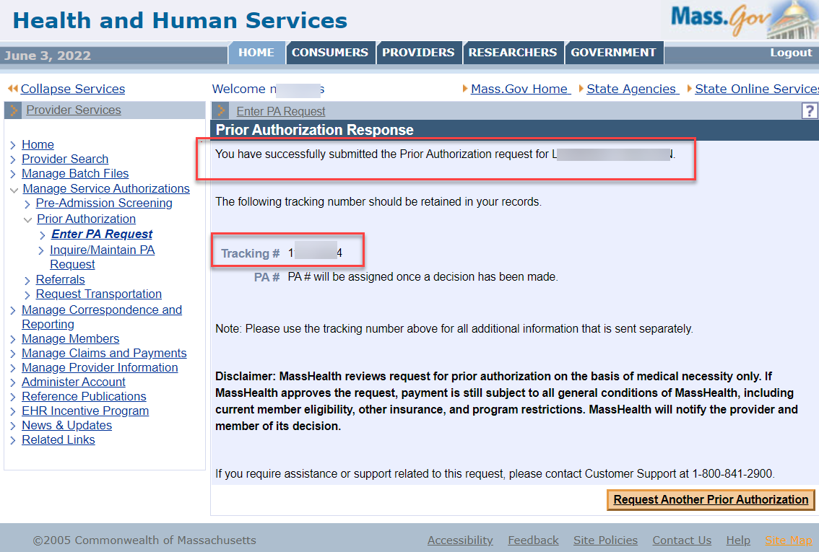

Glossary of Terms
Adjudicate – There are header-level PA statuses that tell where the PA request is in the process. Adjudicated means MassHealth has made a decision on the PA and that all lines have been finalized. Finalized is when all line statuses are cancelled, approved, or denied. When the PA is adjudicated, a letter is sent to the member (with right to appeal).
Control Number – Leave Control Number Field BLANK.
Status – Indicates where the request is in the process of being reviewed and adjudicated. Status options include:
Deferred – Request is pending until requested information is received.
Additional Information Received – Information has been received that was missing from the original request.
Approved – Request is approved by MassHealth. A PA letter is generated and sent to the member.
Cancelled – Request is cancelled by MassHealth due to duplication, eligibility, or PA not required. A PA letter is generated and sent to the member, with the reason for the cancellation.
Cancelled by Provider – Status used for all lines when provider voids the PA request.
The provider can void a PA only while the PA is in Ready for Review status.
Denied – Request has been denied by MassHealth. A PA letter is generated and sent to the member (with the right to appeal).
In Process – Request has only been saved and has not been submitted to MassHealth for review.
In Review – Request has been submitted by provider and assigned to a MassHealth reviewer.
Modified – Request has been altered by MassHealth reviewer in adjudicating. A PA letter is generated and sent to the member (with the right to appeal).
Ready for Review – Request has been submitted but has not been assigned to MassHealth reviewer.
Testing – Request has been submitted to test functionality of the system.
Void – Request has been voided by MassHealth. A PA letter is not generated.
Tracking Number – Number assigned to PA request before MassHealth review.
Transmission Code – Method by which an attachment is transmitted to MassHealth.

