Job Aid: Inquire on Claim Status

This job aid describes how to:

- Research the status of a claim via the Provider Online Service Center (POSC) after it has been submitted to MassHealth for payment.

Access Inquire Claim Status
From the POSC home page:
- Click Manage Claims and Payments.
- Click Inquire Claim Status. The Claims Search panel is displayed.
Note: Fields with a red asterisk are required fields and must be completed to proceed to the next tab.
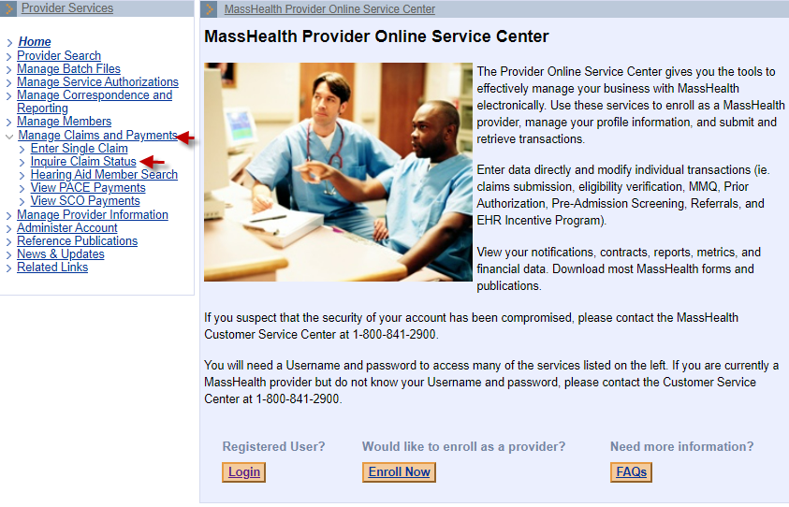

Enter Search Criteria
From the Claims Search panel:
- Select Provider ID from the dropdown list.
- Enter the Member ID.
- Enter From Date of Service and To Date of Service, up to a six-month time span.
Note: For more effective claim searching, enter as much search information as possible. If available, enter the Internal Control Number (ICN). Entering the ICN is the most effective search because it will return only one claim in the Search Results.
- Click Search.
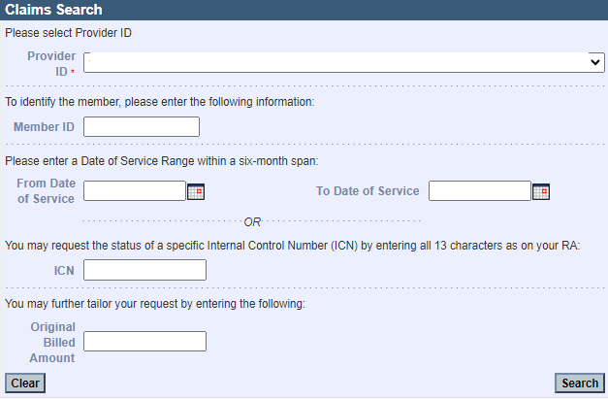

Continue with the Claims Search Results Panel
From the Claims Search Results panel:
- View the claim status.
- If you need more information, select the claim.

Review the Claim Detail Panel
From the Claim Detail panel:
- View the claim status.
- Click Close when you are finished, or click Return to Search Results to view another claim.

Review the Claim Line Detail Information
From the List of Services panel:
- Click the line-item detail number you want to review.
- From the Services Detail panel, review the detail line information.
- Click Close when you are finished, or click Return to Search Results to view another claim.
