Job Aid: Report Coordination-of-Benefits (COB) Information on Professional Direct Data Entry (DDE) Claim Submissions When a Third-Party Insurance Has Adjudicated the Claim
This job aid describes the steps that providers should follow to report coordination of benefits (COB) information on their professional direct data entry (DDE) claim submission to MassHealth when another insurer such as Medicare, Medicare Advantage, Commercial, or Casualty Payer has adjudicated the claim. When submitting a professional DDE claim, follow instructions outlined in the MassHealth Professional Claims Submission job aid, then use this job aid to report COB information.
Note: Fields with an asterisk are required fields and must be completed to proceed to the next panel.
For specific billing information, providers should reference the relevant billing guides available at:
- MassHealth Provider Publications
- MassHealth Administrative and Billing Regulations, Third Party Liability at 130 CMR 450.316 through 450.318
- Administrative and Billing Instructions, Part 7. Other Insurance
- MassHealth Standard HIPAA Companion guide for Health Care Claim: Professional (837P)
Professional claims with COB information must follow COB balancing rules as described in the HIPAA 837 Implementation guide. See examples of COB balancing at the end of this job aid.

Coordination of Benefits
- Click on the Coordination of Benefits tab.
On the List of Coordination of Benefits (COB) panel:
- Click New Item. The Coordination of Benefits (COB) Detail panel displays.
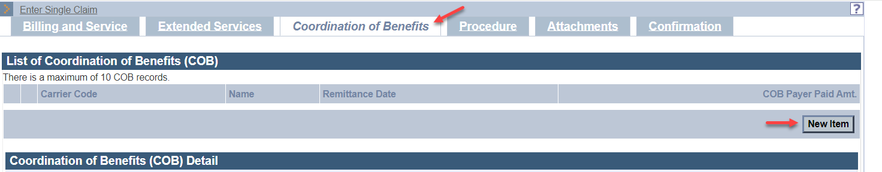
On the COB Detail panel:
- In the Carrier Code* field, enter the MassHealth seven-digit third-party insurance carrier code located in the Eligibility Verification System (EVS). On each date of service and at time of billing, check EVS before submitting your claim to verify the member’s other health insurance coverage and obtain the MassHealth third-party insurance carrier code.
- In the Carrier Name* field, enter the other insurance carrier name.

- The Remittance Date is a critical field and cannot be entered on both the Coordination of Benefits tab and Procedure tab. Do not enter a date in the Remittance Date field on the Coordination of Benefits tab unless you are reporting a Casualty Payer claim or the other payer has applied a HIPAA adjustment amount to the entire claim that cannot be distributed at the detail service lines. For all other claims, enter the Remittance Date on the Procedure tab.
- In the Payer Claim* number field, enter the other insurance claim number.
- In the Payer Responsibility* field, select the appropriate code from the dropdown list.
- In the COB Payer Paid Amount field, enter the amount paid by the other insurance.
- Only authorized provider types may enter a value in the Total Noncovered Amount field. Authorized provider types can refer to the Supplemental Instructions for Submitting Claims with Other Insurance appendix in their provider manual. The appendix outlines the specific conditions for which this field may be used and provides billing instructions.
- Do not enter a value in the Remaining Patient Liability field. This is not a required field and is not necessary for claims adjudication.
- In the Claims Filing Indicator* field, select the appropriate code from the dropdown list.
- Select MA for Medicare Part A
- Select MB for Medicare Part B
- Select CI for Commercial Insurance (includes Medicare Advantage and supplemental plans)

- In the Release of Information* field, select the appropriate code from the dropdown list.
- In the Assignment of Benefits* field, select the appropriate code from the dropdown list.
- In the Relationship to Subscriber* field, select the appropriate code from the dropdown.
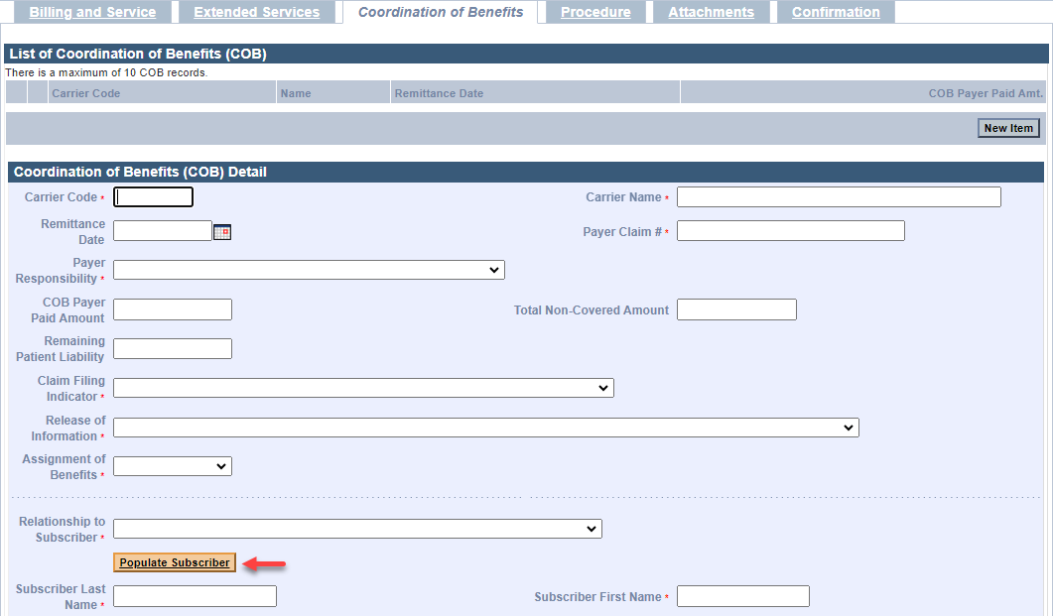
If you selected 18—SELF from the Relationship to Subscriber dropdown list, then click Populate Subscriber. The following data fields that have been entered on the Billing and Service tab will be populated:
- Subscriber Last Name
- Subscriber First Name
- Subscriber Address
- Subscriber City
- Subscriber State
- Subscriber Zip Code
If you select any other value from the Relationship to Subscriber dropdown list, you must enter the following required fields.
- Subscriber Last Name
- Subscriber First Name
- In the Subscriber ID* field, enter the other insurance subscriber ID number.
Note: The remaining data fields on this panel starting from Subscriber Group # through Nonpayable Professional Component Amount are not required for claim adjudication.
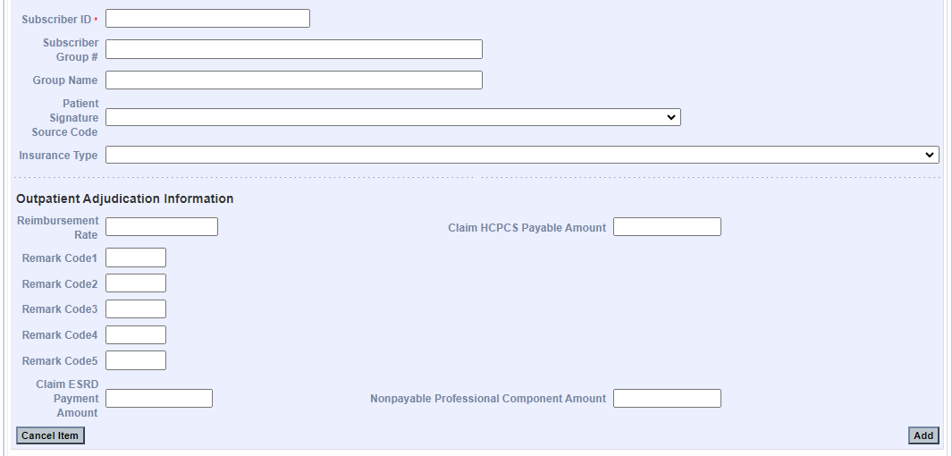
- Skip to step 23 to save the information that has been entered on COB Detail panel unless:
- you are reporting a claim adjustment amount to balance a Casualty Payer claim, OR
- you are reporting a claim adjustment amount that the other payer has applied to the entire claim and cannot be distributed at the detail service lines.
If one of the above is true, continue to the List of COB Reasons/COB Reasons Detail Panel section.

List of COB Reasons/COB Reasons Detail Panel
Note: Do not enter information in the COB Reasons Detail Panel unless:
- you are reporting an adjustment to balance a Casualty Payer claim, OR
- the other payer has applied an adjustment amount to the entire claim that cannot be distributed at the detail service lines.

On the List of COB Reasons panel:
- Click New Item. The COB Reasons Detail panel displays.
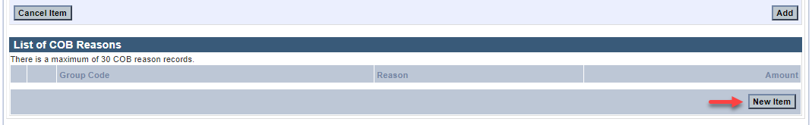
On the COB Reasons Detail panel:
- In the Group Code* field, select the appropriate HIPAA Claim Adjustment Group code from the dropdown list to identify the general category of payment adjustment.
- In the Amount* field, enter the HIPAA adjustment amount associated with the group/reason code.
- In the Unit of Service* field, enter the units of service being adjusted.
- In the Reason* field, enter the HIPAA Claim Adjustment Reason code identifying the detailed reason that the adjustment was made. Do not enter proprietary insurance reason codes.
- Click Add to save COB Reasons Detail.
Note: To report additional COB Reasons, repeat steps 16–22.
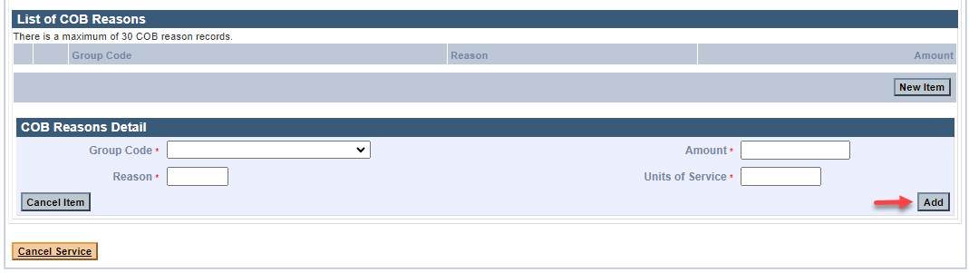
- Click Add on the COB Detail panel to save the COB information.
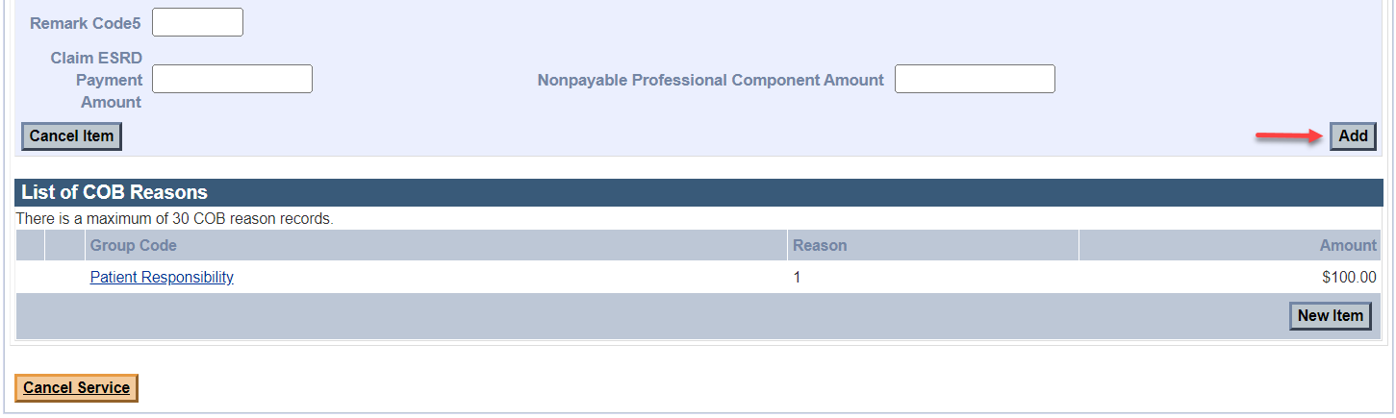
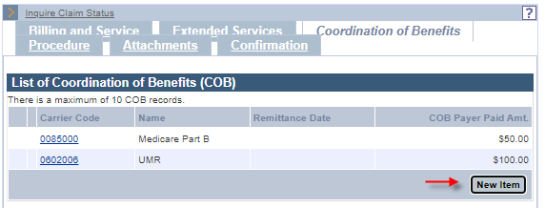
Note: To report multiple payers, click New Item on the List of COB panel, and then repeat steps 1–2. Otherwise, continue to the Procedure tab.

Professional Service Detail Panel
Providers should follow the instructions described in the MassHealth Professional Claims Submission job aid to complete the Professional Services Detail panel. Then, follow these steps to report COB.
Note: You must enter detailed COB information on the COB Line Item Details panel and the COB Reasons Detail panel.
On the List of COB Line Items panel:
- Click New Item. The COB Line Item Details panel displays.
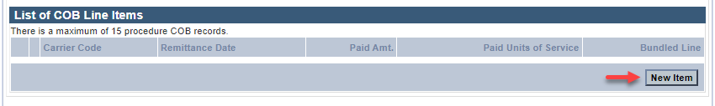
On the COB Line Details panel:
- In the Carrier Code* field, the carrier code will pre-populate with the carrier code that was entered on the Coordination of Benefits tab. If there are multiple carrier codes, select the appropriate code from the dropdown list.
- In the Bundled into Line # field, enter the line number of the service line into which this service has been bundled. This field should only be used when the other payer has bundled payment for a set of services. See example at the end of this job aid.
- In the Remittance Date field, enter the other payer’s remittance date. The Remittance Date is a critical field for COB adjudication and must be entered on the Procedure tab.
- In the Paid Amount field, enter the amount paid by the other insurance.
- In the Paid Units of Service* field, enter the number of paid units.
- Do not enter a value in the Remaining Patient Liability field. This is not a required field and is not necessary for claims adjudication.
- In the Procedure Code* field, enter the procedure code.
- In the Modifier fields, enter the modifiers associated with the procedure code if applicable.
- In the Prior Authorization number field, enter the other payer’s authorization number if applicable. This is not a required field and is not necessary for claims adjudication.
- In the Referral number field, enter the other payer’s referral number if applicable. This is not a required field and is not necessary for claims adjudication.
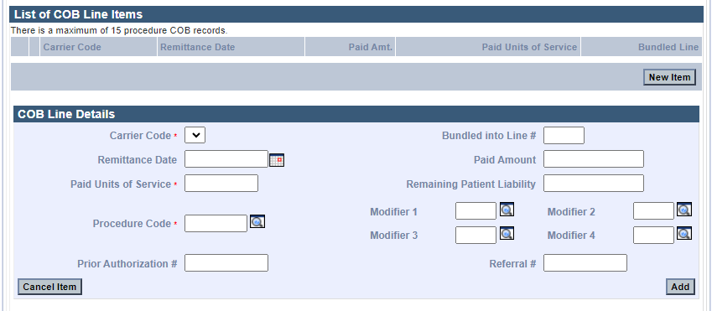
On the List of COB Reasons panel:
- Click New Item. The COB Reasons Detail panel displays.
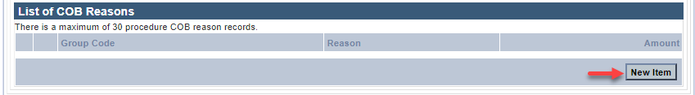
On the COB Reasons Detail panel:
- In the Group Code* field, select the appropriate HIPPA Claim Adjustment Group code (CAGC) from the dropdown list to identify the general category of payment adjustment.
- In the Amount* field, enter the adjustment amount associated with the group/reason code.
- In the Reason* field, enter the HIPAA Claim Adjustment Reason code (CARC) identifying the detailed reason that the adjustment was made. Do not enter proprietary insurance reason codes. Proprietary codes must be translated to a HIPAA CARC.
- In the Units of Service* field, enter the units of service being adjusted.
- Click Add to save COB Reasons Detail.
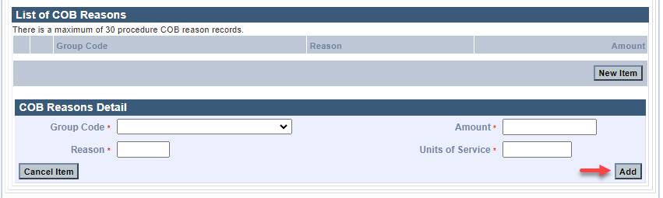

- Click Add again to save the COB Line Details.
Note: To report additional COB Reasons, repeat steps 37–41. To report multiple payers, repeat steps 25–42.
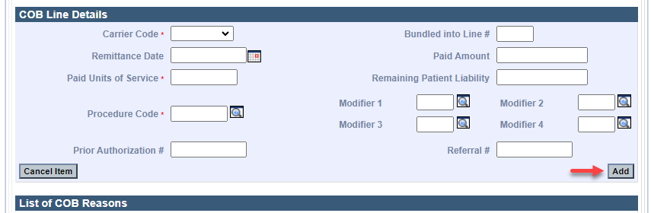

- Click Add again to save the Professional Services Detail panel information.
Note: Refer to the MassHealth Professional Claims Submission job aid to complete a claim submission.
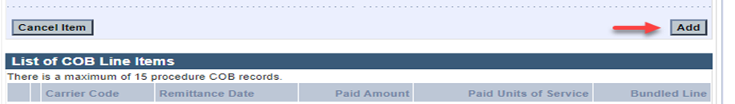

The following pages contain COB Balancing and Bundled Payment Examples.

COB Balancing Examples for Professional Claims (for reference purposes only)

Example 1: COB Payer Paid Amount Balancing and Service Line Billed Amount Balancing
COB Payer Paid Amount Balancing: For each payer on the claim, the COB Payer Paid Amount ($26.00) entered on the Coordination of Benefits tab must balance to the sum of all the service line other payer Paid Amounts entered on the Procedure tab in the COB Line Details panel (detail 1 ($22.00) and detail 2 ($4.00)).
Coordination of Benefits Tab
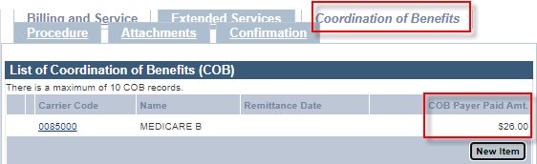
Procedure Tab
Detail 1
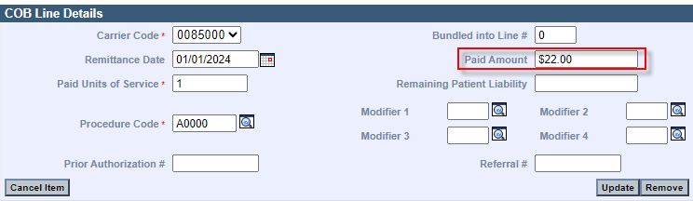
Detail 2
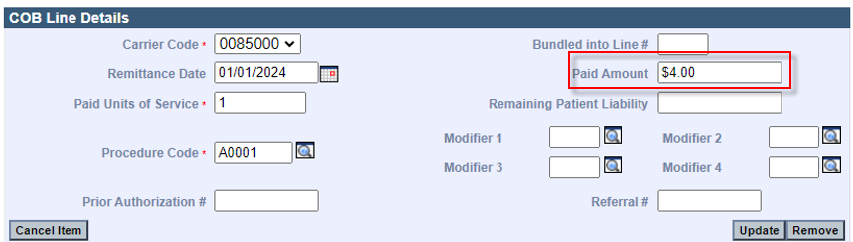

Service Line Billed Amount Balancing: For each payer on the claim, The Provider Billed Amount (Charges) for the service line entered on the Procedure tab must balance to the sum of the service line other Payer Paid Amount and service line HIPAA Adjustment Amounts entered on the Procedure tab.
Detail 1: Provider Billed Amount (Charges) for the service line ($100.00) equals the sum of the other Payer Paid Amount ($22.00) and the service line HIPAA Adjustment Amounts ($68.00 + $10.00=$78.00).
Procedure Tab
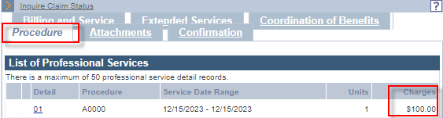
Detail 1
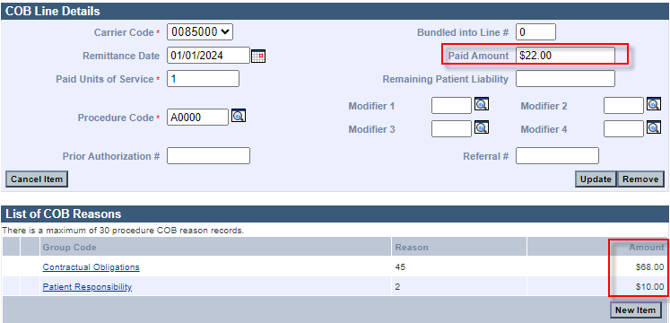

Service Line Billed Amount Balancing: For each payer on the claim, the Provider Billed Amount (Charges) for the service line entered on the Procedure tab must balance to the sum of the service line other Payer Paid Amount and service line HIPAA Adjustment Amounts entered on the Procedure tab.
Detail 2: Provider Billed Amount (Charges) for the service line ($64.00) equals the sum of the other Payer Paid Amount ($4.00) and the service line HIPAA Adjustment Amounts ($58.00 + $2.00=$60.00)
Procedure Tab
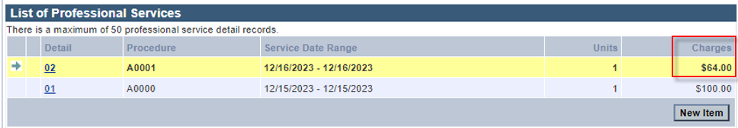
Detail 2
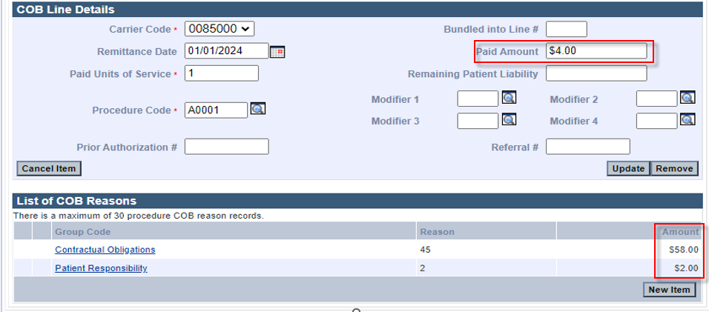

Example 2: COB Payer Paid Amount Balancing
A HIPAA Adjustment Amount has been applied to the entire claim and cannot be distributed at the detail lines and Service Line Billed Amount Balancing.
For each payer reported on the claim, the COB Payer Paid Amount ($55.00) entered on the Coordination of Benefits tab must balance to the sum of all the service line other payer Paid Amounts entered on the Procedure tab in the COB Line Details panel—detail 1 ($60.00) and detail 2 ($10.00)—minus the claim level HIPAA Adjustment Amount ($15.00) entered on the Coordination of Benefits tab.
Coordination of Benefits Tab
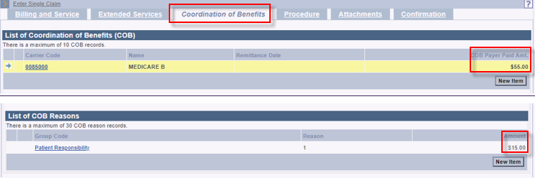
Procedure Tab
Detail 1
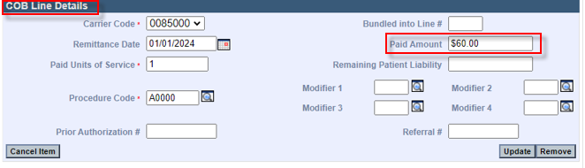Detail 2
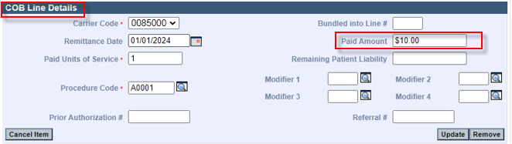

Service Line Billed Amount Balancing: For each payer reported on the claim, the Provider Billed Amount (Charges) for the service line entered on the Procedure tab must balance to the sum of the service line other Payer Paid Amount and service line HIPAA Adjustment Amounts entered on the Procedure tab.
Detail 1: Provider Billed Amount (Charges) for the service line ($150.00) equals the sum of the other Payer Paid Amount ($60.00) and the service line HIPAA Adjustment Amounts ($80.00 + $10.00=$90.00)
Procedure Tab
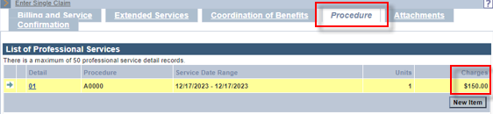
Detail 1
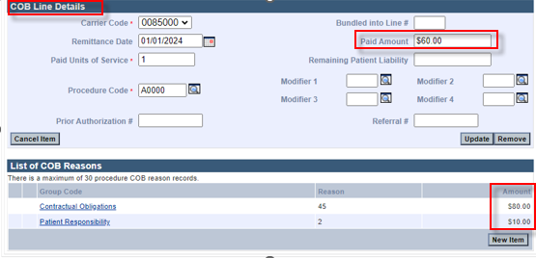

Service Line Billed Amount Balancing: For each payer reported on the claim, the Provider Billed Amount (Charges) for the service line entered on the Procedure tab must balance to the sum of the service line other Payer Paid Amount and service line HIPAA Adjustment Amounts entered on the Procedure tab.
Detail 2: Provider Billed Amount (Charges) for the service line ($50.00) equals the sum of the other Payer Paid Amount ($10.00) and the service line HIPAA Adjustment Amounts ($35.00 + $5.00=$40.00)
Procedure Tab

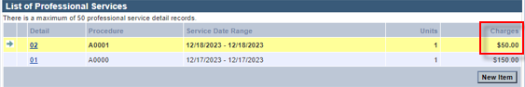
Detail 2
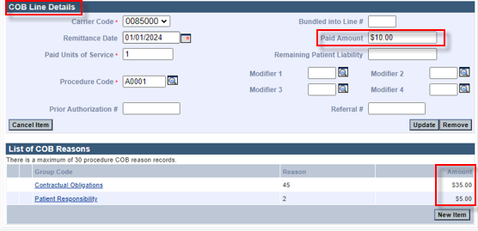

COB Balancing Error Messages
When a COB DDE claim is not balanced, one of the following error messages will appear on the Confirmation page.
- The sum of all line level payments amounts less any claim level adjustment amounts must balance to the claim level payment amount for the matched payer. Please correct and submit.

- The sum of the line level adjustment amounts and line level payments in each line adjudication information loop must balance to the provider’s charge for that line. Please correct and submit.

Bundled Payment Example (for reference purposes only)
The Bundled into Line # field should only be used when the other payer has bundled payment for a set of services.
In this example, there is a bundled payment of $100 on Detail 1.
The Bundled into Line # of 1 on Detail 2 indicates that Detail 2 has been bundled into the other payer paid amount on Detail 1.
Procedure Tab
Detail 1
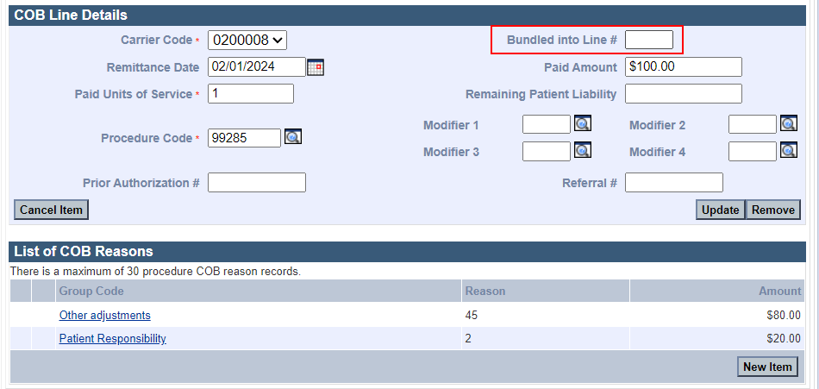
Detail 2
