Job Aid: Resubmit a Denied Claim

This job aid describes how to:

- Resubmit a denied claim immediately after you have received the denial message from MassHealth; and
- Resubmit a denied claim at a later time.

If you are correcting a denied claim immediately:

- From the confirmation panel, click the Resubmit button. Then, skip to step 7.
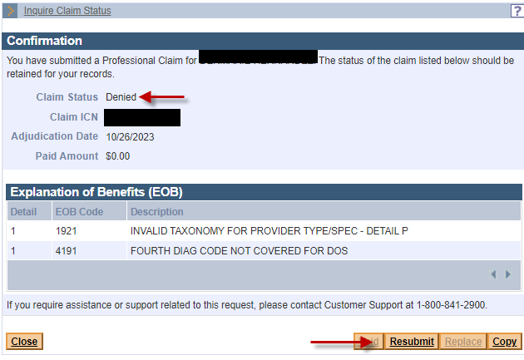

If you are correcting a previously denied claim:

Access Inquire Claim Status
From the POSC home page:
- Click Manage Claims and Payments.
- Click Inquire Claims Status. The Claims Search panel is displayed.
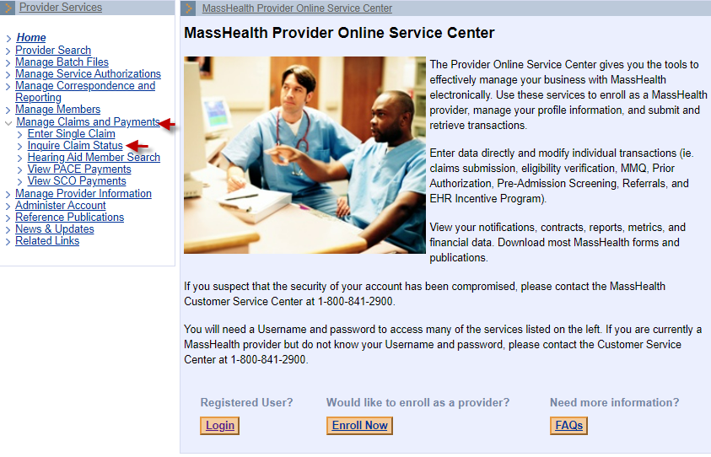
- Enter the ICN of the claim to be corrected and click Search.
- Click on the ICN in the Claims Search Results panel to open the claim.
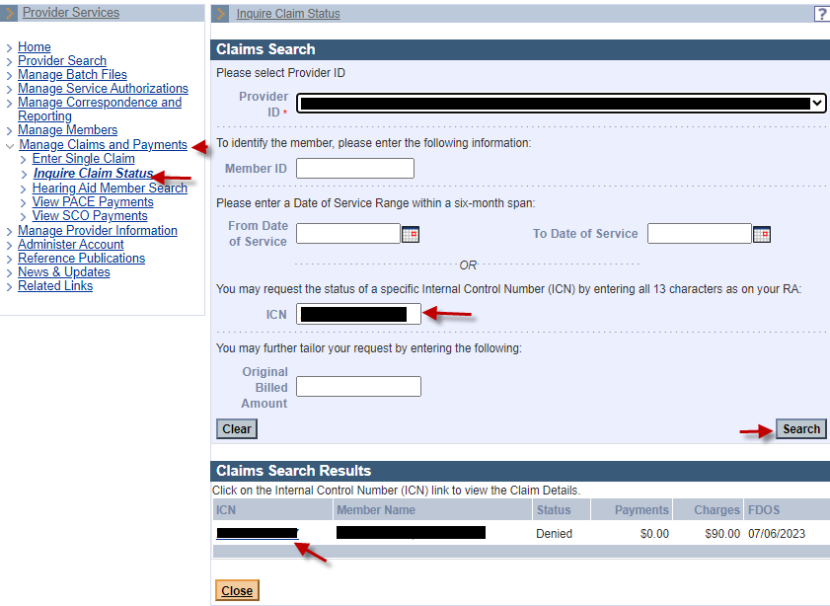

- From the Claim Detail panel, click Resubmit.
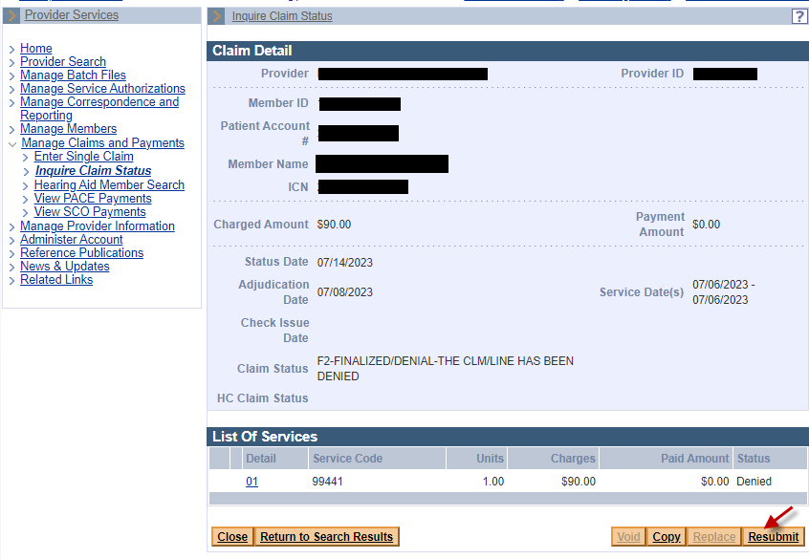

Continue to the tabs/panels where the corrections need to be made.
- Enter the corrected claim information.
From the Confirmation panel:
- Click Submit.

