Job Aid: Void a Paid Claim

This job aid describes how to:

- Void a claim after it has been paid by MassHealth.

Access Inquire Claim Status
From the POSC home page:
- Click Manage Claims and Payments.
- Click Inquire Claims Status. The Claims Search panel displays.

Enter Search Criteria
For more effective claim searching, enter as much search information as possible.
From the Claims Search panel:
- Select Provider ID from the dropdown list.
- Enter the Member ID.
- Enter From Date of Service and To Date of Service.
Note: Enter the exact date of service if known, or enter an ICN, which returns only the specific claim in the Search Results.
- Click Search.
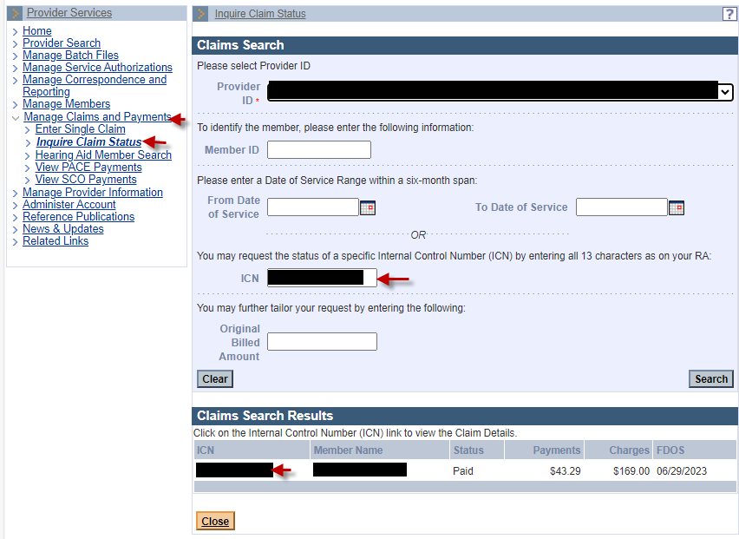
From the Claims Search Results panel:
- Select the paid claim to be voided.

Review the Claim Detail Panel
From the Claim Detail panel:
- Review the claim status.
- Click Void.
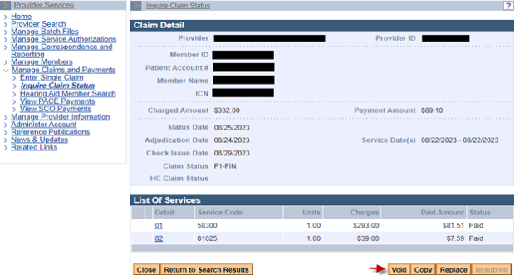

From the Claim Confirmation panel:
- Click Confirm.
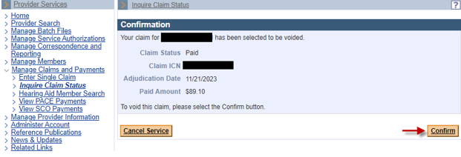
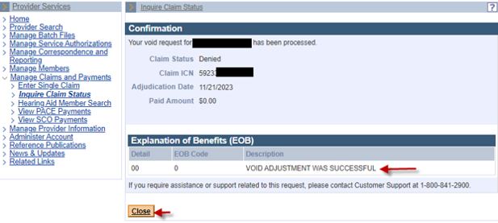
If the void failed, be sure to verify that you are voiding the last claim that paid. You cannot void or adjust a denied claim.
