This document contains detailed instructions for completing the New Site Occupancy (NSO) Application version 2019 07 01 (July 1, 2019). There are four sections.
- Page 1 – Introduction. This brief introduction has general information to keep in mind when completing the NSO application,
- Page 2 – Eligibility & Timeline. Which sites are eligible for the NSO Application process and timeline information going all the way back to when the new site was just an idea between the provider and the DDS area office, and
- Pages 3 to 11 – Instructions. Step-by-step instructions for completing each application section. Each section is defined and includes what documentary requirements are triggered when specific entries are made.
- Page 12 – Total Interest tab. The Annual Interest computation in section [5]’s pertains to provider site purchases of either an (1) Existing House or (2) New Construction. It is the annual interest paid for loan or bond interest using the “straight line method”. That method distributes interest payments evenly over the loan or bond amortization period. The Total Interest tab will compute the Total Interest for the “Total Interest ($)” entry on the NSO Application.

General Information for completing NSO Applications:
- Make entries only in gray boxes.
- Yellow boxes will be automatically computed using data that’s been input to gray boxes.
- Expenses are site-specific, not engagement-wide.
- Expenses paid through a Commonwealth-funded start-up or capital budget are not allowed on the application.
- Salaried staff position expenses are not allowed on the application.
- Vehicle-related expenses are not allowed on the application.
- A Related Party to a provider, includes but is not limited to, another organization that includes a member(s) of the provider’s executive staff or board, or the spouse of an executive staff or board member. Full definition 808 CMR 1.05(8). Also see GAAP Rules pertaining to related parties.
- If ownership of a rental site is not clear (realty trusts or other legal entities where individual ownership is unclear) the lease may be treated as a related party transaction and subject to related party rules.

Questions? Check with your area or regional contacts or, anthony.piccolo@state.ma.us, 617 624 7542

Eligibility & Timelines

DDS ALTR (Adult Long Term Residential) sites that need to go through the NSO Application process:
- Any ALTR site that is brand new to DDS
- Any ALTR site with a change in acquisition status. For example, a site leased to the provider that the provider purchases or otherwise obtains ownership of
- Any former ALTR site that has not been in use as a DDS ALTR site for at least one year
- Any new ALTR site that is replacing an ALTR site that was effectively razed to make way for the new site
DDS central office contracts staff have 30 calendar days from receipt of a complete NSO application package to review and establish an occupancy rate for the new site. A “complete NSO application package” includes all documentation deemed necessary by DDS.
The provider should submit a completed application, with back up documentation, to the area and regional office as soon as possible and not later than two months after the first person has moved into the site. Application packages submitted to DDS more than two months after the first person move-in date risk limiting reimbursement to two months prior to the actual submission date, not the move-in date.
The provider includes the state officer name, title, and area in application section [1]. This is an acknowledgement that the area has worked with the provider to establish the new site; is aware of the site costs; and has funds to cover the occupancy rate established by DDS central office. The area office would notify regional and central office if any of those items could not be acknowledged.
The regional office reviews the submitted NSO application and associated documentation in conjunction with this checklist. If an application and documentation are complete, the regional office will forward the package to Anthony Piccolo at DDS central office and the area office. If the application and documentation are incomplete or incorrect the regional staff will contact the provider for corrective action.
If the provider does not respond to region with requested information in one week, the region will forward application and documentation to Anthony, along with any correspondence to the provider.
Anthony will email the provider and re-request the missing documentation. Provider will be informed that if additional documentation is not submitted, or an explanatory request for more time is not made, within one week, DDS central office may process the application without the requested information. Missing documentation usually adversely impacts the occupancy rate.
Upon receipt of a complete application package DDS central office will establish an occupancy rate and forward that rate and supporting documentation to regional, area, and provider contacts. A provider can appeal an assigned rate within 30 calendar days of rate establishment. An appeal must be in writing, include justification for the appeal, and contain supporting documentation. The appeal should be sent electronically to Victor Hernandez; Anthony and the regional and area contacts need to be cc’d.
The following are section-by-section definitions and trigger requirements of expense documentation.
NEW SITE OCCUPANCY APPLICATION INSTRUCTIONS SECTION 1
APPLICATION SECTION | DEFINED | TRIGGERS REQUIREMENT FOR
“State Agency Contact Name” | The DDS Area Contact. Usually the Area Director for ID/DDS sites, Community Systems Director for ABI/DDS sites | None
“Title” | The title of named State Agency Contact | None
“DDS Area Office/State Agency” | Name of the area office of the Agency Area Contact, or ABI equivalent | None
“Name of Provider Agency” | The legal name of the provider agency that will be operating the new site | None
“Engagement #” | 20 character engagement number with “L” near middle, ending in “M”, (previously known as “Contract #”) | None
Agency Box (not titled, but contains DDS 3153, DDS ABI, MCB, MRC, next to boxes to check) | The lead, or majority financing, Commonwealth agency of the site.  Only select one | None  This selection will let you know the number to use in Section [3] “ALTR Funded Capacity”; that number will be the capacity funded by the agency selected in this box

Notes:

NEW SITE OCCUPANCY APPLICATION INSTRUCTIONS SECTION 2
APPLICATION SECTION | DEFINED | TRIGGERS REQUIREMENT FOR
“Street” | Full street address of new site, including apartment or unit number for apartments and condominiums | None
“City” | Name of the city the new site is in. MA cities must match one of the 351 official cities and towns as listed in the NSO application “Rate Caps & Geographic Lookups” tab | None
“Zip” | 5 or 9 digit zip code of the site | None
“Type of Site” | Drop down menu with three choices: “single unit building” is a free-standing single family building; “2 to 4 unit building” houses 2 to 4 apartments; “5 or more unit building” is a building or complex with five or more apartments.  Note that “unit” is a whole unit of housing, not a bedroom. | None

NEW SITE OCCUPANCY APPLICATION INSTRUCTIONS SECTION 3
APPLICATION SECTION | DEFINED | TRIGGERS REQUIREMENT FOR
“Total Capacity” | Total number of individuals (regardless of funding source), not staff, who can live at the site | Explain in writing any extra bedroom(s) that are not part of “Total Capacity”
“ALTR Funded Capacity” | Total number of individuals, not staff, to live at the site and be funded by the Engagement # in Section 1. This number cannot exceed Total Capacity, but may be equal to or less than Total Capacity | None

NEW SITE OCCUPANCY APPLICATION INSTRUCTIONS SECTION 4
APPLICATION SECTION | DEFINED | TRIGGERS REQUIREMENT FOR
“Acquisition Type” (Financing) Select One:  - Purchase  - Lease  - Capital Lease | - Purchase – provider is purchasing the site  - Lease – provider is leasing the site  - Capital Lease – provider is entering into a capital lease arrangement | None
“Acquisition Type”, second row, only for “Acquisition Type” above of “Purchase”  Select One:  - Existing  - New | (Only for “Purchase” acquisition type)  - Existing – the site existed before provider acquired it  - New – the site was newly constructed at the time provider acquired it | None
“Is lessor a related party (for Lease sites)?”  - Yes  - No | - Yes – the lessor is a related party  - No – the lessor is not a related party | Answer of “Yes” triggers the same documentary requirements outlined in Section 5 for “Purchase” of “Existing House”, page 6, or “New Construction”, page 7
“Ready to move in?” Select One:  - Pending  - Completed | - Pending – provider acquisition of the site is not complete either legally and/or physically  - Completed – provider acquisition of the site is complete legally and physically | None
Notes: Related Party rules apply to lease transactions where the provider rents a site that is owned by a related entity or individual.
As noted on page 1, a related party to a provider, includes but is not limited to, another organization that includes a member(s) of the provider’s executive staff or board, or the spouse of an executive staff or board member. Full “Related Party” definition can be found at 808 CMR 1.05(8). Also see GAAP Rules pertaining to related parties.
If ownership of a site leased to a provider is unclear (realty trusts, or other legal entities where individual ownership cannot be determined) the lease may be treated as a related party transaction and subject to all related party rules.
NEW SITE OCCUPANCY APPLICATION INSTRUCTIONS SECTION 5
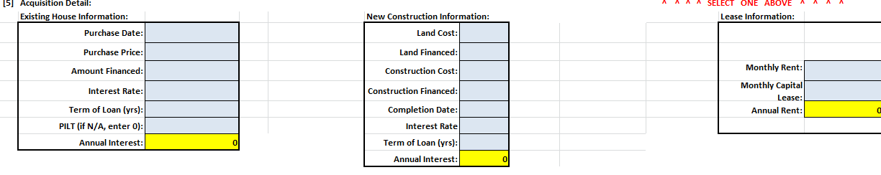
[5] Acquisition Detail: “Existing House Information” - Completed when provider purchases an existing site
APPLICATION SECTION | DEFINED | TRIGGERS REQUIREMENT FOR
“Purchase Date” | Date provider legally purchased site | HUD 1 Settlement Statement, Deed, Land Card, or other document stating provider Purchase Date of site
“Purchase Price” | Purchase price of the site. Only purchase price - no renovation costs, taxes, closing costs, or any other expenses associated with the site | Same as “Purchase Date”
“Amount Financed” | Amount financed by the provider to acquire the site | Financing Documents – mortgage, loan documents, bond documents, or other finance documents associated with provider acquisition of the site  Also, proof of other financed items, associated with the site acquisition, in addition to purchase price, or part of purchase price (examples: closing costs, life safety improvements)
“Interest Rate” | Interest rate of financing the provider uses to acquire the site | Same as first paragraph of “Amount Financed”
“Term of Loan (yrs)” | Number of years the loan or bond amortization is based upon | Same as first paragraph of “Amount Financed”
Total Interest | Total interest paid over life of loan. | Loan or bond amortization schedule
Annual Interest (Total Interest/27.5) | The Total Interest divided by 27.5 years. Computed, using straight line method. | Loan or bond amortization schedule

NEW SITE OCCUPANCY APPLICATION INSTRUCTIONS SECTION 5
[5] Acquisition Detail: “New Construction Information” - Completed when provider constructs a new site
APPLICATION SECTION | DEFINED | TRIGGERS REQUIREMENT FOR
“Land Cost” | Cost of land new site is constructed on | Deed, Land Card, or other document stating provider cost of land purchase to build new site
“Land Financed” | Amount of land cost that is financed by provider | Financing Documents – mortgage, loan documents, bond documents, or other finance documents associated with provider acquisition of land
“Construction Cost” | Cost of construction of the new site. This amount will auto-populate the | Contractor, AIA (American Institute of Architects), or other documents detailing the construction and costs, including number of bedrooms, baths, etc., associated with building the site, and proof of provider payment of those costs, or pending payment
“Construction Financed” | Amount of construction cost that is financed by provider | Same as “Land Financed”
“Completion Date” | Date construction of new site was completed | None
“Interest Rate” | Interest rate of financing the provider uses to build the site | Same as “Land Financed”
“Term of Loan (yrs)” | Number of years the loan or bond amortization is based upon | Same as “Land Financed”
“ Total Interest” | Total interest paid over life of loan
Annual Interest (Total Interest/27.5) | The Total Interest divided by 27.5 years. Computed, using straight line method. | Loan or bond amortization schedule.
NEW SITE OCCUPANCY APPLICATION INSTRUCTIONS SECTION 5
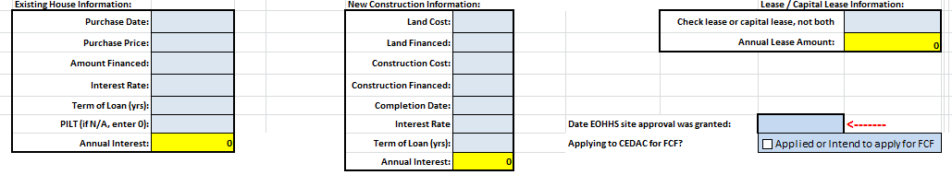
[5] Acquisition Detail: “Lease/Capital Lease Information” - Completed when provider leases a site, or enters into a capital lease arrangement
APPLICATION SECTION | DEFINED | TRIGGERS REQUIREMENT FOR
“Check lease or capital lease (from Section 4) not both” | Amount of monthly lease or capital lease payment | Lease *or Capital Lease Agreement, Capital Lease Budget, and  Proof of payment by capital lease holder of costs listed on Budget
“Annual Lease Amount” | Automatically computed based on information provided | None

Notes: * Related Party leases also require the same documentation as “Existing House Information” or “New Construction Information” (see page 5 for more detail)
[5] Acquisition Detail: “site approval” and “CEDAC for FCF” funding
APPLICATION SECTION | DEFINED | TRIGGERS REQUIREMENT FOR
“Date EOHHS site approval was granted” | The date EOHHS approved this proposed site location | None for provider; DDS area office to provide
“Applying to CEDAC for FCF?” | Question whether CEDAC or FCF funding will, or has been, applied for as part of site funding. Only check box if answer is affirmative. | If answered funding question in the affirmative, complete the “Date of CEDAC application” with a date or TBD if no firm date is available at NSO application time

NEW SITE OCCUPANCY APPLICATION INSTRUCTIONS SECTION 6
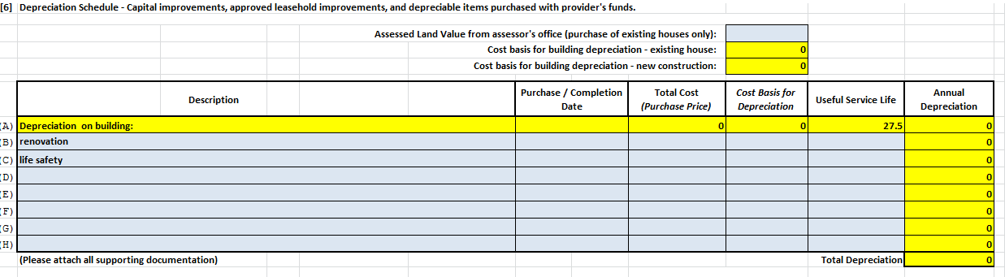
APPLICATION SECTION | DEFINED | TRIGGERS REQUIREMENT FOR
“Assessed Land Value from assessor’s office (purchase of existing houses only)” | Assessed value of land as listed on the city assessor’s office land card (sometimes called property card).  Making the land value entry will compute and auto-enter:  - Cost Basis for “Depreciation on building”, Line A of Depreciation Schedule for an Existing House (Purchase Price from [5] less Assessed Land Value, 1st red arrow)  - Cost Basis for Depreciation on the Depreciation Schedule (Purchase Price less Assessed Land Value, 2nd red arrow) | Land Card or comparable document
“Description – Lines B through H” | Describes renovations and life safety improvements made to existing house  - Does not include start-up costs  - Like renovations grouped together. “Useful Service Life” (Service Life of Assets tab) is sometimes a good indicator of like renovations  Complete “Purchase/Completion Date”(of the improvement), “Total Cost” “Cost Basis for Depreciation” (usually the same amount), and “Useful Service Life” (from Service Life of Assets tab) | For renovations or life safety improvements: American Institute of Architects (AIA) documents or detailed contractor proposals or invoices, and proof of payment to contractor or explanation of pending payment
NEW SITE OCCUPANCY APPLICATION INSTRUCTIONS SECTION 7
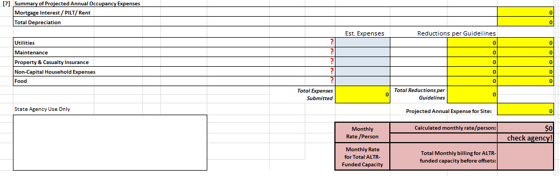
These are estimated, or projected, annual expenses for the new site only. Formulas embedded in the application will cap these expenses based on previously entered data (capacity, type of site, and type of acquisition). Provider can enter any reasonable cost estimate but any amounts higher than the caps will be adjusted downward on the application. All items are stated as annual expenses for each occupancy expense category.
APPLICATION SECTION | DEFINED | TRIGGERS REQUIREMENT FOR
“Utilities” | Electricity, natural gas, heating oil, water/sewer  No vehicle or staff expenses | None
“Maintenance” | General upkeep of site, minor repairs; No vehicle or staff expenses | None
“Homeowner/Rental Insurance” | Property & Casualty insurance on the building and contents (furniture, clothing) only; rental insurance on contents only for leased sites  No vehicle insurance or any other insurance | None
“Non-Capital Household Expenses” | Paper goods, cleaning supplies, small expenditures | None
“Food” | For individuals, not staff, living at the site | None *

Notes: * “Food” is computed at $8.16 per person, per day

NEW SITE OCCUPANCY APPLICATION INSTRUCTIONS SECTION 8
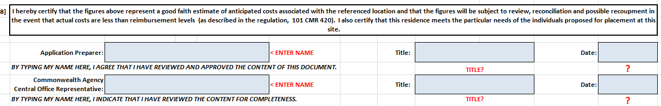
APPLICATION SECTION | DEFINED | TRIGGERS REQUIREMENT FOR
“Application Preparer” | Provider Application Preparer name | None
“Title” | Title of named Provider Application Preparer | None
“Date” | Date of final, complete, application submission | None
Notes: Provider should not complete any information for “Commonwealth Agency Central Office Representative”

NEW SITE OCCUPANCY APPLICATION INSTRUCTIONS SECTION 9
APPLICATION SECTION | DEFINED | TRIGGERS REQUIREMENT FOR
“Estimate of Annual Offsets” | Estimated total amount of annual (twelve months) offsets for all of the individuals comprising “ALTR Funded Capacity”. Offsets are usually SSI, SNAP, and housing benefits received by the individuals living at the site. DDS regional office will pro-rate for actual occupancy used in first FY | None
“Projected move in/start date” | The date the first individual is projected to move, or has moved, into the site | None
“Projected # of months used in first year” | The number of months during the first fiscal year the site will be receiving a DDS Occupancy Rate. Based off the projected move in date | None

Total Interest Tab
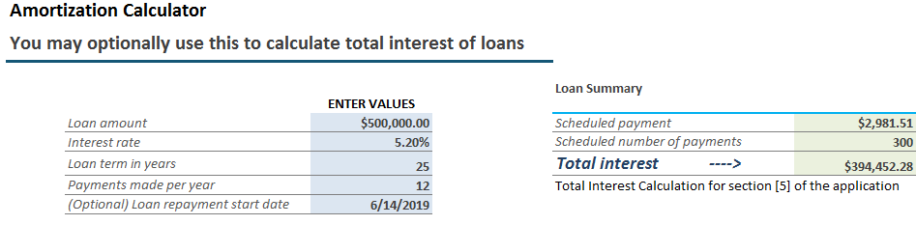
The Total Interest amount would be input to “Total Interest ($)” in [5] Acquisition Detail for Existing House Information or New Construction Information
“Loan Amount” | The amount of the loan or bond directly secured by the new site. | Documents that include the loan amount.
“Interest Rate” | The interest rate of the loan or bond directly secured by the new site. | Documents that include the interest rate.
“Loan Term in Years” | The amortization period used to determine payment amounts. | Documents that include the amortization period.
“Payments made per year” | Typically 12, once per month
“(Optional) Loan repayment start date” | Due date of first loan payment

