|  |
| --- |
| **Substance Exposed Newborns and Maternal Opioid Use Surveillance Data** |
| Massachusetts Department of Public Health POSTED: MAY 2021 |

**Introduction**

DPH monitors the impact of the opioid epidemic on mothers and babies in a number of ways. On the next pages are a series of maps depicting infants exposed to controlled substances and mothers who used opioids or benzodiazepines during pregnancy These maps are created using surveillance data based on standardized administrative codes as reported by the birth hospital. This data provides timely reporting on Neonatal Abstinence Syndrome (NAS) and Substance-Exposed Newborns in Massachusetts. These measures have been validated and found to be relatively sensitive, with a high positive predictive value[1].

Additionally, DPH provides population-based data on NAS and eight other key indicators related to perinatal opioid use. Data are provided for the state overall, as well as by maternal race/ethnicity, education, age, and insurance coverage. In addition to statewide estimates, data are also presented by the six Executive Office of Health and Human Services (EOHHS) regions. This data can be found on DPH’s [NAS Dashboard.](https://www.mass.gov/guides/neonatal-abstinence-syndrome-dashboard)

To learn more about how DPH supports mothers in recovery, please visit our summary of [treatment services for pregnant and postpartum women](https://www.mass.gov/doc/treatment-services-for-pregnant-and-postpartum-women/download) and more resources are available through DPH’s partner, the [Institute for Health and Recovery.](http://www.healthrecovery.org/our-work/pregnant-women-and-families/)

# Glossary of Terms

**Neonatal Abstinence Syndrome (NAS)** – Intrauterine exposure to opioids, antidepressants, barbiturates, or benzodiazepines may result in a neonatal condition known as Neonatal Abstinence Syndrome. Infants with NAS are often fussy and hard to soothe. Treatments for NAS include skin-to-skin, swaddling, low light and low noise, non-nutritive sucking, rocking, and pharmacologic therapy. NAS is a qualifying condition for one year of Early Intervention (EI) services. The EI program provides family-centered services to support child development.

**Neonatal Opioid Withdrawal Syndrome (NOWS)** – While NAS is often caused by exposure to opioids, it can be caused by exposure to other substances. Although NOWS refers to the same constellation of symptoms as NAS, NOWS differs in that it is specifically caused by exposure to opioids. This can include both illicit opioids and Medication for Opioid Use Disorder such as Buprenorphine, Methadone, or Suboxone.

**Infants Exposed to Controlled Substances** – In these maps we look at Infants Exposed to Controlled

Substances. This is based on two administrative ICD-10-CM codes. P96.1: Neonatal withdrawal symptoms,

P04.49: Infant affected by maternal use of Controlled Substances). These ICD-10 codes can include opioids (including medications for opioid use disorder), benzodiazepines, methamphetamine, barbiturate, cocaine, hallucinogens, or cannabis. Percent of infants with exposure to Controlled Substances was calculated as: number of infants reported by facilities in that county as having above ICD codes / total number of births,

living or dead, where the gestational age is estimated to be 24 weeks or greater as reported by facilities in that county.

**Mothers who Used Opioids or Benzodiazepines** – As NAS can be caused by both opioids and/or benzodiazepines, DPH also monitors the number of mothers who use these substances during pregnancy. This is based on two administrative ICD-10-CM codes. F11.20: Opioid dependence, F13.20: Sedative, hypnotic or anxiolytic dependence). Percent of mothers with opioid or benzodiazepine use during pregnancy was calculated as: number of mothers reported by facilities in that county as having above ICD codes / total number of births, living or dead, where the gestational age is estimated to be 24 weeks or greater as reported by facilities in that county.

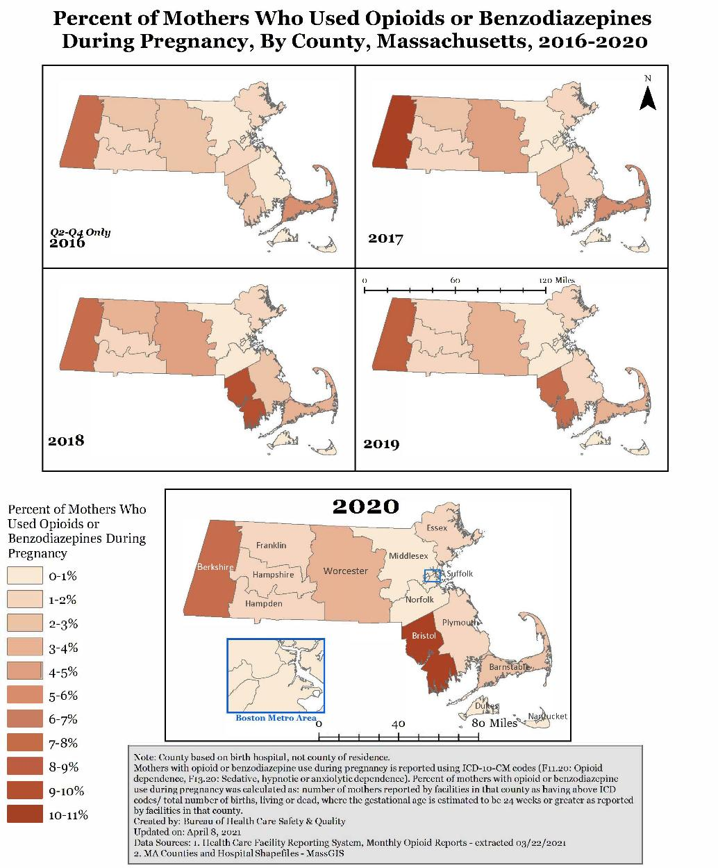

**Figure 1.** Bristol county had a 32% increase in mothers who used opioids or benzodiazepines during pregnancy between 2019 and 2020 (from 7.9% to 10.4%). Berkshire county, which had previously had the highest rates of mothers who used opioids or benzodiazepines showed a decrease of 7% (from 8.5% to 7.9%).

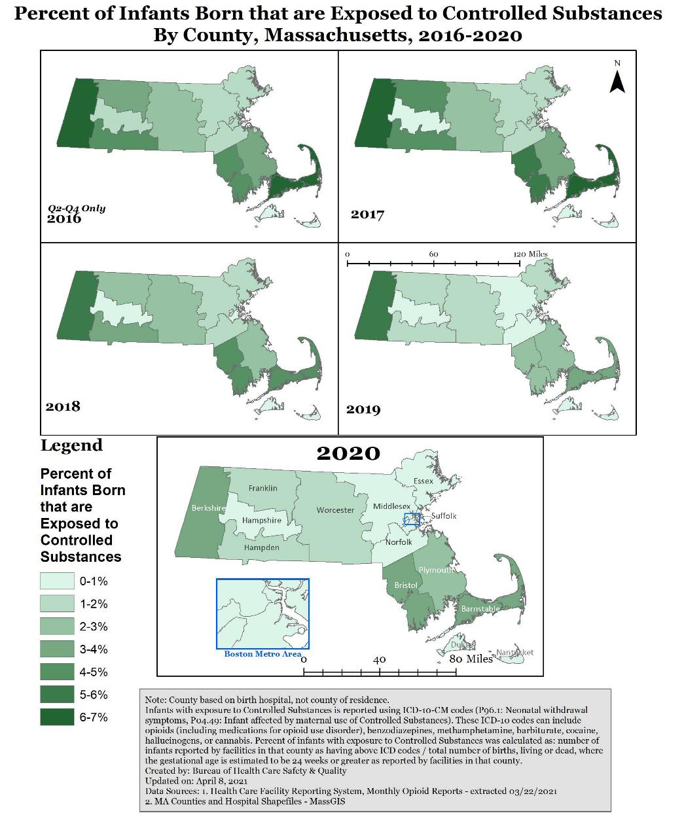

**Figure 2.** In 2020, the three counties with the highest rates of infants born exposed to controlled substances were Bristol, Berkshire and Barnstable. Only Bristol increased from 2019 to 2020 (by 26%, from 2.7% to 3.4% ). Berkshire county decreased 27% (from 5.1% to 3.7%) and Barnstable county decreased 21% (from 3.9% to 3.1%) from 2019 to 2020.

1. https://www.cdc.gov/mmwr/volumes/69/wr/mm6929a2.htm