**Background**

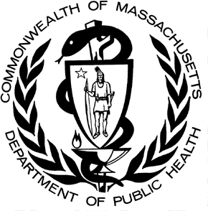

POSTED: NOVEMBER 2019

Massachusetts Department of Public Health

**Substance Exposed Newborns and Maternal Opioid Use Surveillance Data**

This report presents aggregate data by county and by calendar year quarter for opioid or benzodiazepine use in mothers and substance exposure in newborns. When interpreting substance exposure surveillance county- level data, an increase or decrease in a single measure may not indicate an increase or decrease in substance use in that area. It is important to note that the rates of opioid use presented here do not distinguish between mothers using Medication for Opioid Use Disorder (MOUD) and mothers using other prescribed or illicit opioids.

The purpose of this ongoing data collection effort is to inform critical discussions about substance use among pregnant women and provide an important baseline for future policy decisions. Moreover, these data enable the state and stakeholders to more meaningfully measure whether policy initiatives and state-funded programs are effective.

Quarter 2, 2019 (April – June)

|  |  |  |  |  |  |
| --- | --- | --- | --- | --- | --- |
| **County** | **Total Hospital Births** | **Mothers Who Used Opioids or Benzodiazepines During Pregnancy** | | **Infants Exposed to Controlled Substances** | |
| **Percent Reported** | **Change from Prior Quarter** | **Percent Reported** | **Change from Prior Quarter** |
| Barnstable | 281 | 1.07%* | ↓ | 1.78% | ↓ |
| Berkshire | 187 | 8.02% | ↑ | 4.28% | ↓ |
| Bristol | 898 | 8.24% | ↑ | 2.90% | ↑ |
| Dukes | 34 | 0.0% | = | 0.0% | = |
| Essex | 1,587 | 1.32% | ↓ | 1.32% | ↓ |
| Franklin | 127 | 2.36% | ↓ | 0.79% | ↓ |
| Hampden | 1,287 | 0.70%* | ↓ | 1.40% | ↓ |
| Hampshire | 122 | 3.28%* | ↑ | 0.00% | ↓ |
| Middlesex | 3,857 | 0.65%* | ↓ | 0.60% | ↓ |
| Nantucket | 24 | 0.0% | = | 0.0% | = |
| Norfolk | 930 | 0.43% | = | 0.54% | = |
| Plymouth | 822 | 1.70%* | = | 2.19% | ↓ |
| Suffolk | 5,242 | 0.40%* | = | 0.44%* | ↓ |
| Worcester | 2,088 | 3.54% | ↓ | 1.48% | ↓ |
| **State-wide** | **17,486** | **1.53%** | **↓** | **1.02%\*** | **↓** |
| *Key:*  *\* Statistically different from the mean prior to the current quarter at 95% confidence level.*  *↑denotes >0.10% increase from the last quarter.*  = denotes *<0.10% change from the last quarter.*  *↓ denotes >0.10% decrease from the last quarter.* | | | | | |

52

**Trends across the Commonwealth**

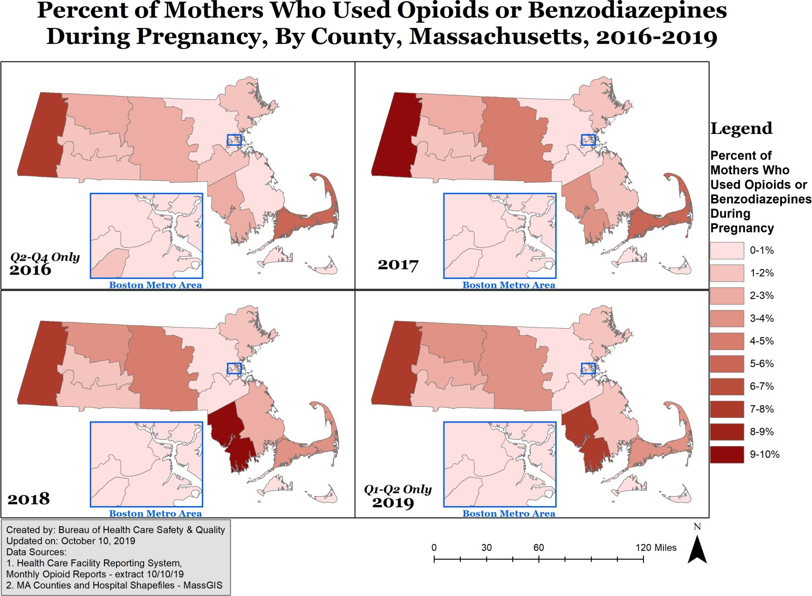Throughout 2016 to 2019, Berkshire County consistently has a higher percentage of mothers who used opioids or benzodiazepines during pregnancy compared to other counties. The state-wide average for all years reported is 1.85% of mothers who used opioids or benzodiazepines during pregnancy while in Berkshire Country the average during the same time period is 8.13%. From 2016 to 2018, Bristol County has increased percentages of mothers who used opioids or benzodiazepines during pregnancy, but this may be going down in 2019 (2016: 2.42%, 2017: 3.72%, 2018: 9.30%, 2019: 7.53%). The percentage of mothers who used opioids or benzodiazepines ranges by county and year from a low of 0% (Dukes and Nantucket Counties) to a high of 10.02% (Berkshire County, 2017).

Between 2016 and 2019, an average of 1.72% of infants statewide were exposed to maternal Controlled Substances. In Berkshire Country during the same time period, 5.66% of infants were exposed to Controlled Substances. From 2016 to 2018, there was clustering in Western Massachusetts (Franklin, Hampden, Berkshire) and Southeastern Massachusetts (Bristol, Barnstable). The percent of Infants Exposed to Controlled Substances ranges by county and year from a low of 0% (Dukes and Nantucket Counties) to a high of 6.47% (Berkshire County, 2016).

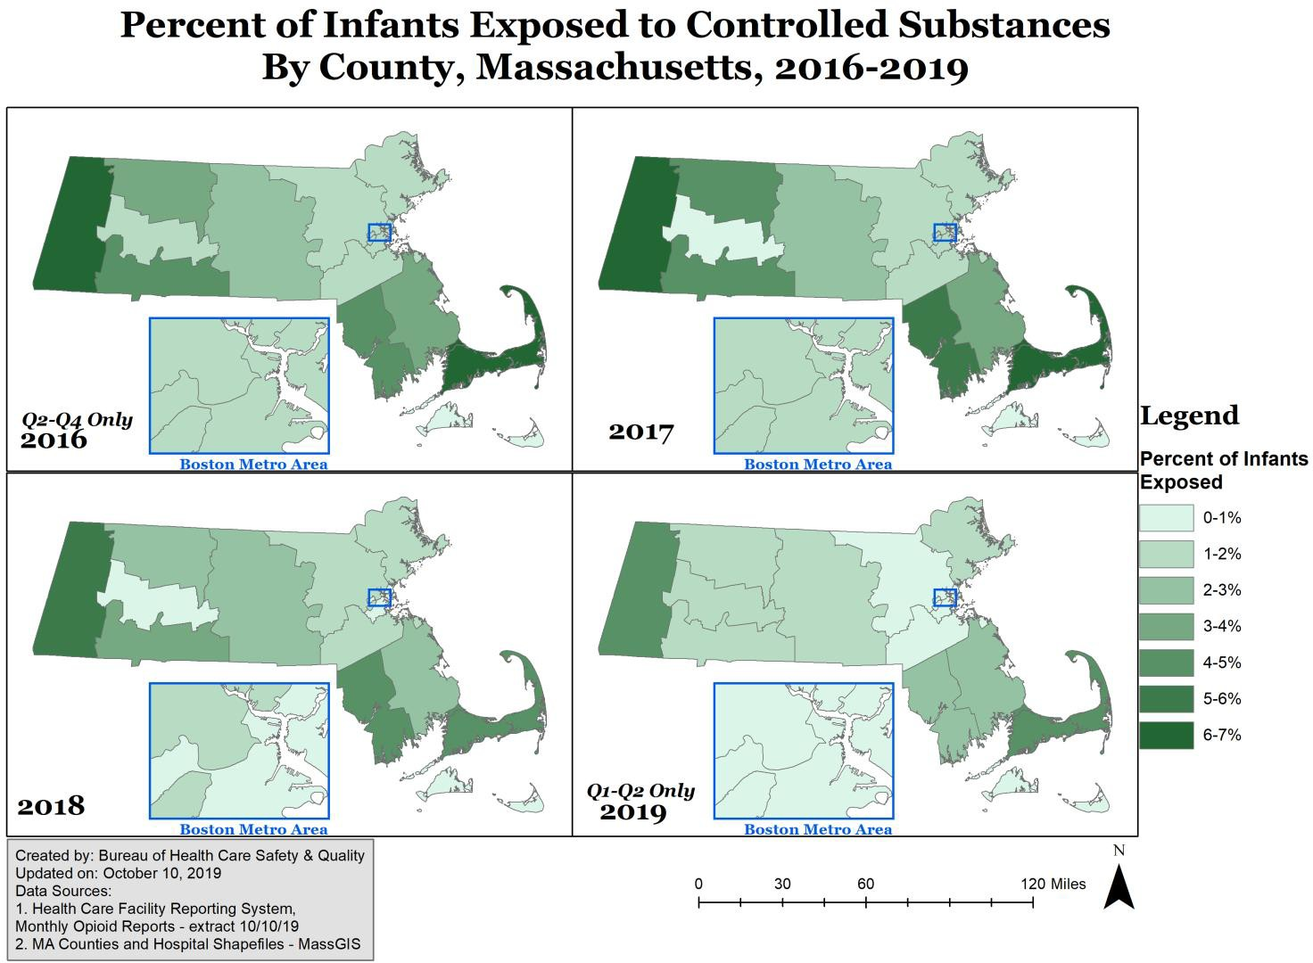

* From April 2016 to June 2019, there were on average 17,385 births per quarter in MA. In the last quarter there were 17,486 births in the Commonwealth.

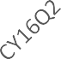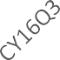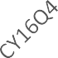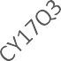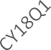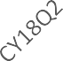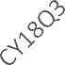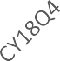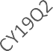

Substance Exposure Surveillance by Quarter, Massachusetts: April 2016 - June 2019

5.00%

4.00%

3.00%

2.00%

1.00%

0.00%

Percent of Infants Exposed to Controlled Substances

Percent of Mothers Who Used Opioids or Benzodiazepines During Pregnancy

Percent of Total Births

* + The average percentage of infants exposed to Controlled Substances in utero was 1.85%.
    - From 2019 Quarter 1 to 2019 Quarter 2 the percentage of infants exposed to Controlled Substances in utero decreased slightly from 1.36% to 1.02%.
  + The average percentage of mothers who used opioids or benzodiazepines was 1.73%.
    - From 2019 Quarter 1 to 2019 Quarter 2 the percentage of mothers who used opioids or benzodiazepines decreased slightly from 2.01% to 1.53%.

**County-Specific Trends**

Barnstable County 56

Berkshire County 56

Bristol County 57

Dukes County 58

Essex County 58

Franklin County 59

Hampden County 60

Hampshire County 60

Middlesex County 61

Nantucket County 62

Norfolk County 62

Plymouth County 63

Suffolk County 64

Worcester County 64

# Barnstable County

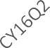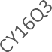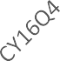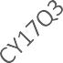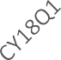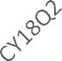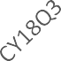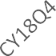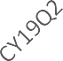

Barnstable County

14.00%

12.00%

10.00%

8.00%

6.00%

4.00%

2.00%

0.00%

Percent of Infants Exposed to Controlled Substances

Percent of Mothers Who Used Opioids or Benzodiazepines During Pregnancy

Percent of Total Births

* From April 2016 to June 2019, there were on average 285 births per quarter in Barnstable County. In the last quarter there were 281 births.
  + The average percentage of infants exposed to Controlled Substances was 5.40%.
    - From 2019 Quarter 1 to 2019 Quarter 2 the percentage of infants exposed to Controlled Substances decreased from 6.85% to 1.78%.
  + The average percentage of mothers who used opioids or benzodiazepines was 4.37%.
    - From 2019 Quarter 1 to 2019 Quarter 2 the percentage of mothers who used opioids or benzodiazepines decreased from 6.85% to 1.07%.

# Berkshire County

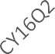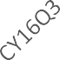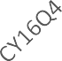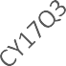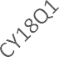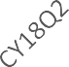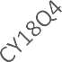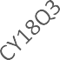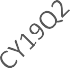

Berkshire County

14.00%

12.00%

10.00%

8.00%

6.00%

4.00%

2.00%

0.00%

Percent of Infants Exposed to Controlled Substances

Percent of Mothers Who Used Opioids or Benzodiazepines During Pregnancy

Percent of Total Births

* From April 2016 to June 2019, there were on average 212 births per quarter in Berkshire County. In the last quarter there were 187 births.
  + The average percentage of infants exposed to Controlled Substances in utero was 5.66%.
    - From 2019 Quarter 1 to 2019 Quarter 2 the percentage of infants exposed to Controlled Substances decreased from 4.97% to 4.28%.
  + The average percentage of mothers who used opioids or benzodiazepines was 8.13%.

# Bristol County

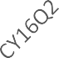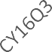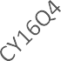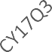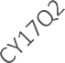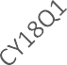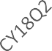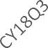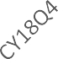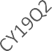

Bristol County

14.00%

12.00%

10.00%

8.00%

6.00%

4.00%

2.00%

0.00%

Percent of Infants Exposed to Controlled Substances

Percent of Mothers Who Used Opioids or Benzodiazepines During Pregnancy

Percent of Total Births

* From 2019 Quarter 1 to 2019 Quarter 2 the percentage of mothers who used opioids or benzodiazepines increased from 7.18% to 8.02%.
  + From April 2016 to June 2019, there were on average 961 births per quarter in Bristol County. In the last quarter there were 898 births.
    - The average percentage of infants exposed to Controlled Substances was 4.49%.
      * From 2019 Quarter 1 to 2019 Quarter 2 the percentage infants exposed to Controlled Substances increased from 2.09% to 2.90%.
    - The average percentage of mothers who used opioids or benzodiazepines was 5.76%.
      * From 2019 Quarter 1 to 2019 Quarter 2 the percentage of mothers who used opioids or benzodiazepines went up from 6.97% to 8.24%.
    - Reporting increases from two hospitals in the county account for the sustained increase that begins in CY 2018 Q1.

# Dukes County

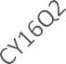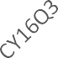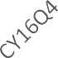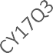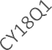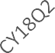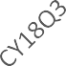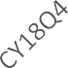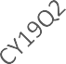

Dukes County

14.00%

12.00%

10.00%

8.00%

6.00%

4.00%

2.00%

0.00%

Percent of Infants Exposed to Controlled Substances

Percent of Mothers Who Used Opioids or Benzodiazepines During Pregnancy

Percent of Total Births

* + From April 2016 to June 2019, there were on average 33 births per quarter in Dukes County. In the last quarter there were 34 births.
    - The average percentage of infants exposed to Controlled Substances was 0.00%.
      * From 2019 Quarter 1 to 2019 Quarter 2 the percentage infants exposed to Controlled Substances stayed the same at 0.00%.
    - The average percentage of mothers who used opioids or benzodiazepines was 0.00%.
      * From 2019 Quarter 1 to 2019 Quarter 2 the percentage of mothers who used opioids or benzodiazepines stayed the same at 0.00%.

*Notes: Dukes County reports an average of 33 births per quarter. No mothers who used opioids or benzodiazepines nor infants exposed to Controlled Substances in utero have been report**ed.*

# Essex County

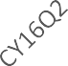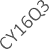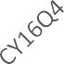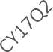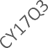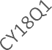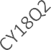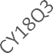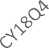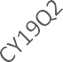

Essex County

14.00%

12.00%

10.00%

8.00%

6.00%

4.00%

2.00%

0.00%

Percent of Infants Exposed to Controlled Substances

Percent of Mothers Who Used Opioids or Benzodiazepines During Pregnancy

Percent of Total Births

* + From April 2016 to June 2019, there were on average 1,670 births per quarter in Essex County. In the last quarter there were 1,587 births.
    - The average percentage of infants exposed to Controlled Substances was 1.55%.
      * From 2019 Quarter 1 to 2019 Quarter 2 the percentage of infants exposed to Controlled Substances decreased slightly from 1.60% to 1.32%.
    - The average percentage of mothers who used opioids or benzodiazepines was 1.52%.
      * From 2019 Quarter 1 to 2019 Quarter 2 the percentage of mothers who used opioids or benzodiazepines decreased slightly from 1.79% to 1.32%.

# Franklin County

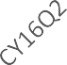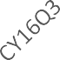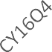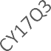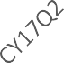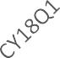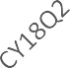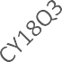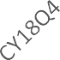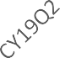

Franklin County

14.00%

12.00%

10.00%

8.00%

6.00%

4.00%

2.00%

0.00%

Percent of Infants Exposed to Controlled Substances

Percent of Mothers Who Used Opioids or Benzodiazepines During Pregnancy

Percent of Total Births

* + From April 2016 to June 2019, there were on average 111 births per quarter in Franklin County. In the last quarter there were 127 births.
    - The average percentage of infants exposed to Controlled Substances was 3.32%.
      * From 2019 Quarter 1 to 2019 Quarter 2 the percentage of infants exposed to Controlled Substances decreased from 2.88% to 0.79%.
    - The average percentage of mothers who used opioids or benzodiazepines was 3.03%.
      * From 2019 Quarter 1 to 2019 Quarter 2 the percentage of mothers who used opioids or benzodiazepines decreased from 3.85% to 2.36%.

# Hampden County

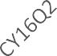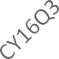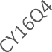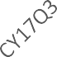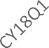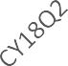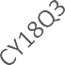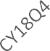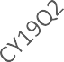

Hampden County

14.00%

12.00%

10.00%

8.00%

6.00%

4.00%

2.00%

0.00%

Percent of Infants Exposed to Controlled Substances

Percent of Mothers Who Used Opioids or Benzodiazepines During Pregnancy

Percent of Total Births

* + From April 2016 to June 2019, there were on average 1,375 births per quarter in Hampden County. In the last quarter there were 1,287 births.
    - The average percentage of infants exposed to Controlled Substances was 3.46%.
      * From 2019 Quarter 1 to 2019 Quarter 2 the percentage of infants exposed to Controlled Substances decreased slightly from 1.83% to 1.40%.
    - The average percentage of mothers who used opioids or benzodiazepines was 1.69%.
      * From 2019 Quarter 1 to 2019 Quarter 2 the percentage of mothers who used opioids or benzodiazepines decreased from 2.23% to 0.70%.

# Hampshire County

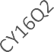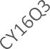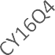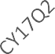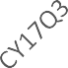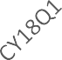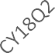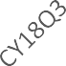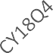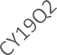

Hampshire County

14.00%

12.00%

10.00%

8.00%

6.00%

4.00%

2.00%

0.00%

Percent of Infants Exposed to Controlled Substances

Percent of Mothers Who Used Opioids or Benzodiazepines During Pregnancy

Percent of Total Births

* + From April 2016 to June 2019, there were on average 126 births per quarter in Hampshire County. In the last quarter there were 122 births.
    - The average percentage of infants exposed to Controlled Substances was 0.77%.
      * From 2019 Quarter 1 to 2019 Quarter 2 the percentage infants exposed to Controlled Substances decreased from 2.54% to 0.00%.
    - The average percentage of mothers who used opioids or benzodiazepines was 1.70%.
      * From 2019 Quarter 1 to 2019 Quarter 2 the percentage of mothers who used opioids or benzodiazepines increased from 1.69% to 3.28%.

# Middlesex County

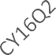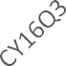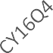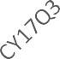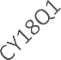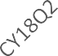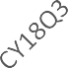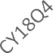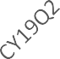

Middlesex County

14.00%

12.00%

10.00%

8.00%

6.00%

4.00%

2.00%

0.00%

Percent of Infants Exposed to Controlled Substances

Percent of Mothers Who Used Opioids or Benzodiazepines During Pregnancy

Percent of Total Births

* + From April 2016 to June 2019, there were on average 3,814 births per quarter in Middlesex County. In the last quarter there were 3,857 births.
    - The average percentage of infants exposed to Controlled Substances was 1.10%.
      * From 2019 Quarter 1 to 2019 Quarter 2 the percentage of infants exposed to Controlled Substances decreased slightly from 0.94% to 0.60%.
    - The average percentage of mothers who used opioids or benzodiazepines was 0.83%.
      * From 2019 Quarter 1 to 2019 Quarter 2 the percentage of mothers who used opioids or benzodiazepines decreased slightly from 1.02% to 0.65%.

# Nantucket County

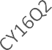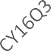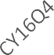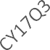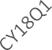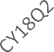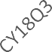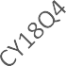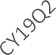

Nantucket County

14.00%

12.00%

10.00%

8.00%

6.00%

4.00%

2.00%

0.00%

Percent of Infants Exposed to Controlled Substances

Percent of Mothers Who Used Opioids or Benzodiazepines During Pregnancy

Percent of Total Births

* + From April 2016 to June 2019, there were on average 33 births per quarter in Nantucket County. In the last quarter there were 24 births.
    - The average percentage of infants exposed to Controlled Substances was 0.17%.
      * From 2019 Quarter 1 to 2019 Quarter 2 the percentage of infants exposed to Controlled Substances stayed the same at 0.00%.
    - The average percentage of mothers who used opioids or benzodiazepines was 0.17%.
      * From 2019 Quarter 1 to 2019 Quarter 2 the percentage of mothers who used opioids or benzodiazepines stayed the same at 0.00%.

# Norfolk County

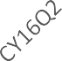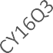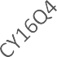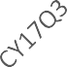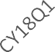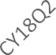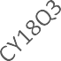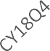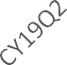

Norfolk County

14.00%

12.00%

10.00%

8.00%

6.00%

4.00%

2.00%

0.00%

Percent of Infants Exposed to Controlled Substances

Percent of Mothers Who Used Opioids or Benzodiazepines During Pregnancy

Percent of Total Births

* + From April 2016 to June 2019, there were on average 917 births per quarter in Norfolk County. In the last quarter there were 930 births.
    - The average percentage of infants exposed to Controlled Substances was 1.22%.
      * From 2019 Quarter 1 to 2019 Quarter 2 the percentage of infants exposed to Controlled Substances was about the same: 0.51% to 0.54%.
    - The average percentage of mothers who used opioids or benzodiazepines was 0.86%.
      * From 2019 Quarter 1 to 2019 Quarter 2 the percentage of mothers who used opioids or benzodiazepines was about the same: 0.38% to 0.43%.

# Plymouth County

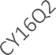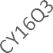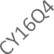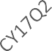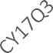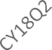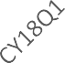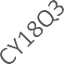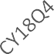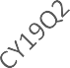

Plymouth County

14.00%

12.00%

10.00%

8.00%

6.00%

4.00%

2.00%

0.00%

Percent of Infants Exposed to Controlled Substances

Percent of Mothers Who Used Opioids or Benzodiazepines During Pregnancy

Percent of Total Births

* + From April 2016 to June 2019, there were on average 808 births per quarter in Plymouth County. In the last quarter there were 822 births.
    - The average percentage of infants exposed to Controlled Substances was 3.09%.
      * From 2019 Quarter 1 to 2019 Quarter 2 the percentage of infants exposed to Controlled Substances decreased slightly from 2.57% to 2.19%.
    - The average percentage of mothers who used opioids or benzodiazepines was 1.70%.
      * From 2019 Quarter 1 to 2019 Quarter 2 the percentage of mothers who used opioids or benzodiazepines was about the same: 1.67% to 1.70%.

# Suffolk County

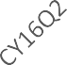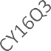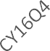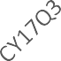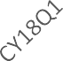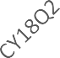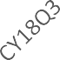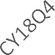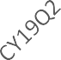

Suffolk County

14.00%

12.00%

10.00%

8.00%

6.00%

4.00%

2.00%

0.00%

Percent of Infants Exposed to Controlled Substances

Percent of Mothers Who Used Opioids or Benzodiazepines During Pregnancy

Percent of Total Births

* + From April 2016 to June 2019, there were on average 4,969 births per quarter in Suffolk County. In the last quarter there were 5,242 births.
    - The average percentage of infants exposed to Controlled Substances was 1.01%.
      * From 2019 Quarter 1 to 2019 Quarter 2 the percentage of infants exposed to Controlled Substances decreased slightly from 0.59% to 0.44%.
    - The average percentage of mothers who used opioids or benzodiazepines was 0.53%.
      * From 2019 Quarter 1 to 2019 Quarter 2 the percentage of mothers who used opioids or benzodiazepines was about the same: 0.46% to 0.40%.

# Worcester County

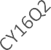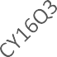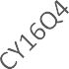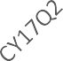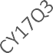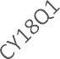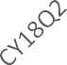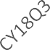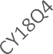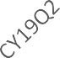

Worcester County

14.00%

12.00%

10.00%

8.00%

6.00%

4.00%

2.00%

0.00%

Percent of Infants Exposed to Controlled Substances

Percent of Mothers Who Used Opioids or Benzodiazepines During Pregnancy

Percent of Total Births

* + From April 2016 to June 2019, there were on average 2,071 births per quarter in Worcester County. In the last quarter there were 2,088 births.
    - The average percentage of infants exposed to Controlled Substances was 2.17%.
      * From 2019 Quarter 1 to 2019 Quarter 2 the percentage of infants exposed to Controlled Substances decreased slightly from 1.68% to 1.48%.
    - The average percentage of mothers who used opioids or benzodiazepines was 4.00%.
      * From 2019 Quarter 1 to 2019 Quarter 2 the percentage of mothers who used opioids or benzodiazepines decreased from 4.12% to 3.54%.

# Technical Notes

1. As part of the Commonwealth’s response to the Opioid Crisis and pursuant to *Massachusetts General Law c. 38, section 16(b), An Act to Increase Opportunities for Long-Term Substance Abuse Recovery (2014*) and amended by *An Act Relative to Substance Abuse, Treatment, Education and Prevention (2016)*, the Massachusetts Department of Public Health (DPH) requires acute care hospitals to submit monthly reports to DPH on the number of infants born in the previous month who were exposed to controlled substances prior to delivery.
2. These data come from birth hospitals and represent where babies were born, which may not be the county where the mother or infant resides.
3. Beginning in April 2016, DPH instructed all birth hospitals to report all instances of newborn exposure and overdose as identified by specific ICD-10-CM codes for mother's drug dependence to opioids or benzodiazepines, and newborns identified as having Neonatal Abstinence Syndrome (NAS) or having been "affected by maternal use of Controlled Substances” through the Health Care Facility Reporting System (HCFRS), a secure, web-based reporting platform within the Virtual Gateway.
   1. Mothers with opioid or benzodiazepine use during pregnancy is reported using ICD-10-CM codes (F11.20: Opioid dependence, F13.20: Sedative, hypnotic or anxiolytic dependence)
      1. Percent of mothers with opioid or benzodiazepine use during pregnancy was calculated as: **number of mothers reported by facilities in that county as having above ICD codes/ total number of live birth events as reported by facilities in that county**
   2. Infants with exposure to Controlled Substances is reported using ICD-10-CM codes (P96.1: Neonatal withdrawal symptoms, P04.49: Infant affected by maternal use of Controlled Substances)
      1. These ICD-10 codes can include opioids (including medications for opioid use disorder), benzodiazepines, methamphetamine, barbiturate, cocaine, hallucinogens, or cannabis.
      2. Percent of infants with exposure to Controlled Substances was calculated as: **number of infants reported by facilities in that county as having above ICD codes / total number of live birth events as reported by facilities in that county**
4. The rates of infants exposed to controlled substances is based on ICD-10-CM codes. These codes include other substances in addition to opioids or benzodiazepines. These ICD-10-CM codes include substances such as methamphetamine, barbiturate, cocaine, hallucinogens, or cannabis, and so are not limited to opioids or benzodiazepines in the same way that the maternal ICD-10-CM codes are.

For reference, the birth hospitals in each county can be identified in the table below.

|  |  |  |
| --- | --- | --- |
| **County** | **Number of**  **Birth Hospitals** | **Hospital Names** |
| Barnstable | 2 | Cape Cod Hospital, Falmouth Hospital |
| Berkshire | 2 | Berkshire Medical Center, Fairview Hospital |
| Bristol | 4 | Morton Hospital (closed perinatal service in April 2018), Southcoast – Charlton,  Southcoast – St. Luke’s, Sturdy Memorial Hospital |
| Dukes | 1 | Martha’s Vineyard Hospital |
| Essex | 5 | Anna Jaques Hospital, Beverly Hospital – Beverly Campus (Includes North Shore Birth Center), Holy Family Hospital, Lawrence General Hospital, North Shore  Medical Center – Salem Hospital |
| Franklin | 1 | Baystate Franklin Medical Center |
| Hampden | 3 | Baystate Medical Center, Holyoke Medical Center, Mercy Medical Center |
| Hampshire | 1 | Cooley Dickinson Hospital |
| Middlesex | 8 | CHA Cambridge (Includes Cambridge Birth Center), Emerson Hospital, Lowell General Hospital, Melrose Wakefield Healthcare – Melrose Wakefield Hospital Campus, MetroWest Medical Center – Framingham Union Campus, Mount Auburn  Hospital, Newton-Wellesley Hospital, Winchester Hospital |
| Nantucket | 1 | Nantucket Cottage Hospital |
| Norfolk | 2 | Norwood Hospital, South Shore Hospital |
| Plymouth | 4 | Beth Israel Deaconess Hospital – Plymouth, Good Samaritan Medical Center,  Signature Healthcare Brockton Hospital, Southcoast Hospital - Tobey |
| Suffolk | 5 | Beth Israel Deaconess Medical Center, Boston Medical Center, Massachusetts  General Hospital, St. Elizabeth’s Medical Center, Tufts Medical Center |
| Worcester | 6 | Harrington Memorial Hospital (perinatal service closed in February 2017), Health Alliance –Leominster Campus, Heywood Hospital, Milford Regional Medical Center,  St. Vincent Hospital, UMASS Memorial Medical Center – Memorial Campus |
| *Total* | *45* | *Current total: 43* |

**Source**

* Division of Quality Improvement, Bureau of Health Care Safety and Quality, DPH