**INDOOR AIR QUALITY ASSESSMENT**

**Newbury Elementary School**

**Administrative Office Area**

**63 Hanover Street**

**Newbury**



Prepared by:

Massachusetts Department of Public Health

Bureau of Climate and Environmental Health

Division of Environmental Health Regulations and Standards

January 2025

# BACKGROUND

|  |  |
| --- | --- |
| Building: | Newbury Elementary School (NES), administrative offices |
| Address: | 63 Hanover Street, Newbury, MA |
| Requestor: | Jon Skoniecki, Manager of Facilities and Grounds, Triton Regional School District |
| Reason for Request: | Concerns about health issues and indoor air quality (IAQ) in the administrative office area |
| Dates of Assessment: | December 18, 2024 |
| Massachusetts Department of Public Health/Bureau of Climate and Environmental Health (MDPH/BCEH) Staff Conducting Assessment: | Ruth Alfasso, Environmental Engineer/Inspector, Division of Environmental Health Regulations and Standards (DEHRS) |
| Building Description: | NES is a sprawling two-story brick and concrete building originally constructed in the 1950s and significantly renovated in the 1990s. |
| Windows: | Openable in most areas |

# METHODS

Please refer to the IAQ Manual for methods, sampling procedures, and interpretation of results (MDPH, 2015).

**RESULTS AND DISCUSSION**

The following is a summary of indoor air testing results (Table 1):

* ***Carbon dioxide*** measurements were below the MDPH guideline of 800 parts per million (ppm) in all areas tested.
* ***Temperature*** was within the recommended range of 70°F to 78°F in all areas.
* ***Relative humidity*** was below the recommended range of 40% to 60% in all areas examined. Low relative humidity is common during the heating season.
* ***Carbon monoxide*** levels were non-detectable (ND) in all indoor areas tested.
* ***Fine particulate matter (PM2.5)*** concentrations were below the National Ambient Air Quality Standard (NAAQS) level of 35 μg/m3 in all areas tested.
* ***Total Volatile Organic Compounds***were ND in all areas tested.

## Ventilation

A heating, ventilating, and air conditioning (HVAC) system has several functions. First it provides heating and, if equipped, cooling. Second, it is a source of fresh air. Finally, an HVAC system will dilute and remove normally occurring indoor environmental pollutants by not only introducing fresh air, but by filtering the airstream and ejecting stale air to the outdoors via exhaust ventilation. Even if an HVAC system is operating as designed, point sources of respiratory irritation may exist and cause symptoms in sensitive individuals.

Fresh air in the areas assessed is provided by air-handling units (AHUs) located on the roof (Picture 1). Air is drawn into the AHUs from outside, it is then heated, or cooled, and delivered to occupied space via supply diffusers (Pictures 2 and 3). Exhaust vents remove stale air from these offices (Picture 4). Note that one of the supply vents in the main office area was covered by what looked like a sheet of plastic (Picture 5) and would thus be prevented from supplying fresh air as designed. If vents are creating uncomfortable drafts, the vent style can be changed to one that blows air more sideways, or the vent can be relocated.

To have proper ventilation with a mechanical ventilation system, the systems must be balanced after installation to provide an adequate amount of fresh air to the interior of a room while removing stale air from the room. It is recommended that HVAC systems be re-balanced every five years to ensure adequate air systems function (SMACNA, 1994). Information regarding balancing was not available at the time of this visit.

Filters for AHUs should be changed periodically, typically 2-4 times a year. While the filters are reported to be changed on that frequency, accessing, and opening this particular AHU to change the filter is somewhat challenging, and may mean that filters aren’t changed as often as desired.

## Water Damage Issues

Concerns regarding musty odors and health concerns in the office area prompted the request for an assessment. Occupants reported that musty odors were noticeable in the early morning and faded as the day went on. No musty or moldy odors were noted in the office area during the assessment, including carpeting and other areas near the floor. Coving at the base of walls was well-adhered and showed no signs of having been moistened in the past.

The area above the ceiling tiles was viewed in the main office area. As shown in Picture 6, there is an open space between the ceiling tile grid and the ceiling. No odors were noted in the space, no water damage was found, and there were no signs of pests.

Plants were noted in a few areas (Picture 7) inside the office. Plants and soil can be a source of pollen, mold, and odors. Plants should be well maintained and placed in non-porous drip pans that are cleaned periodically. Plants should not be placed in the airstream of ventilation equipment.

The exterior of the building outside this office was examined. Trees and other plants abut the building. If windows are opened, pollen and mold spores can enter. In addition, trees can clog roof drains and prevent walls from drying, making water damage more likely.

### Mold testing recommendations

Note that the MDPH DEHRS does not recommend testing for mold in public buildings. More information on the reasons behind this can be found at: <https://www.mass.gov/info-details/guidance-regarding-testing-for-mold-in-water-damaged-public-buildings>.

## Other IAQ Concerns

Testing was conducted for total volatile organic compounds (TVOCs). All measurements were non-detect (ND). An examination was conducted for products that may be a source of VOCs in indoor air. Products such as hand sanitizers, dry erase markers, and cleaning supplies were observed (Pictures 7 and 8). VOCs from these products can build up and lead to irritation of the mucous membranes.

Carpeting in the suite was found to be worn and, in some places, wrinkled (Pictures 9 and 10). Facility staff said that carpet cleaning had been conducted after staff concerns were reported. However, carpeting that is old and worn may not be able to be cleaned effectively and may be a source of irritating fibers.

Personal heaters and air purifiers were noted in the office space. These items need to be kept clean, and the air purifier filters need to be changed periodically in accordance with manufacturer’s instructions. Occupants should take care with heaters to avoid heating materials that can release odors, or create conditions that might lead to a fire.

Note that the offices are on the first floor. Small access hole covers are present in the floor (Picture 11). It is believed that these allow for access to the underfloor to clean and maintain plumbing. All the covers noted were flush with the floor and appeared to be fitted tightly, however if one of them is loose, it may allow odors from the underflooring into occupied spaces. If possible, one or more of these covers should be opened to check for odors, broken piping, or other issues, which should be repaired as needed.

**CONCLUSIONS/RECOMMENDATIONS**

No obvious sources of odors or health issues in the office area were noted during this assessment. Several recommendations are made to improve and maintain good IAQ in the office area:

## Ventilation recommendations

1. Continue to change filters on the rooftop AHU 2-4 times a year. Clean out any dust or debris from the AHU cabinet during filter changes.
2. Remove blockages from supply vents; consider changing vent style or relocating vents to reduce drafts.
3. Ensure supply and exhaust ventilation is operating during all occupied periods.
4. Have the HVAC system balanced every 5 years in accordance with SMACNA recommendations (SMACNA, 1994).

## Water damage recommendations

1. Ensure any indoor plants are well maintained, not overwatered, and kept away from the airstream of ventilation equipment.
2. Trim trees and plants away from the building at least 5 feet, particularly near windows.

## Other recommendations

1. Keep cleaning products and other VOC-containing products in tightly sealed containers. Avoid using scented products in the office.
2. Clean carpets regularly using a HEPA filter equipped vacuum cleaner. Have carpets deep cleaned at least once a year. Ensure that humidity during deep cleaning is low enough that carpeting will dry quickly.
3. Ensure personal heaters and air purifiers are maintained and cleaned in accordance with manufacturer's instructions.
4. Consider opening one of the access covers to see if any issues exist in the underfloor that could lead to odors. Ensure removed covers are returned to a tightly closed condition.

# REFERENCES

MDPH. 2015. Massachusetts Department of Public Health. Indoor Air Quality Manual: Chapters I-III. Available at: <https://www.mass.gov/lists/indoor-air-quality-manual-and-appendices#indoor-air-quality-manual->.

SMACNA. 1994. HVAC Systems Commissioning Manual. 1st ed. Sheet Metal and Air Conditioning Contractors’ National Association, Inc., Chantilly, VA.

**Picture 1**

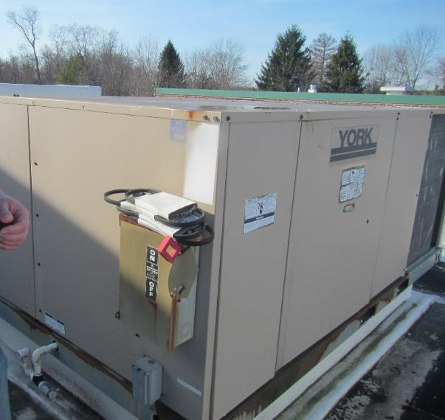

**Rooftop air handling unit (AHU)**

**Picture 2**

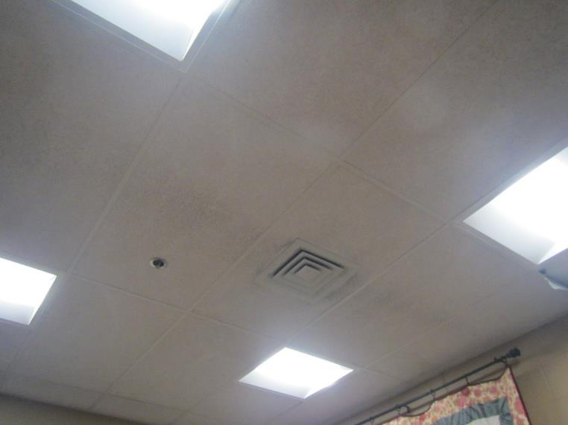

**One style of supply vent**

**Picture 3**

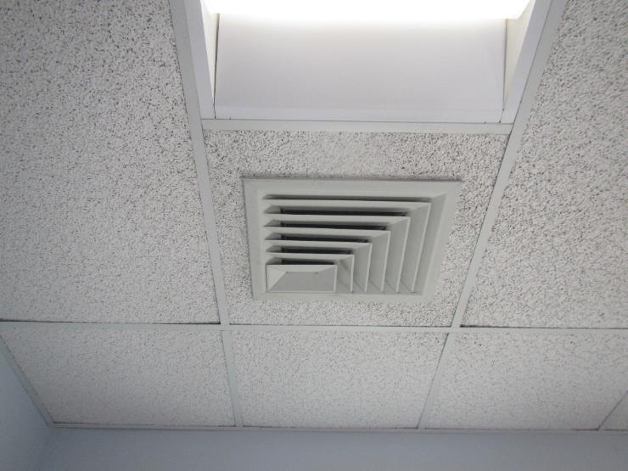

**Another style of supply vent**

**Picture 4**

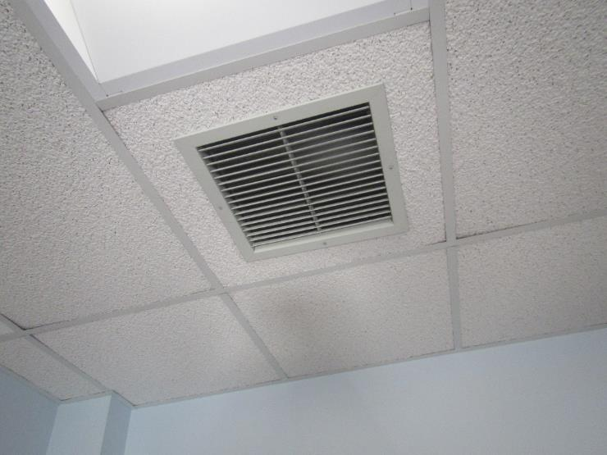

**Exhaust vent**

**Picture 5**

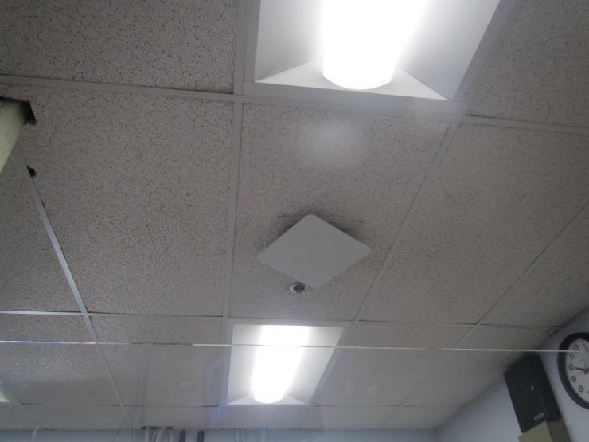

**Blocked supply vent**

**Picture 6**

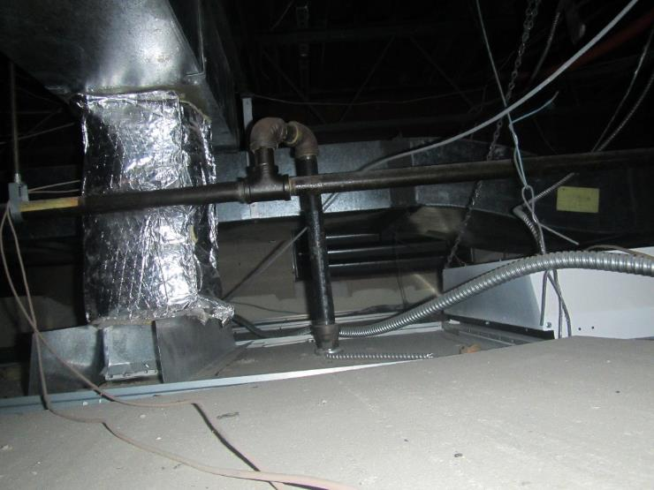

**Clear open space above ceiling tiles showing no sign of water damage or pests**

**Picture 7**

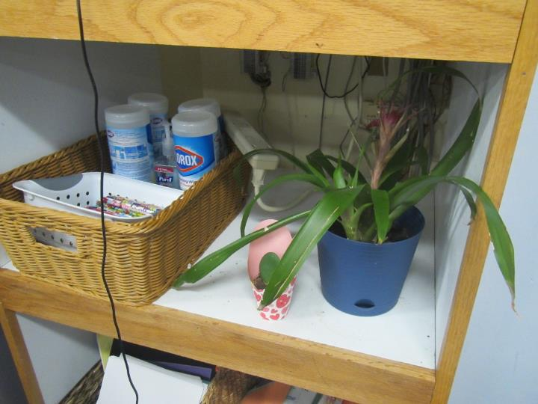

**Plants in an office, also note cleaners/sanitizers**

**Picture 8**

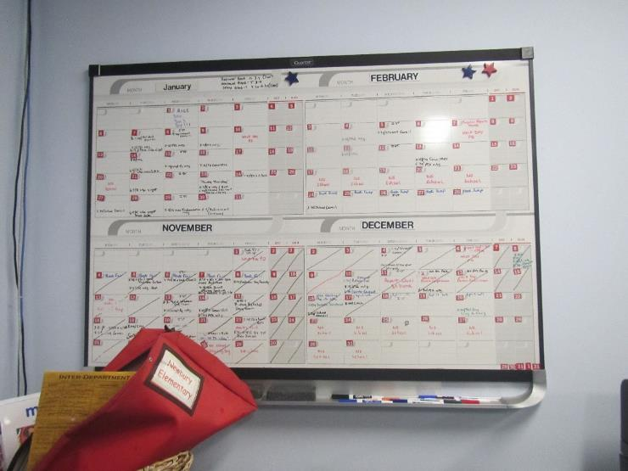

**Dry erase materials**

**Picture 9**

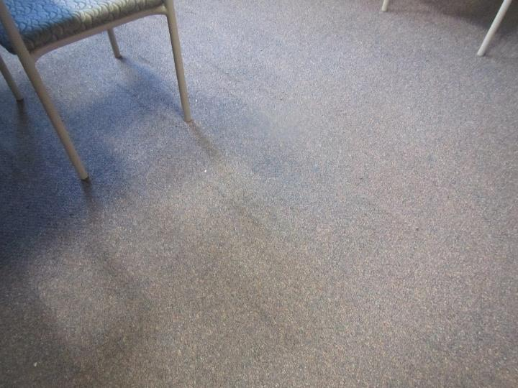

**Wrinkled carpeting**

**Picture 10**

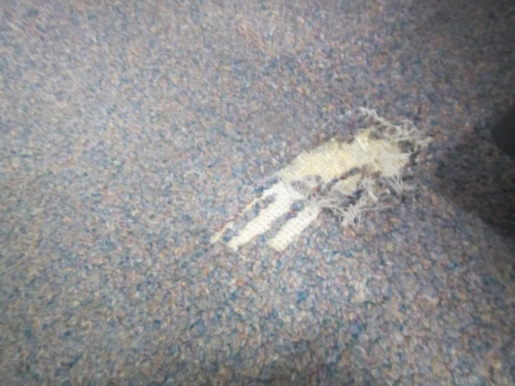

**Damage to carpeting**

**Picture 11**

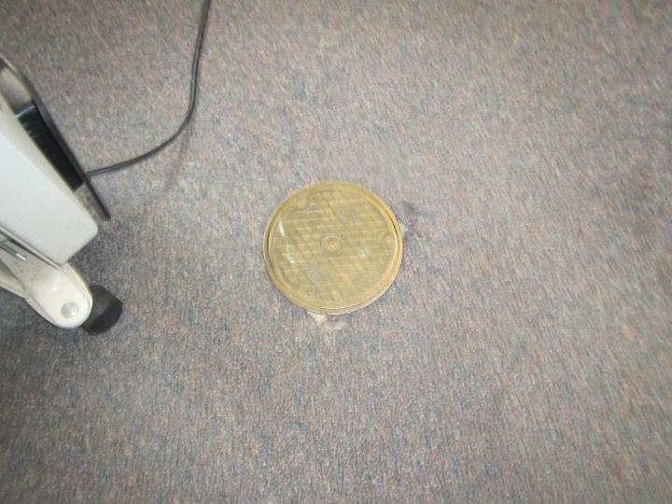

**Access cover for maintaining piping**

| **Location/ Room** | **Carbon**  **Dioxide**  **(ppm)** | **Carbon Monoxide**  **(ppm)** | **Temp**  **(°F)** | **Relative**  **Humidity**  **(%)** | **PM2.5**  **(****µg/m3)** | **TVOC**  **(ppm)** | **Occupants**  **in Room** | **Windows**  **Openable** | **Ventilation** | | **Remarks** |
| --- | --- | --- | --- | --- | --- | --- | --- | --- | --- | --- | --- |
| **Supply** | **Exhaust** |
| Background (outside) | 459 | NA | 52 | 43 | 2 | ND |  |  |  |  | Sunny and breezy |
| Conference room | 642 | NA | 70 | 32 | ND | ND | 2 | Y | Y | Y | Carpet - wrinkled, laminator |
| Main office area | 631 | NA | 71 | 31 | ND | ND | 2 | N | Y | Y | Carpet – old and worn, one supply vent blocked |
| Yando office | 675 | NA | 72 | 30 | ND | ND | 1 | Y | Y | Y | Carpet – worn, air purifier |
| Marino office | 546 | NA | 73 | 28 | 1 | ND | 1 | Y 1 open | Y | Y | Heater, old carpet |