Background

INDOOR AIR QUALITY ASSESSMENT

Commonwealth of Massachusetts
Newbury Police Department
25 High Road
Newbury, MA

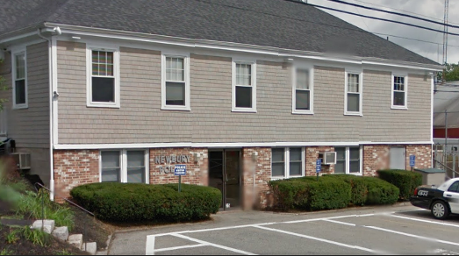

Prepared by:
Massachusetts Department of Public Health
Bureau of Environmental Health
Indoor Air Quality Program
October 2015

Building: | Newbury Police Department
Address: | 25 High Road, Newbury, MA
Assessment Requested by: | Deb Rogers, Health Agent, Town of Newbury  Deputy Chief John R. Lucey Jr., Newbury Police Department (NPD)
Date of Assessment: | August 26, 2015
BEH/IAQ Staff Conducting Assessment: | Jason Dustin, Environmental Analyst/Inspector
Date of Building Construction: | 1977
Reason for Request: | Reports of health concerns and general indoor air quality (IAQ) concerns

Building Description
The NPD is located on the ground floor of the Newbury Town Hall which is the subject of a separate report. The building is built into a hill resulting in portions of the exterior walls of the police department being located below grade. The NPD was visited previously by BEH/IAQ staff following a flooding event which occurred in 2006 (MDPH, June 2006). Some windows are openable.

Results
The space assessed houses approximately 14 employees. Members of the public also visit the space daily. Test results are presented in Table 1. Methods and indoor air related sampling information can be found in the IAQ Manual and Appendices for IAQ Reports that can be found at:
http://www.mass.gov/eohhs/gov/departments/dph/programs/environmental-health/exposure-topics/iaq/iaq-rpts/general-appendices-for-iaq-reports.html

Discussion

Ventilation
It can be seen from Table 1 that carbon dioxide levels were below 800 parts per million (ppm) in all areas tested, indicating adequate air exchange at the time of the assessment. It should be noted that most areas were sparsely occupied and that carbon dioxide levels would be expected to rise with increased occupancy. Limited fresh air is provided to the hallway area of the lower level by an energy recovery ventilator (ERV) located in the basement (Picture 1). Outside air is filtered and tempered by a heat exchange core and delivered to the hallway area by ducted supply diffusers. Return air is drawn into ducted ceiling-mounted vents (Picture 2) and returned to the ERV unit where it passes through the heat exchange core and is then ejected from the building. Most areas of the NPD are not served by the ERV; therefore do not have any mechanical fresh air supply.
As mentioned, many areas of the NPD have no mechanical fresh air supply or exhaust, including the Emergency Operations Center (EOC). The EOC is used to hold emergency training drills with a large number of state and local officials in attendance. It is clear that the lack of ventilation in the EOC room would result in increased buildup of common indoor air pollutants.
Another area lacking any ventilation is the Evidence Room. Upon entering this room, an overwhelming odor of marijuana was detected by BEH/IAQ staff. Given the nature of confiscated chemicals/substances, this area should have a mechanical exhaust vent that is directed immediately outside the building.
The Dispatch Room lacks fresh air supply vents. This room has a wall-mounted AC unit, which reportedly only recirculates air. Due to the lack of fresh air to this space, occupants frequently open windows to maintain comfort. Opening windows in this room allows warm, moist air into the space during summer months as well as particulate matter from the nearby busy street. Furthermore, NPD highlighted the security risk involved when occupants need to open the windows rather than having supplied fresh air to the space.
To maximize air exchange, the MDPH recommends that both supply and exhaust ventilation operate continuously during periods of occupancy. Many areas of the NPD have only exhaust ventilation causing negative pressure in these areas. Makeup air for these locations likely comes from unconditioned and undesirable areas through the many unsealed pathways that exist throughout the NPD (Pictures 3 to 6).

Temperature and Relative Humidity
Indoor temperature measurements at the time of the assessment ranged from 72°F to 76°F (Table 1), which were within the MDPH recommended comfort range. NPD staff reported that the locker room had no temperature control and that the foyer area baseboard heat was nonfunctioning.
Indoor relative humidity measurements at the time of the assessment ranged from 55 to 68 percent (Table 1), which were within the MDPH recommended comfort range with one exception. The higher reading of 68 percent relative humidity was measured in the dispatch area where the exterior wall window was open during the assessment. The MDPH recommends a comfort range of 40 to 60 percent for indoor air relative humidity.

Microbial/Moisture Concerns
In order for building materials to support mold growth, a source of water exposure is necessary. Since the lower level of the NPD is partially below grade, it may be subject to chronic moisture, particularly due to condensation. When warm moist air comes into contact with cooler surfaces that are at or below the dew point temperature, water droplets can form on these surfaces. Gaps around utilities on the exterior of the building as well as open windows during hot, humid weather may allow unconditioned air/moisture into occupied areas (7). There are many breaches in the ceilings and walls of the NPD space which allow moisture, odors and pests to travel throughout occupied spaces.
The NPD has an open hole cut in the floor of the foundation used to drain water from the space during a flood in 2006. This hole is open directly to the soil/stone beneath the foundation. There is no plumbed drain pipe or trap connected to the hole and as a result, allows moisture, odors, soil gases, and pests to enter occupied space (Picture 8). This condition can result in a significant increase in relative humidity in the lower level.
The NPD utilizes a number of wall-mounted air conditioning (AC) units throughout the lower level. These units produce condensation as part of normal operating conditions. The condensation drains into condensate pump units and is ejected above grade outside. The IT space in the lower level was noted to have condensation leaking from the AC unit into containers and onto a desk (Pictures 9 and 10).
The US EPA and the American Conference of Governmental Industrial Hygienists (ACGIH) recommend that porous materials be dried with fans and heating within 24 to 48 hours of becoming wet (US EPA, 2001; ACGIH, 1989). If porous materials are not dried within this time frame, mold growth may occur. Once mold has colonized porous materials, they are difficult to clean and should be removed and discarded.

Other IAQ Evaluations
Indoor air quality can be negatively influenced by the presence of respiratory irritants, such as products of combustion. The process of combustion produces a number of pollutants. Common combustion emissions include carbon monoxide, carbon dioxide, water vapor, and smoke (fine airborne particle material). Of these materials, exposure to carbon monoxide and particulate matter with a diameter of 2.5 micrometers (μm) or less (PM2.5) can produce immediate, acute health effects upon exposure. To determine whether combustion products were present in the indoor environment, BEH/IAQ staff obtained measurements for carbon monoxide and PM2.5.

Carbon Monoxide
Carbon monoxide should not be present in a typical, indoor environment. If it is present, indoor carbon monoxide levels should be less than or equal to outdoor levels. On the day of the assessment, outdoor carbon monoxide concentrations were non-detect (ND) (Table 1). No measurable levels of carbon monoxide were detected inside the building (Table 1).

Particulate Matter
Outdoor PM2.5 was measured at 33 μg/m³ (Table 1). PM2.5 levels measured indoors ranged from 20 to 30 μg/m³ (Table 1), which were below the NAAQS PM2.5 level of 35 μg/m³. BEH/IAQ staff noted that some AC filters were occluded with dust/debris (Picture 11). NPD staff reported that these filters are cleaned biweekly. NPD staff also reported that dust enters the space from the ceiling due to occupants walking on the above floor.
According to the manufacturer’s operating instructions, the ERV unit supplying the fresh air to some NPD spaces requires quarterly filter/unit cleaning in order to reduce particulate matter and function efficiently (Venmar ERV, 2015). In addition, wet wiping and high efficiency particulate arrestance (HEPA) vacuuming of surfaces should also be performed regularly to reduce particulate matter.

Volatile Organic Compounds
In order to determine if VOCs were present, BEH/IAQ staff inspected areas for items containing VOCs. BEH/IAQ staff noted hand sanitizer, cleaners, dry erase materials, and air fresheners at the time of the assessment. All of these have the potential to be irritants to the eyes, nose, throat and respiratory system of sensitive individuals.

Other Conditions
Other conditions that can affect IAQ were observed during the assessment. The NPD has a sewer ejector pump chamber. This sewer ejector pumps sanitary sewage from below grade to the septic system adjacent to the building. During the assessment, a very strong sewer gas odor was detected coming from the area surrounding the sewer ejector pump chamber. A number of unsealed gaps around the piping, wiring and open bolt holes exist in the pump chamber (Picture 12). In addition, the pump chamber has no mechanical exhaust system. Many areas surrounding the pump chamber have exhaust ventilation which depressurizes the occupied space and draws sewer odors form the sewer ejector pump chamber. Although it was reported by NPD staff that the building is planned to be connected to town sewer shortly, this will not remedy the sewer odors as the ejector pump will remain in place. This ejector pump chamber should be completely sealed to keep sewer gases, pests and added moisture from entering the occupied space. Pathways (gaps, cracks, holes in ceiling and wall etc.) leading to this room should also be sealed, including the addition of a tight-fitting door sweep on the entrance door to this room (Pictures 13 and 14).
NPD staff reported that the space has an ongoing sewer fly (drain fly) infestation. Numerous drain flies were observed by BEH/IAQ staff during the assessment (Picture 15). Drain flies feed on the organic matter located within the drains. Accumulated organic matter in the drains should be professionally cleaned to remove the infestation. Any gaps around utilities, windows and doors leading to the exterior and other unconditioned spaces (e.g., space behind cells), should be tightly sealed to prevent any pests as well as moisture from entering occupied spaces. Any unused sinks, toilets (Picture 16) or shower drains should be properly abandoned and capped to remove the likelihood of sewer gases, pests (including drain flies), and odors from entering through a dry drain trap into occupied spaces.
Some exhaust vent grates appeared to be retrofitted plexiglas with holes drilled for ventilation. These grate holes may have insufficient surface area which could restrict the exhaust flow from the space. They also appeared to have a large amount of debris trapped beneath the surface of the plexiglas (Picture 17).
Some fluorescent light fixtures were found to be lacking proper covers (Picture 18). This condition increases the chance that a bulb may be broken releasing mercury into the space. Proper covers should be fitted over the light fixtures and any old bulbs should be securely stored until they can be recycled.

Conclusions/Recommendations
In view of the findings at the time of the visit, the following recommendations are made:
- Completely seal any gaps, crevices and holes in and around the sewer ejector pump chamber to avoid sewer gases, pests and added moisture from entering occupied spaces.
- Install tight-fitting door sweep on entrance to sewer ejector closet door. Also seal any pathways in this closet that lead to occupied spaces (holes in walls, ceilings, gaps around utilities, etc.).
- Seal open floor hole (drain) to avoid excess moisture, pests and soil gases from entering the space.
- Properly abandon and cap any unused sinks, toilets or drains to avoid dry drain traps, which allow sewer gas, pests (drain flies, etc.) and moisture into the space.
- Have all drains professionally cleaned to remove the buildup of organic matter and remove the root cause of the drain fly infestation.
- Seal all gaps in the exterior building envelope that lead to the space (holes around utilities in foundation etc.) to reduce moisture, pests and pollutants from entering the space.
- Seal all pathways in the ceiling and wall systems that allow unconditioned air, pests and odors to travel within the NPD occupied areas (breaches in walls/ceilings leading to area behind cells, missing ceiling tiles, etc.).
- Repair leaking AC condensate lines. Remove and replace any water-damaged porous building materials.
- Follow ERV manufacturer guidelines for required filter/unit cleaning to allow for more effective ventilation unit operation. Inquire about increasing the filter efficiency to reduce particulate matter without hindering unit performance due to pressure drop.
- Add direct exhaust vent to the Evidence Room that ejects pollutants/exhaust immediately outside of the NPD.
- Clean all AC filters and exhaust/supply vents on a regular basis to reduce aerosolizing accumulated particulate matter.
- As a temporary measure, use the AC unit outside of the Dispatch Room (with door open) to supply some outside air in lieu of opening windows.
- Use HEPA vacuuming in conjunction with wet wiping of all surfaces to further reduce particulate matter.
- Consider replacing the plexiglas exhaust grates with properly fitted, secure metal grates of adequate surface area.
- Consider contracting with an HVAC engineer to design a new HVAC system incorporating an air handling unit (AHU) that will support supplying fresh air and removing stale air in all occupied areas of the NPD.
- Consider limiting the use of hand sanitizer, air fresheners, and cleaning products which can cause eye, nose and throat irritations in sensitive individuals.
- Provide for properly fitted fluorescent light covers on fixtures to avoid broken bulbs and the release of mercury into the space.
- Consider adopting a balancing schedule of every 5 years for all mechanical ventilation systems, as recommended by ventilation industrial standards (SMACNA, 1994).
- For buildings in New England, periods of low relative humidity during the winter are often unavoidable. Therefore, scrupulous cleaning practices should be adopted to minimize common indoor air contaminants whose irritant effects can be enhanced when the relative humidity is low. To control for dusts, a high efficiency particulate arrestance (HEPA) filter equipped vacuum cleaner in conjunction with wet wiping of all surfaces is recommended. Avoid the use of feather dusters. Drinking water during the day can help ease some symptoms associated with a dry environment (throat and sinus irritations).
- Avoid the accumulation of large numbers of items on flat surfaces. To prevent excessive dust build up, items should be relocated periodically to allow for cleaning.
- Refer to resource manual and other related indoor air quality documents located on the MDPH’s website for further building-wide evaluations and advice on maintaining public buildings. These documents are available at http://mass.gov/dph/iaq.

References
ACGIH. 1989. Guidelines for the Assessment of Bioaerosols in the Indoor Environment. American Conference of Governmental Industrial Hygienists, Cincinnati, OH.
MDPH. June 2006. Indoor Air Quality Assessment Newbury Police Department. June 2006.
SMACNA. 1994. HVAC Systems Commissioning Manual. 1st ed. Sheet Metal and Air Conditioning Contractors’ National Association, Inc., Chantilly, VA.
US EPA. 2001. Mold Remediation in Schools and Commercial Buildings. US Environmental Protection Agency, Office of Air and Radiation, Indoor Environments Division, Washington, D.C. EPA 402-K-01-001. March 2001.
Venmar ERV. 2015. Venmar ERV Constructo 2.0 ES User Manual. http://www.venmar.ca/DATA/DOCUMENT/189_4_en~v~User_Guide.pdf September 2015.
Picture 1
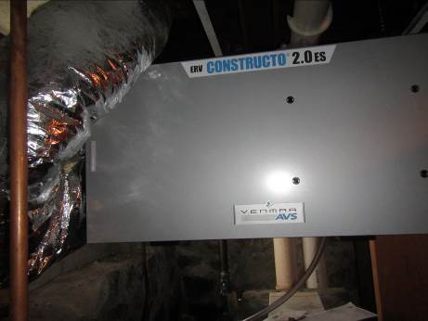
Energy recovery ventilator (ERV) unit located in NPD lower level space
Picture 2
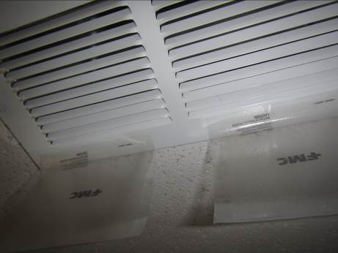
Return vent with attached pesticide strips for drain flies
Picture 3
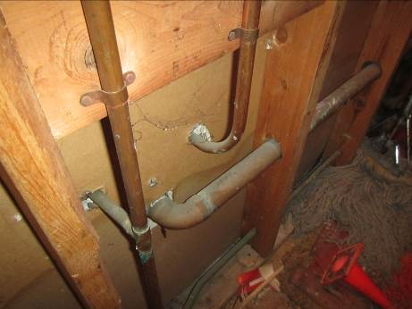
Unconditioned wall space behind NPD occupied areas
Picture 4
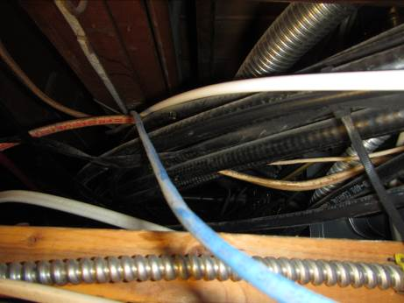
Large pathways above unconditioned wall space area
Picture 5
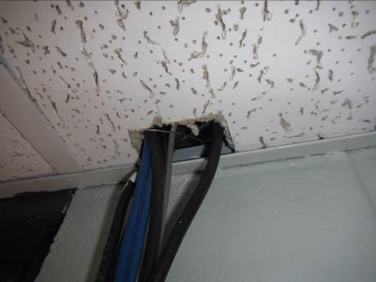
Large gaps around wiring providing pathways to unconditioned space
Picture 6
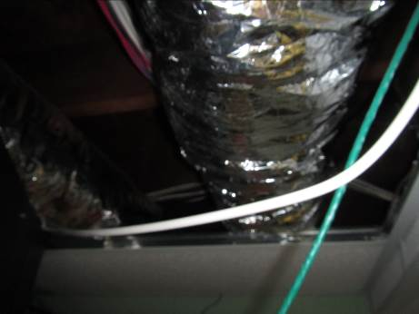
Missing ceiling tiles likely allow moisture and particulate matter into occupied space
Picture 7
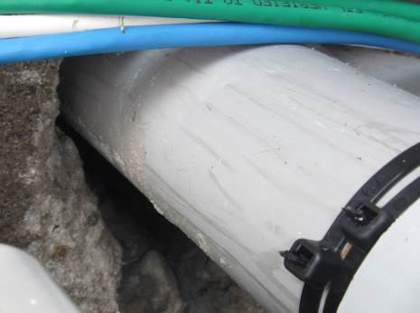
Large gaps around utilities in exterior foundation
Picture 8
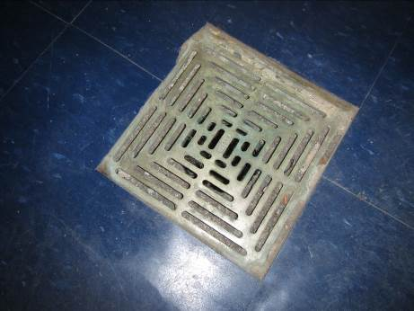
Open floor drain (no water trap) in NPD space
Picture 9
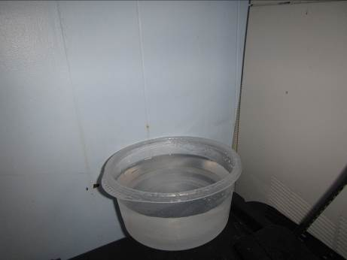
Receptacle used to catch leaking condensate from AC unit
Picture 10
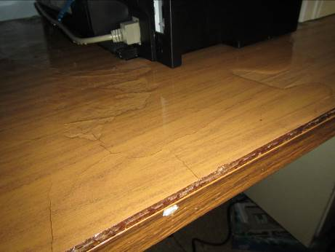
Water leaking onto desk from AC unit
Picture 11
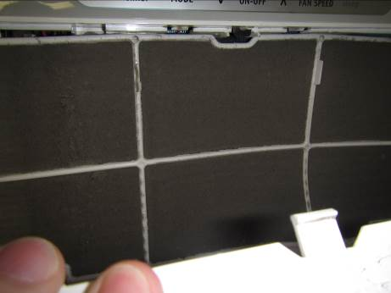
Air conditioning unit filter occluded with dust
Picture 12
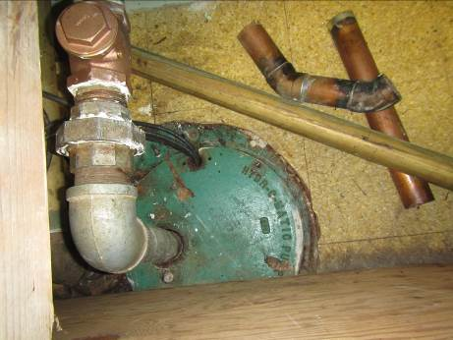
Sewer ejector pump showing gaps around piping and wiring and missing bolts
Picture 13
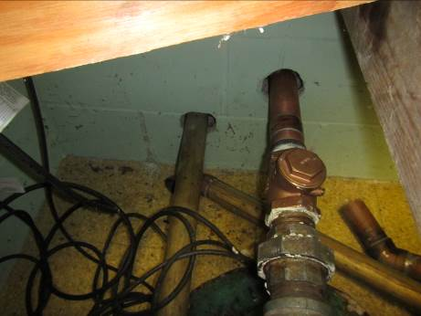
Gaps around piping serve as pathways for sewer gas
Picture 14
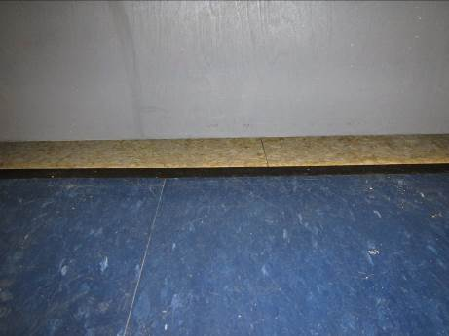
Large gap beneath door to sewer ejector pump chamber
Picture 15
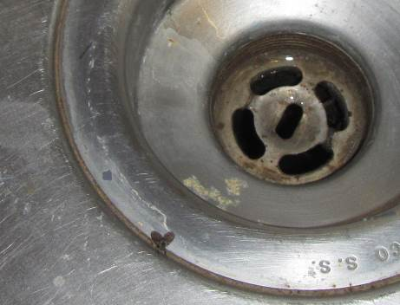
Drain fly in sink
Picture 16
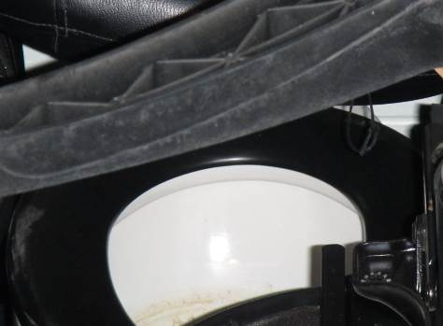
Unused toilet in former cell currently used for storage
Picture 17
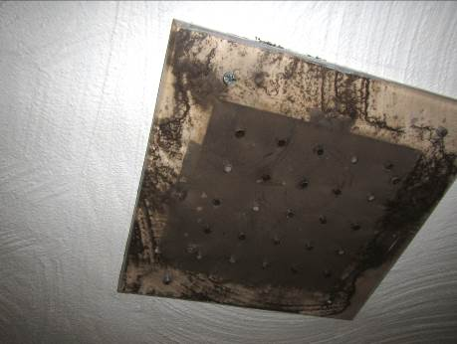
Plexiglas exhaust vent cover with drilled holes (note debris)
Picture 18
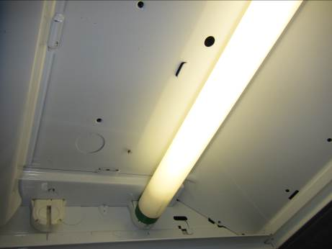
Fluorescent light fixture missing cover, note drain fly (arrow)
Location | Carbon  Dioxide  (ppm) | Carbon Monoxide  (ppm) | Temp  (°F) | Relative  Humidity  (%) | PM2.5  (µg/m³) | Occupants  in Room | Windows  Openable | Ventilation |  |  | Remarks
 |  |  |  |  |  |  |  | Intake | Exhaust
Background | 380 | ND | 79 | 77 | 33 | - | - | - |  | -
Officer entry | 580 | ND | 73 | 58 | 26 | 1 | N | N |  | N | CPs
Bath | - | - | - | - | - | - | N | N |  | Y | AD, sewer flies
Behind wall space | - | - | - | - | - | - | - | - |  | - | Odors, wet mops, dust/debris, unconditioned air and pathways to space
Dispatch foyer | 602 | ND | 73 | 56 | 23 | 0 | N | N |  | N | Window AC occluded with dust
Evidence room | - | - | - | - | - | - | N | N |  | N | No exhaust ventilation, very strong marijuana odor
EOC | 627 | ND | 75 | 59 | 20 | 0 | Y | N |  | N | Split AC unit; recirculates only, no fresh air ventilation
Booking room | 557 | ND | 73 | 56 | 23 | 0 | N | N |  | N | No fresh air ventilation
Photo/processing room | 552 | ND | 73 | 56 | 22 | 0 | N | N |  | N | No fresh air ventilation
Sergeant hallway | 540 | ND | 72 | 56 | 21 | 0 | N | Y |  | Y | Ventilation unit serves this area, pesticide strips on exhaust vent for drain flies
Dispatch | 613 | ND | 76 | 68 | 30 | 1 | Y | N |  | N | Open window, split AC (recirculates only), DEM
Sergeant’s office | 530 | ND | 74 | 55 | 20 | 0 | Y | N |  | N | AC, MTs
IT room | - | - | - | - | - | - | N | N |  | N | Leaking condensate lines from AC unit

