Background

INDOOR AIR QUALITY ASSESSMENT

Commonwealth of Massachusetts
Newbury Town Hall
25 High Road
Newbury, MA

Prepared by:
Massachusetts Department of Public Health
Bureau of Environmental Health
Indoor Air Quality Program
October 2015

Building: | Newbury Town Hall (NTH)
Address: | 25 High Road, Newbury, MA
Assessment Requested by: | Deborah Rogers, Health Agent, Newbury Health Department (NHD)
Date of Assessment: | August 26, 2015
BEH/IAQ Staff Conducting Assessment: | Jason Dustin, Environmental Analyst/Inspector
Date of Building Construction: | 1977
Reason for Request: | General indoor air quality (IAQ) concerns

Building Description
The NTH is located on the first floor of a two-story, clapboard-sided building with a concrete/cobblestone foundation. The NTH is built into a hill, with portions of the lower level below grade. The lower level houses the Newbury Police Department (NPD) and is the subject of a separate report (MDPH, October 2015). Windows are openable.

Results
This space is occupied by approximately 15 employees. Members of the public also visit the space daily. Test results are presented in Table 1. Methods and indoor air related sampling information can be found in the IAQ Manual and Appendices for IAQ Reports that can be found at:
http://www.mass.gov/eohhs/gov/departments/dph/programs/environmental-health/exposure-topics/iaq/iaq-rpts/general-appendices-for-iaq-reports.html

Discussion

Ventilation
It can be seen from Table 1 that carbon dioxide levels were above 800 parts per million (ppm) in all areas measured, indicating inadequate air exchange at the time of the assessment. It should be noted that most areas of the NTH were sparsely occupied and that carbon dioxide levels would be expected to rise further with increased occupancy (e.g., town meetings). It was reported by NTH staff that the air handling unit (AHU) only recirculates room air and does not introduce fresh outside air which is the reason for the elevated carbon dioxide readings given relatively low occupancy with closed windows. Return air is drawn into a single ceiling-mounted vent (Picture 1) and returned to the AHU unit where it is cooled and ducted to supply vents throughout the NTH (Picture 2). To maximize air exchange, the MDPH recommends having an HVAC system with a fresh air supply which operates continuously during periods of occupancy.

Temperature and Relative Humidity
Indoor temperature measurements at the time of the assessment ranged from 71°F to 76°F (Table 1), which were within the MDPH recommended comfort range. Indoor relative humidity measurements at the time of the assessment ranged from 50 to 52 percent (Table 1), which were within the MDPH recommended comfort range in areas tested. The MDPH recommends a comfort range of 40 to 60 percent for indoor air relative humidity.

Microbial/Moisture Concerns
In order for building materials to support mold growth, a source of water exposure is necessary. The NTH has a number of water-damaged ceiling tiles throughout the occupied area (Pictures 3 to 5). According to NTH staff, the water damage is from historic leaks noting that repairs have been made to the roof in recent years.
A storage area adjacent to the meeting room had wet mops stored directly on a wooden surface. The area had some dark staining consistent with mold colonization (Picture 6). Mops should be wrung dry and stored within a mop bucket to avoid chronic moistening of porous materials.
The US EPA and the American Conference of Governmental Industrial Hygienists (ACGIH) recommend that porous materials be dried with fans and heating within 24 to 48 hours of becoming wet (US EPA, 2001; ACGIH, 1989). If porous materials are not dried within this time frame, mold growth may occur. Once mold has colonized porous materials, they are difficult to clean and should be removed and discarded. Before disturbing the older, interlocking ceiling tiles, care should be taken to have them tested for asbestos; if they contain asbestos they must be professionally remediated/disposed of in a manner consistent with Massachusetts asbestos remediation laws (MDLI, 1993).
Indoor plants were noted in some areas. Plants can be a source of pollen and mold, which can be respiratory irritants to some individuals. Plants should be properly maintained and equipped with non-porous drip pans. Plants should also be located away from ventilation sources to prevent the entrainment and/or aerosolization of dirt, pollen or mold.

Other IAQ Evaluations
Indoor air quality can be negatively influenced by the presence of respiratory irritants, such as products of combustion. The process of combustion produces a number of pollutants. Common combustion emissions include carbon monoxide, carbon dioxide, water vapor, and smoke (fine airborne particle material). Of these materials, exposure to carbon monoxide and particulate matter with a diameter of 2.5 micrometers (μm) or less (PM2.5) can produce immediate, acute health effects upon exposure. To determine whether combustion products were present in the indoor environment, BEH/IAQ staff obtained measurements for carbon monoxide and PM2.5.

Carbon Monoxide
Carbon monoxide should not be present in a typical, indoor environment. If it is present, indoor carbon monoxide levels should be less than or equal to outdoor levels. On the day of the assessment, outdoor carbon monoxide concentrations were non-detect (ND) (Table 1). No measurable levels of carbon monoxide were detected inside the building (Table 1).

Particulate Matter
Outdoor PM2.5 was measured at 33 μg/m³ (Table 1). PM2.5 levels measured indoors ranged from 6 to 8 μg/m³ (Table 1), which were below the NAAQS PM2.5 level of 35 μg/m³.

Volatile Organic Compounds
In order to determine if VOCs were present, BEH/IAQ staff inspected areas for items containing VOCs. BEH/IAQ staff noted hand sanitizer, cleaners, and air fresheners at the time of the assessment. All of these have the potential to be irritants to the eyes, nose, throat and respiratory system of sensitive individuals.

Other Conditions
Other conditions that can affect IAQ were observed during the assessment. Gaps around utilities on the exterior of the building as well as open windows during hot, humid weather may allow unconditioned air/moisture into occupied areas (Picture 7).
As mentioned in the Newbury Police Department (NPD) report, the lower level of the building has a sewer ejector pump chamber. Any gaps and openings in this pump chamber should be sealed. Any pathways should be sealed to prevent migration of odors into the NTH building.
Exhaust vents in the bathroom areas of the NTH were observed to contain a large amount of dust/debris (Picture 8). These vents should be cleaned regularly to avoid aerosolizing the particulate matter.
In some areas, items were observed on floors, desks and other surfaces, which provide a source for dusts to accumulate. These items (e.g., papers, folders, boxes) make it difficult for custodial staff to clean. Items should be relocated and/or be cleaned periodically to avoid excessive dust build up. In addition, dust and debris can accumulate on flat surfaces (e.g., desktops, shelving and floors) in occupied areas and subsequently be re-aerosolized causing further irritation.
Many areas of the NTH are carpeted. The Institute of Inspection, Cleaning and Restoration Certification (IICRC) recommends that carpeting be cleaned annually (or semi-annually in soiled high traffic areas) (IICRC, 2012). Regular cleaning with a high efficiency particulate air (HEPA) filtered vacuum in combination with an annual cleaning will help to reduce accumulation and potential aerosolization of materials from carpeting.

Conclusions/Recommendations
In view of the findings at the time of the visit, the following recommendations are made:
- Consider contracting with an HVAC engineer to incorporate fresh air supply and exhaust capabilities to the air handling unit (AHU) to increase the air exchange within the NTH. In the short term, fresh air can be supplemented by opening windows as weather permits.
- After confirming that all leaks have been repaired, remove any water-damaged ceiling tiles and other porous building materials (mold colonized plywood in janitor’s closet). Older, interlocking ceiling tiles should be confirmed to be asbestos-free prior to disturbing the tiles.
- Seal all gaps in the exterior building envelope that lead to occupied space (e.g., holes around utilities in foundation etc.) to reduce moisture, pests and pollutants from entering the space.
- Seal all pathways in the ceiling and wall systems that allow unconditioned air, pests and odors to travel within the NTH occupied areas (e.g., breaches in walls/ceilings).
- Wet mops should be wrung dry and stored within a mop bucket to avoid chronic moistening of porous materials.
- Plants should be properly maintained and equipped with non-porous drip pans. Plants should also be located away from ventilation sources to prevent the entrainment and/or aerosolization of dirt, pollen or mold.
- For buildings in New England, periods of low relative humidity during the winter are often unavoidable. Therefore, scrupulous cleaning practices should be adopted to minimize common indoor air contaminants whose irritant effects can be enhanced when the relative humidity is low. To control for dusts, a high efficiency particulate arrestance (HEPA) filter equipped vacuum cleaner in conjunction with wet wiping of all surfaces is recommended. Avoid the use of feather dusters. Drinking water during the day can help ease some symptoms associated with a dry environment (throat and sinus irritations).
- Ensure that the sewage ejector pump chamber is well sealed, and that there are no gaps in the walls of the room in which it is housed.
- Clean all exhaust/supply vents on a regular basis to reduce aerosolizing accumulated particulate matter.
- Regular cleaning with a high efficiency particulate air (HEPA) filtered vacuum in combination with an annual cleaning will help to reduce accumulation and potential aerosolization of materials from carpeting.
- Consider limiting the use of hand sanitizer, air fresheners, and cleaning products which can cause eye, nose and throat irritations in sensitive individuals.
- Avoid the accumulation of large numbers of items on flat surfaces. To prevent excessive dust build up, items should be relocated periodically to allow for cleaning.
- Refer to resource manual and other related indoor air quality documents located on the MDPH’s website for further building-wide evaluations and advice on maintaining public buildings. These documents are available at http://mass.gov/dph/iaq.

References
ACGIH. 1989. Guidelines for the Assessment of Bioaerosols in the Indoor Environment. American Conference of Governmental Industrial Hygienists, Cincinnati, OH.
IICRC. 2012. Institute of Inspection, Cleaning and Restoration Certification. Carpet Cleaning: FAQ. Retrieved from http://www.iicrc.org/consumers/care/carpet-cleaning/#faq.
MDPH, October 2015. Indoor Air Quality Assessment Newbury Police Department. October 2015.
MDLI. 1993. Regulation of the Removal, Containment or Encapsulation of Asbestos, Appendix 2. 453 CMR 6,92(I)(i).
US EPA. 2001. Mold Remediation in Schools and Commercial Buildings. US Environmental Protection Agency, Office of Air and Radiation, Indoor Environments Division, Washington, D.C. EPA 402-K-01-001. March 2001.
Picture

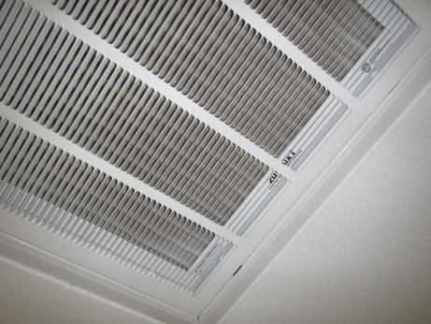

Sole return vent for AHU showing pleated filter behind grate

Picture

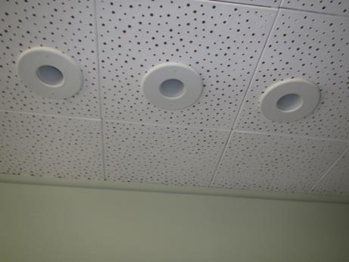

Ceiling-mounted supply air vents
Picture

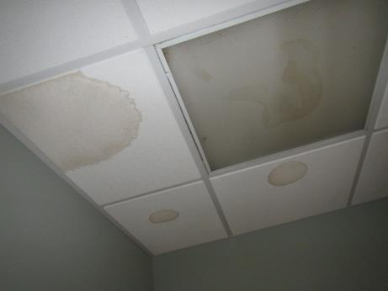

Water-damaged ceiling tiles

Picture

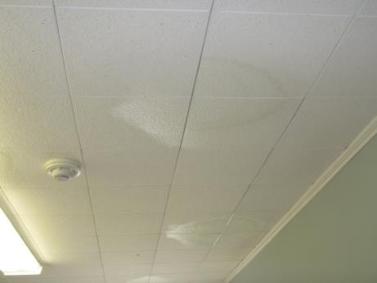

Water-damaged ceiling tiles apparently painted over
Picture

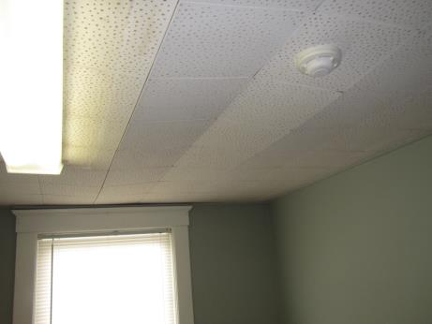

Water-damaged/warped interlocking ceiling tiles

Picture

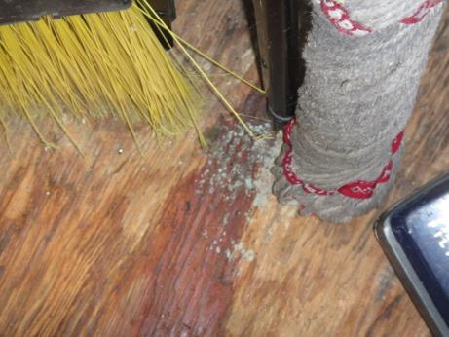

Wet mop stored directly on plywood (note possible microbial growth)
Picture

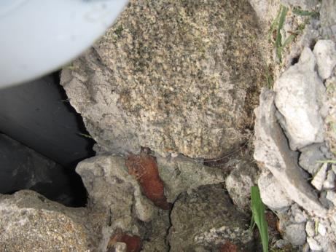

Large gaps around utilities in foundation (arrow)

Picture

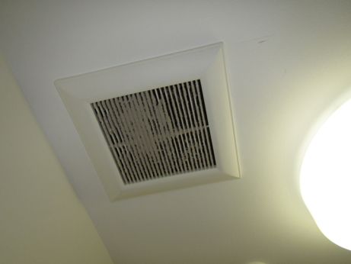

Exhaust vent showing accumulated dust/debris
Location | Carbon  Dioxide  (ppm) | Carbon Monoxide  (ppm) | Temp  (°F) | Relative  Humidity  (%) | PM2.5  (µg/m³) | Occupants  in Room | Windows  Openable | Ventilation |  |  | Remarks
 |  |  |  |  |  |  |  | Intake | Exhaust
Background | 380 | ND | 79 | 77 | 33 | - | - | - |  | -
Town Accountant | 1133 | ND | 76 | 52 | 8 | 0 | Y | Y |  | N | Complaints of black spots on blinds
Treasurer’s | 1122 | ND | 75 | 52 | 7 | 2 | Y | Y |  | N | Carpeted, bowed WD CTs (interlocking), historic leaks
Board of Selectmen | 1096 | ND | 73 | 52 | 7 | 3 | Y | Y |  | N | Photocopier
Town Administrator | 1025 | ND | 71 | 50 | 7 | 0 | Y | Y |  | N | Plant on carpet, split AC wall unit also
Town Meeting area | 1098 | ND | 71 | 51 | 8 | 1 | Y | Y |  | Y | Single return vent for entire floor
Planning | 1123 | ND | 72 | 52 | 8 | 1 | Y | Y |  | N
Assessor’s | 1188 | ND | 72 | 52 | 7 | 1 | Y | Y |  | N | Bowed WD CTs (interlocking)
Principal Assessor | 1138 | ND | 73 | 52 | 6 | 1 | Y | Y |  | N
Clerk’s | 1160 | ND | 73 | 52 | 7 | 3 | Y | Y |  | N

