INDOOR AIR QUALITY ASSESSMENT

Newbury Town Hall Trailers
25 High Road
Newbury, Massachusetts



Prepared by:
Massachusetts Department of Public Health
Bureau of Environmental Health
Indoor Air Quality Program
September 2015

Background
Building: Newbury Town Hall Trailer (NTHT) complex
Address: 25 High Road, Newbury, Massachusetts
Assessment Requested by: Deborah Rogers, Health Agent, Newbury Health Department
Date of Assessment: May 19, 2015
BEH/IAQ Staff
Conducting Assessment: Michael Feeney, Director
Jason Dustin, Environmental Analyst/Inspector

Date of Building
Construction: 1990s

Reason for Request: General IAQ concerns in the building, including issues relating to
water damage, musty odors and reports of staff symptoms
(e.g., headaches).
Building Description
The NTHT complex consists of two modular office trailers adjacent to the Newbury Town Hall building. The trailers are connected by hallways and house administrative offices for the Health, Police and Fire Departments as well as a conference room, break room, bunk room and record storage areas. Windows are openable throughout the trailers.
It should be noted that although the NTHT complex was planned as temporary office space, one trailer has been in use for approximately 15 years while the other has been in use for about 17 years. All building materials and furnishings appear to be original with the exception of some replacement windows.

Methods
Air tests for carbon monoxide, carbon dioxide, temperature and relative humidity were conducted with the TSI, Q-Trak, IAQ Monitor, Model 7565. Air tests for airborne particle matter with a diameter less than 2.5 micrometers were taken with the TSI, DUSTTRAK™ Aerosol Monitor Model 8532. Moisture content of porous building materials (e.g., carpeting, wooden trim, ceiling tiles) was measured with a Delmhorst, BD-2100 Model, Moisture Detector with a Delmhorst Standard Probe. BEH/IAQ staff also performed a visual inspection of building materials for water damage and/or microbial growth.

Results
The NTHT complex has an employee population of approximately 10 with the public visiting to conduct business daily. The tests were taken during normal operations and results appear in Table 1.

Discussion

Ventilation
It can be seen from Table 1 that carbon dioxide levels were below 800 parts per million (ppm) in all areas tested, indicating adequate air exchange at the time of the assessment (Table 1). It is important to note that a number of areas were sparsely populated or unoccupied and doors and windows were open at the time measurements were taken, which can greatly reduce carbon dioxide levels. Carbon dioxide levels would be expected to be higher with full occupancy and with doors and windows closed during the heating/cooling seasons.
Mechanical ventilation is provided by forced hot air (FHA) units mounted on exterior walls (Picture 1), which were deactivated during the assessment. Supply air is distributed via ceiling mounted air diffusers (Picture 2) and returned back to the FHA units through wall/floor-mounted return vents. Cooling is provided by an air conditioning unit that is located in the adjacent Town Hall building.
Thermostats control the heating, ventilating and air conditioning (HVAC) system. Thermostats have fan settings of “on” and “automatic”. The automatic fan setting on the thermostat activates the HVAC system at a pre-set temperature. Once a pre-set temperature is measured by the thermostat, the HVAC system is deactivated. Therefore, no mechanical ventilation is provided until the thermostat re-activates the system. Note that in a few areas, supply vents were diverted or blocked off, which reduces the ability of the system to supply fresh air to that space. Newbury Police staff also reported that the attached FHA units have not been functioning adequately. Without continuous operation of supply/exhaust ventilation, indoor air pollutants can build up and lead to IAQ/comfort complaints.
Minimum design ventilation rates are mandated by the Massachusetts State Building Code (MSBC). Until 2011, the minimum ventilation rate in Massachusetts was higher for both occupied office spaces and general classrooms, with similar requirements for other occupied spaces (BOCA, 1993). The current version of the MSBC, promulgated in 2011 by the State Board of Building Regulations and Standards (SBBRS), adopted the 2009 International Mechanical Code (IMC) to set minimum ventilation rates. Please note that the MSBC is a minimum standard that is not health-based. At lower rates of cubic feet per minute (cfm) per occupant of fresh air, carbon dioxide levels would be expected to rise significantly. A ventilation rate of 20 cfm per occupant of fresh air provides optimal air exchange resulting in carbon dioxide levels at or below 800 ppm in the indoor environment in each area measured. MDPH recommends that carbon dioxide levels be maintained at 800 ppm or below. This is because most environmental and occupational health scientists involved with research on IAQ and health effects have documented significant increases in indoor air quality complaints and/or health effects when carbon dioxide levels rise above the MDPH guidelines of 800 ppm for schools, office buildings and other occupied spaces (Sundell et al., 2011). The ventilation must be on at all times that the room is occupied. Providing adequate fresh air ventilation with open windows and maintaining the temperature in the comfort range during the cold weather season is impractical. Mechanical ventilation is usually required to provide adequate fresh air ventilation.
Carbon dioxide is not a problem in and of itself. It is used as an indicator of the adequacy of the fresh air ventilation. As carbon dioxide levels rise, it indicates that the ventilating system is malfunctioning or the design occupancy of the room is being exceeded. When this happens, a build up of common indoor air pollutants can occur, leading to discomfort or health complaints. The Occupational Safety and Health Administration (OSHA) standard for carbon dioxide is 5,000 parts per million of air (ppm). Workers may be exposed to this level for 40 hours/week, based on a time-weighted average (OSHA, 1997).
The MDPH uses a guideline of 800 ppm for publicly occupied buildings. Inadequate ventilation and/or elevated temperatures are major causes of complaints such as respiratory, eye, nose and throat irritation, lethargy and headaches. For more information concerning carbon dioxide, please see Appendix A.
Indoor temperature readings during the assessment ranged from 67ºF to 69ºF, which were close to the lower end of the MDPH recommended comfort guidelines (Table 1). The MDPH recommends that indoor air temperatures be maintained in a range of 70ºF to 78ºF in order to provide for the comfort of building occupants. In many cases concerning indoor air quality, fluctuations of temperature in occupied spaces are typically experienced, even in a building with an adequate fresh air supply. It was reported that staff in some areas experience discomfort due to direct airflow from supply diffusers. Changing diffuser style to direct airflow away from office personnel can help alleviate the sensation of drafts.
The relative humidity measured in the building during the assessment ranged from 53 to 68 percent (Table 1), almost half the areas surveyed had readings above the MDPH recommended comfort range. The MDPH recommends a comfort range of 40 to 60 percent for indoor air relative humidity. Relative humidity levels in the building would be expected to drop during the winter months due to heating. The sensation of dryness and irritation is common in a low relative humidity environment. Low relative humidity is a very common problem during the heating season in the northeast part of the United States.

Microbial/Moisture Concerns
At the time of the assessment, BEH/IAQ staff detected a musty odor throughout the NTHT complex. Moisture readings of building materials were taken with a Delmhorst probe. Elevated moisture readings were measured in the carpeting of the entryway to the Health Department. Evidence of water-damaged carpeting, furniture and building materials was observed throughout the NTHT complex (Pictures 3 to 5, Table 1). Water-damaged ceiling tiles were visible in the hallway that connects the trailers. BEH/IAQ staff also noted breaches in the building envelope, which can provide a source of water infiltration (e.g., roof, door/window frame and siding leaks).
The US EPA and the American Conference of Governmental Industrial Hygienists (ACGIH) recommend that porous materials be dried with fans and heating within 24 to 48 hours of becoming wet (US EPA, 2001; ACGIH, 1989). If porous materials are not dried within this time frame, mold growth may occur. Once mold has colonized porous materials, they are difficult to clean and should be removed and discarded.
Portions of the NTHT complex are sited over an earth foundation with aluminum skirting of the trailers encompassing a crawlspace. BEH/IAQ staff examined the crawlspace and observed a damaged vapor barrier and moist conditions (Pictures 6 to 9). Water vapor from the moist crawlspace enters the trailers through openings in the vapor barrier and other breaches in the floor decking. Water vapor may then condense on surfaces in the trailers that are below the dew point temperature. This chronic moistening of porous building materials and items (carpeting, pressboard furniture, files, etc.) may cause water damage, mold colonization and associated odors. The possibly shifting support structures (Pictures 10 and 11) below the trailers will lead to further breaches in the building envelope due to shifting and settling of the trailers. The aluminum skirting surrounding the crawlspace had numerous openings, which would allow the entry of debris, storm water and pests (Picture 12).

Other IAQ Evaluations
Indoor air quality can be negatively influenced by the presence of respiratory irritants, such as products of combustion. The process of combustion produces a number of pollutants. Common combustion emissions include carbon monoxide, carbon dioxide, water vapor, and smoke (fine airborne particle material). Of these materials, exposure to carbon monoxide and particulate matter with a diameter of 2.5 micrometers (μm) or less (PM2.5) can produce immediate, acute health effects upon exposure. To determine whether combustion products were present in the indoor environment, BEH/IAQ staff obtained measurements for carbon monoxide and PM2.5.

Carbon Monoxide
Carbon monoxide is a by-product of incomplete combustion of organic matter (e.g., gasoline, wood and tobacco). Exposure to carbon monoxide can produce immediate and acute health effects. Several air quality standards have been established to address carbon monoxide and prevent symptoms from exposure to these substances. The MDPH established a corrective action level concerning carbon monoxide in ice skating rinks that use fossil-fueled ice resurfacing equipment. If an operator of an indoor ice rink measures a carbon monoxide level over 30 ppm, taken 20 minutes after resurfacing within a rink, that operator must take actions to reduce carbon monoxide levels (MDPH, 1997).
The American Society of Heating Refrigeration and Air-Conditioning Engineers (ASHRAE) has adopted the National Ambient Air Quality Standards (NAAQS) as one set of criteria for assessing indoor air quality and monitoring of fresh air introduced by HVAC systems (ASHRAE, 1989). The NAAQS are standards established by the US EPA to protect the public health from six criteria pollutants, including carbon monoxide and particulate matter (US EPA, 2006). As recommended by ASHRAE, pollutant levels of fresh air introduced to a building should not exceed the NAAQS levels (ASHRAE, 1989). The NAAQS were adopted by reference in the Building Officials & Code Administrators (BOCA) National Mechanical Code of 1993 (BOCA, 1993), which is now an HVAC standard included in the Massachusetts State Building Code (SBBRS, 2011). According to the NAAQS, carbon monoxide levels in outdoor air should not exceed 9 ppm in an eight-hour average (US EPA, 2006).
Carbon monoxide should not be present in a typical, indoor environment. If it is present, indoor carbon monoxide levels should be less than or equal to outdoor levels. On the day of the assessment, outdoor carbon monoxide concentrations were non-detect (ND) (Table 1). No measureable levels of carbon monoxide were detected in the building during the assessment (Table 1).
It should be noted that the NTHT complex is adjacent to the town’s back-up generator (Picture 13). This generator has the potential to create carbon monoxide exposure due to the proximity of the trailers, as well as the Town Hall building. It was reported by Newbury Police staff that the testing schedule was shifted to Friday (most offices closed) to avoid previous complaints from emissions during weekly testing. Care should be taken to close windows in close proximity to the generator and prevent the entrainment of emissions through air intake vents.

Particulate Matter
The US EPA has established NAAQS limits for exposure to particulate matter. Particulate matter includes airborne solids that can be irritating to the eyes, nose and throat. The NAAQS originally established exposure limits to PM with a diameter of 10 μm or less (PM10). In 1997, US EPA established a more protective standard for fine airborne particulate matter with a diameter of 2.5 μm or less (PM2.5). This more stringent PM2.5 standard requires outdoor air particle levels be maintained below 35 μg/m³ over a 24-hour average (US EPA, 2006). Although both the ASHRAE standard and BOCA Code adopted the PM10 standard for evaluating air quality, MDPH uses the more protective PM2.5 standard for evaluating airborne PM concentrations in the indoor environment.
Outdoor PM2.5 concentrations were measured at 9 μg/m³ (Table 1). PM2.5 levels indoors ranged from 6 to 8 μg/m³ (Table 1), which were below the NAAQS PM2.5 level of 35 μg/m³. Frequently, indoor air levels of particulate matter (including PM2.5) can be at higher levels than those measured outdoors. A number of activities that occur indoors and/or mechanical devices can generate particulate matter during normal operations. Sources of indoor airborne particulate matter may include but are not limited to particles generated during the operation of fan belts in the HVAC system, use of stoves and/or microwave ovens in kitchen areas; use of photocopiers, fax machines and computer printing devices; operation of an ordinary vacuum cleaner; and heavy foot traffic indoors.
The NTHT complex was utilizing several High Efficiency Particulate Arrestance (HEPA) air purifiers (Picture 14) at the time of the assessment, following the receipt of a consultant’s report that showed elevated mold spore and particulate matter counts (Indoor Doctor, 2015). It should be noted that these HEPA filters should be maintained according to manufacturer recommendations (e.g., cleaning/changing filters). Although helpful in reducing suspended particulate matter, these filters do not address the root cause of chronic water infiltration, water-damaged materials and possible mold colonization.

Volatile Organic Compounds
Indoor air concentrations can be greatly impacted by the use of products containing volatile organic compounds (VOCs). VOCs are carbon-containing substances that have the ability to evaporate at room temperature. Total volatile organic compounds (TVOCs) can result in eye and respiratory irritation if exposure occurs. For example, chemicals evaporating from a paint can stored at room temperature would most likely contain VOCs. In an effort to identify materials that can potentially increase indoor VOC concentrations, BEH/IAQ staff examined rooms for products containing these respiratory irritants.
A dry erase marker (DEM) board and related materials were observed in the Investigations room. Materials such as dry erase markers and dry erase board cleaners may contain VOCs, such as methyl isobutyl ketone, n-butyl acetate and butyl-cellusolve (Sanford, 1999), which can be irritating to the eyes, nose and throat.
Photocopiers can be sources of pollutants such as VOCs, ozone, heat and odors, particularly if the equipment is older and in frequent use. Both VOCs and ozone are respiratory irritants (Schmidt Etkin, 1992). Photocopiers should be kept in well ventilated rooms and should be located near windows or exhaust vents.
Hand sanitizers were found in some offices and common areas. Hand sanitizer products may contain ethyl alcohol and/or isopropyl alcohol, which are highly volatile and may be irritating to the eyes and nose and may contain fragrances to which some people may be sensitive.
Air fresheners and cleaners with deodorizing materials were observed in some areas. Air deodorizers contain chemicals that can be irritating to the eyes, nose and throat of sensitive individuals. Many air fresheners contain 1,4-dichlorobenzene, a VOC which may cause reductions in lung function (NIH, 2006). Furthermore, deodorizing agents do not remove materials causing odors, but rather mask odors that may be present in the area.

Other Conditions
Other conditions that can affect IAQ were observed during the assessment. Dusty vents, personal fans and surfaces were observed throughout the NTHT complex. Dust can be irritating to the eyes, nose and respiratory tract. These items should be cleaned periodically in order to prevent them from serving as a source of aerosolized particulate matter.
In some areas, accumulation of items, including papers, boxes and personal items were found stored on desks, tables and counters. Large numbers of items provide a source for dusts to accumulate. These items make it difficult for custodial staff to clean. Items should be relocated and/or cleaned periodically to avoid excessive dust build up.
Newbury Police staff reported an ongoing rodent infestation of the trailers. Rodent infestation can result in IAQ related symptoms due to materials in their wastes. Mouse urine contains a protein that is a known sensitizer (US EPA, 1992). A sensitizer is a material that can produce symptoms (e.g., running nose or skin rashes) in sensitive individuals after repeated exposure. A three-step approach is necessary to eliminate rodent infestation:
- removal of the rodents;
- cleaning of waste products from the interior of the building; and
- reduction/elimination of pathways/food sources that are attracting rodents.
To eliminate exposure to allergens, rodents must be removed from the building. Please note that removal, even after cleaning, may not provide immediate relief since allergens can exist in the interior for several months after rodents are eliminated (Burge, 1995). Once the infestation is eliminated, a combination of cleaning and increased ventilation and filtration should serve to reduce allergens associated with rodents.

Conclusions/Recommendations
In view of the findings at the time of the visit, the following recommendations are made:
- A building engineer should be consulted to determine the extent of work needed to restore the building envelope of the NTHT complex to prevent chronic water infiltration (roof, siding, door/window frames, vapor barrier, crawlspace integrity, supports, etc.). Other repairs to attached FHA units and removal/replacement of water-damaged building materials/furnishings with appropriate materials should be considered as well. Given the age/condition of the trailers and the cost estimates, a decision should be made whether to proceed with the work or relocate employees to more suitable office space.
- If the decision is to remediate/renovate trailers, make all necessary repairs to stop chronic water infiltration through the building envelope.
- Remove any water-damaged porous building materials/furnishings in a manner consistent with US EPA mold/water damage remediation guidelines: “Mold Remediation in Schools and Commercial Buildings” (US EPA, 2001). This document can be downloaded from the US EPA website at: http://www.epa.gov/mold/mold_remediation.html. Items of importance such as plans or important legal documents could be scanned or copied prior to discarding.
- Replace water-damaged porous building materials (e.g. ceiling tiles, trim, carpeting, insulation, etc.). Carpeting is generally not recommended in areas subject to chronic moisture. Consider replacing any carpet with tile or other non-porous flooring.
- Clean and disinfect any mold-colonized nonporous surfaces with a mild detergent or antimicrobial agent according to US EPA guidelines (US EPA, 2001).
- Avoid storing porous items in areas subject to chronic moisture. In particular, do not store cardboard/paper items in direct contact with floors or walls where condensation may occur during humid conditions.
- Continue to minimize impact from weekly generator testing. Close windows and air intakes in close proximity to the generator during testing. Consider raising the exhaust stack height if necessary.
- Continue to operate HEPA air filters in occupied areas until remediation/relocation is complete. Ensure the HEPA units are maintained according to manufacturer recommendations and that they are removed from remediation/demolition areas to avoid clogging filters with construction related debris.
- It is recommended that the NTHT complex offices be thoroughly cleaned following the removal of water-damaged materials. Use of a HEPA vacuum cleaner and/or damp cloths will help remove dust/debris rather than aerosolizing it.
- Operate all ventilation systems throughout the building continuously during periods of occupancy to maximize air exchange. This would include leaving thermostat fan settings in the “on” mode (not auto) for continuous airflow. Use windows for increased ventilation when weather permits. Windows should not be opened during humid weather conditions while air conditioning is also operating; this will result in further condensation in the space.
- Verify that the NTHT complex has adequate fresh air intake and exhaust capabilities. MDPH typically recommends that 20 cfm/occupant of fresh air is supplied to office areas to avoid IAQ complaints. Exhaust ventilation is important to remove moisture and odors from occupied space.
- To avoid comfort complaints, consider adjusting or replacing supply diffusers to direct airflow away from personnel.
- Eliminate rodent infestation, remove pathways/food sources and thoroughly clean space.
- Remove any obstructions or materials blocking supply and/or exhaust vents.
- To reduce exposure to VOC’s: locate photocopiers in well ventilated rooms and reduce or eliminate the use of dry erase boards, hand sanitizers, air fresheners and cleaners with high VOC content.
- Large amounts of accumulated items on flat surfaces should be relocated and/or cleaned periodically to avoid excessive dust build up.
- Clean supply/exhaust vents and personal fans periodically to avoid aerosolizing accumulated dust.
- Refer to resource manuals and other related indoor air quality documents for further building-wide evaluations and advice on maintaining public buildings. Copies of these materials are located on the MDPH’s website: http://mass.gov/dph/iaq.

References
ACGIH. 1989. Guidelines for the Assessment of Bioaerosols in the Indoor Environment. American Conference of Governmental Industrial Hygienists, Cincinnati, OH.
ASHRAE. 1989. Ventilation for Acceptable Indoor Air Quality. American Society of Heating, Refrigeration and Air Conditioning Engineers. ANSI/ASHRAE 62-1989.
BOCA. 1993. The BOCA National Mechanical Code/1993. 8th ed. Building Officials & Code Administrators International, Inc., Country Club Hills, IL.
Burge, H.A. 1995. Bioaerosols. Lewis Publishing Company, Boca Raton, FL.
Indoor Doctor. 2015. “Mold Testing Report Especially Prepared For: The Town of Newbury”. Indoor Doctor, LLC. J. J. Bradley Owner/Environmental Engineer. March 12, 2015.
MDPH. 1997. Requirements to Maintain Air Quality in Indoor Skating Rinks (State Sanitary Code, Chapter XI). 105 CMR 675.000. Massachusetts Department of Public Health, Boston, MA.
NIH. 2006. Chemical in Many Air Fresheners May Reduce Lung Function. NIH News. National Institute of Health. July 27, 2006. http://www.nih.gov/news/pr/jul2006/niehs-27.htm
OSHA. 1997. Limits for Air Contaminants. Occupational Safety and Health Administration. Code of Federal Regulations. 29 C.F.R 1910.1000 Table Z-1-A.
Sanford. 1999. Material Safety Data Sheet (MSDS No: 198-17). Expo® Dry Erase Markers Bullet, Chisel, and Ultra Fine Tip. Sanford Corporation. Bellwood, IL.
SBBRS. 2011. Mechanical Ventilation. State Board of Building Regulations and Standards. Code of Massachusetts Regulations, 8th edition. 780 CMR 1209.0.
Schmidt Etkin, D. 1992. Office Furnishings/Equipment & IAQ Health Impacts, Prevention & Mitigation. Cutter Information Corporation, Indoor Air Quality Update, Arlington, MA.
Sundell. 2011. Sundell, J., H. Levin, W. W. Nazaroff, W. S. Cain, W. J. Fisk, D. T. Grimsrud, F. Gyntelberg, Y. Li, A. K. Persily, A. C. Pickering, J. M. Samet, J. D. Spengler, S. T. Taylor, and C. J. Weschler. Ventilation rates and health: multidisciplinary review of the scientific literature. Indoor Air, Volume 21: pp 191–204.
US EPA. 1992. Indoor Biological Pollutants. US Environmental Protection Agency, Environmental Criteria and Assessment Office, Office of Health and Environmental Assessment, research Triangle Park, NC. EPA 600/8-91/202. January 1992.
US EPA. 2001. “Mold Remediation in Schools and Commercial Buildings”. Office of Air and Radiation, Indoor Environments Division, Washington, DC. EPA 402-K-01-001. March 2001. Available at: http://www.epa.gov/mold/mold_remediation.html.
US EPA. 2006. National Ambient Air Quality Standards (NAAQS). US Environmental Protection Agency, Office of Air Quality Planning and Standards, Washington, DC. http://www3.epa.gov/ttn/naaqs/criteria.html.
Picture 1

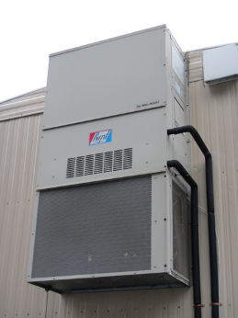

Attached forced hot air (FHA) unit

Picture 2

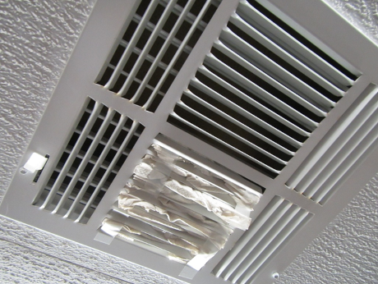

Ceiling-mounted supply air diffuser (partially blocked)
Picture 3

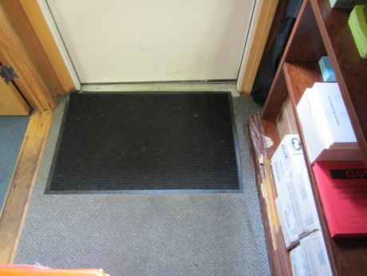

Water-damaged carpeting

Picture 4

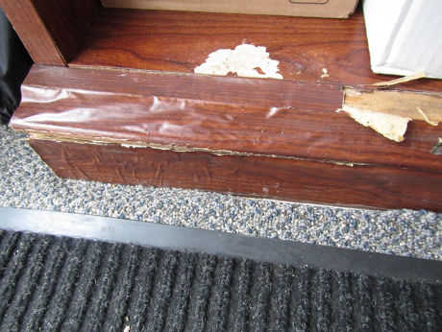

Water-damaged furniture
Picture 5

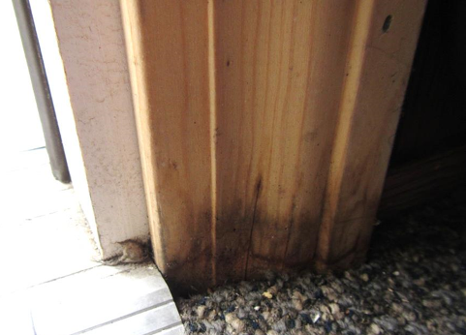

Water-damaged trim

Picture 6

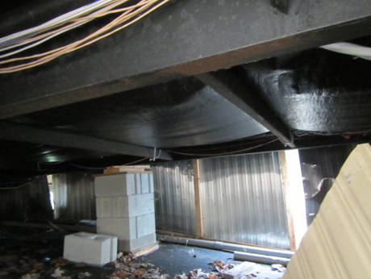

Damaged vapor barrier
Picture 7

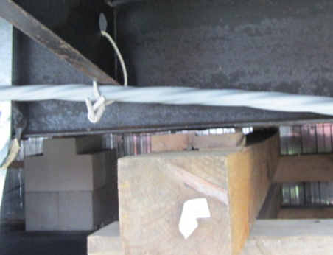

Large gaps beneath supports (arrow)

Picture 8

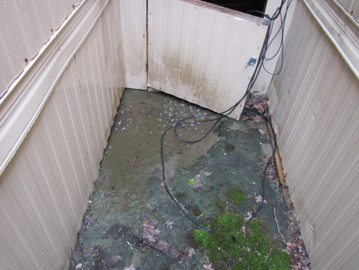

Water pooling under/between trailers
Picture 9

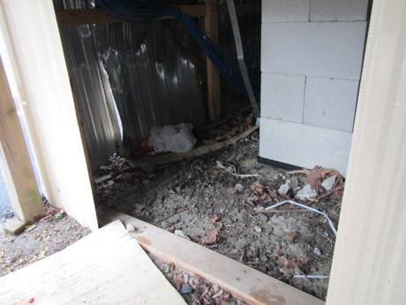

Debris and moist earth in crawlspace

Picture 10

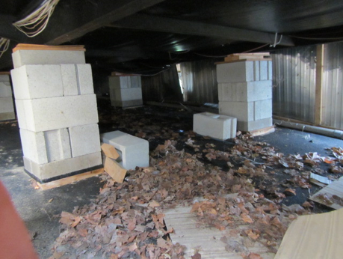

Stacked cement bricks and wood shims used as supports for trailers
Picture 11

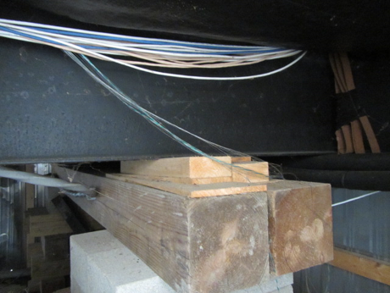

Close-up of wood shims and timber used to support trailers

Picture 12

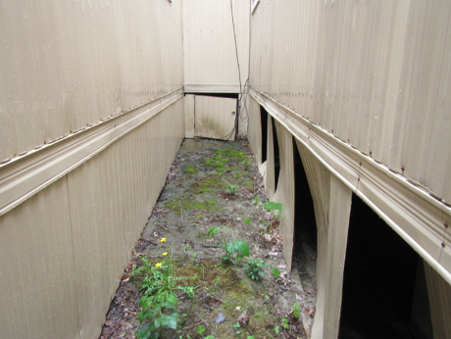

Damaged aluminum skirting around crawlspace
Picture 13

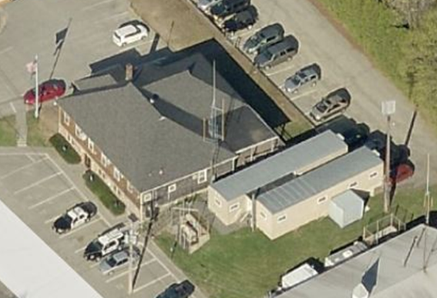
Town Hall
NTHT complex

Location of backup generator (arrow)

Picture 14

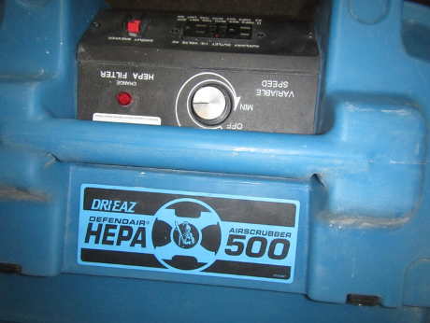

HEPA air filtration unit
Location | Carbon  Dioxide  (ppm) | Carbon Monoxide  (ppm) | Temp  (°F) | Relative  Humidity  (%) | PM2.5  (µg/m³) | Occupants  in Room | Windows  Openable | Ventilation |  | Remarks
 |  |  |  |  |  |  |  | Supply | Exhaust | Remarks
Background | 391 | ND | 66 | 58 | 9 |  |  |  |  | Overcast, light rain
Health Department | 597 | ND | 68 | 63 | 7 | 0 | Y | Y | N | DO, carpet moist near doorway, WD furniture, WD carpet
Fire Chief | 598 | ND | 67 | 67 | 7 | 2 | Y | Y | N | WD carpet, musty odor
Break/foyer | 571 | ND | 67 | 68 | 7 | 3 | Y | Y | N | Tile, DO
Lt. Lucey | 513 | ND | 67 | 57 | 8 | 0 | Y | Y | N | WD carpet, musty odor
Chief Reilly | 562 | ND | 69 | 53 | 6 | 1 | Y | Y | N | WD carpet
Hallway |  |  |  |  |  |  |  |  |  | Multiple ceiling WD stains
Conference room | 662 | ND | 68 | 54 | 6 | 2 | Y | Y | N | WD carpet
Investigations | 700 | ND | 67 | 54 | 6 | 1 | Y | Y | N | WD carpet, DEM
Bunk room | 672 | ND | 67 | 54 | 7 | 1 | Y | Y | N | Musty odor

